
On the Radar
Issue 671
21 October 2024

On the Radar is a summary of some of the recent publications in the areas of safety and quality in health care. Inclusion in this document is not an endorsement or recommendation of any publication or provider. Access to particular documents may depend on whether they are Open Access or not, and/or your individual or institutional access to subscription sites/services. Material that may require subscription is included as it is considered relevant.

On the Radar is available online, via email or as a PDF or Word document from https://www.safetyandquality.gov.au/newsroom/subscribe-news/radar

If you would like to receive On the Radar via email, you can subscribe on our website https://www.safetyandquality.gov.au/newsroom/subscribe-news
or by emailing us at HUmail@safetyandquality.gov.auU.
You can also send feedback and comments to HUmail@safetyandquality.gov.auU.

For information about the Commission and its programs and publications, please visit https://www.safetyandquality.gov.au

On the Radar
Editor: Dr Niall Johnson, Megan Ingman-Jones

Chronic Obstructive Pulmonary Disease Clinical Care Standard
Australian Commission on Safety and Quality in Health Care
Sydney: ACSQHC; 2024.
https://www.safetyandquality.gov.au/standards/clinical-care-standards/chronic-obstructive-pulmonary-disease-clinical-care-standard

Chronic Obstructive Pulmonary Disease (COPD) is a serious chronic condition, affecting an estimated 1 in 13 Australians over the age of 40. It is a leading cause of potentially preventable hospitalisations (PPHs) in Australia, and is associated with significant costs to the healthcare system.

On 17 October 2024 the Australian Commission on Safety and Quality in Health Care released the first national Chronic Obstructive Pulmonary Disease Clinical Care Standard. The standard aims to reduce potentially preventable hospitalisations and improve overall outcomes for people with COPD by supporting best practice in the assessment and management of COPD, including exacerbations. It also aims to increase consideration of the palliative care needs of people with COPD to support symptom management and improve quality of life.

The Commission partnered with a broad range of experts to develop the standard and implementation resources. Download a copy of the standard and watch the official webcast launch here https://www.safetyandquality.gov.au/standards/clinical-care-standards/chronic-obstructive-pulmonary-disease-clinical-care-standard

Reports

Consumer Perspectives on Patient Experience 2024
Wolf JA
Nashville TN: The Beryl Institute; 2024. p. 28.
URL | https://theberylinstitute.org/product/2024-global-healthcare-consumer-report-safe-care-communication-and-respect-lead-key-insights/
Notes | The Beryl Institute in the USA focuses on issues around patient experience. This report is the latest iteration of their survey of patient and consumer perspectives. While claiming to be a ‘global study’, patient perspectives were collected in 13 nations (USA, Australia, Canada, the Philippines, United Kingdom, Brazil, Columbia, France, Kenya, Mexico, Singapore, Spain, and Thailand) with more than 6000 participants.  The top five issues reported by Australian (and UK) participants in the survey were:  - Communicate clearly in a way you can understand  - Treat you with courtesy and respect  - Take your pain seriously  - Listen to you  - A healthcare environment that is clean and comfortable.  It is perhaps notable that the statements around safety, appropriateness and good health outcomes that were highly rated in many of the other nations included did not figure in the top 5 in Australia. This may reflect that Australian consumers take these as something of a given in their health care.

For information on the Commission’s work on person-centred care see https://www.safetyandquality.gov.au/our-work/partnering-consumers/person-centred-care
For information on the Commission’s work on partnering with consumers see https://www.safetyandquality.gov.au/our-work/partnering-consumers

Primary care patient safety strategy
NHS England
London: NHS England; 2024.
URL | https://www.england.nhs.uk/publication/primary-care-patient-safety-strategy/
Notes | NHS England have published this strategy that outlines the primary care implementation of the NHS Patient Safety Strategy (https://www.england.nhs.uk/patient-safety/the-nhs-patient-safety-strategy). The primary care strategy will focus on:  - developing a supportive, learning environment and just culture in primary care, with sharing across the system so that the services can continually improve  - ensuring that the safety and wellbeing of patients and staff is central, and that our approach to managing safety is systematic and based on safety science and systems thinking  - involving patients in the identification and co-design of primary care patient safety ambitions, opportunities and improvements.

Strengthening clinical leadership and management. Lessons from our research in the UK and US
Jones B, Home J, Jones D
London: The Health Foundation; 2024. p. 17.
URL | https://www.health.org.uk/publications/long-reads/strengthening-clinical-leadership-and-management
Notes | This ‘long read’ from The Health Foundation in the UK offers some perspectives on how the NHS in the UK could improve clinical leadership and management. It draws on the literature and a series of interviews with clinical leaders in the UK and the USA. Given the increasing attention being paid to the importance of clinical governance, the role of clinical leadership and management would also seem to be an important consideration.

Journal articles

Impact of team performance on the surgical safety checklist on patient outcomes: an operating room black box analysis
Al Abbas AI, Meier J, Daniel W, Cadeddu JA, Bartolome S, Willett DL, et al
Surgical Endoscopy. 2024 2024/10/01;38(10):5613-5622.
DOI | https://doi.org/10.1007/s00464-024-11064-7
Notes | Paper reporting on the use of an ORBB (Operating Room Black Box) platform to monitor compliance with surgical safety checklists. This study was a retrospective analysis of data from the electronic medical record of 4581 cases performed in five ORBB-equipped operating rooms at a single facility in the USA. The authors report that ‘surgical teams who performed better on the surgical safety checklist tended to have better outcomes’, including lower mortality and decreased length of stay.

Health Policy
Volume 149, November 2024
URL | https://www.sciencedirect.com/journal/health-policy/vol/149/
Notes | A new issue of Health Policy has been published. Articles in this issue of Health Policy include:  - The challenges of regulatory pluralism (Sandra Gillner, Katharina Elisabeth Blankart, Florence Tanya Bourgeois, Ariel Dora Stern, Carl Rudolf Blankart)  - Lessons learned from a pay-for-performance scheme for appropriate prescribing using electronic health records from general practices in the Netherlands (I G Arslan, R A Verheij, K Hek, L Ramerman)  - Freedom of choice for specialized consultation in Portugal: An observational analysis of response to hospital quality (Joana Vales, Joana Cima, Julian Perelman)  - Maternal outcomes and pre, syn, and post-partum care in the United States and five high-income countries: An exploratory comparative qualitative study (Irene Papanicolas, Robert A Berenson, Tania Sawaya, Laura Skopec)  - Understanding the evolution of competing institutional logics in the marketization of care: A stage model analysis of Australia's National Disability Insurance Scheme (Fanny Salignac, Ralf Barkemeyer, Elizabeth Franklin-Johnson, Tulin Dzhengiz)  - The EU Artificial Intelligence Act (2024): Implications for healthcare (Hannah van Kolfschooten, Janneke van Oirschot)  - Promoting early-intervention for suicide prevention: The role of mental health literacy and attitudes towards suicide: A quantitative study in Ireland (McBride Thomás, McBride Ciara, McHugh Laura, Burns Richéal)  - The modernisation of newborn screening as a pan-European challenge – An international delphi study (Sandra Gillner, Gulcin Gumus, Edith Gross, Georgi Iskrov, Ralitsa Raycheva, Georgi Stefanov, Rumen Stefanov, Anne-Sophie Chalandon, Alicia Granados, Julian Nam, A Clemens, C R Blankart)  - Health effects of introducing an unconditional child benefit in Poland: Evidence from a difference in differences analysis (Michal Brzezinski, Artur Yaniuk)  - Development of a practical framework and indicators for monitoring integrated long-term health and care needs and service use (Hongsoo Kim, Nan-He Yoon, Dongmin Seo, Yoon Kim)  - Identifying health inequities faced by older adults with rare diseases: A systematic literature review and proposal for an ethical spectrum and resource allocation framework (Jean Pierre Uwitonze, Lize Duminy, Carl R Blankart)  - Drug company methodologies used for reporting in the UK pharmaceutical industry payment transparency database between 2015 and 2019: A content analysis (James Larkin, Britta Matthes, Mohamed Azribi, Conor Kearns, Shai Mulinari, Emily Rickard, Frank Moriarty, T Fahey, P Ozieranski)  - Responsive patient care in Israel: A qualitative study of hospital rules and regulations (Keren Semyonov-Tal)  - How competition play a role in dental pricing? A study on French medico-administrative and tax reports dataset (Anne-Charlotte Bas, Jérôme Wittwer)  - Enhancing rural community engagement through palliative care networks: A scoping review (Lina María Vargas-Escobar, Erwin Hernando Hernández-Rincón, Marta X León-Delgado, S E Muñoz-Medina, N Mantilla-Manoslava, J E Correa-Morales, J D Amorocho-Morales, M A Sánchez-Cárdenas)  - How general practitioners in France are coping with increased healthcare demand and physician shortages. A panel data survey and hierarchical clustering (Bérengère Davin-Casalena, Dimitri Scronias, Y Videau, P Verger)  - Availability and financing of CAR-T cell therapies: A cross-country comparative analysis (Yulia Litvinova, Sherry Merkur, Sara Allin, Ester Angulo-Pueyo, Daiga Behmane, Enrique Bernal-Delgado, Miriam Dalmas, Antonio De Belvis, Nigel Edwards, Francisco Estupiñán-Romero, Peter Gaal, Sophie Gerkens, Margaret Jamieson, Alisha Morsella, Dario Picecchi, Hilde Røshol, Ingrid Sperre Saunes, T Sullivan, B Szécsényi-Nagy, I Van De Vijver)  - Exploring assisted dying policies for mature minors: A cross jurisdiction comparison of the Netherlands, Belgium & Canada (Sydney Campbell, Alexandra Cernat, Avram Denburg, Fiona Moola, Jeremy Petch, J Gibson)  - Investigating the relationship between health and gender equality: What role do maternal, reproductive, and sexual health services play? (Yuxi Wang, Aleksandra Torbica)

Pediatric Quality & Safety
Volume 9, Number 5, September/October 2024
URL | https://journals.lww.com/pqs/toc/2024/09000
Notes | A new issue of Pediatric Quality & Safety has been published. Articles in this issue of Pediatric Quality & Safety include:  - Decreasing Pain in Hospitalized Patients by Increasing Topical Anesthetic Use for Peripheral IVs (Emilee C Lewis, Stephanie Komkov, Jenny Rickles, Mary Saccoccio, Margaret Thomesen, L Turcotte, W T Zempsky, I Waynik)  - Applying Quality Improvement Methodology to Standardize Pediatric Urinary Tract Infection Diagnosis and Management throughout a Healthcare System (Shannon H Baumer-Mouradian, Lia C Bradley, Sadia T Ansari, Sri S Chinta, Michelle L Mitchell, Anika M Nelson, Laura E Marusinec, Kristine M Wake, Karie A Mantey, Ilanalee C Cabrera, Jessica A De Valk, Aaron P Hanson, Elizabeth M Witkowski, Glenn M Bushee, J S Ellison)  - Reducing Falls in Hospitalized Children and Adolescents with Cancer and Blood Disorders: A Quality Improvement Journey (Lisa K Morrissey, Phuc Ho, Maya Ilowite, David A Johnson, Colleen M Nixon, Marissa K Thomas, Julie A Waitt, Amy Wierzchowski, Ashley M Renaud)  - Sustainability of a PICU Situation Awareness Intervention: A Qualitative Study (Maya Dewan, Jonelle Prideaux, Daniel Loeb, Ruchit V Patel, Matthew Zackoff, Sapna R Kudchadkar, Lisa M Vaughn, Amanda C Schondelmeyer)  - How Super Is Supertrack? Expediting Care of Fast-track Patients through a Pediatric Emergency Department (Daniel Lam, Cortney Braund, Sarah Schmidt, Bernadette Johnson, Sandra P Spencer, Chisom Agbim)  - A Quality Improvement Initiative to Reduce Duplicate Inflammatory Marker Use (Kathryn E Bakkum, Kathy H Stoner, David A Gannon, Thomas B Mike, Prabi Rajbhandari)  - Outpatient Management of Fever and Neutropenia in Low-risk Children with Solid Tumors: A Quality Improvement Initiative (Wallace Bourgeois, Jonathan Paolino, Riley Garland, Kevin Campbell, Francesca Alvarez-Calderon, A Lindsay Frazier, Allison F O’Neill, Maya Ilowite, Chris I Wong)  - Integrating Emotional Health Assessments into Pediatric Care: Initial Learnings from an MOC Part 4 Activity (Carole M Lannon, Christine L Schuler, LaCrecia Thomas, Emily Gehring, Keith J Mann, Laurel K Leslie)  - Focused Team Engagements to Enhance Interprofessional Collaboration and Safety Behaviors among Novice Nurses and Medical Residents (Rosalyn Manuel, Aisha Barber, Jeremy Kern, Kristi Myers, Tara Neary, Laura Nicholson, Heather Walsh, Pavan Zaveri, P Dwivedi, C Maggiotto, S King)

BMJ Quality & Safety online first articles
URL | https://qualitysafety.bmj.com/content/early/recent
Notes | BMJ Quality &Safety has published a number of ‘online first’ articles, including:  - Through the patients’ eyes: psychometric evaluation of the 64-item version of the Experienced Patient-Centeredness Questionnaire (EPAT-64) (Eva Christalle, Stefan Zeh, Hannah Führes, Alica Schellhorn, Pola Hahlweg, Jördis Maria Zill, Martin Härter, Carsten Bokemeyer, Jürgen Gallinat, Christoffer Gebhardt, Christina Magnussen, Volkmar Müller, Katharina Schmalstieg-Bahr, André Strahl, Levente Kriston, Isabelle Scholl)  - Reducing the value/burden ratio: a key to high performance in value-based care (Patrick Runnels, Peter J Pronovost)  - Pragmatic randomised trial assessing the impact of peer comparison and therapeutic recommendations, including repetition, on antibiotic prescribing patterns of family physicians across British Columbia for uncomplicated lower urinary tract infections (Greg Carney, Malcolm Maclure, David M Patrick, Jessica Otte, Anshula Ambasta, Wade Thompson, Colin Dormuth)  - Editorial: Are ‘hybrid’ interventions inherently self-sabotaging? (Penelope Hawe)

Online resources

[UK] Patient Safety Learning – the hub
https://www.pslhub.org/
The UK charity Patient Safety Leaning has developed this an online platform for patient safety that is free to use. It offers a range of tools, resources, stories, case studies and good practice.

My healthy home: home health factsheet series
https://healthinfonet.ecu.edu.au/key-resources/resources/49273/
Australian Indigenous HealthInfoNet (2024)
Perth: Australian Indigenous HealthInfoNet.

The My healthy home: home health factsheet series aims to provide Aboriginal and Torres Strait Islander people with accessible information on preventing illness and the spread of germs in the home environment. The factsheets use icons and plain language to outline actions to take to improve environmental health issues in various areas of the home.
The factsheets were developed in consultation with Nirrumbuk Environmental Health and Services and with guidance from the Expert Reference Panel for Aboriginal and Torres Strait Islander Environmental Health (ERPATSIEH).
The factsheets take a strengths-based approach by outlining some of the issues in the home environment that can affect health and providing practical advice to prevent illness.

Australian Living Evidence Collaboration
https://livingevidence.org.au/

[UK] NICE Guidelines and Quality Standards
https://www.nice.org.uk/guidance
The UK’s National Institute for Health and Care Excellence (NICE) has published new (or updated) guidelines and quality standards The latest reviews or updates include:
- NICE Guideline NG148 Acute kidney injury: prevention, detection and management https://www.nice.org.uk/guidance/ng148
COVID-19 resources
https://www.safetyandquality.gov.au/covid-19
The Australian Commission on Safety and Quality in Health Care has developed a number of resources to assist healthcare organisations, facilities and clinicians. These and other material on COVID-19 are available at https://www.safetyandquality.gov.au/covid-19
These resources include:
- Poster – Combined contact and droplet precautions https://www.safetyandquality.gov.au/publications-and-resources/resource-library/infection-prevention-and-control-poster-combined-contact-and-droplet-precautions
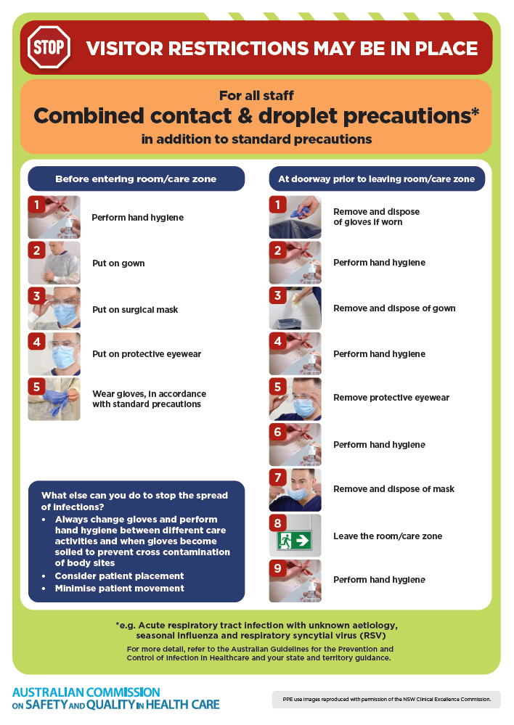
- Poster – Combined airborne and contact precautions
https://www.safetyandquality.gov.au/publications-and-resources/resource-library/infection-prevention-and-control-poster-combined-airborne-and-contact-precautions
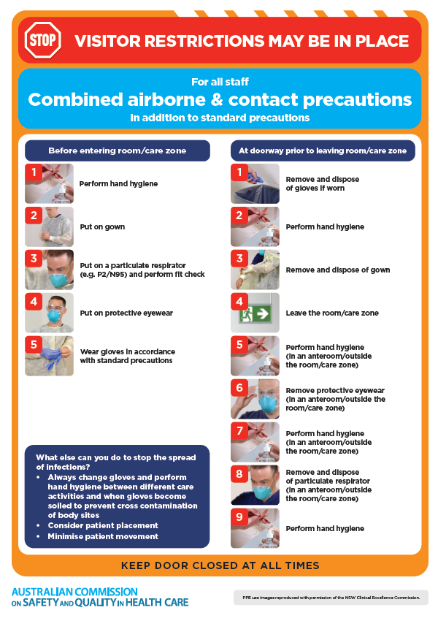
- Environmental Cleaning and Infection Prevention and Control www.safetyandquality.gov.au/environmental-cleaning
- COVID-19 infection prevention and control risk management – Guidance https://www.safetyandquality.gov.au/publications-and-resources/resource-library/covid-19-infection-prevention-and-control-risk-management-guidance
- Safe care for people with cognitive impairment during COVID-19
https://www.safetyandquality.gov.au/our-work/cognitive-impairment/cognitive-impairment-and-covid-19
- Break the chain of infection poster
https://www.safetyandquality.gov.au/publications-and-resources/resource-library/break-chain-infection-poster
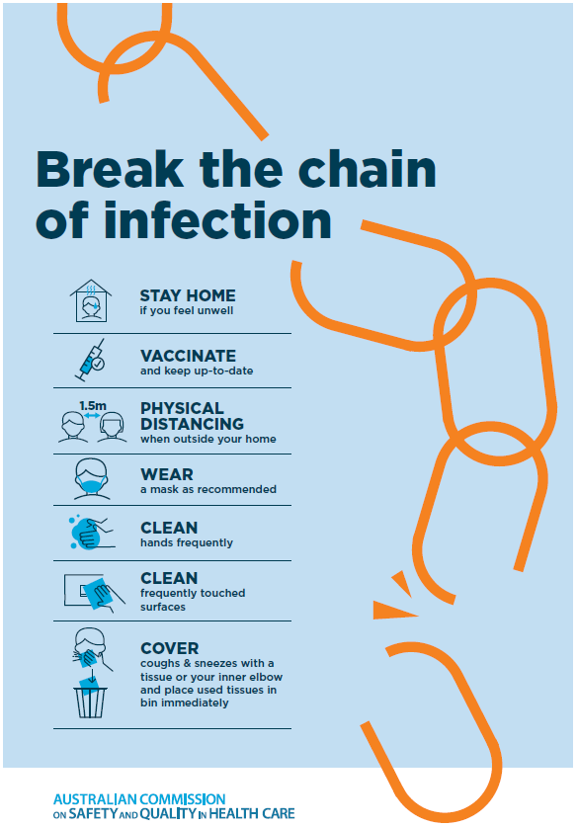
- COVID-19 and face masks – Information for consumers https://www.safetyandquality.gov.au/publications-and-resources/resource-library/covid-19-and-face-masks-information-consumers
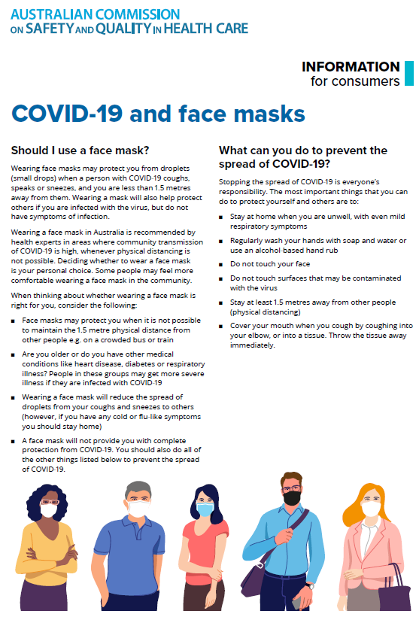

Disclaimer
On the Radar is an information resource of the Australian Commission on Safety and Quality in Health Care. The Commission is not responsible for the content of, nor does it endorse, any articles or sites listed. The Commission accepts no liability for the information or advice provided by these external links. Links are provided on the basis that users make their own decisions about the accuracy, currency and reliability of the information contained therein. Any opinions expressed are not necessarily those of the Australian Commission on Safety and Quality in Health Care.

