
On the Radar
Issue 672
28 October 2024

On the Radar is a summary of some of the recent publications in the areas of safety and quality in health care. Inclusion in this document is not an endorsement or recommendation of any publication or provider. Access to particular documents may depend on whether they are Open Access or not, and/or your individual or institutional access to subscription sites/services. Material that may require subscription is included as it is considered relevant.

On the Radar is available online, via email or as a PDF or Word document from https://www.safetyandquality.gov.au/newsroom/subscribe-news/radar

If you would like to receive On the Radar via email, you can subscribe on our website https://www.safetyandquality.gov.au/newsroom/subscribe-news
or by emailing us at HUmail@safetyandquality.gov.auU.
You can also send feedback and comments to HUmail@safetyandquality.gov.auU.

For information about the Commission and its programs and publications, please visit https://www.safetyandquality.gov.au

On the Radar
Editor: Dr Niall Johnson, Lucia Chiappini



Consultation on the Falls in Older People Guidelines
https://www.safetyandquality.gov.au/newsroom/consultations/updated-falls-guidelines-consultation

The Commission is updating the 2009 Preventing Falls and Harm from Falls in Older People: Best Practice Guidelines (Falls Guidelines).

The updated Falls Guidelines aim to support best practice fall prevention in older people. They highlight recommendations and good practice points based on the best available evidence and expert opinion. The Falls Guidelines have been updated for three settings:
- Falls Guidelines for Residential Aged Care Services
- Falls Guidelines for Community Care
- Falls Guidelines for Hospitals.

The Commission is seeking feedback from the health professionals and the aged care workforce. You can provide feedback on one or more of the Falls Guidelines.

The Falls Guidelines were adapted from reference documents developed by Neuroscience Research Australia in partnership with the Australian and New Zealand Falls Prevention Society and targeted consultation. The Commission will review feedback from the survey and publish the Falls Guidelines, along with the reference documents.

Share your feedback via the online survey before 20 November 2024.

Reports

Patient Safety Principles
Patient Safety Commissioner
London: Patient Safety Commissioner; 2024.
URL | https://www.patientsafetycommissioner.org.uk/principles/
Notes | The Patient Safety Commissioner for England has developed their Patient Safety Principles following a large-scale public consultation. The Principles ‘act as a guide for leaders at all levels on how to design and deliver safer care for patients and reduce avoidable harm in a just and learning culture’. The Principles are:  - Create a culture of safety  - Put patients at the heart of everything  - Treat people equitably  - Identify and act on inequalities  - Identify and mitigate risks  - Be transparent and accountable  - Use information and data to drive improved care and outcomes.  Alongside the Principles the Patient Safety Commissioner has released a brief toolkit on how to use the Principles.  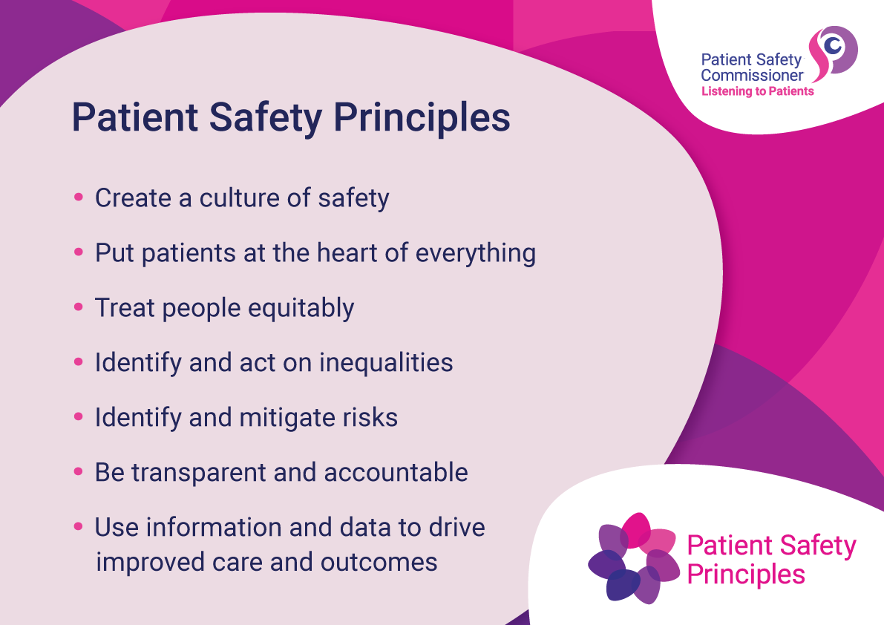
Patients’ experiences of safe care and readmission to hospital over time. The Insights Series
Bureau of Health Information
St Leonards: BHI; 2024.
URL | https://www.bhi.nsw.gov.au/BHI_reports/Insights_Series/patients-experiences-of-safe-care-and-readmission-to-hospital-over-time
Notes | Report from the Bureau of Health Information in New South Wales (NSW) that uses survey responses on more 115,000 people's experiences in NSW public hospitals between 2018 and 2023. The patient experience information links to safety culture, safety indications and hospital readmissions. The report also describes trends over time in readmissions for patients admitted to NSW public hospitals between 2016 and 2022 for a number of conditions.

Diagnostic Excellence in U.S. Rural Healthcare: A Call to Action
Ali KJ, Galvez NJ, Craig S, Fortune M, McNemar M, Fetzer LM, et al
Rockville, MD: Agency for Healthcare Research and Quality. Rockville, MD: Agency for Healthcare Research and Quality; 2024. p25.
URL | https://www.ahrq.gov/diagnostic-safety/resources/issue-briefs/dxsafety-rural-healthcare.html
Notes | The US Agency for Healthcare Research and Quality (AHRQ) has released this issue brief on diagnostic excellence in rural healthcare. The authors recognise that rural settings face ‘distinct healthcare challenges that critically impact the accuracy and timeliness of medical diagnoses’, including ‘limited resources (e.g., availability of healthcare services, workforce, infrastructure) and geographic isolation, which contribute to an elevated risk of diagnostic errors, such as delayed treatments and misdiagnoses, and can lead to poorer health outcomes and increased healthcare costs.’ In this issues brief, the authors explore ‘several critical challenges affecting diagnostic excellence in U.S. rural healthcare settings, emphasizing the need to address these impediments, and proposes three actionable strategies to overcome barriers to delivering high-quality diagnostic care in these areas. The three areas of focus where rural diagnostic patient care can be immediately advanced are:  - Enhancing specialty care and surgical service lines  - Strengthening care coordination  - Screening for social determinants of health.’

Journal articles

The likelihood of hospital-acquired complications in older people with dementia: a matched cohort study
Chróinín DN, Deane V, Pulikotil Zachariah R, Stott K, Shepherd B, Perkins M, et al
Medical Journal of Australia. 2024 2024/10/21;221(8):422-425.
DOI | https://doi.org/10.5694/mja2.52462
Notes | Cognitive impairment is an important safety and quality issue. Cognitive impairment is common, but is often not identified, or it is dismissed or misdiagnosed. This study conducted across five public hospitals in the South Western Sydney Local Health District, New South Wales included 217 649 people aged 60 years or older and sought to examine the incidence of several hospital-acquired complications (HACS) (falls, pressure injuries, delirium, pneumonia, venous thromboembolism, new incontinence, malnutrition, in-hospital death), by dementia status. The authors report ‘In 11 393 matched pairs of people aged 60 years or more with or without dementia admitted to five South Western Sydney hospitals during January 2010 – December 2020, dementia was associated with higher risks of falls, pressure injury, delirium, and pneumonia, but not of venous thromboembolism, malnutrition, or incontinence.’
For information on the Commission’s work on hospital-acquired complications (HACs), including the national list of Hospital-Acquired Complications, see https://www.safetyandquality.gov.au/our-work/indicators-measurement-and-reporting/hospital-acquired-complications-hacs

For information on the Commission’s work on cognitive impairment see https://www.safetyandquality.gov.au/our-work/cognitive-impairment

Learning health systems to implement chronic disease prevention programs: A novel framework and perspectives from an Australian health service
Wolfenden L, Wiggers J, Barnes C, Lane C, Groombridge D, Robertson K, et al
Learning Health Systems. 2024;8(4): e10466.
DOI | https://doi.org/10.1002/lrh2.10466
Notes | Another piece on how a learning health system (LHS) approach is being used to improve care. In this instance an LHS approach was used to improve the implementation of evidence-based interventions for chronic disease prevention. This piece describes how Hunter New England local health district in Australia has used an LHS approach. The paper includes a ‘proposed LHS framework’ that ‘has been adapted to be both implementation and chronic disease prevention focused. The framework describes both broad improvement processes, and the infrastructure and other support (pillars) recommended to support its core functions.’  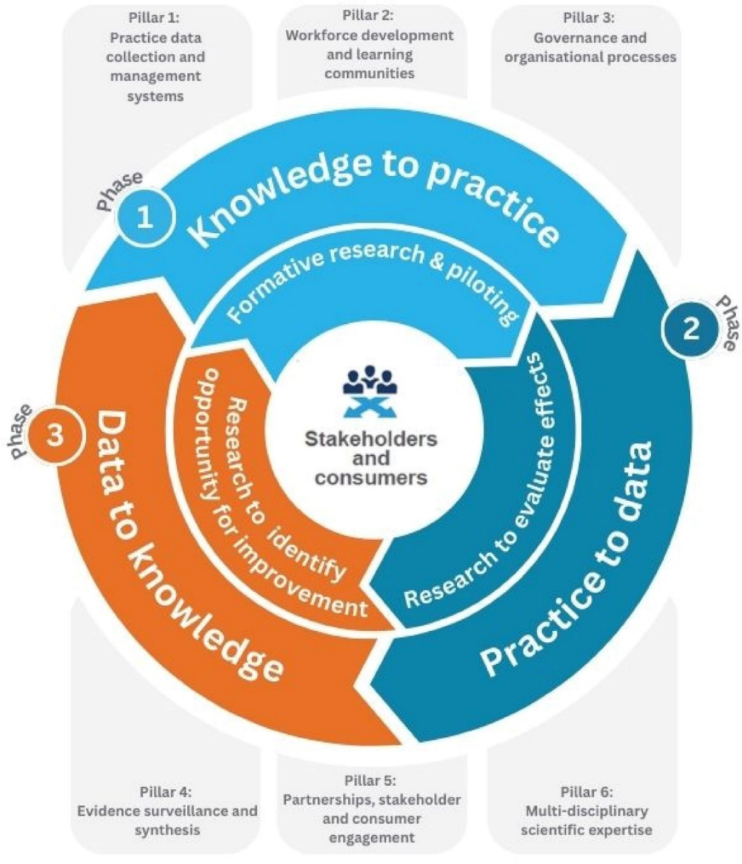
Does financial incentive for diabetes management in the primary care setting reduce avoidable hospitalizations and mortality in high-income countries? A systematic review
Thavam T, Hong M, Devlin RA, Clemens KK, Sarma S
Health Policy 2024:105189.
DOI | https://doi.org/10.1016/j.healthpol.2024.105189
Notes | Paper reporting on a systematic review that sought to ‘impact of financial incentives for diabetes management in primary care settings on diabetes-related hospitalizations, hospitalization costs, and premature mortality.’ Focused on 31 articles, the authors highlight the following findings:  - Impact of financial incentives for diabetes management on patient health is mixed  - Effect of incentives on health outcomes did not vary by health insurance system  - High-quality studies reported incentives to reduce hospitalizations and mortality  - Effectiveness of incentives were beneficial to newly diagnosed diabetes patients.

Beyond error: A qualitative study of human factors in serious adverse events
Mujuru C, Peisah C
Journal of Healthcare Risk Management. 2024.
DOI | https://doi.org/10.1002/jhrm.21583
Notes | Australian study that sought ‘to explore the relational and systemic human factors, including shared clinician attitudes and behavior, that contribute to serious adverse patient events in a public health setting’. The study examined 20 serious adverse events in a metropolitan local health district in New South Wales, Australia by analysing 20 consecutive de-identified Serious Adverse Event Reviews (SAER) over 6 months (January–June 2023) that were classified as a Harm Score 1 (result in serious harm or death) and had a completed root cause analysis investigation report. The authors report that ‘Emergent themes related to human factors in serious adverse events included:  - delays and inertia—with a subtheme of inertia of ageism;  - “All-or-nothing” approach to end-of-life care and planning;  - communication lapses; and  - implementation gap between standards and practice.’

The good, the bad and the ugly: What do we really do when we identify the best and the worst organisations?
Abel GA, Agniel D, Elliott MN
BMJ Quality & Safety 2024: bmjqs-2023-017039.
DOI | https://doi.org/10.1136/bmjqs-2023-017039
Notes | Paper that examined the statistical techniques used to examine performance. The authors argue that being able to accurately ascertain performance, particularly underperformance, ‘was highly dependent on the reliability of the performance measure.’ The authors conclude that despite their widespread use, techniques for identifying the best and worst performing organisations do not necessarily identify truly good and bad performers and even with the best techniques, reliable data are required.’
Australian Prescriber
Volume 47, Issue 5, October 2024
URL | https://australianprescriber.tg.org.au/
Notes | A new issue of Australian Prescriber has been published. Content in this issue of Australian Prescriber includes:  - Editorial: Reflections on community antimicrobial use in Australia (J Turnidge, C Hullick, K Stewart)  - Inhaler device selection for people with asthma or chronic obstructive pulmonary disease (D Rigby)  - Managing medicine shortages (T Simpson, J Yik)  - Immune checkpoint inhibitors and immune‑related adverse events (W Naidoo, K Cuff, M Ryan)  - New drugs:  Avacopan for antineutrophil cytoplasmic antibody–associated vasculitis  Clascoterone for acne  Fezolinetant for moderate to severe vasomotor symptoms associated with menopause  Prasterone for vulvar and vaginal atrophy in postmenopausal women

BMJ Quality & Safety
Volume 33, Issue 11, November 2024
URL | https://qualitysafety.bmj.com/content/33/11
Notes | A new issue of BMJ Quality & Safety has been published. Many of the papers in this issue have been referred to in previous editions of On the Radar (when they were released online). Articles in this issue of BMJ Quality & Safety include:  - Editorial: Aiming for equity in children with chronic conditions: introducing a new population health management system (Persijn Honkoop)  - Investigating a novel population health management system to increase access to healthcare for children: a nested cross-sectional study within a cluster randomised controlled trial (Elizabeth Cecil, Julia Forman, James Newham, Nan Hu, Raghu Lingam, Ingrid Wolfe)  - Quality and reporting of large-scale improvement programmes: a review of maternity initiatives in the English NHS, 2010–2023 (James McGowan, Bothaina Attal, Isla Kuhn, Lisa Hinton, Tim Draycott, Graham P Martin, Mary Dixon-Woods)  - Quality of care for secondary cardiovascular disease prevention in 2009–2017: population-wide cohort study of antiplatelet therapy use in Scotland (Inna Thalmann, David Preiss, Iryna Schlackow, Alastair Gray, B Mihaylova)  - Estimating the impact on patient safety of enabling the digital transfer of patients’ prescription information in the English NHS (Elizabeth M Camacho, Sean Gavan, Richard Neil Keers, Antony Chuter, Rachel A Elliott)  - Health services under pressure: a scoping review and development of a taxonomy of adaptive strategies (Bethan Page, Dulcie Irving, Rene Amalberti, Charles Vincent)  - Generative artificial intelligence, patient safety and healthcare quality: a review (Michael D Howell)  - Need to systematically identify and mitigate risks upon hospitalisation for patients with chronic health conditions (Peter J Pronovost, Eboné M Carrington)

Public Health Research & Practice
Volume 34, Issue 3, October 2024
URL | https://www.phrp.com.au/issues/october-2024-volume-34-issue-3/
A new issue of Public Health Research & Practice has been published. Articles in this issue of Public Health Research & Practice include:
- Editorial: Undertaking public health research with impact (Don Nutbeam)
- Co-creation in public health research: an introduction to basic principles (Cédric NH Middel, Miranda R Blake, Tara Boelsen-Robinson, Joreintje D Mackenbach, Josine M Stuber, Carmen Vargas, Tari Forrester-Bowling)
- Are they the same? Disentangling the concepts of implementation science research and population scale-up (Karen Lee, Heather McKay, Melanie Crane, Andrew Milat, Luke Wolfenden, Nicole M Rankin, Rachel Sutherland, Adrian Bauman)
- Assessment of the first 5 years of pharmacist-administered vaccinations in Australia: learnings to inform expansion of services (Cyra Patel, Kaitlyn Vette, Lauren Dalton, Aditi Dey, Alexandra Hendry, Brynley Hull, Peter McIntyre, Kristine Macartney, Frank Beard)
- Economic benefits of reducing childhood and adolescent overweight and obesity in Australia (Joseph Carrello, Thomas Lung, Louise A Baur, Alison Hayes)
- Travel-associated illness in children in pre-pandemic Western Sydney, 2018–2020 (Paula Mazzocato, Karin Leder, Lucy Deng, Phillip Britton)
- Impact of COVID-19 on lung cancer care in New South Wales, Australia: real-world data from the EnRICH Program (Bea Brown, Jane Young, Kirsty Galpin, Michael Boyer, Venessa Chin, Chris Brown, Robert J Simes)
- Effectiveness of the Go4Fun program: a comparison of face-to-face and digital delivery (Bronwyn McGill, Christian Young, NSW Health, Centre for Population Health Team, Prevention Research Collaboration Team, Margaret Thomas)
- Acceptability of an asymptomatic COVID-19 screening program for schools in Victoria, Australia: a qualitative study with caregivers from priority populations (Isabella Overmars, Frances Justice, Jessica Kaufman, Jane Tuckerman, Margie Danchin)
- Co-designing health policy with Aboriginal and Torres Strait Islander peoples: a protocol (Margaret Fono, Boe Rambaldini, Vita Christie, Kylie Gwynne)
- Aboriginal and Torres Strait Islander peoples’ Quitline use and the Tackling Indigenous Smoking program (Emily Colonna, Christina L Heris, Eden M Barrett, Shavaun Wells, Raglan Maddox)
- UV arrows descend from above: lessons from a mass media campaign to improve sun protection behaviours among young adults (Cameron Sugden, Shamieka Dubois, Philippa Maynard, Nicola Scott, Alexis Le Clerc, Matthew Clarke, Sarah McGill, Tracey A O’Brien)

The Joint Commission Journal on Quality and Patient Safety
Volume 50, Issue 11, November 2024
URL | https://www.sciencedirect.com/journal/the-joint-commission-journal-on-quality-and-patient-safety/vol/50/issue/11
Notes | A new issue of The Joint Commission Journal on Quality and Patient Safety has been published. Articles in this issue of The Joint Commission Journal on Quality and Patient Safety include:  - Efficacy and Impact of a Cleaning and Disinfection Protocol for Musical Instruments Used in Music Therapy Services in ICUs: A Prospective Cohort Study (Mark Ettenberger, Andrés Salgado, Rafael Maya, Adriana Merchán-Restrepo, Pedro Barrera-López)  - Workplace Violence Pervasiveness in the Perioperative Environment: A Multiprofessional Survey (Della M Lin, Meghan B Lane-Fall, Joshua A Lea, Lynn J Reede, Brandon D Gomes, Yuwei Xia, Jennifer A Rock-Klotz, Thomas R. Miller)  - A Quality Improvement-based Approach to Implementing a Remote Monitoring–Based Bundle in Transitional Care Patients for Heart Failure (Farrukh N Jafri, Kenay Johnson, Michelle Elsener, Michael Latchmansingh, Jonathan Sege, Melanie Plotke, Tina Jing, Adeel Arif, Fran Ganz-Lord)  - Implementing an Oral Health Educator Contributes to Reduced MBI-CLABSI Rates for Pediatric Hematopoietic Stem Cell Transplant Patients (Kandice Bledsaw, Zachary D Prudowsky, Mark C Zobeck, Jenell Robins, Sharon Staton, Janet DeJean, Esther Yang, Claudia X Harriehausen, Judith R Campbell, Andrea L Davis, Anil George, David Steffin, Gabriella Llaurador, Alexandra M. Stevens)  - A Mixed Methods Study Exploring Patient Safety Culture at Four VHA Hospitals (Jennifer L Sullivan, Marlena H Shin, Allison Ranusch, David C Mohr, Charity Chen, Laura J Damschroder)  - Using a Built-in Clinical Decision Support to Improve Phosphate Repletion Practice: A Quasi-Experimental Study (Peter Alarcon Manchego, Mona Krouss, Daniel Alaiev, Joseph Talledo, Surafel Tsega, Komal Chandra, Milana Zaurova, Dawi Shin, Victor Cohen, Hyung J Cho)  - Toward Standardization and High Reliability: Improved Sepsis Screening in Emergency Department Triage Across an Academic Health System (Stephen Biederman, Aashish Batheja, Sharon Bednar, Chris Orange, Amy Hicks, Stephen Miller, Patrice Forsen, Amanda Stark, Gonzalo Bearman)  - The Joint Commission Journal on Quality and Patient Safety 50th Anniversary Article Collections: Diagnostic Excellence

BMJ Quality & Safety online first articles
URL | https://qualitysafety.bmj.com/content/early/recent
Notes | BMJ Quality &Safety has published a number of ‘online first’ articles, including:  - The good, the bad and the ugly: What do we really do when we identify the best and the worst organisations? (Gary A Abel, Denis Agniel, Marc N Elliott)  - Editorial: Patient work self-managing medicines: a skilled job at the sharp end of care (Beth Fylan, Justine Tomlinson)  - Editorial: Beyond polypharmacy to the brave new world of minimum datasets and artificial intelligence: thumbing a nose to Henry (Adam Todd, Barbara Hanratty)  - Editorial: Safety netting: time to stop relying on verbal interventions to manage diagnostic uncertainty? (Georgia B Black)  - Editorial: Large language models in healthcare information research: making progress in an emerging field (Harish Tayyar Madabushi, Matthew D Jones)  - Variation in the use of primary care-led investigations prior to a cancer diagnosis: analysis of the National Cancer Diagnosis Audit (Nurunnahar Akter, Georgios Lyratzopoulos, Ruth Swann, Greg Rubin, Sean McPhail, Meena Rafiq, Abodunrin Aminu, Nadine Zakkak, Gary Abel)

Online resources

Future Leaders Communiqué
Volume 9 Issue 1 October 2024
https://www.thecommuniques.com/post/future-leaders-communiqu%C3%A9-volume-9-issue-1-october-2024
This issue of Future Leaders Communiqué focuses on some of the challenges of providing patient care in rural and remote settings. This issue examines a case from rural Queensland where a culmination of missed opportunities and systemic issues resulted in a poor patient outcome during an interhospital transfer. The two expert commentaries reflect on the case and on the need to understand contexts and systems to support the delivery of care.

Australian Living Evidence Collaboration
https://livingevidence.org.au/

[UK] NICE Guidelines and Quality Standards
https://www.nice.org.uk/guidance
The UK’s National Institute for Health and Care Excellence (NICE) has published new (or updated) guidelines and quality standards The latest reviews or updates include:
- Diagnostics guidance DG60 Digital technologies for assessing attention deficit hyperactivity disorder (ADHD) https://www.nice.org.uk/guidance/dg60
- Diagnostics guidance DG61 Heart failure algorithms for remote monitoring in people with cardiac implantable electronic devices https://www.nice.org.uk/guidance/dg61

COVID-19 resources
https://www.safetyandquality.gov.au/covid-19
The Australian Commission on Safety and Quality in Health Care has developed a number of resources to assist healthcare organisations, facilities and clinicians. These and other material on COVID-19 are available at https://www.safetyandquality.gov.au/covid-19
These resources include:
- Poster – Combined contact and droplet precautions https://www.safetyandquality.gov.au/publications-and-resources/resource-library/infection-prevention-and-control-poster-combined-contact-and-droplet-precautions
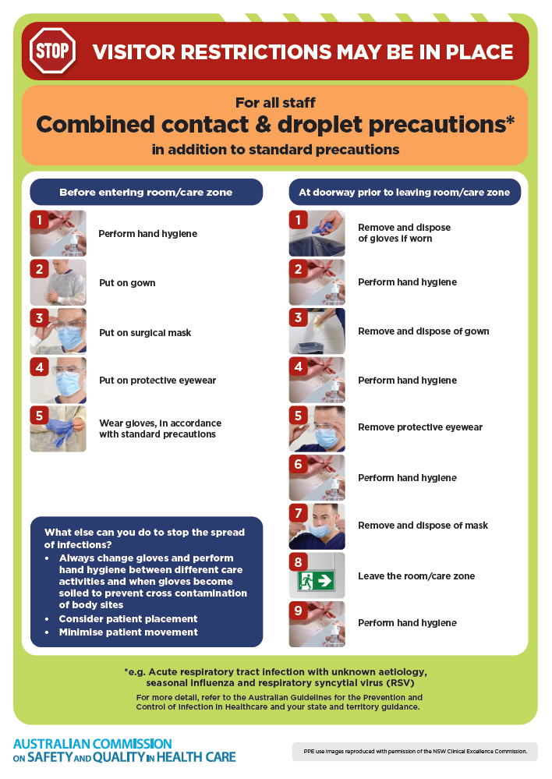
- Poster – Combined airborne and contact precautions
https://www.safetyandquality.gov.au/publications-and-resources/resource-library/infection-prevention-and-control-poster-combined-airborne-and-contact-precautions
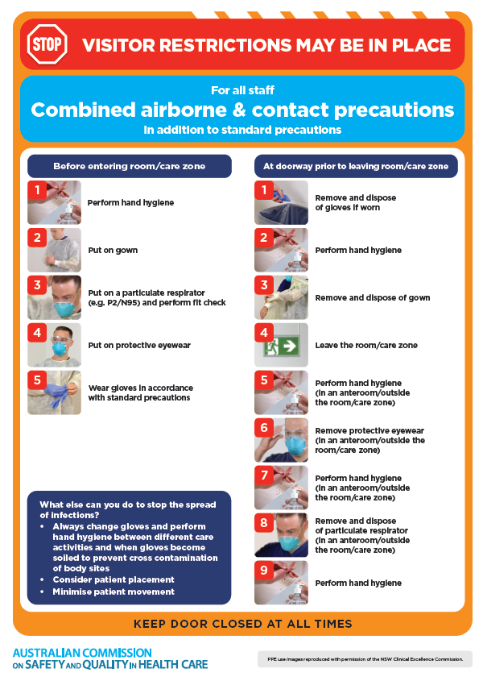
- Environmental Cleaning and Infection Prevention and Control www.safetyandquality.gov.au/environmental-cleaning
- COVID-19 infection prevention and control risk management – Guidance https://www.safetyandquality.gov.au/publications-and-resources/resource-library/covid-19-infection-prevention-and-control-risk-management-guidance
- Safe care for people with cognitive impairment during COVID-19
https://www.safetyandquality.gov.au/our-work/cognitive-impairment/cognitive-impairment-and-covid-19
- Break the chain of infection poster
https://www.safetyandquality.gov.au/publications-and-resources/resource-library/break-chain-infection-poster
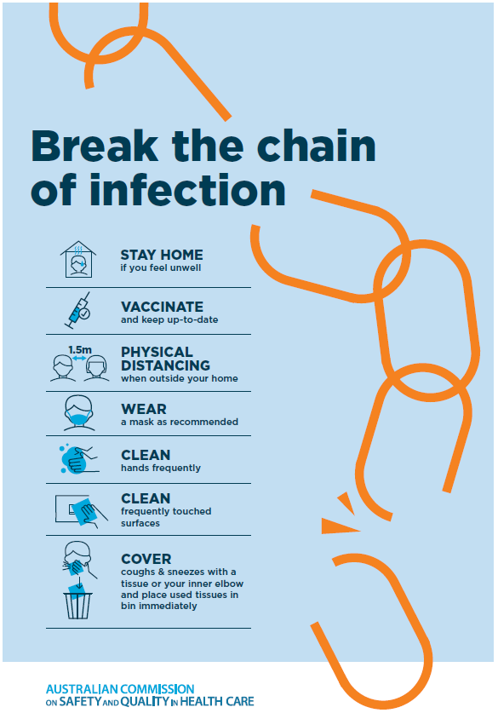
- COVID-19 and face masks – Information for consumers https://www.safetyandquality.gov.au/publications-and-resources/resource-library/covid-19-and-face-masks-information-consumers
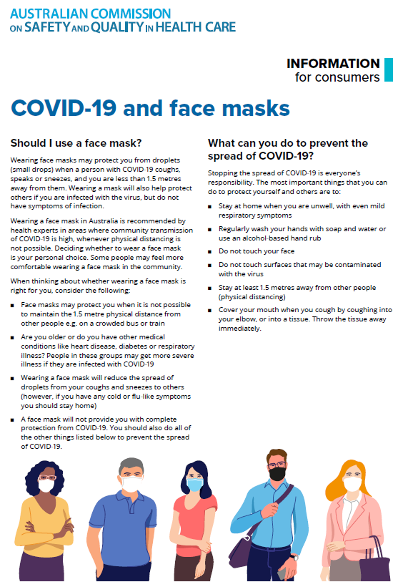

Disclaimer
On the Radar is an information resource of the Australian Commission on Safety and Quality in Health Care. The Commission is not responsible for the content of, nor does it endorse, any articles or sites listed. The Commission accepts no liability for the information or advice provided by these external links. Links are provided on the basis that users make their own decisions about the accuracy, currency and reliability of the information contained therein. Any opinions expressed are not necessarily those of the Australian Commission on Safety and Quality in Health Care.

