
On the Radar
Issue 675
18 November 2024

On the Radar is a summary of some of the recent publications in the areas of safety and quality in health care. Inclusion in this document is not an endorsement or recommendation of any publication or provider. Access to particular documents may depend on whether they are Open Access or not, and/or your individual or institutional access to subscription sites/services. Material that may require subscription is included as it is considered relevant.

On the Radar is available online, via email or as a PDF or Word document from https://www.safetyandquality.gov.au/newsroom/subscribe-news/radar

If you would like to receive On the Radar via email, you can subscribe on our website https://www.safetyandquality.gov.au/newsroom/subscribe-news
or by emailing us at HUmail@safetyandquality.gov.auU.
You can also send feedback and comments to HUmail@safetyandquality.gov.auU.

For information about the Commission and its programs and publications, please visit https://www.safetyandquality.gov.au

On the Radar
Editor: Dr Niall Johnson

Journal articles

Achieving and sustaining reduction in hospital-acquired complications in an Australian local health service
Li QC, Codde J, Karnon J, Hince D
BMJ Open Quality. 2024;13(4):e002940.
DOI | https://doi.org/10.1136/bmjoq-2024-002940
Notes | Paper describing how an Australian metropolitan health service addressed the issue of hospital-acquired complications (HACs). The authors note that much of the literature on reducing HACs tends to focus on a specific complication. This paper describes an organisation-wide HACs Reduction Programme that saw ‘Overall mean HAC rate per 10 000 episodes of care decreased from a baseline of 459.5 across 2017 and 2018 to 363.1 in 2019 and remained lower through to the end of 2022 indicating sustained improvement in performance.’

For information on the Commission’s work on hospital-acquired complications (HACs), including the national list of Hospital-Acquired Complications, see https://www.safetyandquality.gov.au/our-work/indicators-measurement-and-reporting/hospital-acquired-complications-hacs

A stepped wedge randomised controlled trial assessing the efficacy and patient acceptability of virtual clinical pharmacy in rural and remote Australian hospitals
Nott S, Fleming C, Hawthorn G, Luscombe G, Allan J, Webster E, et al
BMC Health Services Research. 2024;24:1375.
DOI | https://doi.org/10.1186/s12913-024-11740-3
Notes | Virtual care in many forms has grown rapidly, particularly during and following the COVID-19 pandemic. This paper describes the development of a Virtual Clinical Pharmacy Service (VCPS) to pharmacy services in a regional health services smaller hospitals. The study sought to ‘to determine whether the VCPS increased adherence to National Safety and Quality Health Service Standards (NSQHS).’ The authors report that patients in the intervention arm were more likely to have admission medication reconciliation, discharge medication reconciliation and Best Possible Medication History completion. Further, ‘Patient feedback was positive and comparable to in-person care’. Such results led the authors to conclude, ‘The VCPS improved compliance with national standards for medication safety, had high patient acceptability and resulted in the detection of clinically relevant medication-related issues in rural and remote settings.’

Improving adverse drug event reporting by healthcare professionals
Shalviri G, Mohebbi N, Mirbaha F, Majdzadeh R, Yazdizadeh B, Gholami K, et al
Cochrane Database of Systematic Reviews. 2024 (10).
DOI | https://doi.org/10.1002/14651858.CD012594.pub2
Notes | Reporting of adverse events can be an important safety signal and is regarded as a standard part of post-market surveillance for medications and medical devices. This Cochrane review sought to ‘assess the effectiveness of different interventions aimed at healthcare professionals to improve the reporting of adverse drug events.’ The review focused on 15 studies ‘(eight RCTs, six ITS, and one non‐randomised cross‐over study) with approximately 62,389 participants’ that were ‘conducted in high‐income countries in large tertiary care hospitals.’ The authors report finding ‘low‐certainty evidence suggests that the number of ADR [Adverse Drug Reaction] reports submitted may substantially increase following an education session, paired with reminder card and ADR report form’. They also report that ‘The evidence for other interventions identified … such as informational letters or emails and financial incentives, is uncertain.’  In Australia, the Therapeutic Goods Administration (TGA) monitors the safety of therapeutic goods to contribute to a better understanding of their possible adverse events when they are used outside the controlled conditions of clinical trials. The TGA notes that reports by consumers and health professionals provide important information for the TGA's safety monitoring program. Consumer, medical professionals and industry are encouraged to report adverse events (https://www.tga.gov.au/safety/reporting-problems)

Adverse Events in Patients Transitioning From the Emergency Department to the Inpatient Setting
Tsilimingras D, Schnipper J, Zhang L, Levy P, Korzeniewski S, Paxton J
Journal of Patient Safety. 2024.
URL | https://doi.org/10.1097/pts.0000000000001284
Notes | It’s been well-known that transitions of care are periods of enhanced risk. This study examined the transition from emergency department to the inpatient setting. This was a relatively small study, with 81 patients ‘who were being admitted to any internal medicine or hospitalist service were recruited from the ED’ of the two participating hospitals by a trained nurse. The authors report that ‘Over 22% of 81 patients experienced AEs from the ED to the inpatient setting. The most common AEs were adverse drug events (42%), followed by management (38%), and diagnostic errors (21%). Of these AEs, 75% were considered preventable.’

For information on the Commission’s work on transitions of care see https://www.safetyandquality.gov.au/our-work/transitions-care

Patient Experience Journal
Volume 11, Issue 3, 2024
URL | https://pxjournal.org/journal/vol11/iss3/
Notes | A new issue of the Patient Experience Journal (PXJ)has been published Articles in this issue of the Patient Experience Journal include:  - Editorial: Why Human Experience Matters (Jason A Wolf)  - Patient Experience (PX) Giants: Pioneers and the Path Forward (Geoffrey A Silvera, Courtney Haun, and Varun Natarajan)  - Trust Remains the Foundation of my Practice (Saria Gouher)  - The ``ableism'' behind Mental Health Professionals' Perceptions of Support (Hideki Muramatsu)  - Exploring Consumer and Clinician Attitudes towards Patient Reported Outcome Measures (PROMs) in an Australian Inpatient Musculoskeletal Rehabilitation Unit: A Qualitative Pilot Study (Rehana Di Rico, Louisa Ng, and Jacquelin T Capell)  - Patient, Family, and Health Professional Perspectives of How Families are Involved in Adult Inpatient Traumatic Brain Injury Rehabilitation (Kaylee Eady, Katherine A Moreau, Shawn Marshall, and Mary Egan)  - Consumers', Family Members', and Health Practitioners' Perspectives on Increasing Activity Engagement of Older Patients Admitted to Geriatric Hospital Units (Yvonne Y K Mak-Yuen, Farnaz Khoshmanesh, and T Tse)  - Efficacy of a Communication Toolkit to Optimize Palliative Care Communication in the Surgical Intensive Unit (Kathryn J Cary, Aubrey Place, Marta McCrum, Joanna Grudziak, and Lauren McGuire)  - “You May Not Appreciate This Now, But You May Later”: A Qualitative Analysis of the Impact and Meaning of Legacy Interventions as Defined by Bereaved Parents (Stephanie Barta, Cassandra Matz, Stephany Griswold, Foster Rosemund, Caroline Boyd, Sarah Scott, Eileen A Bennett, and J Staab)  - Co-developing a Paediatric Patient Reported Experience Measure: The Perspectives of Children and Young People (Karlen R Barr, Jessica Nikolovski, Les White, Sarah Elliott, Lynn McCartney, Claire Treadgold, Barb Vernon, James R John, and Valsamma Eapen)  - Driving Healthy Behaviors through Social Support: The Role of Co-Responsibility in Weight Loss and Maintenance (Melanie Knufinke-Meyfroyt, Carlo Lancia, Yentl Lodewijks, Simon Nienhuijs, and Eva Deckers)  - An Exploratory Qualitative Study of Perinatal Experiences in an Acute Setting during Early Phases of the COVID-19 Pandemic (Sharon Hoosein, Pamela Winchester, Stephanie Babinski, Naomi Smith, P Bhavsar, and S Law)  - Patients' Perceptions: A Group Differences Study Twelve Months Before and Twelve Months During a Worldwide Pandemic (Nancy B Valla)  - Post-Pandemic Needs of Unpaid Family and Friend Caregivers to Effectively Continue Caregiving Duties in one Northern Ontario Health Authority (Jodi Webber, Erin Mulroney, Mark Tatasciore, Brianna Smith, Patti-Jo Duggan, Louis Ferron, Hannah Albani, Bianca Feitelberg, L Tenhagen, and S Myles)  - Experiences of Psychosocial Support in Group Rehabilitation Interventions from Adults with Chronic Conditions – A Qualitative Systematic Review (Jenny Mäkeläinen, Ulla Jämsä, Anne Oikarinen, M Kääriäinen, and H Siira)  - A Quality Improvement Initiative Using Discharge Education Videos to Improve Communication with Families in a Pediatric Urgent Care (Hannah G Carron, Gisella Valderrama, and Adam A Vukovic)  - Laboratory Literacy: Surveying Lab Result Interpretations of a Local Patient Population (Jordan Franco and Mark K Fung)  - Experiences of using Electronic Medical Records among Patients from Ethnic Minority Backgrounds: A Rapid Review (Corey Adams, Reema Harrison, Alison Merchant, Narelle Arblaster, Tracey Bucknall, Kathleen Gray, Guncag Ozavci, Nilmini Wickramasinghe, Vicky Yuan, and Elizabeth Manias)  - A Role Discovered: Exploring Northwell Health's Patient Experience Structure and Leadership Characteristics (Agnes Barden, Nicole Giammarinaro, Natalie Rousseau, and Carolyne Burgess)  - Quality of Outpatient Care in Lebanon: A Cross-Sectional Survey (Georges Choueiry, Anna Maria Henaine, Rayan Darwish, and Pascale Salameh)  - Patient Safety Culture Among Healthcare Settings in Low and Middle-Income Countries: A Systematic Review and Meta-Analysis (Natnael Atnafu Gebeyehu, Kirubel Dagnaw Tegegne, Biruk Adie Admass, Nathan Estifanos Shewangashaw, Yibeltal Assefa Atalay, Dagne Adisu Sewuyew, Awoke Elefachew Gebremariam, and Kelemu Abebe Gelaw)  - Factors Influencing Patient Satisfaction with Zambia's National Health Insurance Scheme: A Systematic Literature Review using Empirical Evidence from Nigeria and Ghana (Wesley Kapaya Mwambazi and Abubaker Qutieshat)  - Patient Engagement and Co-creation in Healthcare Services: A Scoping Review (Thiruppavai Sundaramurthi, Smita Mathews, Ella Bermudez, and Satish M Mahajan)  - A Case Study on the Impact of an Adapted Community Jury in Shaping the Nutrition Standards for Hospital Menus in New South Wales Australia (Tara L. Dimopoulos-Bick, Melanie Schier, Kim Crawley, and Kim Sutherland)

Health Policy
Volume 150, December 2024
URL | https://www.sciencedirect.com/journal/health-policy/vol/150/
Notes | A new issue of Health Policy has been published. Articles in this issue of Health Policy include:  - RSV prevention options for infants and older adults: A specific expanding competitive arena (Livio Garattini, Antonio Clavenna)  - The impact of NHS outsourcing of elective care to the independent sector on outcomes for patients, healthcare professionals and the United Kingdom health care system: A rapid narrative review of literature (Simon Fletcher, Oya Eddama, Michael Anderson, Rachel Meacock, V Wattal, P Allen, S Peckham)  - Variation in attendance at emergency departments in England across local areas: A system under unequal pressure (Nikita Jacob, Martin Chalkley, Rita Santos, Luigi Siciliani)  - German centralization strategy during COVID-19: Continuing or interrupting a trend? (Ines Marina Niehaus, Andreas Lehr, André Kaiser, Helena Sophie Müller, Ludwig Kuntz)  - Voluntarily stopping eating and drinking (VSED): A systematic mixed-methods review focusing on the carers’ experiences (Christina Mensger, Yang Jiao, Maximiliane Jansky, Christian Banse, F Nauck, M Nothacker, H Stanze)  - Do international medical graduates’ recruitment policies help to overcome healthcare shortage areas in developed countries? A systematic review (L Beduchaud, E Celingant, C Faure, M Meunier, I Blanco-Cazeaux)  - Impact of local sports policies in the prevalence of cardiovascular disease: An assessment with spatial data analysis (Miguel Viegas, João Valente dos Santos, Manuel João Coelho e Silva)  - Which factors influence the decision of hospitals to provide procedures on an outpatient basis? –Mixed-methods evidence from Germany (Robert Messerle, Fenja Hoogestraat, Eva-Maria Wild)  - Abolishing age criterion to determine organ transplant recipients in Israel: A qualitative study of medical staff perceptions (Eyal Katvan, Orly Korin, Israel Issi Doron, Eytan Mor, Boaz Shnoor, Daniel Gelman, Tamar Ashkenazi)  - Does financial incentive for diabetes management in the primary care setting reduce avoidable hospitalizations and mortality in high-income countries? A systematic review (Thaksha Thavam, Michael Hong, Rose Anne Devlin, Kristin K Clemens, Sisira Sarma)  - The long-run effect of COVID-19 on hospital emergency department attendances: evidence from statistical analysis of hospital data from England (Nikita Jacob, Rita Santos, Peter Sivey)

JBI Evidence Synthesis
Volume 22, Issue 11, November 2024
URL | https://journals.lww.com/jbisrir/toc/2024/11000
Notes | A new issue of JBI Evidence Synthesis has been published. Articles in this issue of JBI Evidence Synthesis include:  - Editorial: Wealth of information and poverty of attention? Managing the inherent challenges of large scoping reviews (Pesonen, Mari)  - Adverse drug events in cost-effectiveness models of pharmacological interventions for diabetes, diabetic retinopathy, and diabetic macular edema: a scoping review (Pesonen, Mari; Jylhä, Virpi; Kankaanpää, Eila)  - Nursing strategies to address health disparities in genomics-informed care: a scoping review (Limoges, Jacqueline; Chiu, Patrick; Dordunoo, Dzifa; et al)  - Pregnant nurses’ experiences of working shifts: a qualitative systematic review (Ooshige, Narumi; Matsunaka, Eriko; Ueki, Shingo; et al)  - Global prevalence of overweight and obesity among health care workers: a systematic review protocol (Awaluddin, S. Maria; Lim, Kuang Kuay; Shawaluddin, Noor Syaqilah)  - Participatory research in mental health care services in low- and middle-income countries: a scoping review protocol (Krishnan, Naveen; Sunder, Poornima; Lalachan, Nithin; et al)  - Pedagogical and teaching strategies used to teach writing to pre-licensure students enrolled in health professional programs: a scoping review protocol (McCloskey, Rose; Morris, Patricia; Keeping-Burke, Lisa; et al)  - Experiences of undergraduate nursing students and new graduate nurses in paid employment models and health-related work influencing the transition to practice: a qualitative systematic review protocol (Park, Seung A. (Sarah); Eckert, Marion; Sharp, Rebecca; et al)  - Supporting breastfeeding for women with low education levels, psychosocial problems, and/or socioeconomic constraints: a scoping review protocol (Frandsen, Annemi Lyng; Rytter, Maren Johanne Heilskov; Beck,  - Experiences of mental health practitioners after clients’ suicide: a qualitative systematic review protocol (Du, Jian; Li, Jiaoli; Kantor, Jiří; et al)  - Health net-outcome objectives and approaches for spatial planning and development: a scoping review protocol (Stewart-Evans, James; Wilson, Emma; Langley, Tessa; et al)  - Extent, range, and nature of studies examining sleep in nurses: a scoping review protocol (Baljak, Gabriele Raine; Marnie, Casey; Clarke, Jarrod; et al)  - Protocols for breaking bad news in health care: a scoping review protocol (Cardoso, Ana Filipa; Rosendo, Inês; Santiago, Luiz; et al)  - The evidence is clear: prioritizing dignity and quality of life makes a difference for older adults in long-term care (Eisenhauer, Elizabeth)

BMJ Quality & Safety online first articles
URL | https://qualitysafety.bmj.com/content/early/recent
Notes | BMJ Quality &Safety has published a number of ‘online first’ articles, including:  - Editorial: Global perspectives on opioid use: shifting the conversation from deprescribing to quality use of medicines (Aili Veronica Langford, Chung-Wei Christine Lin, Suzanne Nielsen)  - ‘We listened and supported and depended on each other’: a qualitative study of how leadership influences implementation of QI interventions (Liane Ginsburg, Adam Easterbrook, Ariane Geerts, Whitney Berta, Lynda van Dreumel, Carole A Estabrooks, Peter G Norton, Adrian Wagg)  - Contextual factors that influence adoption and sustainment of self-management support in cancer survivorship care: a practical application of theory with qualitative interviews (Nickola Pallin, John Browne, Roisin Connolly, Josephine Hegarty, Sheena McHugh)

Online resources

Australian Living Evidence Collaboration
https://livingevidence.org.au/

[UK] NICE Guidelines and Quality Standards
https://www.nice.org.uk/guidance
The UK’s National Institute for Health and Care Excellence (NICE) has published new (or updated) guidelines and quality standards The latest reviews or updates include:
- NICE Guideline NG73 Endometriosis: diagnosis and management https://www.nice.org.uk/guidance/ng73

COVID-19 resources
https://www.safetyandquality.gov.au/covid-19
The Australian Commission on Safety and Quality in Health Care has developed a number of resources to assist healthcare organisations, facilities and clinicians. These and other material on COVID-19 are available at https://www.safetyandquality.gov.au/covid-19
These resources include:
- Poster – Combined contact and droplet precautions https://www.safetyandquality.gov.au/publications-and-resources/resource-library/infection-prevention-and-control-poster-combined-contact-and-droplet-precautions
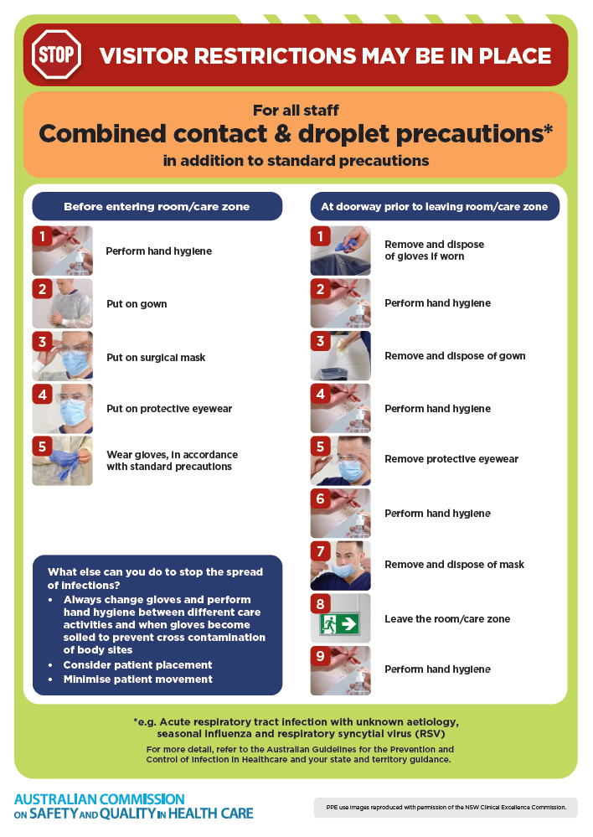
- Poster – Combined airborne and contact precautions
https://www.safetyandquality.gov.au/publications-and-resources/resource-library/infection-prevention-and-control-poster-combined-airborne-and-contact-precautions
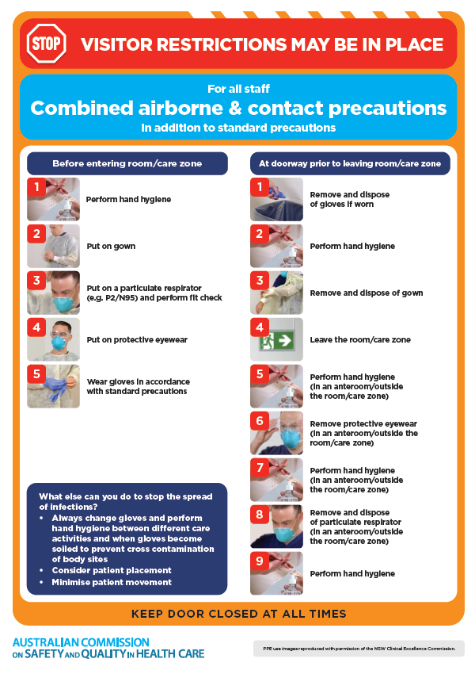
- Environmental Cleaning and Infection Prevention and Control www.safetyandquality.gov.au/environmental-cleaning
- COVID-19 infection prevention and control risk management – Guidance https://www.safetyandquality.gov.au/publications-and-resources/resource-library/covid-19-infection-prevention-and-control-risk-management-guidance
- Safe care for people with cognitive impairment during COVID-19
https://www.safetyandquality.gov.au/our-work/cognitive-impairment/cognitive-impairment-and-covid-19
- Break the chain of infection poster
https://www.safetyandquality.gov.au/publications-and-resources/resource-library/break-chain-infection-poster
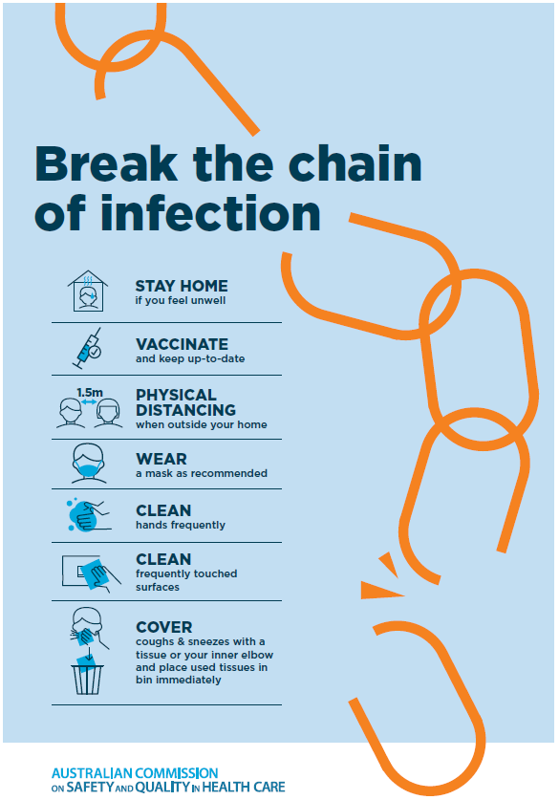
- COVID-19 and face masks – Information for consumers https://www.safetyandquality.gov.au/publications-and-resources/resource-library/covid-19-and-face-masks-information-consumers
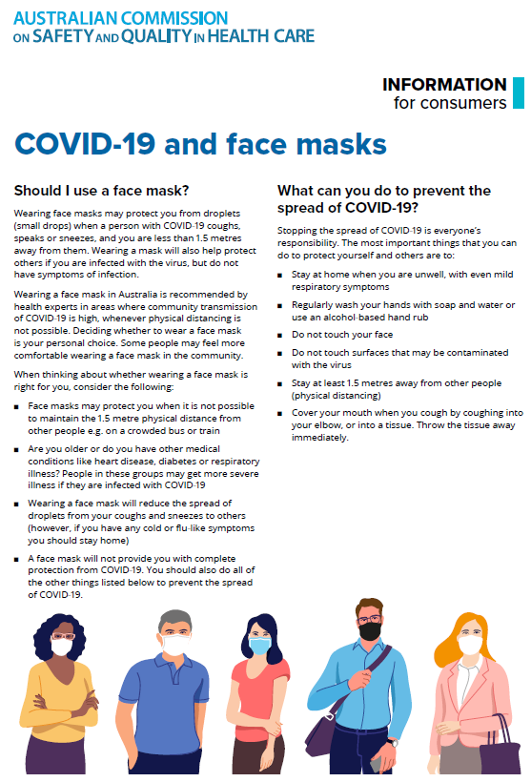

Disclaimer
On the Radar is an information resource of the Australian Commission on Safety and Quality in Health Care. The Commission is not responsible for the content of, nor does it endorse, any articles or sites listed. The Commission accepts no liability for the information or advice provided by these external links. Links are provided on the basis that users make their own decisions about the accuracy, currency and reliability of the information contained therein. Any opinions expressed are not necessarily those of the Australian Commission on Safety and Quality in Health Care.

