
On the Radar
Issue 677
2 December 2024

On the Radar is a summary of some of the recent publications in the areas of safety and quality in health care. Inclusion in this document is not an endorsement or recommendation of any publication or provider. Access to particular documents may depend on whether they are Open Access or not, and/or your individual or institutional access to subscription sites/services. Material that may require subscription is included as it is considered relevant.

On the Radar is available online, via email or as a PDF or Word document from https://www.safetyandquality.gov.au/newsroom/subscribe-news/radar

If you would like to receive On the Radar via email, you can subscribe on our website https://www.safetyandquality.gov.au/newsroom/subscribe-news
or by emailing us at HUmail@safetyandquality.gov.auU.
You can also send feedback and comments to HUmail@safetyandquality.gov.auU.

For information about the Commission and its programs and publications, please visit https://www.safetyandquality.gov.au

On the Radar
Editor: Dr Niall Johnson, Helen Dowling

Reports

He mahi ngātahi kia kounga: He anga hei whakahaere whare haumanu
Collaborating for quality: A framework for clinical governance
Health, Quality and Safety Commission
Wellington: HQSC; 2024. p. 28.
URL | https://www.hqsc.govt.nz/news/updated-clinical-governance-framework-released/
Notes | The Health Quality & Safety Commission in New Zealand has released their updated clinical governance framework. According to the Commission’s website, ‘It replaces previous clinical governance guidance released in 2017, to reflect changes in the health sector, including the Pae Ora (Healthy Futures) Act 2022.’  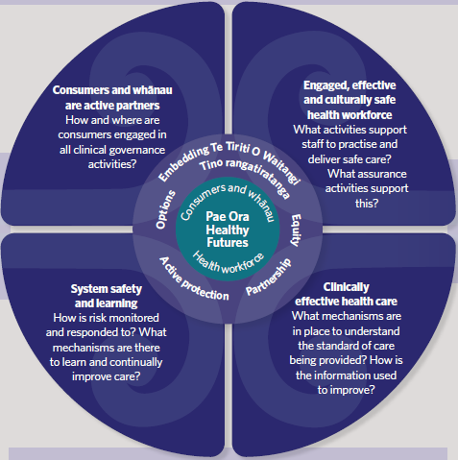

Mental health inpatient settings: out of area placements. Investigation report
Health Services Safety Investigation Body
Poole: HSSIB; 2024.
URL | https://www.hssib.org.uk/patient-safety-investigations/mental-health-inpatient-settings/second-investigation-report/
Notes | The Health Services Safety Investigation Body (HSSIB) in the UK has released this second recent report into mental health inpatient settings. This report details an HSSIB investigation into ‘the patient safety risks associated with inappropriate out of area placements, including those for adult, older people and children and young people.’ Out of area placement covers ‘scenarios where a patient is placed in a mental health inpatient setting that is a long way from their home or usual place of residence.’

The 2024 John Deeble Lecture – Beyond boundaries: Leadership for health
Deeble Institute for Health Policy Research Perspectives Brief no: 33
Gray J, Pervan M
Canberra: Australian Healthcare and Hospitals Association; 2024. p. 13.
URL | https://ahha.asn.au/resource/the-2024-john-deeble-lecture-beyond-boundaries-leadership-for-health/
Notes | This perspectives brief from the Australian Healthcare and Hospitals Association’s Deeble Institute presents the 2024 John Deeble lecture. The 3rd John Deeble Lecture, themed ‘Beyond Boundaries: Leadership for Health’, was delivered by Professor Jonathon Gray, Professor of Innovation, Improvement, and Leadership at Swansea University and Director of the Commonwealth Leadership Institute. Professor Gray highlighted the critical role of emerging health leaders in offering fresh perspectives and providing valuable insights to address complex health challenges.

Journal articles

Implementation and Evaluation of Cultural Safety Initiatives in Australian Hospital Settings: A Scoping Review
Clough B, Fraser J, Flemington T, Power T
Journal of Transcultural Nursing. 2024:10436596241296818.
DOI | https://doi.org/10.1177/10436596241296818
Notes | Paper reporting on a scoping review that sought to ‘synthesize and summarize existing evidence for implementing and evaluating Cultural Safety initiatives in Australian hospitals for Aboriginal and Torres Strait Islander peoples’ with a view to identifying best practices. Based on 9 studies, the review identified 5 themes:  ‘(a) process of implementation;  (b) process of evaluation;  (c) change in health professional’s behavior;  (d) change in patient behavior; and  (e) future recommendations.’  The authors conclude that ‘significant improvement is needed in adopting evidence-based and carefully considered approaches to implementing and evaluating Cultural Safety initiatives in hospital settings. Specifically, implementation should be underpinned by a validated theoretical framework and consider and address potential practical barriers in engaging health practitioners.’

Nurse Burnout and Patient Safety, Satisfaction, and Quality of Care: A Systematic Review and Meta-Analysis
Li LZ, Yang P, Singer SJ, Pfeffer J, Mathur MB, Shanafelt T
JAMA Network Open. 2024;7(11):e2443059-e2443059.
DOI | https://doi.org/10.1001/jamanetworkopen.2024.43059
Notes | Paper reporting on a systematic review and meta-analysis of 85 studies published between 1994 and 2024 covering 288 581 nurses from 32 countries to examine the impacts of nurse burnout. The authors report that ‘nurse burnout was associated with a lower patient safety climate and patient safety grade; more nosocomial infections, patient falls, medication errors, and adverse events; lower patient satisfaction ratings; and lower nurse-assessed quality of care.’

Antibiotic Treatment for 7 versus 14 Days in Patients with Bloodstream Infections
The BALANCE Investigators, for the Canadian Critical Care Trials Group, the Association of Medical Microbiology and Infectious Disease Canada Clinical Research Network, the Australian and New Zealand Intensive Care Society Clinical Trials Group, and the Australasian Society for Infectious Diseases Clinical Research Network
New England Journal of Medicine. 2024.
DOI | https://doi.org/10.1056/NEJMoa2404991
Notes | Paper reporting on a randomised control trial examining duration of antibiotic treatment for patients hospitalised with bloodstream infections. In the study, ‘Across 74 hospitals in seven countries, 3608 patients underwent randomization and were included in the intention-to-treat analysis; 1814 patients were assigned to 7 days of antibiotic treatment, and 1794 to 14 days.’ The authors report that ‘Among hospitalized patients with bloodstream infection, antibiotic treatment for 7 days was noninferior to treatment for 14 days.’

Advanced Pharmacy Australia Clinical Pharmacy Standards
Dooley M, Bennett G, Clayson-Fisher T, Hill C, Lam N, Marotti S, et al
Journal of Pharmacy Practice and Research. 2024.
DOI | https://doi.org/10.1002/jppr.1959
Notes | The Advanced Pharmacy Australia (AdPha) Clinical Pharmacy Standards are a significant update of the 2013 edition. They describe current best practice for clinical pharmacy services in Australia and are defined by 22 new Quality Statements which focus on person-centred care throughout the patient journey, and on equitable access to high quality pharmacy care across all care settings. The Standards provide guidance on the provision of clinical pharmacy services that underpin contemporary medicines management, reflecting the rapidly evolving pharmacy landscape in Australia, and promote proactive interprofessional collaboration and shared decision-making.

For information on the Commission’s work on medication safety see https://www.safetyandquality.gov.au/our-work/medication-safety

Comparing safety, performance and user perceptions of a patient-specific indication-based prescribing tool with current practice: a mixed methods randomised user testing study
Feather C, Clarke J, Appelbaum N, Darzi A, Franklin BD
BMJ Quality & Safety. 2024.
DOI | https://doi.org/10.1136/bmjqs-2024-017733
Notes | Paper describing the development of ‘an indication-based prescribing tool’ and how it compared with current practice. The authors report that this initial work suggests it may be ‘a promising advancement in medication safety, with implications for enhancing patient safety and efficiency.’

Creating a data warehouse to support monitoring of NSQHS blood management standard from EMR data
Cheng-Zarate D, Burns J, Ngo C, Haryanto A, Duncan G, Taniar D, et al
BMC Medical Informatics and Decision Making. 2024;24(1):353.
DOI | https://doi.org/10.1186/s12911-024-02732-8
Notes | Paper reporting on how an Australian health service and academic partners suggest a ‘clinical data warehouse’ could hold ‘transformed data from EMR [electronic medical record] to be able to identify that the hospital is compliant with the …Standards for blood management’. Further, ‘the data warehouse allows the data to be consumed by decision support tools.’

For information on the National Safety and Quality Health Service (NSQHS) Standards see https://www.safetyandquality.gov.au/standards/nsqhs-standards

Is it time to consider how we approach bilateral same-day cataract surgery?
Lawless M
Clinical & Experimental Ophthalmology. 2024 2024/11/01;52(8):795-796.
DOI | https://doi.org/10.1111/ceo.14436
Notes | Editorial reflecting on recent updates in the literature that suggests it may be time to reconsider the use of immediate sequential bilateral cataract surgery (ISBCS) approaches. The author suggests ‘it is now a matter of altering the financial incentives to encourage rather than discourage ISBCS and developing consensus on the best protocols to guide us in how we practice this type of surgery for the benefit of patients and our wider society.’

Organizational Factors Driving the Realization of Digital Health Transformation Benefits from Health Service Managers: A Qualitative Study
Brommeyer M, Whittaker M, Liang Z
Journal of Healthcare Leadership. 2024;16:455-472.
DOI | https://doi.org/10.2147/JHL.S487589
Notes | In the latest paper from a program of work looking at digital health from the health service manager perspective, the authors explore ‘the organizational barriers that health service managers have encountered when realizing the benefits of a digitally transforming environment.’ The authors observe that ‘Addressing these barriers requires macro-, meso- and micro-level system investments. These benefits are enhanced by enabling factors critical for digital health adoption that have been described in key categories involving health system related: (1) policy and system, (2) organizational structure and processes, and human resource management, and (3) people factors.’

Emergency Medicine Australasia
Volume 36, Issue 6, December 2024
URL | https://onlinelibrary.wiley.com/toc/17426723/2024/36/6
Notes | A new issue of Emergency Medicine Australasia has been published. Articles in this issue of Emergency Medicine Australasia include:  - Back to life from being declared dead in the Resus Bay: An integrative review of the phenomenon of autoresuscitation and learning for ED (J Manton)  - The nature of terror medicine (George Braitberg)  - Strategies to improve emergency department care for adults living with disability: A systematic review (Bronwyn Newman, Colleen Cheek, Lieke Richardson, Donna Gillies, Karen Hutchinson, Elizabeth Austin, Margaret Murphy, Luke Testa, Christina Rojas, Louise Raggett, Amanda Dominello, Kylie Smith and Robyn Clay-Williams)  - A primer for clinical researchers in the emergency department: Part XIII Strategies to engage staff and enhance participant recruitment in emergency department research (Sharon O’Brien, Catherine Wilson, Megan Duck, Gaby Nieva, Medhawani P Rao and Libby Haskell)  - Impact of lifeguard oxygen therapy on the resuscitation of drowning victims: Results from an UtsteinStyle for Drowning Study (Ogilvie Thom, Kym Roberts, Susan Devine, Peter A Leggat and Richard C Franklin)  - More than meets the eye: Lid and conjunctival injuries in cases of non-sexual assault are frequently accompanied by non-fatal strangulation (Vanita Parekh, Janine McMinn, Anna Brkic, David Williams, C Boxx, L Bailey and K Reid)  - Assessing the predictors for paediatric intensive care unit for inter-hospital transfer patients on high-flow nasal cannula or continuous positive airway pressure ventilation at a tertiary Australian paediatric hospital (alerie Astle, Meredith Louise Borland, Kim Betts, Simon Erickson and Belinda Gowen)  - Evaluating soft collars in pre-hospital cervical spine immobilisation: A cohort study on neurological outcomes, patient comfort and paramedic perspectives (Liam Bruton, Martin Nichols, S Looi, T Evens, J C Bendall and K J Davis, on behalf of the ESCAPE-Evaluation Steering Committee)  - Navigating competing tensions: A qualitative study of experiences and perceptions of leadership among emergency medicine doctors (Suzanne Rayner, Hayden Richards, Georgie B Lee, Elleanor Lee and Andrew Rixon)  - Australia’s first cardiac emergency department: Patient profile, activity and performance in the initial 6 months (Adam C Cohen, Robert Meek, G Hayden, A Damianopoulos, N Goldie, J J Y Lim, A Duong and D Egerton-Warburton)  - Long-term trends in incidence and outcomes of rib fractures: A population-based data linkage study from New South Wales, Australia (Eliot Salmon, Matthew Oliver, K Bein, M Berry, C Partyka, R Seimon, H Singh and M Dinh)  - Impact of an educational intervention utilising a three-dimensional-printed model for ultrasound-guided intra-articular injections of the dislocated shoulder (Conor Cosgrave, Megan Anakin, Phil Blyth, L Baillie and S Beck)  - Risk factors for older people re-presenting to the emergency department with falls: A case–control analysis (Charlene San Juan, Linda Appiah-Kubi, Joanna Mitropoulos, Lorne Thomson, Athena Demosthenous and Anne-Maree Kelly)  - Trauma team activation for older patients with pelvic fractures: Are current criteria adequate? (Frances Williamson and Elaine Cole)  - Ocular trauma in badminton: A 5-year review of badminton-related eye injury emergency department presentations (Nicholas Dewhurst, Devangna Tangri, Janan Arslan, Gizem Ashraf, Rahul Chakrabarti and Carmel Crock)  - Is clinician reported practice in Western Australian emergency departments aligned with direct discharge pathway protocols for minor self-limiting fractures? A multi-centre professional survey (Piers Truter, Irene Pelletier, Sophie Coates, Louise Giglia-Smith, Karen Richards, David Mountain, Caroline Bulsara, Katrina Spilsbury and Dale W Edgar)  - Process and implementation evaluation of a virtual hospital model of care for low back pain (Back@Home) (Alla Melman, Min J Teng, Danielle M Coombs, Qiang Li, L Billot, T Lung, E Rogan, M Marabani, O Hutchings, J R Zadro, C G Maher and G C Machado, The Back@Home Investigators)  - Factors associated with difficult intravenous access in the paediatric emergency department: A prospective cohort study (Lucy Dunstan, Amy L Sweeny, Clayton Lam, Bianca Goucher, S Watkins, S George and P J Snelling)  - Emergency department staff opinion on newly introduced phlebotomy services in the department. A cross-sectional study incorporating thematic analysis (Abdi D Osman, Daryl Yeak, Michael Ben-Meir and G Braitberg)  - Recommendations for developing a comprehensive point-of-care ultrasound (POCUS) program in the emergency department: an Emergency Medicine Ultrasound Group advocacy statement (Luke Phillips, Alastair Maclean, Josh Monester, Joanne Douglas, Stacey Davidson and Gabriela King)  - Optimising POCUS programs: A summary of EMUG’s recommendations for the development and maintenance of ED POCUS programs (Luke Phillips, Alastair Maclean, Josh Monester, J Douglas, S Davidson and G King)  - Editorial: The future of emergency medicine in Australasia (Joshua I Smith)  - Divide and conquer? Emergency medicine subspecialties in Australasia (Ryan D Metcalfe)  - What can emergency medicine in Australasia learn from the NHS? (Thomas A G Shanahan)  - Emergency medicine needs a narrower scope and a broader worldview (Tom Jerram)  - Emergency medicine will stay big and become the acute decision-making nexus of future health systems (Clare A. Skinner)  - Impact of the Southeast Melbourne Virtual Emergency Department on reducing transfers from residential aged care facilities (Muhuntha Sri-Ganeshan, Biswadev Mitra, Georgia Soldatos, Rachel Rosler, Neil Goldie, Robert Meek,Madeleine Howard, Michelle Bertolucci, D Egerton-Warburton, R Manderson, V Luzuriaga, F McGee, G M O’Reilly and P A Cameron)  - Exploring the value, enablers and barriers of being a clinician-coach: A qualitative pilot study of clinician-coaches in emergency medicine (Andrew Rixon, Samuel Wilson, Lee Wong and Elizabeth Elder)  - Just a head knock? Emergency physicians need to get serious about concussion (Alan J Pearce, Peter Wirth and Michelle Fitts)  - ‘You mean you’re not doing it already?’ A national sentinel toxico-surveillance system for detecting illicit, emerging and novel psychoactive drugs in presentations to emergency departments (Daniel M Fatovich, Paul Dessauer and Nadine Ezard, on behalf of the EDNA Investigators)

Health Affairs Scholar
Volume 2, Issue 11, November 2024
URL | https://academic.oup.com/healthaffairsscholar/issue/2/11
Notes | A new issue of Health Affairs Scholar has been published. Articles in this issue of Health Affairs Scholar include:  - Association between discontinuity in clinicians and outcomes of nursing home residents (Hyunkyung Yun et al)  - All-cause nursing home mortality rates have remained above pre-pandemic levels after accounting for decline in occupancy (Max Weiss et al)  - Measuring hospital inpatient Procedure Access Inequality in the United States (Alon Bergman et al)  - Medicare transitional care management services’ association with readmissions and mortality (Rachel O Reid et al)  - Factors impacting vaccine uptake among adult Medicaid beneficiaries: a systematic literature review (Emily Moss et al)  - Performance of the Washington Group questions in measuring blindness and deafness (Scott D Landes et al)  - Increased spending on low-value care during the COVID-19 pandemic in Virginia (Michelle S Rockwell et al)  - Charting new territory: the early lessons in integrating social determinant of health (SDOH) measures into practice (Adrianna Nava et al)  - Scenarios, not shortage forecasts, are key to better workforce policy (Melinda J B Buntin et al)  - Examining the use of telehealth to initiate buprenorphine for opioid use disorder treatment (Yimin Ge et al)

BMJ Quality & Safety online first articles
URL | https://qualitysafety.bmj.com/content/early/recent
Notes | BMJ Quality &Safety has published a number of ‘online first’ articles, including:  - Comparing safety, performance and user perceptions of a patient-specific indication-based prescribing tool with current practice: a mixed methods randomised user testing study (Calandra Feather, Jonathan Clarke, Nicholas Appelbaum, Ara Darzi, Bryony Dean Franklin)  - Improving the maternity experience for Black, African, Caribbean and mixed-Black families in an integrated care system: a multigroup community and interprofessional co-production prioritisation exercise using nominal group technique (Sarindi Aryasinghe, Phoebe Averill, Carole Waithe, Susan Ibuanokpe, Rhianna Newby-Mayers, Nawal Lakhdar, Moussa Amine Sylla, Elizabeth Cox, Sabrina Das, Erik Mayer)  - The problem with uptake as a quality metric for population-based screening programmes (Natalie Armstrong, Sian Taylor-Phillips)  - Risk-adjusted observed minus expected cumulative sum (RA O-E CUSUM) chart for visualisation and monitoring of surgical outcomes (Quentin Cordier, Hugo Prieur, Antoine Duclos Top Surgeons Study Group)  - Results of a healthcare transition learning collaborative for emerging adults with sickle cell disease: the ST3P-UP study transition quality improvement collaborative (Ifeyinwa Osunkwo, Jennifer S Cornette, Laura Noonan, Cheryl Courtlandt, Sarah Mabus, Patience H White, Margaret McManus, Myra M Robinson, Michelle L Wallander, James R Eckman, Elna Saah, Ofelia A Alvarez, Mark Goodwin, Leila Jerome Clay, Payal Desai, Raymona H Lawrence)

International Journal for Quality in Health Care online first articles
URL | https://academic.oup.com/intqhc/advance-articles
Notes | International Journal for Quality in Health Care has published a number of ‘online first’ articles, including:  - Addressing the Continuing Challenges of Developing and Implementing Clinical Practice Guidelines (Phillip Phan)  - Underreporting of adverse events to health authorities by healthcare professionals: a red flag-raising descriptive study (Maude Lavallée, Sonia Corbin, Pallavi Pradhan, Laura Blonde Guefack, Magalie Thibault, Julie Méthot, Anick Bérard, Marie-Eve Piché, Fernanda Raphael Escobar Gimenes, Rosalie Darveau, Isabelle Cloutier, Jacinthe Leclerc)

Online resources

Australian Living Evidence Collaboration
https://livingevidence.org.au/

[UK] NICE Guidelines and Quality Standards
https://www.nice.org.uk/guidance
The UK’s National Institute for Health and Care Excellence (NICE) has published new (or updated) guidelines and quality standards The latest reviews or updates include:
- NICE Guideline NG244 Asthma pathway (BTS, NICE, SIGN) https://www.nice.org.uk/guidance/ng244
- NICE Guideline NG245 Asthma: diagnosis, monitoring and chronic asthma management (BTS, NICE, SIGN) https://www.nice.org.uk/guidance/ng245

[UK] NIHR Evidence
https://evidence.nihr.ac.uk/
The UK’s National Institute for Health Research (NIHR) has posted new evidence alerts on its site. Evidence alerts are short, accessible summaries of health and care research which is funded or supported by NIHR. This is research which could influence practice and each Alert has a message for people commissioning, providing or receiving care. The latest alerts https://evidence.nihr.ac.uk/browse-content/?_sft_articletype=alert include:
- What drives unprofessional behaviour in healthcare?
- Gallstones: surgery might not always be needed
- Sexual assault referral centres provide high-quality support
- Local green spaces are linked with better mental health
- What support do young carers find helpful?
- Care home app reduced residents’ hospital admissions
- Amoxicillin is effective for many people hospitalised with pneumonia
- Community perinatal mental health teams reduced women’s risk relapses of severe mental illness.
The NIHR has also collated this evidence collection:
- Is surgery the best option? https://evidence.nihr.ac.uk/collection/is-surgery-the-best-option-research-provides-alternatives/

[USA] Effective Health Care Program reports
https://effectivehealthcare.ahrq.gov/
The US Agency for Healthcare Research and Quality (AHRQ) has an Effective Health Care (EHC) Program The EHC has released the following final reports and updates:
- Making Healthcare Safer IV: Interventions to Prevent Nonventilator Hospital-acquired Pneumonia (NV-HAP) for Inpatients. Research Protocol https://effectivehealthcare.ahrq.gov/products/nv-hap/protocol
- The Effect of Protein Intake on Health: A Systematic Review https://effectivehealthcare.ahrq.gov/products/effect-protein-intake/research
- Evaluation of Dietary Protein and Amino Acid Requirements: A Systematic Review https://effectivehealthcare.ahrq.gov/products/dietary-protein-intake/research

COVID-19 resources
https://www.safetyandquality.gov.au/covid-19
The Australian Commission on Safety and Quality in Health Care has developed a number of resources to assist healthcare organisations, facilities and clinicians. These and other material on COVID-19 are available at https://www.safetyandquality.gov.au/covid-19
These resources include:
- Poster – Combined contact and droplet precautions https://www.safetyandquality.gov.au/publications-and-resources/resource-library/infection-prevention-and-control-poster-combined-contact-and-droplet-precautions
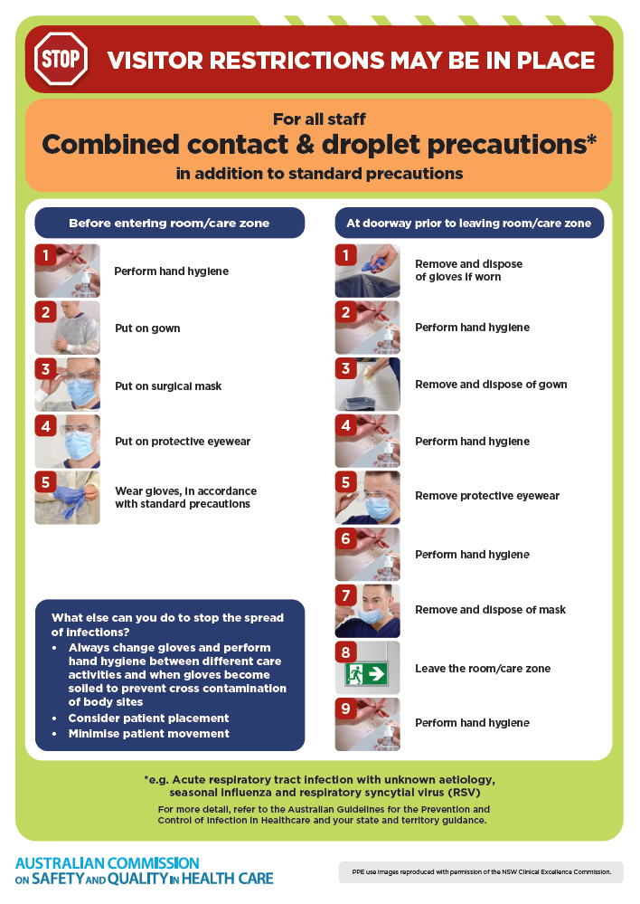
- Poster – Combined airborne and contact precautions
https://www.safetyandquality.gov.au/publications-and-resources/resource-library/infection-prevention-and-control-poster-combined-airborne-and-contact-precautions
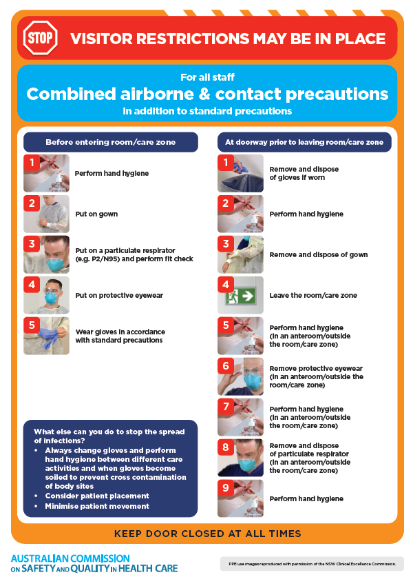
- Environmental Cleaning and Infection Prevention and Control www.safetyandquality.gov.au/environmental-cleaning
- COVID-19 infection prevention and control risk management – Guidance https://www.safetyandquality.gov.au/publications-and-resources/resource-library/covid-19-infection-prevention-and-control-risk-management-guidance
- Safe care for people with cognitive impairment during COVID-19
https://www.safetyandquality.gov.au/our-work/cognitive-impairment/cognitive-impairment-and-covid-19
- Break the chain of infection poster
https://www.safetyandquality.gov.au/publications-and-resources/resource-library/break-chain-infection-poster
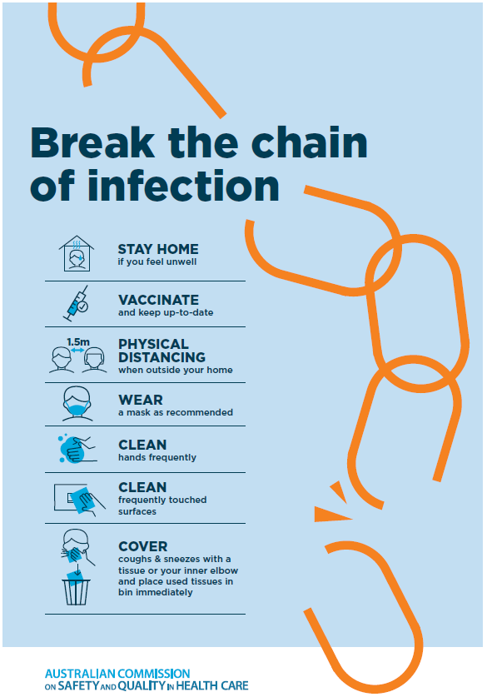
- COVID-19 and face masks – Information for consumers https://www.safetyandquality.gov.au/publications-and-resources/resource-library/covid-19-and-face-masks-information-consumers
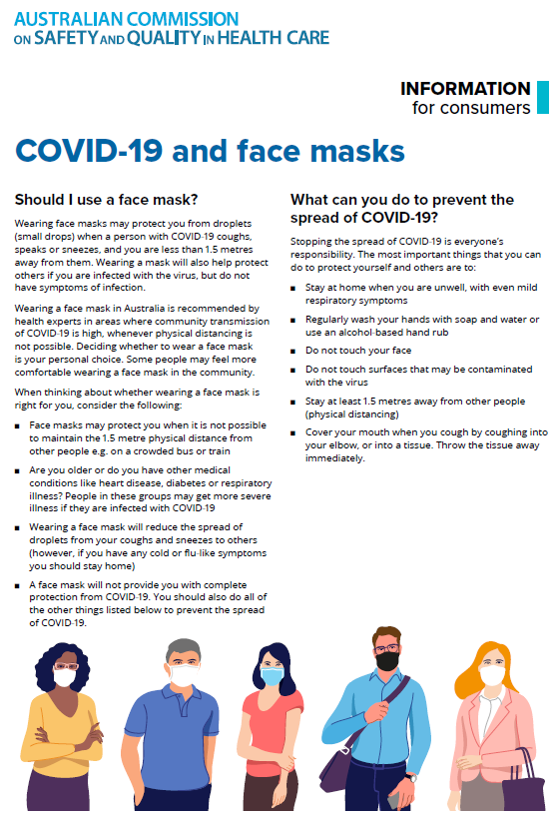

Disclaimer
On the Radar is an information resource of the Australian Commission on Safety and Quality in Health Care. The Commission is not responsible for the content of, nor does it endorse, any articles or sites listed. The Commission accepts no liability for the information or advice provided by these external links. Links are provided on the basis that users make their own decisions about the accuracy, currency and reliability of the information contained therein. Any opinions expressed are not necessarily those of the Australian Commission on Safety and Quality in Health Care.

