
On the Radar
Issue 678
9 December 2024

On the Radar is a summary of some of the recent publications in the areas of safety and quality in health care. Inclusion in this document is not an endorsement or recommendation of any publication or provider. Access to particular documents may depend on whether they are Open Access or not, and/or your individual or institutional access to subscription sites/services. Material that may require subscription is included as it is considered relevant.

On the Radar is available online, via email or as a PDF or Word document from https://www.safetyandquality.gov.au/newsroom/subscribe-news/radar

If you would like to receive On the Radar via email, you can subscribe on our website https://www.safetyandquality.gov.au/newsroom/subscribe-news
or by emailing us at HUmail@safetyandquality.gov.auU.
You can also send feedback and comments to HUmail@safetyandquality.gov.auU.

For information about the Commission and its programs and publications, please visit https://www.safetyandquality.gov.au

On the Radar
Editor: Dr Niall Johnson

Reports

National guide to preventive healthcare for Aboriginal and Torres Strait Islander people: Recommendations
Fourth ed.
National Aboriginal Community Controlled Health Organisation, The Royal Australian College of General Practitioners. East Melbourne: RACGP; 2024. p. 324.
URL | https://www.racgp.org.au/clinical-resources/clinical-guidelines/key-racgp-guidelines/national-guide
Notes | The National Aboriginal Community Controlled Health Organisation (NACCHO) and The Royal Australian College of General Practitioners (RACGP) recently released the fourth edition of the National guide to preventive healthcare for Aboriginal and Torres Strait Islander people: Recommendations. The guide is a practical resource intended for all health professionals delivering primary healthcare to Aboriginal and/or Torres Strait Islander people. Its purpose is to provide GPs and other health professionals with an accessible, user-friendly guide to best practice preventive healthcare for Aboriginal and Torres Strait Islander patients.

Quality Improvement Toolkit
Safer Care Victoria
Melbourne: SCV; 2024.
URL | https://www.safercare.vic.gov.au/best-practice-improvement/quality-improvement/toolkit
Notes | Safer Care Victoria has also released this toolkit to help Victorian health services improve the quality of care. The toolkit includes fact sheets, practical tools, templates and resources to aid services to identify and issues, solution and develop and measure effective improvement strategies and activities.

Health at a Glance: Asia/Pacific 2024
OECD, World Health Organization
Paris: OECD Publishing; 2024.
URL | https://www.oecd.org/en/publications/health-at-a-glance-asia-pacific-2024_51fed7e9-en/full-report.html
Notes | This report from the OECD and the WHO presents indicators on health status, determinants of health, healthcare resources and utilisation, health expenditure and financing, and quality of care for 27 Asia-Pacific countries and territories, including Australia.’

Global report on infection prevention and control 2024
World Health Organization
Geneva: WHO; 2024. p.210.
URL | https://www.who.int/publications/i/item/9789240103986
Notes | The World Health Organization (WHO) has released their second global report on infection prevention and control (IPC) providing updated evidence on the harm caused to patients and health workers by health care-associated infections (HAIs) and antimicrobial resistance (AMR). The report also presents an updated global analysis of the implementation of IPC programmes at the national and health care facility levels across all WHO regions. The report notes that ‘HAIs are among the most frequent adverse events occurring in the context of health service delivery. These infections, many of which are caused by multidrug-resistant organisms, harm patients, visitors and health workers and place a significant burden on health systems, including the associated increased costs.’  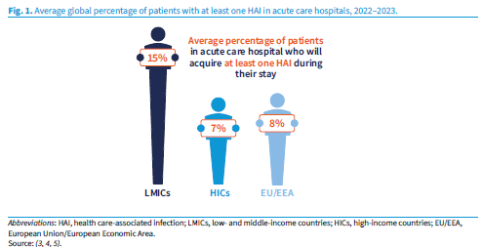

For information on the Commission’s work on infection prevention and control see https://www.safetyandquality.gov.au/our-work/infection-prevention-and-control

Digital transformation handbook for primary health care: optimizing person-centred point of service systems
World Health Organization
Geneva: WHO; 2024. p.95.
URL | https://www.who.int/publications/i/item/9789240093362
Notes | The World Health Organization (WHO) has also released this handbook on transforming primary care with digital tools. The handbook ‘supports two key scenarios: transitioning from paper-only systems and enhancing existing digital solutions to create comprehensive, person-centred, interoperable systems.’ According to the WHO’s webpage for the handbook, ‘Aimed at health programme managers and their digital transformation teams, this digital transformation handbook outlines essential steps that include requirements gathering, workflow mapping, creating data dictionaries, and documenting decision-support logic. It emphasizes the importance of involving health workers, as end-users of these digital systems, in the development process.  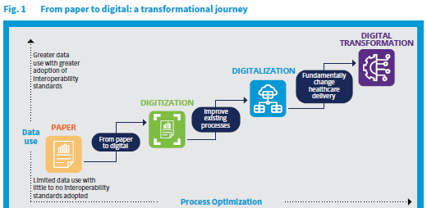

Healthcare provision in prisons: continuity of care. Investigation report
Health Services Safety Investigation Body
Poole: HSSIB; 2024.
URL | https://www.hssib.org.uk/patient-safety-investigations/healthcare-provision-in-prisons/second-investigation-report/
Notes | The Health Services Safety Investigation Body (HSSIB) in the UK has released this second recent report into healthcare provision in UK prisons. This report focuses on the continuity of care for patients in prison. In this context, ‘continuity of care’ meant maintaining a patient’s healthcare throughout the prison system regardless of their location. The investigation considered the movement of patients between prisons, to and from court, and on release.

Health Care Affordability for Older Adults: How the U.S. Compares to Other Countries
Gunja MZ, Jacobson G, Leonard F, Williams RD III
New York: Commonwealth Fund; 2024.
URL | https://doi.org/10.26099/tgjb-1m67
Notes | In this latest iteration of the Commonwealth Fund’s survey of health systems the focus was on affordability for older adults. In many of these national comparisons Australia rates highly. However, on those occasions where out of pocket costs are considered, such as here, the ranking tends to slip. This brief presents the first findings from the 2024 Commonwealth Fund International Health Policy Survey of Older Adults in 10 countries to explore how financial considerations affect older adults’ health care decisions. The survey involved adults age 65 and older in Australia, Canada, France, Germany, the Netherlands, New Zealand, Sweden, Switzerland, the United Kingdom, and the United States. This brief reports that less than 10 percent of older adults across countries skipped needed treatment because of the cost, but those in the U.S. and Australia did so at the highest rates.  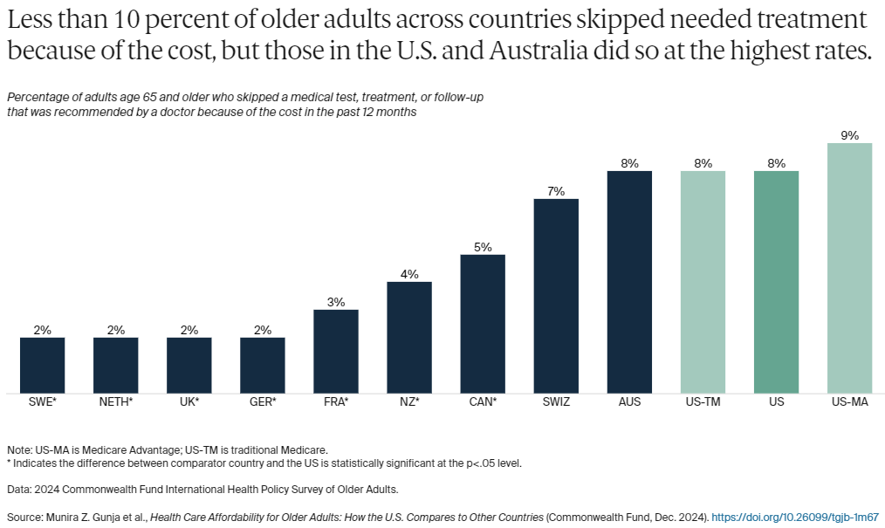

Journal articles

Addressing antimicrobial resistance with digital approaches
The Lancet Digital Health
DOI | https://www.thelancet.com/series/AMR-and-digital-approaches
Notes | The Lancet Digital Health has produced a Series on Addressing antimicrobial resistance (AMR) with digital approaches comprised of three papers discussing the advances and challenges in digital health approaches to AMR. The papers explore how digital health technologies may optimize antimicrobial use worldwide, enhance the management of maternal, fetal, and neonatal infections, and develop innovative diagnostic tools for infectious diseases and AMR.

For information on the Commission’s work on antimicrobial resistance see Antimicrobial resistance | Australian Commission on Safety and Quality in Health Care
Clinicians’ perspective of the opioid analgesic stewardship in acute pain clinical care standard
Dutkiewicz C, Liu S, Patanwala A, McLachlan AJ, Stevens J, Khor KE, et al
Health Policy and Technology 2024;13:100936.
DOI | https://doi.org/10.1016/j.hlpt.2024.100936
Notes | The Opioid Analgesic Stewardship in Acute Pain Clinical Care Standard released in 2022 describes the key components of care that patients can expect when they are prescribed opioid analgesics for acute pain in acute care settings. This paper reports on a study involving qualitative interviews of 32 clinicians ‘including 10 doctors, 10 pharmacists, and 12 nurses from 26 sites across Australia’ that sought to ‘explore clinicians’ perspectives of the implementation of the … Standard’. From their analyses, the authors report that ‘Key findings from this study included the importance of local data to increase organizational prioritization, availability of resources and staffing to increase organizational capacity for implementation to implement the Opioid Stewardship Standard.’

For information on the Opioid Analgesic Stewardship in Acute Pain Clinical Care Standard see https://www.safetyandquality.gov.au/standards/clinical-care-standards/opioid-analgesic-stewardship-acute-pain-clinical-care-standard

The Joint Commission Journal on Quality and Patient Safety
Volume 50, Issue 12, December 2024
URL | https://www.sciencedirect.com/journal/the-joint-commission-journal-on-quality-and-patient-safety/vol/50/issue/12
Notes | A new issue of The Joint Commission Journal on Quality and Patient Safety has been published. Articles in this issue of The Joint Commission Journal on Quality and Patient Safety include:  - Editorial: Supporting Professionalism in a Crisis Requires Leadership and a Well-Developed Plan (Gerald B Hickson)  - Strategies to Mitigate the Pandemic Aftermath on Perioperative Professionalism (Crystal C Wright, Maureen D Triller, Anne S Tsao, Stephanie A Zajac, ... Mark W Clemens)  - Partnership as a Pathway to Diagnostic Excellence: The Challenges and Successes of Implementing the Safer Dx Learning Lab (Jennifer Sloane, Hardeep Singh, Divvy K Upadhyay, Saritha Korukonda, ... Traber D Giardina)  - Identification of Hospitalized Patients Who May Benefit from a Serious Illness Conversation Using the Readmission Risk Score Combined with the Surprise Question (Myrna Katalina Serna, Katrina Grace Sadang, Hanna B Vollbrecht, Catherine Yoon, ... Jeffrey L. Schnipper)  - Engaging Physicians in Improvement Priorities Through the American Board of Medical Specialties Portfolio Program (Teena Nelson, Spencer Walter, Ann Williamson, Kevin Graves, ... Greg Ogrinc)  - The Burden of Health Care Utilization, Cost, and Mortality Associated with Select Surgical Site Infections (Sonali Shambhu, Aliza S Gordon, Ying Liu, Maximilian Pany, ... Eugene Hsu)  - Reducing Automated Dispensing Cabinet Overrides in the Perianesthesia Care Unit: A Quality Improvement Project (Christine D Franciscovich, Anna Bieniek, Katie Dunn, Ursula Nawab)  - Accuracy of a Proprietary Large Language Model in Labeling Obstetric Incident Reports (Jeanene Johnson, Conner Brown, Grace Lee, Keith Morse)  - Quality and Simulation Professionals Should Collaborate (Amy Lu, May C M Pian-Smith, Amanda Burden, Gladys L Fernandez, ... R H Steadman)  - Protecting Parkinson's Patients: Hospital Care Standards to Avoid Preventable Harm (Peter Pronovost, Hooman Azmi, Michael S Okun, Benjamin Walter, ... Sheera Rosenfeld)  - Preserving Resources: The Vital Role of Antimicrobial Stewardship Programs in Mitigating Antimicrobial Shortages (Jennifer A Schweiger, Nicole M Poole, Sarah K Parker, John S Kim, Christine E MacBrayne)  - The Joint Commission Journal on Quality and Patient Safety 50th Anniversary Article Collections: Patient Communication

Australian Health Review
Volume 48, Number 6, December 2024
URL | https://www.publish.csiro.au/ah/issue/11615
Notes | A new issue of Australian Health Review has been published. Articles in this issue of Australian Health Review include:  - Medicare-reimbursed psychiatric consultations before and after telehealth expansion in Australia: a time series study (Luke Sy-Cherng Woon, Paul A Maguire, Rebecca E Reay, Murthy Mittinty, T Bastiampillai and J C L Looi)  - Utilisation of Medicare chronic disease management item numbers for people with cancer in Queensland, Australia (Md Mijanur Rahman, Shafkat Jahan, Bogda Koczwara, Mahesh Iddawela, Raymond J Chan, Elysia Thornton-Benko, Gail Garvey and Nicolas H Hart)  - Standardising workforce cost estimates across Australian jurisdictions: genomic testing as a use case (Dylan A Mordaunt)  - Predicting hospital bed utilisation for post-surgical care by means of the Monte Carlo method with historical data (Andy Wong, Rob Eley, Paul Corry, Brendan Hoad and Prasad Yarlagadda)  - Spatial clusters of potentially preventable hospitalisations and access to allied health services in South Western Sydney: a geospatial study (Janelle Gifford, Soumya Mazumdar, Matthew Jennings, Bin Jalaludin and S Dennis)  - External validation and comparative analysis of the HOSPITAL score and LACE index for predicting readmissions among patients hospitalised with community-acquired pneumonia in Australia (Yogesh Sharma, Arduino A Mangoni, Chris Horwood and Campbell Thompson)  - The carbon footprint of total knee replacements (Forbes McGain, Kasun Wickramarachchi, Lu Aye, Brandon G Chan, Nicole Sheridan, Phong Tran and Scott McAlister)  - Utility of a digital app to enhance patient–nurse communications and patient involvement in bedside handover: patient and nurse perceptions (Penelope Casey, Eva Yuen, Raj Liskaser, Philippa Blencowe, Leanne Boyd, Mohamed Abdelrazek, Zoe Wang and Julie Considine)  - Leading innovation in transdisciplinary care (Martin Chadwick, Jennifer R Hemler and Benjamin F Crabtree)  - The Living Well, Living Longer program: an integrated care strategy to improve the health of people living with severe mental illness (Andrew Simpson, Lisa Parcsi and Andrew McDonald)  - Models of care for voluntary assisted dying: a qualitative study of Queensland’s approach in its first year of operation (Ben P White, Amanda Ward, Rachel Feeney, Laura Ley Greaves and Lindy Willmott)  - A digitally enabled health workforce for Australia (Anna Janssen, Melissa Baysari, Christina Igasto, Kate Quirke, Petra Milnes, Tim Shaw and A Dunn)  - Accreditation as a lever for change in the development of the collaborative practitioner in the Australian health system (Fiona Kent, Lynda Cardiff, Bronwyn Clark, Julie Gustavs, Brian Jolly, Josephine Maundu, Glenys Wilkinson and Sarah Meiklejohn)  - Chief executive officers retention model for Australian hospitals (Nebu Mathew, Chaojie (George) Liu and Hanan Khalil)  - Voluntary assisted dying: impacts on health professionals (Geetanjali (Tanji) Lamba, Camille LaBrooy, Sophie Lewis, Ian Olver, Alexander Holmes, Cameron Stewart and Paul Komesaroff)  - Feasibility of an allied health led, workplace delivered Long COVID service for hospital staff: a mixed-methods study (Aruska N D’Souza, Catherine L Granger, Zoe Calulo Rivera, Aisling Burke, Riley Ngwenya, Carly Struck, Myvanwy Merrett, Timothy N Fazio, Genevieve Juj and Casey L Peiris)

Health Affairs
Volume 43, Number 12, December 2024
URL | https://www.healthaffairs.org/toc/hlthaff/43/12
Notes | A new issue of Health Affairs has been published with the themes ‘Risk Adjustment, Insurance Markets and more’. Articles in this issue of Health Affairs include:  - Nonprofit Hospitals And Community Investment: New Approaches (Marianne Amoss)  - Upcoding Linked To Up To Two-Thirds Of Growth In Highest-Intensity Hospital Discharges In 5 States, 2011–19 (Daniel Crespin, Michael Dworsky, Jonathan Levin, Teague Ruder, and Christopher M Whaley)  - Excess Diagnosis Coding In Medicare Advantage: Evidence From Skilled Nursing Facility Clinical Assessments (Cyrus M Kosar, Hannah O James, Daeho Kim, Amal N Trivedi, Rachel M Werner, M Rahman, and D J Meyers)  - Lack Of Persistent Coding In Traditional Medicare May Widen The Risk-Score Gap With Medicare Advantage (Niru Ghoshal-Datta, Michael E Chernew, and J Michael McWilliams)  - Medicare Advantage: National Carriers Expand Market Share While Regional Carriers Without Affiliation Decline, 2012–23 (Joseph G P Hnath, J Michael McWilliams, and Michael E Chernew)  - Prevalence And Profits Of Insurers In The Administrative Services Only Market Serving Self-Insured Employers, 2010–22 (Jean M Abraham, Amanda C Cook, and E. Tice Sirmans)  - Promoting Access To Hospital Care In Rural Areas: Current Approaches And Ongoing Challenges (Caitlin Carroll, V Berquist, and M E Chernew)  - Providers Paid Substantially Less By Marketplace Nongroup Insurers Than By Employer Small-Group Plans, 2021 (Caroline Hanson, Ian McCarthy, Eamon Molloy, and Karen Stockley)  - Hospital Payment Caps Could Save State Employee Health Plans Millions While Keeping Hospital Operating Margins Healthy (Roslyn C Murray, Christopher M Whaley, Erin C Fuse Brown, and Andrew M Ryan)  - Strengths And Weaknesses Of Introducing An Inflation Factor Into The Medicare Physician Fee Schedule (Michael E Chernew, Ateev Mehrotra, and Riya D Doshi)  - Children’s Mental Health: Living With Parents Who Had Adverse Childhood Experiences (Sandra L Decker, G Meille, X Wu, and S H Zuvekas)  - More US Pharmacies Closed Than Opened In 2018–21; Independent Pharmacies, Those In Black, Latinx Communities Most At Risk (Jenny S Guadamuz, G.Caleb Alexander, Genevieve P Kanter, and Dima Mazen Qato)  - Medicare Local Coverage Determinations: Evidence Quality Is Stronger For Covered Indications (Osman Moneer, Maryam Mooghali, Khadeeja Moosa, Reshma Ramachandran, Joseph S Ross, and Sanket S Dhruva)  - US Trends In Anticancer Medicine Pricing And The Impact Of Competition, 2014–20 (R M Conti, C Mcglave, M B Rosenthal, and D Rodin)  - The Idea Of A Good Daughter (Jennifer Beard)

BMJ Quality & Safety online first articles
URL | https://qualitysafety.bmj.com/content/early/recent
Notes | BMJ Quality &Safety has published a number of ‘online first’ articles, including:  - Large-scale observational study of AI-based patient and surgical material verification system in ophthalmology: real-world evaluation in 37 529 cases (Hitoshi Tabuchi, Naofumi Ishitobi, Hodaka Deguchi, Yuta Nakaniida, Hayato Tanaka, Masahiro Akada, Mao Tanabe)

Online resources

Australian Living Evidence Collaboration
https://livingevidence.org.au/

Hot weather resources: prepare, stay cool, recover
https://www.ahcwa.org.au/2024/11/21/climate-health-resources/
The Aboriginal Health Council of Western Australia has developed a resource package to provide information on how to stay safe during heatwaves or unexpected weather changes.

Quality Use of Medicines Alliance
https://medcast.com.au/qhub
https://qum.hcca.org.au/
The Quality Use of Medicines Alliance is funded through the Quality Use of Diagnostics, Therapeutics and Pathology (QUDTP) Program of the Australian Department of Health and Aged Care. An alliance of 8 organisations it is focused on improving the quality use of medicines (QUM) in primary care. The Alliance has work underway in 4 priority areas:
- Atopic dermatitis (eczema)
- Gout
- Antidepressants in older adults
- Oral anticoagulants.
Each program has a range of foundational resources such as management algorithms, care plans, decision support tools and factsheets, supported by educational activities including educational visits/academic detailing, peer group learning, webinars, podcasts, blogs and toolkits for health professionals and resources for consumers.

Health Innovation Series - e-Medication Safety
https://www.mq.edu.au/research/research-centres-groups-and-facilities/healthy-people/centres/australian-institute-of-health-innovation/our-projects/Health-Innovation-Series/health-innovation-series-e-medication-safety
The Health Innovation Series from the Australian Institute of Health Innovation at Macquarie University has had a number of recent issues added, including:
- Are you on autopilot? Fatal errors involving automated dispensing cabinets
- Patching the system: transdermal patch removal reminders
- The devil is in the detail – safe paracetamol dosing for under- and overweight children and adults
- So many options in the Dose Calculator, which dose is right?
- The curious case of the 100-fold overdose
- The dangers of copying a previous order. Don’t be a copycat.

[Canada] Health Workforce Innovation Challenge
https://www.healthcareexcellence.ca/en/what-we-do/all-programs/health-workforce-innovation-challenge/
Healthcare Excellence Canada conducted their Health Workforce Innovation Challenge to healthcare organisations across Canada in 2023 to 2024. The webpage includes information on how healthcare organizations are addressing workforce challenges including details on strategies and success stories.

[UK] NICE Guidelines and Quality Standards
https://www.nice.org.uk/guidance
The UK’s National Institute for Health and Care Excellence (NICE) has published new (or updated) guidelines and quality standards The latest reviews or updates include:
- Quality Standard QS19 Meningitis (bacterial) and meningococcal disease https://www.nice.org.uk/guidance/qs19

[USA] Effective Health Care Program reports
https://effectivehealthcare.ahrq.gov/
The US Agency for Healthcare Research and Quality (AHRQ) has an Effective Health Care (EHC) Program The EHC has released the following final reports and updates:
- Research Protocol: Misuse of Prescription Stimulants in Adults https://effectivehealthcare.ahrq.gov/products/misuse-prescription

COVID-19 resources
https://www.safetyandquality.gov.au/covid-19
The Australian Commission on Safety and Quality in Health Care has developed a number of resources to assist healthcare organisations, facilities and clinicians. These and other material on COVID-19 are available at https://www.safetyandquality.gov.au/covid-19
These resources include:
- Poster – Combined contact and droplet precautions https://www.safetyandquality.gov.au/publications-and-resources/resource-library/infection-prevention-and-control-poster-combined-contact-and-droplet-precautions
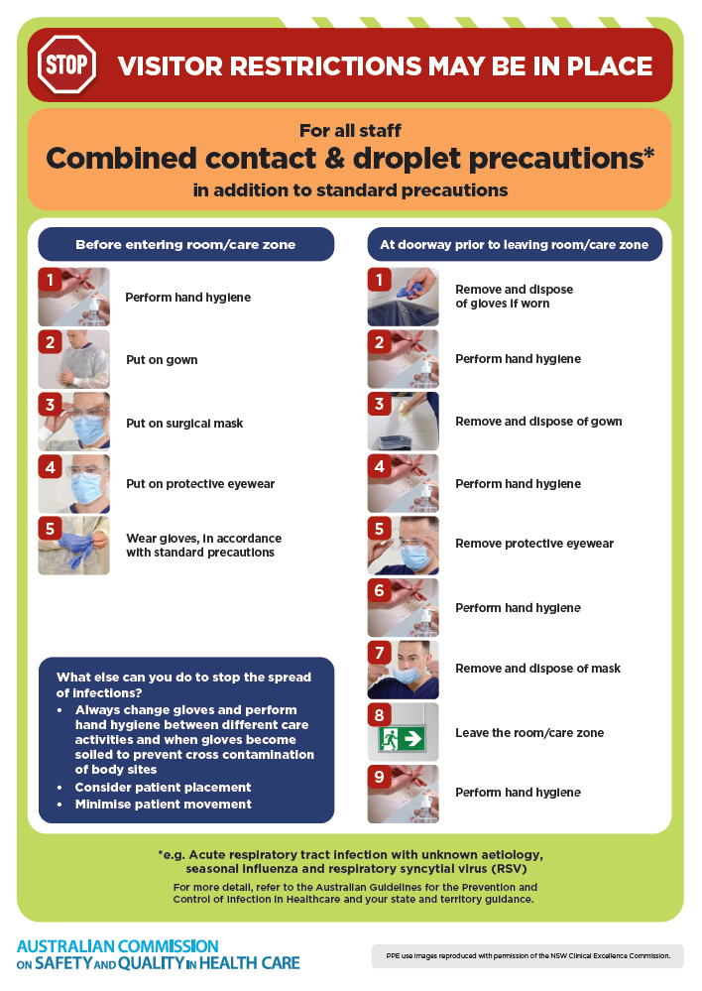
- Poster – Combined airborne and contact precautions
https://www.safetyandquality.gov.au/publications-and-resources/resource-library/infection-prevention-and-control-poster-combined-airborne-and-contact-precautions
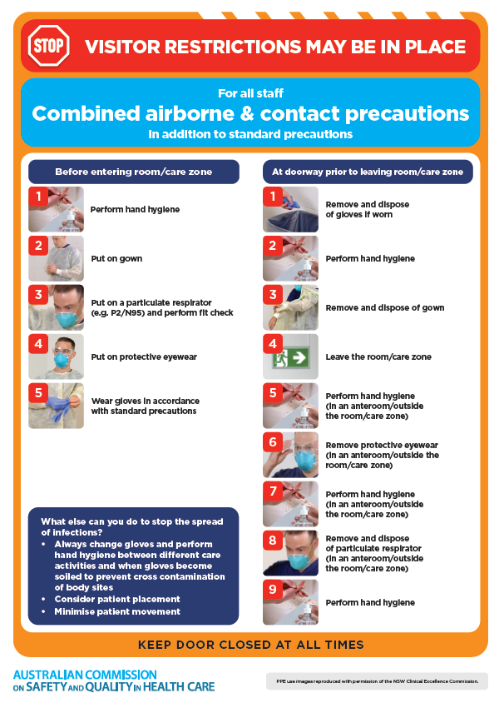
- Environmental Cleaning and Infection Prevention and Control www.safetyandquality.gov.au/environmental-cleaning
- COVID-19 infection prevention and control risk management – Guidance https://www.safetyandquality.gov.au/publications-and-resources/resource-library/covid-19-infection-prevention-and-control-risk-management-guidance
- Safe care for people with cognitive impairment during COVID-19
https://www.safetyandquality.gov.au/our-work/cognitive-impairment/cognitive-impairment-and-covid-19
- Break the chain of infection poster
https://www.safetyandquality.gov.au/publications-and-resources/resource-library/break-chain-infection-poster
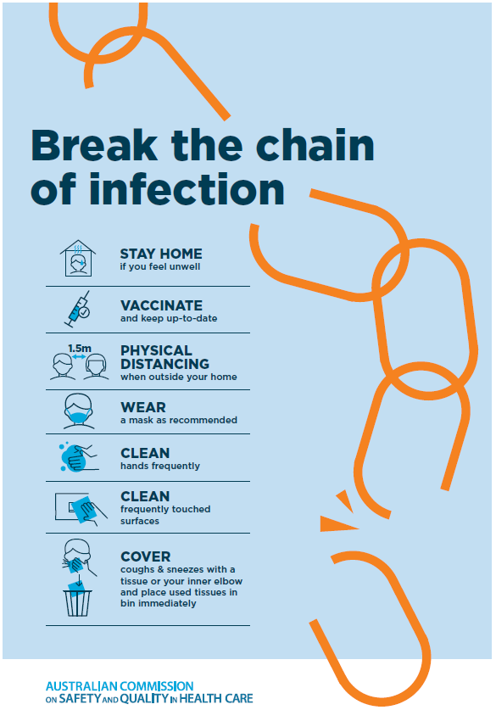
- COVID-19 and face masks – Information for consumers https://www.safetyandquality.gov.au/publications-and-resources/resource-library/covid-19-and-face-masks-information-consumers
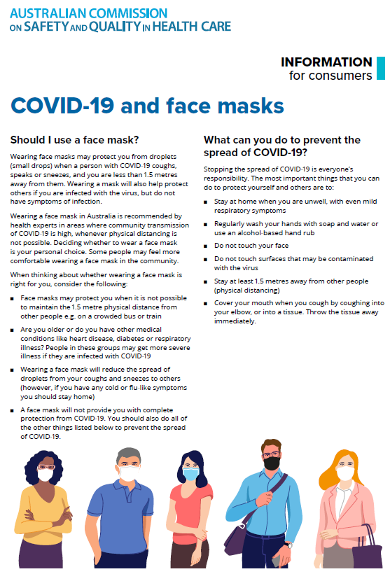

Disclaimer
On the Radar is an information resource of the Australian Commission on Safety and Quality in Health Care. The Commission is not responsible for the content of, nor does it endorse, any articles or sites listed. The Commission accepts no liability for the information or advice provided by these external links. Links are provided on the basis that users make their own decisions about the accuracy, currency and reliability of the information contained therein. Any opinions expressed are not necessarily those of the Australian Commission on Safety and Quality in Health Care.

