
On the Radar
Issue 680
23 December 2024

On the Radar is a summary of some of the recent publications in the areas of safety and quality in health care. Inclusion in this document is not an endorsement or recommendation of any publication or provider. Access to particular documents may depend on whether they are Open Access or not, and/or your individual or institutional access to subscription sites/services. Material that may require subscription is included as it is considered relevant.

On the Radar is available online, via email or as a PDF or Word document from https://www.safetyandquality.gov.au/newsroom/subscribe-news/radar

If you would like to receive On the Radar via email, you can subscribe on our website https://www.safetyandquality.gov.au/newsroom/subscribe-news
or by emailing us at HUmail@safetyandquality.gov.auU.
You can also send feedback and comments to HUmail@safetyandquality.gov.auU.

For information about the Commission and its programs and publications, please visit https://www.safetyandquality.gov.au

On the Radar
Editor: Dr Niall Johnson

Reports

Australian Burden of Disease Study 2024
Australian Institute for Health and Welfare
Canberra: AIHW; 2024
URL | https://www.aihw.gov.au/reports/burden-of-disease/australian-burden-of-disease-study-2024/
Notes | The Australian Institute for Health and Welfare (AIHW) have released their latest Australian burden of disease report. The report includes national estimates for 220 diseases and injuries in 2024 based on projections using historical trends in data. It also includes estimates of the disease burden attributed to 20 individual risk factors in 2024. The AIHW suggest that much of this burden could have been avoided or reduced.

Supporting safe care during transition from inpatient children and young people’s mental health services to adult mental health services
Investigation report
Health Services Safety Investigation Body
Poole: HSSIB; 2024.
URL | https://www.hssib.org.uk/patient-safety-investigations/mental-health-inpatient-settings/third-investigation-report/
Notes | This latest report from the Health Services Safety Investigation Body (HSSIB) in the UK is the third in a series of reports examining mental health inpatient settings. The investigation that informs this report examined the patient safety risks associated with the transition of patients from inpatient children and young people’s mental health services to adult mental health services in the UK. The report includes a number of observations and recommendations.

Embedding cultural safety: National Cultural Safety Training Standards and organisational action for cultural safety
Policy brief
Lowitja Institute
Melbourne: Lowitja Institute; 2024.
URL | https://www.lowitja.org.au/resource/embedding-cultural-safety-nationalcultural-safety-training-standards-andorganisational-action-for-cultural-safety/
Notes | The Lowitja Institute has published this policy brief on cultural safety that follows the earlier publication in 20024 of the Cultural safety in Australia, Discussion paper (https://www.lowitja.org.au/news/discussion-paper-cultural-safety-in-australia/)

Journal articles

Enhancing safe medication use in home care: insights from informal caregivers
Gil-Hernández E, Ballester P, Guilabert M, Sánchez-García A, García-Torres D, Astier-Peña MP, et al
Frontiers in Medicine. 2024;11:1494771.
DOI | https://doi.org/10.3389/fmed.2024.1494771
Notes | Many medication errors occur outside of the health care setting, they occur in the home. This paper reports on a study that sought to examine the medication administration errors made by informal caregivers in the home. Based on a survey of 685 caregivers in Spain, of whom 346 had received more than 20 hours of training, an average of 13.5 errors per caregiver were reported. The authors note that ‘Errors were more prevalent among non-qualified caregivers, males, direct relatives of the care recipient, those with external occupations, or those who used external aids.’

For information on the Commission’s work on medication safety see https://www.safetyandquality.gov.au/our-work/medication-safety

How often do parents administer medications to their children in hospital? A prospective direct observational study
Westbrook JI, Li L, Badgery-Parker T, Fitzpatrick E, Mumford V, Merchant A, et al
BMJ Open Quality. 2024;13(4):e003025.
DOI | https://doi.org/10.1136/bmjoq-2024-003025
Notes | Another paper on what might be regarded as informal medication administration – that by parents to hospitalised children. As the authors observe ‘Administration of medication to young children can be difficult and cause anxiety and stress for children. Parents are often willing and able to assist, yet little is known about how often parents are given responsibility for medication administration in hospital.’ This study used ‘data from a prospective direct observational study of nurses administering medication at a major paediatric referral hospital in Australia’ relating to ‘5137 medication doses to children on nine medical and surgical wards’. The authors report that:  - Parents were at their child’s bedside during 89.7% (n=4610) of observed medication administrations.  - Parents gave 20.3% (n=1045) of medications.  - In 14.3% (n=733), medications were left with parents to administer without a nurse present.  - In 6.1% (n=312) of doses, medications were given to parents, but the administration was observed by a nurse.

Exploring Quality and Safety Best Practices at Leading International Centres
Tosoni S, Chartier LB
Healthcare Quarterly. 2024;27(3):34-40.
DOI | https://doi.org/10.12927/hcq.2024.27489
Notes | Paper reporting on a survey of safety and quality best practices from 9 health organisations, including two Australian health services. Form the interviews, thematic analyses led to the generation of a number of recommendations for quality planning, quality control and quality improvement. The recommendations included:  - Make quality and safety the central focus of the entire organization  - Reimagine quality and safety governance structures that focus on quality in addition to safety  - Culture change is key to success  - Overcome bureaucratic inertia by saying “yes to the mess”  - Quality and safety teams must be right-sized and bring together diverse expertise  - Quality and safety work must be directly informed by the patient experience  - Co-design quality metrics and report them directly to the CEO for accountability  - Advanced analytics and triangulation of quality and safety metrics are crucial to drive change  - Enable the development and growth of quality and safety champions at every layer of the organization  - Invest in front-line quality and safety training programs for widespread gains.

Promoting Psychological Health and Safety in Canadian Healthcare Organizations
Lowe G
Healthcare Quarterly. 2024;27(3):22-27.

Beyond Traditional Practices: Innovating Workplace Mental Health in the Community
Virani T, Ismail F, Brooke J
Healthcare Quarterly. 2024;27(3):28-33.
DOI | Lowe https://doi.org/10.12927/hcq.2024.27490  Virani et al https://doi.org/10.12927/hcq.2024.27444
Notes | A pair of articles from a recent issue of Healthcare Quarterly around the theme of Mental Health in the Healthcare Workplace.  Lowe examines the Global Workforce Survey that has been developed by the Canadian non-profit Health Standards Organization. The survey is intended to allow ‘healthcare organizations to measure, analyze and benchmark their workforce's perceptions of working conditions, safety culture and care quality against peers’. The author notes that ‘Burnout and job stress are two looming concerns for many healthcare workers and their employers. While there is no easy fix for these problems, a start would be giving workers a meaningful opportunity to contribute their ideas for solutions. Maintaining a constant focus on patient safety, care quality and employee well-being should serve as powerful motivators for driving continuous improvement – and using results from the GWS to track progress.’  Virani et al describe the ‘experience of a national social enterprise in designing and implementing innovative and holistic approaches to support healthcare workers’ mental health and well-being’. The authors content that this approach has ‘significantly advanced the well-being of our employees by addressing the root causes of stress and burnout.’ They ‘urge healthcare organizations to develop comprehensive wellness programs focused on three key areas: fostering strong organizational culture, leadership development and supportive environments.’  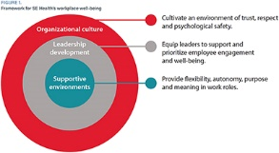

Australian Prescriber
Volume 47, Issue 6, December 2024
URL | https://australianprescriber.tg.org.au/
Notes | A new issue of Australian Prescriber has been published. Content in this issue of Australian Prescriber includes:  - Editorial: Establishing a national standard to achieve better outcomes for people living with chronic obstructive pulmonary disease (L Fong, M B Sukkar, R Ahmed, A Bhasale)  - Therapeutic vapes for smoking cessation and nicotine dependence (E Cole, C Segan, S Filia, J Kyi, D Baird)  - Diagnosis and management of antiphospholipid syndrome (Y Ahn, C Hawkins, E Pearson, P Kubler)  - Pharmacovigilance in Australia: how do adverse event reports from clinicians contribute to medicine and vaccine safety? (D Greenbaum, S Cheung, C Turner, F Mackinnon, C Larter)  - Acute tacrolimus toxicity due to concomitant use of ritonavir (with nirmatrelvir as Paxlovid) (E Browne, C White, D Darley, B Murnion)  - Oral health impacts of vaping (S-C Yeoh)  - Top 10 drugs 2023–24  - New drugs:  Deucravacitinib for plaque psoriasis  Icosapent ethyl for reduction in cardiovascular disease risk in adults with hypertriglyceridaemia

BMJ Quality & Safety
Volume 34, Issue 1, January 2025
URL | https://qualitysafety.bmj.com/content/34/1
Notes | A new issue of BMJ Quality & Safety has been published. Many of the papers in this issue have been referred to in previous editions of On the Radar (when they were released online). Articles in this issue of BMJ Quality & Safety include:  - Editorial: Patient work self-managing medicines: a skilled job at the sharp end of care (Beth Fylan, Justine Tomlinson)  - Patient-activated escalation in hospital: patients and their families are ready! (Christian Peter Subbe, Alison V Phillips, Lorelei Jones)  - Assessing patient work system factors for medication management during transition of care among older adults: an observational study (Yan Xiao, Yea-Jen Hsu, Susan M Hannum, Ephrem Abebe, Melinda E Kantsiper, Ivonne Marie Pena, Andrea M Wessell, Sydney M Dy, Eric E Howell, Ayse P Gurses)  - Understanding the enablers and barriers to implementing a patient-led escalation system: a qualitative study (Elizabeth Sutton, Mudathir Ibrahim, William Plath, Lesley Booth, Mark Sujan, Peter McCulloch, N Mackintosh)  - What do clinical practice guidelines say about deprescribing? A scoping review (Aili Veronica Langford, Imaan Warriach, Aisling M McEvoy, Elisa Karaim, Shyleen Chand, Justin P Turner, Wade Thompson, Barbara J Farrell, Danielle Pollock, Frank Moriarty, Danijela Gnjidic, N J Ailabouni, E Reeve)  - A realist review of medication optimisation of community dwelling service users with serious mental illness (Jo Howe, Maura MacPhee, Claire Duddy, Hafsah Habib, Geoff Wong, Simon Jacklin, Sheri Oduola, Rachel Upthegrove, Max Carlish, Katherine Allen, Emma Patterson, Ian Maidment)  - The good, the bad and the ugly: What do we really do when we identify the best and the worst organisations? (Gary A Abel, Denis Agniel, M N Elliott)  - Sex, drugs and rock ‘n’ roll: the only reasons for regulators to target individuals (Siri Wiig, Catherine Jane Calderwood, Bent Høie, J Braithwaite)

Healthcare Quarterly
Volume 27, Number 2, December 2024
URL | https://www.longwoods.com/publications/healthcare-quarterly/27443/1/vol-27-no.-3-2024
Notes | A new issue of Healthcare Quarterly has been published with a focus on Mental Health in Healthcare Workplaces. Articles in this issue of Healthcare Quarterly include:  - Lung Cancer and COPD: Opportunities to Leverage Lung Cancer Screening Programs to Improve COPD Diagnostics (Stacey J Butler, Lawrence Paszat and Andrea S Gershon)  - Insights on the Healthcare Trajectories of People Living With Dementia (Raquel Souza Dias Betini, Masud Hussain, Rachel Latus, Allie Chen, Liudmila Husak, Catherine Pelletier and Larry Shaver)  - The Siren Call for Business Model Innovation in Healthcare (Neil Seeman)  - Introduction to Mental Health in Healthcare Workplaces (Ruby Brown and Anne Wojtak)  - Promoting Psychological Health and Safety in Canadian Healthcare Organizations (Graham Lowe)  - Beyond Traditional Practices: Innovating Workplace Mental Health in the Community (Tazim Virani, Farah Ismail and Jillian Brooke)  - Exploring Quality and Safety Best Practices at Leading International Centres (Sarah Tosoni and Lucas B Chartier)  - Co-Creating a Vision for the Future of Healthcare Leadership: An Organizational Case Study (Laura Desveaux, Braeden Terpou, Balpreet Panesar, Jayshree Joshi and Marissa Bird)  - A Framework for Developing an Integrated Shelter Health Model in a Mid-Sized Community: The Windsor Shelter Health Experience (Karen Michael, Kathryn A Pfaff, Kelly Goz and Jennifer N Bondy)  - An Integrated Rapid Response Model for Pediatric Patients Requiring In-Patient Medical Stabilization: Lessons Learned to Enable Regional Capacity Building (Natasha Bruno, Kayla Esser, Paul Davis, Debra K. Katzman, Peter J. Azzopardi, Joseph Wiley, Sarah Barker, Sarah Kearney, Leah Bartlett, Cheryl Hoare, Jonathan Sam, Ryan W Smith, Arif Manji, Maria Psihogios, Joan Abohweyere, Zeba Ansari, Samantha Martin, Sheri Ferkl, Ronik Kanani, Michelle Gordon, Celia Atkinson and Julia Orkin)

BMJ Quality & Safety online first articles
URL | https://qualitysafety.bmj.com/content/early/recent
Notes | BMJ Quality &Safety has published a number of ‘online first’ articles, including:  - Risk-adjusted observed minus expected cumulative sum (RA O-E CUSUM) chart for visualisation and monitoring of surgical outcomes (Quentin Cordier, Hugo Prieur, Antoine Duclos Top Surgeons Study Group)

International Journal for Quality in Health Care online first articles
URL | https://academic.oup.com/intqhc/advance-articles
Notes | International Journal for Quality in Health Care has published a number of ‘online first’ articles, including:  - Five-Year Analysis of Hospital Complaints at a Japanese Tertiary Teaching Hospital (Masashi Uramatsu, Yutaka Andoh, Takako Kojima, Shiro Mishima, Megumi Takahashi, Koutaro Uchida, Jun Wada, Tomoko Oto, Takashi Ishikawa, Paul Barach, Yoshikazu Fujisawa)  - Analyzing and Mitigating the Risks of Patient Harm During Operating Room to Intensive Care Unit Patient Handoffs (Nara Regina Spall Martins et al)  - Safeguarding quality of care in active conflict: priority issues and interventions in Sudan (Sheila Leatherman et al)

Online resources

Australian Living Evidence Collaboration
https://livingevidence.org.au/

[UK] NICE Guidelines and Quality Standards
https://www.nice.org.uk/guidance
The UK’s National Institute for Health and Care Excellence (NICE) has published new (or updated) guidelines and quality standards The latest reviews or updates include:
- NICE Guideline NG112 Urinary tract infection (recurrent): antimicrobial prescribing https://www.nice.org.uk/guidance/ng112
- Diagnostics guidance DG62 Home-testing devices for diagnosing obstructive sleep apnoea hypopnoea syndrome https://www.nice.org.uk/guidance/dg62

[UK] NIHR Evidence
https://evidence.nihr.ac.uk/
The UK’s National Institute for Health Research (NIHR) has posted new evidence alerts on its site. Evidence alerts are short, accessible summaries of health and care research which is funded or supported by NIHR. This is research which could influence practice and each Alert has a message for people commissioning, providing or receiving care. The latest alerts https://evidence.nihr.ac.uk/browse-content/?_sft_articletype=alert include:
- Pneumonia vaccine is effective in people with inflammatory diseases
- Brain training improved thinking, memory and attention in older people
- Group-based intervention reduced opioid use among people with long-term pain
- System-level changes are essential to improve the psychological wellbeing of NHS staff
- People on long waiting lists use more healthcare resources than others.

The NIHR has also collated this evidence collection:
- Endometriosis, fibroids and heavy periods: long-term research supports treatment decisions https://doi.org/10.3310/nihrevidence_64953

[USA] Effective Health Care Program reports
https://effectivehealthcare.ahrq.gov/
The US Agency for Healthcare Research and Quality (AHRQ) has an Effective Health Care (EHC) Program The EHC has released the following final reports and updates:
- Making Healthcare Safer IV: Patient Monitoring Systems To Prevent Failure To Rescue https://effectivehealthcare.ahrq.gov/products/patient-monitoring-systems/rapid-research

[USA] AHRQ Perspectives on Safety
https://psnet.ahrq.gov/psnet-collection/perspectives
The US Agency for Healthcare Research and Quality (AHRQ) publishes occasional Perspectives on Safety essays. Recent essays include:
- The Ongoing Journey to Prevent Patient Falls https://psnet.ahrq.gov/perspective/ongoing-journey-prevent-patient-falls

[Canada] 5 Resources for Healthcare Improvement
Healthcare Excellence Canada have developed a number of resources, including these aimed at supporting healthcare improvement:
- Supporting the health workforce – A one-page guide outlining six strategies for improving health workforce retention https://www.healthcareexcellence.ca/en/resources/six-strategies-for-strengthening-the-workforce/
- Reducing the inappropriate use of antipsychotics –Tailored resources for using person-centred approaches to support people living with dementia in long-term care https://www.healthcareexcellence.ca/en/resources/resources-on-the-appropriate-use-of-antipsychotics-for-people-living-with-dementia/
- Advancing health equity –Recorded webinars exploring ways to dismantle systemic inequities that impact the safety and quality of care https://www.healthcareexcellence.ca/en/what-we-do/all-programs/equity-diversity-and-inclusion-virtual-learning-exchange/
- Strengthening understanding of Patient Safety Essentials – A free, 40-minute e-learning module that covers the foundations of patient safety https://www.healthcareexcellence.ca/en/what-we-do/all-programs/patient-safety-essentials/
- Retaining internationally educated healthcare workers – Evidence-guided policy considerations for retaining internationally educated healthcare workers https://www.healthcareexcellence.ca/en/resources/policy-considerations-for-the-retaining-of-internationally-educated-healthcare-workers/

COVID-19 resources
https://www.safetyandquality.gov.au/covid-19
The Australian Commission on Safety and Quality in Health Care has developed a number of resources to assist healthcare organisations, facilities and clinicians. These and other material on COVID-19 are available at https://www.safetyandquality.gov.au/covid-19
These resources include:
- Poster – Combined contact and droplet precautions https://www.safetyandquality.gov.au/publications-and-resources/resource-library/infection-prevention-and-control-poster-combined-contact-and-droplet-precautions
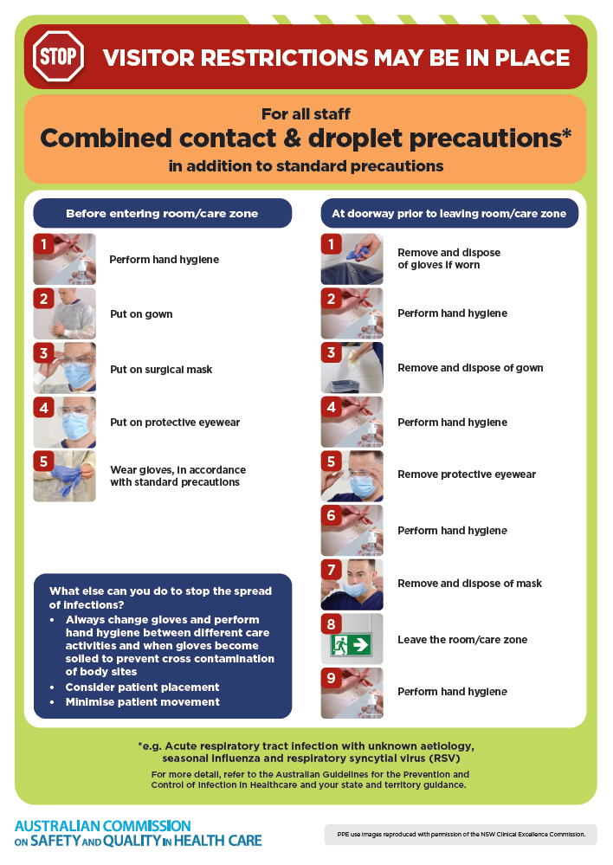
- Poster – Combined airborne and contact precautions
https://www.safetyandquality.gov.au/publications-and-resources/resource-library/infection-prevention-and-control-poster-combined-airborne-and-contact-precautions
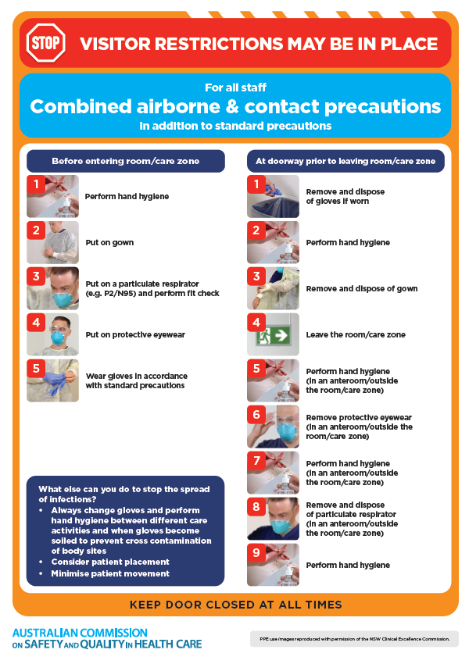
- Environmental Cleaning and Infection Prevention and Control www.safetyandquality.gov.au/environmental-cleaning
- COVID-19 infection prevention and control risk management – Guidance https://www.safetyandquality.gov.au/publications-and-resources/resource-library/covid-19-infection-prevention-and-control-risk-management-guidance
- Safe care for people with cognitive impairment during COVID-19
https://www.safetyandquality.gov.au/our-work/cognitive-impairment/cognitive-impairment-and-covid-19
- Break the chain of infection poster
https://www.safetyandquality.gov.au/publications-and-resources/resource-library/break-chain-infection-poster
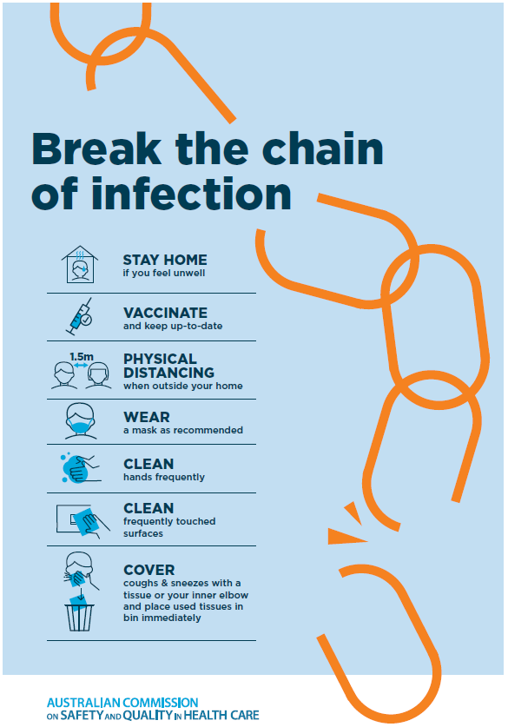
- COVID-19 and face masks – Information for consumers https://www.safetyandquality.gov.au/publications-and-resources/resource-library/covid-19-and-face-masks-information-consumers
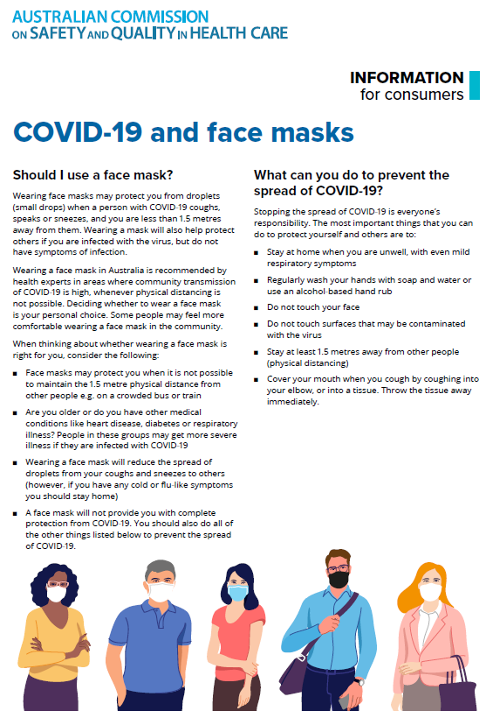

Disclaimer
On the Radar is an information resource of the Australian Commission on Safety and Quality in Health Care. The Commission is not responsible for the content of, nor does it endorse, any articles or sites listed. The Commission accepts no liability for the information or advice provided by these external links. Links are provided on the basis that users make their own decisions about the accuracy, currency and reliability of the information contained therein. Any opinions expressed are not necessarily those of the Australian Commission on Safety and Quality in Health Care.

