
On the Radar
Issue 681
20 January 2025

On the Radar is a summary of some of the recent publications in the areas of safety and quality in health care. Inclusion in this document is not an endorsement or recommendation of any publication or provider. Access to particular documents may depend on whether they are Open Access or not, and/or your individual or institutional access to subscription sites/services. Material that may require subscription is included as it is considered relevant.

On the Radar is available online, via email or as a PDF or Word document from https://www.safetyandquality.gov.au/newsroom/subscribe-news/radar

If you would like to receive On the Radar via email, you can subscribe on our website https://www.safetyandquality.gov.au/newsroom/subscribe-news
or by emailing us at HUmail@safetyandquality.gov.auU.
You can also send feedback and comments to HUmail@safetyandquality.gov.auU.

For information about the Commission and its programs and publications, please visit https://www.safetyandquality.gov.au

On the Radar
Editor: Dr Niall Johnson, Diana Shipp, Elyse Powell

Books

Health Literacy in Medicines Use and Pharmacy
Awaisu A, Munsour EE, Aslani P, Hussain R, Babar Z-U-D, editors
Academic Press; 2025.
URL | https://www.sciencedirect.com/book/9780128244074/
Notes | Health Literacy in Medicines Use and Pharmacy: A Definitive Guide highlights issues related to medication literacy. Medication literacy is a subset of health literacy that encompasses the application of health literacy in medication use process. It aims to support pharmacists, other health professionals, educators, students, and regulators, developing materials that can be understood by a broad range of patients, especially those with low health literacy. The book provides an explanation of medication literacy, presents tools to assess health and medication literacy, readability, and comprehensibility of written medicine information (WMI), and elaborates on different approaches to develop customised and patient-friendly WMI. The book also covers health and medication literacy in special populations, including geriatrics and paediatrics.

For information on the Commission’s work on medication safety see https://www.safetyandquality.gov.au/our-work/medication-safety
Journal articles

What next for the Australian Atlas of Healthcare Variation series? Focusing the system on appropriate and sustainable health care
Giles G, Buchan H, Hullick C, Overs M, Duggan A
Research in Health Services & Regions. 2024;3(1):20.
DOI | https://doi.org/10.1007/s43999-024-00056-8
Notes | The Australian Commission on Safety and Quality in Health Care has produced the Australian Atlas of Healthcare Variation series since 2015. Mapping and addressing unwarranted healthcare variation has a been a powerful tool to improve the appropriateness of health care in Australia.  This paper describes how the Australian Atlas model harnesses partnerships and levers for change across the health system to prompt local-level action. The purpose of the Atlas series is to identify areas where investigation and action could improve the appropriateness of health care. This involves investigation of both potential under provision of care and also attention to the pressing problem of overuse and the impact of misdirecting limited resources towards health care of little value. With a global imperative to focus the health system on sustainability, a continued examination of healthcare variation can direct improvement efforts to support high value care.

For information on the Commission’s work on healthcare variation, including the Australian Atlas of Healthcare Variation series, see https://www.safetyandquality.gov.au/our-work/healthcare-variation

Understanding what leaders can do to facilitate healthcare workers’ feeling valued: improving our knowledge of the strongest burnout mitigator
Stillman M, Sullivan EE, Prasad K, Sinsky C, Deubel J, Jin JO, et al
BMJ Leader. 2024;8(4):329-334.
DOI | https://doi.org/10.1136/leader-2023-000921
Notes | This paper used a survey of US physicians, advanced practice clinicians, nurses, and other clinical staff to examine issues of burnout, intention to leave and feeling valued. The Coping with COVID-19 survey was distributed to 208 US healthcare organisations and 37 685 respondents answered questions that assessed burnout, intent to leave and whether they felt valued. Forty five per cent (45%) of those respondents reported that they felt valued. The authors report that those ‘who felt highly valued had 8.3 times lower odds of burnout and 10.2 lower odds of intent to leave than those who did not feel valued at all.’ The paper identified six ‘major themes associated with feeling value and practical implications for leaders’, including:  - Physical safety  - Compensation and organisational finances  - Transparent and frequent communication  - Teamwork  - Empathetic and respectful leadership  - Supportive organisations.  Of course, this applies to the non-clinical workforce just as it does for the clinical.

Adverse diagnostic events in hospitalised patients: a single-centre, retrospective cohort study
Dalal AK, Plombon S, Konieczny K, Motta-Calderon D, Malik M, Garber A, et al.
BMJ Quality & Safety. 2024.
DOI | https://doi.org/10.1136/bmjqs-2024-017183
Notes | Paper reporting on a study that sought to examine the prevalence of harmful diagnostic errors (DEs) in hospital care. This study, undertaken in one US hospital, reviewed 9147 cases and the authors ‘estimate that a harmful DE occurred in 1 of every 14 patients hospitalised on general medicine, the majority of which were preventable. Our findings underscore the need for novel approaches for adverse DE surveillance.’

Screening for Osteoporosis to Prevent Fractures: US Preventive Services Task Force Recommendation Statement
U. S. Preventive Services Task Force
Journal of the American Medical Association. 2025
DOI | https://doi.org/10.1001/jama.2024.27154
Notes | JAMA has published the Recommendation Statement from the US Preventive Services Task Force (USPSTF) on screening for osteoporosis to prevent fractures. The USPSTF recommends:  - screening for osteoporosis to prevent osteoporotic fractures in women 65 years or older. (B recommendation)  - screening for osteoporosis to prevent osteoporotic fractures in postmenopausal women younger than 65 years who are at increased risk for an osteoporotic fracture as estimated by clinical risk assessment. (B recommendation)  The USPSTF concludes that the current evidence is insufficient to assess the balance of benefits and harms of screening for osteoporosis to prevent osteoporotic fractures in men. (I statement)  JAMA has also published the systematic evidence review that informed the statement (https://doi.org/10.1001/jama.2024.21653) along with the ‘Patient Page’ (https://doi.org/10.1001/jama.2024.27771).  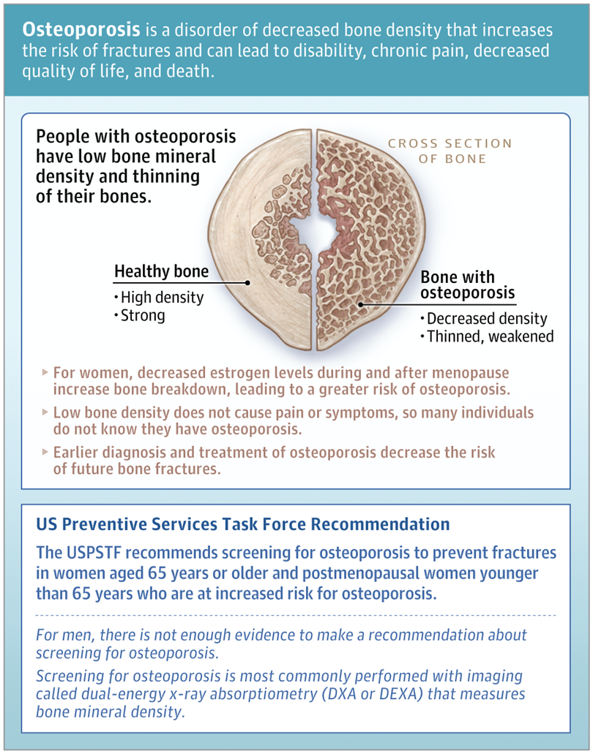
The Joint Commission Journal on Quality and Patient Safety
Volume 51, Issue 1, January 2025
URL | https://www.sciencedirect.com/journal/the-joint-commission-journal-on-quality-and-patient-safety/vol/51/issue/1
Notes | A new issue of The Joint Commission Journal on Quality and Patient Safety has been published. Articles in this issue of The Joint Commission Journal on Quality and Patient Safety include:  - Housing Instability Screening and Referral Programs: A Scoping Review (Shravan Asthana, Luis Gago, Joshua Garcia, Molly Beestrum, Teresa Pollack, Lori Post, Cynthia Barnard, Mita Sanghavi Goel)  - Health Care Workers’ Trust in Leadership: Why It Matters and How Leaders Can Build It (Jessica Greene, D Gibson, L A Taylor, D B Wolfson)  - PROPEL Discharge: An Interdisciplinary Throughput Initiative (Jessica DeMaio, Olivia Purdy, Jennifer Ghidini, Jennifer Menillo, R Viney, C Hogan)  - Optimization of a Sterile Processing Department Using Lean Six Sigma Methodology, Staffing Enhancement, and Capital Investment (Michael E Natarus, Allison Shaw, Abbey Studer, C Williams, C Dominguez, H Mangual, J Olmstead, K Westmoreland, T Gill, W Z Wellington, D S Wheeler, J B Ida)  - Methodological Approaches for Analyzing Medication Error Reports in Patient Safety Reporting Systems: A Scoping Review (O Tchijevitch, S M-B Hansen, J Hallas, S B Bogh, A Mulac, S Walløe, M K Clausen, S Birkeland)  - Development of a Calculator to Determine Individualized Opioid Doses for Treatment of Vaso-Occlusive Episodes for Sickle Cell Disease in the Emergency Department (Patricia L Kavanagh, John J Strouse, Judith A Paice, Stephanie O Ibemere, Paula Tanabe)

Journal of Patient Safety
Volume 21, Issue 1, January 29025
URL | https://journals.lww.com/journalpatientsafety/toc/2025/01000
Notes | A new issue of Journal of Patient Safety has been published. Articles in this issue of Journal of Patient Safety include:  - Translation, Adaptation, and Validation of the Japanese Version of Second Victim Experience and Support Tool-Revised (Gen Aikawa, Mitsuki Ikeda, Ayako Fukushima, Hideaki Sakuramoto, Akira Ouchi, M Uchi, N Shimojo)  - Open Disclosure Among General Practitioners as Second Victim of a Patient Safety Incident: A Cross-Sectional Study in Flanders (Belgium) (Laurens Neyens, Esther Stouten, Kris Vanhaecht, José Mira, Massimiliano Panella, Deborah Seys, Birgitte Schoenmakers)  - Learning by the Visualization of a Nurse-Led Critical Care Outreach Service Using the Functional Resonance Analysis Method (Sabine Adriana Johanna Josepha op ‘t Hoog, Mariëlle van Mersbergen-de Bruin, Nikki Laurina Mathilda Damen, Wendy Chaboyer, Anne Marie Weggelaar-Jansen, Anne M Eskes, Lilian Christina Maria Vloet, Hester Vermeulen)  - Enhancing Sepsis Care at an Academic Emergency Department in a Resource-Constrained Setting: A Quality Improvement Initiative (Haytham Noureldeen, Abdullah Bakhsh, Adel Alshabasy, Maha Alawi, Ahmad Bakhribah, Nihad Nasrallah, Ohoud Aljuhani, Rahaf Margushi, Rafal Bantan, Raneem Bokhari, S Idris, L Alshamrani, A Samman, E Alharthi, A Alothman)  - Effect of a Financial Incentive Scheme for Medication Review on Polypharmacy in Elderly Inpatients With Dementia: A Retrospective Before-and-After Study (Takahito Morita, Yusuke Sasabuchi, Hayato Yamana, Tatsuya Hosoi, Sumito Ogawa, H Ohbe, H Matsui, K Fushimi, H Yasunaga)  - AI: Promise or Peril for Patient Safety (Beth Daley Ullem, Martin J. Hatlie, Olivia Lounsbury)  - Older Adult Misuse of Over-the-Counter Medications: Effectiveness of a Novel Pharmacy-Based Intervention to Improve Patient Safety (Aaron M Gilson, Jason S Chladek, Jamie A Stone, Taylor L Watterson, Elin C Lehnbom, Emily L Hoffins, Maria E Berbakov, Jukrin Moon, Nora A Jacobson, Richard J Holden, Ronald E Gangnon, D L W Pigarelli, L L Welch, E C Portillo, O O Shiyanbola, J Gollhardt, K Walker, M A Chui)  - Anesthesia-Specific Software Module for Voluntary Adverse Event Reporting (Karolina Brook, Su Yeon Song, Julianna Richards, Laura Harrington, Nana Kwame Okyere-Tawiah, R. Mauricio Gonzalez)

Pediatric Quality & Safety
Volume 9, Number 6, November/December 2024
URL | https://journals.lww.com/pqs/toc/2024/11000
Notes | A new issue of Pediatric Quality & Safety has been published. Articles in this issue of Pediatric Quality & Safety include:  - Diagnostic Safety: Needs Assessment and Informed Curriculum at an Academic Children’s Hospital (Morgan Congdon, Irit R Rasooly, Regina L Toto, Danielle Capriola, Anna Costello, Richard J Scarfone, Anna K Weiss)  - Implementing Screening for Neonatal Delirium in the Neonatal Intensive Care Unit: A Quality Improvement Initiative (Meghana Karmarkar, Mark Speziale, Willough Jenkins, D Heath, J Kang, J Suvak, P Grimm, L Moyer)  - The Business Case for Simulation-based Hospital Design Testing; $90M Saved in Costs Avoided (Nora Colman, Christopher Chelette, J Woodward, M Chambers, K Stanley, S Walter, V L Heimbuch, C Webster, K Hebbar)  - Implementation of a Neonatal Hyperbilirubinemia Clinical Pathway in a Pediatric Emergency Department (Collin R. Miller, Catherine Haut, Arezoo Zomorrodi, Karina Chara, Janice Wilson)  - Using Quality Improvement to Design and Evaluate an Outpatient Day Treatment Pathway for Pediatric Patients with Diabetes Mellitus Requiring Insulin Initiation (Svetlana Azova, Charumathi Baskaran, Sara Einis, J Fortin, M Silva, M Gorman, B Ethier, S Nanavati, O Sterns, K Garvey, E T Rhodes)  - Is Neonatal Delirium Ready for Prime Time Quality Improvement? (Matthew J Kielt, L Dupree Hatch III)

International Journal for Quality in Health Care
Volume 36, Issue 4, 2024
URL | https://academic.oup.com/intqhc/issue/36/4
Notes | A new issue of the International Journal for Quality in Health Care has been published. Many of the papers in this issue have been referred to in previous editions of On the Radar (when they were released online). Articles in this issue of the International Journal for Quality in Health Care include:  - Underreporting of adverse events to health authorities by healthcare professionals: a red flag-raising descriptive study (Maude Lavallée, Sonia Corbin, Pallavi Pradhan, Laura Blonde Guefack, Magalie Thibault et al)  - Intravenous iron staining: real-world incidence, preventability, and mitigation tools from a long-term quality improvement project (Martin L Canning, Jodie B Hillen, Maya Kashiwagi, Negin Alizadeh, C R Freeman)  - International research priorities for integrated care and cross-boundary working: an electronic Delphi study (Jason Scott, Justin Waring, Aaron Asibi Abuosi, Yakubu Adole Agada-Amade, Jibril Muhammad Bashar et al)  - Diagnostic performance of a newly launched Canadian fast-track ultrasound clinic by rheumatologists for the diagnosis of giant cell arteritis (Jean-Charles Mourot, Sai Yan Yuen, Mihaela Luminita Popescu, Nicolas Richard)  - The influence mechanism analysis of family doctor team effectiveness: a mixed-method approach (Anning He, Zhimin Guo, Tao Zhang, Meng Zhang, Ziling Ni)  - Effect of integrated medicines management on quality of discharge medication information—a secondary endpoint in a randomized controlled trial (Liv Mathiesen, Tram Bich Michelle Nguyen, Ingrid Dæhlen, Morten Mowé, Marianne Lea)  - Setting standards in residential aged care: identifying achievable benchmarks of care for long-term aged care services (Johannes Schwabe, Gillian E Caughey, Robert Jorissen, Tracy Comans, Len Gray et al)  - Examining the joint effect of clinical quality, meaningful use of HIT and patient–caregiver interaction on mortality rates in US acute care hospitals (Aber Elsaleiby)  - Optimizing neurosurgery clinic operations: a comparative study of interventions in Finland’s public healthcare system (Jukka Huttunen, Timo Koivisto)  - The maturity of lean management in a large academic medical center in Finland: a qualitative study (Irmeli Hirvelä, Paulus Torkki, Mervi Javanainen, Elina Reponen)  - Five-year analysis of hospital complaints at a Japanese tertiary teaching hospital (Masashi Uramatsu, Yutaka Andoh, Takako Kojima, Shiro Mishima, Megumi Takahashi et al)  - Editorial: The future of global graduate training in quality improvement and patient safety (Yash B Shah, Akshay S Krishnan, P J Kumar, Varun Jayanti, Zachary N Goldberg et al)  - Editorial: Developing a patient-centered computerized clinical decision support system with patient-level outcome measures* (Mari Nezu, David Greenfield, Usman Iqbal, Takeshi Morimoto)  - Editorial: Addressing the continuing challenges of developing and implementing clinical practice guidelines (Phillip Phan)  - Promoting holistic and inclusive care for women: a call for updated health policies (Danilo V Rogayan, Jr, Joseline R Tamoria, Karen P Andres)  - Challenges to implementing clinical guidelines for preparticipation physical evaluations in youth sports (Tammy Ng, Jesslyn Magee-Gonzalez, Sandra L Taylor, Ulfat Shaikh)  - Correction: Correction to: Perceived reliability of medical device alarms—a major determinant of medical errors driven by frozen medical thinking

Australian Journal of Primary Health
URL | https://www.publish.csiro.au/py/#Latest
Notes | The Australian Journal of Primary Health has moved to a continuous publication model. In the continuous publication model, once an article is ready for publication, it is immediately published online with final citation details (https://www.publish.csiro.au/PY/Continuouspublication).  Recent articles in the Australian Journal of Primary Health include:  - Exploring oral health challenges and integration strategies in opioid treatment programs: perspectives from clinicians and clients (Grace Wong, Anna Cheng, Kyle Cheng, Angela Masoe, S D’Hary and M E Montebello)  - Health literacy measurement: a comparison of four widely used health literacy instruments (TOFHLA, NVS, HLS-EU and HLQ) and implications for practice (Rebecca L Jessup, Alison Beauchamp, Richard H Osborne, Melanie Hawkins and Rachelle Buchbinder)  - A technology-enabled collaborative learning model (Project ECHO) to upskill primary care providers in best practice pain care (Simone De Morgan, Pippy Walker, Fiona M Blyth, Anne Daly, Anne L J Burke and Michael K Nicholas)  - Uptake of guideline-based testing for chronic viral hepatitis in Australian primary care: retrospective analysis of electronic medical record data (Jennifer H MacLachlan, Nicole Allard, Lien Tran, Amelia Savage, Emily Adamson, Vanessa Price, Christopher Pearce, Gregory J Dore and Benjamin C Cowie)  - How to undertake research with refugees: lessons learned from a qualitative health research programme in Southern New Zealand (Molly George, Lauralie Richard, Chrystal Jaye, Sarah Derrett, E Wyeth and T Stokes)  - Investigating behaviours and attitudes regarding recommended vaccination in adults 50 years and above in Australia (Amalie Dyda, Harriet Lawford, Colleen L Lau and Kim Sampson)  - Attitudes towards models of abortion care in sexual and reproductive health: perspectives of Australian health professionals (Nicola Sheeran, Liz Jones, Bonney Corbin and Catriona Melville)  - The perspectives of people living with dementia and their carers on the role of the general practice nurse in dementia care provision: a qualitative study (Caroline Gibson, D Goeman, C D Pond, M Yates and A M Hutchinson)  - Views of nurses and midwives working in primary healthcare services on intimate partner violence against women (Suna Uysal Yalçin, Sena Dilek Aksoy, Zeynep Zonp and Hülya Bilgin)  - Using quick response codes to access digital health resources in the general practice waiting room (Elizabeth P Hu, Cassie E McDonald, Yida Zhou, Philip Jakanovski and Phyllis Lau)  - Factors informing funding of health services for Aboriginal and Torres Strait Islander children: perspectives of decision-makers (Shingisai Chando, Martin Howell, M Dickson, A Jaure, J C Craig, S J Eades and K Howard)  - Supporting primary care practitioners to promote dementia risk reduction in Australian general practice: outcomes of a cross-sectional, non-randomised implementation pilot study (Kali Godbee, Victoria J Palmer, Jane M Gunn, Nicole T Lautenschlager and Jill J Francis)  - A shared journey: evaluating a patient-assessed measure of self-management of chronic conditions in an Australian setting (Phillip Davis, Joanne Bradbury, Kirstine Shrubsole and John Parke)  - Codesigning a Community Health Navigator program to assist patients to transition from hospital to community (Mark F Harris, An Tran, Mamta Porwal, Parisa Aslani, John Cullen, Anthony Brown, E Harris, B Harris-Roxas, F Doolan-Noble, S Javanparast, M Wright, R Osborne and R Osten)  - Australian healthcare professionals’ beliefs and practice behaviours in management of chronic pelvic pain: a cross-sectional survey (Jennifer Vardy, Edwina Chan, Marika Hart, R Dallin, E Wise, E Karantanis and D Beales)

BMJ Leader
Volume 8, Number 4
DOI | https://bmjleader.bmj.com/content/8/4
Notes | A new issue of BMJ Leader has been published. Articles in this issue of BMJ Leader include:  - Bringing people together through shared purpose and identity: lessons learnt from NHS Providers CEO Sir Julian Hartley (Richard James, Julian Hartley, Laura Stroud)  - Advancement, barriers and collaboration: the ABC’s of addressing challenges and designing solutions between front-line physicians and business-oriented leaders (Shayann Ramedani, Jeffery Miller, Jed D Gonzalo)  - History and its relevance to contemporary and future leadership (Martin Bricknell)  - Leadership development programmes in healthcare research: a systematic review, meta-analysis and meta-aggregation (Harry Kingsley-Smith, Christian E Farrier, Daniel Foran, Koot Kotze, Kamal Mahtani, Sarah Short, Anna Mae Scott, Oscar Lyons)  - Kindness: Poor cousin or equal kin to Compassion and Empathy in the Healthcare Literature? A Scoping Review (Nicki Macklin, Laura Wilkinson-Meyers, Anthony Dowell)  - Psychological safety in the perioperative environment: a cost-consequence analysis (Franklyn P Cladis, Mark Hudson, Joel Goh)  - Faculty retention at a young medical school in crisis times and beyond: prospects, challenges and propositions from a mixed-methods study (Vanda G Yazbeck Karam, Sola Bahous, Ghada M Awada, Nazih Youssef)  - Striving for equity: exploring gender-inclusive medical leadership in India (Kamal Gulati, Julie Davies, Angel Gonzalez de la Fuente, Angel Rajan Singh)  - ‘You just don’t feel like your work goes recognised’: healthcare worker experiences of tension related to public discourse around the COVID-19 pandemic (George Thomas Timmins, Julia I Bandini, Sangeeta C Ahluwalia, Armenda Bialas, Lisa S Meredith, Courtney Gidengil)  - Understanding what leaders can do to facilitate healthcare workers’ feeling valued: improving our knowledge of the strongest burnout mitigator (Martin Stillman, Erin E Sullivan, Kriti Prasad, Christine Sinsky, Jordyn Deubel, Jill O Jin, Roger Brown, Nancy Nankivil, Mark Linzer)  - Comparing hospital leadership and front-line workers’ perceptions of patient safety culture: an unbalanced panel study (Jayson Forbes, Alejandro Arrieta)  - Pilot study exploring the presence of leadership curricula in undergraduate medical education (Melanie Korndorffer, Michael A Dewsnap, Erin S Barry, Neil Grunberg, David W Musick, Joann Farrell Quinn)  - Strategic operations as the heartbeat of healthcare excellence: cultivating a culture of strategic fit in health institutions (Benjamin Laker, Vijay Pereira)  - Reorganising our heads for the care of our health (Henry Mintzberg)  - Balancing health and work: employees demand more flexibility in when, where and how they work (Benjamin Laker, Rita Fontinha, James Walker)  - Can coaching advance medical leadership development? (Fiona Jane Day, Daljit Hothi)  - Nursing home managers’ quality of work life and health outcomes: a pre-pandemic profile over time (Tatiana Penconek, Yinfei Duan, Alba Iaconi, Kaitlyn Tate, Greta G Cummings, Carole A Estabrooks)  - Curriculum mapping to audit and grow longitudinal graduate medical education leadership training (Andrew Goodwin, Kathryn Hughes, Joshua Hartzell, William Rainey Johnson)

JBI Evidence Synthesis
Volume 23, Issue 1, January 2025
URL | https://journals.lww.com/jbisrir/toc/2025/01000
Notes | A new issue of JBI Evidence Synthesis has been published. Articles in this issue of JBI Evidence Synthesis include:  - Editorial: Waiting and the unknown: parental experiences accessing autism spectrum disorder diagnostic services for their children (Joanne Smith-Young, Roger Chafe)  - Parents’ and guardians’ experiences of barriers and facilitators in accessing autism spectrum disorder diagnostic services for their children: a qualitative systematic review (Joanne Smith-Young, A Pike, M Swab, R Chafe)  - Community-dwelling older people’s experiences of advance care planning with health care professionals: a qualitative systematic review (Kieko Iida, Mina Ishimaru, Mayuko Tsujimura, Ayumi Wakasugi)  - Value-based outcome evaluation methods used by occupational therapists in primary care: a scoping review (L Ingham, A Cooper, D Edwards, C Purcell)  - Care partner engagement in patient safety at the direct care level in hospital: a qualitative systematic review protocol (Kayley Perfetto, Laura Pozzobon, Kim Sears, Jane O'Hara, Amanda Ross-White, Lenora Duhn)  - Determining the methodological rigor and overall quality of out-of-hospital clinical practice guidelines: a scoping review protocol (Brendan V Schultz, Timothy H Barker, Emma Bosley, Zachary Munn)

Health Affairs
Volume 44, Number 1, January 2025
URL | https://www.healthaffairs.org/toc/hlthaff/44/1
Notes | A new issue of Health Affairs has been published. Articles in this issue of Health Affairs include:  - Can Innovative Financing Move The Needle On Health Equity? (J Bylander)  - National Health Expenditures In 2023: Faster Growth As Insurance Coverage And Utilization Increased (Anne B Martin, Micah Hartman, Benjamin Washington, and Aaron Catlin)  - Medicare Enrollment Increased Visits To Primary Care Providers But Not Mental Health Care Providers, 2014–21 (Donghoon Lee and Jing Li)  - Use Of Patient Health Survey Data For Risk Adjustment To Limit Distortionary Coding Incentives In Medicare (J Michael McWilliams, Gabe Weinreb, Mary Beth Landrum, and Michael E Chernew)  - Combining Patient Survey Data With Diagnosis Codes Improved Medicare Advantage Risk-Adjustment Accuracy (Meghan Bellerose, Hannah O James, Jay Shroff, Andrew M Ryan, and David J Meyers)  - Medicare Risk Adjustment: Goals, Reform Proposals, And New Frontiers (Aaron L Schwartz)  - Current Use And Evaluation Of Artificial Intelligence And Predictive Models In US Hospitals (Paige Nong, Julia Adler-Milstein, Nate C Apathy, A Jay Holmgren, and Jordan Everson)  - Tubal Sterilization And Vasectomy Increased Among US Young Adults After The Dobbs Supreme Court Decision In 2022 (Julia Strasser, Ellen Schenk, Sara Luckenbill, Danielle Tsevat, L King, Q Luo, and J Maslowsky)  - Adverse Childhood Experiences: Increased Likelihood Of Socioeconomic Disadvantages For Young Adults (Shawn Ratcliff, Keith Finlay, Jordan Papp, Megan C Kearns, Phyllis Holditch Niolon, and Cora Peterson)  - Improving Health Care, One Consent At A Time (Bakhtawar Ahmad)

Health Affairs Sholar
Volume 2, Issue 12, December 2024
URL | https://academic.oup.com/healthaffairsscholar/issue/2/12
Notes | A new issue of Health Affairs Scholar has been published with the theme ‘Health workforce issues and challenges in the post-pandemic era’. Articles in this issue of Health Affairs include:  - Expanding options to recruit, grow, and retain the public health workforce (Kate Beatty et al)  - Low birthweight rate differences associated with distinct perinatal staffing mixes at federally funded health centers (Paula M Kett et al)  - Trends in workplace violence for health care occupations and facilities over the last 10 years (Brianna Lombardi et al)  - Economic insecurity during the COVID-19 pandemic among healthcare workers by educational attainment (Tracy M Mroz et al)  - Nurse practitioner race and ethnicity and interest in independent primary care practice and serving Medicaid enrollees (Ulrike Muench et al)  - The development of the Community Deprivation Index and its application to accountable care organizations (John Robst et al)  - Non–cost-related sources of medication nonadherence in the Medicare population (Jason Petroski et al)  - Politicians, power, and the people's health: US elections and state health outcomes, 2012–2024 (Nancy Krieger et al)  - Lower obstetrician and gynecologist (OBGYN) supply in abortion-ban states, despite minimal state-level changes in the 2 years post-Dobbs (Julia Strasser et al)  - Standardizing social determinants of health data: a proposal for a comprehensive screening tool to address health equity a systematic review (Sarju Ganatra et al)  - Incorporating staffing instability in the nursing home Five-Star Staffing Composite (Dana B Mukamel et al)  - Market segmentation by profit status: evidence from hospice (David A Rosenkranz et al)  - Older adults in social housing: A systemically vulnerable population that needs to be prioritized (Jasmine Dzerounian et al)

BMJ Quality & Safety online first articles
URL | https://qualitysafety.bmj.com/content/early/recent
Notes | BMJ Quality &Safety has published a number of ‘online first’ articles, including:  - Editorial: Audit and feedback to improve antibiotic prescribing in primary care—the time is now (Bradley J Langford, Kevin L Schwartz)  - Editorial: Art of leading quality improvement (Maitreya Coffey, K Smith)  - Duration of antibiotic therapy in the intensive care unit: factors influencing decision-making during multidisciplinary meetings (Robin M E Janssen, Anke J M Oerlemans, Nynke Bos, Johannes G van der Hoeven, Evelien A N Oostdijk, Lennie P G Derde, Jaap ten Oever, Heiman F L Wertheim, Jeroen A Schouten, Marlies E J L. Hulscher)  - Editorial: Co-production in maternal health services: creating culturally safe spaces, respecting difference and supporting collaborative solutions (Jennifer MacLellan, Carmen Byrne, Catherine Pope)  - Effect of text message reminders to improve paediatric immunisation rates: a randomised controlled quality improvement project (Kyra Rosen, Holly Krelle, William C King, Nathan Klapheke, Paulo Pina, Judd Anderman, Alicia Chung, F Mendoza, A Bagheri, J Stadelman, S Tsuruo, L I Horwitz)  - Editorial: Testing and cancer diagnosis in general practice (Stephen Bradley, Jessica Watson)  - Measuring the quality of surgery: should textbook outcomes be an off-the-shelf or a bespoke metric? (Kjetil Søreide)  - Development of a Preliminary Patient Safety Classification System for Generative AI (Bat-Zion Hose, Jessica L Handley, Joshua Biro, Sahithi Reddy, Seth Krevat, Aaron Zachary Hettinger, Raj M Ratwani)  - Socioeconomic inequalities in adherence to clinical practice guidelines and breast cancer survival: a multicentre population-based study in Spain (Dafina Petrova, Daniel Redondo-Sánchez, Miguel Rodríguez-Barranco, Rafael Marcos-Gragera, Marcela Guevara, Marià Carulla, Arantza López de Munain, Ana Vizcaíno, Sonia del Barco, Encarnación González-Flores, Marina Pollán, María-José Sánchez)  - Developing the allied health professionals workforce within mental health, learning disability and autism inpatient services: rapid review of learning from quality and safety incidents (Ceri Wilson, Rachel Wakefield, Louise Prothero, Gillian Janes, Fiona Nolan, Sally Fowler-Davis)  - Adverse diagnostic events in hospitalised patients: a single-centre, retrospective cohort study (Anuj K Dalal, Savanna Plombon, Kaitlyn Konieczny, Daniel Motta-Calderon, Maria Malik, Alison Garber, Alyssa Lam, Nicholas Piniella, Marie Leeson, Pamela Garabedian, Abhishek Goyal, Stephanie Roulier, Cathy Yoon, Julie M Fiskio, Kumiko O Schnock, Ronen Rozenblum, Jacqueline Griffin, Jeffrey L Schnipper, Stuart Lipsitz, David W Bates Patient Safety Learning Laboratory Adjudicator Group)

International Journal for Quality in Health Care online first articles
URL | https://academic.oup.com/intqhc/advance-articles
Notes | International Journal for Quality in Health Care has published a number of ‘online first’ articles, including:  - Holding up the crystal ball: Using regulatory intelligence insights to support quality in healthcare (Martin Fletcher, Samantha Stark, N Balvin, D Greenfield)  - Improvements to safety and quality: mastery of tools and techniques is not enough, people and culture matter (Alessandro Laureani)  - Promoting Human Rights-Based Deinstitutionalisation in Lithuania by Applying the World Health Organization’s QualityRights Assessments (Ugnė Grigaitė et al)  - Adverse medication reactions: raising a red flag locally, sharing lessons globally, improving safety and quality in health care (Linda Velta Graudins)

Online resources

Australian Living Evidence Collaboration
https://livingevidence.org.au/

[UK] NICE Guidelines and Quality Standards
https://www.nice.org.uk/guidance
The UK’s National Institute for Health and Care Excellence (NICE) has published new (or updated) guidelines and quality standards The latest reviews or updates include:
- NICE Guideline NG246 Overweight and obesity management https://www.nice.org.uk/guidance/ng246
- NICE Guideline NG247 Maternal and child nutrition: nutrition and weight management in pregnancy, and nutrition in children up to 5 years https://www.nice.org.uk/guidance/ng247

[USA] Effective Health Care Program reports
https://effectivehealthcare.ahrq.gov/
The US Agency for Healthcare Research and Quality (AHRQ) has an Effective Health Care (EHC) Program The EHC has released the following final reports and updates:
- Trauma Informed Care: A Systematic Review https://effectivehealthcare.ahrq.gov/products/trauma-informed-care/research
- Rapid Evidence Product: Making Healthcare Safer IV: Use of Structured Handoff Protocols for Intrahospital Within-Unit Transitions https://effectivehealthcare.ahrq.gov/products/structured-handoff/rapid-research
- White Paper: Enhancing Systematic Review Methods by Incorporating Unpublished Drug Trials. https://effectivehealthcare.ahrq.gov/products/unpublished-drug-trials/white-paper
- White Paper: Supplementing Systematic Review Findings With Healthcare System Data: Pilot Projects From the Agency for Healthcare Research and Quality Evidence-based Practice Center Program https://effectivehealthcare.ahrq.gov/products/pilot-projects/white-paper
- White Paper: Machine Learning Tools To (Semi-)Automate Evidence Synthesis: A Rapid Review and Evidence Map https://effectivehealthcare.ahrq.gov/products/machine-learning-tools/white-paper

Infection prevention and control and COVID-19 resources
The Australian Commission on Safety and Quality in Health Care has developed a number of resources to assist healthcare organisations, facilities and clinicians. These resources include:
- Poster – Combined contact and droplet precautions https://www.safetyandquality.gov.au/publications-and-resources/resource-library/infection-prevention-and-control-poster-combined-contact-and-droplet-precautions
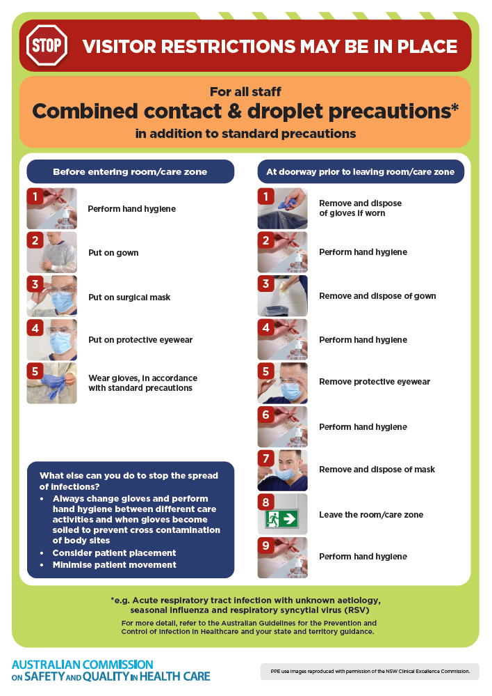
- Poster – Combined airborne and contact precautions
https://www.safetyandquality.gov.au/publications-and-resources/resource-library/infection-prevention-and-control-poster-combined-airborne-and-contact-precautions
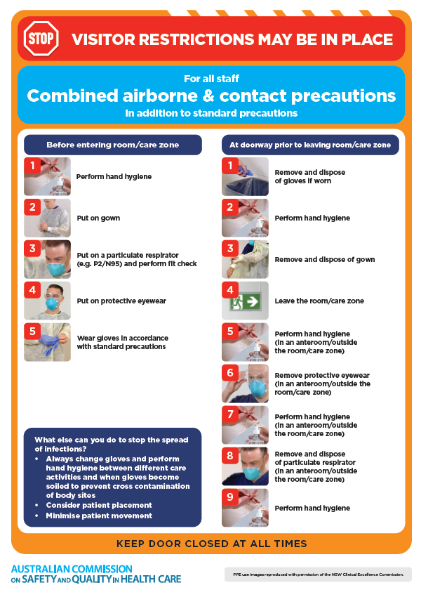
- Environmental Cleaning and Infection Prevention and Control www.safetyandquality.gov.au/environmental-cleaning
- Break the chain of infection poster
https://www.safetyandquality.gov.au/publications-and-resources/resource-library/break-chain-infection-poster
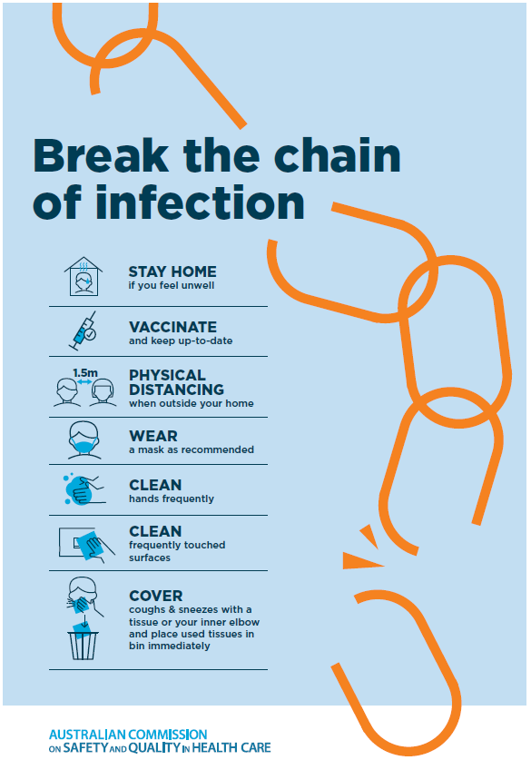

Disclaimer
On the Radar is an information resource of the Australian Commission on Safety and Quality in Health Care. The Commission is not responsible for the content of, nor does it endorse, any articles or sites listed. The Commission accepts no liability for the information or advice provided by these external links. Links are provided on the basis that users make their own decisions about the accuracy, currency and reliability of the information contained therein. Any opinions expressed are not necessarily those of the Australian Commission on Safety and Quality in Health Care.

