
On the Radar
Issue 687
3 March 2025

On the Radar is a summary of some of the recent publications in the areas of safety and quality in health care. Inclusion in this document is not an endorsement or recommendation of any publication or provider. Access to particular documents may depend on whether they are Open Access or not, and/or your individual or institutional access to subscription sites/services. Material that may require subscription is included as it is considered relevant.

On the Radar is available online, via email or as a PDF or Word document from https://www.safetyandquality.gov.au/newsroom/subscribe-news/radar

If you would like to receive On the Radar via email, you can subscribe on our website https://www.safetyandquality.gov.au/newsroom/subscribe-news
or by emailing us at HUmail@safetyandquality.gov.auU.
You can also send feedback and comments to HUmail@safetyandquality.gov.auU.

For information about the Commission and its programs and publications, please visit https://www.safetyandquality.gov.au

On the Radar
Editor: Dr Niall Johnson, Rebecca Peters, Diana Shipp

Have your say on the accreditation of general practices
www.safetyandquality.gov.au/NGPA-consultation

The Australian Commission on Safety and Quality in Health Care is seeking feedback on potential changes to the accreditation cycle and assessment of general practices.

Consultation is now open for the general practice sector to share their views on two proposed options:
- Extended accreditation cycle with at least one mid-point review
- Assessment conducted at short notice.

Help shape changes to the National General Practice Accreditation (NGPA) Scheme by:
- Providing feedback through a short online survey or written submission
- Attending an online focus group facilitated by the Commission
- Sharing the consultation resources with anyone in your network who may be interested.

Alternate ideas and suggestions on how the accreditation experience and assessment process for general practices could be improved are also welcomed.

Share your feedback by 4 April 2025, visit www.safetyandquality.gov.au/NGPA-consultation
Documenting oxygen therapy and response for safety
https://www.safetyandquality.gov.au/publications-and-resources/resource-library/documenting-oxygen-therapy-and-response-safety

The Commission has developed guidance for health service organisations and clinicians on processes to support appropriate documentation around the administration, and monitoring of oxygen therapy for adults in acute healthcare settings. The Fact sheet - Documenting oxygen therapy and response for safety is an addendum to the National Consensus Statement: Essential elements for recognising and responding to acute physiological deterioration and complements the Commission’s Chronic Obstructive Pulmonary Disease (COPD) Clinical Care Standard, which includes specific guidance on the use of oxygen and ventilatory support during COPD exacerbations in acute healthcare settings.

Oxygen is one of the most used emergency therapies. Variation in the documentation, administration and monitoring of oxygen therapy in hospital settings can lead to hypoxaemia or hyperoxaemia, with the risk of significant patient harm. The guidance covers documentation around the requirement, the target saturation range and monitoring and cessation of oxygen therapy.

Reports

Virtual Care Project - Final Report
Nous Group, Health Policy Analysis.
Sydney: Independent Health and Aged Care Pricing Authority; 2025.
URL | https://www.ihacpa.gov.au/resources/virtual-care-project-final-report
Notes | The Independent Health and Aged Care Pricing Authority commissioned this report as part of a program of work to review virtual care in Australia. This report ‘provides an overview of current models of virtual care in Australia and internationally to better understand virtual care activity, costs, and models of care. It also details recommendations and implementation considerations to address potential gaps, improve data collections and support improved integration of virtual care into the national pricing and funding models’. It is observed that ‘Virtual care service delivery has accelerated nationally, with 12% growth in use of virtual service modes for non-admitted services alone in the last five years’. This growth has not been uniform as ‘There is significant variation in virtual models of care across jurisdictions, with different modalities and interaction types across different settings.’ The report’s authors make a number of findings and recommendations. The recommendations cover issues such as definitions, data collection, costing, pricing and funding.  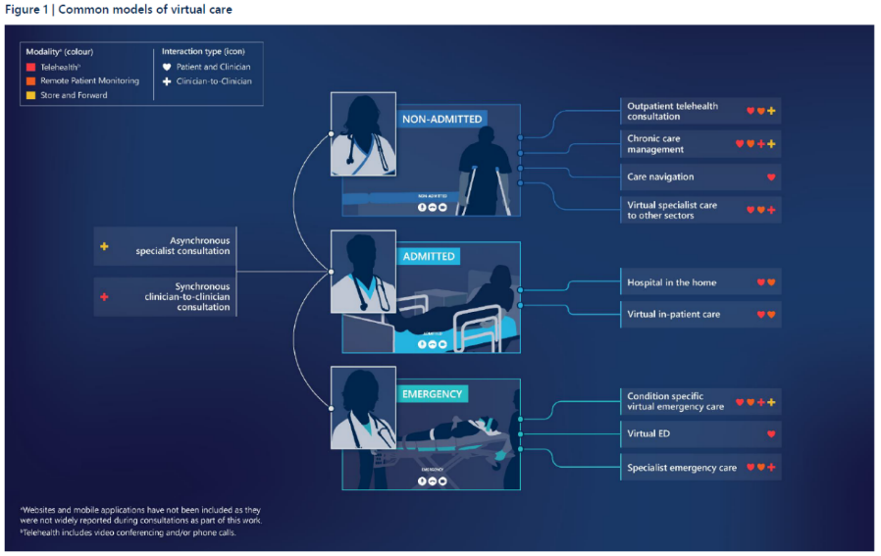
Journal articles

Systems analysis of clinical incidents: development of a new edition of the London Protocol
Vincent C, Irving D, Bellandi T, Higham H, Michel P, Staines A, et al
BMJ Quality & Safety. 2025.
DOI | https://doi.org/10.1136/bmjqs-2024-017987
Notes | Since it was published in 2004, the ‘London Protocol’ has become one of the recognised approaches to incident analysis in health care. This paper describes the development of a new edition of the London Protocol, including ‘the need for a revised and expanded version of the London Protocol, addressing both the changes in healthcare in the last two decades and what has been learnt from the experience of incident analysis across the world’. The authors note that The principal changes in the new edition are as follows:  increased emphasis and guidance on the engagement of patients and families as partners in the investigation;  giving more attention to the support of patients, families and staff in the aftermath of an incident;  emphasising the value of a small number of in-depth analyses combined with thematic reviews of wider problems;  including proposals and guidance for the examination of much longer time periods;  emphasising the need to highlight good care as well as problems;  adding guidance on direct observation of the work environment;  providing a more structured and wide-ranging approach to recommendations and  including more guidance on how to write safety incident reports.’

Protocol for a national intervention programme aimed to reduce unwarranted variation and overuse of shoulder arthroscopy in Norway
Tjomsland O, Bertilsson HM, Bjerkan G, Blomquist PJ, Brox JI, Bøe BM, et al
BMJ Open Quality. 2025;14(1): e003099.
DOI | https://doi.org/10.1136/bmjoq-2024-003099
Notes | In recent years there has been interest in and efforts to address variation in health care provision, particularly around issues of value. This paper describes the latest of a series of efforts in Norway to address low value care. In this instance the focus is on reducing the unwarranted variation and overuse of shoulder arthroscopy.

For information on the Commission’s work on healthcare variation, including the Australian Atlas of Healthcare Variation series, see https://www.safetyandquality.gov.au/our-work/healthcare-variation

Medication-focused telehealth interventions to reduce the hospital readmission rate: a systematic review
Emadi F, Dabliz R, Moles R, Carter S, Chen J, Grover C, et al
Journal of Pharmaceutical Policy and Practice. 2025;18(1):2457411.
DOI | https://doi.org/10.1080/20523211.2025.2457411
Notes | Paper reporting on a systematic review that examined the literature on telehealth interventions that focussed on medication issues. The stated goal of the review ‘was to examine the effect of interdisciplinary telehealth post-discharge services that include a medication-focused component on hospital readmissions.’ Focused on 23 papers, the review found ‘10 studies demonstrated success in reducing readmissions’ and the authors report their review ‘highlights the potential of telehealth medication-focused interventions in reducing hospital readmission rates in patients with HF’ [heart failure]

For information on the Commission’s work on medication safety see https://www.safetyandquality.gov.au/our-work/medication-safety

The Joint Commission Journal on Quality and Patient Safety
Volume 51, Issue 3, March 2025
URL | https://www.sciencedirect.com/journal/the-joint-commission-journal-on-quality-and-patient-safety/vol/51/issue/3
Notes | A new issue of The Joint Commission Journal on Quality and Patient Safety has been published. Articles in this issue of The Joint Commission Journal on Quality and Patient Safety include:  - Editorial: The Invisible Work to Manage Drug Shortages (Erin R Fox)  - The Surgical Pause: The Importance of Measuring Frailty and Taking Action to Address Identified Frailty (Daniel E Hall, Danielle Hagan, LauraEllen Ashcraft, Mark Wilson, Shipra Arya, Jason M Johanning)  - Frailty Screening Using the Risk Analysis Index: A User Guide (Daniel E Hall, Carly A Jacobs, K M Reitz, S Arya, M A Jacobs, J Cashy, J M Johanning)  - Suicide Risk Screening in Children and Adolescents with Autism Spectrum Disorder Presenting to the Emergency Department (Roma A Vasa, Vamsi K Kalari, Christopher A Kitchen, Hadi Kharrazi, John V Campo, H C Wilcox)  - Simulation-Based Clinical System Testing of Neonatal Resuscitation Readiness Across a Rural Health System Identifies Common Latent Safety Threats (Jeffrey Holmes, Micheline Chipman, Beth Gray, Timothy Pollick, Samantha Piro, Leah Seften, Alexa Craig, A Zanno, M Melendi, L Mallory)  - Physicians’ Perspectives on Using Direct Observation to Assess Non-English Language Proficiency for Clinical Practice: A Qualitative Study (Maria Esteli Garcia, Lisa C Diamond, M Williams, S Mutha, J Jih, S Pathak, L S Karliner)  - Reflections on a Dobutamine Shortage in an Academic Health System: A Roadmap for Risk Reduction (Melissa H Chouinard, Natalie L Nguyen, Joshua A Young, Benjamin M Hester, Denise M Reilly, Michael C Kontos, William D Cahoon, Cassandra R Baker, Kylie M Weigel, Gonzalo M Bearman)  - Potentially Preventable Adverse Events in Ambulatory Interventional Radiology: Results from a National Multisite Retrospective Medical Record Review (Christopher Ayeni, Westyn Branch-Elliman, Marva Foster, Mikhail C S S Higgins, Kierstin Hederstedt, Nina Bart, Hillary J Mull)  - Moving the Needle on Measurement of Patient Safety: The Evolving Role of the Agency for Healthcare Research and Quality (AHRQ) Patient Safety Indicators (Amy K Rosen, Peter E Rivard)  - Sentinel Event Alert 69: Environmental Disasters: Preparing to Safely Evacuate or Shelter in Place

Healthcare Policy
Volume 20, Number 1
URL | https://www.longwoods.com/publications/healthcare-policy/27408/1/vol.-20-no.-1-2024
Notes | A new issue of Healthcare Policy has been published. Articles in this issue of Healthcare Policy include:  - Editorial: Does Productivity in Healthcare Matter? An Unfortunate Post-Pandemic Legacy (Jason M Sutherland)  - A Canadian Call for Addressing Physical Health in Specialized Mental Health Settings (Cara Evans, Christopher Canning, Munazzah Ambreen, Brian Lo, Mary Rose Van Kesteren, C M E Walker and V Stergiopoulous)  - Commentary: Reducing the Mortality Gap for the Mentally Ill –Rethinking How and Where We Provide Care (Nick Kates)  - Whose Accountability Matters in Long-Term Care? (Michaella Miller and Ellen MacEachen)  - Commentary: Critical to Care – The Problem of Profit in Ontario’s Long-Term Care Home Sector (Susan Braedley)  - How Good Reforms Fail: The Warning Example of Alberta’s Borderless EMS System (Janna Newton, Travis Carpenter and Jennifer Zwicker)  - Commentary: The Canadian Healthcare Crisis and the Emerging Role of Paramedicine (Michael Feldman and Donald L Pierce)  - Are Small Teams a Viable Strategy to Deliver Early Psychosis Intervention Services in Rural Areas? An Ontario Fidelity Study (Avra Selick, Gordon Langill, Sandy Brooks and Janet Durbin)  - Implementing Active Offer of Services in Both Official Languages in a Hospital Setting in Ontario (Katrine Sauvé-Schenk, Jacinthe Savard and François Durand)

BMJ Quality & Safety online first articles
URL | https://qualitysafety.bmj.com/content/early/recent
Notes | BMJ Quality &Safety has published a number of ‘online first’ articles, including:  - Systems analysis of clinical incidents: development of a new edition of the London Protocol (Charles Vincent, Dulcie Irving, Tommaso Bellandi, Helen Higham, Philippe Michel, Anthony Staines, Sally Adams, Jeff Brown, Peter Damian Hibbert, Carole Hemmelgarn, Lallu Joseph, Karina Pires, Susan Sheridan, Rosa Sunol, Shin Ushiro, Albert W Wu, Lucas Zambon)  - Scoping review identifying interventions that have been tested to optimise the experience of people from ethnic minority groups receiving systemic anticancer therapy (SACT) (Jurga McLean, Pinkie Chambers, Luke Steventon, Susanne Cruickshank, Shereen Nabhani-Gebara)  - Implementation strategies of financial navigation and its effects on alleviating financial toxicity among cancer survivors: a systematic review (Yujia Feng, Mingzhu Su, Xiaojie Sun, Jinxin Zhang, Nengliang Aaron Yao)

Online resources

Australian Living Evidence Collaboration
https://livingevidence.org.au/

Guidance
A number of guidelines or guidance have recently been published or updated. These include:
- Management of Mycobacterium ulcerans infection (Buruli ulcer) in Australia: consensus statement https://doi.org/10.5694/mja2.52591
- Consensus recommendations on multiple sclerosis management in Australia and New Zealand: part 2 https://doi.org/10.5694/mja2.52577

[UK] NIHR Evidence
https://evidence.nihr.ac.uk/
The UK’s National Institute for Health Research (NIHR) has posted new evidence alerts on its site. Evidence alerts are short, accessible summaries of health and care research which is funded or supported by NIHR. This is research which could influence practice and each Alert has a message for people commissioning, providing or receiving care. The latest alerts https://evidence.nihr.ac.uk/browse-content/?_sft_articletype=alert include:
- Children in deprived areas are most at risk of avoidable poisoning by medicines
- Can we improve care for women at risk of early birth?
- Walking just 2 weeks after ankle surgery is safe for many
- Recurrent UTIs: more urine testing would improve choice of antibiotic
- D-mannose does not prevent urinary tract infections
- What impact does hearing loss have on dementia risk?

[USA] AHRQ Perspectives on Safety
https://psnet.ahrq.gov/psnet-collection/perspectives
The US Agency for Healthcare Research and Quality (AHRQ) publishes occasional Perspectives on Safety essays. Recent essays include:
- Are We Safer Today? (David W Bates; Merton Lee; Sarah E Mossburg) https://psnet.ahrq.gov/perspective/are-we-safer-today
- The Evolution of Root Cause Analysis (Jessica Behrhorst; Bryan Gale; Cindy Manaoat Van) https://psnet.ahrq.gov/perspective/evolution-root-cause-analysis
- High Reliability Organization (HRO) Principles and Patient Safety (Timothy Vogus; Merton Lee; Sarah E Mossburg) https://psnet.ahrq.gov/perspective/high-reliability-organization-hro-principles-and-patient-safety
- Learning Health Systems for Patient Safety (Lucy A Savitz; Zoe Sousane; Sarah E. Mossburg) https://psnet.ahrq.gov/perspective/learning-health-systems-patient-safety

[USA] Patient Safety Primers
https://psnet.ahrq.gov/primers-0
The Patient Safety Primers from the (US) Agency for Healthcare Research and Quality (AHRQ) discuss key concepts in patient safety. Each primer defines a topic, offers background information on its epidemiology and context, and provides links to relevant materials.
- Responding to Patient Safety Events (Ulfat Shaikh) https://psnet.ahrq.gov/primer/responding-patient-safety-events
- Retained Surgical Items: Causation and Prevention (Verna Gibbs and Patrick Romano) https://psnet.ahrq.gov/primer/retained-surgical-items-causation-and-prevention
- Safety I, Safety II, and the New Views of Safety (Matthew Scanlon and Nancy Jacobson) https://psnet.ahrq.gov/primer/safety-i-safety-ii-and-new-views-safety

Infection prevention and control and COVID-19 resources
The Australian Commission on Safety and Quality in Health Care has developed a number of resources to assist healthcare organisations, facilities and clinicians. These resources include:
- Poster – Combined contact and droplet precautions https://www.safetyandquality.gov.au/publications-and-resources/resource-library/infection-prevention-and-control-poster-combined-contact-and-droplet-precautions
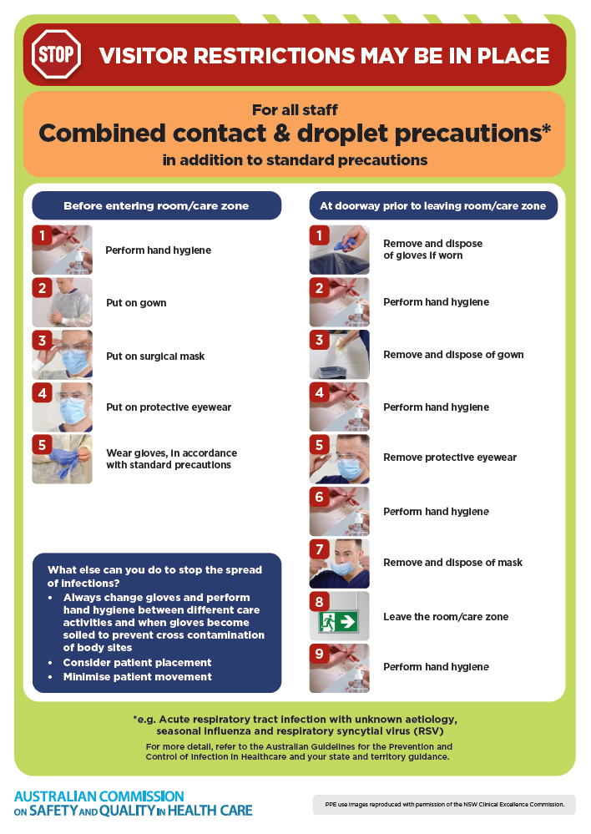
- Poster – Combined airborne and contact precautions
https://www.safetyandquality.gov.au/publications-and-resources/resource-library/infection-prevention-and-control-poster-combined-airborne-and-contact-precautions
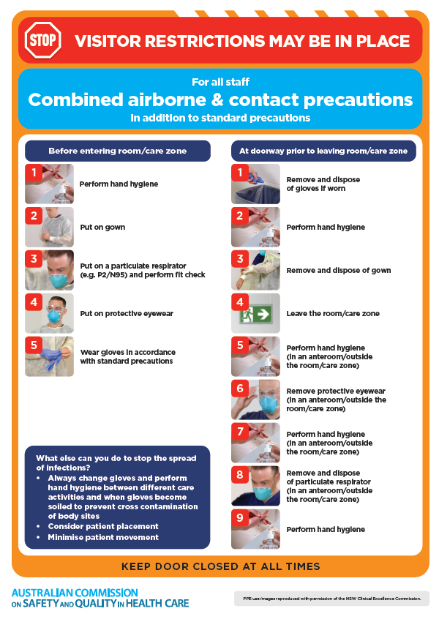
- Environmental Cleaning and Infection Prevention and Control www.safetyandquality.gov.au/environmental-cleaning
- Break the chain of infection poster
https://www.safetyandquality.gov.au/publications-and-resources/resource-library/break-chain-infection-poster
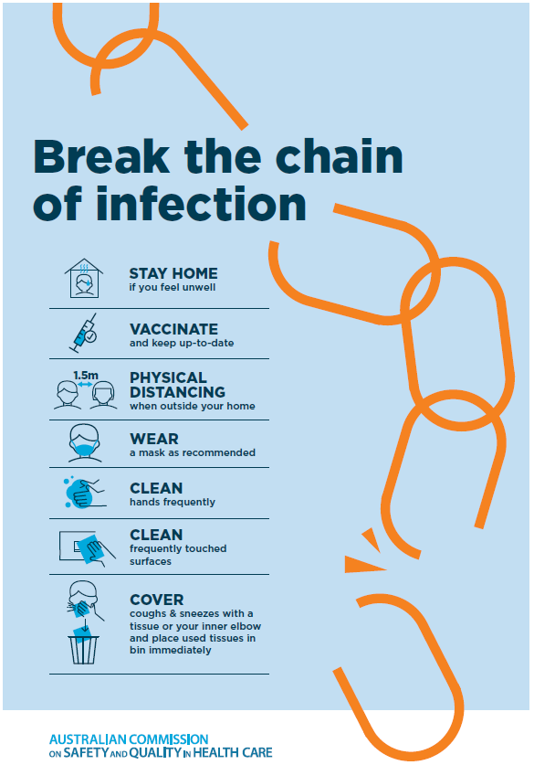

Disclaimer
On the Radar is an information resource of the Australian Commission on Safety and Quality in Health Care. The Commission is not responsible for the content of, nor does it endorse, any articles or sites listed. The Commission accepts no liability for the information or advice provided by these external links. Links are provided on the basis that users make their own decisions about the accuracy, currency and reliability of the information contained therein. Any opinions expressed are not necessarily those of the Australian Commission on Safety and Quality in Health Care.

