
On the Radar
Issue 688
10 March 2025

On the Radar is a summary of some of the recent publications in the areas of safety and quality in health care. Inclusion in this document is not an endorsement or recommendation of any publication or provider. Access to particular documents may depend on whether they are Open Access or not, and/or your individual or institutional access to subscription sites/services. Material that may require subscription is included as it is considered relevant.

On the Radar is available online, via email or as a PDF or Word document from https://www.safetyandquality.gov.au/newsroom/subscribe-news/radar

If you would like to receive On the Radar via email, you can subscribe on our website https://www.safetyandquality.gov.au/newsroom/subscribe-news
or by emailing us at HUmail@safetyandquality.gov.auU.
You can also send feedback and comments to HUmail@safetyandquality.gov.auU.

For information about the Commission and its programs and publications, please visit https://www.safetyandquality.gov.au

On the Radar
Editor: Dr Niall Johnson

Books

Learning Health Systems
Elements of Improving Quality and Safety in Healthcare.
Foley T, Horwitz LI
Cambridge: Cambridge University Press; 2025. p. 44.
DOI | https://dx.doi.org/10.1017/9781009325912
Notes | This volume is the latest release in the Elements of Improving Quality and Safety in Healthcare series from The Healthcare Improvement Studies Institute (the THIS Institute) in Cambridge. This volume looks at the concept of learning health systems. Common to the various approaches is ‘a learning cycle of capturing data from practice, turning it into knowledge, and putting knowledge back into practice’. Among the conclusions drawn, the authors observe:  ‘A learning health system is not another healthcare improvement method.  Instead, it is the development of systematic organisational capabilities that enable the routine deployment of multiple improvement methods.  …a learning health system depends on:  - developing a learning community who can champion the work and foster mutual learning  - explicitly recognising the influence of multiple sociotechnical domains and the crucial role played by institutional culture  - harnessing data effectively but cautiously, with attention to data quality and gaps  - embedding a variety of healthcare improvement and research techniques into routine care  - avoiding oversimplification while valuing complexity.  The complexity of healthcare organisations means that no two learning health systems will be the same.’

Reports

Health and care workforce planning tools: A rapid review
Human Resources for Health Observer Series No. 29
World Health Organization
Geneva: WHO; 2025.
URL | https://iris.who.int/handle/10665/380622
Notes | This document from the WHO reports on a review of nearly 100 health and care workforce (HCWF) planning tools and approaches. The review sought to inform the development of a HCWF planning toolkit. The report states that ‘analysis revealed that no single tool emerges as “ideal,”’ and that users ‘need to understand the strengths and limitations relevant to each tool to be able to identify the most appropriate HCWF planning tool, considering their context and requirements.’

Journal articles

Women who experience heavy menstrual bleeding: prevalence and characteristics from young adulthood to midlife, Australia, 2000–2021: a longitudinal cohort survey study
Wilson L, Copp T, Hickey M, Jenkinson B, Jordan SJ, Thompson R, et al.
Medical Journal of Australia. 2025;222(4):191-197.
DOI | https://doi.org/10.5694/mja2.52596
Notes | Paper reporting on a study that sought to ‘estimate the prevalence of heavy menstrual bleeding among Australian women from young adulthood to midlife (22–48 years) and investigate the characteristics of women who experience this condition’. In this longitudinal cohort survey study, it was reported that ‘The prevalence of sometimes or often experiencing heavy menstrual bleeding increased from 17.6% at age 22 years (124 of 691 respondents) to 32.1% at 48 years (359 of 1132 respondents); the proportion who reported often experiencing the condition increased from 6.1% (45 participants) to 12.1% (136 participants).’ The authors note that ‘Heavy menstrual bleeding was reported by large minorities of women of reproductive age, and the proportion increased with age. Many women experience symptoms that have a substantial impact on their physical and mental health-related quality of life.’

For information on the updated 2024 Heavy Menstrual Bleeding Clinical Care Standard and related resources, see https://www.safetyandquality.gov.au/standards/clinical-care-standards/heavy-menstrual-bleeding-clinical-care-standard

Social Media Posts About Medical Tests With Potential for Overdiagnosis
Nickel B, Moynihan R, Gram EG, Copp T, Taba M, Shih P, et al
JAMA Network Open. 2025;8(2):e2461940.
DOI | https://doi.org/10.1001/jamanetworkopen.2024.61940
Notes | A few years there was concern about the role of ‘Dr Google’. More recently, with the emergence of various social media platforms and the role of “influencers” concerns about the quality and accuracy of medical information have focused on these platforms. This paper reports on an Australian study that examined social media posts ‘that discussed full-body magnetic resonance imaging, the multicancer early detection test, and tests for antimullerian hormone, gut microbiome, and testosterone’. The study examined ‘982 posts from account holders with a combined 194 200 000 followers’ and found that ‘most posts were misleading or failed to mention important harms, including overdiagnosis or overuse.’

Failure to Rescue Female Patients Undergoing High-Risk Surgery
Wagner CM, Joynt Maddox KE, Ailawadi G, Ibrahim AM
JAMA Surgery. 2025;160(1):29-36.
DOI | https://doi.org/10.1001/jamasurg.2024.4574
Notes | Paper reporting on a study that sought to examine why female patients die more often than male patients after high-risk surgery. This US study was a retrospective cohort study of 863 305 Medicare beneficiaries undergoing high-risk vascular or cardiac surgical procedures in 2015 to 2020. The study found that while complication rates were similar, 30-day mortality and failure-to-rescue rates were higher for female patients. The authors observe that ‘Improving the recognition and management of female patients’ complications postoperatively may narrow the sex disparity after high-risk surgery.’

Patient Safety Events Among People from Ethnic Minority Backgrounds: A Retrospective Medical Record Review of Australian Cancer Services
Chauhan A, Joseph K, Chin M, Pitcher M, Wilson C, Manias E, et al
Journal of Racial and Ethnic Health Disparities. 2025.
DOI | https://doi.org/10.1007/s40615-025-02318-8
Notes | Paper reporting on a study examining ‘patient safety events occurring in cancer care among patients from ethnic minority background’. The study was a two-stage retrospective medical record review conducted at four cancer services in two Australian states in which 628 patient records were examined. The authors report finding:  - f the 628 patient records, 212 (33.75%) documented at least one safety event.  - A total of 410 safety events were documented in the 212 patient records.  - Medication-related safety events were most commonly documented (121/410, 29.5%), followed by clinical process/procedure-related safety events (76/410, 18.5%) and patient accidents (60/410, 14.6%).  - The occurrence of a safety event was associated with patient records that documented ‘no interpreter was required’.  The authors concluded ‘Unsafe cancer care for this population is associated with inadequate use of interpreters, lack of shared understanding and expectations of care processes linked to cultural and linguistic barriers.’
A future for the hospital-in-the-home (HITH) deteriorating patient: shifting the paradigm
Cubitt M, Lim S
Medical Journal of Australia. 2025;222(4):168-171.

Supporting older people through Hospital at Home care: a systematic review of patient, carer and healthcare professionals’ perspectives
Wong A, Cooper C, Evans CJ, Rawle MJ, Walters K, Conroy SP, et al
Age and Ageing. 2025;54(2):afaf033.

Comparison of hospitalisation settings and exercise interventions in acute care: a systematic review and meta-analysis
Etayo-Urtasun P, Sáez de Asteasu ML, Izquierdo M
Age and Ageing. 2025;54(2):afaf035.

Why is implementing remote monitoring in virtual wards (Hospital at Home) for people living with frailty so hard? Qualitative interview study
Lindsay RK, Cunnington P, Dixon-Woods M
Age and Ageing. 2025;54(1):afaf003.
DOI | Cubitt and Lim https://doi.org/10.5694/mja2.52588  Wong et al https://doi.org/10.1093/ageing/afaf033  Etayo-Urtasun et al https://doi.org/10.1093/ageing/afaf035  Lindsay et al https://doi.org/10.1093/ageing/afaf003
Notes | A number of articles looking at aspect of Hospital-in-the-home (HITH) or Hospital at Home (HaH) approaches.  Cubitt and Lim examine the challenge of recognising and responding to clinical deterioration in patients in HITH models of care. It is observed that ‘Safely upscaling HITH models of care requires integration of 24/7 HITH-suitable systems to manage deteriorating patients. Accountability to these systems will mitigate the risk of unintended burden on patients, caregivers, clinicians and existing services, such as ambulance and emergency departments.’  Wong et al offer a systematic review of the literature on UK patient, carer and healthcare professionals’ perspectives on these models of care. Focused on 20 studies, the authors report the studies ‘were largely positive’ and identified ‘benefits including home familiarity, enabling person-centred care and shared decision-making and provision of family carer support’. The challenges identified ‘included staff accessibility, patient and carer anxieties regarding the safety of virtual wards, coordination across sectors and older people using technology.’  Etayo-Urtasun et al sought to compare inpatient hospitalisation and HAH in terms of functional outcomes and the efficacy of exercise interventions. The authors report that ‘Findings suggest that HaH may positively affect functional and cognitive outcomes. Inpatient exercise interventions significantly improved physical performance… and functional independence …at discharge.’  Lindsay et al examined the challenges in implementing remote monitoring for people living with frailty. From their qualitative study with 42 stakeholders in the UK, the authors found that ‘Implementing remote monitoring in frailty virtual wards is challenged by lack of consensus on its suitability for this population, the extent and nature of change in clinical practices and work systems design required, and issues relating to equipment and standardisation. More co-design effort is needed to inform decision-making on remote monitoring for those with frailty.’

Care home quality and ‘inappropriate’ emergency healthcare use—failing to engage with complexity
Harrad-Hyde F, Burton JK
Age and Ageing. 2025;54(2):afaf030.
DOI | https://doi.org/10.1093/ageing/afaf030
Notes | Paper examining the use of emergency care by care home residents. The authors examine the framing of some of this as being inappropriate or avoidable. They suggest that there be a greater appreciation of ‘the complexity involved in providing healthcare support to people living in care homes’.

What makes health systems resilient? An analytical framework drawing on European learnings from the COVID-19 pandemic based on a multitiered approach
Reiss M, Kraus M, Riedel M, Czypionka T
BMJ Public Health. 2024;2(1):e000378.
DOI | https://doi.org/10.1136/bmjph-2023-000378
Notes | Paper reporting on a study that sought to ‘develop a comprehensive analytical framework on health system resilience in the context of pandemics’. From the ‘multitiered’ approach the authors have proposed an analytical framework that has a structural dimension distinguishing between prerequisites focussing on capacities and structures and response strategies for times of crisis. These dimensions are ‘divided into six building blocks that were adapted from the WHO health system framework: governance and leadership, information and research, financing, physical resources, human resources, and service delivery.’  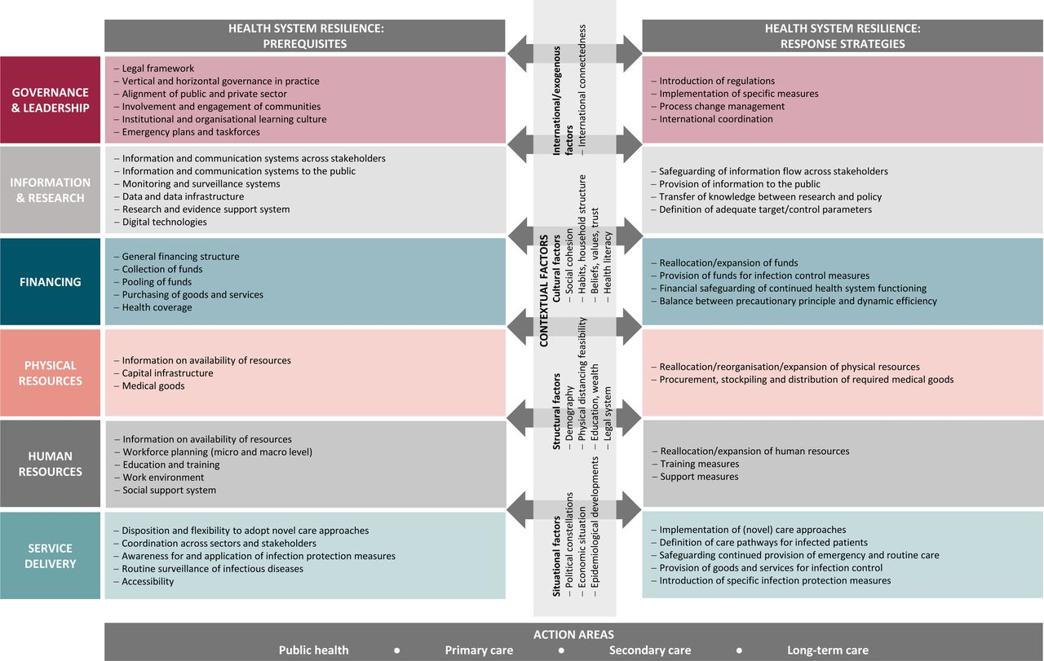

Journal of Health Services Research & Policy
Volume 30, Number 2, April 2025
URL | https://journals.sagepub.com/toc/hsrb/30/2
Notes | A new issue of the Journal of Health Services Research & Policy has been published. Articles in this issue of the Journal of Health Services Research & Policy include:  - Editorial: Moral distress: A structural problem with individual solutions (Monica L Molinaro)  - Engagement in child psychiatry department appointments: An analysis of electronic medical records in one safety-net hospital in New England, USA (Yesenia Aguilar Silvan, Lisa R Fortuna, Andrea E Spencer, and Lauren C Ng)  - Organizing to address overtreatment in cancer care near the end of life: Evidence from Denmark (Amalie M Hauge, Nis Lydiksen, and Mickael Bech)  - The role of collaborative governance in translating national cancer programs into network-based practices: A longitudinal case study in Canada (Dominique Tremblay, Susan Usher, Karine Bilodeau, and Nassera Touati)  - Health care providers’ perceptions of burnout and moral distress during the COVID-19 pandemic: A qualitative study from Saskatchewan, Canada (Jacob Albin Korem Alhassan, Noelle Rohatinsky, Taylor Peru, Carmen Levandoski, D Kendel, J Dmytrowich, T Lafontaine, M Cardinal, and J N Peña-Sánchez)  - Voluntary self-disclosed Indigenous identity of patients in four Canadian health care settings: A multiple-site qualitative case study (Mandi Gray, Samara Wessel, Richard T Oster, Grant Bruno, Chyloe Healy, Rebecca Rich, Shayla Scott Claringbold, Kienan Williams, and Rita Henderson)  - Care homes and primary care in England working together: A multi-method qualitative study (Krystal Warmoth, Alex Aylward, and Claire Goodman)  - Collaborative and integrated working between general practice and community pharmacies: A realist review of what works, for whom, and in which contexts (Emily Owen-Boukra, Ziyue Cai, Claire Duddy, Nina Fudge, Julia Hamer-Hunt, Fran Husson, Kamal R Mahtani, Margaret Ogden, Deborah Swinglehurst, Malcolm Turner, C Whittlesea, G Wong, and S Park)

Health Affairs
Volume 44, Number 3, March 2025
URL | https://www.healthaffairs.org/toc/hlthaff/44/3
Notes | A new issue of Health Affairs has been published with a theme of ‘Pharmaceuticals, Private Equity, Child Health & more’. Articles in this issue of Health Affairs include:  - Demographic Variation In US Outpatient Hydroxychloroquine And Ivermectin Use During The COVID-19 Pandemic (Michelle S Rockwell, Sitaram Vangala, Michael Hadfield, Jonathan Cantor, Dale Skinner, Melody Craff, A Mark Fendrick, Cheryl L Damberg, Katherine Kahn, and N Mafi)  - Estimated Savings From Extending Prescription Drug Inflationary Rebates To All Commercial Plans (Marissa B Reitsma, Stacie B Dusetzina, Jeromie M Ballreich, Antonio J Trujillo, and Michelle M Mello)  - First-In-Class Drugs Experienced Different Regulatory Treatment In The US And Europe (Jihye Han and Aaron S Kesselheim)  - Changes In Biologic Drug Revenues After Administrative Patent Challenges (Adam J N Raymakers, Victor L Van de Wiele, A S Kesselheim, and S S Tu)  - Physician Turnover Increased In Private Equity–Acquired Physician Practices (Yashaswini Singh, Geronimo Bejarano Cardenas, Hamid Torabzadeh, Durga Borkar, and Christopher M Whaley)  - Continuous Eligibility Policies And CHIP Structure Affected Children’s Coverage Loss During Medicaid Unwinding (Erica Eliason, Daniel Nelson, and Aditi Vasan)  - When The Color Line Meets The Borderline: Health Insurance Coverage Among Black Immigrant Adults In The US (E Nwankwo and M Pastor)  - Growth Of Chronic Condition Special Needs Plans Among Dual-Eligible Beneficiaries, 2011–24 (Rebekah I Stein, Yanlei Ma, Jessica Phelan, Eric T Roberts, Kenton J Johnston, E John Orav, and José F Figueroa)  - Dialysis Facility Participation In Medicare Advantage Networks Was Highest For Large Dialysis Organizations In 2021 (Eunhae Grace Oh, Joan F Brazier, Emily A Gadbois, Denise A Tyler, Laura M Keohane, David J Meyers, Momotazur Rahman, Kevin H Nguyen, and Amal N Trivedi)  - Socioeconomically Disadvantaged Groups May Have Underused The Emergency Department For Nonavoidable Visits, 2018–22 (Richard K Leuchter, Melody Craff, Sitaram Vangala, Chi-Hong Tseng, Julia Cave Arbanas, Cyrus Tabatabai-Yazdi, Michael Hadfield, Dale Skinner, Cheryl L Damberg, Catherine A Sarkisian, John N Mafi, and Katherine L Kahn)  - Asian American, Native Hawaiian, And Pacific Islander Population Group Representation In The US Health Workforce (Emmeline Ha, Finn Dobkin, Maria Portela Martinez, Jordan Herring, and Edward Salsberg)  - The Indian Health Service Is Associated With Higher-Quality Perinatal Care For American Indian And Alaska Native People (Julia D Interrante, Jessica L Liddell, E C Sheffield, H A Baker, D Gartner, and K Backes Kozhimannil)  - Arkansas Medical Marijuana Certifications: Higher-Volume Physicians Associated With Less Evidence Of Care Coordination (Joseph W Thompson, Brad Martin, Anthony Goudie, Nichole Stanley, K Noori, and T Hudson)  - Association Between Telehealth Initiation Of Stimulant Therapy And New Substance Use Disorder Diagnoses (Joanne Constantin, Sean Esteban McCabe, Emily Pasman, Timothy Wilens, and Kao-Ping Chua)  - A Stronger Safety Net For The Nation’s Workforce (Kumara Raja Sundar)

Health Policy
Volume 153, March 2025
URL | https://www.sciencedirect.com/journal/health-policy/vol/153
Notes | A new issue of Health Policy has been published. Articles in this issue of Health Policy include:  - The development of a discrete choice experiment: Investigating pharmacy selection in New Zealand (James Nind, Carlo A. Marra, Shane Scahill, Damien Mather, Alesha Smith)  - Health care provider payment schemes and their changes since 2010 across nine Central and Eastern European countries – a comparative analysis (Costase Ndayishimiye, Marzena Tambor, Daiga Behmane, Antoniya Dimova, ... Katarzyna Dubas-Jakóbczyk)  - How and why do health system factors influence general dentists’ participation in publicly funded, contracted primary dental care services: A realist review (Paul Leavy, Sophie Mulcahy Symmons, David Mockler, Pádraic Fleming, ... Sara Burke)  - Classifying the WHO European countries by noncommunicable diseases and risk factors (Tevfik Bulut)  - Regulatory approaches towards AI Medical Devices: A comparative study of the United States, the European Union and China (Daolu Tang, Xuezhi Xi, Yong Li, Meiling Hu)  - Inequality in COVID-19 vaccine acceptance and uptake: A repeated cross-sectional analysis of COVID vaccine acceptance and uptake in 13 countries (Zachary DV Abel, Laurence SJ Roope, Raymond Duch, S Cole, P M Clarke)  - Understanding private equity-owned HHAs in the U.S.: A performance comparison between pe-owned and non-pe-owned agencies (Mohammad Ishtiaque Rahman)

Health Policy
Volume 154, April 2025
URL | https://www.sciencedirect.com/journal/health-policy/vol/154
Notes | A new issue of Health Policy has been published. Articles in this issue of Health Policy include:  - Needs of non-pharmacological management versus sedation or general anesthesia for dental treatment in older adults with special needs: A systematic review (Kamheang Vacharaksa, Ticha Thongrakard, A Vacharaksa)  - Public versus private access in the Italian NHS - The use of propensity score matching to provide more insight on the increasing adoption of voluntary health insurance (Elenka Brenna)  - Avoidable visits to UK emergency departments from the patient perspective: A recursive bivariate probit approach (Chiara Calastri, John Buckell, Romain Crastes dit Sourd)  - Determinants and associated costs of unmet healthcare need and their association with resource allocation. Insights from Finland (Lien Nguyen, Unto Häkkinen)  - Immigrants’ self-perceived barriers to healthcare: A systematic review of quantitative evidence in European countries (Chiara Allegri, Elisa Barbiano di Belgiojoso, Stefania Maria Lorenza Rimoldi)  - The 2017 reform to medical specialty training in Czechia: Exploring student career preferences (Lenka Šlegerová, Lucie Bryndová, Petr Michenka, M Kočí)  - Unveiling patterns and drivers of immigrant health integration policies: A model-based cluster and panel data analysis in MIPEX countries (C Chow)  - Health economic evaluation evidence of interventions for peripartum depression: A scoping review (Gülcan Tecirli, Mehtap Çakmak Barsbay, Greg Sheaf, Nurettin Öner, ... Annette Bauer)

BMJ Quality & Safety online first articles
URL | https://qualitysafety.bmj.com/content/early/recent
Notes | BMJ Quality &Safety has published a number of ‘online first’ articles, including:  - Association of volume and prehospital paediatric care quality in emergency medical services: retrospective analysis of a national sample (Sriram Ramgopal, Caleb E Ward, Rebecca E Cash, Christian Martin-Gill, Kenneth A Michelson)  - Editorial: Using data science to improve patient care: rethinking clinician responsibility (Irene Grossmann, Perla J Marang-van de Mheen)  - The problem with the existing reporting standards for adverse event and medical error research (Christopher R Carpenter, Richard T. Griffey, Anne W S Rutjes, Maria Unbeck, Lee M Adler, David C Stockwell, David Classen SESAME Statement Development Team)  - Psycholinguistic tests predict real-world drug name confusion error rates: a cross-sectional experimental study (Bruce L Lambert, Scott Ryan Schroeder, William L. Galanter, Gordon D. Schiff, Allen J Vaida, Michael J Gaunt, Michelle Bryson Opfermann, Christine Rash Foanio, Suzanne Falck, N Mirea)  - Impact of hospitals’ LGBTQ+ inclusion efforts on patient satisfaction from 2016 to 2023: a retrospective longitudinal observational study (Hyunmin Yu, Matthew D McHugh, José A Bauermeister, Tari Hanneman, H Brom)

International Journal for Quality in Health Care online first articles
URL | https://academic.oup.com/intqhc/advance-articles
Notes | International Journal for Quality in Health Care has published a number of ‘online first’ articles, including:  - Determinants of quality in the independent and public hospital sectors in England (Harriet Bullen, Vasudha Wattal, Rachel Meacock, Matt Sutton)  - Look-Alike, Sound-Alike Medication Perioperative Incidents in a Regional Australian Hospital: Assessment using a Novel Medication Safety Culture Assessment Tool (A N Ryan, K L Robertson, B D Glass)

Online resources

Australian Living Evidence Collaboration
https://livingevidence.org.au/

Residential Aged Care Communiqué
https://www.thecommuniques.com/post/residential-aged-care-communiqu%C3%A9-volume-20-issue-1-february-2025
Volume 20, Issue 1, February 2025
This issue of Residential Aged Care Communiqué examines how workforce issues impact resident safety and quality of care through three separate cases.

Guidance
A number of guidelines or guidance have recently been published or updated. These include:
- National consensus statement on opioid agonist treatment in custodial settings https://doi.org/10.5694/mja2.52603

USA] Effective Health Care Program reports
https://effectivehealthcare.ahrq.gov/
The US Agency for Healthcare Research and Quality (AHRQ) has an Effective Health Care (EHC) Program The EHC has released the following final reports and updates:
- Mental Health and Occupational Stress in the Emergency Medical Services and 911 Workforces https://effectivehealthcare.ahrq.gov/products/ems-911-workforce-mental-health/research
- Association of Digestible Carbohydrate Intake With Cardiovascular Disease, Type 2 Diabetes, Obesity, and Body Composition https://effectivehealthcare.ahrq.gov/products/effect-dietary-digestible/research

Infection prevention and control and COVID-19 resources
The Australian Commission on Safety and Quality in Health Care has developed a number of resources to assist healthcare organisations, facilities and clinicians. These resources include:
- Poster – Combined contact and droplet precautions https://www.safetyandquality.gov.au/publications-and-resources/resource-library/infection-prevention-and-control-poster-combined-contact-and-droplet-precautions
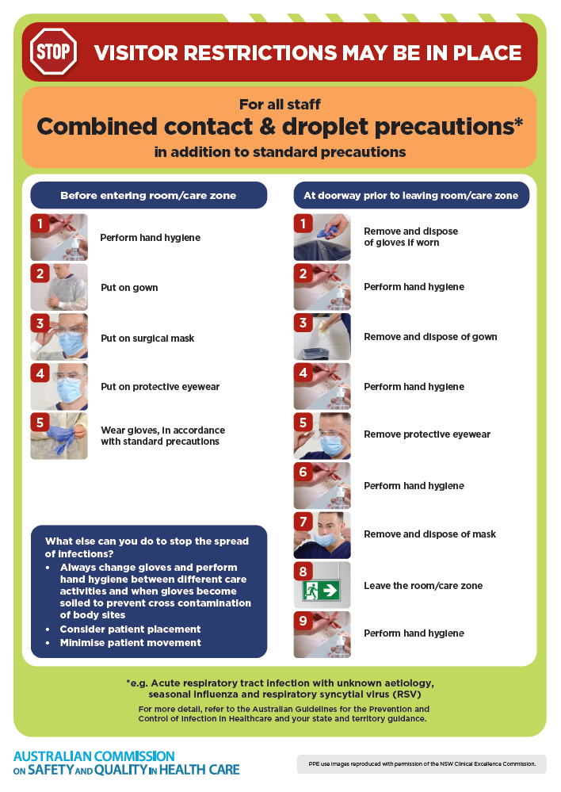
- Poster – Combined airborne and contact precautions
https://www.safetyandquality.gov.au/publications-and-resources/resource-library/infection-prevention-and-control-poster-combined-airborne-and-contact-precautions
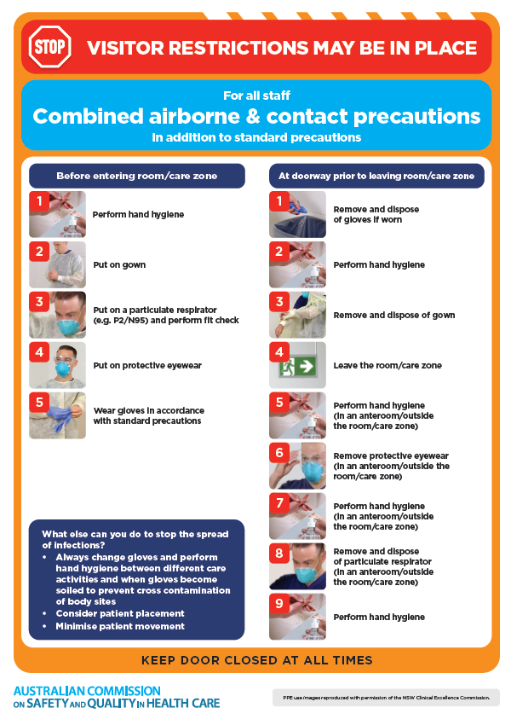
- Environmental Cleaning and Infection Prevention and Control www.safetyandquality.gov.au/environmental-cleaning
- Break the chain of infection poster
https://www.safetyandquality.gov.au/publications-and-resources/resource-library/break-chain-infection-poster
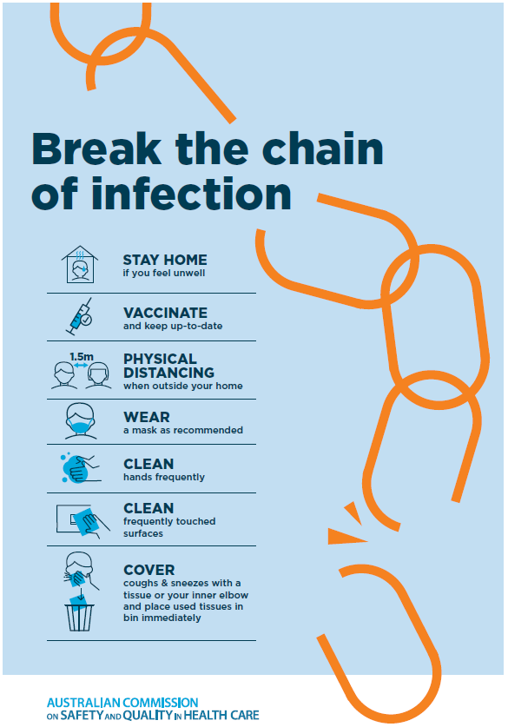

Disclaimer
On the Radar is an information resource of the Australian Commission on Safety and Quality in Health Care. The Commission is not responsible for the content of, nor does it endorse, any articles or sites listed. The Commission accepts no liability for the information or advice provided by these external links. Links are provided on the basis that users make their own decisions about the accuracy, currency and reliability of the information contained therein. Any opinions expressed are not necessarily those of the Australian Commission on Safety and Quality in Health Care.

