
On the Radar
Issue 691
31 March 2025

On the Radar is a summary of some of the recent publications in the areas of safety and quality in health care. Inclusion in this document is not an endorsement or recommendation of any publication or provider. Access to particular documents may depend on whether they are Open Access or not, and/or your individual or institutional access to subscription sites/services. Material that may require subscription is included as it is considered relevant.

On the Radar is available online, via email or as a PDF or Word document from https://www.safetyandquality.gov.au/newsroom/subscribe-news/radar

If you would like to receive On the Radar via email, you can subscribe on our website https://www.safetyandquality.gov.au/newsroom/subscribe-news
or by emailing us at HUmail@safetyandquality.gov.auU.
You can also send feedback and comments to HUmail@safetyandquality.gov.auU.

For information about the Commission and its programs and publications, please visit https://www.safetyandquality.gov.au

On the Radar
Editor: Dr Niall Johnson
Contributors: Niall Johnson

Reports

Delivering tangible population-based outcomes via an alliance model: South West Primary Health Care Alliance Queensland
Evidence Brief no: 25
Nicholson C, Jackson C, Gillies S, Brown A
Canberra: Deeble Institute for Health Policy, Australian Healthcare and Hospitals Association; 2025. p. 18.
URL | https://ahha.asn.au/resource/delivering-tangible-population-based-outcomes-via-an-alliance-model-south-west-primary-health-care-alliance-queensland/
Notes | This evidence brief from the Australian Healthcare and Hospitals Association’s Deeble Institute for Health Policy examines how an alliance governance model can influence changes in the delivery of primary care. The brief’s authors note ‘This model, involving contractual and relational mechanisms, brings local stakeholders within a given geographical area together to collectively address and govern health care design and delivery relevant to a specific shared problem’. Looking at a number of examples, with a focus on the South West Primary Health Care Alliance in Queensland, the brief’s authors suggest that alliance governance is a model that can provide for a ‘better integrated health care platform for Australian communities.’  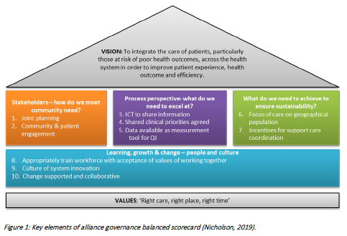

How Do Health System Features Influence Health System Performance?
OECD, The Health Foundation
Paris: OECD Publishing; 2025. p. 84.
DOI | https://doi.org/10.1787/7b877762-en
Notes | This report from the OECD (along with The Health Foundation from the UK), sought to compare national approaches to health systems. The analysis clustered similar approaches so as to allow ‘valid and useful comparisons’. Three areas were of particular focus: the influence of the overall design of health systems on performance, the role of financial incentives to providers and the role of a strong primary care system. Among the observations:  - ‘health systems providing a higher degree of incentives for quality to providers may also achieve better access to high-quality care’  - ‘primary care oriented health systems – defined by a stronger role of General Practitioners (GPs) as gatekeepers, better care continuity and stronger financial incentives directed to primary care physicians to improve quality – also display lower avoidable hospitalisations, a variable often used in the relevant literature as a marker of quality and access to primary care.’  The report notes that:  ‘The analysis confirms the results of previous OECD work suggesting that there is no single health system design that is most associated with higher efficiency. In other words, there is no indication that any one group of health systems would systematically outperform another.  The analysis suggests that there is room for health systems sharing the same broad characteristics to improve performance by adopting policy actions to improved efficiency that might borrow elements from other systems. Rather than engaging in wholesale reforms, improving health system efficiency requires the use of more targeted policies to respond to a specific policy question.’

Journal articles

The Joint Commission Journal on Quality and Patient Safety
Volume 51, Issue 4, April 2025
URL | https://www.sciencedirect.com/journal/the-joint-commission-journal-on-quality-and-patient-safety/vol/51/issue/4
Notes | A new issue of The Joint Commission Journal on Quality and Patient Safety has been published. Articles in this issue of The Joint Commission Journal on Quality and Patient Safety include:  - Editorial: Leveraging Approaches and Tools of Implementation Science and Configurational Comparative Methods in Quality Improvement (Gabrielle Matias, Nandita R Nadig, Reiping Huang)  - Using Implementation Science-Informed Strategies to Improve Transitions of Care for Patients with Venous Thromboembolism (Elizabeth L Ciemins, Cori C Grant, Meghana Tallam, Cori Rattelman, Curt Lindberg, Rae Ann Williams, Paige S Christensen, N Marcus Thygeson)  - Improving Time to Diagnosis and Management of Pediatric Patients with Acute Neurologic Dysfunction (Sandra P Spencer, Nathaniel H Forman, Melissa G Chung, Terri Dachenhaus, Annie I Drapeau, Christopher Gerity, Rodrigo Iglesias, Jeremy Y Jones, Marlina E Lovett, Julie C Leonard)  - Voices of Frontline Leaders: Challenges and Opportunities from Frontline Primary Care Clinic Leaders in a Safety-Net Health Care System (Jessica Wallace, Read Pierce, Thomas JStaff, Rebecca Allyn)  - Patient and Family Engagement in Infection Prevention During the COVID-19 Pandemic: A Q-Methodology Study with Stakeholders from a Canadian University Health Care Center (Nathalie Clavel, Jesseca Paquette, Anaïck Briand, Alain Biron, L Bernard, C Gélinas, M Lavoie-Tremblay)  - Complying with Joint Commission Health Equity Requirements: Medical-Legal Partnership Data and Health-Related Social Needs (Ashley B Tartarilla, Leah Porter, James J Horgan, Phillip D Hahn, Grace Drost, Dionne A Graham, Michele M Garvin, Valerie L Ward)  - Increasing Utilization of an In-Home Remote Exam Device in a Complex Care Center (Marie Pfarr, Scott Callahan, Calise Curry, Karen Jerardi, Kathleen Pulda, Michelle Rummel, D Smith-Sokol, J Stalf, J Thomson, H Sauers-Ford)  - Safety Interventions in Cardiac Anesthesia: A Systematic Review (Lauren O'Callaghan, Shane Ahern, Andrea Doyle)  - Training Hospital Nurses to Write Detailed Narratives and Describe Contributing Factors in Incident Reports: The SAFER Education Program (Tara N Cohen, Teryl K Nuckols, Carl T Berdahl, Edward G Seferian, Sara G McCleskey, Andrew J Henreid, Donna W Leang, M A Lupera, B L Coleman)

American Journal of Medical Quality
Volume 40, Issue 2, March/April 2025
URL | https://journals.lww.com/ajmqonline/toc/2025/03000
Notes | A new issue of the American Journal of Medical Quality has been published. Articles in this issue of the American Journal of Medical Quality include:  - From Data to Improvement: Social Mechanisms as a Key to Understanding Dashboard Adoption (Broughton, Tamara; Weggelaar-Jansen, Anne Marie; Sülz, Sandra)  - Lack of Standardized Coding Limits Accuracy of Electronic Clinical Quality Measure for Pulmonary Embolism Diagnosis (Baumann Kreuziger, Lisa; Keenan, Megan; Dykhoff, Hayley; Hall, Marie; Campbell, Kyle; Cahill, Emily; Hanson, Ryan; McEvoy, D; He, W; Dutta, S; Rosovsky, R P; Houghton, D E)  - Complications of Ambulatory Procedures: Prevalence and Hospital Outpatient Department Variation (Fuller, Richard L.; Hughes, John S.; Young, Samuel D.; Fogerty, Robert; Wadhwa, S; Casey, D; Patterson, M; Chen, Y)  - A Checklist to Improve Acute Stroke Evaluation and Treatment in the Emergency Department (Elam, Meagan; Moyal-Smith, Rachel; Canfora, Madison; Cohen, Wendy; Eum, Ki-Do; Fischer, Christopher; Margo, Judy; McCune, Marie; Moin, Omer; Selim, Magdy; Wendell, Linda; Kumar, Sandeep)  - Promoting a Culture of Civility in High-Reliability Organizations (Murray, John S.; Campbell, Jeannine; Larson, Stacey)  - Six-Year Retrospective Look at the Effects of Institutional Quality Improvement Efforts to Reduce CAUTIs (Kim, Jeong Min; Aboshihata, Heba; Moldowsky, Lee; DiGiovanni, Stephanie)  - Implementation of a Trauma Zone Improves Disposition Times for Patients With Intracerebral Hemorrhage or Hip Fracture (Oshoe, Tenzin; Billig, Adam; Vekaria, Darshak; Li, Jia Jian; Thode, Henry; Heslin, Samita M)  - Team-Based Painting and Learning Approach to Recognizing Topical Ophthalmic Drops (Al-Bahrani, Zuhair; Ponce, Meryl; Teixeira, Elizabeth; Ghiaee, Shayan; Papanagnou, Dimitri; Lloyd, Maureen; Zhang, Xiao Chi)

Public Health Research and Practice
URL | https://www.publish.csiro.au/pu
Notes | Public Health Research & Practice has moved to a continuous publication model.  Recent articles in Public Health Research & Practice include:  - Misread signals: a misinterpretation of population-level vaping and smoking trends (Sam Egger, Michael David, Marianne Weber, Qingwei Luo and Becky Freeman  - Artificial intelligence and public health: prospects, hype and challenges (Don Nutbeam and Andrew J Milat)  - NSW Public Health Training Program: 35 years of strengthening public health systems and practice in an Australian setting (Dawn Arneman, Ashleigh A Armanasco and Andrew J Milat)  - Illuminating a dark field: a case of congenital syphilis in the context of rising rates in Australia and implications for screening guidelines (James M Montgomery, Amanda Robinson and Archana Koirala)  - Planetary health: increasingly embraced but not yet fully realised (Angie Bone, Francis Nona, Selina Namchee Lo and Anthony Capon)  - Estimates of the eligible population for Australia’s targeted National Lung Cancer Screening Program, 2025–2030 (Stephen Wade, Preston Ngo, Yue He, Michael Caruana, Julia Steinberg, Qingwei Luo, Michael David, Annette McWilliams, Kwun M Fong, Karen Canfell and Marianne F Weber)  - Skin checks for potential skin cancers in general practice in Victoria, Australia: the upfront and downstream patterns and costs (David E Goldsbury, Damien McCarthy, Caroline G Watts, Chi So, Olivia Wawryk, Chris Kearney, Gillian Reyes-Marcelino, Kirstie McLoughlin, Jon Emery and Anne E Cust)

BMJ Leader
Volume 9, Issue 1, March 2025
URL | https://bmjleader.bmj.com/content/9/1
Notes | A new issue of BMJ Leader has been published. Articles in this issue of BMJ Leader include:  - Leading across healthcare silos: why relational leadership matters? (Rachel Hawley, Tony Wall)  - Medical education needs a new model for global leadership (Mohammed Ahmed Rashid, Thirusha Naidu)  - Power of saying ‘I Don’t Know’: psychological safety and participatory strategies for healthcare leaders (David Francis Hunt)  - How the ‘Health Leader-as-Coach’ benefits health leaders, their teams, peers, organisation and the system (Fiona Jane Day)  - Well-being in newly qualified doctors: exploring the value of peer-led reflective sessions (Christen Van Den Berghe, Yvette Jaffe, Emily Lachmann, Zahra Ladan, Amber Buckland, S Laurent, S Needleman, S Shanmugalingam)  - Content analysis of succession planning in nursing management: a qualitative study (Mansoureh Ashghali-Farahani, Tahmine Salehi, M Mirzaee)  - Span of control and well-being outcomes among hospital frontline managers: too much to handle? (Ane-Kathrine Lundberg Hansen, Christian Bøtcher Jacobsen, Vita Ligaya Dalgaard)  - Participation in staff engagement campaigns at large healthcare organisations: a focus group study (Richard James, Jenny Lewis, Laura Stroud)  - Return to practice for allied health professionals with protected characteristics: a mixed-methods study (Anita Atwal, Vimal Sriram, Jos Brice)  - Kindness in healthcare leadership and management: an evaluation and analysis of the concept (Rebecca Dyar, Karen Mattick, Andrew Griffiths)  - Countercyclical approach to enhancing health and well-being in healthcare systems: strategies for economic resilience and sustainable care (Benjamin Laker, Natalia Weisz, Roberto Vassolo)  - Paradox of navigating uncertainty: ancient ‘soft stuff’ makes us tough (James K Stoller, Alan Kolp, Andy Walshe, Peter Rea)  - Making the invisible visible: why menopause is a workplace issue we cannot ignore (Benjamin Laker, Tatiana Rowson)  - Global perspectives on governing healthcare AI: prioritising safety, equity and collaboration (Ghasem Dolatkhah Laein)  - Emotionally intelligent themes in medical leaders’ decision-making during COVID-19 (Bobbie Ann Adair White, Heather Valenova Dayag, Erin S Barry, Joann Farrell Quinn)  - Future-ready healthcare leadership: the revised International Hospital Federation competency model (Sylvia Basterrechea, Jan C Frich, A N Garman)  - Digital innovative healthcare during a pandemic and beyond: a showcase of the large-scale and integrated Saudi smart national health command centre (Muaddi F Alharbi, Mohammmed Senitan, Dalia Mominkhan, Sidney Smith, Maram ALOtaibi, Michal Siwek, Tim Ohanlon, Fahad Alqablan, Sarah Alqahtani, Mohammed K Alabdulaali)

BMJ Quality & Safety online first articles
URL | https://qualitysafety.bmj.com/content/early/recent
Notes | BMJ Quality &Safety has published a number of ‘online first’ articles, including:  - Measuring guideline concordance via electronic health records: a new model for estimating concordance scores (Stephanie C C van der Lubbe, Lay Hoon Goh, Evangelos Kontopantelis, Wilson WS Tam, Jose M Valderas)  - Editorial: Diagnostic delay: lessons learnt from marginalised voices (Farah Acher Kaiksow)  - Editorial: Quality improvement collaborative to increase access to caesarean sections: lessons from Bihar, India (Nobhojit Roy, Asad Latif)  - Selecting and tailoring implementation strategies for deimplementing fall prevention alarms in US hospitals: a group concept mapping study (Kea Turner, Mona Al Taweel, Carrie Petrucci, Scott Rosas, Catima Potter, Emily Cramer, Ronald I. Shorr, Lorraine C Mion, Molly McNett)  - False hope of a single generalisable AI sepsis prediction model: bias and proposed mitigation strategies for improving performance based on a retrospective multisite cohort study (Rudolf Schnetler, Anton van der Vegt, Vikrant R Kalke, Paul Lane, Ian Scott)  - Under-reporting of falls in hospitals: a multisite study in South Korea (Insook Cho, Joon-myoung Kwon, Whasuk Choe, Jiseon Cho, Sook Hyun Park, David W Bates)

Online resources

Australian Living Evidence Collaboration
https://livingevidence.org.au/

[UK] NIHR Evidence
https://evidence.nihr.ac.uk/
The UK’s National Institute for Health Research (NIHR) has posted new evidence alerts on its site. Evidence alerts are short, accessible summaries of health and care research which is funded or supported by NIHR. This is research which could influence practice and each Alert has a message for people commissioning, providing or receiving care. The latest alerts https://evidence.nihr.ac.uk/browse-content/?_sft_articletype=alert include:
- Which drugs are best for migraine attacks?
- Population-level policies on risk factors for dementia could reduce NHS costs
- COVID-19 vaccine during pregnancy reduces risks to mother and baby
- Vaping is linked with breathing issues in young people
- Culturally-adapted therapy improved postnatal depression in British South Asian women

The NIHR has also collated these evidence collections:
- Hospital at home and virtual wards: What works? https://evidence.nihr.ac.uk/collection/hospital-at-home-and-virtual-wards-what-works/
- Prostate cancer research: what’s next? https://doi.org/10.3310/nihrevidence_66163
- Adult social care: how to improve support for people at risk through homelessness, learning disabilities or dementia https://doi.org/10.3310/nihrevidence_66104

[USA] AHRQ Perspectives on Safety
https://psnet.ahrq.gov/psnet-collection/perspectives
The US Agency for Healthcare Research and Quality (AHRQ) publishes occasional Perspectives on Safety essays. Recent essays include:
- Suicide Prevention – discusses the role that healthcare providers and organizations can play in suicide prevention, including identifying suicide risk in patients and responding effectively https://psnet.ahrq.gov/perspective/suicide-prevention

[USA] Patient Safety Primers
https://psnet.ahrq.gov/primers-0
The Patient Safety Primers from the (US) Agency for Healthcare Research and Quality (AHRQ) discuss key concepts in patient safety. Each primer defines a topic, offers background information on its epidemiology and context, and provides links to relevant materials. Recent additions and updates include:
- Clinical Decision Support Systems https://psnet.ahrq.gov/primer/clinical-decision-support-systems
- Individual Clinician Performance Issues https://psnet.ahrq.gov/primer/individual-clinician-performance-issues
- Triggers and Trigger Tools https://psnet.ahrq.gov/primer/triggers-and-trigger-tools
- Radiation Safety https://psnet.ahrq.gov/primer/radiation-safety
- Second Victims: Support for Clinicians Involved in Errors and Adverse Events https://psnet.ahrq.gov/primer/second-victims-support-clinicians-involved-errors-and-adverse-events
- Communication Between Clinicians https://psnet.ahrq.gov/primer/communication-between-clinicians
- Patient Engagement and Safety https://psnet.ahrq.gov/primer/patient-engagement-and-safety
- Ambulatory Care Safety https://psnet.ahrq.gov/primer/ambulatory-care-safety
- Disruptive and Unprofessional Behavior https://psnet.ahrq.gov/primer/disruptive-and-unprofessional-behavior
- Reporting Patient Safety Events https://psnet.ahrq.gov/primer/reporting-patient-safety-events
- Computerized Provider Order Entry https://psnet.ahrq.gov/primer/computerized-provider-order-entry

Infection prevention and control and COVID-19 resources
The Australian Commission on Safety and Quality in Health Care has developed a number of resources to assist healthcare organisations, facilities and clinicians. These resources include:
- Poster – Combined contact and droplet precautions https://www.safetyandquality.gov.au/publications-and-resources/resource-library/infection-prevention-and-control-poster-combined-contact-and-droplet-precautions
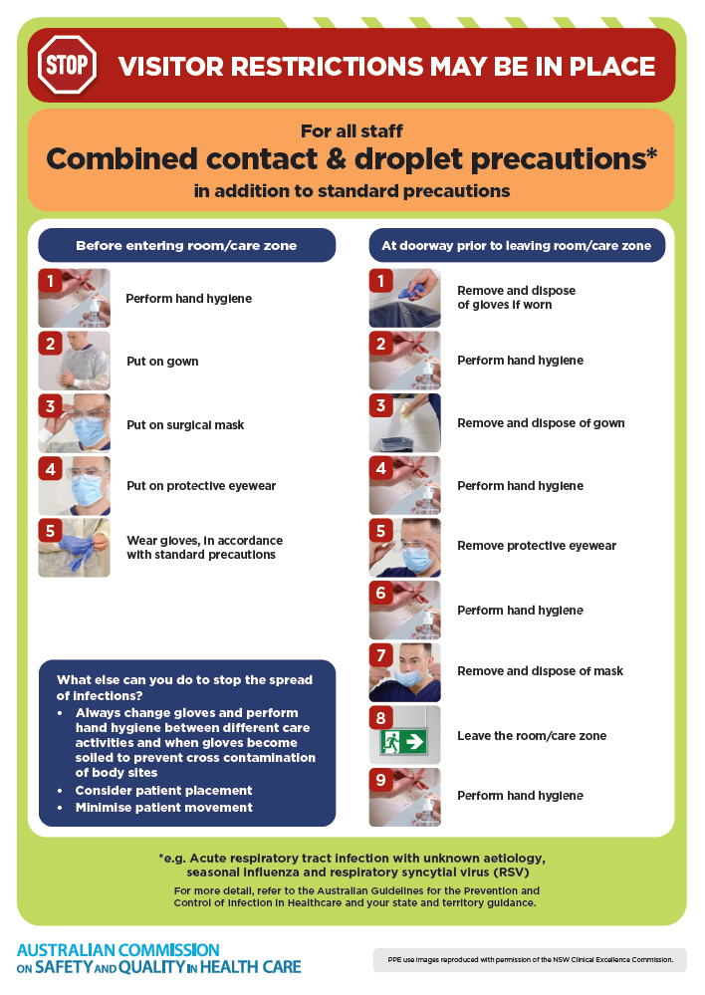
- Poster – Combined airborne and contact precautions
https://www.safetyandquality.gov.au/publications-and-resources/resource-library/infection-prevention-and-control-poster-combined-airborne-and-contact-precautions
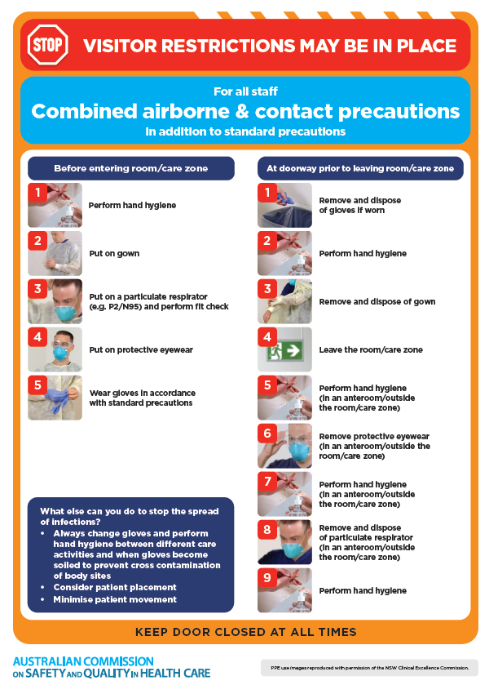
- Environmental Cleaning and Infection Prevention and Control www.safetyandquality.gov.au/environmental-cleaning
- Break the chain of infection poster
https://www.safetyandquality.gov.au/publications-and-resources/resource-library/break-chain-infection-poster
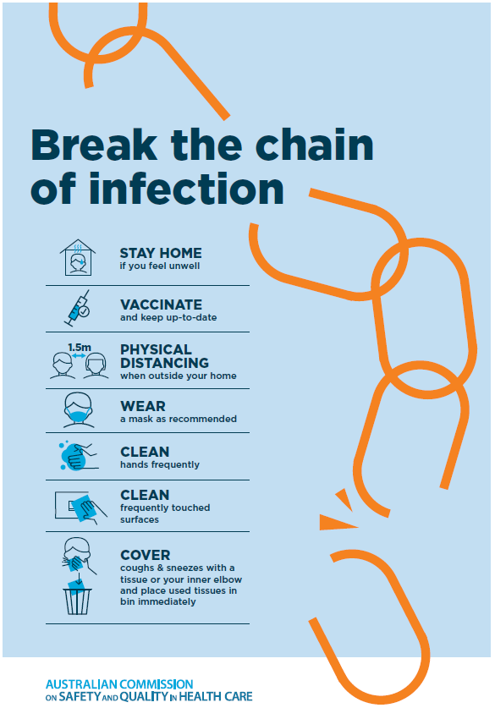

Disclaimer
On the Radar is an information resource of the Australian Commission on Safety and Quality in Health Care. The Commission is not responsible for the content of, nor does it endorse, any articles or sites listed. The Commission accepts no liability for the information or advice provided by these external links. Links are provided on the basis that users make their own decisions about the accuracy, currency and reliability of the information contained therein. Any opinions expressed are not necessarily those of the Australian Commission on Safety and Quality in Health Care.

