
On the Radar
Issue 693
14 April 2025

On the Radar is a summary of some of the recent publications in the areas of safety and quality in health care. Inclusion in this document is not an endorsement or recommendation of any publication or provider. Access to particular documents may depend on whether they are Open Access or not, and/or your individual or institutional access to subscription sites/services. Material that may require subscription is included as it is considered relevant.

On the Radar is available online, via email or as a PDF or Word document from https://www.safetyandquality.gov.au/newsroom/subscribe-news/radar

If you would like to receive On the Radar via email, you can subscribe on our website https://www.safetyandquality.gov.au/newsroom/subscribe-news
or by emailing us at HUmail@safetyandquality.gov.auU.
You can also send feedback and comments to HUmail@safetyandquality.gov.auU.

For information about the Commission and its programs and publications, please visit https://www.safetyandquality.gov.au

On the Radar
Editor: Dr Niall Johnson
Contributors: Niall Johnson

Reports

Creating Team Joy and Wellbeing: A guide for leaders
Interior Health
Kelowna: Interior Health; 2024.
URL | https://www.interiorhealth.ca/sites/default/files/PDFS/Creating-Team-Joy-Wellbeing-Guide-for-Leaders.pdf
Notes | This resource from a health system in British Columbia, Canada builds upon the earlier Institute for Healthcare Improvement (IHI) Framework for Improving Joy in Work and the even earlier Lucian Leape Institute Through the Eyes of the Workforce: Creating Joy, Meaning, and Safer Health Care paper.  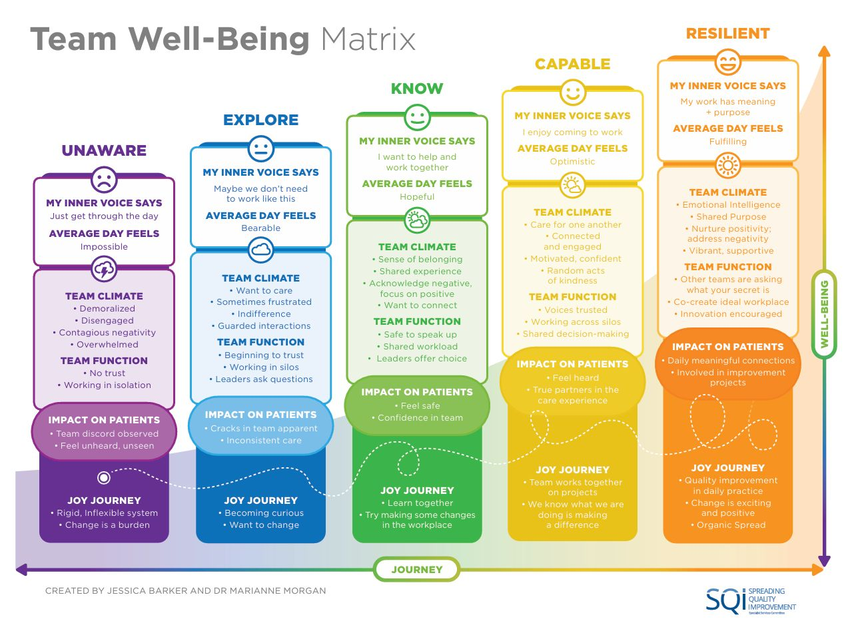

The Safety Gap: Safety and Accessibility of Medicines and Medical Devices for people with sensory impairment
Patient Safety Commissioner
London: Patient Safety Commissioner; 2025. p. 94.
URL | https://www.patientsafetycommissioner.org.uk/our-reports/the-safety-gap-report/
Notes | Report from the UK’s Patient Safety Commissioner that notes ‘For patients with sensory impairment, including people with sight loss or hearing loss, there are greater barriers to access the knowledge and information about medicines and medical devices needed to stay safe.’ The report includes a review of the current context and research, along with observations and recommendations.  The report is available as a PDF along with an audio version, a Braille Ready Formation and an Easy Read version of the introductions and recommendations.

Access and Quality of Care for Older Adults in 10 Countries: Findings from the 2024 Commonwealth Fund International Health Policy Survey of Older Adults
Gunja MZ, Shah A, Leonard F
New York: Commonwealth Fund; 2025.
DOI | https://doi.org/10.26099/4wrj-kj97
Notes | The Commonwealth Fund in the USA has for a number of years conducted surveys of various aspects of health care systems in a number of high-income nations, including the USA and Australia. This report presents the results from their 2024 Commonwealth Fund International Health Policy Survey of Older Adults. As with many of these surveys Australia tends to compare rather favourably with these peer nations. While the Commonwealth Fund’s focus is on the USA, the results can also illuminate issues across and common to the surveyed nations.

Journal articles

Patient-reported harm from NHS treatment or care, or the lack of access to care: a cross-sectional survey of general population prevalence, impact and responses
Crocker H, Cromwell DA, Modha S, Gray AM, Graham C, Thana L, et al.
BMJ Quality & Safety. 2025:bmjqs-2024-017213.
DOI | https://doi.org/10.1136/bmjqs-2024-017213
Notes | Paper reporting on a cross-sectional survey with 10 064 participants that sought to ‘estimate of the proportion of the general public reporting healthcare-related harm in Great Britain’. Among the findings the authors report:  - 9.7% participants reported harm caused by the National Health Service (NHS) in the last 3 years through treatment or care (6.2%) or the lack of access to care (3.5%).  - The main location where the harm first occurred was hospitals.  - A total of 37.6% of participants reported a moderate impact and 44.8% a severe impact of harm.  - The most common response to harm was to share their experience with others (67.1%).  - Almost 60% sought professional advice and support, with 11.6% contacting the Patient Advice and Liaison Service (PALS).  - Only 17% submitted a formal complaint, and 2.1% made a claim for financial compensation.  - People wanted treatment or care to redress the harm (44.4%) and an explanation (34.8%).

Postoperative Outcomes Following Preweekend Surgery
Ranganathan S, Riveros C, Tsugawa Y, Geng M, Mundra V, Melchiode Z, et al.
JAMA Network Open. 2025;8(3):e2458794-e2458794.
DOI | https://doi.org/10.1001/jamanetworkopen.2024.58794
Notes | Paper reporting on a Canadian study looking into what has been termed the “weekend effect”. As with previous studies, the authors report that in their ‘cohort study involving 429 691 patients undergoing 25 common surgical procedures in Ontario, Canada, those who underwent surgery immediately before the weekend experienced a statistically significant increase in the composite outcome of death, complications, and readmissions at 30 days, 90 days, and 1 year compared with those treated after the weekend.’

Development and evaluation of an illustrated paediatric leaflet Coming to Hospital: a guide to what goes on
Clark EKR, Sanghavi SS, Farrell S, Fritz Z
BMJ Paediatrics Open. 2021;5(1):e000889.
DOI | https://doi.org/10.1136/bmjpo-2020-000889
Notes | Paper reporting on the development of a leaflet to inform young patients about their forthcoming hospital visit. The leaflet aimed to ‘better prepare patients for time spent in hospital and to improve experience by informing them what to expect.’ With 3000 leaflets printed and distributed in a UK hospital system an evaluation was undertaken. The evaluation survey had 72 patients involved, with ‘a significant majority of children ‘really liked’ the leaflet and found it helpful.’ Further information about the project and a link to resource are at https://www.thisinstitute.cam.ac.uk/research/outputs/development-and-evaluation-of-an-illustrated-paediatric-leaflet-coming-to-hospital-a-guide-to-what-goes-on/  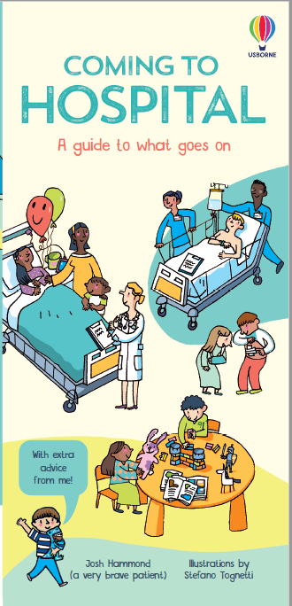

How can I support a neurodivergent colleague?
Rimmer A.
BMJ. 2025;388:r559.
DOI | https://doi.org/10.1136/bmj.r559
Notes | With greater identification and awareness of the neurodivergent, comes this piece providing advice on supporting and working with neurodivergent colleagues. One thing that maybe borne in mind is that the key part of the term neurodiverse is diverse – there are many ways to be neurodivergent.

Addressing Health Literacy
Paasche-Orlow MK, Wolf MS
JAMA. 2025.
DOI | https://doi.org/10.1001/jama.2025.2198
Notes | This short piece in the Journal of the American Medical Association (JAMA) rehearses the issues around health literacy. While, known, it is a reminder that health literacy remains an issue. One omission is that the authors say nothing about digital health literacy.

Health Affairs
Volume 44, Number 4, April 2025
URL | https://www.healthaffairs.org/toc/hlthaff/44/4
Notes | A new issue of Health Affairs has been published with a theme of ‘Food, Nutrition & Health’. Articles in this issue of Health Affairs include:  - Equity And Justice In Food As Medicine (Jessica Bylander)  - A New Approach To Guide Research And Policy At The Intersection Of Income, Food, Nutrition, And Health (Seth A Berkowitz, Hilary K Seligman, and Dariush Mozaffarian)  - Food For Thought: A Vision For Generative ‘Food Is Medicine’ (John R Lumpkin, Merry Davis, and Valerie Stewart)  - ‘Food Is Medicine’ In The US: A National Survey Of Public Perceptions Of Care, Practices, And Policies (Ronit Ridberg, Julia Reedy Sharib, Kathryn Garfield, Erika Hanson, and Dariush Mozaffarian)  - What Is ‘Food Is Medicine,’ Really? Policy Considerations On The Road To Health Care Coverage (Colin M Schwartz, Alexa M Wohrman, Emily J Holubowich, Lisa D Sanders, and Kevin G Volpp)  - Medicaid Nutrition Supports Associated With Reductions In Hospitalizations And ED Visits In Massachusetts, 2020–23 (Kurt Hager, Meagan Sabatino, Jeffrey Williams, A S Ash, Y Halasa-Rappel, J M Flahive, H S Min, G Sing, S Buckler, A Rich, J Bowman, J Himmelstein, and M J Alcusky)  - States’ Use Of Medicaid Managed Care ‘In Lieu Of Services’ Authority To Address Poor Nutrition (Kathryn Garfield, Erika Hanson, Carmel Shachar, Pascale Stain, and Dariush Mozaffarian)  - Food Is More Than Just Medicine (Amanda Bank)  - Estimated Impact Of Medically Tailored Meals On Health Care Use And Expenditures In 50 US States (Shuyue Deng, Kurt Hager, Lu Wang, Frederick P Cudhea, John B Wong, David D Kim, and Dariush Mozaffarian)  - Modeling The Value Of ‘Food Is Medicine’: Challenges And Opportunities For Scaling Up Medically Tailored Meals (Kartika Palar, and Chesa Cox)  - Understanding And Comparing Economic Assistance Models To Improve Food Security And Diet Quality: A Rapid Review (Mary Kathryn Poole, Matthew M Lee, Sara N Bleich, and Erica L Kenney)  - Advancing The FDA’s Human Foods Program Through Additional Authorities And User Fees (Jennifer L Pomeranz, Sean B Cash, Emily Broad Leib, and Dariush Mozaffarian)  - Food Supply And Dietary Guidelines Mismatch: Policy Recommendations To Improve Human And Planetary Health (Ilana Fischer, K M Venkat Narayan, and Karen R Siegel)  - An Urban Farm–Anchored Produce Prescription Program’s Impacts On Weight Reduction (Kaitlyn M Fruin, Elizabeth L Tung, Jean M Franczyk, Ketaurah James, Andrew J Koetz, Angela K Mason, and Wayne M Detmer)  - North Carolina’s FarmsSHARE: Farmers, Food Hubs, And Community-Based Organizations Sustain Healthy Food Programs (Amanda Hege, Monica McCann, Dave Walker, Lenwood Edwards, Claire McLendon, Sara Runkel, and Roland McReynolds)  - Cultural And Place-Based Wisdom For Implementing ‘Food Is Medicine’ Programs In North Carolina (Rochelle Bellin, Sonya J Jones, Sheherzad Maham Rizvi, Meredith Mastramauro, Donyel Barber, Chasidie Glover, Amy Kathryn Marion, Maura McClain, and Susannah Spratt)  - Reclaiming Ancestral Abundance (Jesse Lipman, Kahaulahilahi Vegas, Fiore Anderson, and Kaui Tuihalafatai)  - A Different Type Of Hunger (Heather Thomas)  - ETR (Sass Borodkin)

Emergency Medicine Australasia
Volume 37, Issue 2, April 2025
URL | https://onlinelibrary.wiley.com/toc/17426723/2025/37/2
Notes | A new issue of Emergency Medicine Australasia has been published. Articles in this issue of Emergency Medicine Australasia include:  - Accuracy of colour Doppler ultrasound for nasogastric tube placement in emergency department: A prospective observational study (Ming Yee Ong, Ahmad Zulkarnain Ahmad Zahedi, Aliyah Zambri, Muhaimin Noor Azhar, Aida Bustam, Rabiha Mohd, Mohammad Fadhly Yahya, Khadijah Poh)  - Guanfacine exposure in paediatric and adolescent patients: A multicentre retrospective review (Emma Peters, Sarah E Hodgson, R Elliott, S L Greene)  - Virtual emergency departments and domestic violence: A new frontier in healthcare and safety (Kim Hansen, Karen Wright, James Fraser, Bauke Hovinga, Cheryl Choong, Jaimon T Kelly)  - ICS prescribing practices in the emergency department: Addressing gaps in asthma management (Samuel Ford, Nikesh Gopalkumar)  - Just because we can, does not mean we should: Over investigation and low-value care in our emergency departments (Adelene Hilbig)  - Emergency department in perspective: How emergency department culture drives over-investigation (Simon Judkins)  - Incidentalomas: Incidentally lifesaving or incidentally burdensome? (Nicola Sandler)  - Deliberate clinical inertia: A paradoxical strategy to improve patient flow? (Gerben Keijzers)  - Identification and de-implementation of low-value emergency care (Vinay Gangathimmaiah)  - Enough is enough: Alcohol-related occupational violence and aggression in emergency departments in Australia and New Zealand (Diana Egerton-Warburton, Jolene Lim BPharm, Dinesh Seiji Seneviratne, Sue Bumpstead, Laura R Joyce, Lisa Kuhn, K Moore, D B Richardson, R Lee, D M Fatovich)  - Music in the emergency department and its association with delirium and other clinical outcomes (Hinpetch Daungsupawong, Viroj Wiwanitkit)  - Doing it all well: Resuscitation, observation and the need for deliberate practice (Clare A Skinner)  - Paediatric resuscitation in regional Queensland: A simulation informed biopsy of current system challenges (Alexandra St-Onge-St-Hilaire, Jason Acworth, Benjamin Lawton, Myfanwy Williams, Louise Dodson, B Symon)  - Effect of change of high-sensitivity troponin I assay on emergency department diagnosis and disposition of patients with possible acute coronary syndrome (John W Pickering, Scott Kelland, Otis Williams, Jamin Kim, Sally Aldous, Laura R Joyce, Martin P Than)  - Identity in emergency medicine: Who are we and what are we doing? (Thomas Hitchcock)  - Blood culture collection and administration of intravenous ceftriaxone by paramedics in patients with suspected sepsis (the pass trial) (Daniel Cudini, Karen Smith, Jeffery Shao, Stephen Bernard, Daniel Okyere, Ziad Nehme, Emily Nehme, David Anderson, Nicole Magnuson, Karin Thursky, Dhruv Mori, De Witt Oosthuizen, Andrew Udy)  - Emergency department presentations by trans and gender diverse people in Sydney, Australia: Retrospective case series (Emily Symes, Naomi Derrick, Thomas Hicks, Rhys Ross-Browne, Louisa Degenhardt, Rachel Sutherland, Radhika Seimon, Michael Dinh)  - Scoping a paediatric emergency medicine unit* (Marita S Bolic, Jamie Lew, Drew B Richardson)  - Evaluation of a team-based approach for emergency department patients with time critical intracranial conditions (Skye Macleod, G Melville, A Samimi-Duncan, S Khan, S Binks, D Hernandez, R Cherukuri, S Keane, K Curtis)  - High dose insulin is an inodilator, not an antidote in the poisoned patient! (Katherine Z Isoardi, Betty Chan, Angela L Chiew)  - Evaluating the satisfaction of patients utilising the virtual emergency department service in southeast region of Melbourne (Muhuntha Sri-Ganeshan, Amanda Harris, C Thuring, G O'Reilly, B Mitra, A Underhill, C Charteris, D Egerton-Warburton, P A Cameron, on behalf of the Southeast Region Virtual Emergency Department (SERVED) Research Group)  - Frequent attendance to paediatric emergency departments: Steps towards prevention (Helen Parry, Emily Roxburgh, L Maier, J Louise, M Hill, C Berry)  - Opioid overdoses following use of cocaine and methamphetamine in New South Wales, and the public health responses (Peter Chisholm, Jared Brown, Thanjira Jiranantakan, M E Harrod, C McDonald, U Cullinan, D M Roberts)  - Paediatric Research in Emergency Departments International Collaborative (PREDICT) at 20 years: Challenges of an emergency research network (Elyssia M Bourke, Libby Haskell, Natalie Phillips, Stuart R Dalziel, Franz E Babl, on behalf of Paediatric Research in Emergency Departments International Collaborative (PREDICT)  - Impact of an evidence-based sepsis pathway on paediatric hospital clinical practice: A quality improvement study (B McCarthy, N Middleton, F J Gill, Z Goff, Z Paterson, C C Blyth, on behalf of the CAHS Sepsis Working Group

Health Expectations
Volume 28, Issue 2, April 2025
URL | https://onlinelibrary.wiley.com/toc/13697625/2025/28/2
Notes | A new issue of Health Expectations has been published. Articles in this issue of Health Expectations include:  - Experiences of Home-Based Pulmonary Rehabilitation With mHealth and Centre-Based Pulmonary Rehabilitation in People With Chronic Obstructive Pulmonary Disease: A Qualitative Study (Hannah Rutherford, Marita Dale, Sally Wootton, Rashmi Pithavadian, Sarah Dennis, Sarah Brown, Jennifer A Alison, Andrew S L Chan, Ian A Yang, Zoe McKeough  - Safety Culture Through Patient Voice: Qualitative Validation of the Patients' Perceptions of Safety Culture Scale (PaPSC) in Cardiology and Cardiothoracic Surgery (Clara Monaca, Matthias Weigl, H Pfaff, A Hammer)  - Codesign of Mental Health Interventions With Young People From Racially Minoritised Populations: A Systematic Review of Methods and Outcomes (Ishrat Shahnaz, Kelly Rose-Clarke, D Michelson, P C Gronholm)  - Co-Designing a Framework for Social Media Health Communication to Young People: A Participatory Research Study (Melody Taba, Julie Ayre, K McCaffery, D Vassilenko, I C K Ma, T Haynes, J Leask, A Wilson, C Bonner)  - How Has ‘What Matters to You’ Been Used for Patient Care? A Scoping Review (Carrie Janerka, Ashley-Rose Hooper, Belinda Sanders, O Gallagher)  - “I Became the Messenger Between the Hospitals”: A Study on the Journeys of People With Cancer Using the Critical Incident Technique (Ragnhild Halvorsrud, Line Melby, Kristine Gjermestad, B Bogale, I K Ledel Solem)  - Coproducing an Ecological Momentary Assessment Measurement Burst Mental Health Study With Young People: The MHIM Coproduction Protocol (Luke Power, Tong Xie, Thomas Bartlett, Dejla Hoxha, Heather Bryson, E Drummond, P Fairbairn, A Swan, Y-W Tan, L Caddick, A Murray)  - Co-Authoring and Reporting on Lived Experience Engagement in Mental Health and/or Substance Research: A Qualitative Study and Guidance Document (Natasha Y Sheikhan, Kerry Kuluski, Melissa Hiebert, Charlotte Munro, Vivien Cappe, Mary Rose van Kesteren, Sean Kidd, Lisa D Hawke)  - Announcements of Death During the COVID-19 Pandemic: A Qualitative Study of Family Experiences (Axelle Avazeri, J Bonin, A Maneval, P Vorilhon)  - Enablers and Barriers to an Experience-Based Co-Design Process to Develop Service Improvements in Enhanced Community Care in Ireland: A Qualitative Study (Fay O'Donoghue, Máire T O'Donnell, Tomás P Griffin, Eileen Fahy, Elaine Newell, Ann-Marie Creaven)  - Youth Care Stories: A Scoping Review Into What, Why and How Narrative Approaches Understand and Improve Quality of Care for Young People (Eline Verheijen, Suzanne Rutz, Charlotte Barendregt, Anne Margriet Pot)  - Families' Strategies for Navigating Care for Their Child With Cerebral Palsy: A Qualitative Study (Silje Askeland, Veslemøy Guise, Karina Aase, Maren Kristine Raknes Sogstad)  - One or Many Recoveries? Recoveries in the Plural for a Better Understanding of One's Healing Journey (Elena Faccio, Michele Rocelli, Lia Bitetti, Giuseppe Salamina, Susanna Brunelli, Federica Mangione, L Aquili)  - Translation and Validation of the Medication Understanding and Use Self-Efficacy Scale Among Patients With Type 2 Diabetes in Taiwan (Yen-Ming Huang, Yu-Meng Yang, Tzu Wang, Yunn-Fang Ho, Hsun-Yu Chan)  - Refinement and Validation of a New Patient-Reported Experience Measure for Hearing Loss (My Hearing PREM) (Sian K. Smith, Helen Pryce, Georgina Burns O'Connell, Rebecca C. Knibb, Rosemary Greenwood)  - Using Human-Centred Design to Codesign Patient Engagement Tools With a Patient Advisory Council: Successes and Challenges (Madelyn Knaub, Santiago Leon, Surakshya Pokharel, Veronika Kiryanova, Kim Giroux, Prachi Khanna, Anna Rychtera, D'Arcy Duquette, P Mathura, N Verdin, A Ambasta)  - ‘Don't Assume, Ask’: A Collaboration With Consumers, Interpreters, Clinicians and Health Service Staff to Increase Video Telehealth in Culturally and Linguistically Diverse Groups (Jaimon T Kelly, Monica L Taylor, Victor M Gallegos-Rejas, Susan Pager, Soraia de Camargo Catapan, K Lucas, A Bogicevic, A C Smith, C Snoswell, H M Haydon, E E Thomas)  - Patient and Carer Understandings and Experiences of Living With Type 2 Diabetes in India (Rahul Krishna Puvvada, Joanne Marcucci, Clarice Tang, Jency Thomas, Peter Higgs, Ramesh Madhan, Sabrina Gupta)  - Under-Served Groups and Myalgic Encephalomyelitis Research Workshop; Multiple Barriers to Effective Healthcare, Research and Public Participation (Monica Jane Bolton, C A Chew-Graham, H van Marwijk)  - Artificial Intelligence in Medical Care – Patients' Perceptions on Caregiving Relationships and Ethics: A Qualitative Study (Jana Gundlack, Sarah Negash, Carolin Thiel, Charlotte Buch, Jan Schildmann, Susanne Unverzagt, Rafael Mikolajczyk, Thomas Frese, PEAK consortium)  - Exploring Long Covid Prevalence and Patient Uncertainty by Sociodemographic Characteristics Using GP Patient Survey Data (Mirembe Woodrow, Nida Ziauddeen, Dianna Smith, Nisreen A Alwan)  - Increasing Youth Peer Workers' Impact Through Integration: Peer Worker Perspectives on Best Practice in Youth Mental Health (Rose Singh, Sarah Leung, Vilas Sawrikar, Catherine McHugh, Nan Hu, Oliver Ardill-Young, Raghu Lingam, Valsamma Eapen, Michael Hodgins, Jackie Curtis)  - Understanding Barriers and Facilitators for Ethnic Minority Groups to Audio Recording Recruitment Discussions in Clinical Trials: A Participatory Approach to Improving Informed Consent and Participation (Saba Faisal, Giles Birchley, Julia Wade, Athene Lane, Frida Malik, T Yardley, S Dawson)  - Outpatient Virtual Care Among People Living With and Beyond Cancer From Culturally and Linguistically Diverse Backgrounds in Australia: A Protocol for a Realist Evaluation (Prince Peprah, Sagda Osman, Rebecca Mitchell, Ashfaq Chauhan, Ramya Walsan, Maryam Sina, Bronwyn Newman, Nadine El-Kabbout, Jan Mumford, Emilie Francis-Auton, Elizabeth Manias, Virginia Mumford, Kate Churruca, Michelle Moscova, Natalie Taylor, Craig Nelson, Alexander Cardenas, Robyn Clay-Williams, J Braithwaite, R Harrison)  - Mobilizing the Power of Lived/Living Experiences to Improve Health Outcomes for all (Ambreen Sayani, Linda Monteith, Anam Shahil-Feroz, Diya Srinivasan, Isra Amsdr, Fatah Awil, Emily Cordeaux, Victoria Garcia, Ryan Hinds, Tara Jeji, Omar Khan, Bee Lee, Mursal Musawi, Jill Robinson, Staceyan Sterling, Dean Wardak, Kelly Wu, Mohadessa Khawari, M Gilfoyle, A Maybee)  - The Interactive Work of Implementing Synchronous Video-Conference Calls—A Qualitative Study Within Early Intervention for Infants With Childhood-Onset Neurodisability (Phillip Harniess, Anna Purna Basu, Deanna Gibbs, Jeff Bezemer)  - Barriers and Facilitators to Medicines Use in Patients With Vision Impairment: A Theory-Informed Qualitative Study of Patients and Caregivers (Basma Y Kentab, Heather E Barry, Sinaa A Al-Aqeel, Carmel M Hughes)  - Consumer Experience of an Australian Multidisciplinary Long COVID Clinic That Incorporates Personalised Exercise Prescription: A Qualitative Analysis (Tanya Buettikofer, Allison Maher, V Rainbird, M Bennett, N Freene, I Mitchell, H-C C Huang, P Gaughwin, M Johnson, J Paratz, B Bissett)  - Partnering With Youth to Enhance Healthcare Access and Experience: Lessons Learned From a Teen Advisory Group (Christi H Esquivel, Sara A Flores, Kristen Garcia, Whitney Garney, Kelly Wilson)  - Measuring Goal Progress Using the Goal-Based Outcome Measure in Youth Wellness Hubs Ontario—An Integrated Youth Services Network (Deb Chiodo, Aaron Turpin, Janis Wolfe, Karleigh Darnay, Jo Henderson)  - The Importance of Lived Experience: A Scoping Review on the Value of Patient and Public Involvement in Health Research (Heather Mah, Ruth Dobson, Alison Thomson)  - Development of ACT+: A Novel, Person-Centred Psychological Intervention Based on Acceptance and Commitment Therapy (ACT) to Improve Quality of Life in Patients Living With and Beyond Cancer (Elisavet Moschopoulou, Sheila Donovan, Debbie Brewin, Stephanie Taylor, Damien Ridge, Liam Bourke, Imran Khan, Moïse Roche, Trudie Chalder)  - Factors Affecting the Integration of Dental Services Into Health and Social Care for People With Complex Needs (Afsha Musa, Joelle Booth, Hannah Wheat, Robert Witton, Martha Paisi)  - People Living With Dementia and Their Families as Educators for Social Justice (Clare Mason, Ana Barbosa, Danielle Jones, M Andrews, A Capstick)  - Exploring How Children and Young People With Sickle Cell Disease and Their Families Want to be Involved in Research: A Qualitative Study (Jane Chudleigh, Addassa Follett, E Mcfarlane-Griffith, D Abuo, J Imani, P Holder)  - Understanding Public Judgements on Artificial Intelligence in Healthcare: Dialogue Group Findings From Australia (Emma K Frost, Yves Saint James Aquino, Annette Braunack-Mayer, Stacy M Carter)  - Recommendations for a Communication Strategy to Support Informed Decision-Making About Self or Clinician Sampling for Cervical Screening in the UK: Qualitative Study (Denitza Williams, Eleanor Clarke, Kate J. Lifford, Lindsay Haywood, Fiona Wood, Jo Waller, Adrian Edwards, Natalie Joseph-Williams, Caroline Evans, Gareth Powell, Rhiannon Phillips, Andrew Carson-Stevens, Katie Walbeoff, Ardiana Gjini, Kate Brain)  - Tackling Loneliness, Ineffective Social Support, and Mental Ill-Health Among People With Higher Weight (Joanne A Rathbone, Tegan Cruwys, Kate A B Western, J L Donaldson, C Haslam, E Rieger, F T Wheatland, P Dugdale)  - Evaluation of the Patient Innovation Partner Role: Perceived Benefits, Structures, Supports, and Recommendations for Lived Experience Engagement in Healthcare Innovation Teams (Shoshana H Bardach, Amanda Perry, Terry Sturke, Randy Stevens, Milan F Satcher)  - Older Adults' Experiences and Expectations of Doctor–Patient Interactions During Early Hospital Care (George Wells, Kate White, Vasi Naganathan, Natalie Ambrose, Janani Thillainadesan)  - Strengthening the Delivery of Physical Healthcare for Adults Living With Serious Mental Illness – A Qualitative Description of Patient and Family Member Perspectives (Munazzah Ambreen, Christopher Canning, Brian Lo, Sri Mahavir Agarwal, D Castle, B Konkolÿ-Thege, F Sirotich, S Sockalingam, T Tajirian, P G Tibbo, M R van Kesteren, C Walker, V Stergiopoulos)  - Consumer-Led Codesign of an Effective Online Consumer and Community Involvement Audit Tool (Asvini K Subasinghe, Jo Wilkie, Rebekah Puls, Tanya Tuffrey, Jacqueline A Boyle)  - Adapting an Osteoarthritis Peer Mentorship Intervention for Remote Delivery to People Experiencing Socioeconomic Disadvantage: A Multi-Method Approach (Anna M Anderson, Elizabeth Lavender, Samantha Mason, L Eckersley, S Barry, A Daffu-O'Reilly, H Green, M Conner, G A McHugh)  - Influencing Factors for the Acceptability of Accessing HIV Pre-exposure Prophylaxis via Community Pharmacies in Wales (David Gillespie, Adam D N Williams, Richard Ma, Zoe Couzens, Kerenza Hood, Dyfrig A Hughes, Efi Mantzourani, Eleanor Cochrane, Fiona Wood)  - Methods for Involving People With Dementia in Health Policy and Guideline Development: A Scoping Review (Felix Bühler, Jennifer Geyer, Gabriele Meyer, Anja Bieber)  - Developing Implementation Strategies for the Adoption of the Enhanced Recovery After Surgery (ERAS) Protocols: A Co-Design Study (Georgia Tobiano, Joan Carlini, W Chaboyer, R Liang, K Addy, L Sung, B M Gillespie)  - Translation and Psychometric Evaluation in Cancer Care of the German Version of collaboRATETM—a 3-item Patient-reported Measure of Shared Decision-Making (Pola Hahlweg, Stefan Zeh, Isabelle Scholl, Jördis Zill, Jörg Dirmaier, Paul James Barr, Glyn Elwyn, Martin Härter)  - Empowering Recovery: A Co-Designed Intervention to Transform Care for Operable Lung Cancer (Georgina A Whish-Wilson, L Edbrooke, V Cavalheri, Z T Calulo Rivera, M Cavallaro, Daniel R Seller, C L Granger, S M Parry)  - Lived Experience Participation in Suicide Prevention Activities in Australia, a Scoping Review (Hayley Purdon, T Pearce, B Jackson, S Wayland, M Maple)  - Participatory Research in Clinical Studies: An Innovative Approach to Co-creating Nutritional and Physical Activity Recommendations for Older Adults With Sarcopenia (FOOP-Sarc Project) (Maria Besora-Moreno, Cristina Sepúlveda, Judit Queral, Claudia Jiménez-ten Hoevel, Anna Pedret, Lucia Tarro, Rosa M Valls, Rosa Solà, Elisabet Llauradó)  - Challenges and Facilitators to Patient and Public Involvement In Stroke Research: Protocol for a Qualitative Study (Hamidreza Khankeh, Shima Shirozhan, Ulrich Dirnagl)  - Barriers to Engaging in Blood Donation During the COVID-19 Pandemic Among Nondonors and Lapsed Donors in a Chinese Community: A Critical Medical Anthropology Perspective (Judy Yuen-man Siu, Engle Angela Chan, Angus Siu-cheong Li, Yik Mun Lee)  - A City “Collabatory”: Researchers, Commissioners and Community Members Planning Interventions Together (Neil Small, Rachael H Moss, Josie Dickerson, Shahid Islam)  - Navigating Power Imbalances and Stigma in Mental Healthcare. Patient-Reported Barriers and Facilitators to Participation in Shared Decision-Making in Mental Health Care, a Qualitative Meta-Summary (Lien Mertens, Joris Vandenberghe, Geertruida Bekkering, Karin Hannes, Nicolas Delvaux, Pieter Van Bostraeten, Jasmien Jaeken, Bert Aertgeerts, Mieke Vermandere)

International Journal for Quality in Health Care online first articles
URL | https://academic.oup.com/intqhc/advance-articles
Notes | International Journal for Quality in Health Care has published a number of ‘online first’ articles, including:  - A systematic review of occupational stress and burnout in EMT and paramedic populations and associated consequences (Simran K Gill and Lauren R Kennedy-Metz)  - The second victim phenomenon´s impact in male and female healthcare workers: a scoping review (Vanessa Ribeiro Neves et al)  - Implementation of regional Acute Stroke Care Map increases thrombolysis rates in urban areas of China: an interrupted time series analysis (Rui Wen et al)

Online resources

Australian Living Evidence Collaboration
https://livingevidence.org.au/

Guidance
A number of guidelines or guidance have recently been published or updated. These include:
- INTEGRATE: international guidelines for the algorithmic treatment of schizophrenia
https://doi.org/10.1016/S2215-0366(25)00031-8

[UK] NICE Guidelines and Quality Standards
https://www.nice.org.uk/guidance
The UK’s National Institute for Health and Care Excellence (NICE) has published new (or updated) guidelines and quality standards The latest reviews or updates include:
- NICE Guideline NG12 Suspected cancer: recognition and referral https://www.nice.org.uk/guidance/ng12

USA] Effective Health Care Program reports
https://effectivehealthcare.ahrq.gov/
The US Agency for Healthcare Research and Quality (AHRQ) has an Effective Health Care (EHC) Program The EHC has released the following final reports and updates:
- Management of Suicidal Thoughts and Behaviors in Youth: A Systematic Review https://effectivehealthcare.ahrq.gov/products/suicidal-thoughts-youth/research
- Psychosocial and Pharmacologic Interventions for Disruptive Behavior in Children and Adolescents https://effectivehealthcare.ahrq.gov/products/disruptive-behavior/research
- Implementing Recommended Mental Health and Substance Use Screening and Counseling Interventions in Primary Care Settings for Children and Adolescents https://effectivehealthcare.ahrq.gov/products/behavioral-health-screening/research
- Pediatric Quality Measures Program 3.0: An Evidence Map of Measures for Vision, Hearing, and Developmental Screening and Followup
https://effectivehealthcare.ahrq.gov/products/pqmp/tech-brief
- Assisted Home Dialysis in the United States: New Interest in an Old Idea. Rapdi https://effectivehealthcare.ahrq.gov/products/home-dialysis/rapid-research

Infection prevention and control and COVID-19 resources
The Australian Commission on Safety and Quality in Health Care has developed a number of resources to assist healthcare organisations, facilities and clinicians. These resources include:
- Poster – Combined contact and droplet precautions https://www.safetyandquality.gov.au/publications-and-resources/resource-library/infection-prevention-and-control-poster-combined-contact-and-droplet-precautions
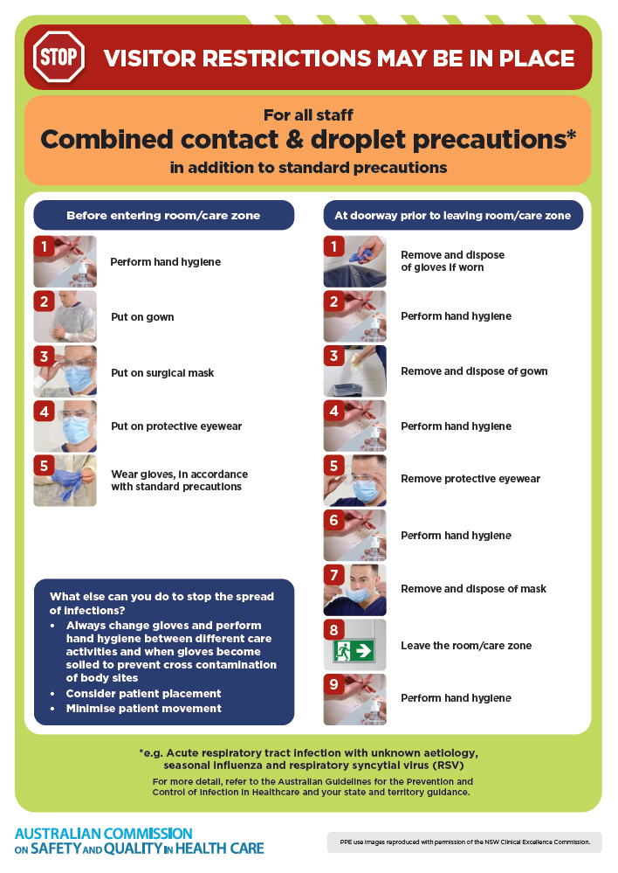
- Poster – Combined airborne and contact precautions
https://www.safetyandquality.gov.au/publications-and-resources/resource-library/infection-prevention-and-control-poster-combined-airborne-and-contact-precautions
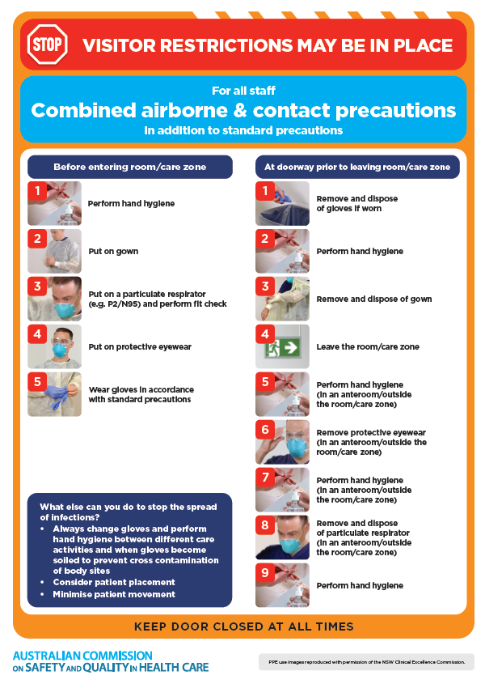
- Environmental Cleaning and Infection Prevention and Control www.safetyandquality.gov.au/environmental-cleaning
- Break the chain of infection poster
https://www.safetyandquality.gov.au/publications-and-resources/resource-library/break-chain-infection-poster
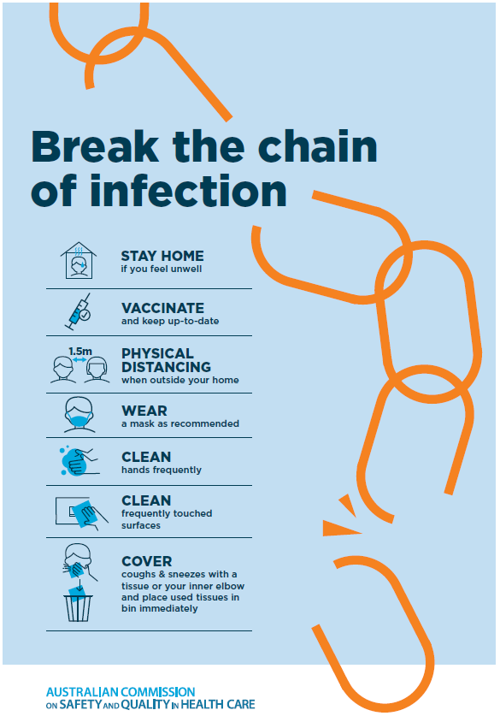
Disclaimer
On the Radar is an information resource of the Australian Commission on Safety and Quality in Health Care. The Commission is not responsible for the content of, nor does it endorse, any articles or sites listed. The Commission accepts no liability for the information or advice provided by these external links. Links are provided on the basis that users make their own decisions about the accuracy, currency and reliability of the information contained therein. Any opinions expressed are not necessarily those of the Australian Commission on Safety and Quality in Health Care.

