
On the Radar
Issue 695
12 May 2025

On the Radar is a summary of some of the recent publications in the areas of safety and quality in health care. Inclusion in this document is not an endorsement or recommendation of any publication or provider. Access to particular documents may depend on whether they are Open Access or not, and/or your individual or institutional access to subscription sites/services. Material that may require subscription is included as it is considered relevant.

On the Radar is available online, via email or as a PDF or Word document from https://www.safetyandquality.gov.au/newsroom/subscribe-news/radar

If you would like to receive On the Radar via email, you can subscribe on our website https://www.safetyandquality.gov.au/newsroom/subscribe-news
or by emailing us at mail@safetyandquality.gov.au.
You can also send feedback and comments to mail@safetyandquality.gov.au.

For information about the Commission and its programs and publications, please visit https://www.safetyandquality.gov.au

On the Radar
Editor: Dr Niall Johnson
Contributors: Niall Johnson

Reports

Promoting good mental health in children and young adults. Best practices in public health
OECD
Paris: OECD Publishing; 2025. p. 25.
doi | https://doi.org/10.1787/ebb8aa47-en.
Notes | The OECD has published this policy paper on mental health for younger people. From the paper’s abstract: ‘With support from the European Commission, the OECD has identified and evaluated 11 best practices for preventing mental ill-health and promoting good mental health. This report offers policy makers effective strategies to safeguard the mental health of future generations, enhancing their well-being, productivity, and long-term prosperity.’

Integrating stroke services in health-care systems: A practical approach
World Health Organization
New Delhi: World Health Organization, Regional Office for South-East Asia; 2025. p. 96.
URL | https://www.who.int/publications/i/item/9789290228134
Notes | The WHO, through its South-East Asia regional office, have produced this document seeking to assist nations in improving prevention and treatment of stroke. It is noted in the document’s preface that ‘As this publication details, countries have great potential to improve and streamline stroke services, for example by strengthening acute management and rehabilitation services, increasing the availability of CT scanners, and enhancing health workers’ knowledge and skills. It is imperative that health services at all levels can provide fast-track referrals and coordinated emergency care for stroke, in addition to ongoing support and rehabilitation for people living with stroke’

For information on the Commission’s work on acute stroke, including the Acute Stroke Clinical Care Standard, see https://www.safetyandquality.gov.au/standards/clinical-care-standards/acute-stroke-clinical-care-standard

Progression pathway for governance of mixed health systems
World Health Organization
Geneva: World Health Organization; 2025.
URL | https://iris.who.int/handle/10665/381086
Notes | The World Health Organization (WHO) has published this as their latest contribution on private sector participation in health systems. This document ‘has been designed to support the work of government agencies in three ways:  - Identify the governance arrangements and capacities needed to deliver better health outcomes that will work in their context.  - Take stock of existing governance arrangements and capacities, their strengths and weaknesses and identify the priority areas for improvement.  - Help define strategies and specific actions for strengthening governance arrangements focused on building the capacity to make and implement health policies in the private sector to improve healthcare access, quality, and cost-effectiveness.’  The authors note that ‘the Progression Pathway is not a prescriptive guideline or a set of mandatory requirements. Health system governance should reflect each country’s unique context, so a one-size-fits-all prescriptive approach is not possible. Instead, the Pathway is intended to support governments make decisions that align with their country’s unique circumstances’

Journal articles

Use of structured handoff protocols for within-hospital unit transitions: a systematic review from Making Healthcare Safer IV
McCarthy S, Motala A, Lawson E, Shekelle PG
BMJ Quality & Safety 2025.
DOI | https://doi.org/10.1136/bmjqs-2024-018385
Notes | Journal article reporting on a systematic review undertaken for the US Agency for Healthcare Research and Quality (AHRQ). The review team – for the Making Healthcare Safer IV program – ‘reviewed the evidence from the last 10 years that the use of structured handoff protocols influences patient safety outcomes within acute care hospital units’. The review team reported that ‘The SBAR [Situation, Background, Assessment, Recommendation] and I-PASS [Illness severity, Patient summary, Action list, Situation awareness, Synthesis to receiver] structured tools for within-unit handoffs probably improve patient safety, with I-PASS having a stronger certainty of evidence. Other published tools lack sufficient evidence to draw conclusions.’

Cost-effectiveness of eliminating hospital understaffing by nursing staff: a retrospective longitudinal study and economic evaluation
Saville C, Jones J, Meredith P, Dall’Ora C, Griffiths P
BMJ Quality & Safety 2025.
DOI | https://doi.org/10.1136/bmjqs-2024-018138
Notes | Paper reporting on a British study that sought to examine if ‘hospital investment in nursing staff, to eliminate understaffing on wards, cost-effective?’ This was a longitudinal observational study that ‘analysed data on 185 adult acute units in four hospital Trusts in England over a 5-year period’ Among the finds reported are:  - ‘Exposure to RN [Registered Nurse] understaffing is associated with increased hazard of death…, increased chance of readmission …and increased length of stay’  - ‘while exposure to NS [Nursing Support] understaffing is associated with smaller increases in hazard of death … and length of stay …but reduced readmissions’.  The authors contend that ‘Rectifying understaffing on inpatient wards is crucial to reduce length of stay, readmissions and deaths. According to the National Institute for Health and Care Excellence £10 000 per QALY threshold, it is cost-effective to eliminate understaffing by nursing staff. This research points towards investing in RNs over NS staff and permanent over temporary workers. Targeting particular patient groups would benefit fewer patients and is less cost-effective.’

Australian Journal of Primary Health
URL | https://www.publish.csiro.au/py/#Latest
Notes | The Australian Journal of Primary Health has moved to a continuous publication model. In the continuous publication model, once an article is ready for publication, it is immediately published online with final citation details (https://www.publish.csiro.au/PY/Continuouspublication).  Recent articles in the Australian Journal of Primary Health include:  - Leading the way: the contribution of Aboriginal community controlled health organisations to community health in Australia (Tamara Mackean, Toby Freeman, C Musolino, D Fry, C MacDougall, V Lewis and F Baum)  - The role of general practice to address the supportive care needs of Australian cancer survivors: a qualitative study (Olivia Bellas, Emma Kemp, Jackie Roseleur, Laura C Edney, Candice Oster and Jonathan Karnon)  - Contraceptive counselling in regions of Victoria with high incidence of teenage pregnancy: general practitioners’ insights (Jessica R Botfield, Greasha Rathnasekara, Danielle Mazza, Elodie Bernard and Cathy J Watson)  - Health promotion activities in Ontario Community Health Centres: a descriptive report (Sara Bhatti and Jennifer Rayner)  - Factors influencing uptake and sustained utility of HealthPathways in Australian general practice: a qualitative study (Susan Saldanha, Riki Lane, Sharon Clifford, Prisha Dadoo, Chris Barton and Grant Russell)  - Developing a preconception medical record audit tool for general practice: a multimethod study (Nishadi N Withanage, Jessica R Botfield, Sharon James, Kirsten I Black, Sharon Cameron and Danielle Mazza)  - Community health in Victoria: a history of challenges, adaptations and potential (Virginia Lewis, Jennifer Macmillan, T McBride and David Legge)  - Perceptions and willingness concerning the collection of sexual orientation and gender identity data in Australian healthcare services (Daniel Demant, P Byron, D Debono, S Jethani, B Goldblatt, M Thomson and Jo (River) River)  - Mental health consumers and primary care providers co-designing improvements and innovations: a scoping review (Kathryn Thorburn, Bani Aadam, Shifra Waks, B Bellingham, M F Harris, K R Fisher and C Spooner)  - The role of general practitioners in the follow-up of positive results from the Australian National Bowel Cancer Screening Program – a scoping review (Jane Gaspar, Caroline Bulsara, Diane Arnold-Reed, K Taylor and A Williams)  - Maximising the potential of type 2 diabetes remission: scale up and sustainability considerations from the DiRECT-Aus implementation trial (Nilakshi Gunatillaka, Jenny Advocat, Lauren Ball, Terry Haines, Cylie Williams, Tze L Chai, M Bowden, M Savaglio, K Gudorf and E Sturgiss)  - Exploring dementia service gaps and barriers in the Australian Capital Territory: a qualitative study (Nathan M D’Cunha, Georgina Chelberg, Ian Huang, Hossein Tabatabaei-Jafari, Nasser Bagheri, K Bail, D Gibson, S Isbel, L Wiseman, P Chowdhury, M A Furst, P S Sachdev and L Salvador-Carulla)  - Perspectives of general practice nurses, people living with dementia and carers on the delivery of dementia care in the primary care setting: potential models for optimal care (Caroline Gibson, Dianne Goeman, Constance Dimity Pond, Mark Yates and Alison M. Hutchinson)

Health Affairs
Volume 44, Number 5, May 2025
URL | https://www.healthaffairs.org/toc/hlthaff/44/5
Notes | A new issue of Health Affairs has been published with a themes of ‘Medicaid, Pharmacies, Hospital Markets & More’. Articles in this issue of Health Affairs include:  - A Promising Prescription For Older Adults: Social Connection (Michele Cohen Marill)  - Medicaid ‘Unwinding:’ Much Of The Reduction In Medicaid-Paid Prescriptions Was Offset By Increased Commercial Coverage (Eden Volkov, Jessica Eloso, Arielle Bosworth, Kenneth Finegold, and T C Buchmueller)  - Updated Medicaid-To-Medicare Fee Index: Medicaid Physician Fees Still Lag Behind Medicare Physician Fees (Laura Skopec, Avani Pugazhendhi, and Stephen Zuckerman)  - Medicare Part D Preferred Pharmacy Networks And The Risk For Pharmacy Closure, 2014–23 (Jenny S Guadamuz, G Caleb Alexander, Genevieve P Kanter, and Dima Mazen Qato)  - Hospital Capital Expenditures Associated With Prices And Hospital Expansion Or Withering, 2010–19 (Nancy D Beaulieu, Andrew L Hicks, and Michael E Chernew)  - Hospitals Acquired By Private Equity Firms: Increased Postoperative Mortality For Common Inpatient Surgeries (Adrian Diaz, Mitchell Mead, Stefanie Rohde, Nicholas Kunnath, Justin B Dimick, and Andrew M Ibrahim)  - Rural Hospital Closures Led To Increased Prices At Nearby ‘Surviving’ Hospitals, 2012–22 (Caitlin Carroll, and Jessica Y Chang)  - Physician Training In Rural And Health Center Settings More Than Doubled, 2008–24 (Emily M Hawes, Brianna Lombardi, Mukesh Adhikari, Evan Galloway, Laney McDougal, Maura Biszewski, and Erin P Fraher)  - Pathways To Primary Care: Charting Trajectories From Medical School Graduation Through Specialty Training (William R Phillips, Jeongyoung Park, and Michael Topmiller)  - Private Equity–Owned Physician Practices Decreased Access To Retinal Detachment Surgery, 2014–22 (Yashaswini Singh, Geronimo Bejarano Cardenas, Hamid Torabzadeh, Christopher M Whaley, and Durga Borkar)  - Rhode Island’s Affordability Standards Led To Hospital Price Reductions And Lower Insurance Premiums (Andrew M Ryan, Christopher M Whaley, Erin C Fuse Brown, Nandita Radhakrishnan, and Roslyn C Murray)  - Eligibility Assistance Increases Insurance Enrollment Within Community Health Centers But Not At The State Level (Leighton Ku, Kristine Namhee Kwon, Feygele Jacobs, and Sara Rosenbaum)  - State-Mandated Opioid Use Disorder Treatment In Maryland Jails Helped Patients Recover Despite Gaps In Care (Camille Kramer, C Lenz, M Song, C Sufrin, A Kennedy-Hendricks, M Fingerhood, S N Bandara, and B Saloner)  - Medicaid Patients With ED Visits For Overdose: Disparities In Initiation Of Medications For Opioid Use Disorder (Thuy Nguyen, Yang Jiao, Stephanie S Lee, Pooja Lagisetty, Amy Bohnert, Keith E Kocher, and Kao-Ping Chua)  - Use Of Social Determinants Of Health Z Codes Was Sparse, 2016–22 (Monica S Aswani, Lauren A Do, and Paul R Shafer)  - The Family Front Lines Of The Opioid Epidemic (Liba Blumberger)  - Oncology Drugs (Matthew Vogel and Rena M Conti)

Health Policy
Volume 156, June 2025
URL | https://www.sciencedirect.com/journal/health-policy/vol/156/
Notes | A new issue of Health Policy has been published. Articles in this issue of Health Policy include:  - The challenge of access to healthcare services as a condition for territorial equity. A methodological approach for sparsely populated rural areas (Héctor Martínez Sánchez-Mateos, Ángel Raúl Ruiz Pulpón)  - The ethics of behaviour-based insurance models: Solidarity-based concerns in Germany's statutory health insurance (Carl Justus Bredthauer, Eva Kuhn, Alena Buyx)  - Disparities in the organisation of national healthcare systems for treatment of patients with psoriatic arthritis and axial spondyloarthritis across Europe (Brigitte Michelsen, Mikkel Østergaard, Michael John Nissen, Adrian Ciurea, Burkhard Möller, Lykke Midtbøll Ørnbjerg, Pavel Horák, Bente Glintborg, Alan MacDonald, Karin Laas, Tuulikki Sokka-Isler, Bjorn Gudbjornsson, Florenzo Iannone, Pasoon Hellamand, Tore Kristian Kvien, Ana Maria Rodrigues, Catalin Codreanu, Ziga Rotar, Isabel Castrejón, J K Wallman)  - Growth and changing landscape of the cost-utility literature: an Australian perspective, 1992-2022 (Qing Xia, Steven M McPhail, Clifford Afoakwah, Linh K Vo, Megumi Lim, David Brain, John P Kuwornu, Hannah E Carter)  - The effect of enrolment policies on patient affiliation to a family physician: A quasi-experimental evaluation in Canada (Caroline King, M Ruth Lavergne, Kimberlyn McGrail, Erin Strumpf)  - Contact time in GP Care: Descriptive patterns and a scoping review of the literature (Simon Reif, Jan Köhler, Sabrina Schubert, Benedikt Stelter)  - Common institutional ownership and the erosion of competition in the American health insurance market: A quantitative analysis (Kevin Smith)  - What are the policy options for regulating private equity involvement in health care? A review of policies implemented or considered in seven high-income countries (Matthew Tracey, Katharine Schulmann, Florian Tille, Thomas Rice, Julien Mercille, Rob Timans, Sara Allin, Alexis Dottin, Sanna Syrjälä, Tiia Sotamaa, Ilmo Keskimäki, Bernd Rechel)

BMJ Quality & Safety online first articles
URL | https://qualitysafety.bmj.com/content/early/recent
Notes | BMJ Quality &Safety has published a number of ‘online first’ articles, including:  - Editorial: Addressing the risk of look-alike, sound-alike medication errors: bending metal or twisting arms? (Denham L Phipp)  - Improving weaning and liberation from mechanical ventilation for tracheostomy patients: a quality improvement initiative (Michael Mikhaeil, Michelle Bernard, Jenna Currie, Caroline Bolduc, Jordana Radke, Savannah Kranjc, Joanne Meyer)

International Journal for Quality in Health Care online first articles
URL | https://academic.oup.com/intqhc/advance-articles
Notes | International Journal for Quality in Health Care has published a number of ‘online first’ articles, including:  - A multi-focused approach to drive improvement in acute stroke care: enhance organisational systems, practice cultures and individual clinician capabilities (Menglu Ouyang and David Greenfield)  - Comparing continuity of care before and after disability registration: A retrospective cohort study (Zhaoyan Piao et al)  - Continuous Glucose Monitoring in Type 2 Diabetes: A Systematic Review of Barriers and Opportunities for Care Improvement (Maria Assunta Barchiesi et al)

Online resources

Australian Living Evidence Collaboration
https://livingevidence.org.au/

UK] NICE Guidelines and Quality Standards
https://www.nice.org.uk/guidance
The UK’s National Institute for Health and Care Excellence (NICE) has published new (or updated) guidelines and quality standards The latest reviews or updates include:
- Quality Standard QS86 Falls https://www.nice.org.uk/guidance/qs86
- NICE Guideline NG249 Falls: assessment and prevention in older people and in people 50 and over at higher risk https://www.nice.org.uk/guidance/ng249
- NICE Guideline NG12 Suspected cancer: recognition and referral https://www.nice.org.uk/guidance/ng12
- NICE Guideline NG191 COVID-19 rapid guideline: managing COVID-19 https://www.nice.org.uk/guidance/ng191

[USA] Effective Health Care Program reports
https://effectivehealthcare.ahrq.gov/
The US Agency for Healthcare Research and Quality (AHRQ) has an Effective Health Care (EHC) Program The EHC has released the following final reports and updates:
- Interventions To Prevent Nonventilator Hospital-Acquired Pneumonia https://effectivehealthcare.ahrq.gov/products/nv-hap/rapid-research
- Examining the Impact of Implementing High-Reliability Organization Principles on Patient Safety Outcomes https://effectivehealthcare.ahrq.gov/products/hro/rapid-research

[UK] Self-reflection toolkit
https://www.nhsemployers.org/publications/self-reflection-toolkit
NHS Employers in the UK have developed this’ self-reflection tool for social care and health workers aimed at personal growth and team development during peak pressure’. This is not intended as a mean of managing performance, but rather ‘a tool to help people think about how working together during times of peak pressure can be helpful. Creating a space allows people to recognise the value of working together during the more difficult times.’

Infection prevention and control and COVID-19 resources
The Australian Commission on Safety and Quality in Health Care has developed a number of resources to assist healthcare organisations, facilities and clinicians. These resources include:
- Poster – Combined contact and droplet precautions https://www.safetyandquality.gov.au/publications-and-resources/resource-library/infection-prevention-and-control-poster-combined-contact-and-droplet-precautions
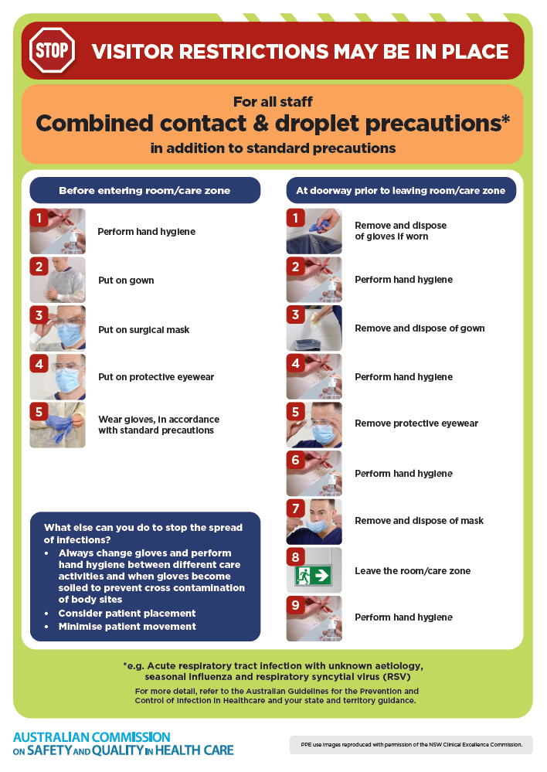
- Poster – Combined airborne and contact precautions
https://www.safetyandquality.gov.au/publications-and-resources/resource-library/infection-prevention-and-control-poster-combined-airborne-and-contact-precautions
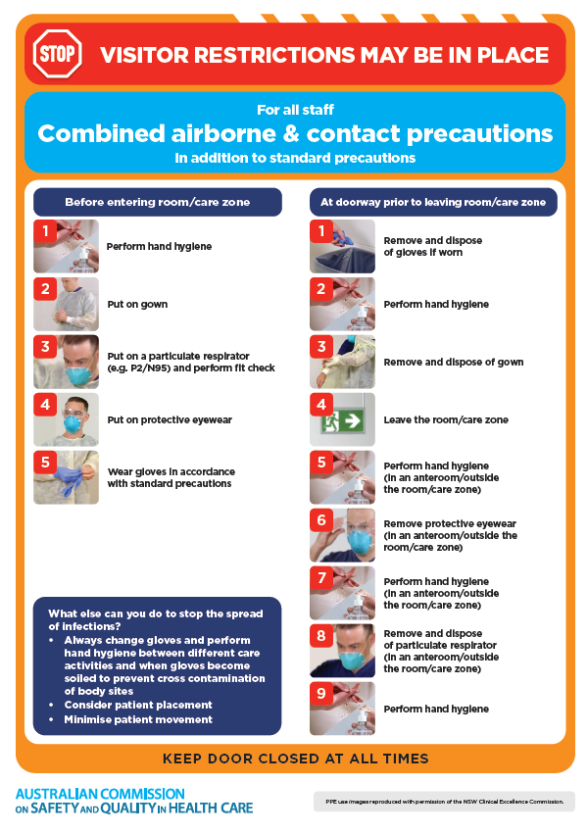
- Environmental Cleaning and Infection Prevention and Control www.safetyandquality.gov.au/environmental-cleaning
- Break the chain of infection poster
https://www.safetyandquality.gov.au/publications-and-resources/resource-library/break-chain-infection-poster
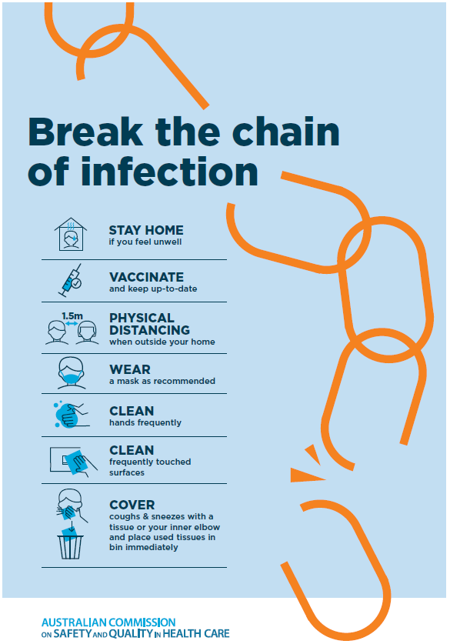

Disclaimer
On the Radar is an information resource of the Australian Commission on Safety and Quality in Health Care. The Commission is not responsible for the content of, nor does it endorse, any articles or sites listed. The Commission accepts no liability for the information or advice provided by these external links. Links are provided on the basis that users make their own decisions about the accuracy, currency and reliability of the information contained therein. Any opinions expressed are not necessarily those of the Australian Commission on Safety and Quality in Health Care.

