
On the Radar
Issue 696
19 May 2025

On the Radar is a summary of some of the recent publications in the areas of safety and quality in health care. Inclusion in this document is not an endorsement or recommendation of any publication or provider. Access to particular documents may depend on whether they are Open Access or not, and/or your individual or institutional access to subscription sites/services. Material that may require subscription is included as it is considered relevant.

On the Radar is available online, via email or as a PDF or Word document from https://www.safetyandquality.gov.au/newsroom/subscribe-news/radar

If you would like to receive On the Radar via email, you can subscribe on our website https://www.safetyandquality.gov.au/newsroom/subscribe-news
or by emailing us at mail@safetyandquality.gov.au.
You can also send feedback and comments to mail@safetyandquality.gov.au.

For information about the Commission and its programs and publications, please visit https://www.safetyandquality.gov.au

On the Radar
Editor: Dr Niall Johnson
Contributors: Niall Johnson, Brighid Carey, Helen Dowling

CARAlert annual report: 2024
Australian Commission on Safety and Quality in Health Care
Sydney: ACSQHC; 2025. p. 48.
https://www.safetyandquality.gov.au/publications-and-resources/resource-library/caralert-annual-report-2024

The Australian Commission on Safety and Quality in Health Care has released the 2024 CARAlert annual report, which provides analyses of data submitted to the National Alert System for Critical Antimicrobial Resistances (CARAlert). CARAlert collects information on priority organisms that have critical resistance to last-line antimicrobials and are uncommon in Australia (CARs). The report shows seasonal and geographic trends in CARs across acute and community settings as reported by laboratories that voluntarily participate in CARAlert.

Key findings include:
- Carbapenemase-producing Enterobacterales (CPE) continues to be the most frequently reported CAR – 45% of reports in 2024
- Rates of CARs in hospitals are rising, particularly CPE, which was most commonly reported from hospitals and accounted for the majority hospital reports in 2024
- There were notable increases in community-onset CARS from 2023 to 2024, including ceftriaxone-nonsusceptible Neisseria gonorrhoeae (up 100%).

Although the increasing rate of reports to CARAlert has slowed from 2023 to 2024 (up 25%) compared to 2022 to 2023 (up 87%), ongoing reports of CARs is concerning. Resumed international travel and social interaction following restrictions associated with the COVID-19 pandemic is likely contributing to the increasing number of reports to CARAlert. This is particularly concerning for vulnerable populations, such as residents of aged care homes. As CARs threaten the efficacy of antimicrobials and patient safety, this report highlights the importance of continuing surveillance of antimicrobial resistance and infections, along with antimicrobial stewardship and infection prevention and control programs.

Reports

World report on social determinants of health equity
World Health Organization
Geneva: WHO; 2025. p. 248.
URL | https://www.who.int/teams/social-determinants-of-health/equity-and-health/world-report-on-social-determinants-of-health-equity
Notes | It is recognised that, as noted at the start of the Executive Summary to this report, ‘The place where you live, the communities you belong to, your education level, ethnicity, race, income and gender, and whether you have a disability, all make a huge difference to how long you can expect to live a healthy life.’ These social determinants of health equity have a powerful influence on avoidable and unjust health gaps. This report ‘presents evidence-based strategies and policy recommendations to guide governments, civil society and international organizations in creating just and equitable health systems’.  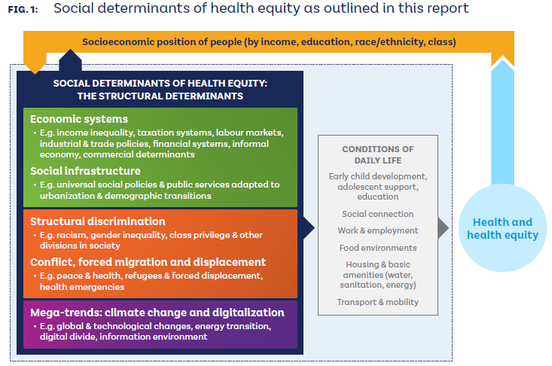
Mental health inpatient settings: overarching report of investigations directed by the Secretary of State for Health and Social Care
Health Services Safety Investigation Body
Poole: HSSIB; 2025.
URL | https://www.hssib.org.uk/patient-safety-investigations/mental-health-inpatient-settings/fifth-investigation-report/
Notes | This report from the Health Services Safety Investigation Body (HSSIB) in the UK is an overarching report and the last in a series of HSSIB investigations on the theme of patient safety in Mental health inpatient settings. The aim of this report is to examine patient safety risks identified across the series of inpatient mental health investigations. This report acknowledges that the delivery of mental health inpatient care is complex and influenced by many interacting factors. The report includes a number of findings, recommendations and observations that ‘offer opportunities to facilitate improvements in systems, practices and future plans to support patient safety in mental health inpatient settings’. While the findings stem from a series of investigations relating to specific facilities in the UK, they may have resonance and relevance elsewhere. The findings cover areas including:  - Safety, investigation, and learning culture  - System integration and accountability  - Physical health of patients in mental health inpatient settings  - Caring for people in the community  - Staffing and resourcing  - Digital support for safe and therapeutic care  - Suicide risk and safety assessment.

Setting the foundation for quality management in home- and community-based long-term care
World Health Organization Regional Office for Europe
Copenhagen: WHO Regional Office for Europe; 2025. p. 26.
URL | https://www.who.int/europe/publications/i/item/WHO-EURO-2025-12064-51836-79440
Notes | Technical brief from the World Health Organization’s Regional Office for Europe seeking to address the ‘gap between the rapid expansion of home- and community-based long-term care (‎LTC)‎ services and the slower development of regulatory frameworks for quality management in these settings’. The brief outlines ‘quality standards for home- and community-based LTC and proposes indicators for measuring their progress. Common quality assurance mechanisms for monitoring and evaluating compliance with these standards and ensuring good quality care in the community are highlighted, along with ways of incentivizing care providers to adopt a mindset of quality improvement. Finally, essential steps for driving transformative change in quality of care in the community are outlined.’

State of the world’s nursing 2025: Investing in education, jobs, leadership and service delivery
World Health Organization
Geneva: WHO; 2025. p. xviii, 143.
URL | https://www.who.int/publications/i/item/9789240110236/
Notes | The 2025 edition of the World Health Organization’s State of the world’s nursing report provides a comprehensive analysis of the nursing workforce globally. The report includes measures on critical areas for nursing, such as education capacity, advanced practice nursing and remuneration. This report has seen a 33% increase in the number of countries reporting on a core set of indicators as compared with State of the world’s nursing 2020. The improved data availability allows greater precision in describing the challenges to nursing education, employment, service delivery and leadership, and for policy responses to address them. Country profiles with national level data are available online for download.

Rapid evidence services: standard operating procedures for rapid response products
World Health Organization Regional Office for Europe
Copenhagen: WHO Regional Office for Europe; 2025. p. 72.
URL | https://www.who.int/europe/publications/i/item/9789289060035
Notes | Resource from the World Health Organization’s Regional Office for Europe that offers guidance on the use and development of rapid response services (RRS) and their rapid response products (RRPs). RRPs ‘) provide timely and evidence-informed policy solutions and options to decision-makers by relying primarily on previously published systematic reviews’ They [are] …an important KT [Knowledge Translation] tool for health systems to include within their repertoire, as they can provide tailored, timely evidence-informed guidance for policy development and implementation.’

Implementing a co-ordinated approach to robotic-assisted surgery
Getting It Right First Time (GIRFT)
London: NHS England; 2025. p. 48.
URL | https://gettingitrightfirsttime.co.uk/implementing-a-co-ordinated-approach-to-robotic-assisted-surgery/
Notes | In the UK the Getting It Right First Time (GIRFT) initiative has developed this guidance that seeks to increase the use of robotic-assisted surgery (RAS) programmes in NHS trusts, including training of staff, evaluation and safety monitoring. The guide presents a framework for NHS providers and commissioners to adopt a co-ordinated approach, supporting clinical teams to implement RAS programmes that are cost-effective, efficient and equitably provided for patients.

Journal articles

Optimizing ward rounds: systematic review and meta-analysis of interventions to enhance patient safety
Treloar EC, Ey JD, Herath M, Edwardes NPR, Edwards S, Bruening MH, et al
British Journal of Surgery. 2025;112(4):znaf041.
URL | https://doi.org/10.1093/bjs/znaf041
Notes | Paper reporting on a systematic review that sought to examine ‘interventions aiming to improve patient and process-based outcomes in ward rounds’. Based on ‘84 studies, from 18 countries, in 23 specialties, involving 43 570 patients’, the review found:  - Checklist interventions significantly reduced ICU length of stay, improved overall documentation, and did not increase ward round duration  - Structure interventions [defined rules or protocol to guide or standardize conduct] did not increase the time spent per patient or impact 30-day readmission rates or patient length of stay.

Oral Anticoagulation and Risk of Adverse Clinical Outcomes in Venous Thromboembolism
Bea S, Iyer GS, Kim DH, Lin KJ, Zhang Y, Zakoul H, et al.
JAMA Internal Medicine. 2025.
DOI | https://doi.org/10.1001/jamainternmed.2025.1109
Notes | Paper reporting on a study that used data from the French National Pharmacovigilance Database (BNPV) to compare three of the most commonly prescribed anticoagulants for prevention of recurrent venous thromboembolism (VTE). The authors report apixaban being associated with a lower risk of hospitalizations for recurrent VTE and major bleeding compared with rivaroxaban or warfarin.

For information on venous thromboembolism and the Venous Thromboembolism Prevention Clinical Care Standard, see https://www.safetyandquality.gov.au/standards/clinical-care-standards/venous-thromboembolism-prevention-clinical-care-standard

HealthcarePapers
Volume 37, special issue, 2025
URL | https://www.longwoods.com/publications/healthcarepapers/27542/
Notes | A new issue of HealthcarePapers has been published with a theme of ‘’Artificial Intelligence for Healthcare in Canada’. Articles in this issue of HealthcarePapers include:  - What Problem Are We Trying to Solve With Artificial Intelligence for Healthcare in Canada? (Ashley Chisholm, Owen Adams, Sara Allin and Audrey Laporte)  - Artificial Intelligence for Healthcare in Canada: Contrasting Advances and Challenges (Jacqueline K Kueper and Jay Pandit)  - Through the Nursing Lens: How AI Will Change Healthcare Practice and Professions (Tracie Risling and Gillian Strudwick)  - Education and the Adoption of AI in Healthcare: “What Is Happening?” (Brian D Hodges)  - How Are Canadians Regulating Artificial Intelligence for Healthcare? A Brief Analysis of the Current Legal Directions, Challenges and Deficiencies (Sian Hsiang-Te Tsuei)  - Achieving Health Equity for All Canadians: Is AI Currently Up to the Task? (Stephanie Garies, Jessalyn K Holodinsky, Jason E Black and T Williamson)  - Training Data Tell Us a Lot About Whom Health AI Tools Are Likely to Benefit (Alison P Paprica)  - Accelerating AI Adoption for Reducing Administrative Burden in Primary Care: Insights from Evaluating AI Scribes (Onil Bhattacharyya, Payal Agarwal, Emily Ha, Jean Yong and Enid Montague)  - Workforce Investments to Accelerate Learning Health Systems With Artificial Intelligence in Northern and Rural Settings (Dominique Cava and Brianne Wood)  - Tipping the Balance Toward Positive Futures for Patients: AI in Healthcare (Jennifer Zelmer and Annette McKinnon)  - Artificial Intelligence in the Canadian Healthcare System: Scaling From Novelty to Utility (Jacqueline K. Kueperand Jay Pandit)

BMJ Quality & Safety online first articles
URL | https://qualitysafety.bmj.com/content/early/recent
Notes | BMJ Quality &Safety has published a number of ‘online first’ articles, including:  - Editorial: Why tackling overuse will not succeed without changing our culture (Rudolf Bertijn Kool, Andrea M Patey)  - Effectiveness of computerised alerts to reduce drug–drug interactions (DDIs) and DDI-related harm in hospitalised patients: a quasi-experimental controlled pre–post study (Melissa Therese Baysari, Sarah Nicole Hilmer, Richard O Day, Bethany Annemarie Van Dort, Wu Yi Zheng, Renee Quirk, Danielle Deidun, Maria Moran, Kristian Stanceski, Nanda Aryal, Ahmed Abo Salem, Lauren Farrow, Jannah Baker, Andrew Hargreaves, James Grant, Paula Doherty, Karma Zarif Sourial Mekhail, Johanna I Westbrook, Ling Li)  - Association between Child Opportunity Index and paediatric sepsis recognition and treatment in a large quality improvement collaborative: a retrospective cohort study (Lori Rutman, Troy Richardson, Jeffery Auletta, Fran Balamuth, Amber Chambers, Julie Fitzgerald, Javier Gelvez, Karen A Genzel, Amy Grant, Vishal Gunnala, Hana Hakim, Leslie Hueschen, Sarah Kandi, Gitte Larsen, Justin Lockwood, Kate Lucey, Elizabeth Mack, Kate Madden, Matthew Niedner, Raina Paul, Anireddy Reddy, Ruth Riggs, Johanna Rosen, Melissa Schafer, Halden Scott, Jennifer Wilkes, Matthew A Eisenberg Improving Pediatric Sepsis Outcomes Collaborative Investigators)  - Editorial: Unreasonable effectiveness of training AI models locally (Gabriel Wardi, Christopher A Longhurst)  - Patient portal messaging to address delayed follow-up for uncontrolled diabetes: a pragmatic, randomised clinical trial (Arielle R Nagler, Leora Idit Horwitz, Aamina Ahmed, Amrita Mukhopadhyay, Isaac Dapkins, William King, Simon A Jones, Adam Szerencsy, Claudia Pulgarin, Jennifer Gray, Tony Mei, Saul Blecker)  - Using implementation science to define the model and outcomes for improving quality in NEST360, a multicountry alliance for reducing newborn mortality in sub-Saharan Africa (Kylie Dougherty, Nebiyou Hailemariam, Georgia Jenkins, Junwei Chen, Jackson Ilangali, John Mwangi, Julius Thomas, Hannah Mwaniki Mwaniki, Olabisi Dosunmu, Robert Tillya, Samuel Ngwala, Joy E Lawn, Rebecca Richards-Kortum, Z Maria Oden, Christine Bohne, Lisa R Hirschhorn)  - Ending nuclear weapons, before they end us (Chris Zielinski)

International Journal for Quality in Health Care online first articles
URL | https://academic.oup.com/intqhc/advance-articles
Notes | International Journal for Quality in Health Care has published a number of ‘online first’ articles, including:  - Association Between Patient Experience and Medical Dispute Costs (Do Hee Kim et al)  - Quality of care for newly diagnosed patients with rheumatoid arthritis in South Korea: A nationwide cohort study (Jun Won Park et al)

Online resources

Australian Living Evidence Collaboration
https://livingevidence.org.au/

[USA] Effective Health Care Program reports
https://effectivehealthcare.ahrq.gov/
The US Agency for Healthcare Research and Quality (AHRQ) has an Effective Health Care (EHC) Program The EHC has released the following final reports and updates:
- Blood-Based Tests for Multiple Cancer Screening: A Systematic Review https://effectivehealthcare.ahrq.gov/products/cell-free-dna/research
- Association Between Outcomes and Dental Services in People With Substance Use Disorder: A Rapid Response Review https://effectivehealthcare.ahrq.gov/products/outcomes-dental-services/rapid-research
- Association Between Outcomes and Dental Services in People at Risk of Post-Transplant Complications: A Rapid Response Review https://effectivehealthcare.ahrq.gov/products/dental-post-transplant-complications/rapid-research

[UK] Patient Safety Learning and The Royal College of Surgeons of Edinburgh
The UK charity Patient Safety Learning asked the Patient Safety Group (PSG) of The Royal College of Surgeons of Edinburgh (RCSEd) to develop a number of resources for surgeons, anaesthetists and other healthcare professionals who work in surgery. These include:
- Top 10 priorities for patient safety in surgery
- Top 10 tips for surgical safety: ‘Think Safety, think SEIPS’ – top 10 tips for surgical safety using the SEIPS (Safety Engineering Initiative for Patient Safety) model.
- Top 10 patient safety tips for surgical trainees.

[Canada] Care Forward
https://www.healthcareexcellence.ca/en/care-forward/
Healthcare Excellence Canada is supporting Care Forward. Care Forward is described as ‘a pan-Canadian movement of people sharing knowledge and applying proven approaches to improve healthcare’.

Infection prevention and control and COVID-19 resources
The Australian Commission on Safety and Quality in Health Care has developed a number of resources to assist healthcare organisations, facilities and clinicians. These resources include:
- Poster – Combined contact and droplet precautions https://www.safetyandquality.gov.au/publications-and-resources/resource-library/infection-prevention-and-control-poster-combined-contact-and-droplet-precautions
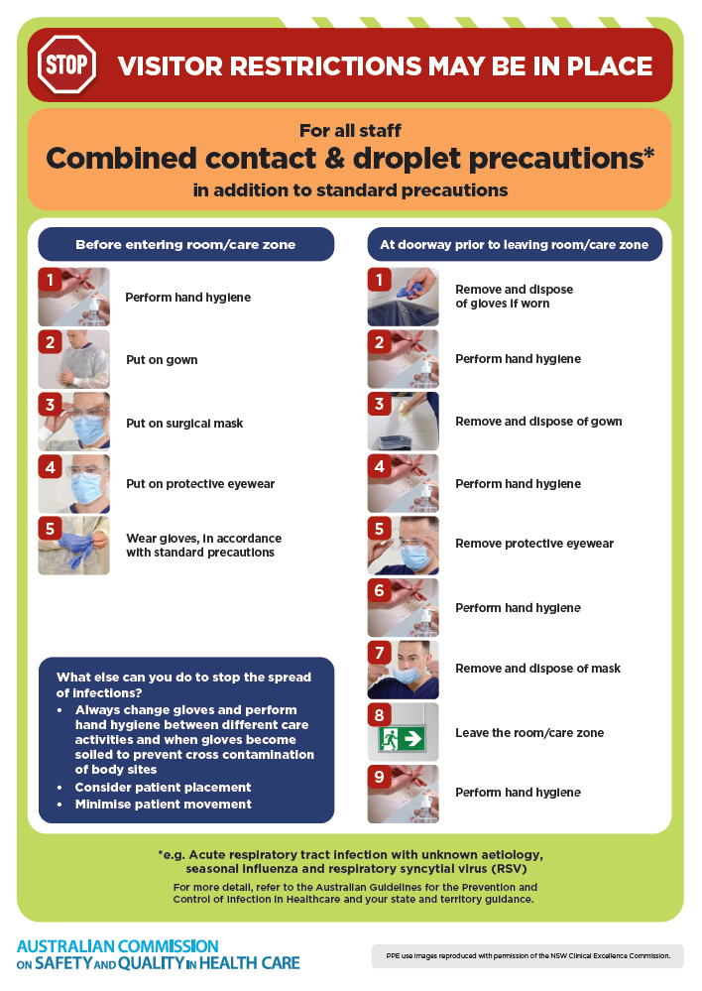
- Poster – Combined airborne and contact precautions
https://www.safetyandquality.gov.au/publications-and-resources/resource-library/infection-prevention-and-control-poster-combined-airborne-and-contact-precautions
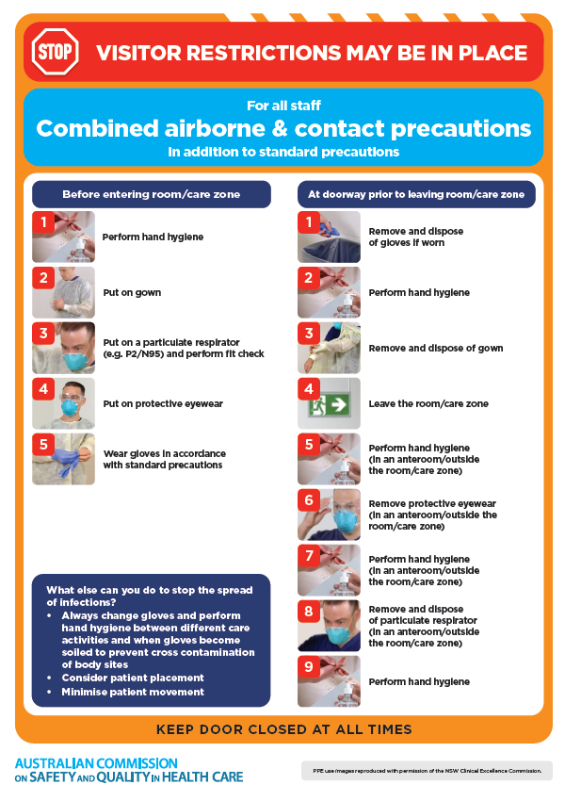
- Environmental Cleaning and Infection Prevention and Control www.safetyandquality.gov.au/environmental-cleaning
- Break the chain of infection poster
https://www.safetyandquality.gov.au/publications-and-resources/resource-library/break-chain-infection-poster
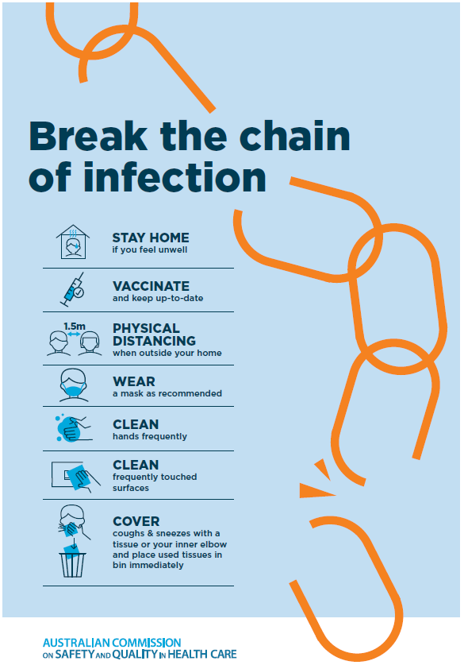

Disclaimer
On the Radar is an information resource of the Australian Commission on Safety and Quality in Health Care. The Commission is not responsible for the content of, nor does it endorse, any articles or sites listed. The Commission accepts no liability for the information or advice provided by these external links. Links are provided on the basis that users make their own decisions about the accuracy, currency and reliability of the information contained therein. Any opinions expressed are not necessarily those of the Australian Commission on Safety and Quality in Health Care.

