
On the Radar
Issue 699
9 June 2025

On the Radar is a summary of some of the recent publications in the areas of safety and quality in health care. Inclusion in this document is not an endorsement or recommendation of any publication or provider. Access to particular documents may depend on whether they are Open Access or not, and/or your individual or institutional access to subscription sites/services. Material that may require subscription is included as it is considered relevant.

On the Radar is available online, via email or as a PDF or Word document from https://www.safetyandquality.gov.au/newsroom/subscribe-news/radar

If you would like to receive On the Radar via email, you can subscribe on our website https://www.safetyandquality.gov.au/newsroom/subscribe-news
or by emailing us at mail@safetyandquality.gov.au.
You can also send feedback and comments to mail@safetyandquality.gov.au.

For information about the Commission and its programs and publications, please visit https://www.safetyandquality.gov.au

On the Radar
Editor: Dr Niall Johnson
Contributors: Niall Johnson, Hayley Warren, Maria Sukkar

Consultation on the new Australian Safety and Quality Medical Imaging Accreditation Scheme
https://safetyandquality.gov.au/ASQMIA

Medical imaging is used to diagnose, monitor and treat a wide range and expanding number of medical conditions. The Australian Commission on Safety and Quality in Health Care has developed the Australian Safety and Quality Medical Imaging Accreditation (ASQMIA) Scheme to ensure medical imaging providers meet high-quality standards, leading to better patient outcomes and safer health care.

This Scheme will be assessed against the National Safety and Quality Medical Imaging Standards and will replace the existing Diagnostic Imaging Accreditation Scheme (DIAS).

The implementation of the ASQMIA scheme signals a significant shift for the medical imaging sector. Changes include a transition from a desktop assessment to a risk-based assessment, including onsite, virtual, hybrid and short notice assessments.

The ASQMIA Scheme will ensure medical imaging providers are assessed on their day-to-day patient care and reduce the documentation burden they have currently under DIAS.

Public consultation on the Scheme is now open. To share your feedback, complete a survey, attend an interview or provide a written submission by 18 July 2025.
For further information, visit https://safetyandquality.gov.au/ASQMIA

Reports

Digital Health Literacy Toolkit
Global Digital Health Partnership
2025. p. 68.
URL | https://gdhp.health/digital-health-literacy-toolkit/
Notes | The Global Digital Health Partnership (GDHP) is described as ‘a collaboration of governments and territories, government agencies and the World Health Organization, formed to support the effective implementation of digital health services’ established in 2018.  Digital health literacy is defined as ‘The ability to find, understand, and apply health information, and to manage one’s own health, by using electronic tools and information sources such as apps, video conferencing platforms, online portals and web sites.’  This toolkit draws together ‘learnings and practices to support the advancement of public digital health literacy’. The toolkit consists of 5 modules:  - Module 1: Introduction  - Module 2: GDHP Digital Health Literacy Survey Findings  - Module 3: Case Examples  - Module 4: Checklists and Considerations  - Module 5: Collection of Digital Health Literacy Resources.

Healthcare in Focus – New South Wales health system performance
Bureau of Health Information
St Leonards: BHI; 2025.
URL | https://www.bhi.nsw.gov.au/BHI_reports/healthcare_in_focus/new-south-wales-health-system-performance
Notes | Report from the Bureau of Health Information in New South Wales (NSW) examining aspects of NSW health system performance in the context of high demand for hospital services and other pressures faced by health systems following the COVID-19 pandemic. The report includes a number of measures of safe care and clinical outcomes including healthcare associated infections and complications after surgery. It also shows that rates of mortality within 30 days of admission to NSW public or private hospitals for six clinical conditions and one surgical procedure have decreased since 2016. The report also examines access and wait times; experiences of patients and healthcare staff; and highlights areas where the system is responding and adapting to new challenges. It shows trends over time, variation across NSW local health districts (LHDs), and provides comparisons with other Australian states and territories and comparable countries for selected measures.

Addressing the digital determinants of youth mental health and well-being: Policy brief
Copenhagen: WHO Regional Office for Europe; 2025. p. 28.
URL | https://www.who.int/europe/publications/i/item/WHO-EURO-2025-12187-51959-79685
Notes | This policy brief published by the WHO Regional Office for Europe ‘aims to support countries to formulate evidence-informed policy responses to the increasing influence of digital determinants on the mental health of young people in the WHO European Region’. The policy brief ‘suggests eight priority actions for countries to promote and protect the mental health and well-being of young people in digital environments, and to mitigate the potential harms related to social media, artificial intelligence and other digital technologies’.

Global standard for safe listening video gameplay and esports
World Health Organization, and International Telecommunication Union
Geneva: World Health Organization and International Telecommunication Union; 2025. p. 84.
URL | https://www.who.int/publications/i/item/9789240108028
Notes | As computer gaming and e-sports have become increasingly popular – crossing generations and seeing gaming surpassing the movie industry in scale – it has also emerged that listening practices for these activities can be harmful and ‘could place many individuals worldwide at risk of permanent hearing loss and/or tinnitus’. The International Telecommunication Union (ITU) and the World Health Organization (WHO) embarked on developing the World’s first technical standard for safe listening in video gameplay and esports. The document ‘outlines the key features and requirements that video gameplay devices and/or video gameplay software titles must have in order to facilitate safe listening practices among users’.

Consideration of environmental impacts in health technology assessment
Deeble Institute for Health Policy Research Issues Brief no: 58
Williams J, Haddock R
Canberra: Australian Healthcare and Hospitals Association; 2025. p. 28.
URL | https://ahha.asn.au/resource/consideration-of-environmental-impacts-in-health-technology-assessment/
Notes | This issues brief from the Australian Healthcare and Hospitals Association’s Deeble Institute for Health Policy examines how health technology assessment (HTA) approaches could be adjusted to take into consideration the environmental impacts of the technologies being assessed. The authors of this brief assert that ‘Considering environmental impacts in HTAs could drive meaningful progress to make the healthcare system more environmentally sustainable.’

Health technology assessment of medical devices.
2nd ed.
WHO medical device technical series
World Health Organization
Geneva: World Health Organization; 2025. P. xii, 58.
URL | https://iris.who.int/handle/10665/381526
Notes | The World Health Organization has published a new edition of this guidance on health technology assessment (HTA) for medical devices. Health technology assessment (HTA) is described as ‘a well-recognized and methodologically robust evidence-based priority-setting process used to provide information on the safety, efficacy, quality, appropriateness, and cost-effectiveness of health technologies’. This document ‘is intended to provide guidance to policy-makers, particularly those in LMICs [low- and middle-income countries] that are currently developing HTA capacity.’ The document describes ‘general concepts of HTA and points to best-practice resources to enable LMICs to make consistent, transparent and informed decision-making on the adoption and use of medical devices to ensure clinical needs are met whilst delivering value to patients, healthcare providers, and the broader health system.’

Journal articles

What Is Important to Older People When Accessing Urgent Health Care: Key Considerations and Recommendations From Consumer Consultations
Rahja M, Zaluski S, Greene L, Crotty M, Whitehead C, Laver K
Health Expectations. 2025;28(3):e70311.
DOI | https://doi.org/10.1111/hex.70311
Notes | Paper reporting on a study that sought ‘to understand the needs and preferences of older people when accessing urgent care, and what an ideal journey through an urgent care service would look like.’ Based on the three workshops undertaken in Adelaide, South Australia with 39 participants aged 65 and above, the authors report that ‘Four themes emerged regarding the needs and preferences for urgent care services:  (1) accessible and responsive,  (2) age appropriate with expert care,  (3) listen to me, my story and  (4) safe and well-planned discharge.’

Optimizing Safety for Patients Transferred From Intensive Care Units to General Medical Wards: A SIMPLER Approach
Redelmeier DA, Haas B, Silverstein WK
JAMA Internal Medicine. 2025
DOI | https://doi.org/10.1001/jamainternmed.2025.1497
Notes | Paper seeking to identify some of issues around transitions of care when a patient leaves an intensive care unit (ICU) for ‘a general medical ward (or other de-escalated care settings, such as a step-down unit) for observation, treatment, and discharge planning.’ The authors describe ‘a checklist to support safe ICU transfers of patients to medical wards or step-down units.’ The proposed 7-step checklist has the mnemonic SIMPLER:  Stable vital signs  Intact aeration  Medications reviewed  Prepared psychology  Lingering catheters  Extreme laboratory findings, and  Return plans.  The authors state ‘The first 3 steps are prerequisites in a medical ward and denote the importance of stable vitals signs, intact aeration, and a diligent medication check. The next 3 steps are priorities in the ICU and involve determining patient expectations, managing catheters or other devices, and reviewing laboratory results. The final step concerns contingency plans for unforeseen deteriorations and goals of care.’  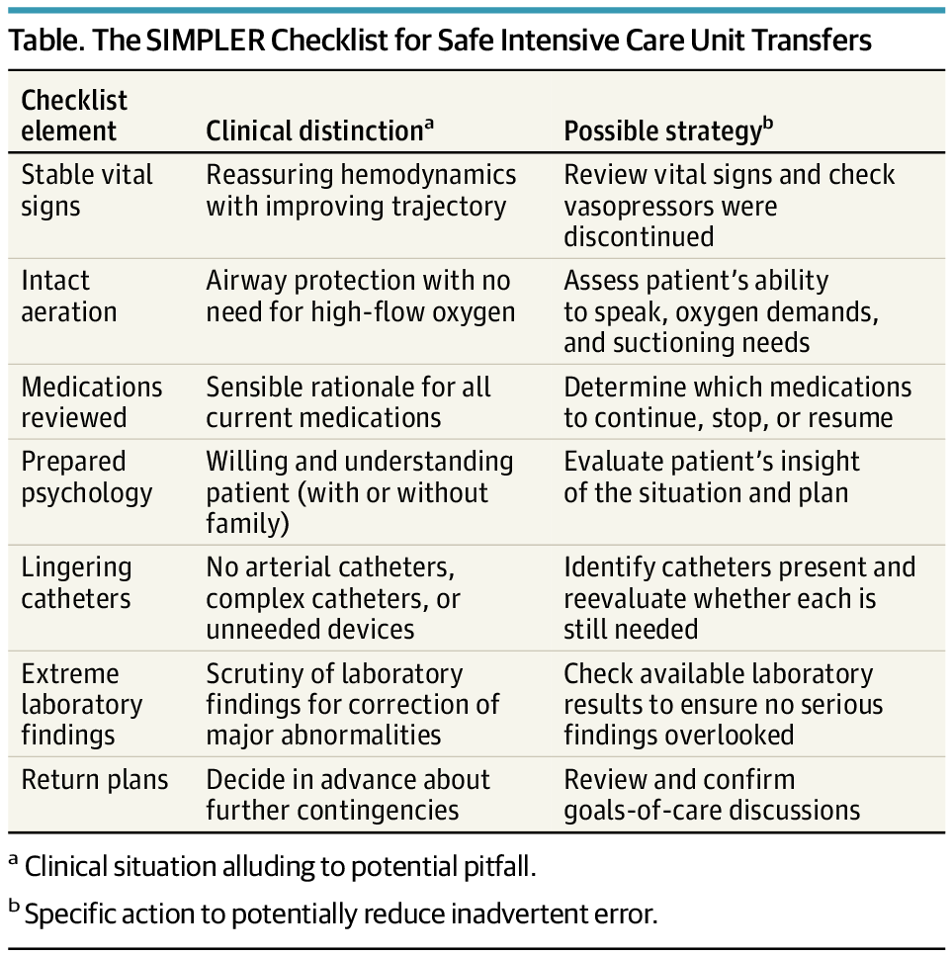

Development of the Australian Rheumatology Association Clinical Care Standard for the diagnosis and management of rheumatoid arthritis in adults
Sukkar MB, Ainley R, Barrett C, Bond S, Bradbury LA, Briggs AM, et al
The Journal of Rheumatology. 2025:jrheum.2024-1034.
DOI | https://doi.org/10.3899/jrheum.2024-1034
Notes | The Australian Rheumatology Association has developed the first Clinical Care Standard for rheumatoid arthritis (RA) in Australia. This Standard outlines what good care looks like for people with RA, from diagnosis through to ongoing treatment.  To create the Standard, a group of experts – including people living with RA – worked together to develop key principles and quality statements about RA care. They looked at existing guidelines and international best practices. They then asked over 900 people, including both healthcare professionals and consumers, to rate each statement based on how important it is and whether they agree with it. Most of the statements (12 out of 13) were rated as both highly important and agreed upon.  This Standard will serve as an important tool for healthcare professionals and services, consumer organisations and policy makers to improve the quality of care for adults with RA.

For information on the Clinical Care Standards developed by the Australian Commission on Safety and Quality in Health Care, see https://www.safetyandquality.gov.au/standards/clinical-care-standards

Australian Health Review
Volume 49 Number 1 2025
URL | https://www.publish.csiro.au/ah
Notes | The Australian Health Review has moved to a continuous publication model. In the continuous publication model, once an article is ready for publication, it is immediately published online with final citation details (https://www.publish.csiro.au/journals/continuouspublication). Recent articles in the Australian Health Review include:  - Enhancing digital healthcare: aligning Australia’s digital health strategies with value-based healthcare principles (Paul Tait, Darren Daff, Pamela Everingham, Ashley Leahy, Rhys Parker, R Perry, M Smith and D Morris)  - Artificial intelligence medical scribes in allied health: a solution in search of evidence? (Laura Ryan and Laetitia Hattingh)  - Evaluation of the Aboriginal and Torres Strait Islander Outpatient Clinic: a mixed-methods study (Tanya Druce, S Cronin, A Vandenberg and D Kerr)  - Promoting access to voluntary assisted dying: an interpretivist exploratory study of health services in Queensland, Australia (Jayne Hewitt, Michael Wilson, Melissa J Bloomer, Cooper Rennie and Ann Bonner)  - Are people with diabetes mHealth-ready? Smartphone utilisation in a socioeconomically marginalised urban Australian general practitioner-led diabetes clinic (David Chua, Carina Vasconcelos Silve, Souhayel Hedfi, Keren Pointon, T A Comans, H L Mayr, M Janda, A W Russell and A Menon)  - A guide to using measures of socio-economic status, remoteness and population denominators from the Australian Bureau of Statistics for epidemiological studies (David Youens, Nita Sodhi-Berry, Ingrid Stacey, Marwan Ahmed and Judith M Katzenellenbogen)  - Assessing the value of online palliative care information (Seth Nicholls and Jennifer Tieman)  - Perceived motivators and barriers to research engagement for psychologists in an Australian public healthcare service: insights from the research capacity and culture survey (Young-Eun C Lee, Christine Miller and A Ure)  - Planning for the future of the Australian midwifery workforce: the Midwifery Futures workforce model (Kirsten Small, Martin Boyce, Chanelle Warton, Kathleen Baird, Zoe Bradfield, Jennifer Fenwick and Caroline Homer)  - Private car travel is the dominant form of transport to work for healthcare workers across Greater Western Sydney: a short report on a large travel survey (Soumya Mazumdar, Bin Jalaludin, David Surplice, Stephen Conaty, Kim Jobburn, Linda Stanbury, Helen Ryan and Josephine Sau Fan Chow)  - Behind the scan: addressing the silent strain on medical radiation professionals’ mental health (Min Ku, Jillian Cavanagh, Timothy Bartram and Leila Afshari)  - The Hospital Harmony program improves interdisciplinary healthcare team functioning and communication (Matthew J. Y. Kang, Ar Kar Aung, Rob Selzer, Ashlee Linck, Floyd F. Dias, Eldho Paul, Jennifer S. N. Tang, Jo Gibbs and Harry Gibbs)  - Where to for digital health? The Australian Council of Senior Academic Leaders in Digital Health action plan (Leanna Woods, Melanie Haines, Salma Arabi, James Boyd, Kerryn Butler-Henderson, Kathleen Gray, Russell L Gruen, Stephen Guinea, Christine Bennett and Clair Sullivan)  - Use of artificial intelligence to generate emergency department discharge summaries (Chuting Tang, Nilupul Mudunna, Ian Turner, Mohammad Asghari-Jafarabadi, Keith Joe and Lisa Brichko)  - Analysis of public dental waiting lists in Queensland – 2015–2024 (Ratilal Lalloo)  - The role of Medicare policy in fertility treatment decisions: perceptions of Australians considering, undertaking or who have undertaken medically assisted reproduction treatment (Lauren Jaensch, J A Grieger and M Oxlad)  - Assessing the unmet need for diabetic eye screening in regional Queensland (Alexander Bremner, David Squirrell and Brett Sillars)  - Impacts of eHealth on hospitals: an updated narrative review of systematic reviews (Mahmoud Abdelghani, Yi-Ting Yeh, Rebekah Eden, Leanna Woods, Graeme Mattison, Sophie Macklin, Oliver Canfell and Clair Sullivan)  - A ‘True North Statement for Care’: charting the course to better care for all Australians (Rebecca K. Golley, Georgia Middleton, Michael T. Lawless, Lucy Anastasi, Alison L. Kitson and Raymond J Chan)  - Accuracy of medication allergy documentation in My Health Record after severe adverse drug reactions (Juliana Yang, William Lay, Linda V. Graudins, Melissa Walker, Celia Zubrinich and Ar Kar Aung)  - Advance care planning: empowering older frail people to document their end of life wishes (Peter Gonski, Melissa Chan and Ken Hillman)  - Sociodemographic and clinical factors affecting advance care planning: results from a large community cohort in New South Wales, Australia (E Yang, A Kabir, J Rhee, C O’Callaghan and M Barr)

Health Affairs
Volume 44, Number 6, June 2025
URL | https://www.healthaffairs.org/toc/hlthaff/44/6
Notes | A new issue of Health Affairs has been published with a themes of ‘Payment Policy, Medicare Advantage & More’. Articles in this issue of Health Affairs include:  - Medicare Part D Redesign Savings May Be Lower For Beneficiaries With Spending Below The Out-Of-Pocket Cap (Stacie B Dusetzina, Youngmin Kwon, Nancy L Keating, and Haiden A Huskamp)  - Site-Neutral Payment Reform: Little Impact On Outpatient Medicare Spending Or Hospital-Physician Integration (Brady Post, Ngoc Thai,Noor-E-Alam, and Gary J Young)  - Medicare Site-Neutral Payment Policies: Effects Of Proposals On Hospitals And Beneficiary Groups (Klara K Lou, Kathryn E Linehan, Lauren N da Fonte, Pikki Lai, and Melinda B Buntin)  - Site-Neutral Payment And Biosimilars Competition Are Complementary Purchaser Strategies For Cancer Biologics (James C Robinson, and Christopher M Whaley)  - Medicare Advantage Plan Disenrollment: Beneficiaries Cite Access, Cost, And Quality Among Reasons For Leaving (Geoffrey J Hoffman, Lianlian Lei, Ishrat Alam, Myra Kim, Lillian Min, Zhaohui Fan, and Deborah Levine)  - Medicare Advantage Dental Benefits: Comprehensive Coverage Available In Fewer Than Half Of US Counties (Lisa Simon, M Vujicic, and K Nasseh)  - Medicare Advantage Denies 17 Percent Of Initial Claims; Most Denials Are Reversed, But Provider Payouts Dip 7 Percent (Boris Vabson, Andrew L Hicks, and Michael E Chernew)  - Claim Denials: Low-Income Patients From Disadvantaged Racial And Ethnic Groups Experienced The Largest Burdens (Michal Horný, Olivia Yu, and Alex Hoagland)  - CMS’s Hospice Star Rating System Limited By Missing Data (Amanda C Chen, and David C Grabowski)  - Skilled Nursing Facility Value-Based Purchasing Failed To Achieve Hospital Readmission Reductions And Other Targets (Robert E Burke, Franya Hutchins, Jonathan Heintz, Scott Appel, Julie Norman, Syama Patel, Atul Gupta, Liam Rose, and Rachel M Werner)  - Transitional Care Management Associated With More Healthy Days At Home, Lower Spending After Hospital Discharge (MacKenzie L Hughes, Wen Hu, Jackie Soo, Joseph H Joo, Shriram Parashuram, Adil Moiduddin, Steven Sheingold, and Joshua M Liao)  - Hospital ‘Boarding’ Of Patients In The Emergency Department Increasingly Common, 2017–24 (Alexander T Janke, Laura G Burke, and Adrian Haimovich)  - Trends In Authorized Generic Drug Launches And Their Effects On Competition In Oral-Solid Drug Markets In The US, 2016–23 (Keith M Drake, Gered Dunne, Aime Mason, Thomas G McGuire, and Amie Price)  - Stipends From Hospitals To Emergency Medicine And Anesthesiology Clinicians Increased In California, 2002–21 (E Duffy, S Green, and E Trish)  - When A Health Economist Becomes A Cancer Patient (David Dranove)

BMJ Quality & Safety online first articles
URL | https://qualitysafety.bmj.com/content/early/recent
Notes | BMJ Quality &Safety has published a number of ‘online first’ articles, including:  - Regulating voluntary assisted dying at the clinical coalface: a qualitative interview study in Victoria, Australia (Casey M Haining, Lindy Willmott, Ben P White)  - Association between Child Opportunity Index and paediatric sepsis recognition and treatment in a large quality improvement collaborative: a retrospective cohort study (Lori Rutman, Troy Richardson, Jeffery Auletta, Fran Balamuth, Amber Chambers, Julie Fitzgerald, Javier Gelvez, Karen A Genzel, Amy Grant, Vishal Gunnala, Hana Hakim, Leslie Hueschen, Sarah Kandil, Gitte Larsen, Justin Lockwood, Kate Lucey, Elizabeth Mack, Kate Madden, Matthew Niedner, Raina Paul, Anireddy Reddy, Ruth Riggs, Johanna Rosen, Melissa Schafer, Halden Scott, Jennifer Wilkes, Matthew A Eisenberg Improving Pediatric Sepsis Outcomes Collaborative Investigators)

International Journal for Quality in Health Care online first articles
URL | https://academic.oup.com/intqhc/advance-articles
Notes | International Journal for Quality in Health Care has published a number of ‘online first’ articles, including:  - Toward a Greener Healthcare: Unveiling the Carbon Costs of Dialysis in China and the Path to Sustainability (Junxiong Ma , Shuhong Bi , Runming Du , Wangteng Jiao , Zhisheng Liang , Qinfeng Zhou , Shuduo Zhou , Yuhang Pan , Wen Tang , Haibin Zhang , Zhijie Zheng , Ming Xu , Tao Wang , Gordon Liu , Zhenyu Zhang)

Online resources

Australian Living Evidence Collaboration
https://livingevidence.org.au/

[UK] NICE Guidelines and Quality Standards
https://www.nice.org.uk/guidance
The UK’s National Institute for Health and Care Excellence (NICE) has published new (or updated) guidelines and quality standards The latest reviews or updates include:
- Clinical Guideline CG150 Headaches in over 12s: diagnosis and management https://www.nice.org.uk/guidance/cg150

Infection prevention and control and COVID-19 resources
The Australian Commission on Safety and Quality in Health Care has developed a number of resources to assist healthcare organisations, facilities and clinicians. These resources include:
- Poster – Combined contact and droplet precautions https://www.safetyandquality.gov.au/publications-and-resources/resource-library/infection-prevention-and-control-poster-combined-contact-and-droplet-precautions
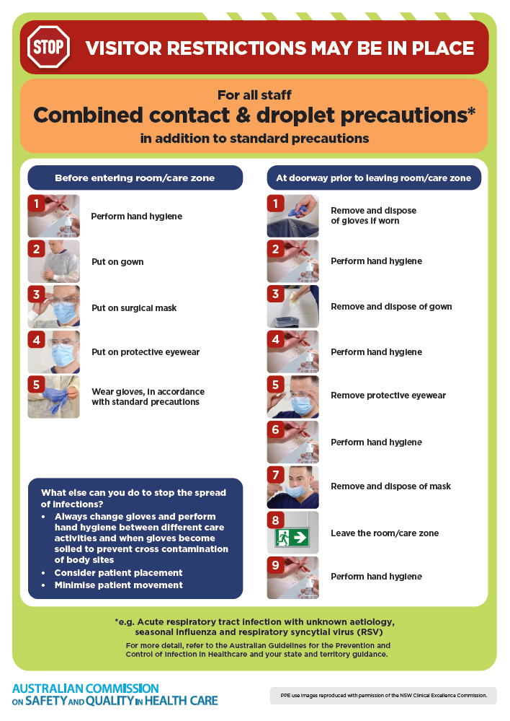
- Poster – Combined airborne and contact precautions
https://www.safetyandquality.gov.au/publications-and-resources/resource-library/infection-prevention-and-control-poster-combined-airborne-and-contact-precautions
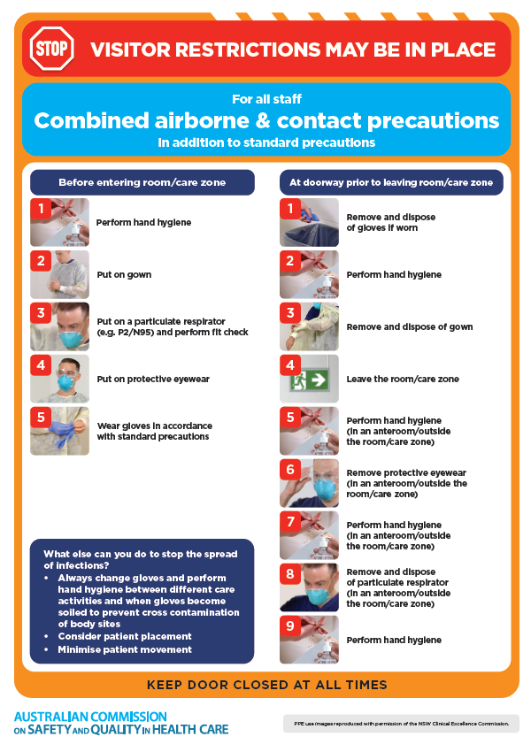
- Environmental Cleaning and Infection Prevention and Control www.safetyandquality.gov.au/environmental-cleaning
- Break the chain of infection poster
https://www.safetyandquality.gov.au/publications-and-resources/resource-library/break-chain-infection-poster
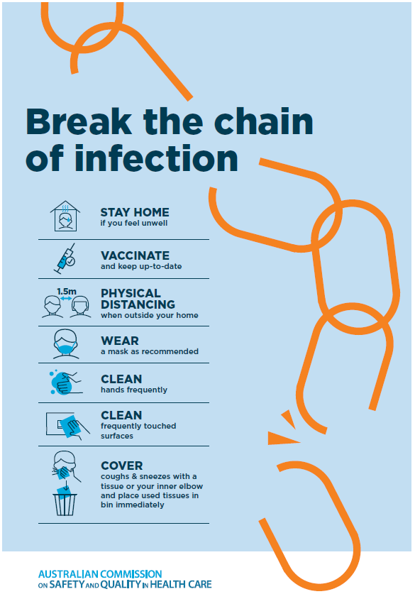

Disclaimer
On the Radar is an information resource of the Australian Commission on Safety and Quality in Health Care. The Commission is not responsible for the content of, nor does it endorse, any articles or sites listed. The Commission accepts no liability for the information or advice provided by these external links. Links are provided on the basis that users make their own decisions about the accuracy, currency and reliability of the information contained therein. Any opinions expressed are not necessarily those of the Australian Commission on Safety and Quality in Health Care.

