
On the Radar
Issue 701
23 June 2025

On the Radar is a summary of some of the recent publications in the areas of safety and quality in health care. Inclusion in this document is not an endorsement or recommendation of any publication or provider. Access to particular documents may depend on whether they are Open Access or not, and/or your individual or institutional access to subscription sites/services. Material that may require subscription is included as it is considered relevant.

On the Radar is available online, via email or as a PDF or Word document from https://www.safetyandquality.gov.au/newsroom/subscribe-news/radar

If you would like to receive On the Radar via email, you can subscribe on our website https://www.safetyandquality.gov.au/newsroom/subscribe-news
or by emailing us at mail@safetyandquality.gov.au.
You can also send feedback and comments to mail@safetyandquality.gov.au.

For information about the Commission and its programs and publications, please visit https://www.safetyandquality.gov.au

On the Radar
Editor: Dr Niall Johnson
Contributors: Niall Johnson

Reports

Policy alignment for place-based solutions for better health outcomes in rural and remote communities
Deeble Institute for Health Policy Research Perspectives Brief no: 34
Woolcock K, Gregg J, Groth A
Canberra: Australian Healthcare and Hospitals Association; 2025. p. 24.
URL | https://ahha.asn.au/resource/policy-alignment-for-place-based-solutions-for-better-health-outcomes-in-rural-and-remote-communities/
Notes | This Perspectives Brief from the Australian Healthcare and Hospitals Association’s Deeble Institute for Health Policy examines the challenge of health care delivery in rural and remote communities across Australia. The authors call for a place-based approach but acknowledge that ‘requires more than local action and community engagement’. They suggest ‘It requires alignment, integration and enablement in government policies and programs to effectively and efficiently deliver those community-led, place-based solutions.’ Four key areas are identified:  - Informing local investment and integration  - Prioritising care over administration  - Enabling a flexible, sustainable workforce  - Achieving aligned purpose across systems.

Journal articles

Eliminating hospital nurse understaffing is a cost-effective patient safety intervention
Lasater KB
BMJ Quality & Safety. 2025.
DOI | https://doi.org/10.1136/bmjqs-2025-018677
Notes | Editorial in BMJ Quality & Safety reflecting upon a longitudinal observational study of 185 acute care units in 4 English hospitals over a 5-year period (http://dx.doi.org/10.1136/bmjqs-2024-018138). The editorial observes ‘Consistent with prior studies, this study finds that eliminating understaffing of registered nurses is associated with avoided deaths and readmissions, and shorter lengths of stay. Eliminating understaffing of nursing support staff is associated with improved patient outcomes, though to a lesser degree. The authors conclude that investment in registered nursing staff is a cost-effective, high-value investment and there are no shortcuts to employing enough registered nurses. In short—eliminating nurse understaffing saves patients’ lives and saves hospitals money.’

The Impact of Definitions of Disease on Overdiagnosis
Tikkinen KA, Halme ALE, Guyatt GH, Glasziou P
JAMA Internal Medicine. 2025.
DOI | https://doi.org/10.1001/jamainternmed.2025.1727
Notes | Viewpoint piece in JAMA Internal Medicine from a group of Finnish, Canadian and Australian writers observing that changes in ‘concept and definition of disease influences both clinical practice and public health.’ The concluding paragraph of this piece reads ‘The evolving definition of disease shapes clinical care and public health, often medicalizing normal life variations and contributing to overdiagnosis. Physicians must discern whether symptoms stem from treatable conditions or are part of normal life, in the process ensuring diagnoses improve health outcomes and quality of life. The global challenge of defining disease underscores the need to balance broader access to medical treatment with avoidance of harmful medicalization and inefficient resource use.’

A ‘True North Statement for Care’: charting the course to better care for all Australians
Golley RK, Middleton G, Lawless MT, Anastasi L, Kitson AL, Chan RJ
Australian Health Review. 2025;49(3).
DOI | https://doi.org/10.1071/AH25063
Notes | Paper reporting on the results of consultation including ‘national forum activities (activity 2, n = 31 organisations)’ and a ‘Delphi survey (activity 3, n = 28 organisations)’ that led to the development of a ‘True North Statement for Better Care. Results’. The authors assert that the Statement offers ‘a starting point to guide individual, organisation and system redesign across the life span. The statements require action at individual consumer, workforce and system level.’ The True North statement has 5 ‘ambition statements’ with 39 related actions. The ambition statements are:  - A culture of care  Consumers experience a culture of care where their health and wellbeing are taken care of in a holistic way, with their physical, mental, emotional, spiritual and cultural needs considered. People are seen as experts in their own health, and their friends and family who take care of them are recognised as important partners.  - Consumer experience of health and social care  A consumer experience of health and social care that empowers, informs and respects individuals, allowing them to easily and equitably access information and services. Consumers should be able to participate in their care according to their preferences, culture and values, provide feedback on their experiences and be involved in co-designing educational and system improvements supported by a comprehensive care team.  - A caring and cared for health and social care workforce  A care workforce that is skilled, respected and supported, working to the highest standards. This includes ensuring fair compensation, providing career pathways, strong leadership and support systems.  - Technology to support health and social care  Technology used to support health and social care systems, to make them more effective and accessible while improving communication and collaboration between providers and consumers.  - Learning health and care systems  Care systems that meet the different needs of communities by providing care that is tailored, accessible and integrated. These systems should be designed together with the people that use them.  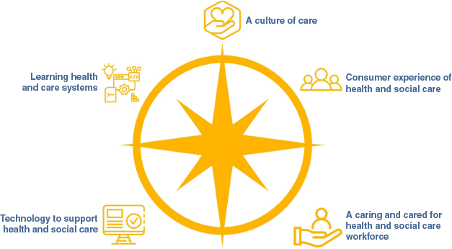

BMJ Quality & Safety
Volume 34, Issue 7, July 2025
URL | https://qualitysafety.bmj.com/content/34/7
Notes | A new issue of BMJ Quality & Safety has been published. Many of the papers in this issue have been referred to in previous editions of On the Radar (when they were released online). Articles in this issue of BMJ Quality & Safety include:  - Editorial: Understanding the evidence for artificial intelligence in healthcare (Gretchen Purcell Jackson, Edward H Shortliffe)  - Editorial: Workforce well-being is workforce readiness: it is time to advance from describing the problem to solving it (Bryan Sexton, Jochen Profit)  - Editorial: We will take some team resilience, please: Evidence-based recommendations for supporting diagnostic teamwork (Gabriela Fernández Castillo, Eduardo Salas, Eric J Thomas)  - Large-scale observational study of AI-based patient and surgical material verification system in ophthalmology: real-world evaluation in 37 529 cases (Hitoshi Tabuchi, Naofumi Ishitobi, Hodaka Deguchi, Yuta Nakaniida, Hayato Tanaka, Masahiro Akada, Mao Tanabe)  - Support for hospital doctors’ workplace well-being in England: the Care Under Pressure 3 realist evaluation (Anna Melvin, Alison Pearson, Daniele Carrieri, Charlotte Bramwell, Jason Hancock, Jessica Scott, Helen Foster Collins, Stuart McPhail, Mark Pearson, Chrysanthi Papoutsi, Geoff Wong, Karen Mattick)  - Doing ‘detective work’ to find a cancer: how are non-specific symptom pathways for cancer investigation organised, and what are the implications for safety and quality of care? A multisite qualitative approach (Georgia B Black, Brian D Nicholson, Julie-Ann Moreland, Naomi J Fulop, Georgios Lyratzopoulos, Ruth Baxter)  - Quantifying the cost savings and health impacts of improving colonoscopy quality: an economic evaluation (Stephen McCarthy, Matthew David Rutter, Peter McMeekin, Jamie Catlow, Linda Sharp, Matthew Brookes, Roland Valori, Rashmi Bhardwaj-Gosling, Tom Lee, Richard McNally, Andrew McCarthy, Joanne Gray)  - Improving weaning and liberation from mechanical ventilation for tracheostomy patients: a quality improvement initiative (Michael Mikhaeil, Michelle Bernard, Jenna Currie, Caroline Bolduc, Jordana Radke, Savannah Kranjc, Joanne Meyer)

Nursing Leadership
Volume 37, Number 4, 2025
URL | https://www.longwoods.com/publications/nursing-leadership/27606/
Notes | A new issue of Nursing Leadership has been published. This issue has a focus on ‘Nursing Data Standards’. Articles in this issue of Nursing Leadership include:  - Data, Advocacy and Policy: A Powerful Trio for Change (Ruth Martin-Misener)  - Embracing the Full Spectrum of Nursing Leadership: A Unified Call to Action for Canada’s Health System Transformation (Valerie Grdisa)  - Clinical Data Standards: It’s Now or Never for the Nursing Profession (Lynn M Nagle and Peggy White)  - Commentary: It is Now and We Need to Unite as One Profession and Drive the Data Structures for the Future (Valerie Grdisa)  - Commentary: The Value of Incorporating Nursing Standards in EHRs: A Vendor Perspective (Sonia Pagliaroli)  - Strengthening Canada’s Healthcare: The Ongoing Need for a Chief Nursing Officer (Sally Thorne, Claire Betker, Jacqollyne Keath, Kathleen MacMillan, Dianne Martin and Michael Villeneuve)  - Developing a Practice Standard to Address Indigenous-Specific Racism in Healthcare: A Case Study (Dave Bhauruth, Stephanie McDonnell, Rebekah Smith, Adiam Brhane and Sabrina Luke)  - People at the Core: Soulful Quality Improvement and Reflexive Nursing Leadership (Leinic Chung-Lee, Jennifer Lapum, Linda Liang, Karen Beckermann and Leah Welsh)

BMJ Quality & Safety online first articles
URL | https://qualitysafety.bmj.com/content/early/recent
Notes | BMJ Quality &Safety has published a number of ‘online first’ articles, including:  - Editorial: Checklist conundrum: are we checking the right boxes? (Gabriel Torrealba-Acosta, César E Escamilla-Ocañas)

Online resources

Australian Living Evidence Collaboration
https://livingevidence.org.au/

Guidance
A number of guidelines or guidance have recently been published or updated. These include:
- Australian guideline for the prevention, diagnosis and management of acute rheumatic fever and rheumatic heart disease: edition 3.3, Menzies School of Health Research, Heart Foundation https://rhdaustralia.org.au/arf-rhd-guidelines/
- Management of Mycobacterium ulcerans infection (Buruli ulcer) in Australia: consensus statement , Medical Journal of Australia https://doi.org/10.5694/mja2.52591
- Pain Management for In-Office Uterine and Cervical Procedures, American College of Obstetricians and Gynecologists https://www.acog.org/clinical/clinical-guidance/clinical-consensus/articles/2025/05/pain-management-for-in-office-uterine-and-cervical-procedures

[UK] NICE Guidelines and Quality Standards
https://www.nice.org.uk/guidance
The UK’s National Institute for Health and Care Excellence (NICE) has published new (or updated) guidelines and quality standards The latest reviews or updates include:
- NICE Guideline NG235 Intrapartum care https://www.nice.org.uk/guidance/ng235

Infection prevention and control and COVID-19 resources
The Australian Commission on Safety and Quality in Health Care has developed a number of resources to assist healthcare organisations, facilities and clinicians. These resources include:
- Poster – Combined contact and droplet precautions https://www.safetyandquality.gov.au/publications-and-resources/resource-library/infection-prevention-and-control-poster-combined-contact-and-droplet-precautions
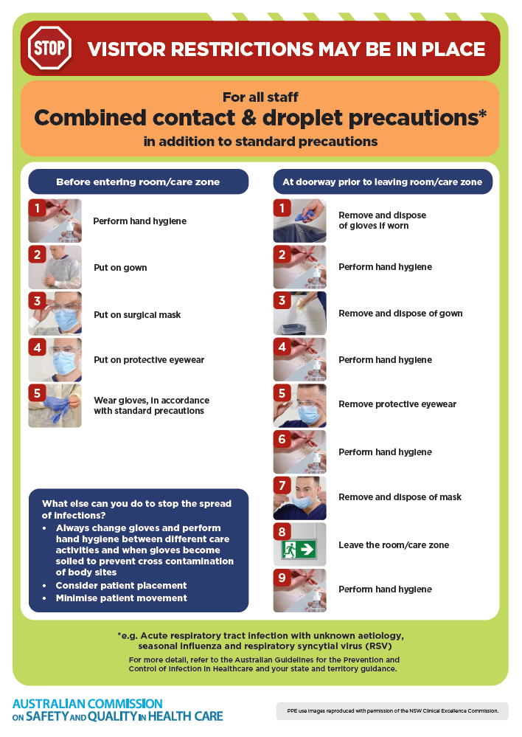
- Poster – Combined airborne and contact precautions
https://www.safetyandquality.gov.au/publications-and-resources/resource-library/infection-prevention-and-control-poster-combined-airborne-and-contact-precautions
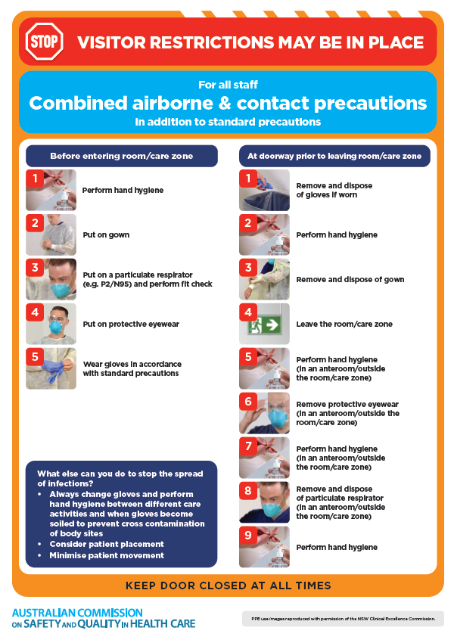
- Environmental Cleaning and Infection Prevention and Control www.safetyandquality.gov.au/environmental-cleaning
- Break the chain of infection poster
https://www.safetyandquality.gov.au/publications-and-resources/resource-library/break-chain-infection-poster
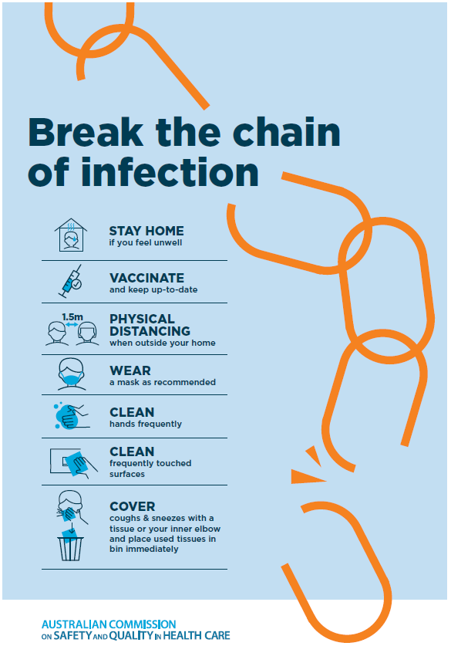

Disclaimer
On the Radar is an information resource of the Australian Commission on Safety and Quality in Health Care. The Commission is not responsible for the content of, nor does it endorse, any articles or sites listed. The Commission accepts no liability for the information or advice provided by these external links. Links are provided on the basis that users make their own decisions about the accuracy, currency and reliability of the information contained therein. Any opinions expressed are not necessarily those of the Australian Commission on Safety and Quality in Health Care.

