
On the Radar
Issue 704
14 July 2025

On the Radar is a summary of some of the recent publications in the areas of safety and quality in health care. Inclusion in this document is not an endorsement or recommendation of any publication or provider. Access to particular documents may depend on whether they are Open Access or not, and/or your individual or institutional access to subscription sites/services. Material that may require subscription is included as it is considered relevant.

On the Radar is available online, via email or as a PDF or Word document from https://www.safetyandquality.gov.au/newsroom/subscribe-news/radar

If you would like to receive On the Radar via email, you can subscribe on our website https://www.safetyandquality.gov.au/newsroom/subscribe-news
or by emailing us at mail@safetyandquality.gov.au.
You can also send feedback and comments to mail@safetyandquality.gov.au.

For information about the Commission and its programs and publications, please visit https://www.safetyandquality.gov.au

On the Radar
Editor: Dr Niall Johnson
Contributors: Niall Johnson, Jackie Coleman, Elyse Powell

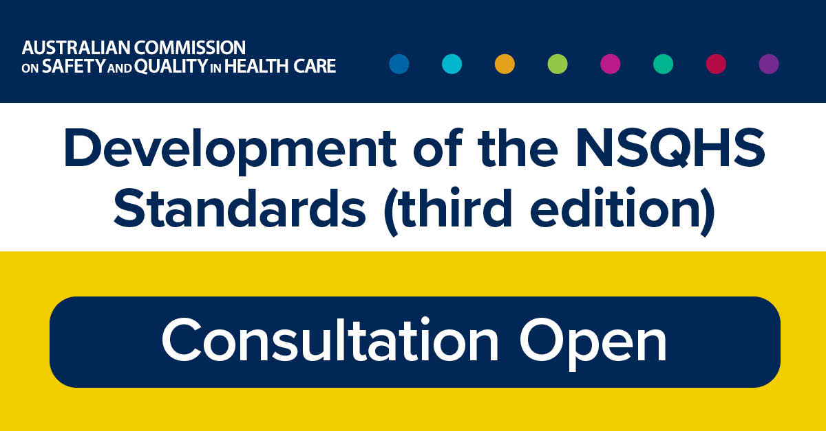
Consultation open – Developing the third edition of the National Safety and Quality Health Service Standards
https://www.safetyandquality.gov.au/newsroom/consultations/nsqhs-standards-third-edition-public-consultation-1

The Commission develops national standards in collaboration with the healthcare system and community representatives. Its flagship, the National Safety and Quality Health Service Standards (NSQHS Standards), provides a structured framework for delivering high-quality care with consistent systems across the continuum of care.

It has been ten years since the NSQHS Standards (second edition) were released and preparation for the third edition is underway. Public consultation opened in July to inform their development. The NSQHS Standards (third edition) will incorporate new evidence-based practices, emerging evidence and contemporary clinical governance approaches.

By consulting broadly, the Commission will design standards to respond to the health system's needs. The initial consultation aims to identify:
- Focus areas for the NSQHS Standards (3rd ed.)
- Emerging and existing safety and quality issues
- Key learnings from the NSQHS Standards (second edition)
- Opportunities to improve the NSQHS Standards structure, support improved engagement and implementation.

If you wish to provide feedback, the Commission is accepting written submissions, undertaking face-to-face forums and online focus groups, or there is a sector survey to complete.
Find out more at https://www.safetyandquality.gov.au/standards/nsqhs-standards/nsqhs-standards-third-edition-engagement-hub

Reports

Renewing the Definitions of 'nursing' and 'a nurse'
Final project report, June 2025
White J, Gunn M, Chiarella M, Catton H, Stewart D
Geneva: International Council of Nurses; 2025. p. 92.
URL | https://admin.icn.ch/resources/publications-and-reports/renewing-definitions-nursing-and-nurse
Notes | The peak global nursing body, the International Council of Nurses (ICN), has released their updated definitions of ‘nurse’ and ‘nursing’ for the first time in over two decades. The ICN’s renewed definitions reflect the profession’s evolving role in contemporary healthcare, moving beyond task-based descriptions to encompass a broader scope of practice. The updated definition of a nurse emphasises the integral role nurses play in leadership, education, research, advocacy and innovation. Importantly, the updated definition of nursing includes the collective commitment to everyone’s right to access high quality care, demonstrating a shift away from individual patient outcomes. Nurses are the largest health workforce, and the release of these updated definitions can aid in strengthening the professions’ identity and influence.

Workforce and patient safety: electronic communications on patient discharge from acute hospitals
Investigation report
Health Services Safety Investigation Body
Poole: HSSIB; 2025.
URL | https://www.hssib.org.uk/patient-safety-investigations/workforce-and-patient-safety/fifth-investigation-report/
Notes | This report from the Health Services Safety Investigation Body (HSSIB) in the UK examines some of the issues around electronic discharge summary documents in the UK. The investigation ‘explored the patient safety risks associated with the communication of critical clinical information when patients are discharged from acute hospital inpatient settings, and the follow-up of ongoing actions for patients by primary and community care.’ The report includes a number of findings, recommendations and observations, along with a number of local-level learning prompts.

For information on the Commission's work on electronic discharge summary systems, see https://www.safetyandquality.gov.au/our-work/e-health-safety/electronic-discharge-summary-eds-systems

Universal access to essential oral healthcare through a priority-setting approach
Deeble Institute for Health Policy Research Issues Brief no: 59
Nguyen T, Haddock R
Canberra: Australian Healthcare and Hospitals Association; 2025. p. 36.
URL | https://ahha.asn.au/resource/universal-access-to-essential-oral-healthcare-through-a-priority-setting-approach/
Notes | This issues brief from the Australian Healthcare and Hospitals Association’s Deeble Institute for Health Policy looks at the issue of oral care in Australia. The exclusion of oral care from Medicare has been much debated. The authors of this issues brief observe that ‘Cost continues to be the most frequently reported barrier to accessing oral healthcare’ and suggest ‘require reforms to payment models and pricing structures to improve affordability and equity in access’ are required with the aim of ‘a more integrated, population-based approach to oral healthcare.’ They suggest ‘Adopting the WHO’s concept of essential oral healthcare would provide a clear, evidence-based framework for defining service coverage.’ They also offer recommendations, including:  - Define essential oral healthcare in Australia  - Implement a formal priority-setting approach  - Integrate oral healthcare into Health Technology Assessment (HTA) processes.

Co-design versus faux-design of Aboriginal and Torres Strait Islander health policy: a critical review
Butler T, Anderson K, Black O, Gall A, Ngampromwongse K, Murray R, et al.
Melbourne: Lowitja Institute; 2025. p. 35.
URL | https://www.lowitja.org.au/resource/co-design-versus-faux-design-of-aboriginal-and-torres-strait-islander-health-policy-a-critical-review/
Notes | The authors of this paper published by the Lowitja Institute assert that “co-design approach that centres Aboriginal and Torres Strait Islander peoples, knowledges, values, and practices offers a policy development solution that more effectively addresses prevailing systemic discrimination and inequities. However, while co-design terminology is increasing in Australian health policymaking, many cases apply only tokenistic or superficial co-design practices; an approach that we term ‘faux-design’.” In the paper they critically review ‘current approaches to co-designing and faux-designing health policy for Aboriginal and Torres Strait Islander peoples.’  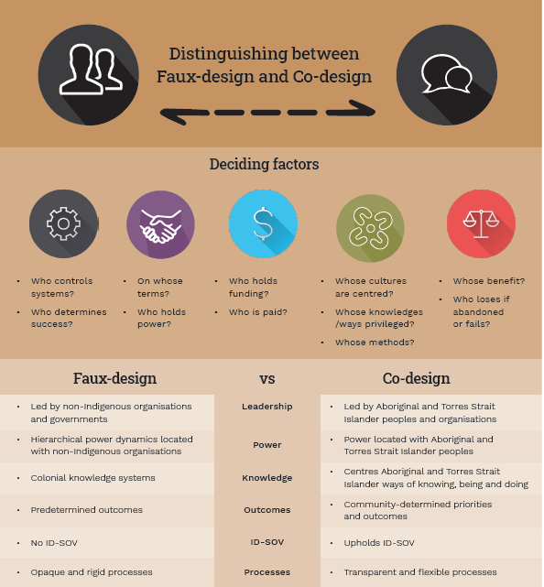

Transforming mental health through lived experience: roadmap for integrating lived and living experience practitioners into policy, services and community
World Health Organization Regional Office for Europe
Copenhagen: WHO Regional Office for Europe; 2025. p. 35.
URL | https://www.who.int/europe/publications/i/item/WHO-EURO-2025-12307-52079-79927
Notes | From the resource’s webpage ‘Integrating lived/living experience practitioners into health-care and social systems is crucial to realizing recovery-oriented mental health care. Practitioners model recovery and bridge gaps between traditional health-care structures and service users, humanizing and promoting inclusivity of services. This roadmap, co-created under the WHO Regional Office for Europe’s collaboration with the European Commission under the “Addressing mental health challenges in the European Union, Iceland and Norway” project, provides a structured framework to integrate lived/living experience expertise into mental health systems and workforce through six essential actions.’

Journal articles

Proposing core competencies for physicians in using artificial intelligence tools in clinical practice
Scott IA, Shaw T, Slade C, Wan TT, Barmanray R, Coorey C, et al
Internal Medicine Journal. 2025 2025/06/27.
DOI | https://doi.org/10.1111/imj.70112
Notes | Artificial intelligence (AI) encompass both a current and emerging set of technologies and their applications in health care. The authors, all working in Australia, of this piece propose ‘a practical and manageable set of core competencies for physicians in using AI tools effectively and ethically and suggests methods for acquiring these competencies.’ The various competencies have been grouped in these domains:  - Foundational knowledge of AI tools  - Critical appraisal of AI tools  - Use of AI tools  - Patient interaction with AI tools  - Professionalism and AI tools.

Healthcare Policy
Volume 20, Number 3, 2025
URL | https://www.longwoods.com/publications/healthcare-policy/27518/1/vol.-20-no.-3-2025
Notes | A new issue of Healthcare Policy has been published. Articles in this issue of Healthcare Policy include:  - Editorial: Provincial Leadership and Green Shoots: Where to Look for Innovation (Jason M Sutherland)  - Adolescent Access to Abortion Care in Canada: Age, Capacity and Parental Consent (Alana Cattapan, Kathleen Hammond and Eleanor McGrath)  - Commentary: Adolescents, Marginalization(s) and Abortion Care in Canada (Tobin LeBlanc Haley and Ghazal Motamedi)  - Advice or Advocacy – Varying Perceptions of Health Services and Policy Researcher Activities (P Alison Paprica, W P Wodchis and K M McGrail)  - Commentary: Risk and Causality: The Contribution of Policy Researchers to Public Decisions (Pierre-Gerlier Forest)  - What Explains Interprovincial Differences in the Uptake of Autonomous NP Primary Care Practice? (Damien Contandriopoulos and Katherine Bertoni)  - Conceiving Policy Design: Perspectives From Women Pursuing IVF in British Columbia (Jenna Quelch)  - Impacts of Home Care Investments in Alberta: Ecological and Economic Trend Analysis (Max Jajszczok, Cathy A Eastwood, Mingshan Lu, Ceara Cunningham and Hude Quan)

Health Affairs
Volume 44, Number 7, July 2025
URL | https://www.healthaffairs.org/toc/hlthaff/44/7
Notes | A new issue of Health Affairs has been published with a themes of ‘Health Spending, Rural Hospitals, Maternal Care & More’. Articles in this issue of Health Affairs include:  - National Health Expenditure Projections, 2024–33: Despite Insurance Coverage Declines, Health To Grow As Share Of GDP (Sean P Keehan, Andrew J Madison, John A Poisal, Gigi A Cuckler, Sheila D Smith, Andrea M Sisko, Jacqueline A Fiore, and Kathryn E Rennie)  - Mixed Evidence That Rural Hospitals’ Finances Improved With Participation In The Pennsylvania Rural Health Model (Paula Chatterjee, Michael Wang, X Chen, S Kim, N B Coe, K E Joynt Maddox, K Murphy, and R M Werner)  - Factors Influencing Rural Hospitals’ Decisions To Join An Alternative Payment Model: A Mixed-Methods Study (Kimberly J Rak, Donald S Bourne, Jacqueline Barnes, Nicole Ober, Zhaojun Sun, Judy C Chang, Eric T Roberts, Manisha Bhattacharya, Bruce L Jacobs, J M Kahn, and L M Sabik)  - Obstetric Care Access Declined In Rural And Urban Hospitals Across US States, 2010–22 (Katy Backes Kozhimannil, Julia D Interrante, Caitlin Carroll, Emily C Sheffield, Alyssa H Fritz, Alecia J McGregor, and Sara C Handley)  - Maternal Contact With Child Protective Services Associated With Less Postpartum Care In Wisconsin, 2010–19 (Nicole Kovski, Lawrence Berger, and Maria Cancian)  - Connecticut’s Novel Prenatal Substance Exposure Policy Is Associated With Declining CPS Reports And Foster Placements (Margaret Lloyd Sieger, Lucas Godoy, Timothy E Moore, Cindy Nichols, Elizabeth J Goldsborough, Shiyi Chen, Mishka Terplan, Beth Ann Griffin, and Stephen W Patrick)  - New Cancer Drug Approvals: Less Than Half Of Important Clinical Trial Uncertainties Reported By The FDA To Clinicians, 2019–22 (Avi Cherla, S Woloshin, A K Wagner, O J Wouters, C Davis, E Mossialos, and H Naci)  - Drug Coverage Policies And Clinical Guidelines Alignment: Most Coverage Decisions Include Additional Restrictions (Julia A Rucker, Molly T Beinfeld, Katherine A Clifford, J D Campbell, J Motyka, and J D Chambers)  - Administrative Claims Data Show Increased Morbidity Risk For US Adults In Same-Sex Versus Different-Sex Relationships (Landon Hughes, Gilbert Gonzales, Sarah McKetta, Alex McDowell, and Brittany M Charlton)  - Medigap Regulations Provide Protections For Beneficiaries, Especially After Health Shocks, But May Raise Premiums (Jingwei Sun, Michael E Chernew, J Michael McWilliams, Boris Vabson, and Timothy J Layton)  - Medicaid Managed Care: Substantial Shifts In Market Landscape And Acquisitions, 2006–20 (Bohan Li and Timothy J Layton)  - Preferred Sources For Suicide Prevention And Crisis Services Among Segments Of The US Adult Population (Jonathan Purtle, Alex Dahlen, Amanda Mauri, Blake R Erickson, and Michael P Lindsey)  - Qualified Medicare Beneficiary Program: Enrollment Trends And Characteristics Of Low-Income Beneficiaries (J Wyatt Koma, Zhiyou Yang, Mary Price, David Cheng, Felippe Marcondes, Kobi Khong, John Hsu, Margarita Alegría, Joseph P Newhouse, and Vicki Fung)  - A Transfer That Shouldn’t Wait (Travis Wassermann)

BMJ Quality & Safety online first articles
URL | https://qualitysafety.bmj.com/content/early/recent
Notes | BMJ Quality &Safety has published a number of ‘online first’ articles, including:  - Impact of online patient access to clinical notes on quality of care: a systematic review (Yoko Yoshimura, Geva Greenfield, Elena Lammila-Escalera, Brian Mcmillan, Benedict Hayhoe, Azeem Majeed, Ana Luisa Neves)  - Editorial: More alerts, less harm? Rethinking medication safety with AI (Clare Tolley, Andrew Kenneth Husband)  - Editorial: From parallel tracks to integrated practice: advancing the integration of quality improvement and implementation science (Stephanie Bogdewic, Susan Cronin, Rohit Ramaswamy)  - RECi-PE (REducing CT in Pulmonary Embolism Diagnosis): an emergency department quality intervention (Jared S Anderson, Andrew Beck, Janette Baird, Timmy R Lin, Anthony M Napoli)  - Evaluation of the accuracy and safety of machine translation of patient-specific discharge instructions: a comparative analysis (Marianna Kong, Alicia Fernandez, Jaskaran Bains, Ana Milisavljevic, Katherine C Brooks, Akash Shanmugam, Leslie Avilez, Junhong Li, Vladyslav Honcharov, Andersen Yang, Elaine C Khoong)

International Journal for Quality in Health Care online first articles
URL | https://academic.oup.com/intqhc/advance-articles
Notes | International Journal for Quality in Health Care has published a number of ‘online first’ articles, including:  - Did the introduction of an electronic booking form for elective caesarean section improve compliance with guidelines for gestational age at delivery? (Julian Vitali et al)

Online resources

Australian Living Evidence Collaboration
https://livingevidence.org.au/

How to Communicate Health Messages to Young People on Social Media
https://www.sydneyhealthliteracylab.org.au/social-media-comms-for-young-people-framework
Resource from the Sydney health literacy lab and Sydney Infectious Diseases Institute on a framework to support more effective health communication with young people on social media, especially during health emergencies. The framework was co—designed with young people and youth researchers.

Guidance
A number of guidelines or guidance have recently been published or updated. These include:
- NHMRC has published version 2.0 of the Procedures and Requirements for Meeting the NHMRC Standards for Clinical Practice Guidelines (Procedures and Requirements). https://www.nhmrc.gov.au/about-us/publications/procedures-and-requirements-meeting-nhmrc-standards-clinical-practice-guidelines

[USA] Effective Health Care Program reports
https://effectivehealthcare.ahrq.gov/
The US Agency for Healthcare Research and Quality (AHRQ) has an Effective Health Care (EHC) Program The EHC has released the following final reports and updates:
- Fiber Intake and Laxation in People With Normal Bowel Function https://effectivehealthcare.ahrq.gov/products/fiber-intake/research

Infection prevention and control and COVID-19 resources
The Australian Commission on Safety and Quality in Health Care has developed a number of resources to assist healthcare organisations, facilities and clinicians. These resources include:
- Poster – Combined contact and droplet precautions https://www.safetyandquality.gov.au/publications-and-resources/resource-library/infection-prevention-and-control-poster-combined-contact-and-droplet-precautions
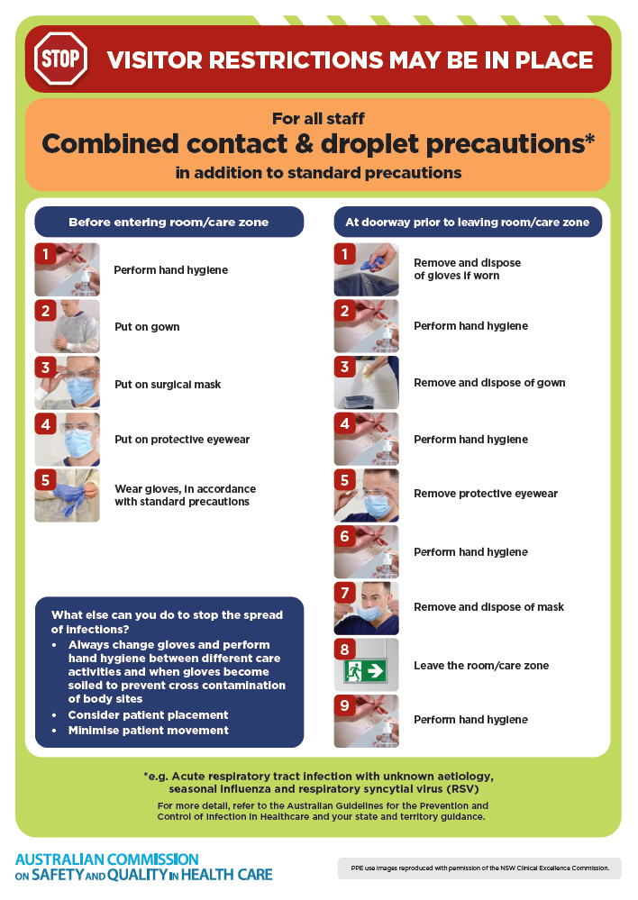
- Poster – Combined airborne and contact precautions
https://www.safetyandquality.gov.au/publications-and-resources/resource-library/infection-prevention-and-control-poster-combined-airborne-and-contact-precautions
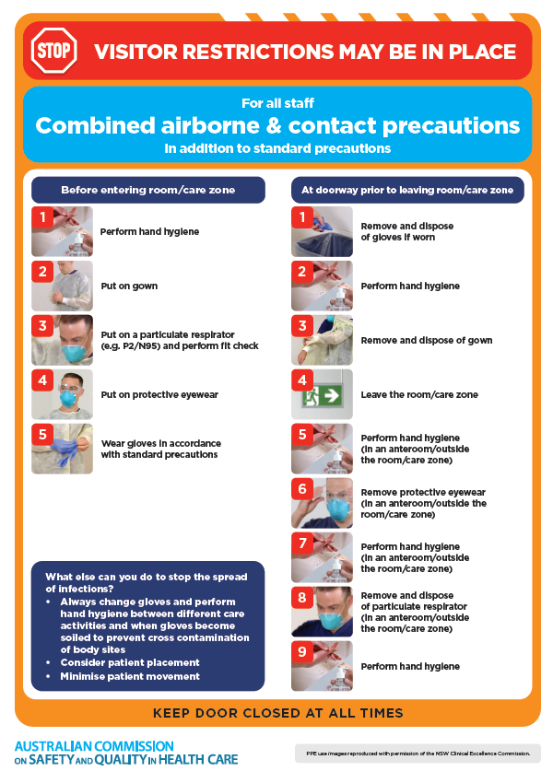
- Environmental Cleaning and Infection Prevention and Control www.safetyandquality.gov.au/environmental-cleaning
- Break the chain of infection poster
https://www.safetyandquality.gov.au/publications-and-resources/resource-library/break-chain-infection-poster
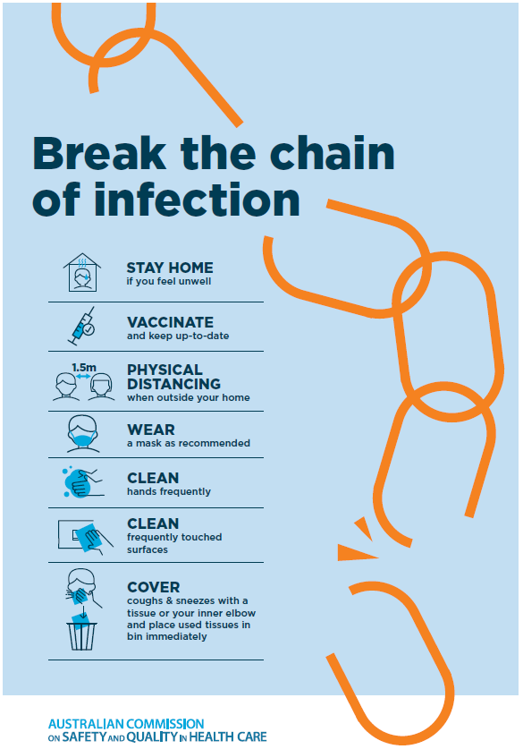

Disclaimer
On the Radar is an information resource of the Australian Commission on Safety and Quality in Health Care. The Commission is not responsible for the content of, nor does it endorse, any articles or sites listed. The Commission accepts no liability for the information or advice provided by these external links. Links are provided on the basis that users make their own decisions about the accuracy, currency and reliability of the information contained therein. Any opinions expressed are not necessarily those of the Australian Commission on Safety and Quality in Health Care.

