
On the Radar
Issue 705
21 July 2025

On the Radar is a summary of some of the recent publications in the areas of safety and quality in health care. Inclusion in this document is not an endorsement or recommendation of any publication or provider. Access to particular documents may depend on whether they are Open Access or not, and/or your individual or institutional access to subscription sites/services. Material that may require subscription is included as it is considered relevant.

On the Radar is available online, via email or as a PDF or Word document from https://www.safetyandquality.gov.au/newsroom/subscribe-news/radar

If you would like to receive On the Radar via email, you can subscribe on our website https://www.safetyandquality.gov.au/newsroom/subscribe-news
or by emailing us at mail@safetyandquality.gov.au.
You can also send feedback and comments to mail@safetyandquality.gov.au.

For information about the Commission and its programs and publications, please visit https://www.safetyandquality.gov.au

On the Radar
Editor: Dr Niall Johnson
Contributors: Niall Johnson, Kerryn Viana, Leanne Cox

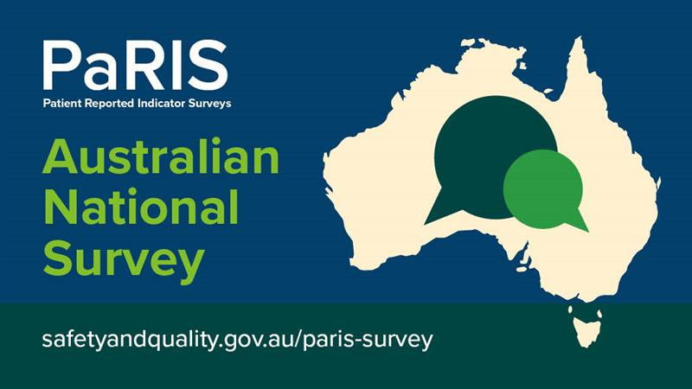
Patient-Reported Indicator Surveys (PaRIS) Australian National Report 2025
Australian Commission on Safety and Quality in Health Care and Department of Health, Disability and Ageing
Sydney: ACSQHC; 2025. p. 15.
https://www.safetyandquality.gov.au/paris-survey

The Australian Commission on Safety and Quality in Health Care has released the Patient-Reported Indicator Surveys (PaRIS) Australian National Report 2025.
The report highlights Australia’s performance in the PaRIS Health Survey – a landmark international survey, led by the OECD, that collected information across 19 countries from patients living with chronic conditions. The aim of the research was to understand patient experiences and outcomes in primary health care, such as GP practices. The report provides valuable insights on how to improve health care to better meet patient needs.

The Australian Commission on Safety and Quality in Health Care implemented the PaRIS Health Survey in Australia on behalf of the Australian Government Department of Health, Disability and Ageing (https://www.safetyandquality.gov.au/paris-survey)

Recognising Excellence in Clinical Care Standards
https://www.safetyandquality.gov.au/standards/clinical-care-standards/10th-anniversary-clinical-care-standards

The Commission’s Clinical Care Standards help to improve the quality of patient care across Australia. Ten years on, the standards remain relevant and achievable to implement. To celebrate the 10th Anniversary, the Commission asked health services and clinicians to share their experiences in successfully implementing Clinical Care Standards.

Five health services from across Australia have been recognised with 10th Anniversary Clinical Care Standards Excellence Awards. These stories of excellence demonstrate significant improvements in patient care, as well as the challenges, experiences and the steps taken to overcome them. Each story highlights how meaningful change can be achieved by effectively implementing a Clinical Care Standard.

- The Commission will be hosting a webinar on 19 August 2025 to showcase these Stories of Excellence, featuring a panel of representatives from each of the five Award winning services. Register for our webinar to hear our panel’s insights on:
- engaging stakeholders to achieve your goal
- improving audits to elevate the quality of your data
- embedding and sustaining change

Find out more at: https://www.safetyandquality.gov.au/standards/clinical-care-standards/10th-anniversary-clinical-care-standards

Reports

Review of patient safety across the health and care landscape
Dash P
London: Department of Health and Social Care; 2025. p. 175.
URL | https://www.gov.uk/government/publications/review-of-patient-safety-across-the-health-and-care-landscape
Notes | Report of an independent review of patient safety across the health and care landscape in England, which was commissioned by the Department of Health and Social Care. The review was asked to look at 6 specific organisations that were established to either assure - or contribute to improving - the safety of care, while also making reference to the wider landscape of organisations influencing quality of care. The review includes a number of finding and recommendations that focus on streamlining the patient safety landscape and improving accountability in England.

Advancing AI integration in hospitals: an appendicitis case-study approach
Deeble Institute for Health Policy Research Perspectives Brief no: 35
Herchen A, Patel B, Woolcock K
Canberra: Australian Healthcare and Hospitals Association; 2025. p. 30.
URL | https://ahha.asn.au/resource/advancing-ai-integration-in-hospitals-an-appendicitis-case-study-approach/
Notes | This perspectives brief from the Australian Healthcare and Hospitals Association’s Deeble Institute for Health Policy looks at the question of the implementation of artificial intelligence (AI) in Australian hospitals using an appendicitis case-study. The authors stress the importance of governance to uphold clinical accountability, transparency, validation processes and ‘A targeted, problem-driven approach’.

Journal articles

Association between caregiver concern for clinical deterioration and critical illness in children presenting to hospital: a prospective cohort study
Mills E, Lin P, Asghari-Jafarabadi M, West A, Craig S
The Lancet Child & Adolescent Health. 2025;9(7):450-458.
DOI | https://doi.org/10.1016/S2352-4642(25)00098-7
Notes | Paper from an Australian study that sought to ‘examine the relationship between documented caregiver concern about clinical deterioration and critical illness in children presenting to hospital’. This prospective observational cohort study was conducted in the tertiary paediatric emergency department and inpatient paediatric wards at Monash Children's Hospital, Melbourne in the period 1 November 2020 to 31 Dec 2022. The authors report that ‘Of the 73 845 children with eligible emergency department presentations, 24 239 had at least one documented response for parent or caregiver concern (11 431 [47·2%] males and 12 808 [52·8%]) females). There were a total of 189 708 responses, and 8937 (4·7%) of these indicated concern for clinical deterioration.’ The study found ‘Compared with patients with caregivers without documented concerns, those with a caregiver reporting concern for clinical deterioration were more likely to be admitted to the ICU (6·9% [326/4721] vs 1·8% [352 of 19 518]), to be mechanically ventilated (1·1% [53 of 4721] vs 0·2% [48 of 19 518]), or die during admission (0·1% [five of 4721] vs 0·02% [four of 19 518]).’  These lead to the observation ‘Caregiver concern for clinical deterioration is associated with critical illness in paediatric patients and, after adjusting for variables including abnormal vital signs, had a strong association with ICU admission and mechanical ventilation. Rapid response systems should incorporate proactive assessment of parent or caregiver concerns for deterioration.’  This paper was also discussed in an article in The Guardian by Australian oncologist Ranjana Srivastava. She particularly noted that ‘parental concern was found to be more strongly associated with ICU admission than any abnormal vital sign including abnormal heart rate or breathing, cardinal signs of deterioration relied upon by clinicians. In 19% of cases, parents reported a problem several hours before any vital sign abnormality.’

Interventions to improve patient safety during the COVID-19 pandemic: a systematic review
Wu AW, Trigg K, Zhang A, Alexander GC, Haut ER, Rock C, et al
BMJ Open Quality. 2025;14(2):e003076.
DOI | https://doi.org/10.1136/bmjoq-2024-003076
Notes | Paper reporting on a mixed-methods systematic review that sought ‘To summarise the literature on healthcare interventions to reduce harm to patients caused by the COVID-19 pandemic across six domains: medication safety, diagnostic safety, surgical safety, healthcare-associated infections, pressure injuries and falls.’ Focused on 61 articles, the authors report finding ‘There has been little research on interventions to reduce patient harm caused in healthcare settings during the COVID-19 pandemic. Interventions focused on preventing nosocomial transmission of COVID-19 and on permitting access to urgent surgical and diagnostic needs. A few studies tested strategies to reduce new risks imposed by the pandemic for medication safety, healthcare-associated infections, pressure injuries and falls.’  The authors also suggest that ‘Development of high-reliability health systems and healthcare organisations to protect patients and health workers from harm will be essential to mitigating the impact of future pandemics’.

Digital health interventions for mental health disorders: an umbrella review of meta-analyses of randomised controlled trials
Crocamo C, Palpella D, Cavaleri D, Nasti C, Piacenti S, Morello P, et al
The Lancet Digital Health. 2025.
DOI | https://doi.org/10.1016/j.landig.2025.100878
Notes | Paper reporting on a review of evidence from randomised controlled trials on the use of digital health interventions for the treatment of mental health issues. The review focused on 16 studies. The authors report that ‘DHIs were effective compared with active interventions for schizophrenia spectrum disorders, major depressive disorder, social anxiety disorder, and panic disorder. Notable treatment effects compared with a waiting list were also observed for specific phobias, generalised anxiety disorder, obsessive-compulsive disorder, post-traumatic stress disorder, and bulimia nervosa.’ However, they also noted that ‘Certainty of evidence was rated as very low or low in most cases, except for generalised anxiety disorder-related outcomes, which showed a moderate rating’.

What's the Point of Quality and Safety Auditing in Healthcare if Nurses Don't Use Data to Drive Improvement?
Ferguson C, Vaismoradi M, Glarcher M
Journal of Advanced Nursing. 2025.
DOI | https://doi.org/10.1111/jan.70050
Notes | Editorial reflecting on the role of auditing and feedback in health care, particularly from the nursing perspective. The authors pose the question ‘Are we auditing for improvement, or auditing for auditing's sake?’ They suggest that ‘There is a need for greater strategic thought on clinical auditing, as a nursing practice to enhance quality and safety in healthcare. Auditing is key in identifying risks and informing safer clinical practices, making it a foundational component of patient safety efforts. However, nursing time is finite, and it is crucial that as a profession we do not busy ourselves with over-auditing, whilst failing to engage and act on data.’

Health Policy
Volume 159, September 2025
URL | https://www.sciencedirect.com/journal/health-policy/vol/159/
Notes | A new issue of Health Policy has been published. Articles in this issue of Health Policy include:  - Addressing workforce gaps in public health medicine subspecialties in Turkiye: A call to action (Eray Ontas)  - Policy makers must adopt agile signal detection tools to strengthen epidemiological surveillance and improve pandemic preparedness (Cédric Mahé, Aimo Kannt, AIOLOS consortium)  - The role of burden of disease estimates in European Union Health policymaking: A systematic analysis of EU legislation (José Chen-Xu, Diana Grad, Nour Mahrouseh, João Vasco Santos, ... Susana Viegas)  - Towards effective policy measures to reduce informal payments in healthcare: addressing sample selection bias and measurement error in surveys (Maria Felice Arezzo, G Guagnano, C C Williams, A V Horodnic)  - A new integrative organizational health literacy framework for preventive action through intersectoral collaboration: Results of a landscape review (Francisco Javier Ferreira-Alfaya, Yasmin Cura, María José Zarzuelo-Romero)  - Shall we call for a doctor? How to build trust toward AI in healthcare: Insights from a Polish cross-sectional preference study (Katarzyna Kolasa, Katarzyna Baliga-Nicholson, Jaroslaw Wasniewski, Nikola Laskowska, ... Dominika Ciupek)  - Do faster‑trained physicians fill the gaps? Geographic concentration of emergency medicine physicians with different postgraduate training in Ontario Canada (David Kanter-Eivin, Calvin Armstrong, Anil Esleben, Grant Sweeny, ... Stephenson Strobel)  - The impact of a medical residents' walkout on mortality rates in South Korea, 2024 (Jin-Hwan Kim, Saerom Kim)  - Implications of multiprofessional collaboration in primary care – benefits for all? A quantitative study of effects on resource utilization of a team-based primary care practice in Sweden (Anna H Glenngård, Mattias Haraldsson)  - Impact of territorial case management on hospital admissions for complex chronic patients in Catalonia (Spain) (Jesús Antonio Vaquero Cruzado, Nuria Gutiérrez Jiménez, Laura Carrillo Ciércoles, Eva García Tarrida, ... Nuria Fabrellas Padrés)  - Exploring differences in performance management across public and private providers in primary care: Evidence from Finland and Sweden (Anna Häger Glenngård, Teemu Malmi)  - The progressivity of health care revenue financing in 29 countries: A comparison (Andres Võrk, Peter Pažitný, Ruth Waitzberg, Sara Allin, ... Thomas Rice)  - The opportunities and challenges of integrating health and social care in post-stroke patient journey: perceptions of Estonian professionals (Kadi Lubi, Helin Pevkur, Katrin Gross-Paju, Maarja-Liis Elland, Peeter Ross)  - Private equity investment in long-term care: The case of Ireland (Nicholas O’Neill, Julien Mercille)  - Overseas general practitioners (GPs) and opioid prescriptions in England (Joan E Madia, Catia Nicodemo, Cristina E Orso, Cristina Tealdi)  - Education and fertility: Evidence from an instrumental variable approach using higher education expansions in Turkey (Badi H Baltagi, Haci M Karatas)  - Urban NO₂-pollution and health outcomes: Evidence from a natural experiment in Italy on the simulated benefits of the EU zero-emission-vehicles resolution (Daniele Bondonio, Paolo Chirico, Massimiliano Piacenza, Simone Robbiano)

BMJ Quality & Safety online first articles
URL | https://qualitysafety.bmj.com/content/early/recent
Notes | BMJ Quality &Safety has published a number of ‘online first’ articles, including:  - Sustainability of the de-implementation of low-value care in infants with bronchiolitis: 2-year follow-up of a cluster randomised controlled trial (Victoria Ramsden, Franz E Babl, Libby Haskell, Catherine Wilson, Sandy Middleton, Rachel Schembri, Alex King, Alexandra Wallace, Alison Partyka, Casey Baldock, Julian Wong, Kai Steinmann, Louise Mills, Natalie Phillips, Nola Poulter, Shefali Jani, Suzanne Kenny, Ed Oakley, Anna Lithgow, Peter Wilson, Elizabeth McInnes, Stuart Dalziel, Emma Tavender)

International Journal for Quality in Health Care online first articles
URL | https://academic.oup.com/intqhc/advance-articles
Notes | International Journal for Quality in Health Care has published a number of ‘online first’ articles, including:  - Temporal dynamics of patient complaints in new hospitals: A dynamic time warping and impulse response function analysis of the South Korean healthcare system (Young Gyu Kwon et al)  - Factors that Influence the Implementation of Quality Improvement Programs (Joseph Adrien Emmanuel Demes et al)  - Availability of six sigma trials for quality improvement in health care: an emerging challenge (Ivan David Lozada-Martinez et al)

Online resources

Australian Living Evidence Collaboration
https://livingevidence.org.au/

[USA] Climate Journey Map
https://nam.edu/our-work/programs/climate-and-health/climate-collaborative/climate-journey-map/
The National Academy of Medicine in the USA has developed this ‘interactive tool designed to support health care suppliers and clinical stakeholders initiating or accelerating efforts to address climate change by reducing greenhouse gas emissions, advancing sustainability, and strengthening resilience.’ The resource now includes two distinct pathways – Supplier and Clinical.

[USA] Effective Health Care Program reports
https://effectivehealthcare.ahrq.gov/
The US Agency for Healthcare Research and Quality (AHRQ) has an Effective Health Care (EHC) Program The EHC has released the following final reports and updates:
- Updating the Framework for the Agency for Healthcare Research and Quality’s National Healthcare Quality and Disparities Report: Technical Brief https://effectivehealthcare.ahrq.gov/products/updating-framework/tech-brief

Infection prevention and control and COVID-19 resources
The Australian Commission on Safety and Quality in Health Care has developed a number of resources to assist healthcare organisations, facilities and clinicians. These resources include:
- Poster – Combined contact and droplet precautions https://www.safetyandquality.gov.au/publications-and-resources/resource-library/infection-prevention-and-control-poster-combined-contact-and-droplet-precautions
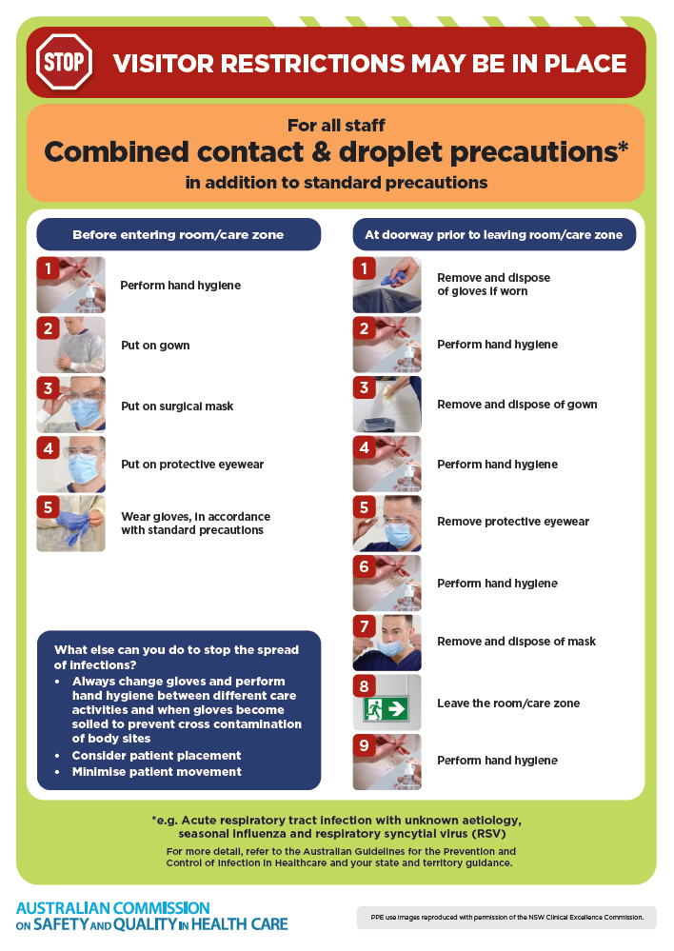
- Poster – Combined airborne and contact precautions
https://www.safetyandquality.gov.au/publications-and-resources/resource-library/infection-prevention-and-control-poster-combined-airborne-and-contact-precautions
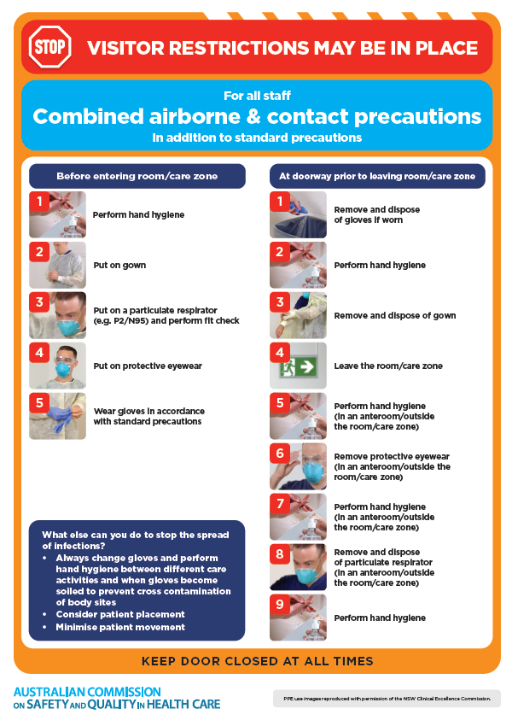
- Environmental Cleaning and Infection Prevention and Control www.safetyandquality.gov.au/environmental-cleaning
- Break the chain of infection poster
https://www.safetyandquality.gov.au/publications-and-resources/resource-library/break-chain-infection-poster
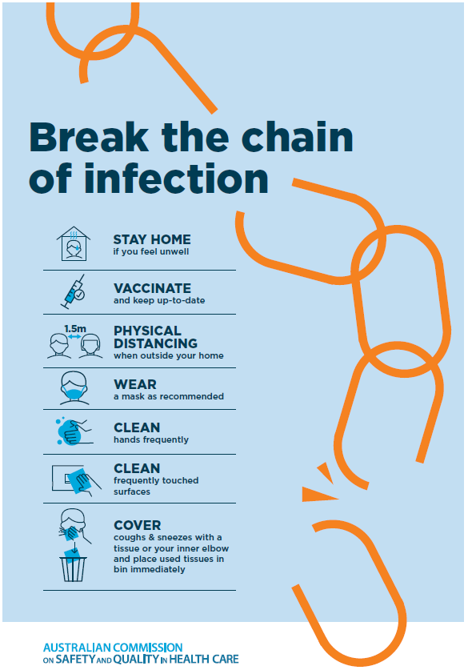

Disclaimer
On the Radar is an information resource of the Australian Commission on Safety and Quality in Health Care. The Commission is not responsible for the content of, nor does it endorse, any articles or sites listed. The Commission accepts no liability for the information or advice provided by these external links. Links are provided on the basis that users make their own decisions about the accuracy, currency and reliability of the information contained therein. Any opinions expressed are not necessarily those of the Australian Commission on Safety and Quality in Health Care.

