
On the Radar
Issue 708
11 August 2025

On the Radar is a summary of some of the recent publications in the areas of safety and quality in health care. Inclusion in this document is not an endorsement or recommendation of any publication or provider. Access to particular documents may depend on whether they are Open Access or not, and/or your individual or institutional access to subscription sites/services. Material that may require subscription is included as it is considered relevant.

On the Radar is available online, via email or as a PDF or Word document from https://www.safetyandquality.gov.au/newsroom/subscribe-news/radar

If you would like to receive On the Radar via email, you can subscribe on our website https://www.safetyandquality.gov.au/newsroom/subscribe-news
or by emailing us at mail@safetyandquality.gov.au.
You can also send feedback and comments to mail@safetyandquality.gov.au.

For information about the Commission and its programs and publications, please visit https://www.safetyandquality.gov.au

On the Radar
Editor: Dr Niall Johnson
Contributors: Niall Johnson

Reports

An Aboriginal and Torres Strait Islander Systems Approach to Suicide Prevention: Framework and Implementation Guidelines
Dudgeon P, Collova J, Schultz C, Darwin L, Chang E-P, McPhee R, et al
Melbourne: Lowitja Institute; 2025.
DOI | https://www.lowitja.org.au/resource/an-aboriginal-and-torres-strait-islander-systems-approach-to-suicide-prevention-framework-and-implementation-guidelines/
Notes | The authors of this resource published by the Lowitja Institute observe that ‘Aboriginal and Torres Strait Islander peoples experience disproportionally high rates of suicide and other health inequities. Suicide is the fifth-leading cause of death among Aboriginal and Torres Strait Islander people, and has increased by approximately 30 per cent from 2018 to 2023.’ In response to this they ‘outline the requirements of an Aboriginal and Torres Strait Islander systems approach to suicide prevention (Section 1) and propose a framework (Section 2) and implementation guidelines (Section 3) for such an approach.’

From ideas to reality: An introduction to generating and implementing innovation in health systems
Fahy N, Mauer N, Panteli D
Copenhagen: European Observatory on Health Systems and Policies, WHO Regional Office for Europe; 2025. p. 138.
URL | https://eurohealthobservatory.who.int/publications/i/from-ideas-to-reality-an-introduction-to-generating-and-implementing-innovation-in-health-systems
Notes | Innovation is challenging in almost any sector or industry. The authors of this report published by the European Observatory on Health Systems and Policies, WHO Regional Office for Europe, observe ‘With all the old and new challenges facing our health systems today, innovation seems the only way to address health needs and strengthen the overall wellbeing of our societies. However, while innovations in medicine and health service delivery have revolutionized health care, they have also put increasing strain on our health budgets. What’s more, a number of new technologies that promised to improve health outcomes have proven to be harmful, or ineffective and wasteful.’ They describe the book’s intent is ‘provide a concise walkthrough on how innovation and its implementation can be understood, what we need to do to get the innovations necessary to address the needs of our populations, how we can make the best use of the innovations we have, and how we can transform our health systems to ensure we are equipped to keep learning from the ground up and innovating to meet new challenges.’

The State of Human Experience 2025: Thriving in the Face of Change
Wolf JA
Nashville: The Beryl Institute; 2025. p. 35.
URL | https://theberylinstitute.org/product/state-of-hx-2025-thriving-in-the-face-of-change/
Notes | The Beryl Institute in the USA has released the eighth iteration of their review of the patient/human experience landscape, particularly that of the USA. The report is informed by a survey of the Institute’s members with 300 respondents in 13 nations completing the survey. These respondents report that patient experience is a top priority for their organisations and patient experience programs are well established in most.

Brain injury: A practitioner guide
Women’s Health NSW
Sydney: WHNSW; 2025.
URL | https://www.itleftnomarks.com.au/resources/brain-injury-a-practitioner-guide/
Notes | The charity/peak body Women’s Health NSW has developed this resource to support service providers to contextualise medical information about brain injuries for women living in violent and stressful domestic settings. There is also the Recovering from brain injury booklet that is designed to fill the gap in resources available to women who have a brain injury caused by domestic, family and sexual violence (DFSV).

ME/CFS: the final delivery plan
Department of Health and Social Care, Department for Education, Department for Work and Pensions
London 2025.
URL | https://www.gov.uk/government/publications/mecfs-the-final-delivery-plan
Notes | For many years myalgic encephalomyelitis/chronic fatigue syndrome (ME/CFS) has been rather contentious. The UK government has released this ‘final delivery plan’ that ‘focuses on 3 main areas where we are seeking to drive change to improve care and support for those with ME/CFS including:  - research  - attitudes and education  - living with ME/CFS’.

Journal articles

Continuity of care in general practice and patient outcomes in Denmark: a population-based cohort study
Prior A, Rasmussen LA, Virgilsen LF, Vedsted P, Vestergaard M
The Lancet Primary Care. 2025.
DOI | https://doi.org/10.1016/j.lanprc.2025.100016
Notes | Paper reporting on a Danish ‘population-based cohort study using data from multiple Danish national registers’ for the period 1 January 2006 to 31 December 2021 that covered 4 530 293 adults who were ‘listed with a general practice clinic on Jan 1, 2022’. The authors report that ‘Compared with a patient listed with the same general practice clinic for 10 years or longer, a patient listed for 0–1 years had a higher risk of all-cause mortality (hazard ratio 1·21, 95% CI 1·17–1·25), lower degree of cross-sectoral continuity of care (odds ratio 1·20, 95% CI 1·13–1·27), more unplanned hospital contacts (incidence rate ratio 1·25, 95% CI 1·21–1·30), and more out-of-hours contacts (1·21, 1·17–1·26). More previous clinic changes were also associated with increased risk of these four outcomes. Some associations between frequent clinic changes and health outcomes were mitigated by long-term listing with the current clinic.’ The authors conclude that ‘continuity at the clinic level in general practice can potentially reduce adverse patient outcomes and improve continuity across health-care sectors’

Patient safety measures for virtual consultations in primary care: a systematic review
Lunova T, Hurndall K-H, Kirk UB, Franklin BD, Darzi A, Neves AL
BMJ Quality & Safety. 2025.
DOI | https://doi.org/10.1136/bmjqs-2025-018712
Notes | The authors of this review frame their work ‘With the growing adoption of virtual consultations in primary care, the need for tailored metrics to evaluate their safety became increasingly urgent. This systematic review seeks to identify and review existing safety measures that could be used for safety evaluation of virtual consultations in primary care.’ Based on 47 studies, the analysis, revealed safety measures that were grouped into two overarching themes: (1) factors that may influence safety of virtual consultations and (2) tangible outcomes of virtual consultation safety (online supplemental table 1). Factors that may influence safety included provider-related, patient-related and system-related factors. Tangible outcomes included adverse events, health outcomes and patient experience and perception of safety.’  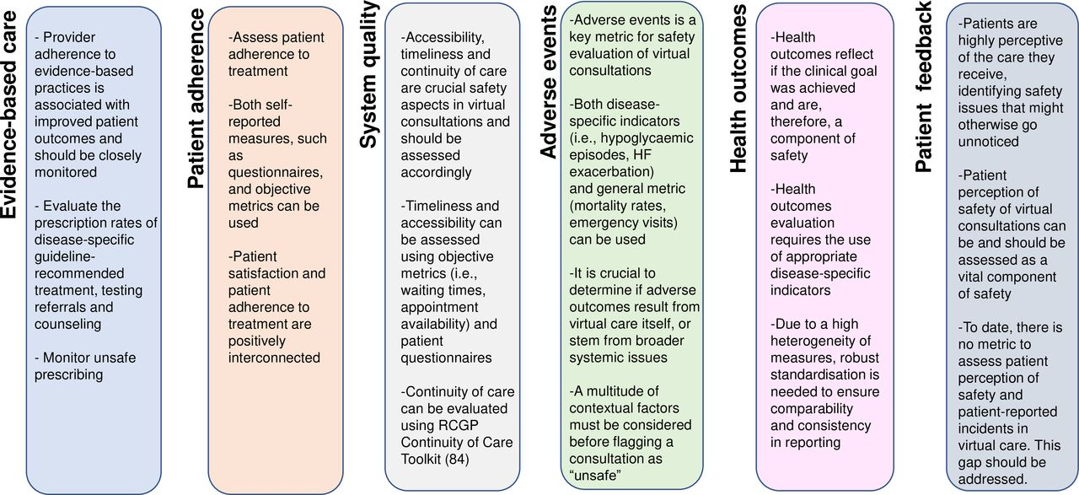

Epidemiology of community acquired sepsis in children in Australia and New Zealand: a multicentre prospective cohort study
Long E, Borland ML, George S, Jani S, Tan E, Phillips N, et al
The Lancet Regional Health – Western Pacific. 2025;60:101608.
DOI | https://doi.org/10.1016/j.lanwpc.2025.101608
Notes | Report on a prospective observational study undertaken in 11 hospitals in Australia and New Zealand in April 2021 to December that sought to ‘describe the epidemiology of community acquired sepsis’. The study also examined the Phoenix sepsis criteria. The authors report ‘Of 822,072 children assessed, 6232 (0.8%) children had suspected sepsis and 306 (<0.1%) met the Phoenix sepsis criteria.’ Children who met the Phoenix criteria had longer intensive care unit and hospital length of stay and higher rates of intensive care unit admission, vasoactive infusion, mechanical ventilation, and extracorporeal life support compared to the overall cohort. However, the authors observe ‘The Phoenix sepsis criteria identified children with more severe illness and worse outcomes, but underestimated the overall burden of sepsis.’

For information on the Commission’s work on sepsis, including the National Sepsis Program and online education and resources, see https://www.safetyandquality.gov.au/our-work/national-sepsis-program

Long-term clinical outcomes of delirium after hospital discharge: a systematic review and meta-analysis
Tesfaye Y, Davis CR, Hull MJ, Greaves D, du Preez J, Johns S, et al
Age and Ageing. 2025;54(7):afaf188.
DOI | https://doi.org/10.1093/ageing/afaf188
Notes | Delirium is an acute change in mental status that is often triggered by acute illness, surgery, injuries or adverse effects of medicines. Despite being a serious condition that is associated with increased mortality, delirium has been poorly recognised in Australian hospitals and internationally. This paper reports on a systematic review and meta-analysis that sought ‘To synthesise evidence comparing post-discharge clinical outcomes in individuals who experienced delirium in hospital compared to those who did not.’ The study synthesised data ‘from 253 studies representing 29 814 participants who experienced delirium and 107 583 participants who did not experience delirium.’ From the analyses, the authors assert ‘those who experienced delirium in hospital showed higher objective cognitive decline (OR = 1.58, P < .001), greater subjective cognitive impairment (OR = 2.11, P = .041), greater functional decline (g = −0.43, P = .001), lower quality of life (g = −0.44, P < .001), higher burden of poor mental health (OR = 1.69, P < .001), increased risk of dementia (OR = 5.37, P < .001), higher likelihood of institutionalisation (OR = 2.80, P < .001), greater rates of hospital readmission (OR = 1.70, P < .001) and increased mortality (OR = 2.55, P < .001) post-hospital discharge compared to those who did not experience delirium in hospital.’

For information on the Commission’s work on cognitive impairment, including the Delirium Clinical Care Standard, see https://www.safetyandquality.gov.au/our-work/cognitive-impairment

Australian Health Review
Value-Driven: Redefining Care for a Healthier Nation collection
URL | https://www.publish.csiro.au/ah/Collection/12990
Notes | The Australian Health Review has released a collection of articles on the theme Value-Driven: Redefining Care for a Healthier Nation. Articles in this collection from Australian Health Review include:  - The value equation: realising value based-health care’s disruptive potential (Adam G Elshaug)  - Navigating ethical landscapes and resolving grievances: cornerstones of value-based healthcare (Grant Davies)  - Value: in the eyes of the beholden (Daniel O’Halloran)  - ‘Booking’ fees for private hospital patients (Steve Robson)  - Listening for meaning: consumer voice in a system built on value (E Deveny)  - Value-based health care definition and characteristics: an evidence-based approach (H Khalil, M Ameen, C Davies, R Arunkumar and C Liu)  - ‘True North Statement for Care’: charting the course to better care for all Australians (Rebecca K Golley, Georgia Middleton, Michael T Lawless, Lucy Anastasi, Alison L Kitson and Raymond J Chan)  - Enhancing digital healthcare: aligning Australia’s digital health strategies with value-based healthcare principles (Paul Tait, Darren Daff, Pamela Everingham, Ashley Leahy, Rhys Parker, R Perry, M Smith and D Morris)  - Value-based health care for Aboriginal peoples with chronic conditions in the Northern Territory: a cohort study (Maya Cherian, Yuejen Zhao, Antonio Ahumada-Canale, P Nihill, M VanBruggen, D Butler and P Burgess)  - The Living Well, Living Longer program: an integrated care strategy to improve the health of people living with severe mental illness (Andrew Simpson, Lisa Parcsi and Andrew McDonald)  - Consumer involvement in health service research: a cross-sectional survey of staff in an Australian public hospital and health service (Laura Ryan, Laetitia Hattingh, Joan Carlini, Kelly A Weir, Margaret Shapiro, Noela Baglot, Magnolia Cardona, G Tobiano, R Muir, S Roberts, S Sargeant and R Wenke)  - Lived Experience Advisor Program initiative: harnessing consumer leadership for best care (Rebecca Barbara, J Lydeker, A Potter and D Kerr)  - Environmental, Social and Governance principles in Australian publicly funded healthcare: an extension of value-based care (Aletha Ward, Mark E Holmes, Isabella Ward, Zerina Lokmic-Tomkins, L East and T Levett-Jones)  - Partnering with consumers and practising clinicians to establish research priorities for public hospital maternity services (Roni Cole, Lauren Kearney, Bec Jenkinson, Imogen Kettle, Beng Ng, L Callaway and R Nugent)  - The role of Medicare policy in fertility treatment decisions: perceptions of Australians considering, undertaking or who have undertaken medically assisted reproduction treatment (Lauren Jaensch, J A Grieger and M Oxlad)

Health Affairs
Volume 44, Number 8, August 2025
URL | https://www.healthaffairs.org/toc/hlthaff/44/8
Notes | A new issue of Health Affairs has been published with themes of Medicare Advantage, Youth Mental Health & More’. Articles in this issue of Health Affairs include:  - Health Technology Assessment, Again: A Transparent, Evidence-Based Approach For CMS Drug Price Negotiations (Daniel A Ollendorf, Leah Z Rand, Alessandra Blonda, Helen Mooney, Marie Phillips and Anirban Basu)  - Inside The Meteoric Rise Of Medicare Advantage (Steven M Lieberman and Rick Mayes)  - Medicare Advantage Enrollment Since The ACA: What The Projections Did Not Foresee (Gretchen A Jacobson and Cori Uccello)  - Fee-For-Service, Accountable Care Organizations, And Medicare Advantage: Why? (Michael E Chernew)  - The Youth Mental Health Crisis In The US: Lack Of Political Will Poses The Greatest Barrier To Meaningful Action (Steven H Woolf)  - Foreign-Born Workers Made Up Half The Increase In The Direct Care Workforce In Home And Community Settings, 2012–22 (Britainy Barnes and David C Grabowski)  - Targeted Regulations Of Abortion Providers Associated With Significant Decreases In OB-GYN Density, 1993–2021 (Aline Vandenbroeck and Justin H Markowski)  - Pay Gap Between Nonprofit Hospital CEOs And Employees Grew, 2009–23 (Cal Chengqi Fang, Sabrina D Wang, Jonathan Cantor, Christopher M Whaley, Brian Briscombe and Joseph Dov Bruch)  - Sharp Rise In Urban Hospitals With Rural Status In Medicare, 2017–23 (Yang Wang, Jared Perkins, Christopher M Whaley, and Ge Bai)  - Staying On Peritoneal Dialysis: A Qualitative Study On The Experiences Of Black And Latino Patients (Elina Serrano, Giana H Davidson, Matthew B Rivara, Andrew Oh, M Ramirez, M N Hantouli, A A S Dick and J L Bullock)  - Insurance Denials And Cost Sharing For PrEP Among Sexual And Gender Minority People (Alexa D’Angelo, Chloe Mirzayi, Naomi Zewde, Emma K Tsui, Adam W Carrico and Christian Grov)  - Changes In Clinicians’ Participation Across Medicare Value-Based Payment Models, 2017–22 (Alexander O Everhart, Peter F Lyu, Karen E Joynt Maddox, Jason M Hockenberry and Kenton J Johnston)  - Trends In Telehealth Initiation Of Prescription Stimulants For Child And Adult Enrollees In Medicaid And CHIP During COVID-19 (Timothy B Creedon, Hefei Wen, Mir M Ali and Rebecca L Haffajee)  - Remote Physiologic Monitoring Use Among Medicare Patients: Differences By Race, Ethnicity (Felippe Marcondes, Mitchell Tang, Jennifer S Haas, Ateev Mehrotra and Arturo Vargas Bustamante)  - Health Insurance Coverage Varied By Children’s Adoption Status In The US, 2018–22 (Jamie Lin Fleishman and Dahai Yue)  - Global Cancer Care: An Unfinished Promise (Saroj Niraula)

BMJ Quality & Safety online first articles
URL | https://qualitysafety.bmj.com/content/early/recent
Notes | BMJ Quality &Safety has published a number of ‘online first’ articles, including:  - QIing your QI: a 13-year experience of a paediatric residency QI programme (Adolfo Leonel Molina, Michele K Nichols, Colm P Travers, Stephanie Berger, Emily A Smitherman, David P Galloway, Rachel Kassel, Samuel Gentle, Andrea Kennedy, Chang L Wu, Susan Walley)  - Examining variations in the prevalence of hazardous opioid prescribing across general practices in England: a cross-sectional study (Teng-Chou Chen, Alex M Trafford, Matthew J Carr, Neetu Bansal, Evangelos Kontopantelis, Anthony Avery, Li-Chia Chen, Darren M Ashcroft)

International Journal for Quality in Health Care online first articles
URL | https://academic.oup.com/intqhc/advance-articles
Notes | International Journal for Quality in Health Care has published a number of ‘online first’ articles, including:  - Improving therapeutic engagement and observations on inpatient mental health wards in the English NHS: Lessons from using QI to scale up interventions (Marco Aurelio et al)  - Quality Improvement and Workplace Wellbeing Capacity and Capability in Aotearoa New Zealand Emergency Departments. A Nationwide Mixed Methods Survey (Mike Nicholls et al)  - A white paper to guide patient safety strategies at the facility level (Carsten Engel and Anuradha Pichumani)  - Impact of Early Interruption from Pay-for-Performance Program on Progression and Medical Utilization for Patients with Early Chronic Kidney Disease (Yeong-Ruey Chu et al)  - Using FRAM Visualisations in quality improvement projects: identifying and testing strategies to improve anticoagulant use in the perioperative process (Nienke M Luijcks et al)

Online resources

Australian Living Evidence Collaboration
https://livingevidence.org.au/

Trauma-informed care resource hub
https://www.gpmhsc.org.au/resourcehub
The General Practice Mental Health Standards Collaboration has compiled information on implementing trauma-informed care in general practice.

Guidance
A number of guidelines or guidance have recently been published or updated. These include:
- Australasian Diabetes in Pregnancy Society (ADIPS) 2025 consensus recommendations for the screening, diagnosis and classification of gestational diabetes https://doi.org/10.5694/mja2.52696
- Guideline for newborn screening in spinal muscular atrophy in Australia and Aotearoa New Zealand https://www.unsw.edu.au/medicine-health/our-schools/clinical-medicine/research-impact/research-groups/womens-health-paediatrics-child-health/nbs-for-sma
- Safer Care Victoria, Prevention of surgical site infection complicating colorectal surgery – Statewide guidance for Victoria https://www.safercare.vic.gov.au/non-urgent-elective-surgery/prevention-of-surgical-site-infection-complicating-colorectal-surgery
- Consultative Council on Obstetric and Paediatric Mortality and Morbidity (CCOPMM) good practice points (https://www.safercare.vic.gov.au/councils/ccopmm/good-practice-points-and-recommendations)
Timing of birth
Supraglottic airway (laryngeal mask)
Uterotonics in the setting of placental abruption
Contact prophylaxis for invasive Group A streptococcus infections
Prescribing antidepressants in adolescence

[UK] Balancing acts Navigating health and work in real life
https://www.health.org.uk/features-and-opinion/features/balancing-acts-navigating-health-and-work-in-real-life
The Health Foundation in the UK has developed this interactive that 'explores people's experiences of work and health and calls for these perspectives to shape policy and workplace practice.’

[UK] NICE Guidelines and Quality Standards
https://www.nice.org.uk/guidance
The UK’s National Institute for Health and Care Excellence (NICE) has published new (or updated) guidelines and quality standards The latest reviews or updates include:
- Quality Standard QS212 Overweight and obesity management https://www.nice.org.uk/guidance/qs212

[USA] Effective Health Care Program reports
https://effectivehealthcare.ahrq.gov/
The US Agency for Healthcare Research and Quality (AHRQ) has an Effective Health Care (EHC) Program The EHC has released the following final reports and updates:
- Living Systematic Review on Cannabis and Other Plant-Based Treatments for Chronic Pain https://effectivehealthcare.ahrq.gov/products/plant-based-chronic-pain-treatment/living-review

Infection prevention and control and COVID-19 resources
The Australian Commission on Safety and Quality in Health Care has developed a number of resources to assist healthcare organisations, facilities and clinicians. These resources include:
- Poster – Combined contact and droplet precautions https://www.safetyandquality.gov.au/publications-and-resources/resource-library/infection-prevention-and-control-poster-combined-contact-and-droplet-precautions
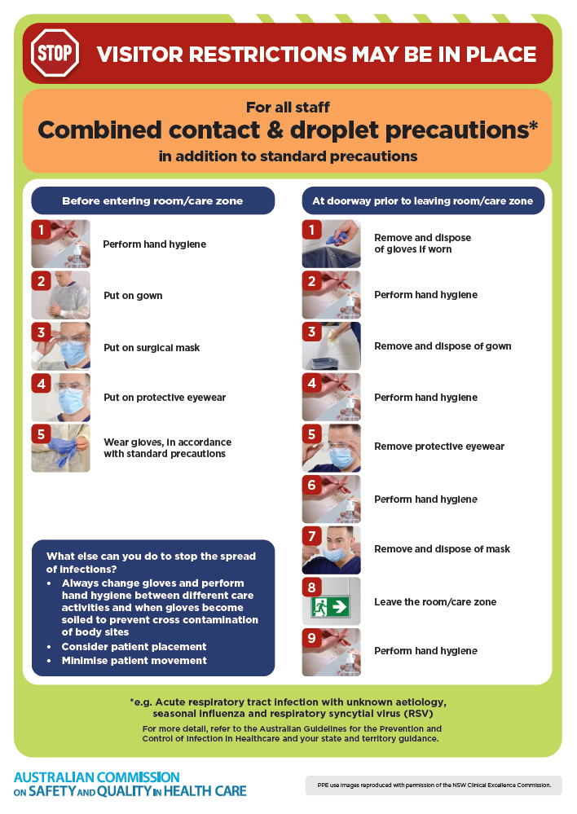
- Poster – Combined airborne and contact precautions
https://www.safetyandquality.gov.au/publications-and-resources/resource-library/infection-prevention-and-control-poster-combined-airborne-and-contact-precautions
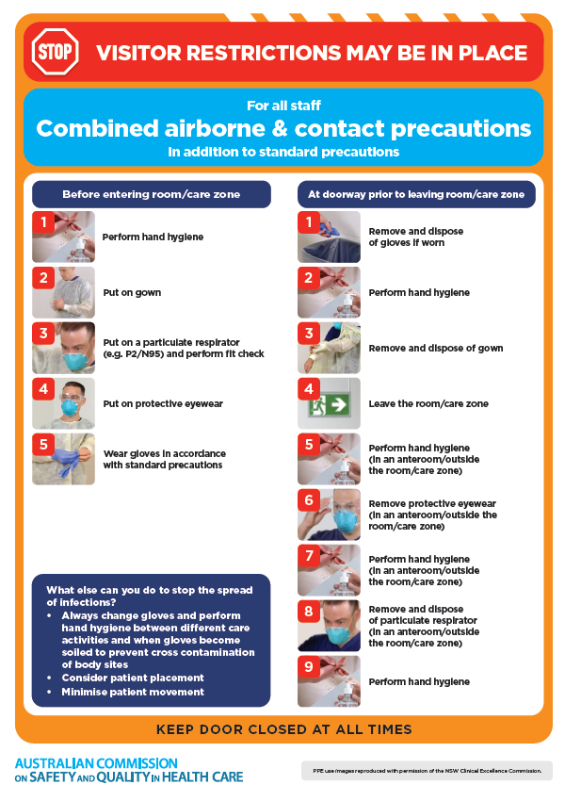
- Environmental Cleaning and Infection Prevention and Control www.safetyandquality.gov.au/environmental-cleaning
- Break the chain of infection poster
https://www.safetyandquality.gov.au/publications-and-resources/resource-library/break-chain-infection-poster
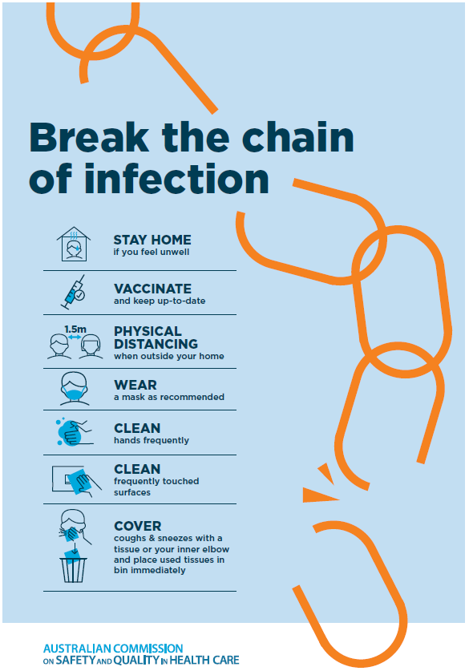

Disclaimer
On the Radar is an information resource of the Australian Commission on Safety and Quality in Health Care. The Commission is not responsible for the content of, nor does it endorse, any articles or sites listed. The Commission accepts no liability for the information or advice provided by these external links. Links are provided on the basis that users make their own decisions about the accuracy, currency and reliability of the information contained therein. Any opinions expressed are not necessarily those of the Australian Commission on Safety and Quality in Health Care.

