
On the Radar
Issue 709
18 August 2025

On the Radar is a summary of some of the recent publications in the areas of safety and quality in health care. Inclusion in this document is not an endorsement or recommendation of any publication or provider. Access to particular documents may depend on whether they are Open Access or not, and/or your individual or institutional access to subscription sites/services. Material that may require subscription is included as it is considered relevant.

On the Radar is available online, via email or as a PDF or Word document from https://www.safetyandquality.gov.au/newsroom/subscribe-news/radar

If you would like to receive On the Radar via email, you can subscribe on our website https://www.safetyandquality.gov.au/newsroom/subscribe-news
or by emailing us at mail@safetyandquality.gov.au.
You can also send feedback and comments to mail@safetyandquality.gov.au.

For information about the Commission and its programs and publications, please visit https://www.safetyandquality.gov.au

On the Radar
Editor: Dr Niall Johnson
Contributors: Niall Johnson, Toby Mathieson

Pragmatic Artificial Intelligence (AI) guidance for clinicians
Australian Commission on Safety and Quality in Health Care
Sydney: ACSQHC; 2025
https://www.safetyandquality.gov.au/our-work/e-health-safety/artificial-intelligence

The Commission, with expert advice from Macquarie University, Wollongong University and our AI Program Advisory Group, has released new guidance to support clinicians in the day-to-day use of Artificial Intelligence (AI) tools.
New AI tools and technologies are being rapidly developed and implemented and may bring significant benefits for patient care but could also introduce new risks, especially as evidence of safety and efficacy may lag behind implementation.
To support clinicians, meet their professional responsibilities in using AI tools safely and responsibly, the Commission has developed short and pragmatic guides on the important topics of:
- Reviewing the evidence on the efficacy of the AI tool
- Common limitations and risks of AI
- Transparency in the use of AI and informed consent
- Understanding the implications for patient information
- Understanding AI and automation bias
- Ongoing evaluation and monitoring of AI tools.

The guidance documents include:
- An overarching AI clinical use guide
- Ambient AI Scribe safety scenario
- AI interpretation of medical images safety scenario.

Reports

Survey results – Experiences of adults admitted to hospital in 2024
Bureau of Health Information
St Leonards: BHI; 2025.
URL | https://www.bhi.nsw.gov.au/BHI_reports/patient_survey_results/adult-admitted-patient-survey-2024
Notes | The Bureau of Health Information (BHI) in New South Wales (NSW) has released their latest report on patient experiences in NSW public hospitals. This report is based on the responses from more than 25,000 on their experiences of care as admitted patients in one of 84 NSW public hospitals from January to December 2024.Results for individual hospitals and local health districts (LHDs) are available to download in the supplementary data tables and can be further explored through the BHI Data Portal.

For information on the Commission’s work on person-centred care, see https://www.safetyandquality.gov.au/our-work/partnering-consumers/person-centred-care

Sentinel Events Annual Report 2023-2024
Safer Care Victoria
Melbourne: SCV; 2025. p. 67.
URL | https://www.safercare.vic.gov.au/publications/sentinel-events-annual-report-2023-2024
Notes | Safer Care Victoria (SCV) has released their latest report on sentinel events in Victorian public health services. It is noted in the report’s foreword that ‘Learning from sentinel event reviews is key to continuous improvement and achieving the aim of harm reduction and improving patient safety’.

For information on the Commission’s work on incident management and sentinel events, see https://www.safetyandquality.gov.au/our-work/indicators-measurement-and-reporting/incident-management-and-sentinel-events

Delivering quality care more efficiently, Interim report
Productivity Commission
Canberra: Productivity Commission; 2025. p. 93.

Productivity with Purpose: Clear pathways to a more equitable future
Centre for Policy Development
Sydney and Melbourne: Centre for Policy Development; 2025. p. 33.
URL | Productivity Commission https://www.pc.gov.au/inquiries/current/quality-care/interim  Centre for Policy Development https://cpd.org.au/work/productivity-with-purpose/
Notes | Productivity, and our apparent low levels of it in many sectors, has been attracting a lot of attention – and contention – recently. In some sectors, such as the care sectors, it can at times be difficult to conceptualise and measure productivity as so much that is important in these areas relates to the quality and the relationships as these may not be so amenable to the way productivity tends to be measured. Two new reports on productivity both examine productivity in the care economy.  The Productivity Commission has released a number of interim reports recently, including Delivering quality care more efficiently, Interim report. The Productivity Commission identified three ‘opportunities to boost productivity in the care economy’:  - greater alignment of safety and quality regulation in the care economy …Regulation is essential for protecting people’s rights and safety, but taking different approaches across sectors creates risks and reduces choice for care users and leads to unnecessary costs for care workers and providers. … developing a standardised safety and quality reporting framework and data repository, and introducing a single set of practice and quality standards for aged care and National Disability Insurance Scheme services.  - organisations working in partnership to plan, procure and evaluate services for their local communities. This practice, known as collaborative commissioning, has potential to support more integrated care, address service gaps and tailor care services to local needs.  - a new approach to prevention investment is needed, through a National Prevention Investment Framework.  The Centre for Policy Development (CPD) has released their report Productivity with Purpose: Clear pathways to a more equitable future In this report, the CPD ‘sees the government’s focus on productivity as an opportunity to shift how we think about it, not as a narrow measure of output, but as a tool to build an equitable, inclusive, and sustainable society.’ Among the recommendations are some that explicitly link to those in the Productivity Commission report, including:  - Investigate how productivity is currently measured in the care economy, and propose productivity metrics that align with performance, quality and social value.  - Combine the emphasis on collaborative commissioning with relational contracting and long-term funding timelines—particularly for First Nations programs and services that address complex, intersecting issues.  - Expand the exploration of prevention frameworks beyond the care sector to capture structural conditions like poverty, income inequality, and housing affordability that drive demand for services and are some of the root causes of vulnerability.

Journal articles

Financial penalty associated with a decline in hospital-acquired complications in Australia
Slawomirski L, Otahal P, Hensher M, Campbell J, Newell S, de Graaff B
Health Policy. 2025:105416.
DOI | https://doi.org/10.1016/j.healthpol.2025.105416
Notes | Paper examining the impact of a policy of applying a financial penalty to hospital-acquired complications (HACs) in Australia. The study used ‘Administrative data on every Australian public hospital separation (age >17 years) between 1 January 2014 and 30 June 2021’ in order to ‘examine [the] association between the introduction of a financial penalty on 1 July 2018 and the prevalence of 13 high-priority hospital-acquired complications (HACs) in Australian public hospitals.’ This examination of nearly 20 million separations led the authors to conclude ‘In this large, observational study drawing on seven-and-a-half years of Australian public hospital separations, the implementation of a financial penalty was associated with a decline in the national rate of hospital-acquired complications. The careful and gradual fashion in which the policy was developed and implemented—rather than the penalty itself—is a plausible driver and the influence of other, separate, policies and practices cannot be ruled out. Either way, the decline in complications is good news for Australian inpatients.’  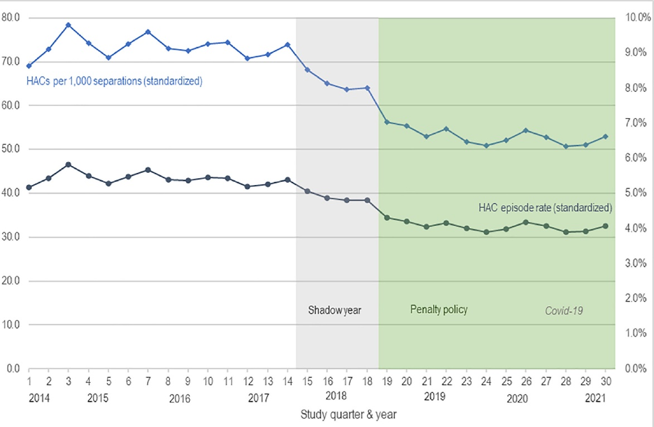

For information on the Commission’s work on Hospital-acquired complications (HACs), including the national list of HACs, see https://www.safetyandquality.gov.au/our-work/indicators-measurement-and-reporting/hospital-acquired-complications-hacs

Australian Prescriber
Volume 48, Issue 4, August 2025
URL | https://australianprescriber.tg.org.au/volumes/48/issues/4.html
Notes | A new issue of Australian Prescriber has been published. Content in this issue of Australian Prescriber includes:  - Practical guidance for stopping glucocorticoids (F Khalili, MG Burt)  - Preparation for blood tests: what can go wrong before the sample reaches the lab (L Lee, W Rankin)  - Potentially inappropriate medicines for older people: consensus-based lists (A Choo)  - Aminoglycosides: an update on indications, dosing and monitoring (H Moore, D Yeoh, C Hughes, E Raby, I Sandaradura)  - Choosing a nonsteroidal anti-inflammatory drug for pain (S Hopkins, V Yang, DFL Liew)  - COX-2 selective nonsteroidal anti-inflammatory drugs: what is their place in managing dental pain? (G Moses)  - Tools to support medication management in people with multimorbidity and polypharmacy  - New drugs:  Momelotinib for myelofibrosis  Selpercatinib for RET fusion-positive non-small cell lung cancer

Healthcare Quarterly
Volume 28, Number 1, 2025
URL | https://www.longwoods.com/publications/healthcare-quarterly/27625/
Notes | A new issue of Healthcare Quarterly has been published with a theme of ‘Issues in Canadian Youth Mental Health’. Articles in this issue of Healthcare Quarterly include:  - Is Ontario Ready for the Health Costs Associated With Dementia? (Susan E. Bronskill, Laura C. Maclagan, Luke Mondor, Longdi Fu, Jun Guan, Isabella J. Sewell, Andrea Iaboni, Richard H. Swartz, C J Maxwell and C de Oliveira)  - Strengthening Canada’s Health Workforce: The Role of Pan-Canadian Data (Tyler Pirie, Agata Logvin, Romaisa Pervez, Shannon Weir-Seeley, Laura Salter, Gregory Feng, Cathy Huynh, A McCabe, C Couris and N Damiano  - Our Aging Disconnect: Billions for Longevity, Pennies for Dignity (Neil Seeman)  - Introduction - Canadian Youth Mental Health (Ruby Brown and A Wojtak)  - Foundry, the British Columbia Integrated Youth Services Initiative: Sharing Lessons From a Decade of Innovation (Kelli Wuerth, Karen Tee, Steve Mathias and Skye Barbic)  - Stepped Care 2.0: A Framework to Facilitate Leadership in Youth Mental Health System Building (Kaitlin G Saxton, Alexia Jaouich, Mary Bartram, Mélanie Hood, Janis Dawson, Hajin Lee and Peter Cornish)  - Campus Community Project: Coming Together to Support Student Mental Health (Selena Norman)  - Stronger Together: A Collaborative Approach to Solving Canada’s Healthcare Supply Chain Crisis (Anne Snowdon, Alexandra Wright, Saba Ghadiri and Cindy Ly)  - Health Quality 5.0: Putting Patient Safety Back on the Front Burner: The Time Is Now (Leslee J Thompson and G Ross Baker)  - Evaluating Ontario’s High Priority Communities Strategy: Integrating Care, Redressing Health Inequities and Improving Population Health “From the Ground-Up” (A. Paul Williams, Sherlyn Hu, Janet Lum, Helen Leung, Freida Chavez, Suleman (Deen) Sule and Nasma Ashraf)  - Collaborative Community Support for People Impacted by Dementia: A Social Return on Investment Analysis (Anne Miller, Karenn Chan, Blair Wold, Bri Krekoski and Helen Lightfoot)  - Ongoing Leadership Development in a Northwestern Ontario Healthcare Organization: Implementing a Leadership ECHO Pilot Project (Ashley Lyon, Stacey Freemantle and Tyler Drawson)  - Understanding the Population Health Needs of Tenants in Residential Care Facilities (RCFs) in Hamilton, Ontario (Helen Harris, Megan Lynch, Mary Vaccaro and Chi-Ling Joanna Sinn)

Patient Experience Journal
Volume 12, Issue 2, 2025
URL | https://pxjournal.org/journal/vol12/iss2/
Notes | A new issue of the Patient Experience Journal (PXJ)has been published Articles in this issue of the Patient Experience Journal include:  - Editorial: Mastering the Art of Listening: The Human Experience Superpower (Jason A Wolf)  - “Those boxes do not hold me”: Using Narrative Health Experiences Research to Learn from Patients and Care Partners Beyond Surveys (Rachel Grob, Barbara Warren, Erika Cottrell, Njeri Grevious, Sara Knight, Mark Schlesinger, Kate Clegg Smith, and Nancy Pandhi)  - Why We Need a Patient-Centered Innovation Renaissance: A Horizontal and Vertical Integration of Knowledge to Transform Care Pathways (Pieter Vandekerckhove, Benjamin H L Harris, Louis J Koizia, Ashok Handa, Chris Brainard, and Steven Howard)  - From Fear to Hope: How Communication Transformed Our Pregnancy Journey A Personal Narrative on the Critical Role of Healthcare Communication in Patient Experience (Valan P and Pulidindi Venugopal)  - Taking Time and Making Space for Patient and Caregiver Partners (R Hamilton and L Hives)  - The Art of Diagnosis: How to Actively Participate in Your Healthcare (Vladislav Ilin, Daniel J Morgan, and Brad Peckler)  - Holding Space: An Effective Intervention for When Hope Wanes (Annette Lane, Marlette Reed, and Rose Schroeder)  - My Husband Didn’t Have to Die: A Doctor Reflects on all that Went Wrong with Her Husband’s Care in One of the Nation’s Top Medical Centers (Joanna A Cooper)  - Psychosocial Dimensions of Living with Hep B: Notes from the Field: The Lived Experience of a Mother Raising a Daughter with Hepatitis B (Julie Gerhardt)  - “Why Should Anyone Want to Make Things Better for me Particularly?” – A Qualitative Exploration of Care Opinion and NHS Care Improvements (Emma Berry, Zoe Skea, Marion K Campbell, and Louise Locock)  - Understanding Patient Experiences: A Qualitative Study on Communication and Cultural Competence in Multiple Sclerosis Care (Vaishnavi Sridharan, Charee Thompson, Rola Mahmoud, Minnatallah N E Eltinay, and C Chiu)  - Role of Patient-Reported Measures (PRMs) in Addressing Ethical Challenges During Telemedicine Consultation: A Narrative Review (Asiya Attar and Kasturi Shukla)  - I felt more confident that it would work for me: A Grounded Theory of Person-centered Interprofessional Collaboration Based on Patients’ Lived Experiences (Katherine Hope Morgan, Cristina S Barroso, Kathleen Conroy Brown, Michael R Bleich, Soghra Jarvandi, Elizabeth B Strand, and S Rowe)  - Family-Centered Care in Pediatric and Neonatal Intensive Care Units: A Systematic Review of Effects on Parental Satisfaction and Length of Stay (Vincenzo Andretta, Valentina Cerrone, Veronica Strini, and Angela Prendin)  - Understanding Online Reviews of Geriatricians: Correlations within a Dataset of 53,210 Physician Reviews (Yizhong Wu, Eric Reuben Smith, Nick Shaffer, Hanh Dieu Trinh, and Becky Powers)  - The Implementation of a Telehealth Patient Advisory Council in a Network of Federally Qualified Health Centers (Jessica Korins, Lisa Schaffer, and Nandini Shroff)  - “All Together”: A Case Study Demystifying Patient and Public Involvement (PPI) in Brief Psychological Interventions within a Community Mental Health Service for Adults in the UK (Molly H Nadel, Katherine Parkin, Stephanie Casey, Rachel Maciag, Alice Xie, Mu-Yin Chang, and Y Kim)  - Peer Mentoring, Camaraderie, and Support (PMCS) Program: Veterans’ Journey in Suicide Prevention (Ali A Poorani, Matthew Jacobs, Patrick Carney, and Jaclyn Tomasetti)  - Partnership, Collaboration, and Co-Production to Improve Patient Experience Beyond Conducting Surveys – Lessons from the Quebec Model, Canada (Marie-Pascale Pomey, Catherine Wilhelmy, Myriam Fournier-Tombs, Vincent Dumez, Cécile Vialaron, Monica Nelea Iliescu, Karina Prevost, Simon Courtemanche, Louise Normandin, and Geneviève David)

Nursing Leadership
Volume 38, Number 1, 2025
URL | https://www.longwoods.com/publications/nursing-leadership/27654/
Notes | A new issue of Nursing Leadership has been published. Articles in this issue of Nursing Leadership include:  - Values Are the Foundation of Leadership Strategies to Catalyze Change (Ruth Martin-Misener)  - Championing Specialty Nursing Certification: A Call to Action for Canadian Nurse Executives (Valerie Grdisa)  - The Critical Role of Nurse Leaders in Integrating Physical and Mental Healthcare: A Commentary (Gillian Strudwick, Pam Hubley, Dionne Sinclair, Aideen Carroll, Sherida Chambers, Maria Nelson and Satinder Kaur)  - Relational Coaching for Leadership and Team Development in Long-Term Care: An Appreciative Inquiry Approach (Shoshana M Helfenbaum, Daniel Galessiere, Christina E Gallucci and Raquel M Meyer)  - Beyond the 1%: Advocating for Comprehensive Data on Perinatal Substance Use in Canada (Jodie Bigalky, April Mackey, Oluwafemi Serrano and Pammla Petrucka)  - Connecting to Meaning and Purpose Through Mission and Values Alignment (Donna Romano, Vanessa Nicholas-Schmidt, Natalie Weiser, Christopher E. De Bono and Daniela Bellicos)  - Implementing the Nurse Practitioner Lead Role in Acute Care: Supporting Leaders and Optimizing Role Utilization (Margo Devries-Rizzo, Lori Harwood and Lillian Mess)

BMJ Quality & Safety online first articles
URL | https://qualitysafety.bmj.com/content/early/recent
Notes | BMJ Quality &Safety has published a number of ‘online first’ articles, including:  - From complaint material to quality improvement: Exploring the use of patient complaints or compensation claims in quality improvement initiatives—a scoping review (Sebrina Maj-Britt Hansen, Mette Kring Clausen, Nana Roust Hansen, Mette Brandt Eriksen, Anne Kragh Sørensen, Søren Bie Bogh, Søren Fryd Birkeland, Lars Morsø)  - Retrospective analysis of preventable procedural adverse events (ICD-10 Y62–Y69) in the TriNetX network: a multiregional study before, during and after the COVID-19 pandemic (Rosario Caruso, Marco Di Muzio, Emanuele Di Simone, Sara Dionisi, Arianna Magon, Gianluca Conte, Alessandro Stievano, Emanuele Girani, Sara Boveri, Pier Mario Perrone, Silvana Castaldi, Lorenzo Menicanti, Mary Dolansky)

International Journal for Quality in Health Care online first articles
URL | https://academic.oup.com/intqhc/advance-articles
Notes | International Journal for Quality in Health Care has published a number of ‘online first’ articles, including:  - Voices from homes: A mixed methods study on gaps in palliative care for patients and their families in rural Alappuzha, Kerala (Anjum John et al)  - Challenges around the quality of care provided during the last days of life (Vilma A Tripodoro and Ezequiel Garcia-Elorrio)  - Getting valuable and valid insight in life after ICU: Evaluating the representativeness of a large cohort of ICU survivors (Julian van Gemert et al)  - Why patient safety is akin to weaving textiles: An International Society for Quality in Health Care (ISQua) perspective on the 7th Global Ministerial Summit on Patient Safety 2025 (Jeffrey Braithwaite et al)  - From innovation to influence: Publishing Quality Improvement projects—key issues to address to enable successful publishing (Poonam Gupta et al)  - Satisfaction with Healthcare Services in Dubai: Findings from the 2023 Household Survey (Gamal M Ibrahim et al)

Infection prevention and control and COVID-19 resources
The Australian Commission on Safety and Quality in Health Care has developed a number of resources to assist healthcare organisations, facilities and clinicians. These resources include:
- Poster – Combined contact and droplet precautions https://www.safetyandquality.gov.au/publications-and-resources/resource-library/infection-prevention-and-control-poster-combined-contact-and-droplet-precautions
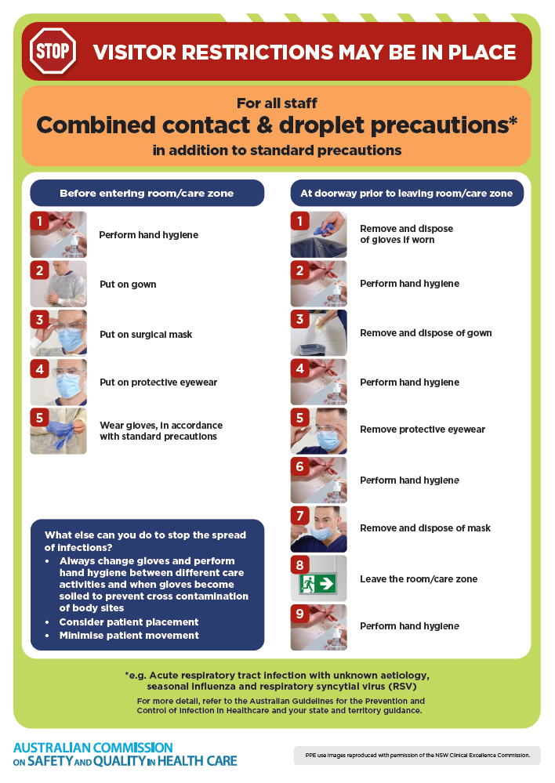
- Poster – Combined airborne and contact precautions
https://www.safetyandquality.gov.au/publications-and-resources/resource-library/infection-prevention-and-control-poster-combined-airborne-and-contact-precautions
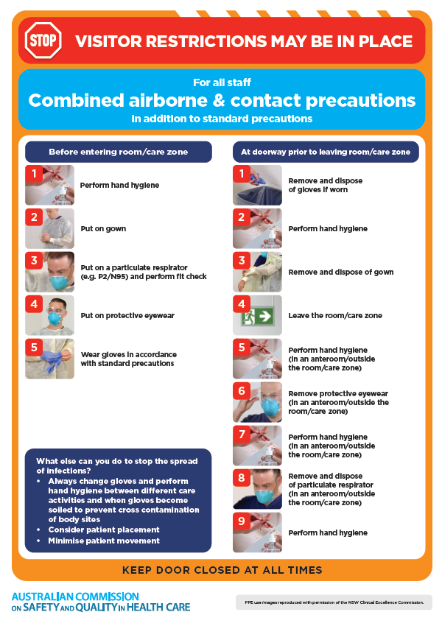
- Environmental Cleaning and Infection Prevention and Control www.safetyandquality.gov.au/environmental-cleaning
- Break the chain of infection poster
https://www.safetyandquality.gov.au/publications-and-resources/resource-library/break-chain-infection-poster
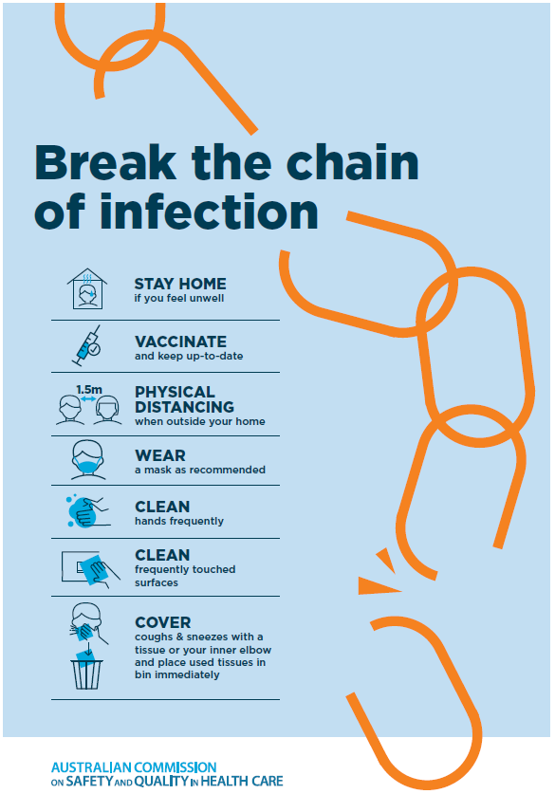

Disclaimer
On the Radar is an information resource of the Australian Commission on Safety and Quality in Health Care. The Commission is not responsible for the content of, nor does it endorse, any articles or sites listed. The Commission accepts no liability for the information or advice provided by these external links. Links are provided on the basis that users make their own decisions about the accuracy, currency and reliability of the information contained therein. Any opinions expressed are not necessarily those of the Australian Commission on Safety and Quality in Health Care.

