
On the Radar
Issue 711
1 September 2025

On the Radar is a summary of some of the recent publications in the areas of safety and quality in health care Inclusion in this document is not an endorsement or recommendation of any publication or provider Access to particular documents may depend on whether they are Open Access or not, and/or your individual or institutional access to subscription sites/services Material that may require subscription is included as it is considered relevant.

On the Radar is available online, via email or as a PDF or Word document from https://www.safetyandquality.gov.au/newsroom/subscribe-news/radar

If you would like to receive On the Radar via email, you can subscribe on our website https://www.safetyandquality.gov.au/newsroom/subscribe-news
or by emailing us at mail@safetyandquality.gov.au.
You can also send feedback and comments to mail@safetyandquality.gov.au.

For information about the Commission and its programs and publications, please visit https://www.safetyandquality.gov.au

On the Radar
Editor: Dr Niall Johnson
Contributors: Niall Johnson, Kylie Tran

Antimicrobial use in the community: 2024
Australian Commission on Safety and Quality in Health Care
Sydney; ACSQHC, 2025.
https://safetyandquality.gov.au/community-antimicrobial-use-2024

The Australian Commission on Safety and Quality in Health Care has released Antimicrobial use in the community: 2024 which analyses data on antimicrobials supplied under the Pharmaceutical Benefits Scheme and Repatriation Pharmaceutical Benefits Scheme from 2015 to 2024. The report features analyses of aged care data and local area data by Statistical Area 3 and Primary Health Network.

Key findings include.
- There were 23,190,360 antimicrobial prescriptions supplied in 2024 which is an increase of 4.8% from 2023, but still 20.8% lower than 2015.
- There were 659,767 antimicrobial prescriptions supplied to residents of aged care homes in 2024, which is an increase of 14.4% from 2023.
- Older Australians in aged care homes, aged 65 years and over, received more than double the number of systemic antibacterial prescriptions compared to older Australians in the community in 2024.
- Usage rates in Australia remain higher than comparable European countries, and there are opportunities to improve prescribing practices locally. It is likely that local prescriber preference is a major influence on antimicrobial use given ongoing supply trends by local area.

It is encouraging that overall antimicrobial use has declined since 2015, however the gradual increase from 2022 indicates need for action to reduce the spread of antimicrobial resistance and increase the sustainability of health care.

Reports

Strengthening primary health care-oriented health systems to address antimicrobial resistance: policy brief
World Health Organization
Geneva: World Health Organization; 2025.
URL | https://iris.who.int/handle/10665/382348
Notes | The World Health Organization has published this policy brief on antimicrobial resistance with an emphasis on primary care. It is noted that ‘Most patient interactions occur in primary care and in the community, where an estimated 80–90% of antibiotics are prescribed. Effective primary care plays a vital role in improving the management of infectious diseases and in reducing overuse and inappropriate use of antibiotics, thus slowing the emergence of antimicrobial resistance (AMR) and ensuring the continued effectiveness of antimicrobials.’  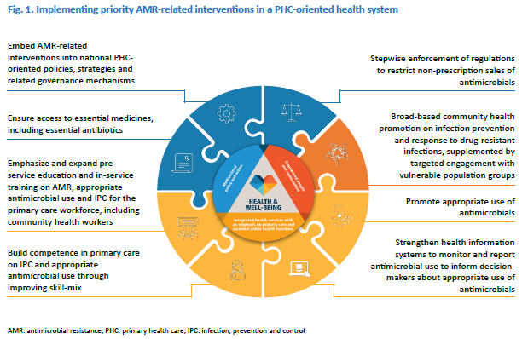
For information on the Commission’s work on antimicrobial resistance, see https://www.safetyandquality.gov.au/our-work/antimicrobial-resistance
For information on the Commission’s work on antimicrobial stewardship, see https://www.safetyandquality.gov.au/our-work/antimicrobial-stewardship

Climate change and workplace heat stress: technical report and guidance
Flouris AD, Nybo L, Kjellstrom T, Shumake-Guillemot J, Ivanov ID, editors
Geneva: World Health Organization and World Meteorological Organization; 2025
URL | https://www.who.int/publications/i/item/9789240099814
Notes | The World Health Organization (WHO) and World Meteorological Organization (WMO) have published this report providing ‘an in-depth analysis of the multifaceted impacts of rising heat levels on occupational safety and health.’ The report examines the health and productivity risks faced by workers, especially in manual labour sectors. The report details the physiological, socioeconomic, and mental health impacts of heat stress and outlines evidence-based strategies for prevention and mitigation.

Risk communication and community engagement readiness and response toolkit: mass gatherings
World Health Organization
Geneva: World Health Organization; 2025. p. 68.
URL | https://iris.who.int/handle/10665/382356
Notes | In recent years communicating risk in health issues has become more contested and complicated. The WHO has published this ‘toolkit’ that ‘contains a comprehensive set of practical tools and resources designed to support country-level risk communication and community engagement (RCCE) practitioners, decision-makers and partners to plan and implement readiness and response activities for health emergencies related to mass gathering events.’

Journal articles

Clinical quality registries: Establishing the socio-technical infrastructure for learning health systems
Stirling RG, Ahern S, Millar J, Evans S, Dawkins P, Zalcberg J
Learning Health Systems. 2025:e70036.

Development of a Best Practice Guide to Optimise the Reporting of Patient Reported Measures by Clinical Quality Registries for Quality Improvement Purposes
Ruseckaite R, Mudunna C, Ackerman I, Gabbe B, Ahern S
Health Services Insights. 2025;18:11786329251347343.
DOI | Stirling et al https://doi.org/10.1002/lrh2.70036  Ruseckaite et al https://doi.org/10.1177/11786329251347343
Notes | A pair of recent articles on clinical quality registries (CQRs) by Australian authors.  Stirling et al examine some of the issues around clinical quality registries and their role in learning health systems. The authors observe that clinical quality registries ‘have demonstrated significant national impacts in quality improvement in high burden disease domains. These registries rely on the construction and resourcing of socio-technical infrastructures that support quality improvement.’  Ruseckaite et al offer a somewhat more practical paper in describing a best practice guide for incorporating patient reported measures (PRMs) into clinical quality registries. The authors describe their ‘practical guideline to support CQRs and standardise their PRMs reporting for QI purposes, with the overarching goal of optimising the value of PRM data within CQRs.’
For information on the Commission’s work on clinical quality registries, including the Australian Framework for National Clinical Quality Registries and the Australian Register of Clinical Registries, see https://www.safetyandquality.gov.au/our-work/indicators-measurement-and-reporting/national-guidance-clinical-quality-registries

The Joint Commission Journal on Quality and Patient Safety
Volume 51, Issue 9, September 2025
URL | https://www.sciencedirect.com/journal/the-joint-commission-journal-on-quality-and-patient-safety/vol/51/issue/9
Notes | A new issue of The Joint Commission Journal on Quality and Patient Safety has been published. Articles in this issue of The Joint Commission Journal on Quality and Patient Safety include:  - Editorial: The Next 50 Years (Elizabeth Mort)  - Remembering Lucian Leape (Elizabeth Mort)  - The Joint Commission Journal on Quality and Patient Safety Welcomes New Editors (Dojna Shearer)  - Editorial: True Dialogue Across Language Difference Is Essential to Health Care Quality (Leonor Fernández, Rose L Molina)  - Language-Concordant Health Care: Implementation of a Bilingual Competency Program (Nkiru Ogbuefi, Alexandra Forauer, Maryana Kovalchuk, Javier Gonzalez, Catalina G Luna, Y Niu, F Gany, L C Diamond)  - Understanding Psychological Safety in Health Care: A Qualitative Investigation and Practical Guidance (Stephanie A Zajac, Kimberly N Williams, S M Patel, E H Lazzara, J R Keebler, M W Clemens, C L Holladay)  - Effects of a Workplace Well-Being Program on Professional Quality of Life Among Health Care Personnel (Nicholas A Giordano, Ingrid M Duva, Beth Ann Swan, Theodore M Johnson, Jeannie P Cimiotti, Dorian A Lamis, JoAnna Hillman, Janelle Gowgiel, Kristin Giordano, Nikki Rider, Lisa Muirhead, Michelle Wallace, Tim Cunningham, Maureen Shelton, Timothy Harrison, LaTanya Holland, Ammar A Rashied. Jennifer S Mascaro)  - Patient Safety Metrics Monitoring Across Harvard-Affiliated Hospitals: A Mixed Methods Study (Hojjat Salmasian, Astrid Van Wilder, Michelle Frits, Christine Iannaccone, Merranda Logan, Jonathan P Zebrowski, David Shahian, Mitchell Rein, David Levine, David W Bates)  - A Remote Patient Management Care Model for Pediatric Home Care Ventilator Patients Conserves Resources: A Quality Improvement Initiative (Lynn Shesser, John Tamasitis, John Chuo)  - Improving Awareness and Communication of Do Not Resuscitate Orders During Transitions of Care (Hanne Irene Jensen, Hanne Andersen, H Bruun)  - Addressing the Inpatient Capacity Crunch: A Quality Improvement Initiative to Increase Expected Discharge Date Documentation (Elizabeth C Kuhn, Katherine Pumphrey, Tyler Bruinsma, Christopher Oskins, Max Hans, Jessica Nguyen, Fredrick Chang, Brock Hoehn, Emily Kane)  - Peer Support Programs for Physicians and Health Care Providers: A Scoping Review (Bailey Russell, Arezoo Ahmadzadeh, Khadija Haris, Stephanie Jiang, Tyler R Chesney, Helen MacRae, Marisa Louridas)  - System Strategies to Optimize the Critical Role of the Medical Interpreter (Kathy Sliwinski, Eileen Johnson, Ana Galli, Victor Buzeta, Cynthia Barnard)

Emergency Medicine Australasia
Volume 37, Issue 4, August 2025
URL | https://onlinelibrary.wiley.com/toc/17426723/2025/37/4
Notes | A new issue of Emergency Medicine Australasia has been published Articles in this issue of Emergency Medicine Australasia include:  - A Validation Study of the Paediatric Non-Urgent Risk Assessment Management and Nurse Escort Assessment (PaNURAMA) Tool for Paediatric Inter-Hospital Transfers (M Davison, C Thomas, N White, L MacDowall, D Crookston, R Cole)  - Staff and Referrer Experiences and Challenges With a New Emergency Department Avoidance Service for Older People: A Qualitative Study (Miia Rahja, Sarah Collyer, Elizabeth Lynch, Gillian Harvey)  - Simplicity Is the Ultimate Sophistication: Improve the System to Improve the Basics (Sarah Beatty, Daniel Fatovich)  - Initial Clinical Impressions Are Absent in Around a Quarter of Adult Emergency Department Patient Consultations: Let's Get Back to Basics (Diana Egerton-Warburton, Andy Lim, Yuhan H Tan, Sophie Balzat, Ahnaf Chowdhury, Habibullah Paygham, Suzanne Bumpstead, Paul Crawford, Anjali Dhulia, Alex Duong, Neil Goldie, Ciaran Joyce, Erin Mills, Helen Psihogios, Yash Patwardhan, Adam West, Joanne Enticott, Lisa Kuhn)  - The Problem With ‘Gillick’ (Sarah Martin, Shih-Ning Then, Samuel Boyle)  - Enhancing Person-Centred Care in the Final Years of Life: Insights From Emergency Department Visits and Hospitalisations in Victorian Residential Aged Care (2015/16 to 2022/23) (Janine J Alan, Bridget Laging, Peter Cameron, Rohan Laging, James Boyd, Davina Porock, Sean Randall)  - Opioid Prescribing Patterns and Characteristics of Hand Injury Presentations to the Emergency Department of a Surgical Referral Centre in Western Sydney (Marco Stocca, Khanh Nguyen, Pramod Chandru)  - Improving Emergency Department Prescribing of Anticoagulation for Atrial Fibrillation Through an Iterative Quality Improvement Process (Finn Brokenshire, Kaleb Addy, John W Pickering, Ibrahim Al-Busaidi, Martin Than, Richard Troughton, Laura R Joyce)  - Characteristics and Outcomes of Emergency Department Patients Who Did Not Wait for Treatment: A State-Wide Data Linkage Analysis From New South Wales Australia (Michael M Dinh, Radhika V Seimon, Jenae O'Sullivan, Saartje Berendsen Russell, Kendall Bein)  - Predictors of ICU Admission in Intentional Overdose Presentations to the Emergency Department (Oliver Sutcliffe, Andrew McCombie, Calum Fisher, Maria Milkina, Tessa Burry, Jackie Hazelhurst, Rosalind Crombie, L R Joyce)  - Could Low-Value Diagnostic Tests be Compounding Access Block? A Single-Site, Cross-Sectional Study (Heidi Walker, Courtney West, Luke Lawton, Theophilus I Emeto, Vinay Gangathimmaiah)  - The Utility of Point-Of-Care Ultrasound for Paediatric Lumbar Puncture: A Narrative Review (Jacinta Trang, Dominic Ku, Peter J Snelling)  - An Inexpensive and Ultrasound-Compatible Lumbar Puncture Model Using SCOBY as an Effective Simulation Tool: The DIY LP Study (Gisela A Kristono, Henry Li, Peter Watts, Melita Macdonald, Alice Rogan, B Peckler)  - Perceived Impact of a Sonographer Educator in the Emergency Department (SEED) on Emergency Ultrasound (EUS) Training (Benjamin Taylor, Wai Chung Tse, Joshua Monester, Oriana Tolo, Adam Bystrzycki, Vijay Manivel, Peter Cameron, Elissa Kennedy Smith)  - Open and Closed Models of Emergency Care: Navigating Change in Rural Hospitals (Tim Baker, Tahnee Dunlop)  - The Impact of the COVID-19 Pandemic on Cardiac Related Emergency Department Presentations in Queensland: A Retrospective Cohort Study (Emma J Hall, Gerben Keijzers, Jamie Ranse, Amy L Sweeny, Julia Crilly, COVERED-COVID Study Investigators)  - Impact of Clinician Education on Emergency Department Mechanical Restraint: An Interrupted Time-Series Study (Daiv Lown, Anne-Maree Kelly, Joseph Miller, Ellis Keddie, Paul Buntine, Ainslie Senz, J Hope, P J Owen)  - Where Are the Greatest Risks for Choosing Unwisely? A Survey of Emergency Department Clinicians (Joseph Tuxen-Vu, Gerard O'Reilly, Julia Morphet, Peter Jones, Diana Egerton-Warburton, Anselm Wong, Peter Cameron, Amith Shetty, Simon Craig)  - Evaluating the Introduction of Humidified High-Flow Nasal Cannula Therapy Into an Australian Aeromedical Service Within a Paediatric Population: A Retrospective Cohort Study (Cameron Yap, Adelaide Withers, Nicole Ghedina, Elaine O'Connell)  - Emergency Department Presentations Are Increasing in Acuity in the State of Victoria, Australia—Statewide Hierarchical Regression Model for 2018–2024 (Andy Lim)  - Prevalence of GHB-Related Presentations to a Metropolitan Emergency Department in Melbourne (Hamed Akhlaghi, Jacqueline Maplesden, Greta Moon, Eden Pham, Felicia Zurzolo, Brendan Morrissey, Amanda Norman, Yvonne Bonomo, Sam Freeman, Jonathan Karro)  - Yield of Continuous Cardiac Monitoring in Pre-Specified Low-Risk Patients: A Retrospective Cohort Study (Danny Marhaba, Conor O'Flynn, Conor Jones, Jamie Formosa, Dion Stub, De Villiers Smit, Biswadev Mitra)  - Emergency Physicians in Trauma Care: Expertise, Collaboration, and Coordination (Nicola Sandler, Eva Andreotti, Brittany Hulbert)  - Leading the Way for Optimal Trauma Care (Frances Williamson)  - Prehospital Trauma Care (John Glasheen)  - ‘Panscans’ for Trauma in the Emergency Department (Peter A Cameron, Biswadev Mitra)  - Australian Emergency Department Doctors and Nurses' Perspectives on the Duration of Persistent Tachycardia in Children (Anastasia Mutic, Eunicia Tan, Michael Fahey, Emily Callander, Libby Haskell, Shane George, Meredith Borland, Naomi Loftus, Jessica Kasza, Jeremy Furyk, Natalie Phillips, Stuart R Dalziel, Simon Craig, on behalf of the PREDICT Network)  - The Implementing Clinical Pathways for Acute Care in Tasmania (IMPACT) Project (Viet Tran, Amanda Neil, Sarah Prior, Emma Tavender, Maria Unwin, Simone Page, Jan Radford, James E Sharman, Biswadev Mitra, Jim Stankovich, Giles Barrington, Ashley Loughman, Simon Brown, Graeme Zosky, Anthony J Lawler, Simon Craig)  - A Qualitative Examination of Job Satisfaction in Emergency Medicine From the Perspective of Physicians Also Working in Prehospital and Retrieval Medicine (J A Myers, S Aldington, D M C Powell)  - Serendipity, Flexibility, Calling and Commitment: How Clinicians Navigate the Path to Clinician-Coach (Andrew Rixon, Victoria Lister, Lee Yung Wong, Elizabeth Elder, Samuel Wilson)  - Computed Tomography Scan Rates and Outcomes in Children Risk-Stratified Using the PREDICT Guideline Algorithm for Risk Stratification of Mild and Moderate Head Injuries (Stephen J C Hearps, Emma Tavender, Meredith L Borland, Ed Oakley, Anneke Grobler, Vicki Anderson, Karen M Barlow, Stuart R Dalziel, Natalie Phillips, Amit Kochar, Sarah Dalton, Jeremy Furyk, Jocelyn Neutze, Amanda Williams, F E Babl, on behalf of Paediatric Research in Emergency Departments International Collaborative (PREDICT))  - Emergency Department Presentations for Low Back Pain by Remoteness and Socioeconomic Status in New South Wales: A Population-Based Study (Jacqueline North, Zoe A Michaleff, Michael Lee, Christopher Williams, Alexandre S Stephens)

Health Expectations
Volume 28, Issue 4, August 2025
URL | https://onlinelibrary.wiley.com/toc/13697625/2025/28/4
Notes | A new issue of Health Expectations has been published Articles in this issue of Health Expectations include:  - Migrants Living in the United Kingdom and Their Perceptions of Participation in Health Research: A Mixed-Methods Study (Mayuri Gogoi, Rebecca F Baggaley, Luisa Silva, Zainab Lal, Holly Reilly, Vishant Modhwadia, Daniel Pan, Paul Bird, Laura Nellums, Manish Pareek)  - The Experience of Manual Wheelchair Training for People With Chronic and Progressive Conditions: Perspectives of Users and Trainers (Kimberly Charlton, Carolyn Murray, Natasha Layton, Stacie Attrill)  - Public Involvement in a Systematic Review Project: Reporting Our Approach Using the ACTIVE Framework (Carmel McGrath, Sarah R Davies, Ifra Ali, Blessing Dick, Prakash Dewani, Clare E French)  - Insights Into the Expectations of Infertile Men Regarding Multidisciplinary Reproductive Health Services (Mehrdad Abdullahzadeh, Zohreh Vanaki, Eesa Mohammadi, Jamileh Mohtashami)  - Addressing Inequalities in Long Covid Healthcare: A Mixed-Methods Study on Building Inclusive Services (Ghazala Mir, Jordan Mullard, Amy Parkin, Cassie Lee, Jonathan Clarke, Johannes H De Kock, Denys Prociuk, Julie L Darbyshire, Sophie Evans, Manoj Sivan, LOCOMOTION Consortium)  - Stakeholder Perspectives on Built Environmental Factors to Support Stroke Rehabilitation and Return to Everyday Life (Laila de Vries, Maya Kylén, Tony Svensson, Jodi Sturge, Ruby Lipson-Smith, Steven M Schmidt, Hélène Pessah-Rasmussen, Marie Elf)  - TRANSFER-I: Hospitalised Older Adults and Their Carers' Perspectives of the Transition Home: A Qualitative Study (Kirsten J Parker, Caleb Ferguson, Julee McDonagh, Richard Lindley, Louise D Hickman)  - Identifying the Impacts, Obstacles and Information Barriers for Parents of Children Living With Genetic Neurodevelopmental Disorders: A Qualitative Study (Karen J Low, GenROC Consortium , Georgia Treneman-Evans, Sarah L Wynn, Jenny Ingram)  - Public and Healthcare Professional Attitudes Towards Risk-Stratified Bowel Screening: A Qualitative Study Using an Info-Comic Book (Hannah Miles, Una Macleod, David Weller, Joanne Cairns)  - A Proposal for Addressing Bioethical Concerns Along the 10-Step Framework for Community Engagement (Abdou Simon Senghor, Michelle Medeiros, Claudia Baquet, Franklin Lance, C Daniel Mullins)  - Uncovering the Dynamic System Driving Older Adults' Vitality: A Causal Loop Diagram Co-Created With Dutch Older Adults (Djoeke Besselink, Fons van der Lucht, Lisa Barsties, Martine Jansen- van der Vliet, Thomas G Kuijpers, Lidwien Lemmens, Evelyn J Finnema, Saskia W van den Berg)  - Children's Communication Choices About Musculoskeletal Pain and Injury: Insights From a Public Involvement Event (Rhiannon Joslin, Maggie Donovan-Hall, Mary Barker, Kathryn A Birnie, Eleanor Melfi, Lisa Roberts)  - Advancing the Care Experience for Patients Receiving Palliative Care as They Transition From Hospital to Home (ACEPATH): Phase 2 of Codesigning an Intervention to Improve Hospital-to-Home Transitions for Patients and Family Caregivers (Madeline McCoy, Taylor Shorting, Vinay Kumar Mysore, Edward Fitzgibbon, Jill Rice, Meghan Savigny, Natalie C Ernecoff, Marianne Weiss, Shirley H Bush, Daniel Vincent, Meaghen Hagarty, Geneviève Lalumière, Rex Pattison, Mona Kornberg, Maya Stern, Kerry Kuluski, Colleen Webber, Adrianna Bruni, Tara Connolly, Sarina R Isenberg)  - Seeing the Invisible Resiliency (STIR): Chronic Autoimmune Conditions and Post-Secondary Education Experiences in Young Adulthood (Samantha A Morin, Angelina Horta, Katelyn Greer, Parveen Priya Rai, Haley Gross, Raegan Reiter, Ingrid Nielssen, Marcia Bruce, Kim Giroux, D A Marshall)  - Patient–Registered Nurse Communication: Exploring Patients' Expectations and Experience in Primary Care Consultations (Sofia Östensson, Mariela Acuña Mora, Laura Darcy, Lotta S Huttu, S Van Dulmen, A J Sundler)  - Lived Experiences of New-Onset Long Covid Pain and Its Impact on Health-Related Quality of Life A Scoping Review of Current Evidence (Minimol Paulose, Nicholas Norman Adams, Kathryn R Martin, Aileen Grant)  - Acceptability and Feasibility of Health Measures in Preteens: Findings From the ROLO Longitudinal Birth Cohort Study (Sophie Callanan, Anna Delahunt, Rachel K Crowley, Patrick J Twomey, Catherine M Phillips, Alex O Start, Ciara M McDonnell, Declan Cody, Fionnuala M McAuliffe)  - User Input in the Development of Digital Sexual Health Tools: A Scoping Review and Guidance for Tool Developers (Alicia King, Ethan Cardwell, Eric Chow, Paul Flowers, Mark Gilbert, Kath Albury)  - Editorial: Making Room for Every Voice: Reimagining Person-Centred Care in the Neurosciences (Miguel Toribio-Mateas, Gareth Noble)  - What Are the Important Health and Well-Being Outcome Dimensions for Parent Carers of Disabled Children? A Qualitative Study (Caomhán McGlinchey, Phillip Harniess, Aleksandra J Borek, Alice Garrood, Annabel McDonald, Fleur Boyle, Stuart Logan, Christopher Morris)  - Acceptability of Self-Sampling for Cervical Screening in Ethnically Diverse Groups in Northwest England: A Focus Group Study (Sophie Whitley, Rachel L Hawkins, J C Davies, J Cao, L Malcomson, E J Crosbie, L McWilliams)  - From Dialogue to Action: Community Recommendations for Inclusive Research Participation Among Underrepresented Populations (Samuel Byiringiro, Grace C Bellinger, Akunna Mezu, Erin Wong, Tosin Tomiwa, M Guerrero Vazquez, A Foster, P Sheikhattari, C R Himmelfarb, H N Miller)  - Identifying Common Patient-Oriented Priorities for Child and Adolescent Health Research and Care: A Systematic Review of Priority Setting Partnerships (Jenna S Jessa, Muning (Linda) Zhang, Justin Bonhomme, Dawn P Richards, Diane L Lorenzetti, Christine T Chambers, Kathryn A Birnie)  - Public Involvement in Complex Theorising: A Co-Produced Logic Model of the Role of Context in Shaping Child Health (Dylan Kneale, Alison O'Mara-Eves, Bridget Candy, Lizzie Cain, Jessica Catchpole, Angela Chesworth, Sandy Oliver, Katy Sutcliffe, N Hutchinson Pascal, J Thomas)  - Cost-Effectiveness of a Personalised Self-Management Intervention for People Living With Long Covid: The LISTEN Randomised Controlled Trial (Shaun R S Harris, Bernadette Sewell, Monica Busse-Morris, Adrian Edwards, Fiona Jones, Fiona Leggat, Philip Pallman, Deborah Fitzsimmons)  - Co-Creation Methodology for Developing a Racial Inclusivity Training Resource in Physiotherapy Education (Yetunde Dairo, Meriel Norris, Annabel Williams, John A Hammond)  - Adaptation of the Content of a Behavioural Text Message Delivered Weight Management Intervention for a Socio-Culturally and Geographically Diverse Population of Postpartum Women in the UK: The Supporting MumS (SMS) Intervention (Eleni Spyreli, Lizzie Caperon, Emma Ansell, Sara Ahern, Sally Bridges, Elinor Coulman, Stephan U Dombrowski, Frank Kee, Jayne V Woodside, Dunla Gallagher, Michelle C McKinley)  - ‘It Is Like a Cross-Stitch … All Joined Together But Not Making a Very Nice Pattern’: A Qualitative Study of Patient Perspectives on Physical Health Inequalities in Severe Mental Illness (Tassia Kate Oswald, Stan Papoulias, Julie Williams, Jayati Das-Munshi)  - Understanding Medicine Preferences of Older Adults: The Role of Messaging in a Multi-Methods Experimental Survey (Alexander Chaitoff, Kristie Rebecca Weir, Vincent D Marshall, Sarah E Vordenberg)  - Exploring Young Adults' Experiences of Atopic Dermatitis Self-Management and Use of Community Pharmacy: A Qualitative Study (Abdi Berk Cayci, Adam Pattison Rathbone, Charlotte Lucy Richardson, L Lindsey)  - Coproducing COVID-19 Health Information Resources: A Participatory Study With Older Adults From Minoritised Ethnic Communities in the UK (Priyamvada Paudyal, Aghna Wasim, Saliha Majeed-Hajaj, Naresh Khapangi Magar, Rebecca Sharp, Emily Skinner, Arya Sharma, Laura Hughes, Debbie Isobel Keeling, Jo Armes, K Kulasabanathan, K Canvin, S Gaihre, J Cassell)  - An Innovative Youth-Friendly Electronic Questionnaire to Identify Mental, Sexual and Reproductive Health Risks: A Validation Study of the Total Teen Assessment (Whitney R Garney, K L Wilson, M Patterson, C B Holden, S Flores, S Panjwani, K Garcia, C Esquivel, A Khanhkham, K V Ajayi)  - Community Engagement in Long Covid Research: Process, Evaluation and Recommendations From the Long COVID and Episodic Disability Study (Margaret E O'Hara, Kiera McDuff, Hannah Wei, Lisa McCorkell, Catherine Thomson, Mary Kelly, Susie Goulding, Imelda O'Donovan, Sarah O'Connell, Ruth Stokes, Nisa Malli, Natalie St Clair-Sullivan, Soo Chan Carusone, Angela M Cheung, Kristine M Erlandson, Ciaran Bannan, Liam Townsend, Colm Bergin, Jaime H Vera, Richard Harding, L Avery, D A Brown, K K O'Brien)  - Evaluating a Codesign Process in Mental Health: ‘Harnessing the Power of Together’ (Michelle Kehoe, Hannah Friebel, Kirsty Rosie, Paul Kremer, Frances Shawyer, Graham Meadows, Ingrid Ozols)  - Co-Designing Aphasia Services: Evaluation of Involvement and Processes to Support Inclusion of People With Post Stroke Aphasia (Lisa Anemaat, David A Copland, Victoria J Palmer, Sarah J Wallace)  - Navigating Discharge From Early Intervention in Psychosis Services: A Qualitative Exploration of the Experiences of Service Users and Carers (Michelle Rickett, Tom Kingstone, Veenu Gupta, David Shiers, Paul French, Belinda Lennox, Ed Penington, Ryan Williams, I Hoppe, C A Chew-Graham)  - Experiences of Tobacco Smoking and Quitting Among Mental Health Consumers (Helena Roennfeldt, Marianne Wyder, Coral Gartner, Alice Holland, Norah Elvidge, Dan Siskind, Cheneal Puljević)  - Establishing a Public Involvement Network for Chronic Pain Research in the United Kingdom: Lessons Learned (Sharon Grieve, Rosie Harrison, Carolyn Chew-Graham, Ian Taverner, Joanne Lloyd, Noureen Shivji, Ellen Readman, Adele Higginbottom, C Wilkinson, L Austin, E Keogh, C McCabe)  - Co-Designing an Engagement Strategy to Include the Voices of a Minority Group in Assessing the Quality of Maternity and Neonatal Care (Thérèse McDonnell, Jaspreet Kaur Dullat, Louise Hendrick, Léan McMahon, Gemma Moore, Emily Murphy, Carmen Nae, Danut Nae, M Prontera, E McAuliffe)  - Co-Design or Faux-Design? Reflections on Co-Designing Safe Spaces for People in Emotional Distress or Suicidal Crisis in Australia (Erin Oldman, Michelle Banfield, Heather Lamb, Erin Stewart, Helen Tosin Oni, Benn Miller, Mel Giugni, Alyssa R Morse, Scott J Fitzpatrick)  - Exploring Patient Understandings of Navigation Services Within Alberta's Healthcare System: A Qualitative Study (Sarah Rabi, Maria Santana, Gina Dimitropoulos, Kerry McBrien, Eleanor Benterud, Lorraine Wigston, K Tang)  - ‘I Wish It Were More Often Told to People Before They Are Prescribed These Medications How Hard It Is to Get Off Them’: A Qualitative Descriptive Analysis of Free-Text Responses to a Survey on Reducing and Stopping Psychiatric Medication (Miriam Boland, Agnes Higgins, Sookyung Kwak, Cathal Cadogan)  - Barriers and Facilitators to Accessing Healthcare for People With Parkinson's Disease in Latin America: A Qualitative Study (Christine Jeyachandran, Catherine Spooner, Ana Margarita Rodriguez Salgado, Matthew Prina, Joel Rhee, Jorge Jesus Llibre-Guerra, Dani Kim, J J Llibre-Rodriguez, M F Harris)  - The CIRCLE Care Home Guide: A Co-Designed Resource on LGBTQ+ Inclusion for Care Homes (Jolie R Keemink, John Hammond, Grace Collins, J Price, M Wells, S Johnson, S A Rugg, M Parish, A King, K Almack)  - Gaps in the Engagement of People With Lived and Living Experience and Caregivers in Mental Health and Substance Use Health Research: A Qualitative Study of Untapped Potential (Lisa D Hawke, Jingyi Hou, C Munro, C Sendanyoye, S Hauer, M R van Kesteren, K Upham, T Halsall, Y Lunsky)  - Nurturing Acceptance for Research in the Community: Conceptualising Engagement Towards Research Through Normalisation Process Theory (Tanvir C Turin, Nashit Chowdhury, Tanmoy Newaz, Mohammad M H Raihan, Nafiza Rahman, Nahid Rumana)  - Experience, Process, and Impact of Involving Informal Caregivers of People With Dementia as Public Contributors to Inform the Development of a Complex Intervention: A Mixed-Methods Study (Frida Svedin, Ida Österman Menander, Oscar Blomberg, Anders Brantnell, Paul Farrand, Theresia Lückner, Kristina Sundelin, Joan Turney, A C Åberg, J Woodford)  - The Heart Health Yarning Tool: Co-Designing a Shared Decision-Making Tool With Aboriginal and Torres Strait Islander People for Cardiovascular Disease Prevention and Risk Management (Shannon McKinn, Judith Parnham, D Follent, M Tracy, R Wyber, N Freeman, R Puranik, M Dickson, C Bonner)  - Advance Care Planning in German General Practice: A Longitudinal Qualitative Study on Patients' Expectations and Experiences (Alexandra Schmidt, Klaus Weckbecker, Jürgen in der Schmitten, K Götze, A Mortsiefer)  - Understanding a Minority Group's (Roma) Experiences of Access and Quality in Maternity Services (Jaspreet Kaur Dullat, Thérèse McDonnell, Louise Hendrick, Léan McMahon, Gemma Moore, Emily Murphy, Carmen Nae, Danut Nae, Marianna Prontera, Eilish McAuliffe)  - ‘Why Didn't I Get That Choice?’: A Qualitative Exploration of How Cervical Screening Choices Are Understood and Experienced by Screen-Eligible People in Australia, Two Years After Self-Collection Became an Option for All (Ana Machado Colling, Tessa Saunders, Nicola Creagh, Maleeha Ashfaq, Julia Brotherton, Claire Nightingale)  - ‘The Difficulty of Diagnosis Compromises Patient Care for People With Endometriosis’: Interview Study With Aotearoa New Zealand General Practitioners (Katherine Ellis, Alina Meador, Anna P Ponnampalam, R Wood)  - Recurrent Miscarriage and Infertility Services and Supports: A Qualitative Study of Views and Experiences in the Republic of Ireland (Laura Aoife Linehan, Marita Hennessy, Keelin O'Donoghue)  - Assessment of Hope in Pediatric Oncology: Development, Content and Face Validation of a Parental Questionnaire (Laurine Milville, Pascal Antoine, Sophie Lelorain)  - How Do Participatory Citizenship Models Inform Co-production in Health Research? A Systematic Review (Catharine Rose, Lois Donnelly, Jess Howdle, Mark Lynes, Katharine Arnett, Mary Nettle, Eleanor Bradley)  - Research in Partnership With Older People—Involvement in Conducting and Analysing Focus Groups (Nadja Reeck, Anna Völkel, Margarethe Mammes, D Urbahn-Schiefer, B Reineking, T Stuckenschneider, A L Brütt)  - High Psychological Impact of Covid-19 on French Healthcare Workers: An Observational Cohort Study of PTSD, Depression and Burn-Out (Wissam El-Hage, Alexandre Lemé, Myriam Blanchin, Eric Bui, Hala Kerbage, Sarah Ibouhsissen, Aude Allemang-Trivalle, Valérie Gissot, Bénédicte Gohier, Coraline Hingray, Philippe Birmes, Eric Fakra, Nathalie Prieto, C Lemogne, M-O Krebs, B Aouizerate, I Jalenques, P Vidailhet, A Sauvaget, A Caille)  - Long COVID Optimal Health Programme to Enhance Mental and Physical Health: A Feasibility Randomised Controlled Trial (Hiyam Al-Jabr, David J Castle, David R Thompson, Karen Windle, John Belcher, Mónica M De Icaza Valenzuela, Toby Helliwell, Chantal F Ski)  - ‘It Would've Been Nice to Know About Allied Health Earlier’: Insights From People With Parkinson's Disease (Cassandra M Wong, Sarah M Dennis, Natalie E Allen, Serene S Paul)  - Engagement of People With Lived Experience in Spinal Cord Injury to Address Innovation Priorities (Julia T Ross, Vanessa K Noonan, John Chernesky, James Hektner, Richard Peter, Spring Hawes, Andrew Forshner, Shweta Shekhar, Tathagata Ray, Arushi Raina, James J Laskin)  - Reducing the Delay in the Diagnosis of Bipolar Disorder: A Qualitative Study (Hoppe I, S Watson, N Ahuja, L Azim, A Cipriani, E Clark, J Evans, T Gergel, J Gibson, J Hall, T Kabir, A Mathias, N Nixon, Prasad V, L Wall, C Chew-Graham)  - Healing Through Empowerment and Active Listening: Experience-Based Co-Design of a Nurse-Led Personalised Self-Care Support Intervention for Primary Care Patients With Diabetic Foot Ulcers (Xiaoli Zhu, Eng Sing Lee, Frederick H F Chan, Ruoyu Yin, Rachel W S Koh, Phoebe X H Lim, Carpenter Judith, Voon Hooi Lim, Richard S Y Low, Yee Chui Chen, Yan Chen, Xiuhong Wang, Pei Pei Ng, C T Y Tan, S Tan, K Pereira, K Griva)  - Co-Development of the CoMUni Intervention: A Social-Media-Based Resource to Increase B(N Wilde, J Foster, V Jones, A Kossivas, Jill Çakmak, O C Knight, M Grzywacz, D Foxcroft, E L Davies)

BMJ Quality & Safety online first articles
URL | https://qualitysafety.bmj.com/content/early/recent
Notes | BMJ Quality &Safety has published a number of ‘online first’ articles, including:  - Bridging diagnostic safety and mental health: a systematic review highlighting inequities in autism spectrum disorder diagnosis (Abirami Srivarathan, Andrea Bradford, Sara Shearkhani, Layla Heimlich, Sheryl Jefferson, Kristen E Miller, Kelly Smith, Helen Haskell, Traber D Giardina)  - Key partner priorities for measures of safe outpatient paediatric medication use (Jonelle Prideaux, Maria T Britto, Lisa M Vaughn, Katherine A Auger, Cassandra Dodds Fetters, James M Hoffman, Julia M Kim, Kathleen E Walsh)

International Journal for Quality in Health Care online first articles
URL | https://academic.oup.com/intqhc/advance-articles
Notes | International Journal for Quality in Health Care has published a number of ‘online first’ articles, including:  - Barriers and Facilitators to Disseminating Quality Improvement and Patient Safety Research: A Scoping Review Open Access (Aisling Byrne, Roisin O’Malley, Paul O’Connor, Sinéad Lydon)  - Designing a Chest Tube Checklist using a multidimensional human factor approach: a hierarchical task analysis, a failure mode and effect analysis and a Bow-tie analysis (Johanna Ludwig, Stephanie Schneider, Axel Ekkernkamp, Thomas Auhuber, Lauren Morgan)  - Beyond the Silo: Harnessing Interdisciplinary Collaboration for Health (John Patrick C Toledo)  - Equity in Universal Health Coverage: Do Individuals with Disabilities Benefit Equally? (Szu-Han Chen et al)

Online resources

Australian Living Evidence Collaboration
https://livingevidence.org.au/

[Canada] Tobacco smoking in adults
https://canadiantaskforce.ca/guidelines/published-guidelines/tobacco-smoking-in-adults/
The Canadian Task Force on Preventive Health Care has produced a guideline that includes a patient-clinician discussion tool to help people quit smoking, with behavioural and medication-related options that can be tailored and combined for personal choice.

Infection prevention and control and COVID-19 resources
The Australian Commission on Safety and Quality in Health Care has developed a number of resources to assist healthcare organisations, facilities and clinicians These resources include:
- Poster – Combined contact and droplet precautions https://www.safetyandquality.gov.au/publications-and-resources/resource-library/infection-prevention-and-control-poster-combined-contact-and-droplet-precautions
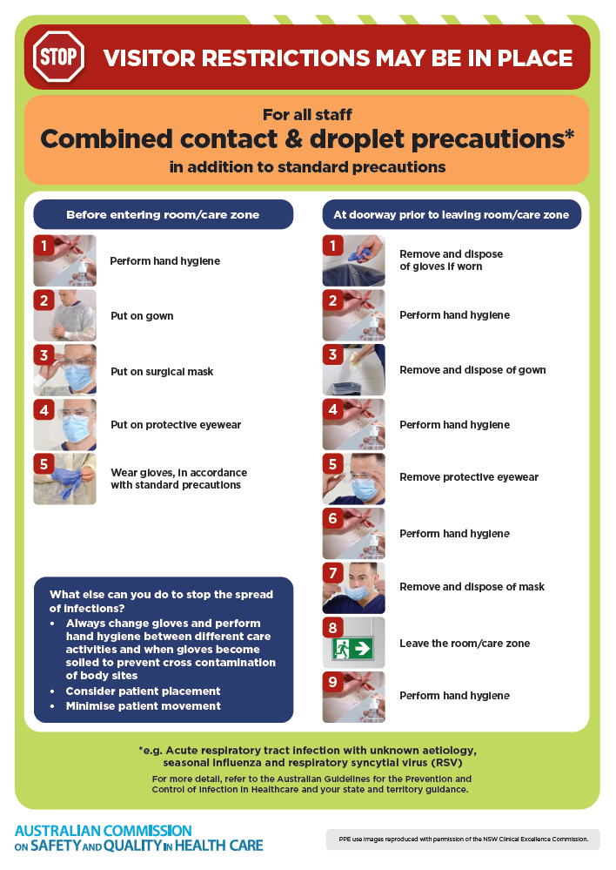
- Poster – Combined airborne and contact precautions
https://www.safetyandquality.gov.au/publications-and-resources/resource-library/infection-prevention-and-control-poster-combined-airborne-and-contact-precautions
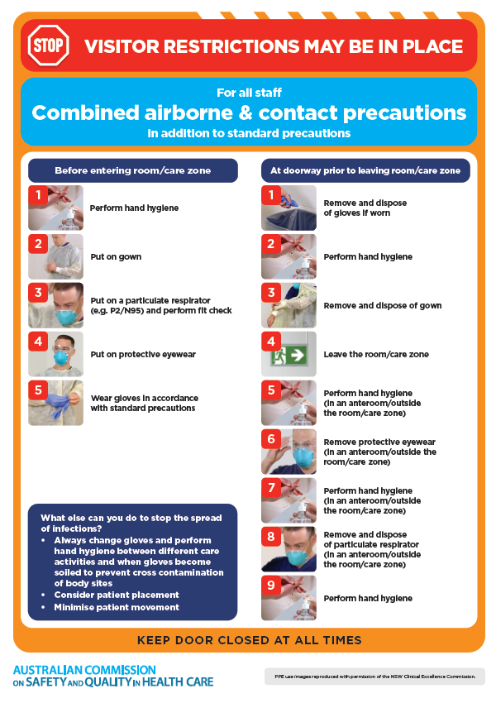
- Environmental Cleaning and Infection Prevention and Control www.safetyandquality.gov.au/environmental-cleaning
- Break the chain of infection poster
https://www.safetyandquality.gov.au/publications-and-resources/resource-library/break-chain-infection-poster
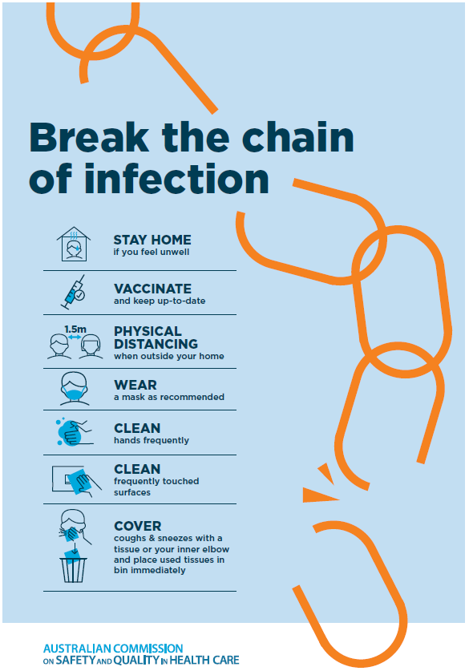

Disclaimer
On the Radar is an information resource of the Australian Commission on Safety and Quality in Health Care The Commission is not responsible for the content of, nor does it endorse, any articles or sites listed The Commission accepts no liability for the information or advice provided by these external links Links are provided on the basis that users make their own decisions about the accuracy, currency and reliability of the information contained therein Any opinions expressed are not necessarily those of the Australian Commission on Safety and Quality in Health Care.

