
On the Radar
Issue 712
8 September 2025

On the Radar is a summary of some of the recent publications in the areas of safety and quality in health care Inclusion in this document is not an endorsement or recommendation of any publication or provider Access to particular documents may depend on whether they are Open Access or not, and/or your individual or institutional access to subscription sites/services Material that may require subscription is included as it is considered relevant.

On the Radar is available online, via email or as a PDF or Word document from https://www.safetyandquality.gov.au/newsroom/subscribe-news/radar

If you would like to receive On the Radar via email, you can subscribe on our website https://www.safetyandquality.gov.au/newsroom/subscribe-news
or by emailing us at mail@safetyandquality.gov.au.
You can also send feedback and comments to mail@safetyandquality.gov.au.

For information about the Commission and its programs and publications, please visit https://www.safetyandquality.gov.au

On the Radar
Editor: Dr Niall Johnson
Contributors: Niall Johnson

Reports

The role of Health, Research and Education Precincts in establishing local learning health systems and achieving value-based healthcare
Deeble Institute for Health Policy Research Perspectives Brief no: 37
Radmore S, Haddock R
Canberra: Australian Healthcare and Hospitals Association; 2025. p. 29.
URL | https://ahha.asn.au/resource/the-role-of-health-research-and-education-precincts-in-establishing-local-learning-health-systems-and-achieving-value-based-healthcare/
Notes | This perspectives brief from the Australian Healthcare and Hospitals Association’s Deeble Institute for Health Policy brings together two concepts that have been discussed over recent years, learning health systems (LHS) and value-based health care (VBHC). Indeed, this brief discusses physically locating the two approaches within Health Research and Education Precincts (HREPs) together so as to leverage one another. The authors describe these various initialisms:  - Value-based healthcare (VBHC) has emerged as a global response to the challenges of delivering high-quality, sustainable care in an environment of evolving and increasing demands.  - LHS are dynamic healthcare ecosystems that continuously and systematically integrate data, research, and practice to improve patient care and health outcomes. LHS foster a culture of ongoing learning where every experience, decision, and outcome become part of a cycle of continuous improvement.  - Health Research and Education Precincts (HREPs) play a critical role in advancing value-based healthcare (VBHC) by bringing together researchers, clinicians, educators, and policymakers to enable evidence-informed, outcome-driven care.  The authors argue that ‘HREPs represent a critical yet underutilised opportunity to embed VBHC and LHS principles into the fabric of Australia’s health system. By integrating clinical care, research, education, and industry, HREPs create high-performing, place-based ecosystems that accelerate innovation, foster continuous learning, and deliver measurable system impact.’ They also offer a number of recommendations to realise this vision, including developing a nationally consistent definition, developing a national strategic framework, establishing national coordination and governance and identifying and allocating investment.

Journal articles

National Aged Care Reforms and Trends in Psychotropic Medication Use in 428 Residential Age Care Facilities, 2018-2022
Raban MZ, Rahman B, Wabe N, Li L, Manias E, Morgan M, et al
Journal of the American Medical Directors Association. 2025.
DOI / URL | https://doi.org/10.1016/j.jamda.2025.105832  https://www.jamda.com/article/S1525-8610(25)00349-4/fulltext
Notes | Paper reporting on a ‘retrospective cohort study using routinely collected electronic medication administration data’ in order to examine ‘changes in the prevalence of psychotropic medication administration in Australian residential aged care (RAC) during a period of national reforms, including the introduction of mandatory reporting of antipsychotic use.’ The study examined daily medication administration data for 52,201 residents of 428 RAC facilities in 7 Australian states and territories between January 2018 and December 2022. The authors report finding ‘Significant reductions occurred in the administration of antipsychotic, sedative and anxiolytic, and antiseizure medication to residents with and without dementia between 2018 and 2022. They also observed ‘However, antidepressant use may be increasing in people with dementia as a form of chemical restraint. Ongoing monitoring of the national Quality Indicator program and other initiatives is crucial to ensure there are no unintended consequences such as switching between psychotropic medication classes.’

For information on the Commission’s work on medicines safety and quality, see https://www.safetyandquality.gov.au/our-work/medicines-safety-and-quality
Improving Awareness and Communication of Do Not Resuscitate Orders During Transitions of Care
Jensen HI, Andersen H, Bruun H
The Joint Commission Journal on Quality and Patient Safety. 2025;51(9):574-581.
DOI | https://doi.org/10.1016/j.jcjq.2025.06.003
Notes | Transitions of care has long been recognised as a site of safety and quality lapses. They have been a focus of much of the Commission’s work, from the early work on clinical handover through to recent work on medication management at transitions of care. This piece reports on a Danish study that looked at the communication of Do Not Resuscitate (DNR) orders at transitions of care. The authors describe the study thus: ‘This intervention initiative with pre- and post-measurements (2020 and 2023) involved hospital departments and nursing homes in Denmark. The intervention consisted of a practical instruction brochure and an end-of-life presentation. The measurements included audits of resuscitation attempts and of DNR order documentation at transitions of care. Furthermore, the participating institutions completed an electronic survey on perceived challenges.’ While ‘The number of inappropriate resuscitation attempts was identical at pre- and post-measurements (none in nursing homes and five at the hospital)’, there was an increase in correct documentation to hospital discharge and a reported ‘significant increased focus on DNR orders’.

For information on the Commission’s work on transitions of care, see https://www.safetyandquality.gov.au/our-work/transitions-care

Evaluating learning health systems: a jurisdictional scan
Panesar B, Whitmore C, Vanderhout S, Bird M
SSM - Health Systems. 2025;5:100117.

What should a learning health system look like?
Foy R, Carder P, Johnson S, Copsey B, Alderson S
BMJ Open Quality. 2025;14(3):e003455.
DOI | Panesar et al https://doi.org/10.1016/j.ssmhs.2025.100117  Foy et al https://doi.org/10.1136/bmjoq-2025-003455
Notes | A pair of items looking at what a learning health system may entail.  Panesar et al reviewed 45 papers in their ‘international jurisdictional scan to highlight common evaluation approaches, indicators, outcomes, challenges, and assumptions related to establishing counterfactuals in LHS evaluation.’ They noted that ‘‘Ingredients perceived to contribute to a successful LHS included engagement of key individuals, establishment of a LHS culture, data considerations, and contextual factors.’  Foy et al provide their perspective from a ‘collaborative evolution towards a primary care learning health system and consider the conditions necessary for such a system.’ They consider the barriers, the integration of research and quality improvement, the potential value of a learning health systems and the enabling conditions (which unsurprisingly echo those in Panesar et al). Their ‘Suggested conditions for a learning health system’ include:  - Leadership and organisation  - Values and expectations  - Priority setting  - Resources and logistics  - Governance and monitoring.
Effectiveness of clinician-directed default nudges on reducing overuse of tests and treatments in healthcare: a systematic review of randomised controlled trials
Altinger G, Jones CMP, Ferreira GE, Soon J, Hoffmann TC, Maher C, et al
BMJ Quality & Safety. 2025.
DOI | https://doi.org/10.1136/bmjqs-2025-018793
Notes | A few years ago, ‘nudges’ were the focus of many in a range of policy areas. This paper reports on a review of the randomised controlled trials that had examined the use of nudges to influence the ordering of diagnostic tests and treatments. Much of the evidence on the efficacy of nudges has come from observational studies. This study sought to ‘synthesise evidence from randomised controlled trials examining the effect of clinician-directed default nudges on overuse of tests or treatments, measured as a proportion of encounters or patients.’ The review focused on six trials that ‘targeted overuse of opioids, antibiotics, high-risk medicines for older patients and imaging during palliative radiotherapy.’ From the review of this small number of trials, the authors concluded ‘Clinician-directed default nudges had inconsistent effects on overuse of healthcare, with limited and mostly low certainty evidence.’

Sustainable surgery: Merging health care and environmental impact
Shah AN, Fitzpatrick CM
Surgery. 2025;187.
DOI | https://doi.org/10.1016/j.surg.2025.109639
Notes | The authors of this piece contend that ‘Surgeons are uniquely positioned to implement sustainable practices and advocate for transparency in environmental impact reporting.’ The authors propose ‘life cycle analysis and life cycle impact assessment as critical tools for evaluating the environmental effects of medical devices and practices.’  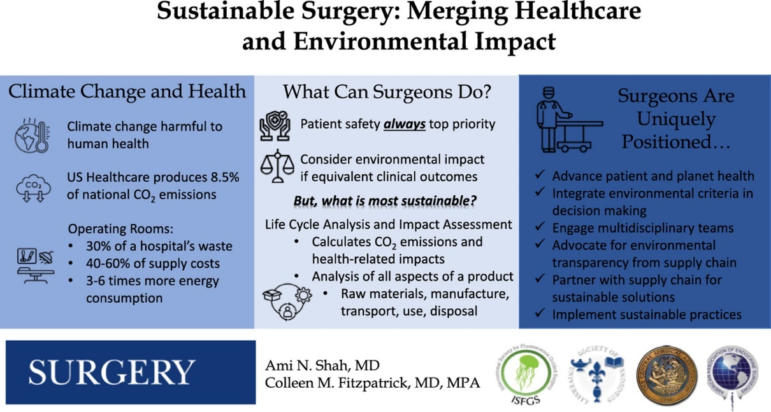

For information on the Commission’s recently released Healthcare Sustainability and Resilience Module see https://www.safetyandquality.gov.au/standards/healthcare-sustainability-and-resilience-module

Medical colleges have an obligation to ensure full participation in Clinical Quality Registries
Aitken RJ, Smith JA, Maddern GJ
Medical Journal of Australia. 2025;223(5):233-235.
DOI | https://doi.org/10.5694/mja2.70010
Notes | Following a pair of articles on clinical quality registries (CQRs) by Australian authors in last week’s On the Radar, is this piece on registries that appeared in the Medical Journal of Australia. This piece notes that ‘there is abundant evidence that CQRs improve outcomes and are cost-effective’. It also notes the critical importance of data quality and suggests the data quality could be improved. The authors ‘argue that colleges should use their position to ensure high quality data, which requires full participation, high case ascertainment and data completeness’.  A number of Commission publications are referenced. The piece does not quite capture the extent of Commission activity on CQRs as it starts with the 2014 Australian Framework for National Clinical Quality Registries and notes later activities, including the 2016 economic evaluation of CQRs, the Australian Register of Clinical Registries, etc. The Commission’s activity on CQRs dates back to 2007 – and led to the 2008 Operating Principles and Technical Standards for Australian Clinical Quality Registries, co-authoring articles in 2010 (McNeil JJ, Evans SME, Johnson NP, Cameron PA. Clinical-quality registries: their role in quality improvement. Medical Journal of Australia. 2010;192(5):244-245) and 2011 (Evans SM, Scott IA, Johnson NP, Cameron PA, McNeil JJ. Development of clinical-quality registries in Australia: the way forward. Medical Journal of Australia. 2011;194(7):360-363). The 2008 principles were then incorporated into the Framework (2014 and 2024). The original 2008 principles included principles on data collection, data elements, data, security, and data quality, data completeness that have echoes in this 2025 piece.

For information on the Commission’s work on clinical quality registries, including the Australian Framework for National Clinical Quality Registries and the Australian Register of Clinical Registries, see https://www.safetyandquality.gov.au/our-work/indicators-measurement-and-reporting/national-guidance-clinical-quality-registries

American Journal of Medical Quality
Volume 40, Issue 5, September/October 2025
URL | https://journals.lww.com/ajmqonline/toc/2025/09000
Notes | A new issue of American Journal of Medical Quality has been published. Articles in this issue of American Journal of Medical Quality include:  - Preventing Postoperative Sepsis: Multidisciplinary Implementation of Diverse Countermeasures in our first NSQIP Project (J Stuart Wolf, Jr, Margaret L Whitney, Rebekah M Summey, Michelle P Sanchez, Dusten T Rose, Mara B Rosalsky, Sabino T Lara IV, Mitchell J Daley, Ben Coopwood, Bryan G Carter, Ramsey R Ashour, Joseph E Mette)  - The Clinician in Quality and Innovation: A Qualitative Study of a Novel Academic Pathway at 10 Years (Joanne Goldman, Brian M Wong, Gillian Hawker, Wendy Levinson, Kaveh G Shojania)  - The Effect of Individualized Surgeon Comparative Feedback on Arthroplasty Outcomes: An Interrupted Time Series Analysis (Stephen E Asche, Ella A Chrenka, Steven P Dehmer, Jeanette Y Ziegenfuss, Ann M Werner, Marc F Swiontkowski, Megan Reams, Leif I Solberg)  - Closing the Communication Gap: Assessing the Alignment Between UME and GME Competencies Anita M Wilson, Katherine Berg, Aaron Douglas, John Caruso, Gretchen Diemer, K Day, R Frasso, S K Herrine, D Abraham)  - What Is Health Care For? Proposing a Purpose That Connects and Transforms (Zachary Schulman, Peter Pronovost)  - Resident-Driven Population Management to Improve Primary Care Statin and Blood Pressure Measures (Mitchell Dittus, Zhuo Yu, Michael Jorgensen, Lisa Fisher)  - Reducing Cardiovascular Risk and Improving Treatment Adherence With a Novel Medical Student–Delivered Education Program (Rithvik Kata, Ayush Shah, Tamanaa Atrafi, Benjamin Varughese, C Christman, C Cheng)  - Promoting a Culture of Quality and Safety via Morbidity and Mortality (M&M) Conferences (Ashlee Newton, Victoria E Boyd, Hope Feldman, Prakash Kharel, Erin Walker, A Dhanya Mackeen)

Health Affairs
Volume 44, Number 9, September 2025
URL | https://www.healthaffairs.org/toc/hlthaff/44/9
Notes | A new issue of Health Affairs has been published with a theme of ‘Insights About The Opioid Crisis’. Articles in this issue of Health Affairs include:  - Empowering A New Kind Of Research Team To Study Substance Use (Akilah Wise)  - The Opioid Crisis: Scaling Up Treatment And Harm Reduction Programs To Reach More People Who Would Benefit (Brendan Saloner, and Pooja Lagisetty)  - Improving Policy Evaluations Of The Opioid Crisis (Rosalie Liccardo Pacula, Beth Ann Griffin, Megan S Schuler, Rosanna Smart, Sean Grant, David Powell, Sarah Axeen, Seema Pessar, Corey S Davis, Elizabeth A Stuart, Flora Sheng, Courtney Kase, S W Patrick, R Bluthenthal, and B D Stein)  - Geography And Fentanyl: Explaining The Disproportionate Rise In Opioid Overdose Deaths Among Black Americans (David Powell, Dan Han, Jevay Grooms, and Rosalie Liccardo Pacula)  - Fewer Than 1 In 3 Adolescents With Past-Year Opioid Use Disorder Received Substance Use Treatment, 2022–23 (Manuel Cano, Nika Hernandez, Natasha S Mendoza, and Sarah M Bagley)  - Improving Access To Substance Use Disorder Care In Nursing Facilities (Lauren A Kelly, Robert C Accetta, Mary Beth Conroy, and Anne Myrka)  - Black, Hispanic, And Asian Adults In The US Had Substantially Lower Engagement On The Naloxone Care Cascade, 2024 (Lindsay Allen, Joshua C Black, and Carlton M Kelly)  - The Quality Of Opioid Use Disorder Treatment In Medicare Is Low And Lags Behind Medicaid (Tami L Mark, William J Parish, Deborah Steinberg, Minglu J Sun, and Miku Fujita)  - Medicaid Enrollees With Opioid Use Disorder Were More Likely To Receive Medication Treatment Than Commercial Enrollees (Karen Shen, Benjamin Thornburg, Alene Kennedy-Hendricks, and Mark Katz Meiselbach)  - States With Substantial Increases In Buprenorphine Uptake Did So With Increased Medicaid Prescribing, 2018–24 (Stephen Crystal, Fangzhou Xie, Hillary Samples, Allen Campbell, Peter Treitler, Elizabeth M Stone, Sumedha Gupta, Kosali I Simon, and Jennifer Miles)  - Medicaid And Methadone For Opioid Use Disorder: Expanded Coverage Increased Distribution In 10 States, 2019–24 (Ellen Latsko, Alina Denham, and Michael L Barnett)  - Medicaid: Increased Patient Access To MOUD In Residential Treatment Associated With Facility Openings And Closures, 2012–22 (Tamara Beetham, Helen Newton, Chima D Ndumele, David A Fiellin, and Susan Busch)  - Telemedicine Buprenorphine Access For Incarcerated People: Lessons Learned From Maryland’s Rural Jails (Max Spaderna, Annabelle M Belcher, Chris Welsh, Hannah Campbell Smith, Heather Fitzsimons, Kelly Coble, Natalie Spicyn, Elana Rosenthal, Tracy Liu, and Eric Weintraub)  - Increasing Emergency Department Patient Navigation And Buprenorphine Use: A Model For Low-Barrier Treatment (Elizabeth A Samuels, Allison D Rosen, Sarah Abusaa, Annette M Dekker, David L Schriger, Steven J Shoptaw, Mariah M Kalmin, Chunqing Lin, Serena Clayton, S Windels, E Keating, S Cisneros, A Campbell, A Moulin, and A A Herring)  - Indiana Adults Who Participated In Treatment Court Programs Had Better Health Outcomes Than Those Who Did Not (Elizabeth Van Nostrand, Alyssa Johnston, Mark S Roberts, Steven M Albert, and Jeanine M Buchanich)  - Trends In The Availability Of Buprenorphine At US Retail Pharmacies, 2017–23 (Jenny S Guadamuz, Sarah Axeen, and Dima Mazen Qato)  - Key-Informant Perspectives On Pharmacy-Based Methadone Treatment For Opioid Use Disorder In The US (Maureen T Stewart, Sage R Feltus, Cynthia A Tschampl, Jeffrey P Bratberg, and Traci C Green)  - Restrictive State Opioid Treatment Program Regulations Constrain Local Access To Methadone Maintenance Treatment (J Travis Donahoe, Noa Krawczyk, Julie M Donohue, Dylan Nagy, and Paul J Joudrey)  - Private Equity Acquiring Large Shares Of The Opioid Treatment Market Without Changing Market-Level Methadone Supply (Yashaswini Singh, Jonathan Cantor, C M Whaley, B Shuey, R Bilden, and J T Donahoe)  - Reflections On The Black Recovery Journey With Willie Pearl Evans (Jessica Bylander)  - Supporting Formerly Incarcerated People With Recovery (Akilah Wise)  - Criminalized For Surviving: Parenthood Under Surveillance (M Perry)  - My Methadone Journey: The Gold Standard In Frustration (Andrew Goodman)  - You Found Your Home There (Cari Ann Fisher)  - To The Best Friend Who Gave Up On Me, 20 Years Later (Kaia Renouf)  - How Conflict Ravages A Health Care System (Rabih Torbay)

BMJ Quality & Safety online first articles
URL | https://qualitysafety.bmj.com/content/early/recent
Notes | BMJ Quality &Safety has published a number of ‘online first’ articles, including:  - Editorial: Learning from healthcare complaints: challenges and opportunities (Tom W Reader)  - Service users’ experiences of maternity care in England informed by the Saving Babies’ Lives Care Bundle Version 2: A reflexive thematic analysis (Holly E Reid, Debbie M Smith, Kate Widdows, Alexander EP Heazell)  - Effectiveness of clinician-directed default nudges on reducing overuse of tests and treatments in healthcare: a systematic review of randomised controlled trials (Gemma Altinger, Caitlin M P Jones, Giovanni E Ferreira, Jason Soon, Tammy C Hoffmann, Christopher Maher, Rui Chang, Jeffrey A Linder, Adrian Traeger)
International Journal for Quality in Health Care online first articles
URL | https://academic.oup.com/intqhc/advance-articles
Notes | International Journal for Quality in Health Care has published a number of ‘online first’ articles, including:  - Patient Perspectives on the Quality of Primary Care for Chronic Conditions in Slovenia: Evidence from the PaRIS Survey (Ksenija Tušek-Bunc, Maja Prah Rakovič, Nina Rružič Gorenc, Zalika Klemenc-Ketiš)  - Optimising Goals of Care research in general medicine: a multifaceted problem (Andy K H Lim)  - Controlling Nosocomial Transmission of Respiratory Infections in Neurological Wards: Insights from COVID-19 Pandemic Data (Wanji Xie, Chengyue Zhu, Yue Dong, Junqing Li, Yi Zang, Junhong Jiang, Xihai Zhu, Chang Shu, Yaojun Xiang, Zhijun Jie, Zhenzhen Zhang, Jindong Shi)

Online resources

Australian Living Evidence Collaboration
https://livingevidence.org.au/

Residential Aged Care Communiqué
https://www.thecommuniques.com/post/residential-aged-care-communiqu%C3%A9-volume-20-issue-3-august-2025
Volume 20, Issue 3, August 2025
This issue of Residential Aged Care Communiqué examines two deaths related to medications and medication management.

Guidance
A number of guidelines or guidance have recently been published or updated These include:
- Abortion care guideline. 2nd ed. World Health Organization. Geneva: WHO; 2024. p. 214.
https://www.who.int/publications/i/item/9789240104204
- Guidelines on meningitis diagnosis, treatment and care: executive summary, World Health Organization. Geneva: World Health Organization; 2025. p. 19. https://doi.org/10.2471/B09452

[UK] NICE Guidelines and Quality Standards
https://www.nice.org.uk/guidance
The UK’s National Institute for Health and Care Excellence (NICE) has published new (or updated) guidelines and quality standards The latest reviews or updates include:
- Quality Standard QS9 Chronic heart failure in adults https://www.nice.org.uk/guidance/qs9
- NICE Guideline NG106 Chronic heart failure in adults: diagnosis and management https://www.nice.org.uk/guidance/ng106
- Quality Standard QS110 Pneumonia: diagnosis and management https://www.nice.org.uk/guidance/qs110
- NICE Guideline NG250 Pneumonia: diagnosis and management https://www.nice.org.uk/guidance/ng250
- NICE Guideline NG237 Suspected acute respiratory infection in over 16s: assessment at first presentation and initial management https://www.nice.org.uk/guidance/ng237
- Clinical Guideline CG CG185 Bipolar disorder: assessment and management https://www.nice.org.uk/guidance/cg185
Infection prevention and control and COVID-19 resources
The Australian Commission on Safety and Quality in Health Care has developed a number of resources to assist healthcare organisations, facilities and clinicians These resources include:
- Poster – Combined contact and droplet precautions https://www.safetyandquality.gov.au/publications-and-resources/resource-library/infection-prevention-and-control-poster-combined-contact-and-droplet-precautions
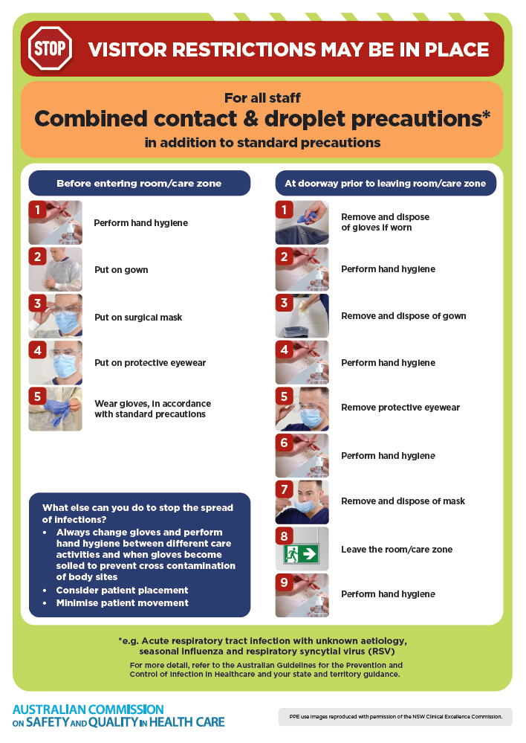
- Poster – Combined airborne and contact precautions
https://www.safetyandquality.gov.au/publications-and-resources/resource-library/infection-prevention-and-control-poster-combined-airborne-and-contact-precautions
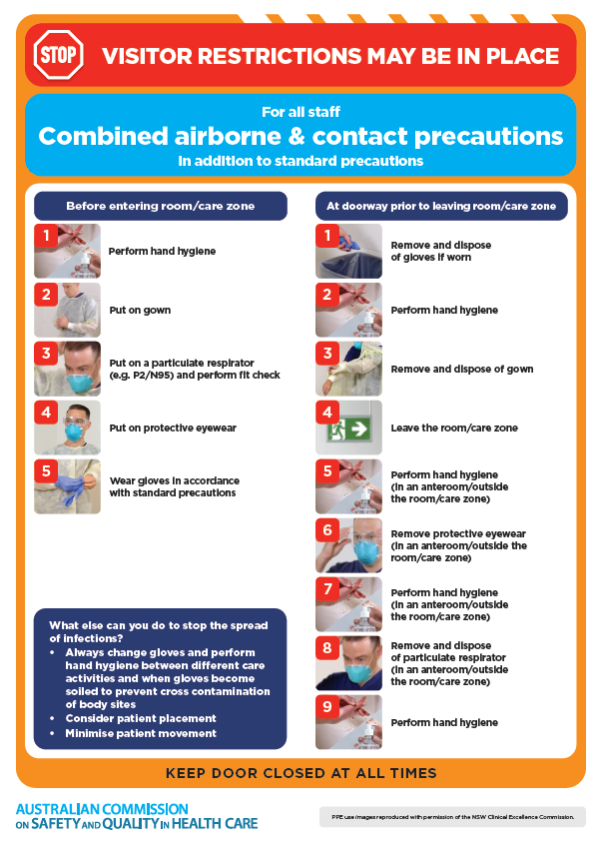
- Environmental Cleaning and Infection Prevention and Control www.safetyandquality.gov.au/environmental-cleaning
- Break the chain of infection poster
https://www.safetyandquality.gov.au/publications-and-resources/resource-library/break-chain-infection-poster
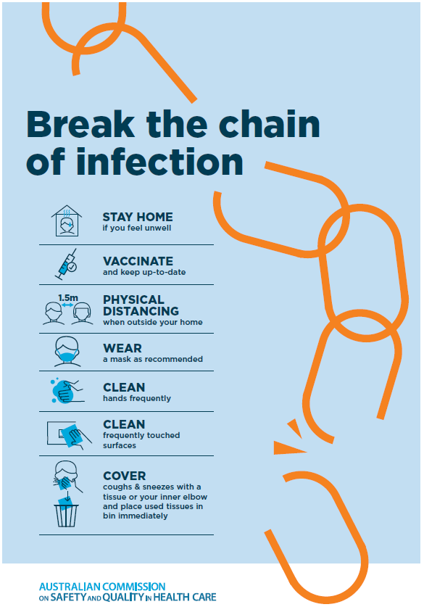

Disclaimer
On the Radar is an information resource of the Australian Commission on Safety and Quality in Health Care The Commission is not responsible for the content of, nor does it endorse, any articles or sites listed The Commission accepts no liability for the information or advice provided by these external links Links are provided on the basis that users make their own decisions about the accuracy, currency and reliability of the information contained therein Any opinions expressed are not necessarily those of the Australian Commission on Safety and Quality in Health Care.

