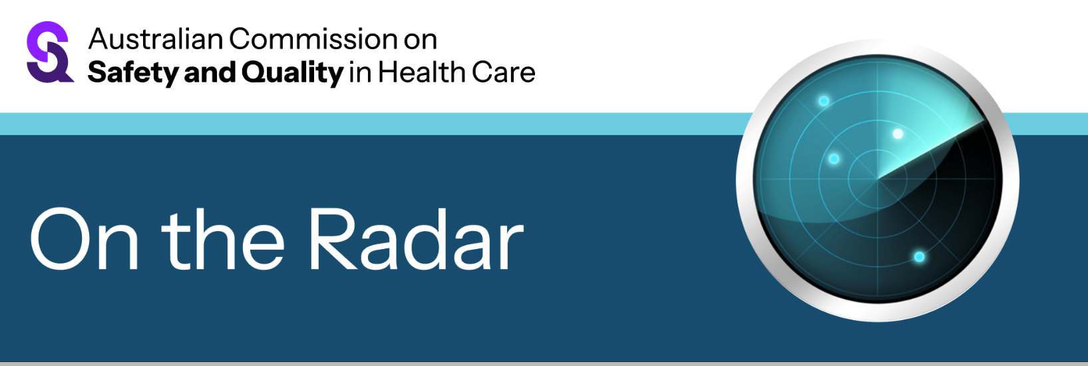
On the Radar
Issue 714
22 September 2025

On the Radar is a summary of some of the recent publications in the areas of safety and quality in health care Inclusion in this document is not an endorsement or recommendation of any publication or provider Access to particular documents may depend on whether they are Open Access or not, and/or your individual or institutional access to subscription sites/services Material that may require subscription is included as it is considered relevant.

On the Radar is available online, via email or as a PDF or Word document from https://www.safetyandquality.gov.au/newsroom/subscribe-news/radar

If you would like to receive On the Radar via email, you can subscribe on our website https://www.safetyandquality.gov.au/newsroom/subscribe-news
or by emailing us at mail@safetyandquality.gov.au.
You can also send feedback and comments to mail@safetyandquality.gov.au.

For information about the Commission and its programs and publications, please visit https://www.safetyandquality.gov.au

On the Radar
Editor: Dr Niall Johnson
Contributors: Niall Johnson, Natalie Kahwajy, Jennifer Caldwell

Medication Management at Transitions of Care Stewardship Framework
Australian Commission on Safety and Quality in Health Care
Sydney: ACSQHC; 2025. p. 82.
https://www.safetyandquality.gov.au/our-work/transitions-care/medication-management-transitions-care-stewardship-framework

The Australian Commission on Safety and Quality in Health Care has released a Medication Management at Transitions of Care Stewardship Framework that aims to:
- support coordinated governance of medication management at transitions of care
- promote and optimise safe and high-quality medication management at transitions of care
- reduce medication-related harm and hospital readmission rates due to errors and miscommunication
- improve communication between hospitals and primary and aged care, to enable timely discharge planning and post-discharge medication management follow-up
- ensure continuous improvement.

Underpinned by effective communication between clinicians, person-centred care and digital enablers, the new Framework includes four elements:
- Governing committee
- Multidisciplinary stewardship team
- Medication management activities
- Monitoring, evaluation and reporting

An overview of the Framework and the full version detailing steps to implementation can be accessed on the Commission’s website.

Clostridioides difficile infection: Data snapshot report 2022–2023
Australian Commission on Safety and Quality in Health Care
Sydney: ACSQHC; 2025. p. 25.
https://www.safetyandquality.gov.au/publications-and-resources/resource-library/cdi-data-snapshot-report-2022-and-2023

The Australian Commission on Safety and Quality in Health Care has published the Clostridioides difficile infections Data snapshot report: 2022 and 2023.
The key findings from the report:
- community-onset Clostridioides difficile (CDI) (pre-existing CDI symptoms on admission) has increased year on year and accounts for nearly 80% of all separations with a CDI diagnosis
- hospital-onset CDI accounts for less than 20% of all CDI separations.
CDI is a preventable and significant healthcare-associated infection (HAI), and surveillance of CDI in Australia focuses mainly on hospital-identified CDI (HI-CDI) rates. However, the rate of community-onset CDI is increasing, suggesting that CDI is a larger health problem in the community than previously understood. The role of primary health practitioners in the prevention and management of CDI in the community is vital.
Key messages for primary health practitioners:
- CDI is a potentially life-threatening infection. Primary health practitioners can help to reduce this risk through early detection and appropriate testing for CDI.
- The Public Health Laboratory Network provide laboratory case definitions provide guidance for CDI testing protocols
- Antimicrobial stewardship in primary care can substantially reduce the risk and severity of disease.

Reports

Measuring what really matters for Aboriginal and Torres Strait Islander Peoples – racism and cultural safety in healthcare
Deeble Institute for Health Policy Research Issues Brief no: 60
Elvidge E, Haddock R
Canberra: Australian Healthcare and Hospitals Association; 2025. p. 48.
URL | https://ahha.asn.au/resource/measuring-what-really-matters-racism-and-cultural-safety-in-healthcare/
Notes | This issues brief from the Australian Healthcare and Hospitals Association’s Deeble Institute for Health Policy examines the issue of racism, particularly institutional racism, in Australian health care. The authors observe ‘This racism is not merely a collection of isolated incidents; it's a systemic problem that affects patients at both an individual and societal level. Experiences of racism and culturally unsafe care create significant barriers to accessing healthcare, directly impact the quality of care received, and impair clinical decision-making. This lack of safety in the system contributes to poorer health outcomes, lifelong harm, and in some cases, preventable deaths.’  The authors also make a number of recommendations, including:  - Establish a national framework for cultural safety and anti-racism.  - Mandate and standardise cultural safety and anti-racism education and training.  - Implement independent and transparent complaints and reporting mechanisms.  - Strengthen data collection and measurement of racism and cultural safety.  - Enhance meaningful community engagement and shared decision-making.  A recent issue of the Medical Journal of Australia included a number of papers that touch on some of the issues raised. Papers in that issue of the MJA included:  - Land, culture, rights and self-determination: foundations of Indigenous health https://doi.org/10.5694/mja2.70040  - The contribution of evidence-based practice and the practice-based evidence approaches to contemporary Australian psychology: implications for culturally safe practice https://doi.org/10.5694/mja2.70028  - Explaining risk in chronic conditions: the Yolŋu science of signs https://doi.org/10.5694/mja2.70031  - Voluntary assisted dying: challenges in Northern Territory remote Aboriginal communities https://doi.org/10.5694/mja2.70023  - Systemic challenges for meaningful partnerships in Aboriginal and Torres Strait Islander health and medical research grant applications: a critical reflection https://doi.org/10.5694/mja2.70025  - Alison Bush memorial oration: supporting First Nations community-designed and led maternal health initiatives https://doi.org/10.5694/mja2.70024  - Beyond endorsement: reflecting on the 18th anniversary of the United Nations Declaration on the Rights of Indigenous Peoples https://doi.org/10.5694/mja2.70029  - Country revealing the way: evaluating Elder-governed cultural therapy for Aboriginal and Torres Strait Islander young people with mental health conditions https://doi.org/10.5694/mja2.70019  - An Aboriginal women-led approach to design a maternal and child health model when cardiometabolic complications are experienced in pregnancy in South Australia https://doi.org/10.5694/mja2.70033  - Values in health and health care for Indigenous people globally: an umbrella review http://doi.org/10.5694/mja2.70027

World patient safety day goals 2025: safe care for every newborn and every child
World Health Organization
Geneva: World Health Organization; 2025. p. 16.
URL | https://iris.who.int/handle/10665/382490
Notes | Marking World Patient Safety Day (17 September), the World Health Organization (WHO)released this report.  ‘Safe care for every newborn and every child’, with the slogan ‘Patient safety from the start!’ is the theme of World Patient Safety Day 2025.  To support this year’s World Patient Safety Day campaign, five goals are proposed that address the most pressing safety concerns for this age group, namely:  - Engage children and families  - Enhance medication safety  - Improve diagnostic safety  - Prevent health care-associated infections; and  - Reduce risks for small and sick newborns.  In many locations around the world, landmarks are illuminated orange to mark this World Patient Safety Day. The WHO will be illuminating the Jet d’Eau in Geneva. The Australian Commission on Safety and Quality in Health Care has arranged for five monuments across Canberra to be illuminated: the Captain Cook Memorial Jet, the National Carillon, the John Gorton Building, the Treasury, and the Museum of Australian Democracy (Old Parliament House).  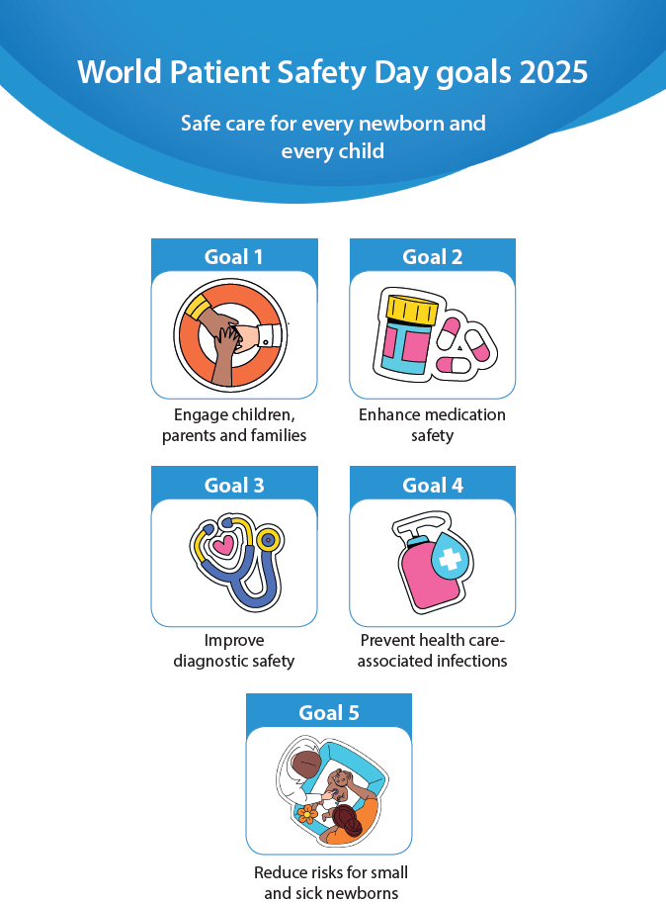
The selection and use of essential medicines, 2025: WHO Model List of Essential Medicines, 24th list
World Health Organization
Geneva: World Health Organization; 2025. p. 72.
URL | https://www.who.int/publications/i/item/B09474
Notes | The World Health Organization (WHO) has published the latest iteration of their list of essential medicines. The WHO Model List of Essential Medicines and Model List of Essential Medicines for Children are updated and published every two years, intended as a guide for countries or regional authorities to adopt or adapt in accordance with local priorities and treatment guidelines for the development and updating of national essential medicines lists. According to an item in the BMJ, 20 new treatments have been added taking the list to a total of 523.

Journal articles

Mapping heatwave-related mortality across 2288 local communities in Australia: a nationwide time-series analysis
Xu Z, Xu R, Yang Z, Huang W, Muray S, Guo Y, et al
Environment International. 2025;203:109747.
DOI | https://doi.org/10.1016/j.envint.2025.109747
Notes | In recent years there has been appreciation that heat can be more dangerous than extreme cold as heat waves in Europe have been recognised as having a greater mortality than winters. In Australia the knowledge that heat can be dangerous has been long-known. This piece highlights that:  - Heatwave mortality risk in Australia varies significantly across local communities.  - Community factors influence the burden of heatwave-related mortality.  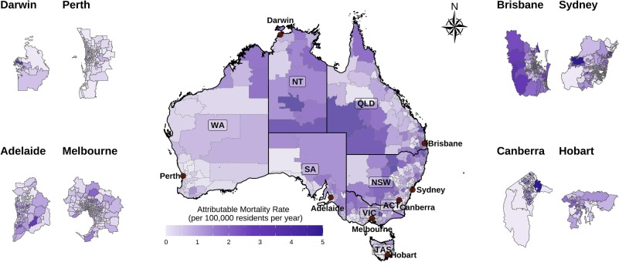  The National Academy of Medicine in the USA has produced a shortlist of Key Actions for Health Professionals to Advance Sustainable Health Care. The shortlist is designed for health professionals who are interested in practical, individual actions to advance sustainable health care in their workplace. It offers a concise set of immediate steps that promote environmentally sustainable practices and encourage clinicians to consider environmental impact in their care decisions. The document has five individual action areas where health professionals can take direct steps, followed by four system-level actions to advance sustainability initiatives and establish supportive programs.  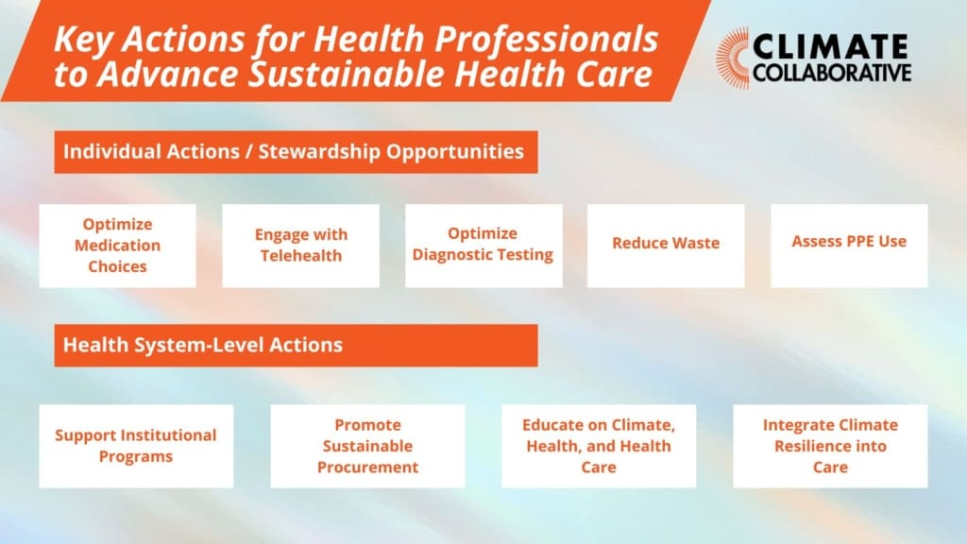

For information on the Commission’s work on environmentally sustainable healthcare, including the Joint Statement on Climate Change and Health, see https://www.safetyandquality.gov.au/our-work/environmentally-sustainable-healthcare
For information on the Commission’s Healthcare Sustainability and Resilience Module see https://www.safetyandquality.gov.au/standards/healthcare-sustainability-and-resilience-module

Australian Journal of Primary Health
URL | https://www.publish.csiro.au/py/#Latest
Notes | The Australian Journal of Primary Health has moved to a continuous publication model. In the continuous publication model, once an article is ready for publication, it is immediately published online with final citation details (https://www.publish.csiro.au/PY/Continuouspublication).  Recent articles in the Australian Journal of Primary Health include:  - A qualitative evaluation of the Enough Talk, Time for Action male health and wellbeing program: a primary health care engagement strategy designed with Aboriginal and Torres Strait Islander males (Kootsy Canuto, Celina Gaweda, Corey Kennedy, Douglas Clinch, Bryce Brickley, Oliver Black, Rosie Neate, Karla J. Canuto, Cameron Stokes, Gracie Ah Mat and Kurt Towers)  - What are the barriers to parents using child and family health nursing services during the first year of their child’s life in NSW? (Kim Dunlop, Michelle Fulton, Vanessa Hamilton and Catherine Llewellyn)  - ‘Back to square one’ – experiences influencing topical corticosteroid use in paediatric atopic dermatitis (Christabel Hoe, Yasin Shahab and Phyllis Lau)  - Considerations in the development of an mHealth approach to increase cervical screening participation in primary care in Victoria, Australia (Claire Zammit, Maleeha Ashfaq, Lucy Boyd, Caitlin Paton, Joyce Jiang, Julia Brotherton and Claire Nightingale)  - ‘I’m sick of being called insane’: experiences of Australian healthcare support for premenstrual distress (Megan E Buys)  - Impacts of long COVID on disability, function and quality of life for adults living in Australia (Danielle Hitch, Tanita Botha, Fisaha Tesfay, Sara Holton, Catherine M Said, Martin Hensher, Kieva Richards, Mary Rose Angeles, Catherine M Bennett, G Pepin, B Rasmussen and K Nicola-Richmond)  - Assessing the digital health maturity of general practice in Australia: results from a cross-sectional national survey (Tim Blake, Debbie Passey, Joanne Lee and Farwa Rizvi)  - A critical realist exploration of health professionals’ perspectives on prediabetes diagnosis, management and type 2 diabetes prevention programs in a rural setting (Britney McMullen, Kerith Duncanson, David Schmidt, Clare Collins and Lesley MacDonald-Wicks)  - Partnership factors enabling co-planning of sustainable rural health models (Belinda O’Sullivan, Pam Harvey, Catherine Lees, Mandy Hutchinson, Trevor Adem, Dallas Coghill, Donna Doyle and Nerida Hyett)  - Building health equity through community health: insights from Victoria, Australia (Jennifer Tobin, Rosamaria Tascone, Bec Morgan, Keira Leike, Ju-Lin Lee, Linda Crisci and Youstina Tawadros)  - Effect of a combined exercise and nutrition program on sarcopenia in older adults: a randomised controlled trial in primary care (Sunghwan Ji, Ji Yeon Baek, Jin Go, Chang Ki Lee, Sang Soo Yu, Hee-Won Jung, Eunju Lee and Il-Young Jang)  - Carer and staff preferences for characteristics of health services delivery for Aboriginal and Torres Strait Islander children: a best–worst scaling study (Shingisai Chando, Martin Howell, Janice Nixon, Simone Sherriff, Kym Slater, Natalie Smith, Laura Stevenson, Michelle Dickson, Allison Jaure, Jonathan C Craig, Sandra J Eades and Kirsten Howard)  - Adolescent health presentations to Victorian general practice: a descriptive study using electronic medical records (Ronnen Leizerovitz, Ian Williams, Adrian Laughlin and Lena Sanci)  - Searching for Utopia: emerging models for primary care in 21st century Australia (Lester Mascarenhas)

BMJ Quality & Safety
Volume 34, Issue 10, October 2025
URL | https://qualitysafety.bmj.com/content/34/10
Notes | A new issue of BMJ Quality & Safety has been published. Many of the papers in this issue have been referred to in previous editions of On the Radar (when they were released online). Articles in this issue of BMJ Quality & Safety include:  - Editorial: Can handoffs bridge the interprofessional divide to build a team? (Aubrey Samost-Williams, Eric J Thomas)  - Editorial: How to scale and spread catheter avoidance nationwide (J A Leis)  - Through the patients’ eyes: psychometric evaluation of the 64-item version of the Experienced Patient-Centeredness Questionnaire (EPAT-64) (Eva Christalle, Stefan Zeh, Hannah Führes, Alica Schellhorn, Pola Hahlweg, Jördis Maria Zill, Martin Härter, Carsten Bokemeyer, Jürgen Gallinat, Christoffer Gebhardt, Christina Magnussen, Volkmar Müller, Katharina Schmalstieg-Bahr, André Strahl, Levente Kriston, Isabelle Scholl)  - Factors affecting implementation of a National Clinical Programme for self-harm in hospital emergency departments: a qualitative study (Selena O'Connell, Grace Cully, Sheena McHugh, Margaret Maxwell, Anne Jeffers, Katerina Kavalidou, Sally Lovejoy, Rhona Jennings, Vincent Russell, Ella Arensman, Eve Griffin)  - County-level racial bias is associated with worse care for white and especially black older US adults: a cross-sectional observational (Matthew L Mizel, Ann Haas, John L Adams, Steven C Martino, Amelia M Haviland, Bonnie Ghosh-Dastidar, Jacob W Dembosky, Malcolm Williams, Gary Abel, Jessica Maksut, Jennifer Gildner, Marc N Elliott)  - Use of structured handoff protocols for within-hospital unit transitions: a systematic review from Making Healthcare Safer IV (Sean McCarthy, Aneesa Motala, Emily Lawson, Paul G Shekelle)  - Implementation strategies of financial navigation and its effects on alleviating financial toxicity among cancer survivors: a systematic review (Yujia Feng, Mingzhu Su, Xiaojie Sun, Jinxin Zhang, Nengliang Aaron Yao)  - Better without catheter: the nationwide spread of a deimplementation strategy in clinical practice (Eva Willemiek Verkerk, Maike WM Raasing, Rudolf Bertijn Kool, Bart J Laan)

Health Affairs Scholar
Volume 3, Issue 8, August 2025
URL | https://academic.oup.com/healthaffairsscholar/issue/3/8
Notes | A new issue of Health Affairs Scholar has been published. Articles in this issue of Health Affairs Scholar include:  - Income-related disparities in the value of health care in South Korea (Sungchul Park et al)  - Total cost of coverage for members in California's marketplace (Emily Kohn et al)  - State variation in staffing and characteristics of nursing homes most impacted by new federal standards (Robert J Skinner et al)  - A cross-country analysis of the effects of spousal migration on health care access for families left behind (Heidi West et al)  - Universal free school meals and child body mass index: impact among children in community-based health care organizations (Jessica C Jones-Smith et al)  - Transportation barriers for Iowa Medicaid-enrolled adults with and without non-emergency medical transportation services (Kandyce Larson et al)  - Trends in hospital administrative costs: urban–rural disparities, barriers, and reduction strategies (Lauree Handlon et al)  - Home care workforce participation and household co-residence with people with LTSS needs (Ari Ne’eman and Bijan Niknam)  - Ambulatory care for individuals dually eligible for Medicare and Medicaid (Joshua M Liao et al)  - Effectiveness of Washington State's hub and spoke model to improve opioid use disorder outcomes (Sharon Reif et al)  - Medical debt and collections in the United States (Scott L Fulford and Eric Wilson)  - The relationship between state-level abortion policy and maternal mortality in the United States: a scoping review (Gaia Zori et al)  - Legal challenges to the 340B drug pricing program: administration, regulation, and reform (Ryan P Knox and Ameet Sarpatwari)  - A policy roadmap for sustainable mass-testing (Sergey N Krylov et al)  - Workforce impact of emergency department boarding (Vicki Norton et al)  - Self-measured blood pressure service and device use increased among Medicaid enrollees from 2018-2022 (Nathan Pauly et al)  - Early impact of the Inflation Reduction Act on small molecule vs biologic post-approval oncology trials (Hanke Zheng et al)  - Affordability trade-offs following a public option: learning from the Colorado Option (Andrew Shermeyer)  - Opportunities for employers to address the opioid epidemic: results from a national survey (Gillian K SteelFisher et al)  - Time to use large-scale biobank databases in health policy and public health research (José A Pagán et al)  - Electronic health record market consolidation and implications for cybersecurity (A Jay Holmgren et al)  - Inequities in weathering California wildfires (Michelle S Wong et al)  - Research and development financing models for new biopharmaceuticals in the United States (So-Yeon Kang et al)

BMJ Quality & Safety online first articles
URL | https://qualitysafety.bmj.com/content/early/recent
Notes | BMJ Quality &Safety has published a number of ‘online first’ articles, including:  - Do patient safety incident investigations align with systems thinking? An analysis of contributing factors and recommendations (Lorelle Bowditch, Charlotte Molloy, Brandon King, Masoumeh Abedi, Samantha Jackson, Mia Bierbaum, Yinghua Yu, Louise Raggett, Paul Salmon, Jeffrey Braithwaite, Johanna I Westbrook, Robyn Clay-Williams, Raghu Lingam, Sandy Middleton, Farah Magrabi, Virginia Mumford, Peter Hibbert)  - Editorial: Translation without substitution: the need for responsible AI integration in patient instructions (Ricky Odedra, Ruud Gerard Nijman, Phoebe Averill, Erik Mayer)

International Journal for Quality in Health Care online first articles
URL | https://academic.oup.com/intqhc/advance-articles
Notes | International Journal for Quality in Health Care has published a number of ‘online first’ articles, including:  - Reviewing the Validity of Existing Measures of Emergency Physician Workload—A Scoping Review (Steven Foster, Sudeep Hegde, Ronald Pirrallo, Kevin Taaffe, Dixizi Liu)  - Key lessons in caring for caregivers: Acknowledging identity to strengthen second victim support (Annelise Brochier, Albert W Wu, Phillip H Phan)  - The Protective Effect of Pathway to Excellence Designation on Patient Satisfaction During the COVID-19 Pandemic (Hyunmin Yu, Daniela Golinelli, Linda H Aiken, Matthew D McHugh, J Margo Brooks Carthon)

Online resources

Australian Living Evidence Collaboration
https://livingevidence.org.au/

Guidance
A number of guidelines or guidance have recently been published or updated These include:
- National Mental Health Commission, National Guidelines for including mental health and wellbeing in early childhood health checks https://www.health.gov.au/resources/publications/national-guidelines-for-including-mental-health-and-wellbeing-in-early-childhood-health-checks
- National Asthma Council, Australian Asthma Handbook: The National Guidelines for Health Professionals https://www.asthmahandbook.org.au/

Infection prevention and control and COVID-19 resources
The Australian Commission on Safety and Quality in Health Care has developed a number of resources to assist healthcare organisations, facilities and clinicians These resources include:
- Poster – Combined contact and droplet precautions https://www.safetyandquality.gov.au/publications-and-resources/resource-library/infection-prevention-and-control-poster-combined-contact-and-droplet-precautions
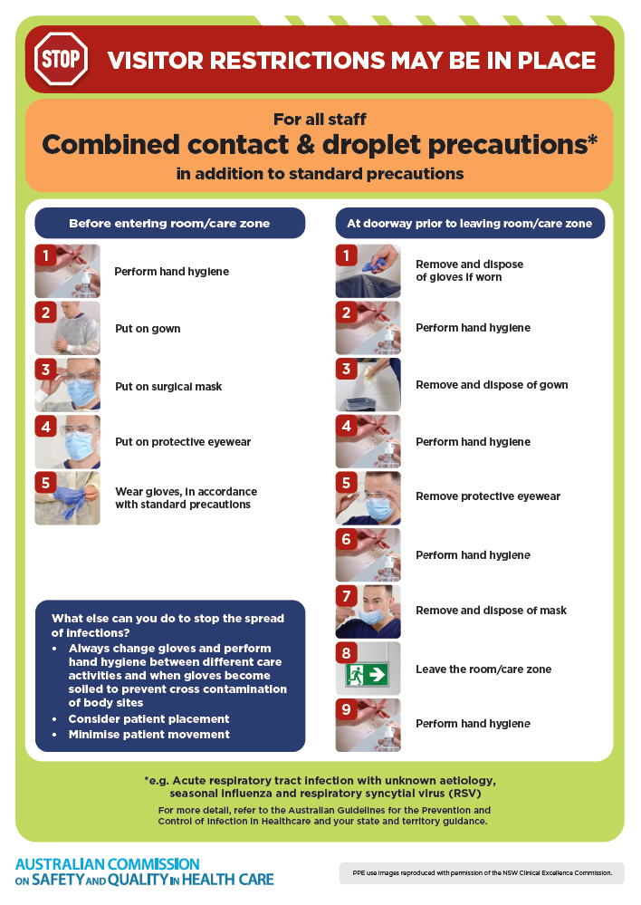
- Poster – Combined airborne and contact precautions
https://www.safetyandquality.gov.au/publications-and-resources/resource-library/infection-prevention-and-control-poster-combined-airborne-and-contact-precautions
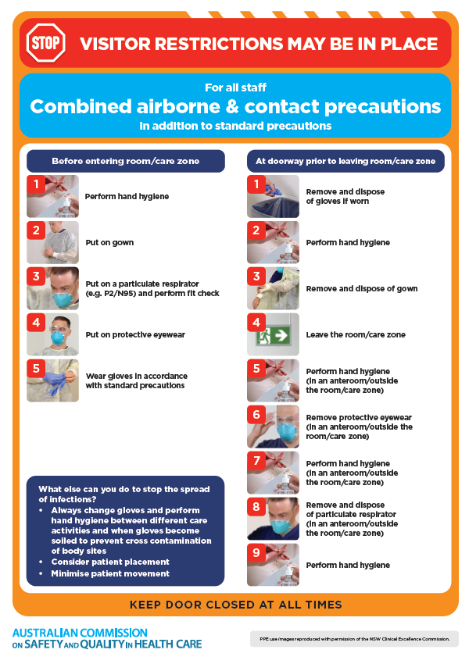
- Environmental Cleaning and Infection Prevention and Control www.safetyandquality.gov.au/environmental-cleaning
- Break the chain of infection poster
https://www.safetyandquality.gov.au/publications-and-resources/resource-library/break-chain-infection-poster
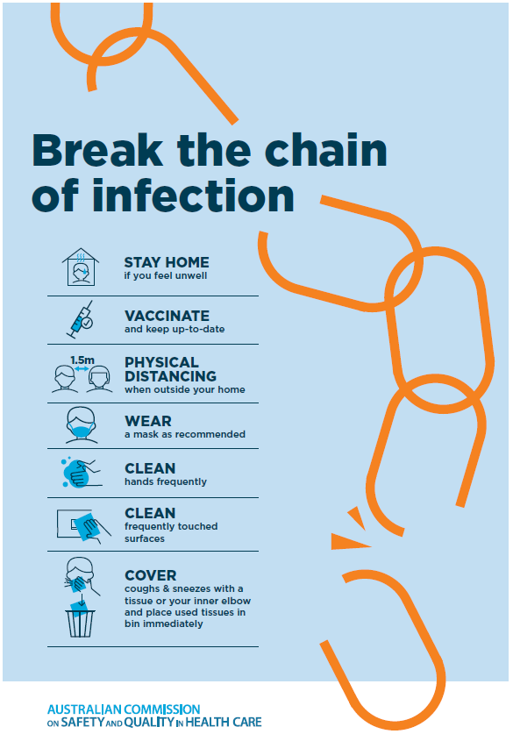

Disclaimer
On the Radar is an information resource of the Australian Commission on Safety and Quality in Health Care The Commission is not responsible for the content of, nor does it endorse, any articles or sites listed The Commission accepts no liability for the information or advice provided by these external links Links are provided on the basis that users make their own decisions about the accuracy, currency and reliability of the information contained therein Any opinions expressed are not necessarily those of the Australian Commission on Safety and Quality in Health Care.

