
On the Radar
Issue 717
13 October 2025

On the Radar is a summary of some of the recent publications in the areas of safety and quality in health care Inclusion in this document is not an endorsement or recommendation of any publication or provider Access to particular documents may depend on whether they are Open Access or not, and/or your individual or institutional access to subscription sites/services Material that may require subscription is included as it is considered relevant.

On the Radar is available online, via email or as a PDF or Word document from https://www.safetyandquality.gov.au/newsroom/subscribe-news/radar

If you would like to receive On the Radar via email, you can subscribe on our website https://www.safetyandquality.gov.au/newsroom/subscribe-news
or by emailing us at mail@safetyandquality.gov.au.
You can also send feedback and comments to mail@safetyandquality.gov.au.

For information about the Commission and its programs and publications, please visit https://www.safetyandquality.gov.au

On the Radar
Editor: Dr Niall Johnson
Contributors: Niall Johnson

Books

Lean as a Healthcare Improvement Approach
Elements of Improving Quality and Safety in Healthcare
Radnor Z, Williams S J
Cambridge: Cambridge University Press; 2025.
DOI | https://doi.org/10.1017/9781009326124
Notes | This volume is the latest release in the Elements of Improving Quality and Safety in Healthcare series from The Healthcare Improvement Studies Institute (the THIS Institute) in Cambridge, England. This volume examines the use of Lean approaches in health care. The authors provide an overview of the evidence for using Lean in healthcare, summarising the supporting tools and techniques, and outlining the challenges.
Reports

Improving health literacy in the NHS
NHS Providers
London: NHS England; 2025. p. 46.
URL | https://nhsproviders.org/resources/improving-health-literacy-in-the-nhs
Notes | This resource from NHS Providers in the UK examines ‘what is meant by health literacy, the benefits of applying health literacy interventions, recommendations for trust board members, and case studies from five trusts that have effectively embedded interventions.’  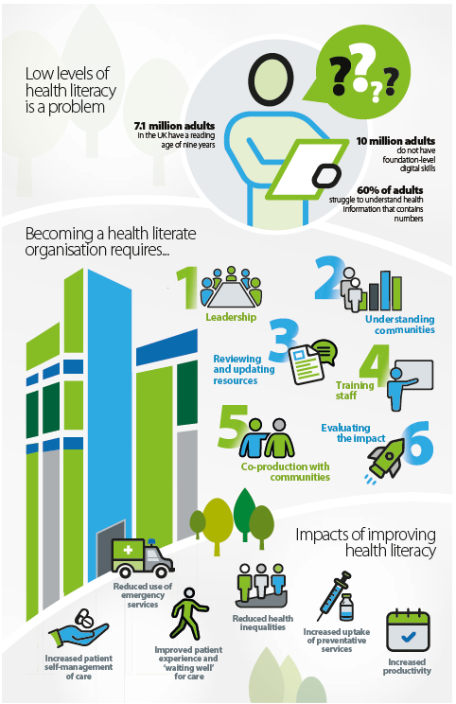

For information on the Commission’s work on health literacy, including the 2014 National Statement on Health Literacy, see https://www.safetyandquality.gov.au/our-work/patient-and-consumer-centred-care/health-literacy
Embedding quality: Principles for a national quality management system
NHS Providers
London: NHS England; 2025
URL | https://nhsproviders.org/resources/embedding-quality-principles-for-a-national-quality-management-system
Notes | Also from NHS Providers is this briefing examining the potential quality management systems (QMSs) in the UK context. The briefing examines how these systems ‘extend beyond quality improvement to include management of other key components of quality – planning, control and assurance’. They can offer a systematic approach to ensuring that products and services meet stringent safety and performance standards. The briefing examines the applicability of these safety systems in the UK health service context.

Transition to reusable medical products in NHS hospitals: Current practice and challenges. Policy Brief
Centre for Sustainable Healthcare, Brighton & Sussex Medical School
London: Department of Health & Social Care; 2025. p. 34.
URL | https://sustainablehealthcare.org.uk/reusable-medical-products-in-the-nhs-adoption-barriers-and-enablers/
Notes | Report from the Centre for Sustainable Healthcare in the UK that was commissioned by the UK’s Department of Health and Social Care's Design for Life programme. The report examines the adoption of reusable products across NHS trusts. The report highlights key barriers and enablers, as well as the environmental, financial, and social benefits of switching to reusables. The webpage includes the report (policy brief) and case reports.

Green maternity report: Taking collective action to deliver low carbon, equitable maternity care
Royal College of Obstetricians and Gynaecologists
London: Royal College of Obstetricians and Gynaecologists; 2025. p. 39.
URL | https://www.rcog.org.uk/about-us/sustainability-at-the-rcog/green-maternity/green-maternity-report-2025
Notes | Also seeking to address sustainability and environmental impact is this report from the Royal College of Obstetricians and Gynaecologists in the UK. The report combines case studies from the Green Maternity Challenge with lived experience insights and carbon modelling to identify eight priorities for sustainable maternity care and a set of evidence-based recommendations. The recommendations are intended to help maternity teams and leaders to drive down health-related emissions from the front line, improve outcomes and experience for women, birthing people and their families, and reduce costs. The report’s eight initial priorities for green maternity care include:  - Improve information sharing  - Right care, right away  - Prevention  - Streamlined outpatient maternity care  - Better care for hyperemesis gravidarum  - Straightforward pathways for complex pregnancies  - Green labour and birth  - Improved infant feeding support.

Journal articles

Understanding factors influencing sustainability and sustainment of evidence-based bronchiolitis management of infants in Australian and New Zealand hospital settings: a qualitative process evaluation
Ramsden V, Babl FE, Haskell L, Wilson C, McInnes E, Middleton S, et al
BMJ Quality & Safety. 2025:bmjqs-2025-019007.
DOI | https://doi.org/10.1136/bmjqs-2025-019007
Notes | Paper reporting on an evaluation of a series of targeted interventions provided over one bronchiolitis season that effectively de-implemented five low-value practices by 14.1%. A 2-year follow-up study found de-implementation was sustained. This process evaluation aimed to identify factors that influenced sustainability of de-implementation of these five low-value practices and examine fidelity and/or adaptation of the targeted interventions over 4 years post intervention delivery (sustainment). Using interviews with 50 clinicians from 12 intervention hospitals it was identified that:  - ‘Facilitators were a culture of evidence-based practice, ongoing multimodal education, strong clinical leadership as unofficial champions and the previous effectiveness of the PREDICT Bronchiolitis KT Study interventions.’  - ‘Barriers were lack of paediatric trained ED staff, assumptions by senior clinicians that junior doctors can provide evidence-based bronchiolitis management, bronchiolitis not a current improvement priority and lack of bronchiolitis education sessions.’

Can multidisciplinary teams improve the quality of primary care? A scoping review
Bates SM, Lin J, Allen LN, Wright M, Kidd M
eClinicalMedicine. 2025 2025/10/01/;88:103497.
DOI | https://doi.org/10.1016/j.eclinm.2025.103497
Notes | Paper reporting on a review that ‘sought to understand the impact of MDT [multi-disciplinary teams] on the quality of primary care, including continuity of care, and the enablers and barriers to implementation.’ Based on 39 studies, the review found that ‘models of MDT-care varied substantially. They ranged from multiple providers working together to care for a patient, to interprofessional teams providing patients the option to see an alternative provider.’ The review also found:  - mixed outcomes from MDTs in primary care, driven by contextual, policy, organisational, professional and patient factors.  - In some cases, MDT strengthened the management of chronic disease.  - In other cases, MDT reduced continuity of care by fragmenting relational continuity.  - MDT care also impacted access to care, comprehensiveness of care, and coordination of care—in some cases positively, and other cases negatively.  The authors suggest ‘effective MDT-care was likely to be goal and context specific.’ Further, ‘The introduction of MDTs will require careful planning and implementation to ensure that the potential benefits of MDT are realised and that it does not compromise the quality of primary care.’

Health Affairs
Volume 44, Number 10, October 2025
URL | https://www.healthaffairs.org/toc/hlthaff/44/10
Notes | A new issue of Health Affairs has been published with a theme of ‘Vaccine Economics, Private Equity and more. Articles in this issue of Health Affairs include:  - Comparing COVID-19 Acute And Postacute Medical Spending By Vaccination Status For Child And Adult Medicaid Enrollees (Jamison Pike, Lyudmyla Kompaniyets, Laura P Hurley, Rachel M Everhart, Gabrielle F Miller, Sharon Saydah, Kristin Breslin, and Megan C Lindley)  - Hospital- And Private Equity–Affiliated Specialty Physicians Negotiate Higher Prices Than Independent Physicians (Alexander P Philips, Nandita Radhakrishnan, Christopher M Whaley, and Yashaswini Singh)  - Private Equity–Owned Hospices Report Highest Profits, Lowest Patient Care Spending Compared With Other Ownership Models (Alexander Soltoff, Dunc Williams, and Robert Tyler Braun)  - Reduced Medicare Advantage Insurer Concentration Associated With Small Improvements In Market Outcomes, 2013–23 (Bowen Garrett and John Holahan)  - Inpatient Prices In Medicare Advantage Vary Modestly Across And Within Hospitals (Grace Mackleby, Geronimo Bejarano, David J Meyers, Erin Trish, and Mark Katz Meiselbach)  - Favorable Selection Among Dually Enrolled Beneficiaries In Private Medicare Plans (Daria Pelech, Ru Ding, Jing Guo, and Joyce Shin)  - Impact Of Medicaid Expansion On HIV Pre-Exposure Prophylaxis Coverage, 2012–23 (Elizabeth M Stone, Nicholas J Seewald, and J G Rosen)  - Medicaid Expansion Boosted Specialty Treatment Episodes For Substance Use Disorder In Expansion States, 2010–22 (Johanna Catherine Maclean, Skyler Hulser, Bradley D Stein, and Brendan Saloner)  - Trends In Registered Nurse Wages Relative To Other Health Care Occupations, 2012–23 (Hannah C Ratliff, Megan Czerwinski, Deanna Marriott, Deena Kelly Costa, and Olga Yakusheva)  - Impact Of Risk Evaluation And Mitigation Strategies On Generic Approvals Of US Pharmaceutical Products (Jennifer Kao, Victor L Van de Wiele, Reed F Beall, and Ameet Sarpatwari)  - Commercial Insurers Paid More For Procedures At Hospital Outpatient Departments Than At Ambulatory Surgical Centers (Matthew P Maughan, Andrew M Ryan, Christopher M Whaley, and Nandita Radhakrishnan)  - Expanded Child Tax Credit Payments During Pregnancy Were Associated With Decreased Odds Of Adverse Birth Outcomes (Aditi Vasan, Jordan I Wood, Xianqun Luan, Chén C Kenyon, and Meredith Matone)  - Public Benefit Avoidance And Safety Concerns Among Mixed-Status Latino Families In California, 2021–22 (Clara B Barajas, Maria-Elena De Trinidad Young, Arturo Vargas Bustamante, Brent A Langellier, D H Roby, J P Stimpson, N A Ponce, K Kietzman, J M Eberth, M Stehr and A N Ortega)  - Uninformed Consent In An Alzheimer’s Clinical Trial (Kristine E Shields)

BMJ Quality & Safety online first articles
URL | https://qualitysafety.bmj.com/content/early/recent
Notes | BMJ Quality &Safety has published a number of ‘online first’ articles, including:  - Widespread inappropriate prescribing for older people with reduced kidney function: what are the harms and how do we tackle them? A scoping review for primary care (Owen Thomas, Liz Glidewell, Sarah Alderson, David K Raynor, Su Wood)  - Less continuity with more complaints: a repeated cross-sectional study of the association between relational continuity of care and patient complaints in English general practice (Jinyang Chen, Panos Kasteridis, Zecharias Anteneh, Sheila Greenfield, Fiona Scheibl, Kamil Sterniczuk, Brian H Willis, Iestyn Williams, Tom Marshall)  - Barriers and facilitators to reducing overuse of thyroid function testing: a mixed-methods study (Annabel Jane Chapman, Aneesa Khan, Jordyn Thompson, Vernon Curran, Jessica Otte, Sana Ghaznavi, Greg Carney, Kate Campbell, Vivian Lam, Caldon Saunders, Ken Bassett, Colin Dormuth, I Fan Kuo, Anshula Ambasta)  - Evaluating the impact of a collaborative quality initiative on surgical disparities: a retrospective analysis of surgical outcomes (Erin Isenberg, Shukri Dualeh, Nicholas Kunnath, Andrew Ibrahim, Michael Thompson, Michael Englesbe, Calistah M Harbaugh)  - Understanding factors influencing sustainability and sustainment of evidence-based bronchiolitis management of infants in Australian and New Zealand hospital settings: a qualitative process evaluation (Victoria Ramsden, Franz E Babl, Libby Haskell, Catherine Wilson, Elizabeth McInnes, Sandy Middleton, Lisa Kuhn, Alexandra Wallace, Elyssia Bourke, Faye Jordan, Julian Wong, Kai Steinmann, Lauren Shumack, Lisa Kane, Natalie Phillips, Paige Marsh, Shefali Jani, Trevor Kuang, Yvonne Janiszewski, Ed Oakley, Anna Lithgow, Peter Wilson, Rachel Schembri, Stuart Dalziel, Emma Tavender)  - Advancing AI in healthcare: three strategic roles for quality and safety leaders (Jeffrey Rakover, Marina Lynne Renton, Pierre Barker, Gareth Kantor)

International Journal for Quality in Health Care online first articles
URL | https://academic.oup.com/intqhc/advance-articles
Notes | International Journal for Quality in Health Care has published a number of ‘online first’ articles, including:  - Sustaining Perioperative Patient Safety Improvement: The Relevance of Patient Safety Policies and Contextual Factors in European Healthcare Systems (Kaja Kristensen, Sophie Wang, Daniel Arnal Velasco, Kaja Põlluste, Adam Žaludek, Paulo Sousa, Carola Orrego, O Groene, SAFEST Consortium)  - Litigation following Traumatic Brain Injury—what are the challenges and what can we do? (Nichola Robson, G Bradley, R Morris, L Jones, Z Jones)  - Assessment of the Trends of Never Events Across NHS England: A Six-Year Analysis (Mohamed Abosheisha, Ahmed Hafez, Islam Omar)  - Health conditions that impact fitness-to-practice in physicians: A scoping review (Richard Roberts, Tanya Jackson, Ryan Gerdes, Danika Deibert, Liz Dennett, Ellina Lytvyak, Sebastian Straube)  - Sustaining Quality Improvement in times of crisis: Lessons from Lebanon (Maysaa Jaafar)

Online resources

Australian Living Evidence Collaboration
https://livingevidence.org.au/

Guidance
A number of guidelines or guidance have recently been published or updated These include:
- Clinical practice guidelines for hepatocellular carcinoma surveillance for people at high risk in Australia: summary of recommendations https://doi.org/10.5694/mja2.70061
- Consultative Council on Obstetric and Paediatric Mortality and Morbidity (CCOPMM) good practice points (https://www.safercare.vic.gov.au/councils/ccopmm/good-practice-points-and-recommendations
  - Access to expert ultrasound to confirm or diagnose fetal death in utero
  - Activation of an Advanced Care Directive in children
  - Availability of mental health secondary consultations for general practitioners and paediatricians
  - Charting and monitoring trajectory of fundal height
  - Handover and information sharing between services for young people at high-risk of suicide being discharged from mental health services
  - Mandatory notification to obstetric teams of women presenting to emergency departments from 16 weeks gestation
  - Use of point-of-care ultrasound in obstetric emergencies
  - Safety of intubation in children with deteriorating shock
  - Timing of birth in uncomplicated twin pregnancies.

Infection prevention and control and COVID-19 resources
The Australian Commission on Safety and Quality in Health Care has developed a number of resources to assist healthcare organisations, facilities and clinicians These resources include:
- Poster – Combined contact and droplet precautions https://www.safetyandquality.gov.au/publications-and-resources/resource-library/infection-prevention-and-control-poster-combined-contact-and-droplet-precautions
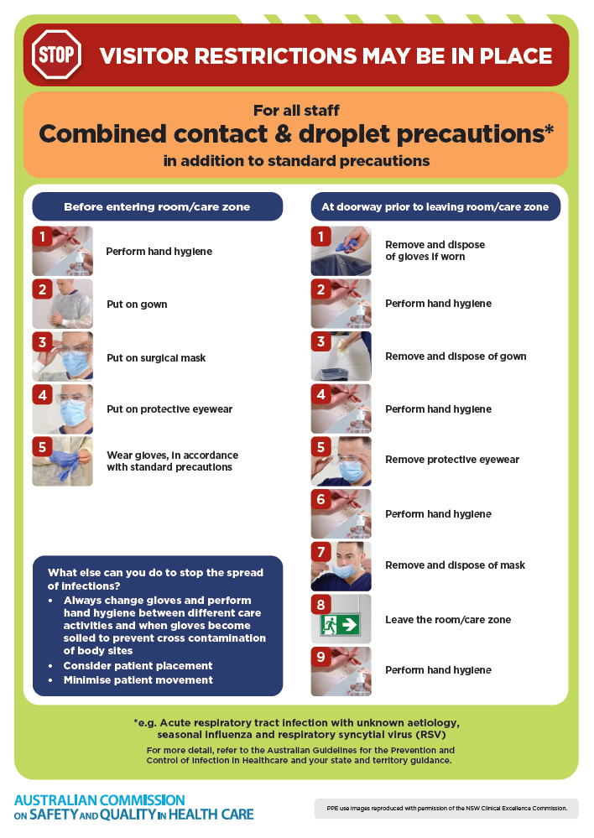
- Poster – Combined airborne and contact precautions
https://www.safetyandquality.gov.au/publications-and-resources/resource-library/infection-prevention-and-control-poster-combined-airborne-and-contact-precautions
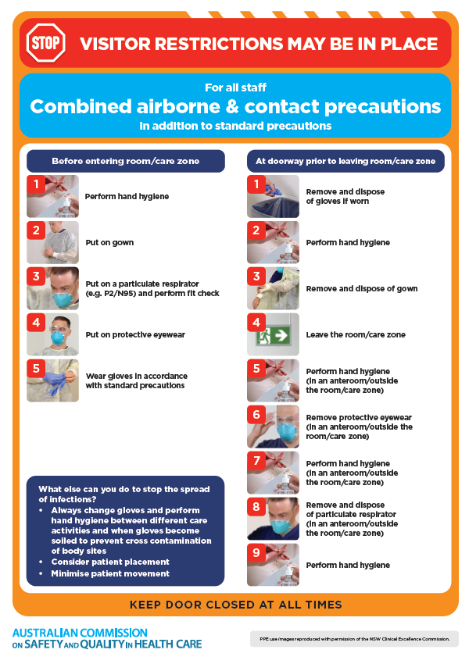
- Environmental Cleaning and Infection Prevention and Control www.safetyandquality.gov.au/environmental-cleaning
- Break the chain of infection poster
https://www.safetyandquality.gov.au/publications-and-resources/resource-library/break-chain-infection-poster
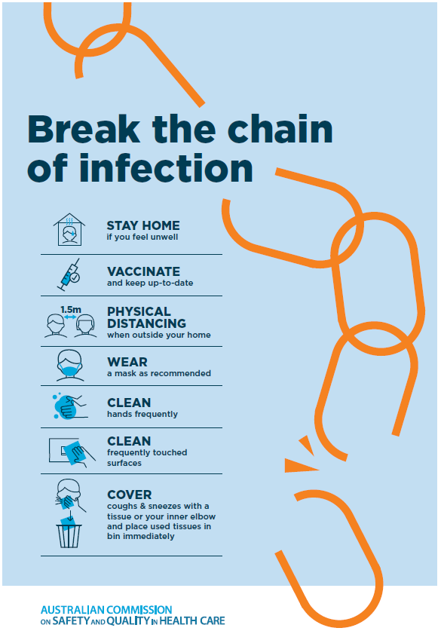

Disclaimer
On the Radar is an information resource of the Australian Commission on Safety and Quality in Health Care The Commission is not responsible for the content of, nor does it endorse, any articles or sites listed The Commission accepts no liability for the information or advice provided by these external links Links are provided on the basis that users make their own decisions about the accuracy, currency and reliability of the information contained therein Any opinions expressed are not necessarily those of the Australian Commission on Safety and Quality in Health Care.

