
On the Radar
Issue 718
20 October 2025

On the Radar is a summary of some of the recent publications in the areas of safety and quality in health care Inclusion in this document is not an endorsement or recommendation of any publication or provider Access to particular documents may depend on whether they are Open Access or not, and/or your individual or institutional access to subscription sites/services Material that may require subscription is included as it is considered relevant.

On the Radar is available online, via email or as a PDF or Word document from https://www.safetyandquality.gov.au/newsroom/subscribe-news/radar

If you would like to receive On the Radar via email, you can subscribe on our website https://www.safetyandquality.gov.au/newsroom/subscribe-news
or by emailing us at mail@safetyandquality.gov.au.
You can also send feedback and comments to mail@safetyandquality.gov.au.

For information about the Commission and its programs and publications, please visit https://www.safetyandquality.gov.au

On the Radar
Editor: Dr Niall Johnson
Contributors: Niall Johnson, Jennifer Caldwell

Infection Prevention and Control Week 2025
https://www.safetyandquality.gov.au/our-work/infection-prevention-and-control/infection-prevention-and-control-week

Infection Prevention and Control (IPC) Week held from 19 to 25 October, highlights the important role that IPC has in protecting the community from infection. The Commission’s theme for IPC Week 2025 is A proactive approach to IPC: Identify the risk, Protect patients and the workforce, Control the spread of infection.
This year’s theme aims to highlight the importance of knowing how to identify infection risks and actions all healthcare workers can take to prevent the spread of infection in their workplace.

Identify, Protect and Control
Identifying and managing the risks for infections reduces the risk of infection transmission and improves patient safety in all healthcare settings. Protecting patients and the workforce from infection involves using preventative health strategies and promoting simple IPC practices such as standard precautions including hand hygiene, vaccination and the correct use of personal protective equipment. Understanding how infections spread helps healthcare workers learn what actions they can take to control infections before they spread to others.

Get behind IPC Week efforts in your health service! Use the Commission’s resources for infection prevention and control to support your organisation improve patient and healthcare worker safety.

Reports

Global antibiotic resistance surveillance report 2025: WHO Global Antimicrobial Resistance and Use Surveillance System (GLASS) – Summary
World Health Organization
Geneva: World Health Organization; 2025; 2025. p. 20.
URL | https://doi.org/10.2471/B09585  https://www.who.int/publications/i/item/B09585
Notes | This report from the World Health Organization (WHO) is an executive summary of a new WHO report which presents a global analysis of antibiotic resistance prevalence and trends, drawing on more than 23 million bacteriologically confirmed cases of bloodstream infections, urinary tract infections, gastrointestinal infections, and urogenital gonorrhoea. Data were reported by 104 countries in 2023 and 110 countries between 2016 and 2023. The report:  The report:  - provides adjusted global and regional estimates of AMR in 2023 for 93 infection type–pathogen–antibiotic combinations;  - presents adjusted national AMR estimates for 2023 for key pathogen–antibiotic combinations; and  - tracks global and regional resistance trends for 16 combinations between 2018 and 2023.

For information on the Commission’s work on antimicrobial resistance, see https://www.safetyandquality.gov.au/our-work/antimicrobial-resistance

Mental Health Promotion and Prevention: Best Practices in Public Health
OECD
Paris: OECD Publishing; 2025. p. 333.

Understanding and addressing inequalities in mental health
OECD Health Working Papers, No. 180
Vargas Lopes F, Llena-Nozal A
Paris: OECD Publishing; 2025. p. 93.
DOI | https://doi.org/10.1787/88bbe914-en  Vargas Lopes and Llena-Nozal https://doi.org/10.1787/56adb10f-en
Notes | A pair of documents from the OECD on mental health.  The first ‘identifies eleven promising best practice interventions implemented across OECD and EU27 countries. These include school-based resilience programmes, mental health literacy training with a focus on front-line professionals, suicide prevention initiatives, and improved access to mental healthcare services. OECD analyses show these interventions improve mental well-being, prevent symptom deterioration, enhance educational and occupational outcomes, and deliver measurable health and economic benefits. With adequate policy support - especially investment in workforce planning and the use of established implementation strategies - these interventions can be successfully scaled and transferred across countries.’  The second report is an OECD working paper that explores the variation and inequalities in mental health. The ‘Working Paper starts with an overview of inequalities in mental health status and access, experience and outcomes of mental health care, quantifying these differences and reviewing their determinants and risk factors. The second part of the paper strengthens the evidence base on policies to address the inequalities identified.’ The paper seeks to highlight ‘relevant and innovative strategies implemented by countries in addressing inequalities and complements country information with evidence from the literature on what interventions seem effective to reinforce population mental health resilience and close the mental health gaps.’

For information on the Commission’s work on mental health, see https://www.safetyandquality.gov.au/our-work/mental-health

Investigating under the Patient Safety Incident Response Framework (PSIRF): sharing HSSIB learning for future development
Health Services Safety Investigation Body
Investigation report. Poole: HSSIB; 2025.
URL | https://www.hssib.org.uk/patient-safety-investigations/investigating-under-the-patient-safety-incident-response-framework-psirf-sharing-hssib-learning-for-future-development/investigation-report/
Notes | This report from the Health Services Safety Investigation Body (HSSIB) in the UK examines the approach to investigating patient safety incidents in the NHS, the Patient Safety Incident Response Framework (PSIRF). This approach was adopted in the UK from 2023. According to a commentary on the Patient Safety Learning site, this represented a ‘significant shift in the way the NHS responds to patient safety incidents and is intended to be a major step towards establishing a systems approach to patient safety, maximising learning and improvement. A systems approach is one that focuses on understanding how different parts of the healthcare system interact, rather than placing blame on individuals when things go wrong.’ The HSSIB report includes insights and learnings and is ‘t is intended for national and local organisations and policymakers to help inform future work to support staff in system-based investigation across the NHS.’

Journal articles

Cultivating Health Care Innovation: Beyond the Disruption Paradigm
Rose C, Kabeer R, Bunney G, Preiksaitis C
NEJM Catalyst. 2025;6(10):CAT.25.0060.
DOI | https://doi.org/10.1056/CAT.25.0060
Notes | Commentary in NEJM Catalyst observing how innovation in health care may differ from that in other sectors. The authors observe that ‘Health care innovation stands at a crossroads between disruptive transformation and systematic improvement. While venture capital and technology companies advocate for disruption, evidence suggests that sustainable health care innovation requires a more nuanced approach.’ They also identify ‘three recurring patterns in failed disruption attempts: oversimplification of clinical decision-making, fragmentation of care delivery processes, and underestimation of health care’s physical and human requirements.’ They propose a ‘cultivation framework’ emphasizing ‘systematic innovation while preserving and enhancing existing clinical expertise’.  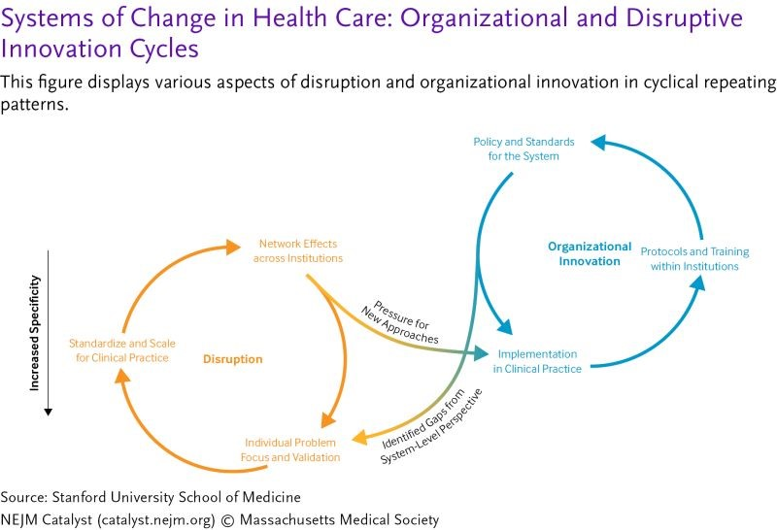

To Achieve Zero Harm, We Must Address Financial Harm
Gandhi TK, Hemmelgarn C
Journal of Patient Experience. 2025;12:23743735251383264.
DOI | https://doi.org/10.1177/23743735251383264
Notes | A paper in a recent issue of Health Affairs Scholar reported that ‘In 2024, 36% of US households had medical debt’. There is also a literature on ‘financial toxicity’ and the need for ‘financial navigation’ in health care. While it may be comforting to imagine that these issues are worse in some nations, they may exist in any setting.  This paper, in the Journal of Patient Experience, focuses on the financial impacts/harms caused by preventable medical errors. Along with better measurement, mitigation, disclosure and ‘Communication and Resolution’ efforts, the authors argue that ‘the full health care system, including health systems and payers, must come together to create best practices and policies to ensure that patients are not harmed financially when experiencing medical error.’

Australian Prescriber
Volume 48, Issue 5, October 2025
URL | https://australianprescriber.tg.org.au/volumes/48/issues/5.html
Notes | A new issue of Australian Prescriber has been published. Content in this issue of Australian Prescriber includes:  - Pharmacological management of attention deficit hyperactivity disorder in children and adolescents (D Efron, N Coscini)  - Oral anticoagulation for adults with atrial fibrillation or venous thromboembolism (PKL Chin, MP Doogue)  - Gestational diabetes: update on screening, diagnosis and maternal management (S Baddock, C Petersons, CJ Nolan)  - Sun protection: a practical guide for health professionals (S Morriss, L Scardamaglia)  - New drugs:  Edaravone for amyotrophic lateral sclerosis  Iptacopan for paroxysmal nocturnal haemoglobinuria  Lebrikizumab for atopic dermatitis

Healthcare Quarterly
Volume 28, Number 2, 2025
URL | https://www.longwoods.com/publications/healthcare-quarterly/27674/
Notes | A new issue of Healthcare Quarterly has been published. Articles in this issue of Healthcare Quarterly include:  - From Crisis to Silence: Systemic Failures in Mental Healthcare for Transgender and Gender Diverse People in Ontario (June Sing Hong Lam, Juveria Zaheer, Victoria Anderson, R de Silva Wijeyeratne and P Kurdyak)  - Timely, Connected and Person-Centred: How the Integrated interRAI Reporting System Is Supporting Senior Care in Canada (Phoebe Cheng)  - Talking about Declining Trust in Health Systems — and What to do About it (Neil Seeman)  - Introduction: Social Determinants of Mental Health (Ruby Brown and Anne Wojtak)  - Social Prescribing: A Pragmatic Pathway to Address Loneliness and Mental Health in Canada (Nicole Anne D’souza, Srija Biswass and Kate Mulligan)  - Intersectoral Collaboration to Address Loneliness: A Canadian Initiative (Rachel D. Savage, Parya Borhani, Christina Yu, Susan E. Bronskill, Laura Tamblyn Watts, Dena Silverberg, Kristina Fernando and Paula A. Rochon)  - Building Community Capacity in Mental Health: What Leaders Can Do (Steve Lurie)  - A Health Economic Analysis of the Potential in Transforming Canada’s Health Data Systems (Thomas Mullie, Anderson Chuck and Fahad Razek)  - System Transformation. Leadership Perspective: A Conversation With Anderson Chuck (Anne Wojtak and Richard Lewanczuk)  - Supply Chain Challenges. Built Here, Bought Here: Strengthening Self-Reliance to Support “Canada First” Healthcare (Anne W Snowdon, Cindy Ly, Alexandra Wright and Saba Ghadiri)  - Planetary Health. Polypharmacy: Institutional approaches to Support Patients, Systems and the Climate (Sarah Fallis, Ivy Lam, Lisa McCarthy and Myles Sergeant)  - Enhancing Behavioural Support in Long-Term Care: Evaluation of a Regional Behavioural Support Program for Older Persons Living With Dementia (Kayla Brooks, Paul Stolee, Jacobi Elliott and Carrie McAiney)  - A Plan-Do-Study-Act Framework for Adaptive Vaccine Messaging Using Artificial Intelligence (Olivia A. Stein and Neil Seeman)

Health Policy
Volume 161, November 2025
URL | https://www.sciencedirect.com/journal/health-policy/vol/161/
Notes | A new issue of Health Policy has been published. Articles in this issue of Health Policy include:  - Unraveling the policies, legislations, and regulations of psychedelics in Australia, Canada, Netherlands, New Zealand, and India (Ramesh Joga, Sravani Yerram, Jayasri Devi Patnam, K K Choudhary, ... S Srivastava)  - New government, old habits? The opportunity for a turning point in prevention health policies in Germany is now! (Marike Andreas, Lisa Kellermann, Ludgera Lewerich, Falko F Sniehotta)  - Can de-budgeting save primary care in Germany? A turning point for general practice (Damon Mohebbi, Rumeysa Yasar, Altina Ademi, Nazmiye Acar, Shadan Rahimpour)  - Urgent action needed to address the epidemiological threat of prolonged war in Gaza (Hanane EL Hafa)  - We should care about informal carers: Reforms are needed to improve their health and wellbeing (Natalie Winter, Rebecca Haddock)  - Implementation of the European health data space: a qualitative study on expectations of health data experts from 23 countries (Patricia Cervera de la Cruz, Teodora Lalova-Spinks, Mahsa Shabani)  - Health care coverage and access for displaced persons from Ukraine: Assessing the implementation of the Temporary Protection Directive across EU Member States (Nicole Mauer, Cristina Hernandez-Quevedo, Astrid Eriksen, Giada Scarpetti, ... Ingrid Schmidt)  - Comparative analysis of tuberculosis management in Indigenous North Canada and Alaska, USA from 1950s to 2019 (Hongyu Huang, Raja Faisal Abbas, Shishi Wu, Jerome Song, ... Xiaolin Wei)  - Impacts of social determinants on the transient and persistent inefficiency of health systems in OECD countries (Ezgi Önen Efecan, Volkan Efecan)  - The role of private equity in the German outpatient sector (Beate Jochimsen, Bernhard Gibis)  - A new integrated conceptual framework of health insurance literacy: Results of a critical interpretive synthesis (Reut Ron, Paula Feder-Bubis, Kierstin Trocha, Moriah Ellen)  - Operationalising public trust for health policymakers - A qualitative study in the EU, France, Italy, and Switzerland (Federica Zavattaro, Viktor von Wyl, Felix Gille)  - The use of discrete choice experiments in evaluating telehealth: a systematic review (Feby Savira, Madison Frith, Dieu Nguyen, R Norman, ... S Robinson)  - Large language models in radiology workflows: An exploratory study of generative AI for non-visual tasks in the German healthcare system (Stefanie Steinhauser, Sabrina Welsch)  - What matters most to the population in case of chronic conditions? Results from a discrete choice experiment in Italy (Milena Vainieri, Veronica Spataro, Sabina De Rosis, Filippo Quattrone, Sabina Nuti)  - Accounting for morbidity in capitation payments: A person-based workload formula for primary medical care in England (Laura Anselmi, Shaolin Wang, Yiu-Shing Lau, Michael Anderson, ... Matt Sutton)  - Employment models for general practitioners in England: evidence from repeated surveys (J M Gibson, S Urwin, S Spooner, K Checkland, M Sutton)  - Under what conditions do people accept health inequality? A cross-national regression analysis of OECD countries (Minjung Kim, Young Jun Choi)  - The associations between prices and taxes and the use of tobacco products in Latin America and the Caribbean: a systematic review and meta-analysis (G. Emmanuel Guindon, Ignacio Finot Cornejo, Mauricio Flores Muñoz, Luca Pruzzo, Guillermo Paraje)  - Impact of the 2012 pharmaceutical co-payment reform on drug consumption among children in Catalonia: Evidence from a regression discontinuity design (Toni Mora)  - Public perceptions of front-of-package warning label during policy design and implementation in Uruguay: A content analysis of social media narratives (Gastón Ares, Carlos Gómez Corona, Lucía Antúnez, Anne-Marie Thow)  - The 2023 European Commission proposal and the 2024 European Parliament proposal for the EU pharmaceutical legislation: policy content analysis (Simona Gamba, Laura Magazzini, Paolo Pertile)  - Overview of Australia’s state-wide cardiovascular program and reflections on its piloting between 2021 and 2024 (N.N. Khan, S. Jennings, E. Lugg, A. Beauchamp, ... A. Driscoll)  - The use of social return on investment approaches to evaluate integrated long-term care in high-income countries: A scoping review (Susana Ramalho Marques, Ricardo Rodrigues, Jürgen Zerth, Carola Orrego)  - A population-based exploration of immigrants undergoing general surgery procedures in British Columbia: Do immigrants present for emergency surgeries more than non-immigrants? (Michael Guo, Nicolas Mourad, Ahmer Karimuddin, Jason M. Sutherland)  - Financial penalty associated with a decline in hospital-acquired complications in Australia (Luke Slawomirski, Petr Otahal, Martin Hensher, Julie Campbell, ... Barbara de Graaff)  - Strengthening primary health care: The new contribution of midwives to gynecological care in France (Quitterie Roquebert, Henri Panjo, C Franc)  - Understanding physician prescription behaviors: a systematic review and meta-analysis of macro, meso, and micro-level influences (Giaele Moretti, Francesca Ferrè, Alma Martelli, Paola Cantarelli)  - Mental health as a determinant of work: a scoping review on the impact of mental health on precarious employment (Claire de Oliveira, Margaret Jamieson, Sara Bonato)  - Reducing mental health emergency department visits through community-based assessment services. A controlled time-series analysis in the city of Lyon, France (Guillaume Barbalat, Romane De Rozario, Nicolas Franck)  - Comparing health outcomes and costs of home and community-based services (HCBS) versus institutional care (IC) for long-term care insurance beneficiaries in South Korea: Can the less severe benefit more? (Sunghun Yun, Soonman Kwon)  - Is health financing fair? Evidence from 29 countries on the progressivity of health care revenue collection (Thomas Rice, Ruth Waitzberg, A Võrk)  - The effects of private equity ownership in U.S. nursing homes quality and financial performance: A systematic review (Gregory N. Orewa, Aizhan Karabukayeva, Rohit Pradhan, Itopa Jimoh, Robert Weech-Maldonado)  - The role of private equity funds in healthcare: trends, impact and policy responses (Bernd Rechel, Florian Tille, J Mercille, P Groenewegen, R Timans)  - The challenge of the first 1000 days. The dynamics of early-life health inequalities in a universal healthcare system: Evidence from Italy (Paolo Berta, Gilberto Turati)  - A scoping review of transformational leadership development in health-related PhD programs (Barbara Maria Löfflad-Bürkin, Anja Matthiä, Heather Krasna, Nino Künzli, ... Katarzyna Czabanowska)  - Meso-organisational determinants of healthcare workers’ resilience: results of a scoping review (Natalia Oprea, Giorgio Giacomelli, Marco Sartirana, Elisabetta Trinchero, Irène Georgescu)  - Strengthening innovation capacity in health and care workforce: A role-based framework for the procurement professionals (Klaas Stek, Luc Lefers, Carolina Belotti Pedroso)  - Health workforce planning should be strategy or policy-driven: From linear forecasts to normative futures (Gareth H Rees, Graham Willis, Cris Scotter)  - Cumulative legacies and crisis decision-making in shocks to the Irish health system: A mixed methods analysis (Steve Thomas, Catherine O’Donoghue, Arianna Almirall-Sanchez, Liz Farsaci)  - Measuring health system resilience: Understanding the relationship between excess mortality and health system performance (Irene Papanicolas, Jorge Ledesma)

BMJ Quality & Safety online first articles
URL | https://qualitysafety.bmj.com/content/early/recent
Notes | BMJ Quality &Safety has published a number of ‘online first’ articles, including:  - Evaluating the effects of increasing nursing numbers on quality of newborn care in understaffed neonatal units in Kenya: a prospective intervention study (Abdulazeez Imam, Mike English, Jalemba Aluvaala, Vincent Kagonya, Onesmus Onyango, Fred Were, Sebastian Fuller, Kenneth Karumba, Attakrit Leckcivilize, David Gathara, Michuki Maina)  - Diminishing returns: how treatment delays undermine the mortality benefits of high-quality stroke care (Ruize Guo, Mengyang Liu, Qianni Li, Jingkun Li, Meina Liu)

Online resources

Australian Living Evidence Collaboration
https://livingevidence.org.au/

Guidance
A number of guidelines or guidance have recently been published or updated These include:
- Stroke Foundation, Australian and New Zealand Clinical Guidelines for Stroke Management https://informme.org.au/guidelines/living-clinical-guidelines-for-stroke-management
- Living Evidence for Australian Pregnancy and Postnatal Care (LEAPP) consortium, Australian Pregnancy Care Guidelines https://app.magicapp.org/#/guideline/jm83RE/section/jNxeDG
- Living Evidence for Australian Pregnancy and Postnatal Care (LEAPP) consortium, Australian Postnatal Care Guidelines https://app.magicapp.org/#/guideline/jW0ZbL

[UK] NICE Guidelines and Quality Standards
https://www.nice.org.uk/guidance
The UK’s National Institute for Health and Care Excellence (NICE) has published new (or updated) guidelines and quality standards The latest reviews or updates include:
- Quality Standard QS74 Head injury https://www.nice.org.uk/guidance/qs74
- NICE Guideline NG252 Rehabilitation for chronic neurological disorders including acquired brain injury https://www.nice.org.uk/guidance/ng252

Infection prevention and control and COVID-19 resources
The Australian Commission on Safety and Quality in Health Care has developed a number of resources to assist healthcare organisations, facilities and clinicians These resources include:
- Poster – Combined contact and droplet precautions https://www.safetyandquality.gov.au/publications-and-resources/resource-library/infection-prevention-and-control-poster-combined-contact-and-droplet-precautions
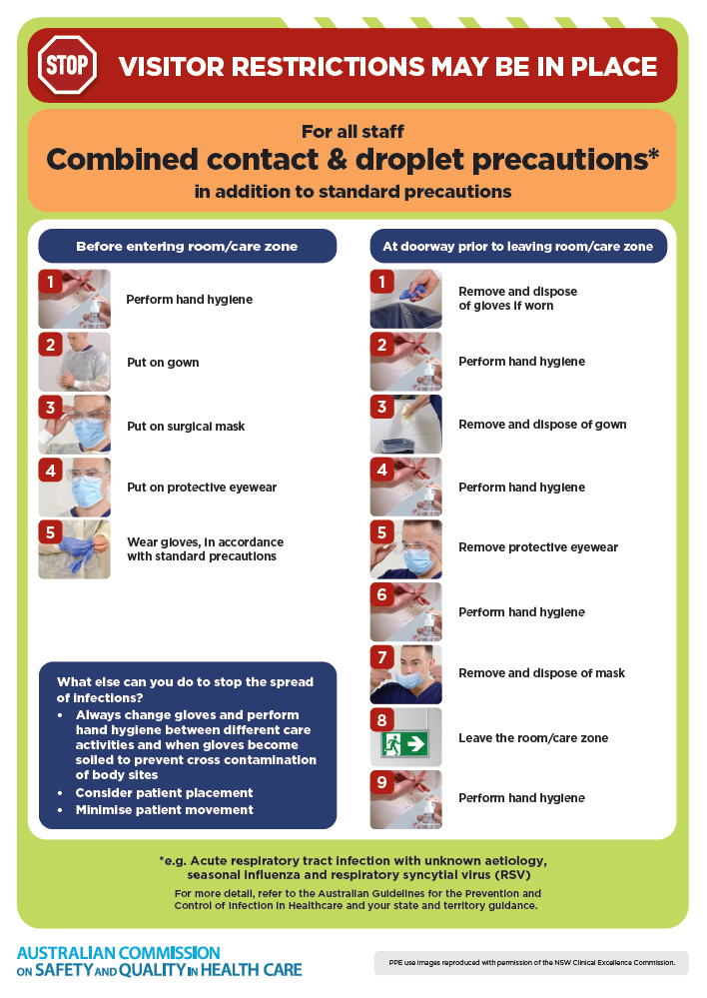
- Poster – Combined airborne and contact precautions
https://www.safetyandquality.gov.au/publications-and-resources/resource-library/infection-prevention-and-control-poster-combined-airborne-and-contact-precautions
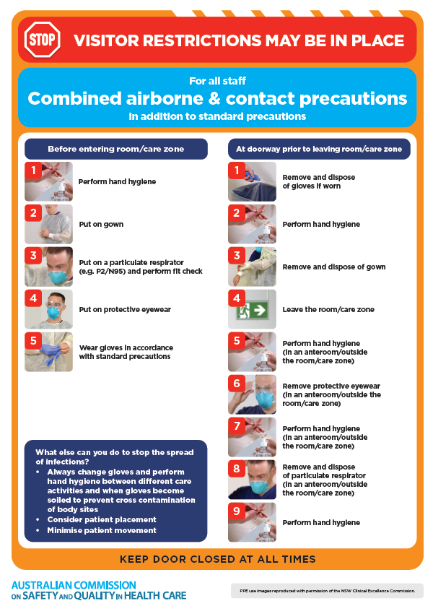
- Environmental Cleaning and Infection Prevention and Control www.safetyandquality.gov.au/environmental-cleaning
- Break the chain of infection poster
https://www.safetyandquality.gov.au/publications-and-resources/resource-library/break-chain-infection-poster
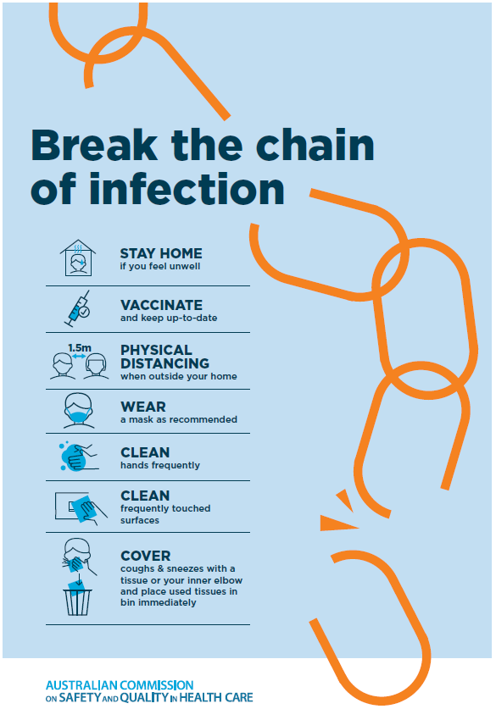

Disclaimer
On the Radar is an information resource of the Australian Commission on Safety and Quality in Health Care The Commission is not responsible for the content of, nor does it endorse, any articles or sites listed The Commission accepts no liability for the information or advice provided by these external links Links are provided on the basis that users make their own decisions about the accuracy, currency and reliability of the information contained therein Any opinions expressed are not necessarily those of the Australian Commission on Safety and Quality in Health Care.

