
On the Radar
Issue 719
27 October 2025

On the Radar is a summary of some of the recent publications in the areas of safety and quality in health care Inclusion in this document is not an endorsement or recommendation of any publication or provider Access to particular documents may depend on whether they are Open Access or not, and/or your individual or institutional access to subscription sites/services Material that may require subscription is included as it is considered relevant.

On the Radar is available online, via email or as a PDF or Word document from https://www.safetyandquality.gov.au/newsroom/subscribe-news/radar

If you would like to receive On the Radar via email, you can subscribe on our website https://www.safetyandquality.gov.au/newsroom/subscribe-news
or by emailing us at mail@safetyandquality.gov.au.
You can also send feedback and comments to mail@safetyandquality.gov.au.

For information about the Commission and its programs and publications, please visit https://www.safetyandquality.gov.au

On the Radar
Editor: Dr Niall Johnson
Contributors: Niall Johnson, Alice Bhasale

New resources to guide post-sepsis care and survivor support
https://www.safetyandquality.gov.au/our-work/national-sepsis-program

The Australian Commission on Safety and Quality in Health Care has released four new resources to help health services address gaps and inconsistencies in care coordination and post-sepsis support for survivors, families, carers and those bereaved by sepsis. Developed as part of the National Sepsis Program, these resources aim to improve care delivery and ensure patients receive consistent, high-quality support throughout the sepsis journey.

These resources include:
- Coordination of care and post-sepsis support - Model of Care Framework – outlining the essential elements for effective sepsis care and follow-up support https://www.safetyandquality.gov.au/publications-and-resources/resource-library/coordination-care-and-post-sepsis-support-model-care-framework
- Coordination of care and post-sepsis support - Business Case – supporting investment in coordinated care and post-sepsis services
https://www.safetyandquality.gov.au/publications-and-resources/resource-library/coordination-care-and-post-sepsis-support-business-case
- Coordination of care and post-sepsis support - Supporting evidence and implementation ideas – offering practical steps for applying the framework in different healthcare settings. https://www.safetyandquality.gov.au/publications-and-resources/resource-library/coordination-care-and-post-sepsis-support-supporting-evidence-and-implementation-ideas
- Coordination of care and post-sepsis support - Interactive PDF– an interactive tool developed to help health services explore how these elements can be adapted for local settings
https://www.safetyandquality.gov.au/publications-and-resources/resource-library/coordination-care-and-post-sepsis-support-interactive-pdf

These resources align closely with the Sepsis Clinical Care Standard and particularly support the implementation Quality Statements 4 to 7.

Journal articles

Benefits and challenges of implementing statutory duty of candour in Victoria, Australia: a mixed methods analysis of healthcare provider perspectives
Harrison R, Adams C, Walsan R, Manias E, Chauhan A, Youngs N, et al.
Frontiers in Health Services. 2025;5.
DOI | https://doi.org/10.3389/frhs.2025.1669958
Notes | Paper reporting on the impacts of introducing the Statutory Duty of Candour in Victoria. The authors note that ‘Statutory duty of candour (SDC) requires healthcare services by law to provide the patient or their family or carer who experiences a serious adverse patient safety event (SAPSE) with a written account of the facts, an apology, and the steps being taken to prevent reoccurrence.’ This paper draws on survey responses and interviews of health service staff working in Victorian health settings in order to examine staff and service delivery impacts of SDC.  The authors report that ‘Implementing SDC has contributed to greater structure, consistency and routine inclusion of patient and family perspectives when examining patient safety events. Opportunities for improvement identified by respondents and interviewees included developing person-centered and context-sensitive timeframes for communication, relaxing legalistic documentation requirements, findings ways to more consistently apply SAPSE definitions, and addressing the cultural implications and administrative burden of SDC requirements.’

For information on the Commission’s work on open disclosure, including The Australian Open Disclosure Framework, see https://www.safetyandquality.gov.au/standards/nsqhs-standards/clinical-governance/clinical-governance-standard/open-disclosure
From words to action: time for Australia to take shared decision making implementation seriously
Hoffmann TC, McCaffery KJ, Légaré F, Bakhit M, Tracy M
Medical Journal of Australia. 2025.
DOI | https://doi.org/10.5694/mja2.70065
Notes | This paper in the Medical Journal of Australia describes how shared decision making has been adopted in Australia, including the Commission’s engagement in this area. The authors observe that ‘Shared decision making is a process of engagement and partnership between a patient and their clinician that enables a collaborative decision to be made based on the best evidence, individual circumstances, and what matters most to the patient. Patient involvement in making informed health decisions is a fundamental right and is central to safe and quality health care. Shared decision making represents the highest standard of informed consent and is a cornerstone of value‐based health care.’ However, the aim of this piece is to call for greater adoption and ‘urgent scaling up so that more individuals and the health system can benefit from it.’

For information on the Commission’s work on shared decision making, see https://www.safetyandquality.gov.au/our-work/partnering-consumers/shared-decision-making

Does policy and practice for peripheral intravenous catheters match clinical standards? A point prevalence study
Lovegrove J, Havers S, Schults J, Ray-Barruel G, Bhasale A, Keogh S, et al
Infection, Disease & Health. 2025.
DOI | https://doi.org/10.1016/j.idh.2025.09.004
Notes | This study assessed the implementation of the Management of Peripheral Intravenous Catheters Clinical Care Standard (PIVC Clinical Care Standard) in 134 acute hospital wards in Queensland. Assessment of the indicators in a point prevalence study found varying adherence and room for improvement. While 91% of PIVS had been used since insertion, only 70% had been inserted on first attempt and only 42% had documented PIVC inspections 8-hourly. The authors observe that ‘Reform of local guidelines, policies, and processes to standardise PIVC care across hospitals and strategies to improve Standard adherence are needed’

BMJ Quality & Safety
Volume 34, Issue 11, November 2025
URL | https://qualitysafety.bmj.com/content/34/11
Notes | A new issue of BMJ Quality & Safety has been published. Many of the papers in this issue have been referred to in previous editions of On the Radar (when they were released online). Articles in this issue of BMJ Quality & Safety include:  - Editorial: Better bottom lines: patient satisfaction associated with addressing sexual and gender minority health (Carl Streed, Jessica Halem, Amy LeClair)  - Editorial: Addressing the risk of look-alike, sound-alike medication errors: bending metal or twisting arms? (Denham L Phipps)  - Impact of hospitals’ LGBTQ+ inclusion efforts on patient satisfaction from 2016 to 2023: a retrospective longitudinal observational study (Hyunmin Yu, Matthew D McHugh, José A Bauermeister, Tari Hanneman, H Brom)  - Psycholinguistic tests predict real-world drug name confusion error rates: a cross-sectional experimental study (Bruce L Lambert, Scott Ryan Schroeder, William L. Galanter, Gordon D. Schiff, Allen J Vaida, Michael J Gaunt, Michelle Bryson Opfermann, Christine Rash Foanio, Suzanne Falck, N Mirea)  - Comparing safety, performance and user perceptions of a patient-specific indication-based prescribing tool with current practice: a mixed methods randomised user testing study (Calandra Feather, Jonathan Clarke, Nicholas Appelbaum, Ara Darzi, Bryony Dean Franklin)  - Results of a healthcare transition learning collaborative for emerging adults with sickle cell disease: the ST3P-UP study transition quality improvement collaborative (Ifeyinwa Osunkwo, Jennifer S Cornette, Laura Noonan, Cheryl Courtlandt, Sarah Mabus, Patience H White, Margaret McManus, Myra M Robinson, Michelle L Wallander, James R Eckman, Elna Saah, Ofelia A Alvarez, Mark Goodwin, Leila Jerome Clay, Payal Desai, Raymona H Lawrence)  - RECi-PE (REducing CT in Pulmonary Embolism Diagnosis): an emergency department quality intervention (Jared S Anderson, Andrew Beck, Janette Baird, Timmy R Lin, Anthony M Napoli)  - Scoping review identifying interventions that have been tested to optimise the experience of people from ethnic minority groups receiving systemic anticancer therapy (SACT) (Jurga McLean, Pinkie Chambers, Luke Steventon, Susanne Cruickshank, Shereen Nabhani-Gebara)

Healthcare Papers
Volume 23, Number 2, 2025
URL | https://www.longwoods.com/publications/healthcarepapers/27694/
Notes | A new issue of Healthcare Papers has been published with a theme of Governance – The Good, the Bad and the Ugly. Articles in this issue of Healthcare Papers include:  - Governance – The Good, the Bad and the Ugly (Sara Allin and Audrey Laporte)  - The Big Swing: Reforming Governance Authorities in Canadian Health Systems (Jean-Louis Denis)  - Comparative Perspectives on Health Governance as Political Practice: A Commentary (Viola Burau)  - Three Readings of the Concept of Governance (Damien Contandriopoulos)  - Alberta: The Next Reform Is Always Just Ahead (Neale Smith and J Church)  - The Big Swing Toward Centralized Governance: What We Heard From Rural Saskatchewan Healthcare Workers (Tom McIntosh, Cheryl A Camillo, Nuelle Novik, Bonnie Jeffery and May Ly)  - Governing for or Governing With? Advancing Governance Models That Include Patients, Caregivers and Communities as Valued Partners (Kerry Kuluski, Emily Cordeaux, Carol Fancott, Adrienne Zarem and G Ross Baker)  - Of Big and Small Swings: Toward a Hybrid View of Healthcare Systems Governance (Jean-Frederic Levesque)  - Broadening the Analysis of Canadian Healthcare Reforms (Mark Exworthy and Russell Mannion)  - Just Out of the Starting Blocks: Advancing Province-Wide Integrated Health and Social Services Governance in Quebec (Elisabeth Martin)  - How to Achieve Meaningful Change (Gregory P Marchildon)  - Reforming Governance: Careful Advice (Jean-Louis Denis)
Health Expectations
Volume 28, Issue 5, October 2025
URL | https://onlinelibrary.wiley.com/toc/13697625/2025/28/5
Notes | A new issue of Health Expectations has been published Articles in this issue of Health Expectations include:  - Co-Design of a Weekly Meal Box for Neurological Conditions: Findings From Consumer and Healthcare Provider Collaborative Workshops (Joanna Rees, Kelly Moes, A Devine, M Clark, R Sambell, S Laws, T Cruickshank)  - Anticipated First Contact and Time to Seek Healthcare for Possible Breast Cancer Symptoms: A Cross-Sectional Study in Rural Ghana (Adwoa Bemah Boamah Mensah, Kofi Boamah Mensah, Anita Eseenam Agbeko, Emmanuel Kwaku Nakua, Joshua Okyere, Gloria Anane, Joseph Sakyi Baah, Madalyn Nones, Keith J. Horvath, Beth Virnig, Joe-Nat Clegg-Lamptey, S Kulasingam)  - Exiting Surveillance From Abdominal Aortic Aneurysm Screening: The Views of Clinicians, and Men in Surveillance and Their Family Members (Elizabeth Lumley, Jane Hughes, Alan Elstone, Jo Hall, Niall MacGregor-Smith, Jonathan Michaels, Akhtar Nasim, Stephen Radley, Phil Shackley, Gerry Stansby, Emily Wood, Alicia O'Cathain)  - Editorial: Partnering With Patients to Conduct High-Quality Research – Where Have We Been and Where Are We Going? (Daniel Whibley, Greg Merritt, Megan Haymart, Patricia Piechowski, Knoll Larkin, David Williams)  - Older Patients' Verbal Communication in Interactions With Primary Care Staff: A Qualitative Systematic Review and Meta-Ethnography (Rebecca Goulding, Peter Bower, Tom Blakeman, Sarah Peters)  - Evaluation of a ‘Research Methods’ Training Course for Novice Lived Experience Researchers (Andrew C. Grundy, Anam Bhutta, Ashgan Mahyoub, Rebecca Jenkins, Sadia Mir, Jahanara Miah, Gail Faragher, Karina Lovell)  - Twenty-One Years and Still Going Strong: A Qualitative Study Exploring the Contribution of Young Adult, Adolescent, and Stakeholder Involvement to the Resilience of a Type 1 Diabetes Transition Program (Ann Carrigan, Veslemøy Guise, D. Jane Holmes-Walker, Kaye Farrell, Ann M. Maguire, Siri Wiig, Nehal Singh, S Wijekulasuriya, P N Arfirsta Dharmayani, Z Simone, E Davis, T W Jones, T Huynh, D E Bloom, J Braithwaite, Y Zurynski)  - Co-Producing Patient-Reported Experience Measures With People With Intellectual Disability to Improve Healthcare Quality and Outcomes: The ‘Listen to Me’ Project Protocol (Reema Harrison, Bronwyn Newman, Beth Catlett, Laurel Mimmo, Ling Wu, Maya Tokutake, Karen Phillips, Matthew Van Hoek, Debbie Van Hoek, Elizabeth Manias, Pandora Patterson, Dalal Dawood Baumgartner, Kim Bowen, Julian Trollor, Sue Woolfenden, Iva Strnadova, Johanna Westbrook, Rebecca Mitchell, Angela Dew, Patrick Olivier, V Mumford, T Badgery-Parker, L Ellis, S Rodier, T Szanto, J Small, C Adams, M Templeton, J Evans, N A Hackl, K Churruca, A M Hadley)  - Developing a Typology of Women's Attitudes Towards AI Use in the BreastScreen Programme—A Qualitative Study With BreastScreen Victoria Clients (Maho Omori, Prabhathi Basnayake, Louise Keogh, Helen M L Frazer, Katrina Kunicki, Jocelyn F Lippey)  - Optimising Calorie Intake for People With Amyotrophic Lateral Sclerosis: A Process Evaluation of a Complex Behaviour Change Intervention (Katie Hullock, Alicia O'Cathain, Fiona Sampson, Jonathan Woodward, Elizabeth Coates, Theocharis Stavroulakis, Sean M White, David White, Paul Norman, Christopher McDermott)  - Impact of YouTube User-Generated Content on News Dissemination and Youth Information Reception (Wu Chunqiong, Jiang Shan, Sun Jianhong, Liu Yingqi)  - Smart Rings in Remote Monitoring at Home: Older Patients' Perceptions and Expectations (Melika Azim Zadegan, Eeva Aromaa, Tero Montonen, Rosa Sahlström, Päivi Eriksson, Ville Leinonen)  - Design Mapping: A Conceptual Framework for Co-Designing Evidence-Based Digital Mental Health Programs (Kelsie Bufton, Maria Bates, Matthew Fuller-Tyszkiewicz, Jasmin Hamid, Elizabeth Westrupp)  - “The Culturally and Linguistically Diverse Community Is Not Just Minoritised But Ignored”: Engaging Culturally and Linguistically Diverse Communities in Australia With Blood-Borne Viruses and Sexually Transmissible Infections Healthcare (S R Okeke, R Horwitz, L Brener, H M K Vu, E Wu, D Jin, S Yu, T Broady, C Treloar, E Cama)  - Intersectionality and Long Covid: Understanding the Lived Experiences of Ethnic Minority Groups in the United Kingdom (Yojana Lotankar, Anna Cheshire, Damien Ridge, Carolyn Chew-Graham, Nina Smyth, Claudia R Knowles, Dipesh Gopal, Tom Kingstone, Shoba Dawson)  - Understanding the Scope, Intent and Extent of Published Conceptual Frameworks of Frameworks for Patient and Public Involvement in Health and Social Care Research: A Rapid Scoping Review (Eugenie Evelynne Johnson, Sean Gill, Madeleine Still, Daisy Trenchard, Debbie Smith, Rebecca Harmston, Jane McDermott, Fiona Pearson)  - Exploring Parental Experiences of Childhood Ear Health Clinics and Their Acceptability of AI-Based Diagnostic Tools: A Qualitative Study (Jacqueline H Stephens, Celine Northcott, Amanda Machell, Trent Lewis, Eng H Ooi)  - Supporting Older People Living With Frailty to Self-Manage Multiple Medicines: An Experience-Based Co-Design of a Complex Intervention Developed in UK Primary Care (Giorgia Previdoli, Ruth Simms-Ellis, Jonathan Silcock, David Phillip Alldred, V-Lin Cheong, Savi Tyndale-Biscoe, Justine Tomlinson, Beth Fylan)  - The Experiences of Social Connection and Isolation in Adults With Acquired Brain Injury: A Qualitative Systematic Review and Metasynthesis (Jordan Ayden, María-José Bracho-Ponce, Julia Ajayi, Sarah Hanson, Fergus Gracey)  - Developing Community-Informed Communication Resources to Improve Human Papillomavirus Vaccine Uptake in Tonga (Yasmin Mohamed, Emma Luey, ‘Ungatea Kata, Isabella Overmars, Ofakiokalani Tukia, Jane Frawley, Afu Tei, Susana Lotulelei, ‘Asinate Toluta'u, Meleane Lomu, Luisa Vodonaivalu, Julie Leask, Holly Seale, Kylie Jenkins, Reynold ‘Ofanoa, Kshitij Joshi, Halitesh Datt, Sonya Sagan, Michelle Dynes, M Danchin, J Kaufman)  - Accessing Care Across Cultures: Qualitative Insights Into the Reality of Informal Caregivers From Ethnically Minoritised Groups (Anna Robinson-Barella, Trinette Wayoe, Rosabella Louise Deakin, C L Richardson)  - Navigating Challenges in Peer Support Work: Perspectives of Peer Supporters From a Stepped Care Intervention for Older Adults With Depressive Symptoms (Eric Kwok Lun Yiu, Stephanie Ming Yin Wong, Jessica Kang Qi Lee, Zuna Loong Yee Ng, Dara Kiu Yi Leung, Wai Chi Chan, Gloria Hoi Yan Wong, Terry Yat Sang Lum)  - A Qualitative Examination of the Content Validity of the EQ-5D-5L and EQ-5D-Y-3L in Adult and Paediatric Patients With Duchenne Muscular Dystrophy (Richard Huan Xu, Rui Jiang, Chenxi Yang, Dong Dong)  - Experiences of Social Relationships for Adults Living With Multiple Long-Term Conditions: A Qualitative Interview Study (Hilda Hounkpatin, Leanne Morrison, Al Richards, Miriam Santer)  - Citizens' Jury as a Strategy to Increase Social Participation Among Older People (Nancy Flores-Castillo, Carmen García-Peña, Sara Torres-Castro, Héctor García-Hernández)  - Challenges of Inclusion: A Population-Based Interview Study of Long Covid (Emily Cooper, Adam Lound, Kathryn Jones, Jane Bruton, Sophie Day, Christina J. Atchison, Caroline Eccles, Alex Piper, Graham S. Cooke, Marc Chadeau-Hyam, Paul Elliott, Helen Ward)  - No Time for Waste! Co-Producing Practice Guidelines and Research Recommendations to Promote Earlier Diagnosis of Colorectal Cancer in Community Pharmacies: A Qualitative Analysis (Evelyn Brunsdon, Shakira Hollyfield, Sanjana Challa Venkat, Aradhna Kaushal, Willie Hamilton, Lindy Berkman, Stephen Rowley, Adam Todd, Andy Husband, C von Wagner)  - Developing a Co-Produced Practice Framework to Support Personalised Safety Planning for Adults Experiencing Suicidality (Katherine McGleenan, Isabel Gordon, Hollie Smith, Jill Barker, Rebecca Lilley, Tara Scott, Paula Mart, Victoria Walker, Nicola Clibbens, Julie Taylor, Sarah Fishburn, Andrew Ramtohul, Sandra Chidimma Nwokoroku, Darren Flynn)  - Evaluating the Feasibility of the Participant-Led Video Intervention to Train Support Workers From the Perspective of Disability Sector Professionals (Megan Topping, Jacinta Douglas, Kate D'Cruz, Di Winkler)  - Co-Creation Study Protocol for Developing a Nurse-Led Intervention to Deprescribe Benzodiazepines and Z-Hypnotics in Primary Care Aimed at Empowering Women (Amaia Cuesta-Zigorraga, Carlota Las Hayas Rodríguez)  - The REDUCE Intervention: The Development of a Person-Centred Cognitive Behavioural Intervention to Improve Ulcer Outcomes in People at Risk of Diabetic Foot Ulceration (Kavita Vedhara, Debbie Brewin, Fran Game, Christina Sheehan, Kieran Ayling, Kat Bradbury, Joanna Slodkowska-Barabasz, Judith Joseph, Ruth Hart, Natasha Mitchell, J Lawton, T Chalder)  - Co-Design of Maternity Discussion Cards for Aboriginal and Torres Strait Islander Women (Tanya Druce, Vidanka Vasilevski, Cara Kennedy, Ann Hallett, Karah Edwards, Linda Sweet, Debra Kerr)  - Co-Design of a Framework for Person-Centred Care at Emergency Department Triage and Waiting Room (Carrie Janerka, Gavin D Leslie, Fenella J Gill, PCC ED Triage Group)  - Patient Voices: What Can We Learn From the Covid-19 Pandemic About Follow-Up Care in Gynaecologic Oncology? (Esther M. Vermaas, Luc R. C. W. Van Lonkhuijzen, Henrike Westerveld, Maaike A. Van Der Aa, Tijmen J. Bonestroo, Brigitte F. M. Slangen, Johanna W. M. Aarts)  - Living With Persistent Respiratory Symptoms of Long COVID: Qualitative Study Among Brazilian Adults 12 Months After Acute Infection (Giovana Alves Santos, Carlos Laranjeira, Lígia Carreira, Vanessa Denardi Antoniassi Baldissera, Maria Fernanda do Prado Tostes, Viviani Camboin Meireles, Rosella Santoro Ageno, Maria Aparecida Salci)  - Relying on Trust: A Qualitative Study on Home-Dwelling Older Adults' Experiences and Preferences With Multimorbidity Management in Municipal Healthcare Assessments (Turid R. Aarønes, Kristin Taraldsen, Linda A H Kvæl)  - Continuity Is Essential: The Experiences of Co-Design Participants During the Implementation of a New Health Service (Deirdre McGowan, Claire Morley, Emily Hansen, Kelly Shaw, Tania Winzenberg)  - Long-Term Benefits Following Hepatitis C Cure Through Facilitated Telemedicine; Experiences of People With Opioid use Disorder Five Years After Achieving a Sustained Virological Response (Zoi Papalamprakopoulou, Tin H Dang, Christopher J Gonzalez, Colin J Tedesco, Paul F Updike, C Corl, A Dharia, N Hernandez, M F Shapiro, E Wethington, A H Talal)  - What Is Shared in an Online Peer-Support Group Run by Stroke Survivors? An Exploratory Study With a Participatory Approach (Malin Tistad, Lill Hultman, Jeanette Nelson, F Sandman, M Åkerlund, U-K Schön, L von Koch)  - Dimensions of Social Capital for Supporting Informal Carers of Patients With Advanced Chronic Illness in the Community: A Concept Mapping Study (Marques Shek Nam Ng, Winnie Kwok Wei So, Kai Chow Choi, Wallace Chi Ho Chan, Helen Yue Lai Chan, Carmen Wing Han Chan)  - Developing a Set of Key Principles for Care Planning Within Older Adult Care Homes: A Modified Delphi Survey (Jonathan Taylor, Thais Caprioli, Jacqueline Damant, Yuri Hamashima, Nick Smith, Madalina Toma, M Peters)  - Hospital Food Service Experiences Between Older Patients From English- and Non-English Speaking Backgrounds in a Large Public Hospital in Australia: A Qualitative Analysis (Caitlin Wyman, Morgan Pankhurst, Sue Yi Lee, Shahid Ullah, Edwin C. K. Tan, Bich Tran, Yogesh Sharma, Zhaoli Dai)  - Ripple Effects Mapping: Evaluating Multilevel Perspectives and Impacts of a Statewide Community–Academic Partnership Network on Covid-19 Health Disparities (Evelyn Vázquez, Isabel Duong, Borsika A Rabin, Nicole A Stadnick, Paul L Watson Jr., Kelli L Cain, Maria Pozar, Ann Cheney)  - U.S. Vietnamese Parents' Perceptions of Different Approaches for Confirming Adolescent HPV Vaccination Records in Research Studies (Lilian Bui, Valerie Espinoza, Huyen-Anh Giang, Linh P. Schiffer, Phuong Do, Phuong Ngu, Chi Vu, Jasmin Tiro, Eric Adjei Boakye, Siobhan M. Phillips, Heather Brandt, Ella Berry, S Tran, E Macdonald, C Khuc, J Nguyen, T Vuong, M Vu)  - Consulting With First Nations Communities to Develop Text-Based Support for Grieving Fathers (Craig Hammond, Mick Adams, R Fletcher)  - Understanding the Clinical Characteristics and Timeliness of Diagnosis for Patients Diagnosed With Long Covid: A Retrospective Observational Cohort Study From North West London (Denys Prociuk, Jonathan Clarke, Nikki Smith, Ruairidh Milne, Cassie Lee, Simon de Lusignan, Ghazala Mir, Johannes De Kock, Erik Mayer, Brendan C Delaney, LOCOMOTION Consortium)  - The Experience of Accessing Primary Healthcare Centres in a Lebanese Community: Perspectives of Older People, Family Members and Service Providers (Saydeh Dableh, Kate Frazer, Mathilde Azar, Thilo Kroll)  - Evaluating the Study Designs and Outcome Measures Used in Service User Involvement in Health Professional Entry-Level Education: A Systematic Review (Jonathan Green, Jennifer Oates, Sam Robertson, E Barley, C Jacobs)  - Institutional Abuse, Neglect and Harm in UK Community Mental Health Services: A Scoping Review of the Peer-Reviewed Evidence (Bethan M Edwards, Alan Meudell, Ellen Thomas, Eva Broeckelmann, Eva Roberts, Mark Farmer, Naomi Ghafoor, Sarah Markham, Catherine A Robinson, Angela Sweeney, Sarah Carr, Michael Clark)  - Developing a Patient Experience Questionnaire for the Man Van Mobile Clinical Unit (Masood Moghul, Netty Kinsella, Fionnuala Croft, Patrick Kierkegaard, Declan Cahill, Nicholas David James)  - Family Caregivers' Experiences of Services for Children With Medical Complexity: A Systematic Review and Qualitative Evidence Synthesis (Bethan Page, Pru Holder, Katie Doidge, Lisa Hinton, Lorna K. Fraser)  - Authentic Consumer–Clinician Co-Design of a Labour and Childbirth Intervention to Optimise Maternal Hydration in Labour: Reaching Consensus to Enhance Rigour (Lauren Kearney, Bec Jenkinson, Christoph Lehner, Victoria Eley, Nicole Marsh, Deanne August, Susan de Jersey, N Lee)  - Identifying Priorities for Enhancing Village Health Volunteer's Mental Health Recovery Practices in Thai Rural Communities: A Nominal Group Technique Study (Chonmanan Khanthavudh, Annmarie Grealish, Vasiliki Tzouvara, Mary Leamy)  - Challenges and Opportunities in Delivering and Providing Culturally and Linguistically Tailored Cardiovascular Disease and Stroke Prevention Education: A Qualitative Exploratory Study (Sabine M. Allida, Della Maneze, Scott William, Maree Hackett, Caleb Ferguson)  - Co-Production, Co-Creation and Co-Design in Primary Health Care: A Scoping Review of Design, Implementation, Impact and Sustainability (Cate Dingelstad, Nicolette Hodyl, Rebecca Wyse, Suzanne Lewis, Alison Koschel, Nicholas Goodwin)  - Patient Advocacy Group Leaders' Perceptions on Primary Care's Role in Caring for Patients With a History of Breast Cancer (Kacie Barry, Sarah J Fadem, Jennifer R Hemler, Jenna Howard, Lisa Mikesell, Denalee M O'Malley, Shawna V Hudson, Benjamin F Crabtree)  - Post Covid-19 Condition as a Diagnosis: A Qualitative Study on Epistemological Tensions Among Experts in Sweden (Anna Bredström, Sofia Morberg Jämterud)  - Exploring the Role of Peer Health Navigators in the Australian Health System: A Qualitative Interview Study (Natali Cvetanovska, Simone Said, Rebecca L Jessup)  - Patient and Public Involvement in Action: Shaping an Intergenerational Engagement Intervention in a Long-Term Care Facility in China (Hao Liu, Anne Topping, Ping Guo)  - How Are People Undergoing Dialysis Expected to Benefit From Cognitive Behavioural Therapy? A Realist Analysis (Katrin Micklitz, Joanne Greenhalgh, Lori Suet Hang Lo, Richard Sawatzky, Kara Schick-Makaroff)  - Disclosing the Decision to Decline Breast Screening and/or Breast Cancer Treatment Due to Concerns About Overdiagnosis and Overtreatment (Shavez Jeffers, Alison Pilnick, Natalie Armstrong)  - Co-Designing Lived Experience Guide Support for First Responder Mental Health: Defining the Role and Considerations for Implementation (Hussain-Abdulah Arjmand, Tim Peck, Meaghan Louise O'Donnell, Nicole Sadler, Anita Savic, Michelle Spinks, Michael Symons, Tracey Varker)  - Advance Care Planning in Multicultural Communities: A Document Analysis of Resources to Support Healthcare Staff and Consumers in Australia (Upma Chitkara, Ashfaq Chauhan, Ramya Walsan, Mary Li, Maha Pervaz Iqbal, Nadine El-Kabbout, Misbah Faiz, Vitor M. Rocha, Ursula M. Sansom-Daly, Reema Harrison)  - ‘Every Voice Matters’: A Photovoice Study on the Personal Impacts of Co-Production in Recovery Colleges (Lisa D. Hawke, Shelby McKee, Holly Harris, Amy Hsieh, James Svoboda, Maral Sahaguian, Gail Bellissimo, Melissa Hiebert, Kelly Lawless, George James, Sean Patenaude, J Rovet, S Soklaridis)  - Development and Evaluation of a Persian-Language Self-Management Mobile Application for People With Spinal Cord Injury (Amir Hossein Daeechini, Azamossadat Hosseini, Reza Rabiei, Saeed Oraee-Yazdani, Somayeh Paydar)  - Pesticide Exposure and Parkinson's Disease: A Qualitative Study of Experiences in Ireland (Lucy M. Collins, Sarah Moore, Emma O'Shea, Aidan White, Aideen M Sullivan)

BMJ Quality & Safety online first articles
URL | https://qualitysafety.bmj.com/content/early/recent
Notes | BMJ Quality &Safety has published a number of ‘online first’ articles, including:  - Editorial: Near-wins in the pursuit of quality: does transparency matter if no one is looking? (Sigall K Bell, Catherine DesRoches)  - Correction: Expression of concern: Reducing opioid use for chronic non-cancer pain in primary care using an evidence-based, theory-informed, multistrategic, multistakeholder approach: a single-arm time series with segmented regression

International Journal for Quality in Health Care online first articles
URL | https://academic.oup.com/intqhc/advance-articles
Notes | International Journal for Quality in Health Care has published a number of ‘online first’ articles, including:  - Integrated, holistic palliative community services require the co-evolution and integration of palliative care within primary health care (Daniel Munday and David Greenfield)  - Physician Assistant Legalisation and Conflicts in South Korea: Need for an Approach Based on Lessons from Three Countries (Suhyun Oh, Kye-Hyun Kim, Seog-Kyun Mun)

Online resources

Australian Living Evidence Collaboration
https://livingevidence.org.au/

Guidance
A number of guidelines or guidance have recently been published or updated These include:
- National Standards for Counsellors and Psychotherapists
https://www.health.gov.au/news/now-available-national-standards-for-counsellors-and-psychotherapists
https://www.health.gov.au/sites/default/files/2025-10/national-standards-for-counsellors-and-psychotherapists-summary-report_0.pdf
- American Gastroenterological Association, Clinical practice guideline on management of gastroparesis https://doi.org/10.1053/j.gastro.2025.08.004

[UK] NICE Guidelines and Quality Standards
https://www.nice.org.uk/guidance
The UK’s National Institute for Health and Care Excellence (NICE) has published new (or updated) guidelines and quality standards The latest reviews or updates include:
- Interventional procedures guidance:IPG807 VA ECMO for severe acute heart failure in adults https://www.nice.org.uk/guidance/ipg807
- Interventional procedures guidance:IPG808 VA ECMO for extracorporeal cardiopulmonary resuscitation (ECPR) in adults with refractory cardiac arrest https://www.nice.org.uk/guidance/ipg808

[Canada] Celebrating Everyday Safety Acts
https://www.healthcareexcellence.ca/en/resources/celebrating-everyday-safety-acts-activity-card/
Healthcare Excellence Canada has developed a Celebrating Everyday Safety Acts Activity Card as part of Canadian Patient Safety Week. The activity card ‘‘invites everyone involved in delivering or receiving care to recognize, share and celebrate actions that make care safer’. It is intended to inspire healthcare professionals, patients and care partners to be proactive about patient safety.

Infection prevention and control and COVID-19 resources
The Australian Commission on Safety and Quality in Health Care has developed a number of resources to assist healthcare organisations, facilities and clinicians These resources include:
- Poster – Combined contact and droplet precautions https://www.safetyandquality.gov.au/publications-and-resources/resource-library/infection-prevention-and-control-poster-combined-contact-and-droplet-precautions
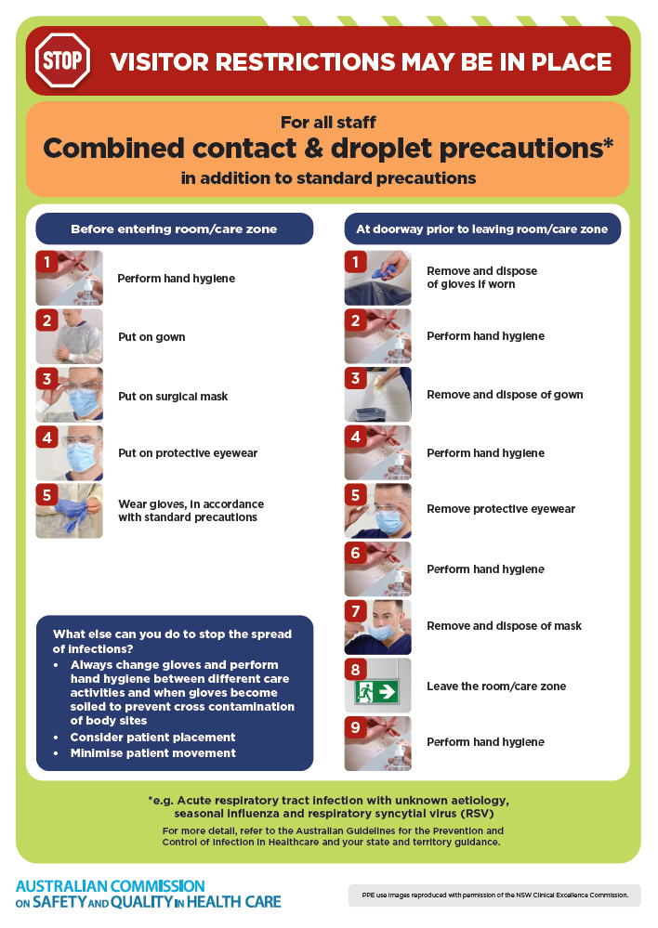
- Poster – Combined airborne and contact precautions
https://www.safetyandquality.gov.au/publications-and-resources/resource-library/infection-prevention-and-control-poster-combined-airborne-and-contact-precautions
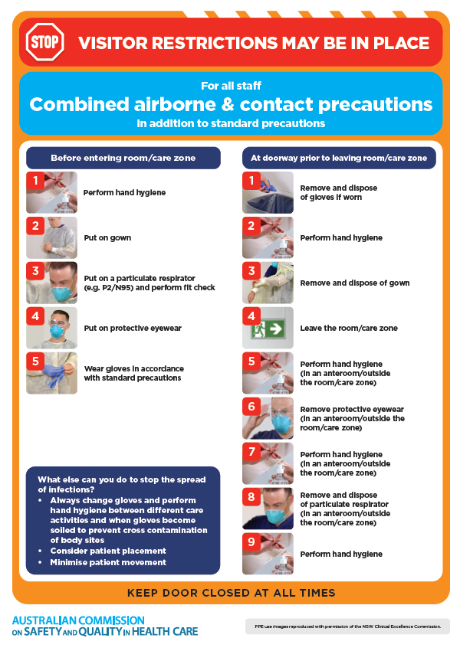
- Environmental Cleaning and Infection Prevention and Control www.safetyandquality.gov.au/environmental-cleaning
- Break the chain of infection poster
https://www.safetyandquality.gov.au/publications-and-resources/resource-library/break-chain-infection-poster
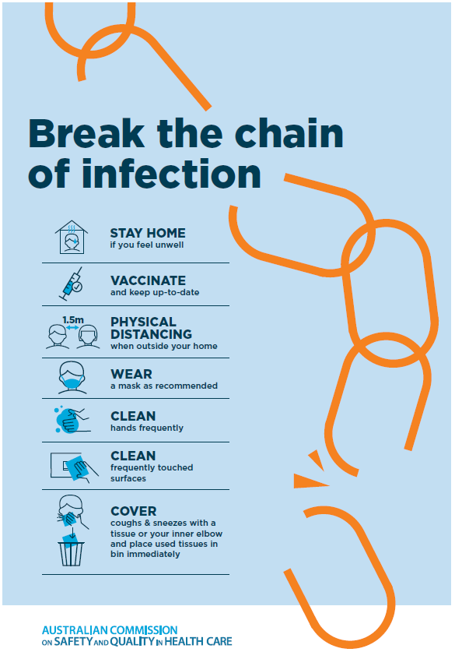

Disclaimer
On the Radar is an information resource of the Australian Commission on Safety and Quality in Health Care The Commission is not responsible for the content of, nor does it endorse, any articles or sites listed The Commission accepts no liability for the information or advice provided by these external links Links are provided on the basis that users make their own decisions about the accuracy, currency and reliability of the information contained therein Any opinions expressed are not necessarily those of the Australian Commission on Safety and Quality in Health Care.

