
On the Radar
Issue 720
3 November 2025

On the Radar is a summary of some of the recent publications in the areas of safety and quality in health care Inclusion in this document is not an endorsement or recommendation of any publication or provider Access to particular documents may depend on whether they are Open Access or not, and/or your individual or institutional access to subscription sites/services Material that may require subscription is included as it is considered relevant.

On the Radar is available online, via email or as a PDF or Word document from https://www.safetyandquality.gov.au/newsroom/subscribe-news/radar

If you would like to receive On the Radar via email, you can subscribe on our website https://www.safetyandquality.gov.au/newsroom/subscribe-news
or by emailing us at mail@safetyandquality.gov.au.
You can also send feedback and comments to mail@safetyandquality.gov.au.

For information about the Commission and its programs and publications, please visit https://www.safetyandquality.gov.au

On the Radar
Editor: Dr Niall Johnson
Contributors: Niall Johnson

Reports

WHO strategic approach on air quality, energy access and health
World Health Organization
Geneva: WHO; 2025. p. 52.
URL | https://www.who.int/publications/i/item/9789240114968
Notes | The COVID-19 pandemic brought the question of air quality, particularly internal air quality, to the attention of many. This strategy seeks, in part, to address air quality but in concert with other aims. The World Health Organization (WHO) has released this ‘WHO strategic approach on air quality, energy access and health – for healthier populations and universal health coverage’. The stated overall objective is to ‘Protect public health through evidence-based actions to improve air quality and ensure access to clean, sustainable energy solutions’. Earlier in 2015, the WHO had also released the Updated road map for an enhanced global response to the adverse health effects of air pollution.  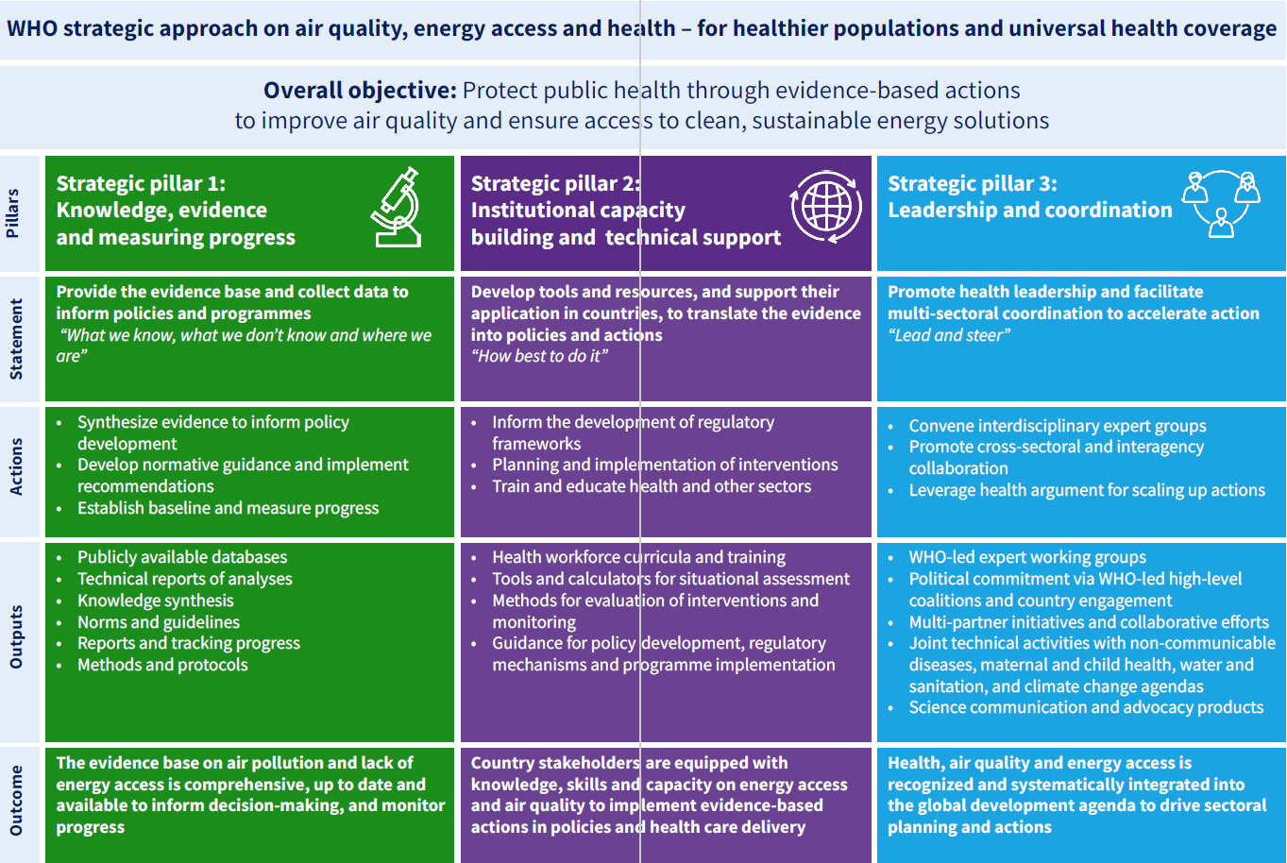

Mortality following hospitalisation for seven clinical conditions, July 2021 – June 2024
Bureau of Health Information
St Leonards: BHI; 2025.

Readmission and returns to acute care following hospitalisation for eight clinical conditions, October 2021 – June 2024
Bureau of Health Information
St Leonards: BHI; 2025.
URL | https://www.bhi.nsw.gov.au/BHI_reports/mortality/mortality-following-hospitalisation-2021-2024  https://www.bhi.nsw.gov.au/BHI_reports/readmission/readmission-and-returns-to-acute-care-2021-2024
Notes | The Bureau of Health Information (BHI) in New South Wales has released a couple of reports recently. These have included:  - Mortality following hospitalisation for seven clinical conditions, July 2021 – June 2024 provides information regarding mortality for seven clinical conditions in the 30 days following admission to 69 NSW public hospitals between July 2021 and June 2024. The seven conditions are acute myocardial infarction, ischaemic stroke, haemorrhagic stroke, congestive heart failure, pneumonia, chronic obstructive pulmonary disease and hip fracture surgery.  - Readmission and returns to acute care following hospitalisation for eight clinical conditions, October 2021 – June 2024 provides information regarding readmission and returns to acute care for eight clinical conditions in 71 NSW public hospitals in the 30 days (60 days for total hip replacement and total knee replacement) following discharge between October 2021 and June 2024. The eight conditions are acute myocardial infarction, ischaemic stroke, congestive heart failure, pneumonia, chronic obstructive pulmonary disease, hip fracture surgery, total hip replacement and total knee replacement.

Journal articles

Reducing rates of preterm and early-term singleton births safely in Australia: results of the national prevention programme
Newnham JP, Vernon BA, Ward SV, Brown K, Lehner C, Kane SC, et al
The Lancet Obstetrics, Gynaecology, & Women’s Health. 2025.
DOI | https://doi.org/10.1016/j.lanogw.2025.100042
Notes | Paper reporting on a national preterm birth prevention programme in Australia. The authors observe that ‘Being born too early is the single largest cause of newborn death and one of the major causes of disability.’ Variation in early planned births was examined in The Fourth Australian Atlas of Healthcare Variation 2021. The results of this national preterm birth prevention programme have also garnered media attention, for example here. The authors of this piece offer a modest interpretation in suggesting ‘The results of the national preterm birth prevention programme in Australia suggest that, in the context of a highly resourced setting, multifaceted preterm birth prevention projects applying existing knowledge and conducted at scale might produce meaningful benefits at a population level.’  For further information on the variation in early planned births published in 2021, see https://www.safetyandquality.gov.au/our-work/healthcare-variation/fourth-atlas-2021/early-planned-births/11-early-planned-births-without-medical-or-obstetric-indication

Medication safety standards and the World Health Organization global patient safety challenge
Waller S
Journal of Pharmacy Practice and Research. 2025.
DOI | https://doi.org/10.1002/jppr.70040
Notes | Commissioned editorial in the Journal of Pharmacy Practice and Research that draws the connections between the World Health Organization’s Global Patient Safety Challenge, Medication Without Harm including Medication safety: global burden of preventable medication-related harm in health care and Medication without harm: policy brief publications, the Australian Commission on Safety and Quality in Health Care’s response to the WHO, the existing Australian medication safety programs and relevant standards and the forthcoming Advanced Pharmacy Australia Medication Safety Standards.

For information on the Commission’s work on medicine safety and quality, see https://www.safetyandquality.gov.au/our-work/medicines-safety-and-quality

Hospital pharmacist interventions to correct medication errors on discharge prescriptions: a prospective observational study
Kullar N, Tibb I, Lam A, Elliott RA, Ting C, Taylor SE
Journal of Pharmacy Practice and Research. 2025.
DOI | https://doi.org/10.1002/jppr.70048
Notes | Paper reporting on a study examining the rate and nature of hospital pharmacist interventions in discharge medications. This study was a prospective, observational study undertake at a tertiary referral metropolitan health service in Victoria, Australia that included 300 ‘consecutive patients discharged on weekdays with a prescription from a general medicine, surgical, or oncology/haematology unit.’ The authors report that 199 (66.3%) patients ‘required a total of 477 pharmacist interventions with no significant differences between clinical areas’. They note that the ‘predominant intervention types were the removal of unnecessary medications (n = 93, 19.5%), the addition of omitted medications (n = 85, 17.8%), and correction of wrong directions (n = 81, 17.0%)’  The authors also make an observation about the future implementation of electronic hospital discharge prescriptions using electronic tokens (e-tokens). They suggest that ‘In the community, e-tokens are sent directly from prescribers to patients or their community pharmacy. If discharge prescriptions were to bypass hospital pharmacist review, some errors would be difficult for community pharmacists to detect and easily resolve without access to hospital records and medical teams and some medications require specialised expertise. Therefore, the integration of hospital pharmacist review into electronic discharge workflows is imperative to ensure medication safety prior to e-token transmission.’

For information on the recently released Medication Management at Transitions of Care Stewardship Framework, see https://www.safetyandquality.gov.au/our-work/transitions-care/medication-management-transitions-care-stewardship-framework

The Joint Commission Journal on Quality and Patient Safety
Volume 51, Issue 11, November 2025
URL | https://www.sciencedirect.com/journal/the-joint-commission-journal-on-quality-and-patient-safety/vol/51/issue/11
Notes | A new issue of The Joint Commission Journal on Quality and Patient Safety has been published. Articles in this issue of The Joint Commission Journal on Quality and Patient Safety include:  - Déjà Vu? How Might Lessons Learned from Electronic Health Record Implementation Apply to Artificial Intelligence? (Eric G Poon, Andrew L. Rosenberg, Adam B. Landman, Tejal K. Gandhi)  - Prediction or Prevention? Nurse Interactions with an Electronic Early Warning System for Fall Risk (Meriel McCollum, Yimei Wu, LeeAnna Spiva)  - Association of Age-Friendly Hospital Care and Patient Outcomes for Older Adults (Kathleen Drago, Bryanna De Lima)  - Improving Door-to-ECG Time at a Quaternary Care Emergency Department (Michael D Stocker, Chrissie Schaeffer, R Cox, E Tew, ... W B Stubblefield)  - A Multihospital Analysis of Clinician-Reported Safety Events in People Living with Dementia: Contributing Factors and System Recommendations (Lauren Bangerter, Garrett Zabala, Nicole E. Werner, Y K Kim, ... R Ratwani)  - The Morbidity, Mortality, and Improvement Conference: An Innovative, Action-Oriented Learning Space (Julie Dickinson, Sebastian Placide, Samantha Magier, Naseema B Merchant)  - A Community-Based Intervention to Address Social Determinants of Health: A Pilot Study (Nathan LDelafield, Amogh Havanur, Timethia J Bonner, Robert Horsley, ... Adam J Milam)  - Mediating Clinical Conflict: An Expanded Role for Patient Relations Offices (Autumn Fiester)

Emergency Medicine Australasia
Volume 37, Issue 5, October 2025
URL | https://onlinelibrary.wiley.com/toc/17426723/2025/37/5
Notes | A new issue of Emergency Medicine Australasia has been published. Articles in this issue of Emergency Medicine Australasia include:  - What Factors Could Create a More Comfortable Waiting Experience for Patients on Emergency Department Ramps? A Scoping Review (Vicki Binnie, Robert Eley, Andrew Staib)  - Rate, Mode, Reasons and Factors Associated With Re-Presentation in People Diagnosed With Musculoskeletal Conditions at a Single Emergency Department: A Cross-Sectional Exploratory Study (Patricia Slapp, Linda Spencer, Rob Waller, Karen Richards, A Smith, N Saraceni, P Truter)  - The Complexity of the Emergency Department as Seen by People With Psychosocial Disability and an NDIS Plan and the Clinicians Caring for Them (Heather McIntyre, Laura Hayes, Mark Loughhead, Anit Manudhane, Caroline Allen, Dean Barton-Smith, B Bickley, L Vega, J Smith, U Wharton, N Procter)  - Health Services and Economic Impacts of the Limit of Detection in Emergency Department (LEGEND) Rule-Out Strategy in Australian Emergency Departments: A Stepped-Wedge Cluster Randomised Trial (Olivia Dobson, Louise Cullen, William Parsonage, Laura Stephensen, David Brain, Steven Mcphail, Emma Hall, Niranjan Gaikwad, Siegfried Perez, Katrina Starmer, G Starmer, J Greenslade, on behalf of the LEGEND investigators)  - Food as a Component of Patient-Centred Care in Emergency Departments: Preliminary Findings (Vicki Barrington, Vanessa Carter, Andrew Tagg, Danielle Hitch)  - Did Not Wait Patients: Low-Risk for Admission and Deterioration (Daniel Stewart, Miles Greenberg, Simon Heppell, Jonathan Storrar)  - The Impact of Interim Care Plans for Direct Inpatient Admissions on Emergency Department Length of Stay: A Retrospective Single-Site Matched-Cohort Study (Henry Tsao, Adam Cureton, Rory Thompson, Claire Merry, Dale Ramdath, Sanjaya Herath, Philip Jones, Edward Pink, John Sutherland)  - The ‘Second Shift’ in Emergency Medicine: Strengths and Barriers of the Gendered Double Burden (Jennifer Jamieson, Zoe Ling, K Mehta, J Howell)  - The Viscoelastic Haemostatic Assay Landscape in Queensland, Australia: An Analysis of Use, Indications and Integration (Akmez Latona, Samantha Lennard, Mark Rane, James Winearls, Biswadev Mitra)  - Urgent Care Centre Eligible Presentations in a Remote Emergency Department (Jack Johnstone, Chris Perry, Ellice Rigby, L Capps, R Johnson)  - What Proportion of Emergency Department Headache Patients With Normal Neurology Have a Serious Secondary Headache Cause? A HEAD Study Report (Anne Maree Kelly, Kevin H. Chu, Win Sen Kuan, Gerben Keijzers, Frances B. Kinnear, Alejandro Cardozo-Ocampo, on behalf of the HEAD Study and HEAD Colombia Investigators)  - Antibiotic Therapy for Pyelonephritis in the Emergency Department (Jessica Yu, Christine Koolstra, De Villiers Smit, Biswadev Mitra)  - In-Flight Deterioration Occurs Early in Aeromedical Trauma Patients (Benjamin Powell, Susanna Cramb)  - Computed Tomography Head Ordering Practices in Residential Aged Care Facility Residents Presenting to Emergency Department After an Unwitnessed Fall (Elizabeth Chen, Clover Donohue, Amy Sweeny, Nemat Alsaba, Megan McGonagle, Gerben Keijzers)  - Lignocaine Liberation: Reclaiming Patient Centred Care During Emergency Department Speculum Examinations (Haddijatou Hughes)  - Invalid Results With a Point-Of-Care High Sensitivity Troponin Assay in the Emergency Department (Simone Canovi, Rocco Pio D'Andrea, Nicola Macarone Palmieri, Rossana Colla)  - Editorial—Research in Emergency Medicine: Barriers, Opportunities, and the Road Ahead (A. Hilbig, E. Andreotti)  - What Does a Research Lead Actually Do? Reflections From the Emergency Department Frontline (Faye Jordan)  - Journal Editors: The Invisible Architects of Academia (Viet Tran)  - The Role of Artificial Intelligence in Enabling Medical Research (Ryan P Radecki)  - ACEM Research Requirement—Is It Worth the Effort or the Money? (Eva Andreotti)  - Prescription Practises in the Emergency Department of a Tertiary Level Hospital of a Lower-Middle Income Country: Drug Use Indicator Analysis (Anjan Khadka, Sammodavardhana Kaundinnyayana, Kabir Thakali, Jebish Pradhan, Mili Koirala, Niranjan Chapagain, Madhu Sudan Aryal)  - Exploring Senior Emergency Physicians' Perspectives on the Inclusion of Clinical Biomarkers in Clinical Decision Rules for CT Head Use in Patients With Suspected Traumatic Brain Injury (Alice Rogan, Peter Larsen)  - Inhale Relief, Exhale Risk: Breathing Easier With BATURA (Sierra Beck, Tahnee Dunlop, Bridget Honan, Abhishek Mitra, M Sri-Ganeshan, J Ting)  - Measurement of Serum Ammonia in the ED: Lost Opportunities (Ciselle Meier, Catherine Manolikos, Kharis Burns, Damon A Bell)  - Effect of Optimised Single Role Versus Multirole Physician Response Model on Time to Contact in Patients Requiring Advanced Interventions in Greater Sydney, Australia (Alan A Garner, Russell Hoore, S Kamarova)  - Clinical Outcomes and Management of Body Stuffing: A Retrospective Review (Angela L Chiew, Abbey Tan, Bash Jagarlamudi, Dinuka Dadallage, Betty S H Chan, Katherine Z Isoardi)  - Reconsidering Evidence Gaps in Antibiotic Therapy for Acute Pyelonephritis (Ying Han)  - Point-of-Care High-Sensitivity Troponin Use in an ESC-Type Pathway for Assessment of Possible Acute Myocardial Infarction in the Emergency Department (Logan Fann, Laura R Joyce, John W Pickering, Andrew Munro, Nick Fisher, Martin Than)  - Fractured Neck of Femur Clinical Pathway Use in Tasmanian Emergency Departments: A Retrospective Study (Innocent Tawanda Mudzingwa, Sarah Jane Prior, Phoebe Griffin, Emma Tavender, Viet Tran)  - Variable Adherence to Australian Clinical Care Standard: An Audit of Patients With Acute Low Back Pain Attending a Tertiary Emergency Department (Jane Males, Leigh Hobday, Michelle Hobday, Carly Fitzgerald, Janice Power, Maeve Kiely, B Wicksteed, K Connell, G Humphreys, C Watson, D W Edgar  - Reflections From the Edge: Emergency Medicine and Completing a PhD (Siegfried R S Perez)  - Response to: Reconsidering Evidence Gaps in Antibiotic Therapy for Acute Pyelonephritis (Biswadev Mitra, Jessica Yu, C Koolstra, De Villiers Smit)  - The Use of Mobile Health and Wearable Technologies for the Follow-Up of Patients With Acute Episodes of Atrial Fibrillation: A Scoping Review (Alex Stothart, Ibrahim Al-Busaidi, Laura Joyce)  - pH-Corrected Ionised Calcium Predicts Coagulopathy After Major Trauma: A Retrospective Cohort Study (Nicholas G Chapman, Conor S O'Flynn, James E Moore)

JBI Evidence Synthesis
Volume 23, Issue 10, October 2025
URL | https://journals.lww.com/jbisrir/toc/2025/10000
Notes | A new issue of JBI Evidence Synthesis has been published. Articles in this issue of JBI Evidence Synthesis include:  - Editorial: Economic evaluation synthesis: time for a methodological update to support equitable decision-making (Jadotte, Yuri; John, Denny; Lockwood, Suzy et al)  - Experiences of health care professionals in intensive care when families participate in clinician handovers: a qualitative systematic review (Wong, Pauline; Gamble, Andree; Chen, Ruofei et al)  - Teaching professional writing in prelicensure health professional education programs: a scoping review (Morris, Patricia; McCloskey, Rose; McGill, Alexis et al)  - Registered nurses’ experiences of organizational change in acute care settings: a qualitative systematic review (Jantzen, Darlaine; Marcellus, Lenora; Damianos, Danielle et al)  - Effectiveness of health literacy interventions for knowledge, skills, and attitudes in community health workers: a systematic review protocol (Chan, Kerwyn Jim C.; De Silos, Jeriel R.; Gabrieles, Madelyn A. et al)  - Structured evidence summaries designed to inform decision-makers in health research: a scoping review protocol (Auladell-Rispau, Ariadna; Khabsa, Joanne; Pollock, Danielle et al)  - Large language models and their current use in perioperative medicine: a scoping review protocol (Mbadjeu Hondjeu, Arnaud Romeo; Zhao, Zi Ying; Newton, Luka et al)  - Effectiveness of palliative care for the management of end-stage liver disease: a systematic review protocol (Manjunath, Harshitha; Manoj, Aditi; S, Bhagya et al)  - Physical activity–based interventions in the management of dementia or cognitive impairment in sub-Saharan Africa: a scoping review protocol (Ibekaku, Michael C.; Adebusoye, Lawrence; Weeks, Lori et al)  - Experiences of rehabilitation professionals in the provision of palliative care: a qualitative systematic review protocol (Rivero, Jon Timothy M.; Santos, Nikka Karla R.; Dones III, Valentin C.)  - Experiences of perinatal depression screening in women during perinatal period: a qualitative systematic review protocol (Tao, Xuemei; Rongyu, Hua; Bhatarasakoon, Patraporn)  - Measures of shared decision-making for multiple long-term condition consultations: a scoping review protocol (Butterworth, Joanne; Mattick, Karen; Richards, Suzanne et al)  - Experiences of parents of children with cleft lip and/or cleft palate: a qualitative systematic review protocol (Ueki, Shingo; Nakayama, Yuichi; Koto, Yuta)  - Mapping clinical pathways and evaluation in joint arthroplasty: a scoping review protocol (Seguro, José Miguel; Abreu, Ana Cláudia; Matos, Francisco; Esteves, Inês Martins; Santos, Márcia Pestana)

BMJ Quality & Safety online first articles
URL | https://qualitysafety.bmj.com/content/early/recent
Notes | BMJ Quality &Safety has published a number of ‘online first’ articles, including:  - How can we promote greater adoption of AI in healthcare? (Ian Scott, Kathrin Cresswell, Robin Williams, Anton van der Vegt)  - Editorial: From SMART aims to systems thinking: expanding the scope of quality improvement and patient safety education (Elena Huang, Jessica Hart, James Won)

International Journal for Quality in Health Care online first articles
URL | https://academic.oup.com/intqhc/advance-articles
Notes | International Journal for Quality in Health Care has published a number of ‘online first’ articles, including:  - Sequential risk and impact analyses in securing chemotherapy circuit through traceability digitalization and RFID technology implementation (Kimberley Lefevre, Amélie Andrieu, Amandine Lassalle, Erwin Raingeard)  - Closing the gap in disparities of access to kidney transplant for First Nations communities: lessons from Australia Free (Janet Kelly, Elizabeth Rix, Odette Pearson, David Greenfield)

Infection prevention and control and COVID-19 resources

The Australian Commission on Safety and Quality in Health Care has developed a number of resources to assist healthcare organisations, facilities and clinicians These resources include:
- Poster – Combined contact and droplet precautions https://www.safetyandquality.gov.au/publications-and-resources/resource-library/infection-prevention-and-control-poster-combined-contact-and-droplet-precautions
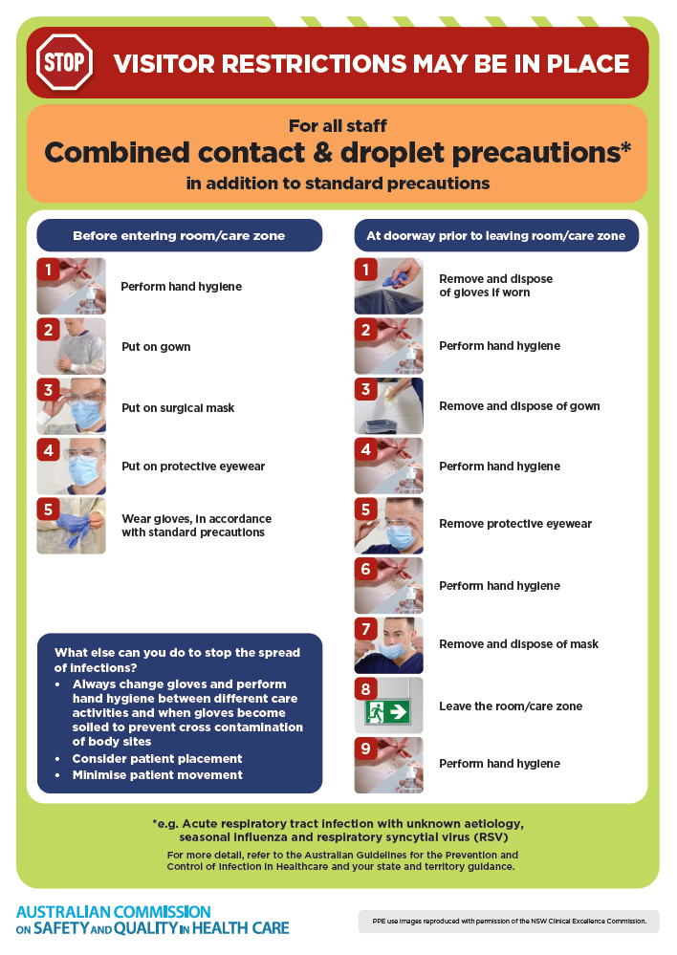
- Poster – Combined airborne and contact precautions
https://www.safetyandquality.gov.au/publications-and-resources/resource-library/infection-prevention-and-control-poster-combined-airborne-and-contact-precautions
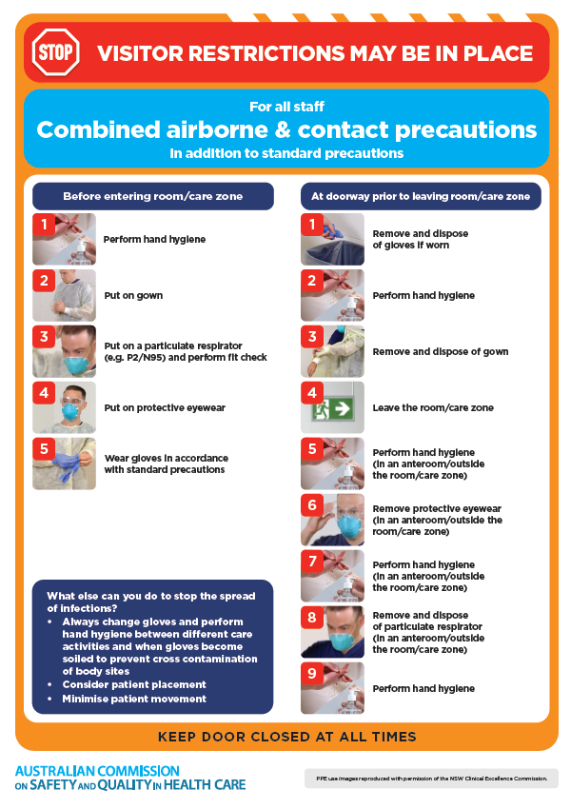
- Environmental Cleaning and Infection Prevention and Control www.safetyandquality.gov.au/environmental-cleaning
- Break the chain of infection poster
https://www.safetyandquality.gov.au/publications-and-resources/resource-library/break-chain-infection-poster
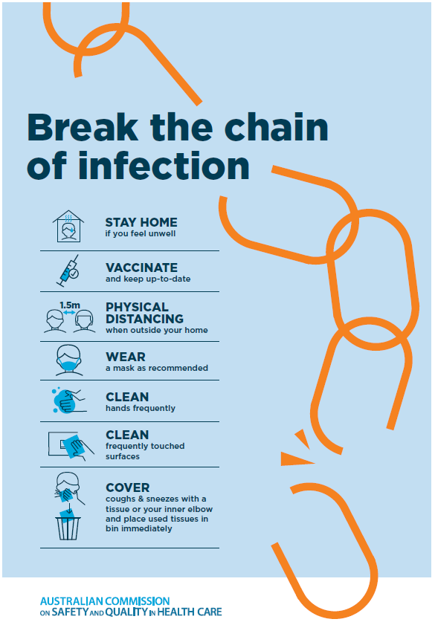

Disclaimer
On the Radar is an information resource of the Australian Commission on Safety and Quality in Health Care The Commission is not responsible for the content of, nor does it endorse, any articles or sites listed The Commission accepts no liability for the information or advice provided by these external links Links are provided on the basis that users make their own decisions about the accuracy, currency and reliability of the information contained therein Any opinions expressed are not necessarily those of the Australian Commission on Safety and Quality in Health Care.

