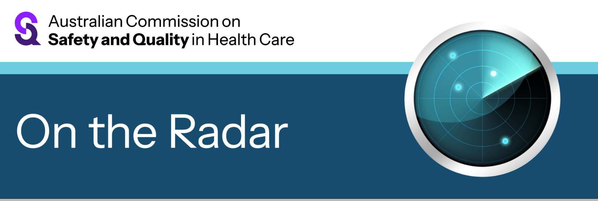
On the Radar
Issue 721
10 November 2025

On the Radar is a summary of some of the recent publications in the areas of safety and quality in health care Inclusion in this document is not an endorsement or recommendation of any publication or provider Access to particular documents may depend on whether they are Open Access or not, and/or your individual or institutional access to subscription sites/services Material that may require subscription is included as it is considered relevant.

On the Radar is available online, via email or as a PDF or Word document from https://www.safetyandquality.gov.au/newsroom/subscribe-news/radar

If you would like to receive On the Radar via email, you can subscribe on our website https://www.safetyandquality.gov.au/newsroom/subscribe-news
or by emailing us at mail@safetyandquality.gov.au.
You can also send feedback and comments to mail@safetyandquality.gov.au.

For information about the Commission and its programs and publications, please visit https://www.safetyandquality.gov.au

On the Radar
Editor: Dr Niall Johnson
Contributors: Niall Johnson, Kylie Tran

World Antimicrobial Resistance (AMR) Awareness Week (WAAW)
Australian Commission on Safety and Quality in Health Care
Sydney: ACSQHC; 2025.
https://www.safetyandquality.gov.au/our-work/antimicrobial-stewardship/world-amr-awareness-week

World Antimicrobial Resistance (AMR) Awareness Week (WAAW) is a global campaign held annually from 18 to 24 November to raise awareness of AMR and encourage best practice among the public, One Health stakeholders and policy makers. The World Health Organization identifies AMR among the top 10 global health threats. It is estimated that by 2050, AMR could potentially cause 1.91 million deaths each year, worldwide.

The theme for 2025 is ‘Act Now: Protect Our Present, Secure Our Future’, highlighting the need to prioritise long-term investment in surveillance and strategies to prevent and contain AMR.
Antimicrobial Stewardship (AMS) remains a critical strategy in Australia’s effort to prevent the development of resistance. Responsible antimicrobial use today will ensure a sustainable healthcare system for tomorrow.

The Commission has updated a range of resources to support health service organisations participate in WAAW. For more information, visit https://www.safetyandquality.gov.au/our-work/antimicrobial-stewardship/world-amr-awareness-week

Reports

Speaking Up for Health: Findings from the 2024 National Consumer Sentiment Survey
Consumers Health Forum of Australia
Melbourne: CHF; 2025. p. 39.
URL | https://www.chf.org.au/our-work/national-consumer-sentiment-survey
Notes | The Consumers Health Forum of Australia conduct surveys of Australians relating to their satisfaction with, and experiences of health care. This report provides insights from the 2024 National Consumer Sentiment Survey. The authors note that ‘The 2024 NCSS highlights that while Australians are generally satisfied with the healthcare they receive, there are notable disparities in satisfaction as well as access, awareness and confidence. Key population groups – including younger people, those with chronic conditions, people from lower socio-economic backgrounds and those without private insurance – are especially likely to face ongoing challenges in accessing care.’

Taking a strategic approach to urban health: a guide for decision-makers
World Health Organization
Geneva: WHO; 2025. p. 170.
URL | https://www.who.int/publications/i/item/9789240116177
Notes | A large proportion of the world’s population lives in urban centres. As is noted in the Foreword to this report from the World Health Organization (WHO), while ‘urban systems and environments are driving the world’s most pressing health challenges, from climate change to resource scarcity to growing inequality’ they can ‘also have an array of benefits for health. If well managed, they can generate the goods and services, institutions, relationships and opportunities needed to protect and promote health and well-being.’ Furthermore, ‘To achieve the best outcomes, we must approach urban health strategically, grappling with the full complexity of urban environments; making visible the policy linkages between health, sustainable development, inequality, and other challenges; and strengthening the mechanisms that make integrated action possible.’ This report ‘describes such an approach, drawing on evidence-based research from WHO and others.’
Global status report on neurology
World Health Organization
Geneva: WHO; 2025. p. 285.
URL | https://www.who.int/publications/i/item/9789240116139
Notes | Also from the World Health Organization (WHO), the Global status report on neurology presents the first comprehensive global assessment of the public health response to neurological disorders under the Intersectoral global action plan on epilepsy and other neurological disorders 2022–31. It is observed that ‘The growing burden of neurological disorders represents a major global public health issue. Every year, disorders such as stroke, meningitis and epilepsy kill over eleven million people, making them the world’s leading cause of ill health and disability combined. Over forty percent of the world’s population are living with a neurological disorder, impairing the physical and mental health, quality of life and well-being, and ability for full participation in society of those affected’

12-lead electrocardiograms (ECGs) in ambulance services: diagnosis of suspected ST elevation myocardial infarction (STEMI)
Investigation report
Health Services Safety Investigation Body
Poole: HSSIB; 2025.
URL | https://www.hssib.org.uk/patient-safety-investigations/12-lead-electrocardiograms-in-ambulance-services/second-investigation-report/
Notes | This latest report from the Health Services Safety Investigation Body (HSSIB) in the UK examines the use of 12-lead electrocardiograms (ECGs) in UK ambulance services with particular reference to the diagnosis of suspected ST elevation myocardial infarction (STEMI). This follows an earlier report that examined paramedic education, training and competence in the use of 12-lead ECGs. This investigation looked at how patients with suspected ST elevation myocardial infarction (STEMI) (a type of heart attack) are diagnosed. It explored the clinical advice and support available to ambulance crews, including the design, functionality and use of 12-lead ECG equipment to aid clinical decision making. The report includes a number of observations, findings and recommendations.

Journal articles

Experiences of health care professionals in intensive care when families participate in clinician handovers: a qualitative systematic review
Wong P, Gamble A, Chen R, Endacott R
JBI Evidence Synthesis. 2025;23(10):1898-1937.
DOI | https://doi.org/10.11124/JBIES-24-00154
Notes | Paper reporting on a study that sought to examine ‘health care professionals’ experiences when families participate in clinician handovers in adult, pediatric, and neonatal intensive care units (ICUs).’ Focused on 11 studies, the review found that while ‘health care professionals value family participation in multidisciplinary bedside rounds, they experienced challenges’. While there were benefits, ‘such as improved communication between the health care team and families’, there were also barriers identified. These included ‘families’ emotional responses to bad news and impact on workflow and teaching opportunities during handovers’.

American Journal of Medical Quality
Volume 40, Number 6, November/December 2025
URL | https://journals.lww.com/ajmqonline/toc/2025/11000
Notes | A new issue of the American Journal of Medical Quality has been published. Articles in this issue of the American Journal of Medical Quality include:  - Editorial: Framing Quality and Laying the Bricks (Sreeramoju, Pranavi V)  - Uncovering Latent Failures Using Human Factors Approach as a Diagnostic Tool for Quality Improvement in Orthopedic Surgery (Khan, Asfandyar; Cohen, Tara; Shappell, Scott A; Boquet, Albert J)  - Anticoagulation Optimization Through a Specialized Center for Atrial Fibrillation (Coons, James; Singla, Virginia; White, Evan; Byers, Erica; Dueweke, Eric; Mulukutla, Suresh; Solano, Francis; Jain, Sandeep K)  - A Physician Conduct Improvement Program to Address Disruptive Behavior in a Health Care Setting (Kharasch, Morris; Fazio, Lindsay T; Rosca, Tabitha; Schindler, Nancy; Fisher, Susan G; Halasyamani, Lakshmi K)  - A Roadmap to Excellence: Insights From Quality Structures of Top-Performing Healthcare Organizations (Cerese, Julie; Chang, Phillip; Graves, Kencee; Grubeling, Nikki; Ikezuagu, Mbonu; Levine, David; Lu, Amy; Miller, Matt; Schaal, Shlomit; Sauls, Thomas; Siddiqui, Maha)  - Leading in Healthcare Quality and Safety in the Era of Digital Health and AI: Applying Discipline to Manage Fear and FOMO (Weber, Stephen)  - Culture of Civility Drives Safe Patient Care in High-Reliability Organizations (Hoque, Farzana)  - Addressing Diuresis Delays in Heart Failure: An Electronic Health Record Intervention (Temel, Brandon; Ardeshna, Nelish; Allen, Joye; Siler, Andrew; Breitlow, Malte; Solomon, Gabriel; Grondin, Christopher)  - Emergency Department Rapid Assessment of Obstetric Patients Improves Length of Stay (McCartney, Joshua; Heslin, Samita M)  - Using a Thromboelastography-Based Transfusion Protocol for Acute Gastrointestinal Bleeding in Cirrhotic Patients (Khataniar, Himsikhar; Tabaku, Fjona; Dharia, Ashni; Grover, Dheera; Gadani, Mrudula; Gadani, Aakash)  - Identifying Inappropriate Dual Antiplatelet Therapy (DAPT) Utilization in the Outpatient Setting: A Quality Improvement Proposal (Elfatatry, Youssef; Palecki, Julia; Majeed, Amry; Varghese, Nevin; Wickersham, Alexis)

Health Affairs
Volume 44, Number 11, November 2025
URL | https://www.healthaffairs.org/toc/hlthaff/44/11
Notes | A new issue of Health Affairs has been published with themes of ‘Medicaid, Private Health Insurance and more. Articles in this issue of Health Affairs include:  - Pairing AI-Powered Predictions With High-Touch Care (Michele Cohen Marill)  - Interventions To Automate Medicaid Renewals Reduce Procedural Denials And Increase Coverage (Pamela Herd, Eric R Giannella, Jeremy Barofsky, Luke Farrell, and Donald Moynihan)  - Children’s Medicaid Enrollment Increased During First Year Of Consolidated Appropriations Act (Erica Eliason, R E Howland, and A Vasan)  - Associations Between Dependent-Related Job Lock And Adult Mental And Physical Health (Tiffany L Lemon, M E Domino, N Thomas, and X Zhang)  - Health Benefits In 2025: Family Premiums Rise 6 Percent, Large Employers Increase Coverage Of GLP-1s For Weight Loss (Gary Claxton, Matthew Rae, Anthony Damico, Aubrey Winger, and Emma Wager)  - State Laws Banning Prior Authorization For Medications For Opioid Use Disorder Increased Substantially, 2015–23 (Ju-Chen Hu, Kayla Hutchings, Ali Jalali, Shashi N. Kapadia, Yuhua Bao, and Kristen Underhill)  - Private Equity Acquisition Of Substance Use Treatment Centers Increases Probability Of Public Health Insurance Acceptance (Jackson Reimer, Marissa King, and Susan H Busch)  - Practices That Adopted Remote Physiologic Monitoring Increased Medicare Revenue And Outpatient Visits (Mitchell Tang, Ariel D Stern, Felippe Marcondes, and Ateev Mehrotra)  - UnitedHealthcare Pays Optum Providers More Than Non-Optum Providers (Daniel R Arnold, and Brent D Fulton)  - Value-Based Payments Associated With Improved Quality Of Care At Federally Qualified Health Centers, 2014–23 (Kun Li, Kristine Namhee Kwon, Anne Markus, and Avi Dor)  - Contraceptives At The Counter: Pharmacists Prescribed A Fraction Of Overall Contraceptives, 2022 (Summer Rak, Julia Strasser, Ellen Schenk, and Maria W. Steenland)  - Improved Insurance Coverage Increased Biosimilar Semglee’s Market Share After The FDA’s Interchangeability Designation )Pragya Kakani, Bradley A Katcher, and Luca Maini)  - Health Care Workforce Pay Gaps: COVID-19 Modestly Compressed Wage Disparities, 2015–24 (Janette Dill, LaTonya Trotter, Kyla Woodward, John Mulcahy, and Bianca K Frogner)  - When Protection Becomes Punishment (Rupi Legha)

Health Affairs Scholar
Volume 3, Issue 10, October 2025
URL | https://academic.oup.com/healthaffairsscholar/issue/3/10
Notes | A new issue of Health Affairs Scholar has been published. Articles in this issue of Health Affairs Scholar include:  - How to make one line in the FDA Commissioner's new drug review program into a force for affordable access for patients (Sarah K Emond and Daniel A Ollendorf)  - Models attempting to quantify the relationship between drug development and financial return are missing a key element: the effect on post-approval research (Dan Crippen and Kirsten Axelsen)  - Stranded in the emergency department: an analysis of boarding trends in older adults in the United States (Natalia Sifnugel et al)  - Social policies as determinants of health: new evidence, ongoing challenges, and future pathways (Rita Hamad)  - Reconsidering risk: instrumental social support and 30-day utilization after discharge (Andrea S Wallace et al)  - Trends in consolidation of outpatient providers into health systems and corporate owners, 2020–2023 (Michael F Furukawa et al)  - Prevalence and trends in cannabis use disorder and cannabis poisoning among Medicaid enrollees: a multistate analysis, 2011–2022 (Jayani Jayawardhana and Jialin Hou)  - New York state's paid family leave improved postpartum health care among women with hypertensive disorders in pregnancy (Donglan Zhang et al)  - From 4Ms to 5 domains: ensuring new CMS Age-Friendly hospital measure improves care for older adults (Julia Adler-Milstein et al)  - Why the Medicare physician fee schedule misvalues fee levels and how to fix it (Laura Skopec and Robert A Berenson)  - Caregivers at the crossroads: shifting policies and the challenges faced by employed caregivers (Amber D Thompson et al)  - Gold standard research—reflections on the NIH announcement (Howard Bauchner and Frederick P Rivara)

The Milbank Quarterly
September 2025
URL | https://www.milbank.org/quarterly/issues/September-2025/
Notes | A new issue of The Milbank Quarterly has been published. Articles in this issue of The Milbank Quarterly include:  - Editorial: The Ongoing Assault on Science and Truth (Alan B Cohen)  - From Disappointment to Predominance: Medicare Advantage’s Ascendancy and Transformation of Medicare (Rick Mayes, Micah Johnson)  - National Analysis of the Requirements and Implementation of State Prescription Drug Price Transparency Laws (Hannah Rahim, Aaron S Kesselheim)  - No Data, No Problem: Quantifying Latine Individuals Eligible for but Not Enrolled in Medicaid or Affordable Care Act Marketplace-Based Insurance in North Carolina (Gabriela Plasencia, Kamaria Kaalund, Olurotimi Kukoyi, Viviana Martinez-Bianchi, Andrea Thoumi)  - Changing the Story on Health and Racial Equity: Why Public Health Needs an Infrastructure for Building Narrative Power (Loria Dorfman, Sarah E Gollust, Makani Themba, Pritpal S Tamber, Anthony Iton)  - A Framework for Assessing the Permissibility of Academic Leaders’ Outside Activities (Matthew S McCoy, Martha E Gaines, Steven Joffe, Genevieve Pham-Kanter, Emily A Largent, Bernard Lo, Holly Fernandz Lynch, Allison M Whelan, Michelle M. Mello)  - Turf Wars: How Growth and Competitive Shocks Have Affected the Performance and Stability of Community Health Centers (J Markowski)  - The Significance of Definitions in Determining the Level of Community Benefits for Nonprofit Hospitals (Hossein Zare, Gerard Anderson)  - State Public Coverage of Pregnant Undocumented Immigrants and Prenatal Insurance Uptake (Meghan Bellerose, Linqing Zheng, Arielle Desir, Rachel E Fabi, Laura R Wherry, Maria W Steenland)  - Lobbying in the Shadows: A Comparative Analysis of Government Lobbyist Registers (Jennifer Lacy-Nichols, Hedeeyeh Baradar, E Crosbie, K Cullerton)  - Incarceration and Psychiatric Emergency Department Visits Among Black Americans (Abhery Das, Michael Esposito, Tim A Bruckner, H Lee)  - Advancing Equity: Lean Leader Practices and a Path Forward (Dorothy Y Hung, Lillian C Levy, Thomas G Rundall, E Reponen, W Huen, S M Shortell)

BMJ Quality & Safety online first articles
URL | https://qualitysafety.bmj.com/content/early/recent
Notes | BMJ Quality &Safety has published a number of ‘online first’ articles, including:  - Integrating equity into incident reporting and patient concerns systems: a critical interpretive synthesis (Joanne Goldman, Leahora Rotteau, Lisha Lo, Brian M Wong, Ayelet Kuper, Allison Kooijman, Maitreya Coffey, Saleem Razack, Shail Rawal, Michael Palomo, Myrtede Alfred, Marie Pinard, Andrew Milroy, Carol Pauline Anderson, Arvin Minocha, Patricia Trbovich)

International Journal for Quality in Health Care online first articles
URL | https://academic.oup.com/intqhc/advance-articles
Notes | International Journal for Quality in Health Care has published a number of ‘online first’ articles, including:  - Impact of a Clinical Encounter Time Protection Program on Pain Management: a Retrospective Difference-in-Difference Study (Clement P Buclin et al)  - Reducing medication-related harm (Linda V Graudins and Aziz Sheikh)  - “Controlling Nosocomial Transmission of Respiratory Infections in Neurological Wards: Insights from COVID-19 Pandemic Data—a Critical Appraisal.” (Anum Choudhry et al)  - Extending Pediatric Care Beyond Hospitals: Lessons from Multisector Collaborations in Addressing Social Drivers of Health (Catherine C Salvo et al)

Online resources

Australian Living Evidence Collaboration
https://livingevidence.org.au/

Guidance
A number of guidelines or guidance have recently been published or updated These include:
- Australian and New Zealand joint society consensus statement on genetic testing for monogenic diabetes in adults https://doi.org/10.5694/mja2.52717
- Australian evidence‐based guidelines on male infertility https://doi.org/10.5694/mja2.70080
https://www.mja.com.au/journal/2025/223/11/first-australian-evidence-based-guidelines-male-infertility

Infection prevention and control and COVID-19 resources
The Australian Commission on Safety and Quality in Health Care has developed a number of resources to assist healthcare organisations, facilities and clinicians These resources include:
- Poster – Combined contact and droplet precautions https://www.safetyandquality.gov.au/publications-and-resources/resource-library/infection-prevention-and-control-poster-combined-contact-and-droplet-precautions
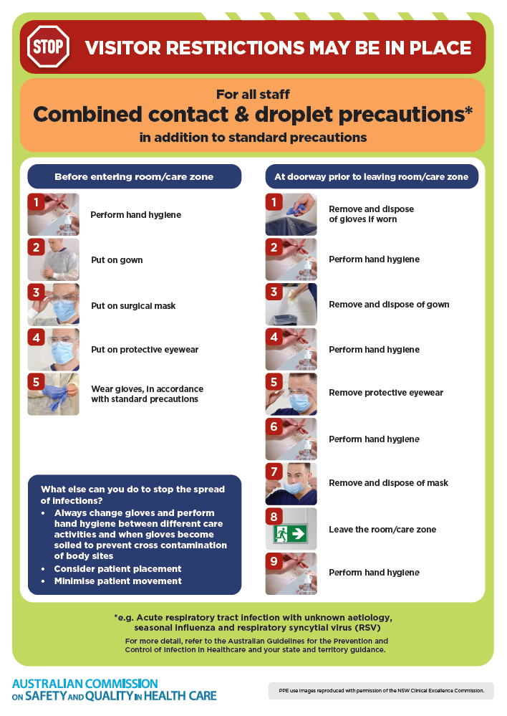
- Poster – Combined airborne and contact precautions
https://www.safetyandquality.gov.au/publications-and-resources/resource-library/infection-prevention-and-control-poster-combined-airborne-and-contact-precautions
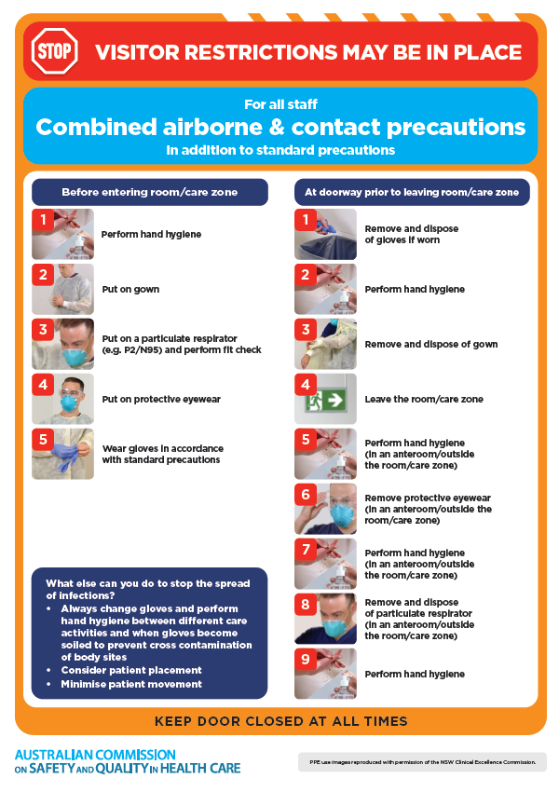
- Environmental Cleaning and Infection Prevention and Control www.safetyandquality.gov.au/environmental-cleaning
- Break the chain of infection poster
https://www.safetyandquality.gov.au/publications-and-resources/resource-library/break-chain-infection-poster
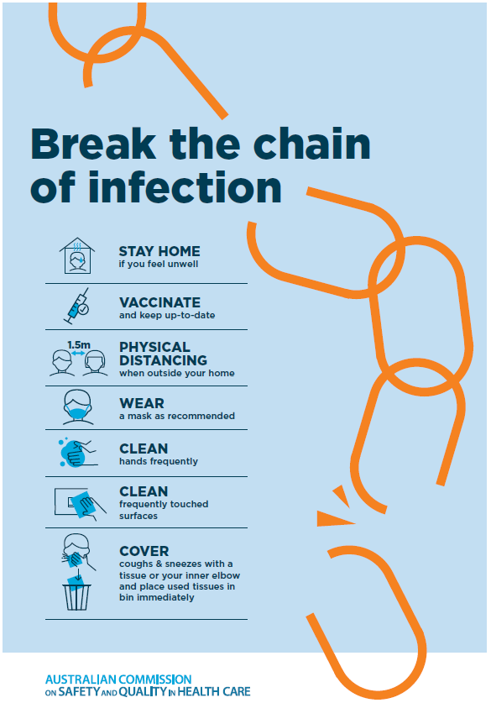

Disclaimer
On the Radar is an information resource of the Australian Commission on Safety and Quality in Health Care The Commission is not responsible for the content of, nor does it endorse, any articles or sites listed The Commission accepts no liability for the information or advice provided by these external links Links are provided on the basis that users make their own decisions about the accuracy, currency and reliability of the information contained therein Any opinions expressed are not necessarily those of the Australian Commission on Safety and Quality in Health Care.

