
On the Radar
Issue 722
17 November 2025

On the Radar is a summary of some of the recent publications in the areas of safety and quality in health care Inclusion in this document is not an endorsement or recommendation of any publication or provider Access to particular documents may depend on whether they are Open Access or not, and/or your individual or institutional access to subscription sites/services Material that may require subscription is included as it is considered relevant.

On the Radar is available online, via email or as a PDF or Word document from https://www.safetyandquality.gov.au/newsroom/subscribe-news/radar

If you would like to receive On the Radar via email, you can subscribe on our website https://www.safetyandquality.gov.au/newsroom/subscribe-news
or by emailing us at mail@safetyandquality.gov.au.
You can also send feedback and comments to mail@safetyandquality.gov.au.

For information about the Commission and its programs and publications, please visit https://www.safetyandquality.gov.au

On the Radar
Editor: Dr Niall Johnson
Contributors: Niall Johnson

Reports

Competency and outcomes framework for adolescent health and well-being
World Health Organization
Geneva: WHO; 2025. p. 96.
URL | https://www.who.int/publications/i/item/9789240115736
Notes | This document from the World Health Organization (WHO) is an addendum to the he WHO Global Competency and Outcomes Framework for Universal Health Coverage that extends that framework ‘to serve the world’s 1.3 billion adolescents and highlights the importance of building a workforce adapted to the unique health needs of adolescents. It addresses emerging clinical priorities, technological advances, and the importance of adolescent participation in the development of health services.’  The document’s Foreword states that the ‘Framework provides guidance for developing pre-service and in-service competency-based adolescent health education programmes, relevant curricula, learning activities and assessment approaches. It identifies essential competencies, behaviours, knowledge, and skills that enable health service providers to deliver quality, adolescent-centred care that is respectful, confidential, and responsive to adolescents’ evolving capacities.’

The health of people in prison, on probation and in the secure NHS estate in England
A report commissioned by the Lord Chancellor and Secretary of State for Justice and the Secretary of State for Health and Social Care from the Chief Medical Officer
Whitty C
London: Department of Health and Social Care and Ministry of Justice; 2025. p. 409.
URL | https://www.gov.uk/government/publications/the-health-of-people-in-prison-on-probation-and-in-the-secure-nhs-estate-in-england
Notes | The carceral population has particular vulnerabilities and health challenges and these can be exacerbated for women, younger people and older people. This report from the Chief Medical Officer for England seeks to improve health outcomes for people in prison, on probation, and within the secure NHS estate by supporting professionals, practitioners, and policymakers working across health and justice. It was produced in collaboration with the Ministry of Justice, HM Prison and Probation Service, NHS England, and the Department of Health and Social Care, following engagement with frontline health and justice professionals, as well as individuals with lived experience of the justice system. Health and social factors are often involved in the lives of people as they interact with the justice system. It is noted that ‘n some cases offending and reoffending on leaving prison or probation are linked to health. For example, access to treatment for drug and alcohol misuse and mental health in the community can help reduce offending behaviour. There are also benefits to the health of those in prison, prison and probation staff and wider society from addressing communicable diseases that might otherwise be passed on.’  It is recognised that structural barriers exist. It is also recognised that ‘There will always be a tension between optimising security and safety …and health’. It is also acknowledged that ‘Many areas can be improved however, ranging from better medicine delivery through to improved integration of health data between NHS and prison and probation health services. Some of the greatest health risks predictably occur during and just after transitions: on arrival in prison; after transfer between prisons and just after release from prison or probation. These are exacerbated by poor data flows between prison health and wider NHS services. This report concentrates in particular on the areas where we consider improvements are practically possible and likely to have an impact in improved health for those in prison or on probation.’

Journal articles

Patient Experience Journal
Volume 12, Issue 3, 2025
URL | https://pxjournal.org/journal/vol12/iss3/
Notes | A new issue of the Patient Experience Journal (PXJ)has been published Articles in this issue of the Patient Experience Journal include:  - Editorial: We Are Not THERE Yet! Why the Journey for Experience Excellence Must Persist (Jason A Wolf)  - Beyond the Numbers: Elevating Meaning through Metrics in Patient Experience (Geoffrey A Silvera)  - Changing Myths Into Truths: Dispelling Physician Misconceptions on Patient Experience (Amit Singh, Syed Ahmed, James Castellone, Michael H Kanter, Mikelle Key-Solle, Sherry Kroll, Paul A Lansdowne, Winnie Lee, Swati Mehta, Sofie Morgan, Sephora Morrison, Susan N Nathan, Sachin Patel, Alexie Puran, Donald Wickline, and Liza DiLeo Thomas)  - The Hand We Hold: Reflections on Empathetic Practice in Medicine (Aravind Sreeram)  - Narrative Medicine Skills for End-of-Life (Elizabeth Summerfield)  - Patients’ Experiences of Triage and Waiting in Emergency Departments: A Cross-sectional Survey (Carrie Janerka, Leslie D Gavin, Fenella J Gill, and PCC ED Triage Group)  - Correlation Between Resident Physician and Patient Perceptions of Empathy in the Emergency Department (Austin Porter, James Christian, Meryll E Bouldin, Erin Willard, S Graw, S House, S Morgan, K Parker, and C Eastin)  - Perceived Social Support and Its Associated Factors in Patients Undergoing Hemodialysis: A Cross-Sectional Study (Hosna Karami and Parvin Abbasi)  - Impact of Non-Pharmacological Interventions on Patient Experience, Opioid Use, and Healthcare Utilization in Adult Cardiac Surgery: A Randomized Controlled Mixed Methods Trial (Julie R Piazza, Alexander A Brescia, Jessica N Jenkins, Alexander J Ivacko, Xiaoting Wu, Sara M Jafri, Christopher J Varlamos, James C Piazza, Lindsay K Heering, Stefanie L Peters, Molly Dwyer-White, Bailey H Brown, Faraz N Longi, Katelyn P Monaghan, Frederick W Bauer, Varun G Kathawate, Melissa C Webster, Amanda M Kasperek, Nickole L Garvey, Claudia Schwenzer, Kiran H Lagisetty, Michelle Riba, D S Likosky, J F Waljee, N H Osborne, M E Byrnes, and G M Deeb)  - “Better Than Any Medicine:” Understanding How Therapy Dogs Support Patients Presenting with Mental Health and Substance Use Concerns in an Emergency Department Setting (Alexandria R Pavelich, C A Dell, J Stempien, H McKenzie, A Hozack, J Smith, A Rowsell, J Gunderson, and E Pease)  - Communicating Effectively when Engaging People with Lived Experience in Mental Health and Substance use Health Research: A Qualitative Descriptive Study (Lisa D Hawke, Wuraola Dada-Phillips, Charlotte Munro, S Hauer, C Sendanyoye, Y Lunsky, G Strudwick, T Halsall, and N Y Sheikhan)  - The Patient Experience of the #Hellomynameis... Campaign and the Value of Personalised Embroidered Student Uniforms (Julie Derbyshire, Gemma Bradley, Sasha Ban, Lianne Horscroft, and Joanne Woodhead)  - Patient Experience Second Opinion: Expanded Telemed Simulation Broadens Inquiry of Health Care Provider Verbal and Nonverbal Communication Issues (Mike C Porter, Xiaowen Guan, and Paul G Omodt)  - Understanding Patient Experience Through Narrative Complaint Analysis: A Mixed Methods Study in a Rural Academic Health System (Htun Ja Mai, Jabeen Ahmad, and Brant Oliver)  - Enhancing System-Level Quality Improvement through Patient-Inclusive Teamwork: A Review (Shaik Mohiuddin)  - Using Patient Experience Data With IMPACT: A Framework for Healthcare Improvement (Corey Adams, Ramesh Walpola, and R Harrison)  - Assessing patient satisfaction with the services provided under the National Health Insurance Scheme at the Outpatient Department of the Levy Mwanawasa University Teaching Hospital in Lusaka, Zambia (Wesley Kapaya Mwambazi and Mubanga Mpundu)  - Reliability and Validity of a Modified Version of the Consumer Assessment of Healthcare Providers and Systems (CAHPS®) Clinician and Group Visit Survey 4.0 (beta) for Ambulatory Behavioral Health Care (Jessica K Jeffrey, Ron D Hays, Randi Hissom, Mark Grossman, and Samuel A Skootsky)  - A Systematic Review of the Literature on the Validity, Reliability, and Utility of the NHS Friends and Family Test as a Method for Gathering Feedback on and Improving the Experiences of Patients (enny King, Catherine Davidson, Hannah Wade, and Chris Graham)  - A Case Report on Meeting the Spiritual Need of Intubated Conscious Patient (Mahuya Karmakar, Santhna Letchmi Panduragan, and F Mohd Said)  - Empowering Frontline Staff in Service Recovery (Sarah E Duncan, Brianna Camera, Iva Ervin-Stanberry, and Heather L Pezzullo)  - Triad: A Novel Team Structure Pilot and its Impact on Patient Experience in the Pediatric Emergency Department (Walter Palmer; Joseph R Mijares III; and Sephora Morrison)  - Virtual Nurse Discharge: Improving Patient and Nurse Experience (Dina Flihan, Christine Odell, Stacey Davis, Carolyn Oates, and Fay Wright)  - Leading Through Partnership: Development of a Hospital-Wide Family-Centered Care Collaborative (Jessica T Fry, Naomi Shapiro, Barbara Lawlor Burke, Kalee Ryan, and Kerri Z Machut)  - Co-Designing a Patient-Facing Version of a Mental Healthcare Pathway for People Receiving Dialysis (Alexandra Albers, Charlotte Berendonk, Julie Robison, Richard Sawatzky, Loretta Lee, Monika Bolin, J Costley, S Johnstone, K Kemp, J LeRoux, M Tourangeau, S Zaman, and K Schick-Makaroff)

Health Policy
Volume 162, December 2025
URL | https://www.sciencedirect.com/journal/health-policy/vol/162/
Notes | A new issue of Health Policy has been published. Articles in this issue of Health Policy include:  - Health impact assessments should be mandatory for all relevant government policies (Heidi Lynch, Ian Holdroyd, Martin Birley, Daniel Black, Ben Cave, Margaret Douglas, Rowena Ekermawi, Liz Green, Fiona Haigh, Ben Harris-Roxas, Monica O'Mullane, J Purdy, A Stevenson, S Vohra, J Ford)  - Anticipating ethical and social dimensions of the European Health Data Space: A rapid systematic review (Joseph Donia, Luca Marelli )  - Gender differences in healthcare utilization across Europe: Evidence from the European Health Interview Survey (Davide Golinelli, Francesco Sanmarchi, Giovanni Guarducci, J Palombarini, P Benetti, S Rosa, J Lenzi)  - Communication difficulties and strategies in migrant mental healthcare: A European survey of health and social care professionals (Graham Hieke, Demi Krystallidou, Özlem Temizöz, Fang Wang, Cristina Álvaro Aranda, Łucja Biel, Agnieszka Biernacka, Antoon Cox, Katarzyna Czarnocka-Gołębiewska, Silviya Damianova Radeva, Melanie de Looper, Nora Gattiglia, Saskia Hanft-Robert, Soňa Hodáková, Ily Hollebeke, Koen Kerremans, Raquel Lázaro Gutiérrez, Dalia Mankauskienė, Mike Mösko, Urszula Okulska-Łukawska)  - Impact of midwifery-led units in Spain: lessons from the first 5 years (Roser Palau-Costafreda, Lluna Orus-Covisa, Edgar Vicente-Castellví, Xavier Espada-Trespalacios, Albert Medina Català, Carlota Alcover, Noemí Obregón Gutiérrez, Ramon Escuriet, Eva Padrosa)  - Are long-term care systems aligned with person-centered integrated care? Evidence from the Western Pacific (Dongkyu Lee, Soojung Kim, Soonman Kwon, Sunghun Yun, Mikiko Kanda, Siwon Lee, N Sutton, P Ong, A Inder)  - Emotions associated with teleconsultation: An analysis of users' messages on X (Twitter) in Chile (Patricio E Ramírez-Correa, F. Javier Rondán-Cataluña, Jorge Arenas-Gaitán)  - Public Health Guidelines for Social Connection: An International Delphi Study (Kiffer G Card, Jocelle Refol, Taylor G Hill, Cecilia Benoit, Robert J Coplan, Steve Joordens, Charlotte M. Roddick, John L Oliffe, Erin Dej, Frances S Chen, E C Pinel, P J Helm, S Skakoon-Sparling, K McKenzie)  - Barriers to Responsiveness and Provision of Dignified care: A qualitative study of Israeli Physicians (Keren Semyonov-Tal)  - Population health impacts of national health insurance coverage for neonatal intensive care unit admission in South Korea: evidence from regression discontinuity analyses (Jin-Hwan Kim, Woojoo Lee)  - Frameworks, theories and models used in the development of health policies: A systematic review of systematic reviews (Simone Diamandis, Tracey Thornley, Shalom Charlie Benrimoj, Kevin Ou, Sarah Dineen-Griffin)  - Governance of nonpowdered firearms across high-income countries: Results of a scoping review (Nardin Kirolos, Rachel Strauss, Tharani Raveendran, Charlotte Moore Hepburn, Natasha Saunders)  - Physician and relatives’ role change after shifting to an opt-out organ donation system in the Netherlands: A before and after ethnographic study (Niek Kok, Myrthe van de Meulenhof, W F Abdo, J L P van Gurp, G Olthuis)  - Determinants of time to access to EMA-approved cancer drugs in Spanish NHS in the past decade: a two cohorts study (Pelayo Nieto-Gómez, Celia Castaño-Amores, Antonio José García-Ruiz, Juan Oliva-Moreno)  - The same, but different: Understanding responsibility attributions for depression with a cross-national survey in the United States and Germany (Anna Wagner, Doreen Reifegerste, Sebastian Scherr)  - Health hazard discrimination or prejudice? A correspondence experiment in Italy (Paolo Buonanno, Flavio Porta, Marcello Puca)  - The contribution of health and health systems to other sustainable development goals. An overview of the evidence on co-benefits (Luigi Siciliani, Jonathan Cylus)  - Conceptualising the primary health care workforce: A meta-narrative-inspired review of stakeholder perspectives in Denmark (Andreas Nielsen Hald, Ulrika Enemark, Martin Limbikani Mwale, Viola Burau)  - High health system performance, low health system resilience: Navigating vulnerability – an illustrative example using Small and Island States (Finn McGuire, Megha Rao, Simon Walker, Bruno Meessen, Juliet Nabyonga-Orem, Gibril Jarjue, N Ginindza, E Odame, S Bland, A Bershteyn, P Revill)

JBI Evidence Synthesis
Volume 23, Issue 11, November 2025
URL | https://journals.lww.com/jbisrir/toc/2025/11000
Notes | A new issue of JBI Evidence Synthesis has been published. Articles in this issue of JBI Evidence Synthesis include:  - Editorial: Position statement on artificial intelligence (AI) use in evidence synthesis across Cochrane, the Campbell Collaboration, JBI, and the Collaboration for Environmental Evidence 2025 (Ella Flemyng, Anna Noel-Storr, Biljana Macura, Gerald Gartlehner, James Thomas, Joerg J Meerpohl, Z Jordan, J Minx, A Eisele-Metzger, C Hamel, P Jemioło, K Porritt, M Grainger)  - Health care professionals’ experiences and perceptions of making treatment decisions for older adults with memory loss and comorbid conditions: a qualitative systematic review (Kimberly Shapkin, Karen MacKinnon, Esther Sangster-Gormley, Bernadette Zakher, Lorelei Newton, Jayna Holroyd-Leduc)  - Methodological rigor and reporting quality of clinical practice guidelines for adults hospitalized with bacterial pneumonia: a scoping review (Amy Hagedorn Wonder, Jan M Nick, Olayemi O Adeoye, Gurmeet Sehgal)  - Intervention mapping in the development of health promotion interventions for adults with chronic conditions: a scoping review (Tom Herbert, Michael Malone, Nicola Rhind, Kay Cooper)  - Assessment tools to measure the vulnerability of older people: a systematic review protocol of measurement properties (Tainá Maria Cavassana, Henrique Ceretta Oliveira, Kirsten Hanrahan, Flávia de Oliveira Motta Maia)  - Alternative grading approaches in health professions education: a scoping review protocol (Elena Wong Espiritu, Aine O’Connor, Sara Blass, Kathryn L Dambrino, Angela Shelton Clauson)  - Resilience development in nursing students and new nurse graduates: a qualitative umbrella review protocol (Susan Salmond, Lisa Keeping-Burke, Andrea Norberg, Barbara Sinacori, Susan Maiocco, Amanda Ross-White)  - Assessment of clinical skills in laboratory settings in prelicensure health education programs: a scoping review protocol (Karen Eileen Furlong, Jaime Riley, Alexis McGill, Richelle Witherspoon, Patricia Morris, Rose McCloskey, Renee Gordon, Lisa Keeping-Burke)  - Alternatives to traditional pharmacy internships: a scoping review protocol (Sabreen Yousif Mohammed Alhassan Nasr, Fazlollah Keshavarzi, Phayom Sookaneknun Olson, Ratree Sawangjit, A K Thabit, J Jose, P Bhatarasakoon)  - Effect of edible marine seaweeds on plasma glucose in healthy, at-risk, and type-2 diabetic individuals: a systematic review protocol (Pratishtha Jain, Lokesh Ravi, Denny John)  - Implementation strategies for reducing carbon emissions in acute care: a scoping review protocol (Brittany Victoria Barber, Fiona A Miller, Daniel Rainham, Sean Christie, Melissa Berry, Kelachi Nsitem, Georgia Murray, Stephanie Hanna, Leah Boulos, Doug Sinclair, Christine Cassidy)  - Investigating multilevel language interventions targeting spoken production in post-stroke aphasia: a scoping review protocol (Grace Aryee, Jade Cartwright, Denis Visentin, Janet Webster, Anne Whitworth)  - Factors influencing the de-implementation of seclusion and restraint in inpatient mental health settings: a qualitative systematic review protocol (Sophie Sergerie-Richard, Guillaume Fontaine, Lewys Beames, Vincent Billé, Rachael Laritz, Marie-Hélène Goulet)

BMJ Quality & Safety online first articles
URL | https://qualitysafety.bmj.com/content/early/recent
Notes | BMJ Quality &Safety has published a number of ‘online first’ articles, including:  - Editorial: Inappropriate prescribing for older people with reduced kidney function: can we do better at the primary care level? (Laetitia Hattingh, Matt Percival)

International Journal for Quality in Health Care online first articles
URL | https://academic.oup.com/intqhc/advance-articles
Notes | International Journal for Quality in Health Care has published a number of ‘online first’ articles, including:  - Predictive values of trigger tools for identifying adverse events in hospitalised patients using a medical record review: A systematic review (Luis Meave Gutierrez-Mendoza, Elizabeth Manías, Patricia Nicholson)

Online resources

Australian Living Evidence Collaboration
https://livingevidence.org.au/

Guidance
A number of guidelines or guidance have recently been published or updated These include:
- Mild traumatic brain injury and concussion and persisting post-concussion symptoms: new guidelines to support evidence-based assessment and management in Australia and Aotearoa New Zealand https://doi.org/10.5694/mja2.70082
ANZ concussion guidelines https://anzconcussionguidelines.com/

[UK] NICE Guidelines and Quality Standards
https://www.nice.org.uk/guidance
The UK’s National Institute for Health and Care Excellence (NICE) has published new (or updated) guidelines and quality standards The latest reviews or updates include:
- NICE Guideline NG229 Fetal monitoring in labour https://www.nice.org.uk/guidance/ng229

Infection prevention and control and COVID-19 resources
The Australian Commission on Safety and Quality in Health Care has developed a number of resources to assist healthcare organisations, facilities and clinicians These resources include:
- Poster – Combined contact and droplet precautions https://www.safetyandquality.gov.au/publications-and-resources/resource-library/infection-prevention-and-control-poster-combined-contact-and-droplet-precautions
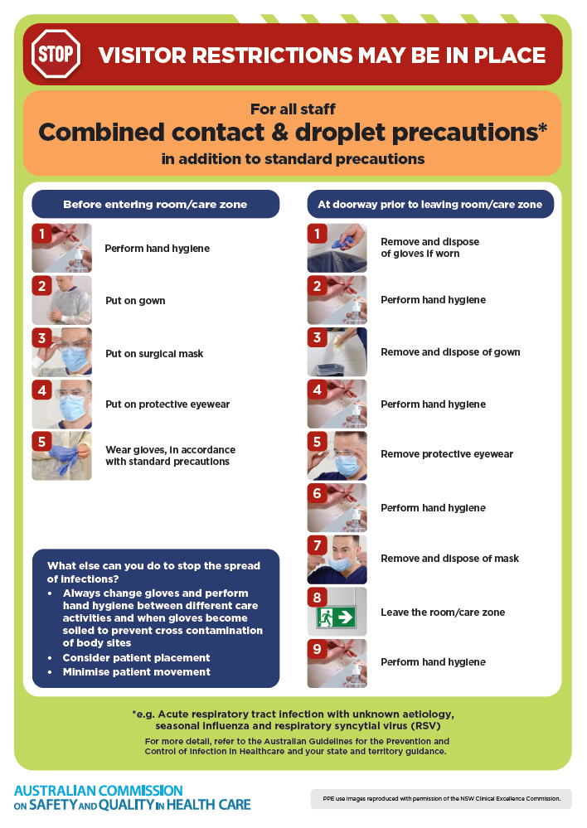
- Poster – Combined airborne and contact precautions
https://www.safetyandquality.gov.au/publications-and-resources/resource-library/infection-prevention-and-control-poster-combined-airborne-and-contact-precautions
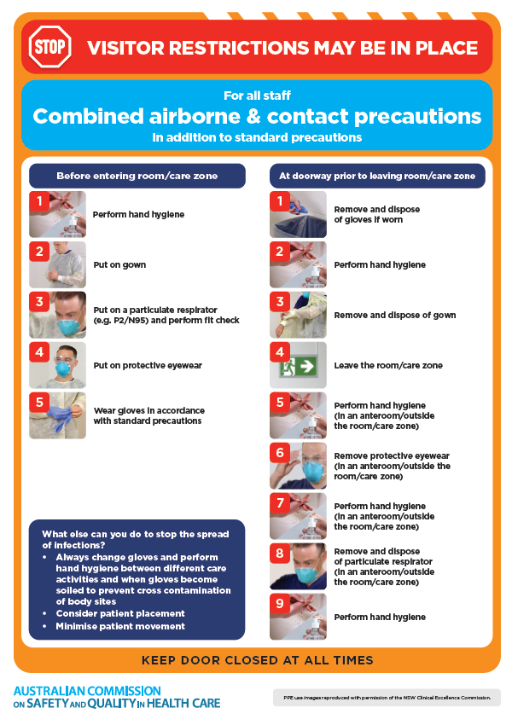
- Environmental Cleaning and Infection Prevention and Control www.safetyandquality.gov.au/environmental-cleaning
- Break the chain of infection poster
https://www.safetyandquality.gov.au/publications-and-resources/resource-library/break-chain-infection-poster
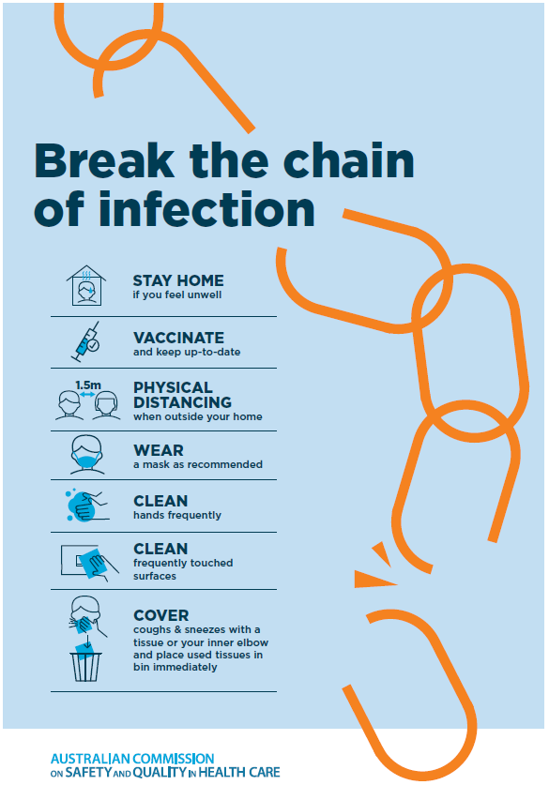

Disclaimer
On the Radar is an information resource of the Australian Commission on Safety and Quality in Health Care The Commission is not responsible for the content of, nor does it endorse, any articles or sites listed The Commission accepts no liability for the information or advice provided by these external links Links are provided on the basis that users make their own decisions about the accuracy, currency and reliability of the information contained therein Any opinions expressed are not necessarily those of the Australian Commission on Safety and Quality in Health Care.

