
On the Radar
Issue 723
24 November 2025

On the Radar is a summary of some of the recent publications in the areas of safety and quality in health care Inclusion in this document is not an endorsement or recommendation of any publication or provider Access to particular documents may depend on whether they are Open Access or not, and/or your individual or institutional access to subscription sites/services Material that may require subscription is included as it is considered relevant.

On the Radar is available online, via email or as a PDF or Word document from https://www.safetyandquality.gov.au/newsroom/subscribe-news/radar

If you would like to receive On the Radar via email, you can subscribe on our website https://www.safetyandquality.gov.au/newsroom/subscribe-news
or by emailing us at mail@safetyandquality.gov.au.
You can also send feedback and comments to mail@safetyandquality.gov.au.

For information about the Commission and its programs and publications, please visit https://www.safetyandquality.gov.au

On the Radar
Editor: Dr Niall Johnson
Contributors: Niall Johnson

Reports

Smarter spending: Getting better care for every hospital dollar
Breadon P, Baldwin E
Melbourne: Grattan Institute; 2025. p. 96.
URL | https://grattan.edu.au/report/smarter-spending-getting-better-care-for-every-hospital-dollar/
Notes | This latest report from the Health program at the economics-focussed thinktank the Grattan Institute focuses on spending on Australia’s public hospitals. The authors call for ‘smarter spending’ and argue that ‘Cutting costs doesn’t mean cutting quality’. They also advocate for changes to the public hospital funding approach in Australia calling for fairer funding, greater transparency, productivity, efficiency and accountability ‘so our public hospitals spend smarter and provide more care.’
Health at a Glance 2025
OECD
Paris: OECD Publishing; 2025.
URL | https://doi.org/10.1787/8f9e3f98-en
Notes | The OECD has released the latest edition of its regular Health at a Glance report summarising a range of health indica tors across the ‘OECD Members, Key Partners and accession candidate countries’. As is typically the case with such comparisons, the Australian health system compares rather well on many indicators, but less so in some areas.  Some of the findings across the OECD include:  - Health systems account for nearly a tenth of economic output  - The health workforce is growing fast – and foreign-trained workers are helping to fill the gaps in many nations  - Obesity is placing growing pressure on health systems and economies  - Antimicrobial resistance is one of the fastest-growing threats to global health  - A renewed focus on value-for-money is essential:  There are ‘country notes’ on each nation surveyed that shows how each nation compares to other OECD countries across a selection of key indicators from the report. For the ‘country note on Australia see https://www.oecd.org/en/publications/health-at-a-glance-2025_15a55280-en/australia_7cad4f74-en.html  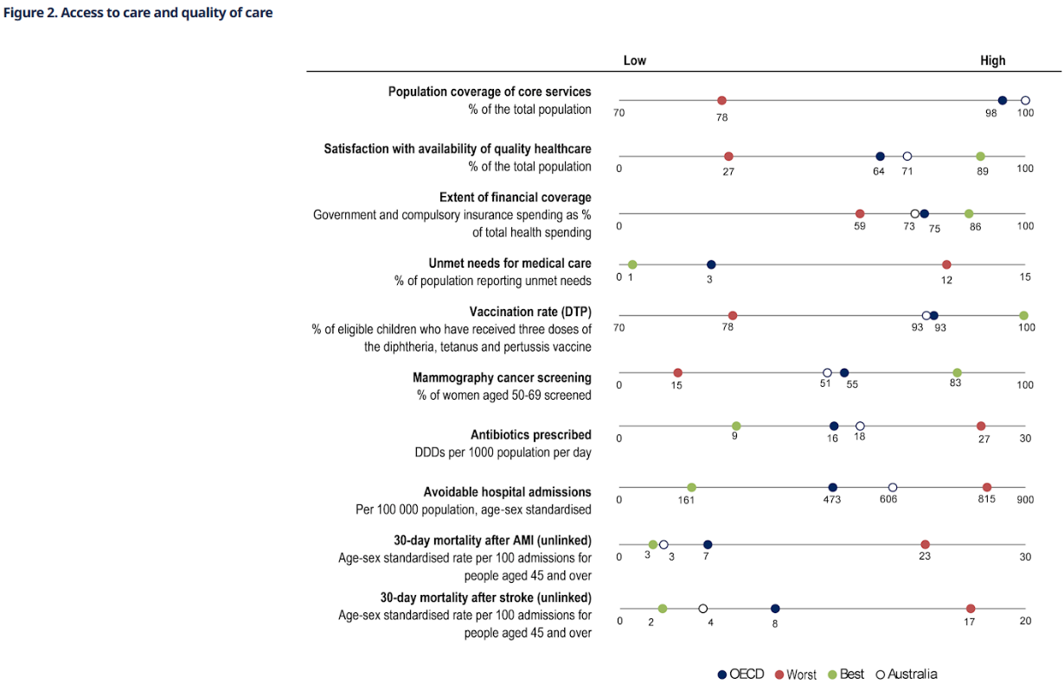

Climate change and mental health: thematic assessment report
UK Health Security Agency
London: UK Health Security Agency; 2025. p. 75.
URL | https://www.gov.uk/government/publications/climate-change-and-mental-health-report
Notes | Report from the UK Health Security Agency that examines ‘the evidence of pathways between climate change and mental health impacts relevant to the UK, identifying the most at-risk populations.’ The report notes that ‘There is considerable evidence suggesting increased risk of depression, anxiety, PTSD, suicide, substance misuse and violent behaviour, as well as reduced wellbeing and difficult climate emotions. These impacts can be long-lasting, ranging from months, years and even decades. There is evidence, however, that clinical interventions (such as CBT), psychosocial interventions (with or without clinical components), and complementary and alternative therapies delivered both in person and digitally (through applications or text message-based) can reduce the negative impacts of climate change on mental health, and climate change mitigation and adaptation actions can have positive mental health co-benefits.’ ‘The report finds that the evidence on the mental health impacts of climate change is wide ranging, including increases in depression, anxiety and suicide. The impacts will not be felt equally among the population, with certain groups such as farmers, those who depend on the land, and children and young people particularly at risk. Addressing these interconnected risks requires urgent, coordinated action across health systems, policy, and society, but there is much we can do to minimise the adverse health impacts from climate change on mental health’

Journal articles

Uniting academies of medicine on climate and health
Dzau VJ, Bouskela E, Galvao LA, Hanley C
The Lancet. 2025.
DOI | https://doi.org/10.1016/S0140-6736(25)02323-2
Notes | The UN Climate Change Conference (COP30) saw the launch of the Global Coalition of Academies of Medicine on Climate and Health to mobilize shared leadership and support the Belém Health Action Plan which is Brazil’s framework to integrate health across climate adaptation and mitigation. The article in The Lancet discusses both while noting that ‘Climate change is not only an environmental crisis but also a defining health emergency of our time. Its cascading effects, from rising temperatures, extreme weather events, air pollution, and disrupted ecosystems, to food and water insecurity, are undermining decades of progress in global health and development.’  The US National Academy of Medicine’s webpage for the Global Coalition of Academies of Medicine on Climate and Health is at https://nam.edu/our-work/programs/climate-and-health/global-coalition-of-academies-of-medicine-on-climate-and-health/

For information on the Commission’s work on environmentally sustainable healthcare, including the Joint Statement on Climate Change and Health, see https://www.safetyandquality.gov.au/our-work/environmentally-sustainable-healthcare
For information on the Commission’s Healthcare Sustainability and Resilience Module, see https://www.safetyandquality.gov.au/standards/healthcare-sustainability-and-resilience-module
A Seat at the Table, But on Whose Terms? The Illusion of Meaningful Engagement
Ugliara Barone MT, Klatman E
Journal of Patient Experience. 2025;12
DOI | https://doi.org/10.1177/23743735251395370
Notes | Piece in the Journal of Patient Experience that offers the perspective from ‘lived-experience contributors’ on engagement in ‘design of equitable and effective healthcare, research, and policy’. While there is great stated intent for inclusion, the reality seems to be lacking. The authors offer a number of recommendations, including:  - Meaningful cocreation and integration  - Equitable reimbursement and support  - Upholding “Nothing about us without us"  - Ensuring parity, respect, and transparency.

For information on the Commission’s work on partnering with consumers, see https://www.safetyandquality.gov.au/our-work/partnering-consumers

Health care professionals’ experiences and perceptions of making treatment decisions for older adults with memory loss and comorbid conditions: a qualitative systematic review
Shapkin K, MacKinnon K, Sangster-Gormley E, Zakher B, Newton L, Holroyd-Leduc J
JBI Evidence Synthesis. 2025;23(11). 10.11124/JBIES-23-00486
DOI | https://doi.org/10.11124/JBIES-23-00486
Notes | Paper reporting on a systematic review that sought to examine ‘qualitative studies that explored licensed health care professionals’ treatment decisions when providing care for older people (over 65 years) living with memory loss and comorbid conditions.’ Based on 14 studies, the authors report three ‘synthesized findings’:  - ‘Health care professionals experience uncertainty and perceive older people with memory loss in ways that influence their treatment decision-making;  - Communication challenges and contextual factors unique to older persons, families, and health service organizations influence health care professionals’ treatment decision-making affecting older people with memory loss and comorbid conditions; and  - Health care professionals identify processes to support safeguarding older people with memory loss in treatment decision-making.’

Public Health Guidelines for Social Connection: An International Delphi Study
Card KG, Refol J, Hill TG, Benoit C, Coplan RJ, Joordens S, et al.
Health Policy. 2025;162:105452.
DOI | https://doi.org/10.1016/j.healthpol.2025.105452
Notes | Loneliness, isolation and disconnection have been increasingly recognised as having health impacts. This paper reports on a project that ‘aimed to develop recommended public health guidelines for social connection’. The project led to the development of 12 guidelines, ‘six for individuals and six for communities’.  The Community guidelines ‘focus on: (1) raising awareness of connection, (2) supporting social-emotional development, (3) prioritizing social health in policy, (4) designing connection-friendly environments, (5) promoting accessibility and inclusion, and (6) measuring social wellbeing.’  The guidelines for individuals ‘emphasize: (1) making connection a lifelong priority, (2) cultivating a positive social outlook, (3) building diverse networks, (4) prioritizing meaningful interactions, (5) developing new relationships, and (6) using technology wisely.’

BMJ Quality & Safety
Volume 34, Issue 12, December 2025
URL | https://qualitysafety.bmj.com/content/34/12
Notes | A new issue of BMJ Quality & Safety has been published. Many of the papers in this issue have been referred to in previous editions of On the Radar (when they were released online). Articles in this issue of BMJ Quality & Safety include:  - Editorial: From SMART aims to systems thinking: expanding the scope of quality improvement and patient safety education (Elena Huang, Jessica Hart, James Won)  - Editorial: More alerts, less harm? Rethinking medication safety with AI (Clare Tolley, Andrew Kenneth Husband)  - Effectiveness of computerised alerts to reduce drug–drug interactions (DDIs) and DDI-related harm in hospitalised patients: a quasi-experimental controlled pre–post study (Melissa Therese Baysari, Sarah Nicole Hilmer, Richard O Day, Bethany Annemarie Van Dort, Wu Yi Zheng, Renee Quirk, Danielle Deidun, Maria Moran, Kristian Stanceski, Nanda Aryal, Ahmed Abo Salem, Lauren Farrow, Jannah Baker, Andrew Hargreaves, James Grant, Paula Doherty, Karma Zarif Sourial Mekhail, Johanna I Westbrook, Ling Li)  - Contextual factors that influence adoption and sustainment of self-management support in cancer survivorship care: a practical application of theory with qualitative interviews (Nickola Pallin, John Browne, Roisin Connolly, Josephine Hegarty, Sheena McHugh)  - Socioeconomic inequalities in adherence to clinical practice guidelines and breast cancer survival: a multicentre population-based study in Spain (Dafina Petrova, Daniel Redondo-Sánchez, Miguel Rodríguez-Barranco, Rafael Marcos-Gragera, Marcela Guevara, Marià Carulla, Arantza López de Munain, Ana Vizcaíno, Sonia del Barco, Encarnación González-Flores, Marina Pollán, María-José Sánchez)  - QIing your QI: a 13-year experience of a paediatric residency QI programme (Adolfo Leonel Molina, Michele K Nichols, Colm P Travers, Stephanie Berger, Emily A Smitherman, David P Galloway, Rachel Kassel, Samuel Gentle, Andrea Kennedy, Chang L Wu, Susan Walley)

Online resources

[UK] NICE Guidelines and Quality Standards
https://www.nice.org.uk/guidance
The UK’s National Institute for Health and Care Excellence (NICE) has published new (or updated) guidelines and quality standards The latest reviews or updates include:
- Quality Standard QS Suspected sepsis in over 16s https://www.nice.org.uk/guidance/qs213
- NICE Guideline NG253 Suspected sepsis in people aged 16 or over: recognition, assessment and early management https://www.nice.org.uk/guidance/ng253
- NICE Guideline NG254 Suspected sepsis in under 16s: recognition, diagnosis and early management https://www.nice.org.uk/guidance/ng254
- NICE Guideline NG255 Suspected sepsis in pregnant or recently pregnant people: recognition, diagnosis and early management https://www.nice.org.uk/guidance/ng255
- NICE Guideline NG235 Intrapartum care https://www.nice.org.uk/guidance/ng235
- Interventional procedures guidance IPG809 Low-energy contact X-ray brachytherapy for rectal cancer https://www.nice.org.uk/guidance/ipg809
Infection prevention and control and COVID-19 resources

The Australian Commission on Safety and Quality in Health Care has developed a number of resources to assist healthcare organisations, facilities and clinicians These resources include:
- Poster – Combined contact and droplet precautions https://www.safetyandquality.gov.au/publications-and-resources/resource-library/infection-prevention-and-control-poster-combined-contact-and-droplet-precautions
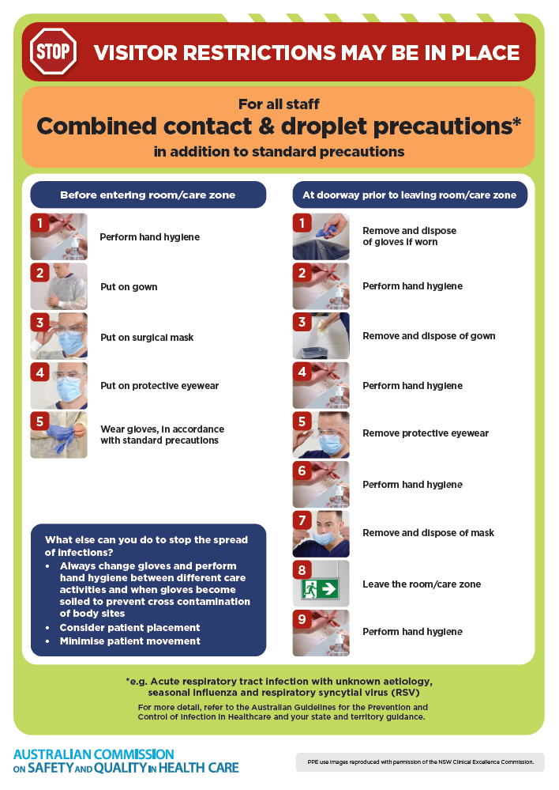
- Poster – Combined airborne and contact precautions
https://www.safetyandquality.gov.au/publications-and-resources/resource-library/infection-prevention-and-control-poster-combined-airborne-and-contact-precautions
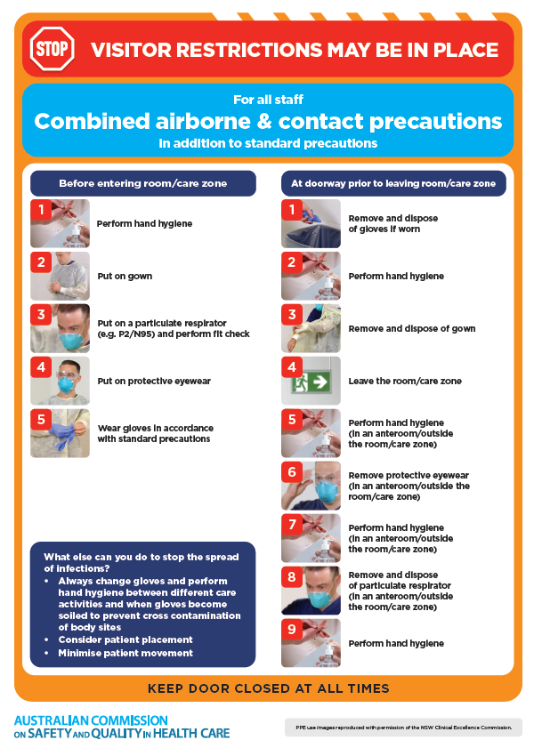
- Environmental Cleaning and Infection Prevention and Control www.safetyandquality.gov.au/environmental-cleaning
- Break the chain of infection poster
https://www.safetyandquality.gov.au/publications-and-resources/resource-library/break-chain-infection-poster
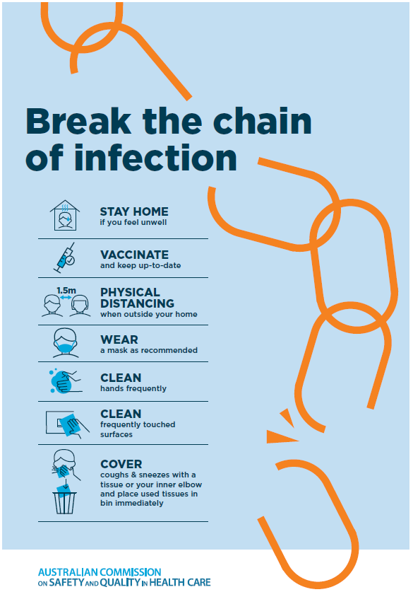

Disclaimer
On the Radar is an information resource of the Australian Commission on Safety and Quality in Health Care The Commission is not responsible for the content of, nor does it endorse, any articles or sites listed The Commission accepts no liability for the information or advice provided by these external links Links are provided on the basis that users make their own decisions about the accuracy, currency and reliability of the information contained therein Any opinions expressed are not necessarily those of the Australian Commission on Safety and Quality in Health Care.

