
On the Radar
Issue 724
1 December 2025

On the Radar is a summary of some of the recent publications in the areas of safety and quality in health care Inclusion in this document is not an endorsement or recommendation of any publication or provider Access to particular documents may depend on whether they are Open Access or not, and/or your individual or institutional access to subscription sites/services Material that may require subscription is included as it is considered relevant.

On the Radar is available online, via email or as a PDF or Word document from https://www.safetyandquality.gov.au/newsroom/subscribe-news/radar

If you would like to receive On the Radar via email, you can subscribe on our website https://www.safetyandquality.gov.au/newsroom/subscribe-news
or by emailing us at mail@safetyandquality.gov.au.
You can also send feedback and comments to mail@safetyandquality.gov.au.

For information about the Commission and its programs and publications, please visit https://www.safetyandquality.gov.au

On the Radar
Editor: Dr Niall Johnson
Contributors: Niall Johnson

Reports

Care, courage, change: health-sector leadership in tackling violence against women and girls
World Health Organization
Copenhagen: WHO Regional Office for Europe; 2025. p. 36.
URL | https://www.who.int/europe/publications/i/item/WHO-EURO-2025-12846-52620-81536
Notes | The World Health Organization has recently published this report analysing 241 policies across 53 Member States in the European region to provide ‘a roadmap for the health sector to strengthen its role within the multisectoral system of prevention and response to violence against women and girls.’ The report observes that ‘Health systems are central to preventing and responding to violence. They must integrate prevention and response into policies and services, supported by continuous monitoring and evaluation to track progress and improve actions and responses. Health systems are uniquely positioned to establish and sustain safe, effective, survivor-centred services.’

Patient safety issues associated with electronic patient record (EPR) systems – a thematic review
Investigation report
Health Services Safety Investigation Body
Poole: HSSIB; 2025.
URL | https://www.hssib.org.uk/patient-safety-investigations/electronic-patient-record-epr-systems-thematic-review/investigation-report/
Notes | This latest report from the Health Services Safety Investigation Body (HSSIB) in the UK examines some of the issues around electronic record systems used in the UK. This report is ‘thematic review of investigation reports by HSSIB and its predecessor organisation – the Healthcare Safety Investigation Branch (HSIB) – that included consideration of electronic patient record (EPR) systems.’ This review found that ‘EPR systems could contribute to the risks of patient care being missed, delayed or incorrect. These risks were persistent despite national recommendations and actions seeking to mitigate them.’ The authors made a number of findings, observations and recommendations, along with ‘local-level learning prompts’ around selection and procurement, implementation and ongoing optimisation of EPR systems.

Journal articles

Reducing inpatient deterioration and improving patient safety in emergency departments with a standardised nursing framework: A stepped-wedge cluster randomised controlled trial
Curtis K, Murphy M, Lam MK, Kennedy B, Shaban RZ, Fry M, et al
International Journal of Nursing Studies. 2026;173:105256.
DOI | https://doi.org/10.1016/j.ijnurstu.2025.105256
Notes | Paper reporting on an Australian study of a framework that seeks to standardise nursing assessment and management of patients in the emergency department (ED). The study sought to test the effect of the HIRAID framework [History including Infection risk, Red flags, Assessment, Interventions, Diagnostics, reassessment, and communication] on the quality and safety of emergency care. The study was a ‘modified (staircase) stepped–wedge, cluster randomised controlled trial was conducted in 29 Australian metropolitan, regional, rural Emergency Departments involving 1377 nurses from June 2020 to February 2024’. Among the results reported:  - ‘HIRAID reduced the proportion of patients requiring a rapid response team call by 7.4 % (OR = 0.92, 95 % CI = 0.81–0.99) including 8.2 % fewer calls related to emergency nursing care (47 % to 38.8 %, OR = 0.72, 95 % CI = 0.56–0.93).  - Patient experience improved in all measures, particularly feeling more informed (OR = 1.74, 95 % CI = 1.37–2.19).  - There was no change in time to first analgesia.  - There was a 7.0 % improvement in handover of relevant history (t = 5.57, p < 0.001) and physical assessment (t = 4.72, p < 0.001).’  The authors conclude that ‘Emergency nurses' use of HIRAID significantly reduced inpatient deterioration requiring a rapid response team call and improved patient experience and perceived quality of clinical handover.’

For information on the Commission’s work on recognising and responding to acute deterioration, see https://www.safetyandquality.gov.au/our-work/recognising-and-responding-acute-deterioration

Non-technical errors associated with deaths in surgical care, Australia, 2012–2019, by surgical specialty (Australian and New Zealand Audit of Surgical Mortality): a retrospective cohort study
Ey J, Kollias V, Lee O, Hou K, Herath M, North JB, et al
Medical Journal of Australia. 2025.
DOI | https://doi.org/10.5694/mja2.70055
Notes | Report of an analysis of Australian and New Zealand Audit of Surgical Mortality (ANZASM) data that examined ‘the frequency of non-technical errors in cases of surgical care-related deaths in Australia, by surgical specialty.’ The authors note that ‘Non-technical skills, the cognitive and interpersonal components of medical professionalism, encompass a diverse range of behaviours in four domains: decision making, situational awareness, communication and teamwork, and leadership.’  The study reviewed 30 971 surgical care-related deaths reported to ANZASM during 2012–2019 of which 3695 were flagged with adverse events or areas of concern. Of these, 3422 cases occurred in five surgical specialties: general surgery (1570 deaths), cardiothoracic surgery (626), orthopaedic surgery (510), vascular surgery (385), and neurosurgery (331). The authors report that the analysis found ‘At least 50% of surgical care-related deaths in five surgical specialties were associated with non-technical errors, and the proportions did not substantially change during 2012–2019.’ The authors suggest that ‘Differences between specialties in the frequency of fatal non-technical error suggest that targeted improvement strategies are needed, but the persistently high frequency for all specialties indicates that systemwide improvement is crucial.’

Nursing Leadership
Volume 38, Number 2, 2025
URL | https://www.longwoods.com/publications/nursing-leadership/27711/
Notes | A new issue of Nursing Leadership has been published with a theme on internationally educated nurses (IENs). Articles in this issue of Nursing Leadership include:  - The Rapidly Evolving Field of Recruitment and Retention of Internationally Educated Nurses (Ruth Martin-Misener)  - Introducing a Special Series: Integration of Internationally Educated Nurses Into the Canadian Workforce (Alyssa Indar and Edward Cruz)  - A Collaborative Approach to the Recruitment and Retention of Internationally Educated Nurses Into Rural Communities (C Baxter)  - Internationally Educated Nurse Integration: Insights From the Supervised Practice Experience Partnership Program at the University Health Network (Jennifer Hou, Irene Azurin, Karelin Martina, Pam Hubley and Alyssa Indar)  - Empowering Nurse Mentors: A Multi-Site Exploration of the Clinical Scholar Program Implementation (Kimberly Lawrence, Lori Delaney, Julie McShane, Lisa Freeman, Tracey DasGupta, Alexandra Harris and G Barton)  - Enhancing Evaluation Capacity to Advance Program Evaluation in Nursing Mentorship (Karolina Kaminska, Sarah Sousa, Kimberly Lawrence, Tracey DasGupta and Kelly Skinner)  - Supporting Nurse Practitioners Through Virtual and Hybrid Mentorship: Insights From Program Design and Delivery in Nova Scotia (Melanie Dunlop, Breanna Lloy, Sylvie Laprise, Nancy Cashen, Tricia Lane, Jennifer MacDougall, Jaime Perrin and Sohani Welcher)  - Ontario Emergency Department Models of Care With Nurse Practitioners and Clinical Nurse Specialists (Samantha Horvath, Sanja Visekruna, Kelley Kilpatrick, Melissa McCallum and Nancy Carter)

BMJ Quality & Safety online first articles
URL | https://qualitysafety.bmj.com/content/early/recent
Notes | BMJ Quality &Safety has published a number of ‘online first’ articles, including:  - Partnership makes performance: integration approaches to optimise implementation science and quality improvement collaboration (Rinad S Beidas, Cynthia Barnard, Lisa R Hirschhorn, Miriam R Rafferty, Kelli Scott, Sara J Becker, Patricia D Franklin)  - Mandatory specialist approval requirements reduce valproate prescribing: population-based evaluation of a National Patient Safety Alert (James Galloway, Matthew Jones, Mark Gibson, Kaiyang Song, Katie Bechman, Rajiv Mohanraj, Sam Norton, Mark D Russell)  - Artificial intelligence chain-of-thought reasoning in nuanced medical scenarios: mitigation of cognitive biases through model intransigence (Jonathan Wang, Donald A Redelmeier)  - Editorial: From measurement to improvement: new evidence towards reducing emergency diagnosis of cancer (Marta Berglund, Matthew E Barclay, Georgios Lyratzopoulos)  - Editorial: Are we careless about continuity of care? (Persijn Honkoop, Marco Krukerink)

International Journal for Quality in Health Care online first articles
URL | https://academic.oup.com/intqhc/advance-articles
Notes | International Journal for Quality in Health Care has published a number of ‘online first’ articles, including:  - Prediction of prolonged length of stay from first 2 days of hospitalization data: a SHAP value-based variable selection method for a simplified model (Rui Fa, Daniel Stoessel, Svetlana Artemova, Ursula von Schenck, Hadiseh Nowparast Rostami, Pierre-Ephrem Madiot, Caroline Landelle, Jean-Luc Bosson)

Online resources

Australian Living Evidence Collaboration
https://livingevidence.org.au/

Residential Aged Care Communiqué
https://www.thecommuniques.com/post/residential-aged-care-communiqu%C3%A9-volume-20-issue-4-november-2025
Volume 20, Issue 4, November 2025
This issue of Residential Aged Care Communiqué examines the potential for inadvertent consequences of changing environmental restrictive practices.

Infection prevention and control and COVID-19 resources
The Australian Commission on Safety and Quality in Health Care has developed a number of resources to assist healthcare organisations, facilities and clinicians These resources include:
- Poster – Combined contact and droplet precautions https://www.safetyandquality.gov.au/publications-and-resources/resource-library/infection-prevention-and-control-poster-combined-contact-and-droplet-precautions
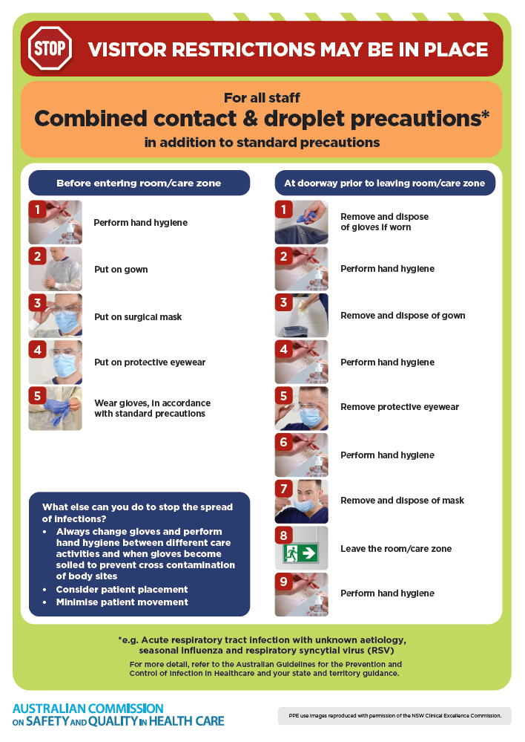
- Poster – Combined airborne and contact precautions
https://www.safetyandquality.gov.au/publications-and-resources/resource-library/infection-prevention-and-control-poster-combined-airborne-and-contact-precautions
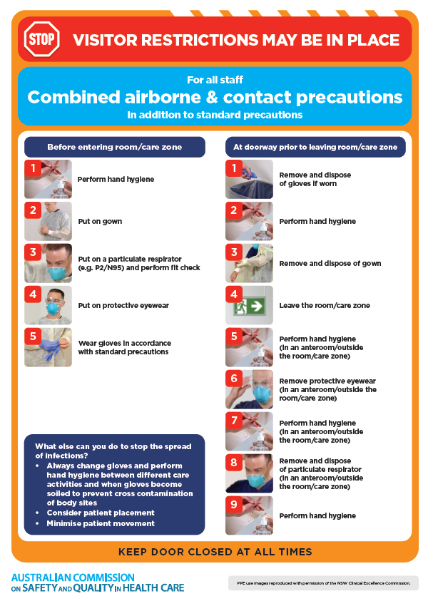
- Environmental Cleaning and Infection Prevention and Control www.safetyandquality.gov.au/environmental-cleaning
- Break the chain of infection poster
https://www.safetyandquality.gov.au/publications-and-resources/resource-library/break-chain-infection-poster
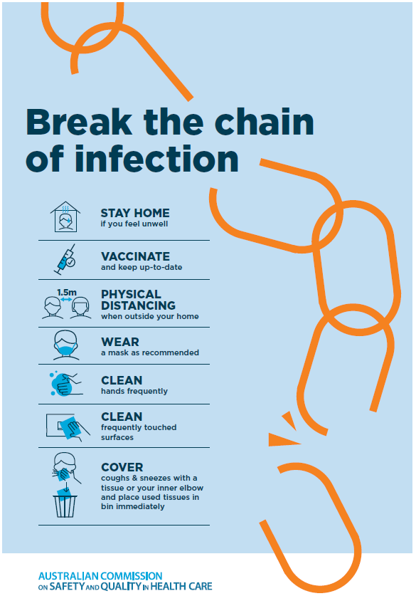

Disclaimer
On the Radar is an information resource of the Australian Commission on Safety and Quality in Health Care The Commission is not responsible for the content of, nor does it endorse, any articles or sites listed The Commission accepts no liability for the information or advice provided by these external links Links are provided on the basis that users make their own decisions about the accuracy, currency and reliability of the information contained therein Any opinions expressed are not necessarily those of the Australian Commission on Safety and Quality in Health Care.

