
On the Radar
Issue 725
8 December 2025

On the Radar is a summary of some of the recent publications in the areas of safety and quality in health care Inclusion in this document is not an endorsement or recommendation of any publication or provider Access to particular documents may depend on whether they are Open Access or not, and/or your individual or institutional access to subscription sites/services Material that may require subscription is included as it is considered relevant.

On the Radar is available online, via email or as a PDF or Word document from https://www.safetyandquality.gov.au/newsroom/subscribe-news/radar

If you would like to receive On the Radar via email, you can subscribe on our website https://www.safetyandquality.gov.au/newsroom/subscribe-news
or by emailing us at mail@safetyandquality.gov.au.
You can also send feedback and comments to mail@safetyandquality.gov.au.

For information about the Commission and its programs and publications, please visit https://www.safetyandquality.gov.au

On the Radar
Editor: Dr Niall Johnson
Contributors: Niall Johnson, Alice Bhasale, Leanne Cox, Rozanna Alameddine

National guidelines for presentation of electronic discharge summaries
Australian Commission on Safety and Quality in Health Care
Sydney: ACSQHC; 2025. p. 30.
https://www.safetyandquality.gov.au/our-work/e-health-safety/electronic-discharge-summary-eds-systems

The Australian Commission on Safety and Quality in Health Care has published the updated National guidelines for presentation of electronic discharge summaries (the Guidelines).

The Guidelines provide recommendations about the structure, format, and content of electronic discharge summaries, contributing to national consistency. They emphasise the important role of robust clinical governance, training and evaluation processes in achieving accurate, concise, and well-designed electronic discharge summaries.
High-quality and timely discharge summaries are an essential part of effective clinical handover at this high-risk transition.
For more information visit safetyandquality.gov.au/EDSS

Reports

A framework to guide early planning (“the front end”) of large-scale change programmes in health and healthcare
Lindsay RK, Bridson E, Greig A, Lawrie M, Scott J, Watt A, et al
Cambridge: THIS Institute; 2025. p. 45.
URL | https://doi.org/10.17863/CAM.123407  https://www.thisinstitute.cam.ac.uk/research/outputs/a-framework-to-guide-early-planning-the-front-end-of-large-scale-change-programmes-in-health-and-healthcare/
Notes | The THIS Institute ((The Healthcare Improvement Studies Institute) has published this framework that was developed through a collaboration between THIS Institute, the Health Foundation, and the market research company Ipsos. The THIS Institute states that ‘This framework is intended for people who are designing large-scale change programmes in the health and healthcare sector, defined as follows:  A complex change programme in health and healthcare is a set of inter-related interventions and activities that are organised around a high-level goal or theme and that need to be directed and coordinated as a whole on a large scale.’  The framework prompts users to consider  - Programme purpose and content  - Contexts, stakeholders and implementation strategy  - Programme management, governance, costing and scheduling, and learning.

Guidelines on Hand Hygiene in Community Settings
Geneva: World Health Organization and the United Nations Children’s Fund (UNICEF); 2025. p. 78.
URL | https://www.who.int/publications/i/item/9789240116559
Notes | The World Health Organization (WHO) and the United Nations Children’s Fund (UNICEF) have released hand hygiene guidelines designed for non−health care settings, including homes, schools, and other public and institutional settings. According to the WHO’s website, the ‘Guidelines are concerned with the practice of hand hygiene to protect community health outcomes, in particular, the reduction of diarrhoeal diseases and acute respiratory infections’.

Journal articles

Peripheral intravenous catheter policies and procedures across Queensland: a document review and analysis of underpinning evidence and alignment with clinical standards
Lovegrove J, Havers S, Smith A, Ball DL, Ullman AJ, Bhasale A, et al
Australian Health Review. 2025;49(6):AH25234.
DOI | https://doi.org/10.1071/AH25234
Notes | Queensland-based vascular access researchers Josie Lovegrove and team recently published their study examining whether policy for peripheral intravenous catheters matched the standards of care outlined in the Commission’s Management of Peripheral Intravenous Catheters Clinical Care Standard (the Standard). Binary adherence of policy documents was assessed against the Standard’s ten quality statements. While 13 of 15 policies published after the Standard (2021) referred to it, no individual document was adherent to all ten statements - suggesting that significant improvements are needed in policy to support adherence to the Standard. A related point-prevalence study in 134 hospital wards found that binary adherence to all Clinical Care Standard indicators was only met for 20% of patients.

Facemask and Respirator Use for Bushfire Smoke Protection: A Cross-Country Comparison of Public Health Policies in Australia, Canada, India, and the United States
Chughtai AA, Kpozehouen E, Seale H, Shah S, Marks GB, MacIntyre CR
Health Policy. 2025:105510.
DOI | https://doi.org/10.1016/j.healthpol.2025.105510
Notes | Paper reporting on an examination of public policies regarding use of facemasks and respirators for bushfire or wildfire smoke in selected nations.  Among the findings noted by the authors: ‘There is variability in policies regarding mask and respirator use during bushfires. Health departments generally recommend using P2/ N95 respirators to protect the public from particulate exposure arising bushfire smoke, while emergency and fire services generally recommend surgical or cloth masks. Few guidelines provided detailed instructions on the proper use of respirators, including fit testing, or fit checking procedures. Most guidelines emphasised monitoring air quality and avoiding bushfire smoke, particularly for high-risk groups. There is no guidance provided on the length of time a mask should be used in any guideline.’

The Joint Commission Journal on Quality and Patient Safety
Volume 51, Issue 12, December 2025
URL | https://www.sciencedirect.com/journal/the-joint-commission-journal-on-quality-and-patient-safety/vol/51/issue/12
Notes | A new issue of The Joint Commission Journal on Quality and Patient Safety has been published. Articles in this issue of The Joint Commission Journal on Quality and Patient Safety include:  - Global Health Impact: Sustainable Healthcare in Practice (K Zacharyasz)  - Implementing Clinical Decarbonization Actions: Lessons Learned from the University of California Health System (Clémence Marty-Chastan, Claire D Brindis, Sheri D Weiser, Sapna Thottathil, Jodi D Sherman, Arianne Teherani)  - Optimizing Pediatric Surgical Kits: A Cost-Effective Approach to Reducing Environmental Impact in Healthcare (Alison Lehane, Mallory Perez, Gwyneth A Sullivan, Jennifer Dunn, Timothy B Lautz, Mehul V Raval)  - The Impact of Semistructured Safety-Focused Site Visits Between Children’s Hospitals (Sarah Kandil, Michelle Vonderhaar, Patsy Sisson, Lara Wood, Patrick W Brady, Anne Lyren)  - Big Access Week: Decreasing Dermatology Patient Wait Times in a Strained Healthcare System (Dylan J Parker, Iman M Salem, Dylan J Badin, Brian J Simmons, M Shane Chapman)  - Advancing Parkinson’s Care and Patient Safety Through CMS’s Age-Friendly Hospital Measure (Peter Pronovost, Leslie J Pelton, Hooman Azmi, Annie Brooks, Eboné Carrington, Michael Siao Tick Chong, Sheera Rosenfeld)  - Leveraging Implementation Science to Address Diagnostic Disparities and Promote Equity in Healthcare (Lucy Schulson, M-L Drainoni, K Austad)  - Patient Safety in Transition from Pediatric to Adult-Centered Care (Carole Lenz Hemmelgarn, Margaret A. McManus, Kiera Peoples, Rashmi Singh, Laura Blum Meisnere)

Australian Health Review
Volume 49, Issue 6, December 2025
URL | https://connectsci.au/ah/issue/49/6
Notes | The Australian Health Review has moved to a continuous publication model. In the continuous publication model, once an article is ready for publication, it is immediately published online with final citation details. These are compiled into issues over time. Recent articles in the Australian Health Review include:  - Navigating medication safety with electronic medical records: insights from a dual-phase implementation in paediatric, neonatal and maternity care (Dylan A Mordaunt, N Johnson, S Verghese, R Parker, K Gibb, L J Palmer)  - Profile and clinical characteristics of alcohol-related hospital admissions within four public hospitals in New South Wales between 2011 and 2021 (Cameron McLean, Linda Tapsell, I Fallas, S Grafenauer, A-T McMahon)  - Surgical site infection surveillance in Australian public and private hospitals: a comparative analysis (Ann L Bull, Lyn-li Lim, Stephanie K Tanamas, Leon J Worth, Deborah N. Friedman)  - Adaptive leadership in health care: a rapid review (Nicky Robinson, Grace Claringbold, Jeromy Anglim, Sarah Fischer, Arlene Walker, Loch Forsyth)  - The influence of specialty training selection criteria on medical students’ career pathway choices in Australia (Thomas Muecke, Dinan Perera, Jinara Devinuwara, Christina Gao, S Satheakeerthy, S Bacchi, R Casson, W O Chan)  - Clinical practice guidelines for Indigenous peoples with middle ear disease in Australia: a systematic scoping review (Kai Nash, Rona Macniven, Carmen Parter, Margaret Apolima Fono, Y Dimitropoulos, C McMahon)  - Changes in size and co-location of health services for Australian general practice, 2000–2016 (Preet Kalkat, Shaun Larkin, Jennifer Lacy-Nichols, Adam Elshaug, Christopher Harrison)  - Telehealth use in Voluntary Assisted Dying: a systematic review (Imogen Summers, Elizabeth Reymond, Helen M Haydon)  - ‘Most important is understanding primary care in the context of the whole health system.’ The data-use aspirations of primary care leaders in Australia: a qualitative study (Andrew D Webster, Deborah Askew, Vivian Lyall, Jason D Pole, Geoffrey Spurling)  - Staff and consumer experience of capabilities for successful governance and quality improvement committee partnerships: a coproduced cross-sectional qualitative survey (Ruth Cox, Raeleen Parker, Melanie Lynch, Faiza El-Higzi, Jodie Nixon)  - Health workforce policy in Queensland: mapping the state government landscape (Stephanie M Topp, Thu Nguyen, Lana M Elliott)  - A scoping review of multi-component suicide and self-harm prevention programs for young people in Australia (Anna Morrison, Charlotte Comben, Claudia Pagliaro, Eryn Wright)  - Strategies to reduce ‘failure to attend’ rates in specialist clinics: an implementation framework (Brigette M de Visser, Tamzin M Dimmock, Colleen L White, Peter A Schulz, Alison Hardman, Glen P Westall)  - Critical care survivors’ reported satisfaction with experience of their general practitioner and general practice clinic: a multi-centre observational cohort study (Nina Leggett, Yuhao Wang, Sarah Burleigh, Mayra Cuming, Adam M Deane, Craig French, Matthew J Maiden, Jo-Anne Manski-Nankervis, Mark Merolli, T C Rollinson, J Stewart, C Zhang, Y A Abdelhamid, K J Haines)  - The process of adapting an innovative program for the self-management of type 2 diabetes in Aboriginal peoples: guided self-determination in healthcare settings (Tanya Druce, Sharon Atkinson-Briggs, Debra Kerr, Catharine McNamara, Bodil Rasmussen)  - ‘I love my job, but it’s time to go’: wellbeing triggers for retirement in Australian female general practitioners (Louise Stone, Karen Price, Michelle Barrett, Megan Cahill, Erin Walsh)  - The implementation of a virtual fracture clinic in Far North Queensland: satisfaction and success without travel (John Maunder, William O’Callaghan, Callum Fryer, Dougal Middleton, Tim Dwyer)  - Australia’s research investment in the health of justice-involved populations (Stuart A Kinner, Rohan Borschmann, Rebecca Shuttleworth, Sarah Pellicano, Fiona Kouyoumdjian, Brie Williams)  - ‘The time for experimenting on patients is over’: a policy scan and qualitative study of doctors’ experience with the oversight of clinical innovation in Australia (Miriam Wiersma, Ian Kerridge, Wendy Lipworth)  - A document analysis exploring Australian health service expectations of competency and training in recent Advanced Musculoskeletal Physiotherapy roles (David Jovic, Matthew Beard, Marie-Louise Bird, Romany Martin, Steven Milanese)  - The financial viability of Australian private hospitals: a systematic review (Grzegorz Brylski, Shaun Larkin, Andrew Wilson)  - MindLink: preliminary evidence on a virtual Community of Practice for child and adolescent mental health in the Australian context (Valsamma Eapen, Antonio Mendoza Diaz)  - Integrating cybersecurity into healthcare quality governance: a policy perspective on artificial intelligence risks in Australia (Dieu Phuong Lan Luc, Mai Phuong Nguyen)  - Voices of the future: an exploration of the Australian Capital Territory speech pathology workforce (Lilian Anderson, My Tran, Jinhu Li, Mark Cormack)  - Challenges and strategies for international medical graduates in registration and integration into the Australian healthcare system: a systematic scoping review (Wen Li, Mehwish Nisar, Robyn M Gillies, Matthew McGrail, A Khan)  - Pilot testing of the Research Impact Assessment Framework (Robyn L Ward, Don Nutbeam, Wilfred Mijnhardt, Philip Nelson, Angela L Todd, Janine Richards, Kirsten Jackson, Nadia N Khan, Sean Chung)  - Developing best practice principles for enhancing engagement with consumers from culturally and linguistically diverse backgrounds in cancer services (Ashfaq Chauhan, Bronwyn Newman, Melvin Chin, Allan Ben Smith, Meron Pitcher, Holly Seale, N T Tieu, E Manias, C Wilson, R Harrison)  - The current state of legislation and education of Traditional Chinese Medicine in Australia (Yanfang Zheng, Siheng Xie, Yinghao Wang, Mingqing Huang)  - Costs of 30-day potentially avoidable unplanned readmissions following discharge from general medicine wards: a South Australian retrospective cohort study (Taylor-Jade Woods, Yogesh Sharma, Campbell Thompson, Arduino A Mangoni, Boloor Sudhir Rao, Isuru Kariyawasam, Richard Woodman, Chris Horwood, Billingsley Kaambwa)  - Corporatisation without clarity: empirical gaps in Australian general practice data (Preet Kalkat, Shaun Larkin, A G Elshaug, C Harrison, J Lacy-Nichols)  - Peripheral intravenous catheter policies and procedures across Queensland: a document review and analysis of underpinning evidence and alignment with clinical standards (Josephine Lovegrove, Sally Havers, Alison Smith, Daner L Ball, Amanda J Ullman, Alice Bhasale, Claire M Rickard)  - Consumer involvement enhances allergy research: a National Allergy Centre of Excellence Consumer Engagement Framework (Kylie Gwynne, Tanya O’Farrell, Angela Young, Thilanka Morawakage, Lisa Gamble, Kirsten Perrett)  - Predictors of willingness to undergo back surgery: a survey of Australian privately insured adults with chronic back pain (Daniel S Harvie, Catherine Keating, Neala Fulia, Manuela L Ferreira, Ian A Harris, Mark Catley)  - Have we [fully] untapped the potential of allied health in the Australian healthcare system? (Sarah Dennis, Elise Baker, Leanne Hassett, Steven J Kamper, Bronwyn Morris-Donovan, G Nisbet, I Novak, T Rebbeck, A Baillie)  - Equity of delivery: access to voluntary assisted dying substances using a centralised pharmacy model (Elisha Cole, Liz Reymond, Enna Stroil-Salama, Caroline Phelan)  - Chronic breathlessness is associated with much longer lengths of hospital stay (David Currow, Slavica Kochovska, R Evans, J Yorke, P M Davidson)

Australian Journal of Primary Health
Volume 31, Issue 6, December 2025
URL | https://connectsci.au/py/issue/31/6
Notes | The Australian Journal of Primary Health has moved to a continuous publication model. In the continuous publication model, once an article is ready for publication, it is immediately published online with final citation details. These are compiled into issues over time. Recent articles in the Australian Journal of Primary Health include:  - Understanding issues of driving safety and transport utilisation among clients receiving opioid agonist treatment: a cross-sectional survey in New South Wales, Australia (Daniel T Winter, Lauren A Monds, Nicholas Lintzeris, Benjamin C Riordan, Paul S Haber, Carolyn A Day)  - Applying an Indigenous strengths-based theoretical framework for nutrition-related health and wellbeing for Aboriginal and Torres Strait Islander Peoples of Australia impacted by chronic kidney disease (Tracy Hardy, J T Kelly)  - Keeping the Body in Mind-Primary: evaluation of a community-based lifestyle intervention for people with severe mental illness accessing primary care (Eliza Draper, Scott Teasdale, Jackie Curtis, Philip B Ward, Liam Conlon, Andrew Watkins, Rachel Morell, Belinda Parmenter, Hamish Fibbins)  - Screening of adolescent Atypical Anorexia Nervosa in primary care: is the current use of the eating disorders examination a barrier to accessing treatment? (Renata A Mendes, Daniel Wilson, Natalie J Loxton)  - Are Australian physiotherapists and exercise physiologists interested in providing pulmonary rehabilitation in primary care? A national survey (Jessica A Walsh, Sarah M Dennis, Jennifer A Alison, Jeanette M Thom, Kelcie Herrmann, Hailey Fisher, Zoe J McKeough, Marita T Dale)

Health Policy
Volume 163, January 2026
URL | https://www.sciencedirect.com/journal/health-policy/vol/163/
Notes | A new issue of Health Policy has been published. Articles in this issue of Health Policy include:  - Association between socioeconomic disadvantage and low-value care in acute care hospitals in Japan: Cross-sectional study (So Sato, Hideo Yasunaga, Yuichiro Matsuo, Hiroki Matsui, Kiyohide Fushimi, A Miyawaki)  - Towards the development and implementation of hospital-based health technology assessment (HB-HTA) in Poland: Achievements of an exploratory HB-HTA project from 2019–2022 (Małgorzata Gałązka-Sobotka, Maciej Furman, Anna Sagan, Iwona Kowalska-Bobko)  - Healthcare utilization and costs for cardiovascular diseases across different levels of bundled payment adoption in general practice: A data linkage study (J T Dros, C E van Dijk, R A Verheij, I Bos, B R Meijboom)  - Spatial equity of physiotherapy accessibility in Aotearoa New Zealand in relation to Māori and Pacific ethnicity, socioeconomic deprivation, and rurality (Miranda Buhler, T Shah, M Perry, M Tennant, E Kruger, S Milosavljevic)  - Mortality risk factors in Catalonia’s long-term care system: A population-based survival analysis (Albert Prades-Colomé)  - The effectiveness of pharmaceutical tenders as a cost containment mechanism: analysis through the Synthetic Control Method. The case of Andalusia (Spain) (Pedro A Montero, L Á Hierro Recio, A J Garzón Gordón)  - How do strategy, scanning, and assessment shape decision-making on technologies in hospitals? insights from a qualitative study in Dutch hospitals (Maria Pinelli, Marcia Tummers, Janneke Grutters)  - Impact of quality clusters on antibiotic prescribing patterns. A difference-in-differences study from Danish general practice (Line Bjørnskov Pedersen, Maria Bundgaard, Eskild Klausen Fredslund, Jens Søndergaard, Marius Brostrøm Kousgaard, Sonja Wehberg, Dorte E Jarbøl)  - Exploring barriers to nutritional support for oncology patients in regional and rural settings: A scoping review through the lens of Levesque’s accessibility framework (Annemarie De Leo, Christelle Schofield, Emily Jeffery, Emily Mountford, Elle Cotton, J Lewis, J Hodgson, M A Kennedy)  - A scoping literature review of rehabilitation policy recommendations during the COVID-19 pandemic in the WHO European Region (Callum Thomas, Justine Gosling, Ruth EAshton, Rebecca Owen, Mark A Faghy)  - Cash transfers and health outcomes: Evidence from Italian municipalities (Stefania Fontana, Calogero Guccio, Giacomo Pignataro, Domenica Romeo)  - Exploring financial challenges of students and early-career professionals working in the healthcare sector: A scoping review (Samin Huq, Yoonjung Choi, Paul Künzle, Mfonobong Timothy, C Santoso, S Hwang, S Meilianti)  - Different systems, same challenges: a comparative analysis of long-term care resilience in Norway, Finland, the Netherlands, Romania, Spain, Italy and Australia (Martijn Felder, Roland Bal, Eline Ree, Maren Sogstad, Sharon Stoddart, Louise A Ellis, Florin Tibu, F Vola, P Cantarelli, J M Delgado-Saborit, E Aparicio, M Lahti, E Kankaanpää, S Wiig, I Wallenburg, H B Lyng)  - Health and care workforce preparedness in response to the influx of Ukrainian refugees: a qualitative study from the Czech Republic (Zuzana Kotherová, Karolína Dobiášová, Jolana Kopsa Těšinová, Elena Tulupova)  - Strategies to improve recruitment, retention, working conditions, and skills among the long-term care workforce: An umbrella review of existing evidence (Andreea Corina Badache, Maja Dobrosavljevic, Sarah L Barber)  - Co-developing an inclusive interprofessional health workforce minimum data standard for enhanced planning and decision-making: A Canadian case with international relevance (Katherine Zagrodney, Dax Bourcier, Neeru Gupta, S Simkin, R Ashcroft, B Bath, H E Ben-Ahmed, N Crown, B Gamble, K Leslie, A Mashford-Pringle, S Myles, D Rice, A Sweetman, I L Bourgeault)  - How health workers experience health system reform: A qualitative study from Finland (Laura Kihlström, M Viita-aho, I Keskimäki, L-K Tynkkynen)  - Backlogs, waiting times and waiting lists of elective surgeries across OECD countries (Luigi Siciliani, Gaetan Lafortune, M-C Canaud, C Madichie)

Health Affairs
Volume 44, Number 12, December 2025
URL | https://www.healthaffairs.org/toc/hlthaff/44/12
Notes | A new issue of Health Affairs has been published with themes of ‘Cancer Drugs, Medical Debt, Cybersecurity and more. Articles in this issue of Health Affairs include:  - For Community Health Centers, A Winding Path To Accountable Care (Harris Meyer)  - Follow-On Cancer Drugs Target Earlier Stages Than Initial Drugs: Implications Of The IRA (Tomas J Philipson, Qi Zhao, Deyu Zhang, Kira Fujibayashi, and Heather Johnson)  - Medical Debt In The US: Associations With Cancer Screening, Mortality, And Health Status (Odysseas P Chatzipanagiotou, Andrea Baldo, Miho Akabane, A Sarfraz, A Mevawalla, J King, R Thammachack, and T M Pawlik)  - Lessons From CMS Relief Funding After Cyberattack On Change Healthcare (Hannah T Neprash, Timothy J Beebe, G Yost, and C Carroll)  - Growth In Number Of Practices And Clinicians Participating In Concierge And Direct Primary Care, 2018–23 (Jane M Zhu, Trisha Marsh, Daniel Polsky, Aine Huntington, and Zirui Song)  - Hospital Finances, Operations, And Patient Experience Remain Stable After Oregon’s Hospital Payment Cap Was Implemented (Roslyn C Murray, Andrew M Ryan, and Christopher M Whaley)  - California’s Heat Standard And Heat-Related Deaths Among Outdoor Workers (Adam Dean, and Jamie McCallum)  - New York’s Basic Health Program Increased Subsidized Insurance Coverage From Preconception To The Postpartum Period (Julia C P Eddelbuettel, Jamie R Daw, A A Galbraith, S H Gordon, A Kaimal, and L F Garabedian)  - Maternity Care Bundled Payments In The Netherlands: Changes In Health Outcomes, Spending, And Care Delivery After 5 Years (Anouk Klootwijk, Eline F de Vries, Xiaoheng Huang, Albert Wong, Zirui Song, and J N Struijs)  - Medicare Advantage Enrollment Increased Disproportionately In Chain-Owned Dialysis Facilities After The Cures Act (Daeho Kim, David J Meyers, Kevin H Nguyen, Maricruz Rivera-Hernandez, Yoojin Lee, Beth A Dana, Ankur D Shah, Rajnish Mehrotra, and Amal N Trivedi)  - Number Of States Providing Medicaid Hearing Aid Coverage For Adults Increased; Variability Was Substantive, 2017–23 (Michelle L Arnold, L Tonti, S Phillips, S P Kershner, B J Lipton, B Heslin, B D Ukert, and M F Pesko)  - Estimating Medicaid Reimbursement For Psychological Services (Jane M Zhu, Aine Huntington, Emily Mitchell, and Briana Last)  - Association Between Medicaid Prescription Drug Caps And Antiretroviral Adherence Among People Living With HIV (Christopher M Santostefano, O Galárraga, M Rahman, P M Dow, P A Chan, I B Wilson, and T I Shireman)  - Making Time For More Compassionate Care (Elena Rosenbaum)  - Health Workers Are Key To Meeting The Climate Crisis (Rabih Torbay, and Uche Ralph-Opara)

BMJ Quality & Safety online first articles
URL | https://qualitysafety.bmj.com/content/early/recent
Notes | BMJ Quality &Safety has published a number of ‘online first’ articles, including:  - Editorial: Physician participation in pre-emptive patient safety huddles (Allison Bond, Andrew D Auerbach)  - Editorial: From measurement to improvement: new evidence towards reducing emergency diagnosis of cancer (Marta Berglund, Matthew E Barclay, Georgios Lyratzopoulos)  - Confidence and certainty in medical diagnoses within acute healthcare: a scoping review (Sriraj Aiyer, Helen Higham, Nick Yeung)  - Re-establishing control limits in statistical process control analyses: the stable shift algorithm (Thomas Woodcock, Imogen O’Connor, Derek Bell)

Online resources

[UK] NICE Guidelines and Quality Standards
https://www.nice.org.uk/guidance
The UK’s National Institute for Health and Care Excellence (NICE) has published new (or updated) guidelines and quality standards The latest reviews or updates include:
- Clinical Guideline CG89 Child maltreatment: when to suspect maltreatment in under 18s https://www.nice.org.uk/guidance/cg89

Infection prevention and control and COVID-19 resources
The Australian Commission on Safety and Quality in Health Care has developed a number of resources to assist healthcare organisations, facilities and clinicians These resources include:
- Poster – Combined contact and droplet precautions https://www.safetyandquality.gov.au/publications-and-resources/resource-library/infection-prevention-and-control-poster-combined-contact-and-droplet-precautions
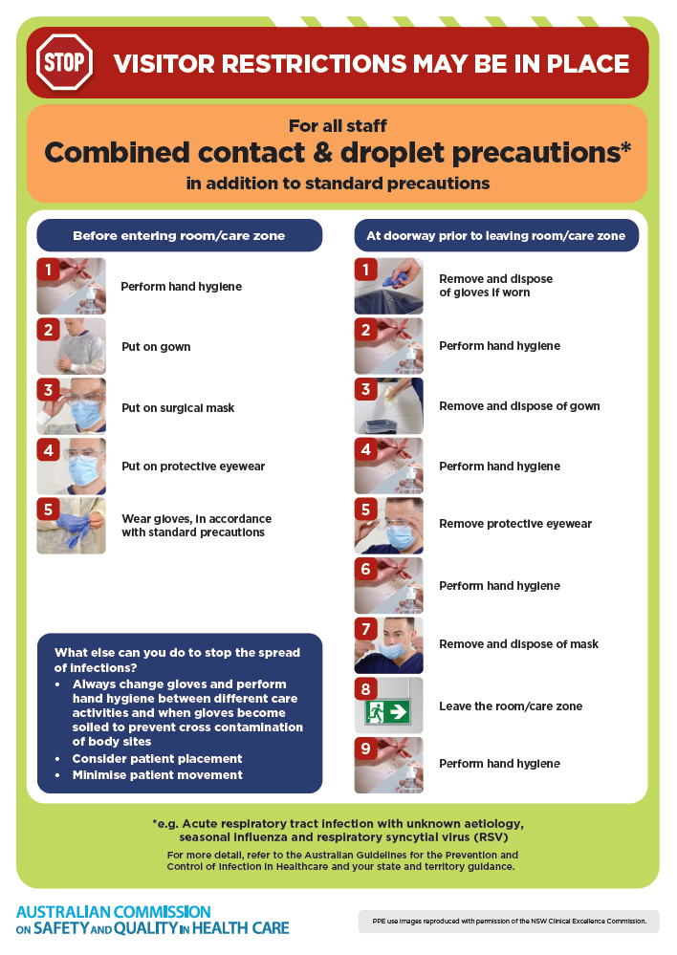
- Poster – Combined airborne and contact precautions
https://www.safetyandquality.gov.au/publications-and-resources/resource-library/infection-prevention-and-control-poster-combined-airborne-and-contact-precautions
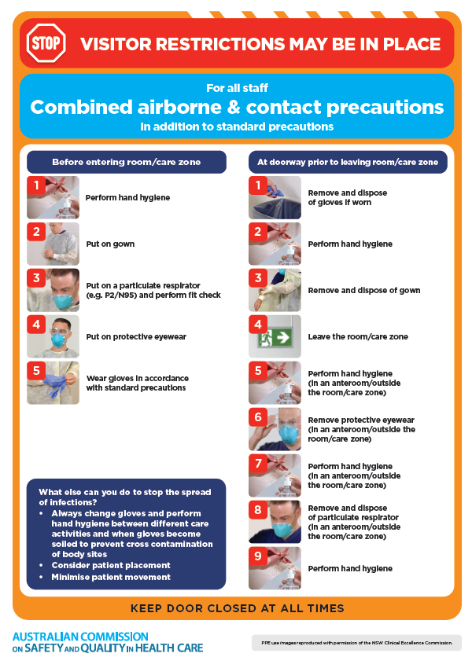
- Environmental Cleaning and Infection Prevention and Control www.safetyandquality.gov.au/environmental-cleaning
- Break the chain of infection poster
https://www.safetyandquality.gov.au/publications-and-resources/resource-library/break-chain-infection-poster
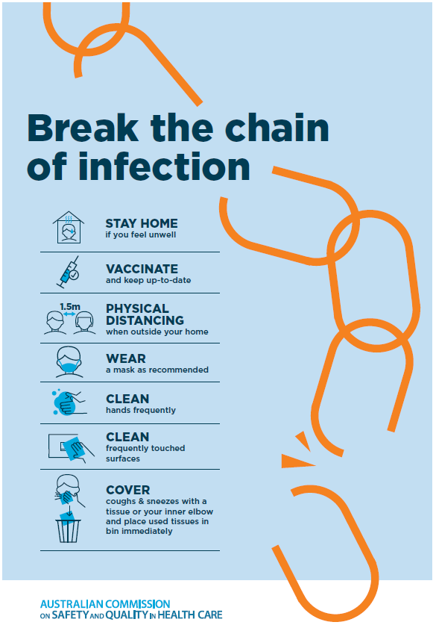

Disclaimer
On the Radar is an information resource of the Australian Commission on Safety and Quality in Health Care The Commission is not responsible for the content of, nor does it endorse, any articles or sites listed The Commission accepts no liability for the information or advice provided by these external links Links are provided on the basis that users make their own decisions about the accuracy, currency and reliability of the information contained therein Any opinions expressed are not necessarily those of the Australian Commission on Safety and Quality in Health Care.

