
On the Radar
Issue 726
15 December 2025

On the Radar is a summary of some of the recent publications in the areas of safety and quality in health care Inclusion in this document is not an endorsement or recommendation of any publication or provider Access to particular documents may depend on whether they are Open Access or not, and/or your individual or institutional access to subscription sites/services Material that may require subscription is included as it is considered relevant.

On the Radar is available online, via email or as a PDF or Word document from https://www.safetyandquality.gov.au/newsroom/subscribe-news/radar

If you would like to receive On the Radar via email, you can subscribe on our website https://www.safetyandquality.gov.au/newsroom/subscribe-news
or by emailing us at mail@safetyandquality.gov.au.
You can also send feedback and comments to mail@safetyandquality.gov.au.

For information about the Commission and its programs and publications, please visit https://www.safetyandquality.gov.au

On the Radar
Editor: Dr Niall Johnson
Contributors: Niall Johnson

Reports

Guidance on policy and strategic actions for mental health and the health sector
World Health Organization
Geneva: WHO; 2025.
URL | https://www.who.int/publications/i/item/9789240114784
Notes | A collection of guidance from the World Health Organization designed to support ‘governments in assessing how sector mandates, policies, and plans affect mental health, and provides practical steps to integrate mental health and well-being into the development, implementation, and evaluation of sectoral policies.’ The collection comprises 12 publications:  - Policy and strategic actions to protect and promote mental health and well-being across government sectors  - Government-led cross sectoral mental health initiatives  - Mental health and the culture, arts, and sport sector  - Mental health and the defense and veterans sector  - Mental health and the education sector  - Mental health and the employment sector  - Mental health and the environment, conservation and climate protection sector  - Mental health and the health sector  - Mental health and the interior sector  - Mental health and the justice sector  - Mental health and the social protection sector  - Mental health and the urban and rural development sector.

Guideline for the prevention, diagnosis and treatment of infertility
World Health Organization
Geneva: WHO; 2025. p. 262
URL | https://www.who.int/publications/i/item/9789240115774
Notes | The World Health Organization has published this guideline that ‘aims to improve the implementation of evidence-based interventions related to infertility’. The WHO states that ‘The objectives of this guideline are:  - to provide evidence-based recommendations for the prevention, diagnosis and treatment of infertility;  - to provide explicit explanations of all the relevant factors that guided the development of the recommendations in order to maximize the adaptation and implementation of the guideline in different settings;  - to provide a source for countries to adopt, adapt or update their national guidelines for the prevention, diagnosis and treatment of infertility. This guideline is primarily intended for use by health care professionals (including physicians, embryologists, nurses, midwives, laboratory specialists and other health care providers) involved in the provision of fertility care.’  It is noted in the document’s Foreword, that ‘Of course, infertility also involves decisions far beyond the clinic, including policy, social and non-clinical aspects, all of which must be addressed through evidence-informed interventions. The guideline calls for ongoing evidence generation to inform future editions so that fertility care continues to advance in line with scientific progress and the evolving needs of all people.’

Decarbonizing the healthcare supply chain strategic actions for health systems
World Health Organization
Geneva: WHO; 2025.
URL | https://iris.who.int/handle/10665/384071
Notes | Report examining how health systems may decarbonise their supply chains. The report observes that ‘Health systems themselves contribute to climate change, with the healthcare sector responsible for roughly 5% of global greenhouse gas (GHG) emissions’. Furthermore, ‘Of the emissions associated with healthcare, 60–80% are generated by the healthcare supply chain through the goods and services supplied to health systems’. The report explicitly aims to:  - provide guidance to health systems on decarbonizing their supply chains through changing the way they select, procure and use goods and services, building an approach that fits their systems, priorities and resources;  - support greater alignment in sustainable procurement practices across health systems, to amplify decarbonization efforts and accelerate collective actions.  The development of this report was led by Greener NHS, NHS England and the World Health Organization (WHO) Environment, Climate Change and Health Department with expert advice and authoring also from the Australian Government Department of Health, Disability and Ageing; Health Service Executive, Ireland; Ministry of Health, France; Ministry of Health, Germany; and Norwegian Hospital Procurement Trust.

Journal articles

Diagnostic safety in the policy landscape - a comparative policy document analysis of Australian and Aotearoa New Zealand vs US health care and research policy
Dahm MR, Carey RM, Tucker L, Haddock R, Graber ML
BMC Health Services Research. 2025.
DOI | https://doi.org/10.1186/s12913-025-13782-7
Notes | Piece reflecting on the place of diagnostic safety as ‘a subset of patient safety’ contrasting how the field has developed in the USA with that of Australia and Aotearoa New Zealand. The authors of this piece compared national policy documents across Australia and Aotearoa New Zealand versus the United States and found rather different foci. They observed that ‘US policy documents had a greater dedicated diagnostic safety focus (n=58, 67%) compared to a generic patient safety focus (n=28; 33%) and had higher emphasis on research compared to diseases. AUS/AoNZ [Australia and Aotearoa New Zealand] documents focused more on generic patient safety (n=102, 68%) than diagnostic safety (n=49, 32%) and concentrated more on diseases than research.’ The authors also offer the suggestions that ‘Australian policymakers should support the ACSQHC [Australian Commission on Safety and Quality in Health Care] to coordinate diagnostic safety initiatives with increased dedicated research funding. Both Australia and Aotearoa New Zealand should prioritise investing in the development of a comprehensive framework for implementing diagnostic safety measures across healthcare settings’

Australian Prescriber
Volume 48, Issue 6, December 2025
URL | https://australianprescriber.tg.org.au/volumes/48/issues/6.html
Notes | A new issue of Australian Prescriber has been published. Content in this issue of Australian Prescriber includes:  - Editorial: Fifty years of Australian Prescriber – continuing a proud tradition of trusted, independent information (M Kidd)  - Editorial: Hypertension – a major modifiable and undertreated risk factor (C Hespe, N Stocks, M Nelson)  - Injectable drugs for weight management (N Yates, T-L South)  - Testing for human immunodeficiency virus (L Owen, I Woolley)  - Near-fatal reaction associated with cotrimoxazole, metformin and kidney impairment (J Marley)  - Top 10 drugs 2024–25 210  - Australian clinical guideline for deprescribing in older people  - New drugs:  Calcifediol high-strength formulation for vitamin D deficiency  Fenfluramine for seizures associated with Dravet syndrome and Lennox—Gastaut syndrome

Public Health Research and Practice
Volume 35, Issue 4, December 2025
URL | https://connectsci.au/pu/issue/35/4
Notes | Public Health Research & Practice has moved to a continuous publication model. In the continuous publication model, once an article is ready for publication, it is immediately published online with final citation details. These are compiled into issues over time.  Recent articles in Public Health Research & Practice include:  - Development of a digital dashboard to address population-level obesity using electronic medical record data (Oliver J Canfell, Andrew Burton-Jones, Elizabeth Eakin, Leanna Woods, Sophie Macklin, Jodie Austin, Reji Philip, Han Chang Lim, Kazi Rumana Ahmed, Christine Slade, D Francis, C Sullivan)  - Examination of factors affecting SARS-CoV-2 transmission among healthcare workers following a large healthcare-associated outbreak of COVID-19 in North West Tasmania (Meru Sheel, Amish Talwar, Kylie J Smith, Nicola Stephens, Frances Sheehan, Louise Causer, Tara Anderson, Louise Parry, Laura J Edwards, Martyn D Kirk, Fay H Johnston)  - Creating user-friendly resources for healthy food retail implementation – a case study (Miranda R Blake, Tara Boelsen-Robinson, Tari Forrester-Bowling, Victoria Hobbs, Adyya Gupta, Margaret Rozman, Anna Peeters)  - Dementia risk literacy in older Australians: beyond knowledge (Claire Eccleston, Alex Kitsos, James Vickers, KathleenV. Doherty)  - Opening the policy window: how Australia banned engineered stone (Yonatal Tefera, Kate Cole, Chandnee Ramkissoon, Dino Pisaniello, Shelley Rowett, Sharyn Gaskin, Mija Coad, Neha Kishan Lalchandani, C Williams)  - How do current adolescent digital health prevention initiatives across Australia align with wellbeing domains? (Imogen Croucher, Mariah Issa, Allyson R Todd, Shuwei Guo, Nitika Sharma, S R Partridge, R Raeside)

Emergency Medicine Australasia
Volume 37, Issue 6, December 2025
URL | https://onlinelibrary.wiley.com/toc/17426723/2025/37/6
Notes | A new issue of Emergency Medicine Australasia has been published. Articles in this issue of Emergency Medicine Australasia include:  - Low Clinical Value Pathology Tests in the Emergency Department: Audit of Urine Microbiology and Culture Use at a Large Regional Centre (Daniel Brouillard, Sophie Pickavance, Walid Hammoud, Daniel van der Merwe, Geoffrey Melville, Chloe Story, Sandra Jones, Simon Binks, K Curtis)  - Tele-Toxinology: Using Mobile Phone Images to Safely Avoid Aeromedical Evacuation for Snakebite in Northern Australia (Bart J Currie, Chris Peberdy, Celeste Woerle, Claire Peberdy, Kelly McCrory, Adrian Nightingale, D Palmer)  - Non-Invasive Management of Blunt Traumatic Pneumothorax—a Meta-Analysis (Mark Harrison)  - Retrieval of Rural and Remote Paracetamol Poisoning in Queensland (Katherine Allen, Ben Aston, Anja Dehn, Jacob O'Gorman, Katherine Isoardi)  - Paediatric Fever Management Practices and Antipyretic Use Among Doctors and Nurses in Australian Emergency Departments (Anastasia Mutic, Rui Zhi Tan, Eunicia Tan, Michael C Fahey, Emily Callander, Libby Haskell, Shane George, Meredith L Borland, Naomi Loftus, Jeremy Furyk, N Phillips, J Bourke, S R Dalziel, Simon Craig, on behalf of the PREDICT Network)  - Development and Validation of the Dengue Simplified Severity Score Based on the Marois Severity Score for Predicting Severe Dengue in the Emergency Department (Kaur Dhesi Preetvinder, Khadijah Poh, Aida Bustam, Aliyah Zambri, Muhaimin Noor Azhar)  - Assessing Sex Disparities in Rapid Sequence Intubation Procedures in the Emergency Department: Registry Study (Hatem Alkhouri, Isaac Arnold, Samantha Bennett, Sally McCarthy)  - Monoclonal Antibody Therapies in Alzheimer's Disease: A Guide for Emergency Physicians (Scott Wrigley, Andrew L H Huynh, Sanka Amadoru, Henry Zeimer, Irene Tan, Michael Woodward, George Braitberg, P A Yates)  - Feasibility of a Pre-Hospital Virtual Triage and Care Model: A Mixed-Methods Pilot in Emergency Care (James Young-Jamieson, Roy Bekkeli, Adelaide Michael, Rachael Smithson)  - Patterns of Clinical Toxicologist Referrals at the New South Wales Poisons Information Centre (Charlotte Yim, Nicholas A Buckley, R Cairns, B S Chan)  - What the Sigma? Exploring the Change From Single to Dual Anti-Platelet ROTEM on the FIBTEM to Clauss Fibrinogen Relationship in Neurotrauma (Abhiram Hiwase, Mahni Foster, Christopher Dillon Ovenden, Kit Yan Wong, Ngee Foo, Lola Kaukas, Benjamin Reddi, A J Wells, D Y Ellis)  - A Prospective Series of Poisonings in Brisbane, Australia 2014–2024: A Changing Pharmaceutical Landscape and the Rise of Recreational Intoxication (Amanda Holford, Keith Harris, Andrew Staib, Katherine Isoardi)  - Dental Trauma in Australian Emergency Departments: Time for a New Perspective? (Luke Chung)  - Examining Emergency Doctors' Perspectives and Attitudes Regarding EBM and Chest X-Ray Request for Abdominal Pain (Brian Evans, Nicola Giannotti, Ernest Ekpo)  - Forensic Medicine in the Emergency Department: Principles, Practices and Challenges (Nicola Cunningham, Jo Ann Parkin)  - Doctors as Witnesses (Anna McNeil)  - The Intersection of Forensic and Emergency Medicine (Tee Indawongse)  - Examining the Trends in Long Inpatient Length of Stay for Patients Admitted From New South Wales Emergency Departments 2015–2022: A State-Wide Data Linkage Study (Michele Fiorentino, Michael M Dinh, Radhika Seimon, Kendall Bein)  - Emotional Analgesia and the Decline of Rational Decision Making in Emergency Medicine (Daniel Stewart)  - The Implementation of an Extended Hours Child Life Therapy Service in a Paediatric Emergency Department (Sally J Cahill, Tammy Young, Carlie Alicastro, Amanda Stock, Sandy M Hopper)  - Uncomplicated Acute Alcohol Intoxication in the Emergency Department: A 12-Year Retrospective Study to Understand Practice Change in Intravenous Fluid Usage and Patient Outcomes (Jamie Ranse, Amy L Sweeny, Gerben Keijzers, Stephanie Rae Hagan, Sharon Mickan, Matthew Brendan Munn, Alison Hutton, Michelle Buckland, Laura Hamill, C Delany, K East, J Crilly)  - Interobserver Agreement of Ankle Fracture Classification Among Emergency Physicians (Gabriel Ayonmegbesimi Akra, Arunesh Das, Victoria Kristensen, Elizabeth Coren, Cynthia Wu, Duncan J Reed, Bronwyn Shin)  - Nudging Emergency Department Clinicians to Reduce Unnecessary Diagnostic Test Ordering: A Multi-Arm Vignette-Based Experiment (Lu Bai, Shijia Gao, Frada Burstein, Jithin Sajeev, Simon Craig, Diana Egerton-Warburton, Gerard O'Reilly, Peter Cameron, Gabriel Blecher, Liam Hackett, Joseph Miller, Emily Schembri, Patrick J Owen, Paul Buntine  - Pre-Hospital Resuscitative Thoracotomy Performed in New South Wales, Australia: A Case-Series (Christopher Ennis, Jacob Tant, Brian Burns, Helen Oliver, Kevin Ostrowski, Matthew Oliver, Natalie Kruit, Ian Ferguson)  - Revising the Ambulance Clinical Response Model in Victoria, Australia: The Impact on Patient Safety (Emily Nehme, Karen Smith, Colin Jones, Peter Cameron, Ziad Nehme)

Health Expectations
Volume 28, Issue 6, December 2025
URL | https://onlinelibrary.wiley.com/toc/13697625/2025/28/6
Notes | A new issue of Health Expectations has been published Articles in this issue of Health Expectations include:  - Understanding Health Literacy Through Patients' Interpretation of Health Education Leaflets: A Thematic Narrative Review (Yung-Hui Tang, Chin Tsai Lin, Li-Chu Wu)  - Co-Design of a Registry-Based Tailored Follow-up Service Intervention for People Living With Stroke: A Multiple Method Consensus Approach (Tara Purvis, Andrew G Ross, Jannette M Blennerhassett, Karen M Barclay, Tanya Frost, Dana Wong, Susan Hillier, Kathleen L Bagot, Joosup Kim, Jennifer Cranefield, Katherine Jaques, M R Nelson, G Russell, C Scott, M Stirling, M F Kilkenny, N A Lannin, T J Kleinig, R S Grimley, J L Morrison, S Middleton, V Thijs, A K Gibbs, D A Cadilhac, the A-LISTS investigator group)  - A Longitudinal Qualitative Study of Resourcefulness Training Needs During the Hospital-to-Home Transition After Stroke in Young and Middle-Aged Adults (Juan Sun, Yali Li, Yongmei Wang, Yilin Du, Hui Shen, Sijia Zhang, Hongru Wang, Huimin Zhang)  - Identification and Applications of Key Elements in the Development of Pictorial Support for People With Aphasia After Stroke: A Co-Design Approach (Malin Bauer, Monica Blom Johansson, Ellika Schalling, E Kjörk)  - “I Put a Lot of Emphasis on Work Because I Want to Keep My Job”: A Population-Based Interview Study of Long Covid and Employment Changes in England (Viveka Guzmán, Chiara Di Gravio, Emily Cooper, Adam Lound, Nikki Smith, Margaret O'Hara, Christina J Atchison, Graham Cooke, Marc Chadeau, Paul Elliott, Helen Ward)  - Experiences of Home-Based Pulmonary Rehabilitation With mHealth and Centre-Based Pulmonary Rehabilitation in People With Chronic Obstructive Pulmonary Disease: A Qualitative Study (Wen Sun, Caixia Qiu, Shungui Xu)  - Corection to “Co-Creation Methodology for Developing a Racial Inclusivity Training Resource in Physiotherapy Education”  - Trauma-Informed Principles in Practice: A Mixed-Method Study of Co-Producing Systems Change With People Who Have Experienced Multiple Disadvantage (Tracey Stone, Emily Eyles, Thomas Traub, Jason Burrowes, R Halsley, S J M, J Gillam, M T Redaniel, S Redwood, C Totti, T Smith, M Farr  - Mobilising Knowledge for General Practice Decarbonisation: Maximising Impact Through a Multi-Stakeholder Workshop (Ana Raquel Nunes, Olivia Geddes, Florence Karaba, Abi Eccles, Helen Twohig, Helen Atherton, Frederik Dahlmann, Michael Gregg, Rachel Spencer, Jeremy Dale)  - Co-Producing Personalised Discharge Planning: Developing a Toolkit to Improve Caregiver Involvement in Hospital Transitions (Kathryn McEwan, Tom Sanders, Sue Carr, Peter Van Der Graaf, Susan Jones, Maria Raisa Jessica Aquino, Mitchell James Hogg, R Hameed, F Lai, C Cooper, S Potthoff)  - What Can We Learn Four Years On? A Multi-Centre Service Evaluation Exploring Symptoms, Functional Impact, Recovery and Care Pathways in Long Covid (Cassie Lee, Paul Williams, Amiad Abrahams, Julie Darbyshire, Helen E Davies, Johannes De Kock, Umut Esmer, S A Jones, V Newey, J Scott, N Smith, D Winch, H Master, S Elkin, LOCOMOTION Consortium  - Co-Designing a Sensory Support Intervention for Older Adults With Hearing and Vision Impairment Living in Australian Home Care Settings (Helen Gurteen, Melinda Toomey, Bronwyn Franco, Najwan El-Saifi, Chyrisse Heine, Iracema Leroi, Carly J Meyer, Sheela Kumaran, Piers Dawes)  - Assessing the Quality of Community Jury Deliberations in Online and In-Person Community Juries Using a Deductive Coding Framework (Hanan Abukmail, Rebecca A Dennison, Juliet A Usher-Smith, Lily C Taylor)  - Deliberating at a Distance: Evaluating the Feasibility of a Fully Virtual CHAT Exercise Among Low-Income Communities (Lydia Perry, Gloria Carmona, Marion Danis, Charo Ledón, M Alvarez, Z Rowe, S Dorr Goold)  - Study Protocol for the PARTICIPATE Project: Co-Creating Resources for Public Engagement in Maternity Care Clinical Audit and Learning (Tamara Escañuela Sánchez, Indra San-Lázaro Campillo, Joye McKernan, Paul Corcoran, Richard A Greene, the PARTICIPATE Project Advisory Group)  - Public and Patient Involvement in Artificial Intelligence and Big Data Healthcare Research: An Exploration of Issues and Challenges Within the AI-Multiply Project (Alexandra Thompson, Victoria Bartle, Elizabeth A Remfry, Duncan J Reynolds, Michael R Barnes, Nick J Reynolds, B Hanratty)  - Talking the Walk (Along): Lessons Learned From Engaging With Children With Cerebral Palsy and Their Parents for Investigating Lived Experiences of Falls (Rebecca L Walker, Thomas D O'Brien, Gabor J Barton, Bernie Carter, David M Wright, Richard J Foster)  - Prevalence and Predictors of Long Covid in a Cohort of Brazilian Adults 12 Months After Acute Infection: A Cross-Sectional Study (Eduardo Rocha Covre, Carlos Laranjeira, Lígia Carreira, Carla Franciele Höring, Herbert Leopoldo de Freitas Góes, Vanessa Denardi Antoniassi Baldissera, Priscila Garcia Marques, Viviane Camboin Meireles, Maria Fernanda do Prado Tostes, Rosana Rosseto de Oliveira, M Paiano, R Santoro Ageno, M Moroskoski, J Puente Alcaraz, J Nickenig Vissoci, L Augusto Facchini, M Aparecida Salci)  - Telemedicine and Cultural Competency in Dementia Care: Mapping Stakeholder Roles in Digital Toolkit Development in SSA: A Systematic Review (Abiodun Adedeji, Huseyin Dogan, Festus Adedoyin, M Heward)  - ‘Co-Production Is Caring’: Young People's Reflections on Responsible and Dialogic Co-Production in Youth Mental Health (Josimar Antônio de Alcântara Mendes, Ayan Mahamud, Sarah Doherty, Mathijs Lucassen, Joanna Lockwood, Ellen Townsend, Chris Hollis, Marina Jirotka)  - Exploring Emotional and Cognitive Perceptions of Cervical Cancer Screening and Self-Sampling Among Vulnerable Romanian Women: A Qualitative Study (Nicoleta-M Pașca, D Tăut, R Greenley, P Kirkegaard, R B Bøje, M McKee, M Bardou, A-S Băban, and the CBIG-SCREEN Consortium  - People With Non-Communicable Diseases Using Ayurveda: A UK-Based Qualitative Study (Patricia Egwumba, K Chattopadhyay, L Nellums, M Bains)  - Development and Validation of a Patient Classification System for Rehabilitation Hospitals Based on Patient and Stakeholders Engagement: A Study Protocol (Shima Shirozhan, Kian Norouzi Tabrizi, Mahdieh Motie, Rouhollah Mirshafiee, Hasan Mohammadi, Amin Ajalli)  - A Qualitative Evaluation Exploring Co-Production of Falls Management in Care Homes (Fran Hallam-Bowles, Alice Kilby, Adam Gordon, S Timmons, P Logan, L Rees, W Lawry, CHAFFINCH stakeholder group , K Robinson)  - Experiencing Socioeconomic Deprivation as a Carer in the United Kingdom: A Qualitative Study (Megan Armstrong, Alma Jeri-Wahrhaftig, Abi Woodward, Danielle Nimmons, Carolyn A. Chew-Graham, Joanne Protheroe, Fiona Stevenson, Nathan Davies, Kate Walters  - ‘A Forever Imprint on Me…I Couldn't Be There When He Needed Me the Most’: Care Partner Experiences of Patient Safety During Covid-19 Restrictions (Kayley Perfetto, Kim Sears, Jane O'Hara, Lenora Duhn)  - Conceptualising Essential Oral Health Benefits Baskets: A Thematic Analysis of Public and Expert Perspectives (Béatrice Durvy, Lukas Schöner, Tamara Reyes Ojopi, K Achstetter, R Busse, K Carr, S Listl, O Németh, A Skandrani, S Tubert-Jeannin, C Vernazza, J Winkelmann, R Waitzberg)  - Look on the Bright Side: The Interactional Construction of a Survivor Identity in the Breast Cancer Clinic (Stephanie Mace, Susan Speer)  - Exploring the Lived Experiences of Earthquake Survivors in Temporary Camps: Challenges and Transformations in Khoy, Iran (Zeinab Habibpour, Roghieh Sodeify, Moslem Birami, Leila Mokhtari)  - Stakeholders' Experiences and Perspectives of Patient and Public Involvement (PPI) in Maternal and Neonatal Clinical Trials: A Qualitative Evidence Synthesis (Kathleen Hannon, Jessica Eustace-Cook, Déirdre Daly, V Smith)  - Co-Designing Solutions to Improve Communication About Serious Illness During Hospitalisation (I Caven, M Frew, J Hyc, W Lewin, J Rosart, A Troup, L Kim, H James, S Agbeyaka, A Chau, R Dunbar-Yaffe, K Okrainec)  - An Exploration of Patient Experiences Concerning Coercive Measures: A Qualitative Study in Closed Psychiatric Settings in Iran (Hamid Asayesh, Mohammad Parvaresh-Masoud, Vahideh Nayeri, Ali Khaji, A Mashkoori)  - Effect of Health Model-Based Menopausal Self-Care Training on Quality of Life and Health: A Randomised Controlled Trial (Khadijeh Khademi, Mohammad Hossein Kaveh, Mahin Nazari, Abdolrahim Asadollahi)  - Enablers and Barriers to Alternative Care: Perspectives of Community-Dwelling Older Adults and Service Providers in Kerala (Anu Mohan, Teddy Andrews Jaihind Jothikaran, Lena Ashok)  - Understanding Acceptability of AI Triage Tools Amongst Underserved Populations: Lessons From the Early Phases of Co-Production With Bangladeshi Communities in Birmingham, UK (Ian Litchfield, Gayathri Delanerolle, Lorraine Harper, Sian Dunning)  - Can the Development of Orphan Drugs Include Wider Patient Engagement? A Citizens' Jury to Explore a Promissory Notion (Julia Frost, Widening Engagement Patient Advisory Group , Jessica Mandizha, Chantal van den Dungen, Lauren Asare, Catherine Pope)  - Correction to “Involving Knowledge Users in Health Services Research: Collective Reflections and Learning From a National Evaluation of Recurrent Miscarriage Services”  - Community Engagement in Long Covid: Insights From the Boston COVID Recovery Cohort (Marisha E Palm, Callie A Gu, Ingrid V Bassett, Bruce D Levy, Li Qing Chen, Janice John, Cheralyn Johnson, Jacqui Lindsay, Rebecca Lobb, Netia McCray, Bisola Ojikutu, Linda Sprague Martinez, Jacqueline Rodriguez-Louis, Alice Rushforth, Robert Torres, D L Zionts, C R Clark)  - Fostering Physician-Patient Partnerships: The Importance of Embracing the Ontological and Epistemological Understandings of Knowledge (Nicolas Fernandez, Joachim P Sturmberg)

Journal of Health Services Research & Policy
Volume: 31, Number: 1 (January 2026)
URL | https://journals.sagepub.com/toc/hsrb/31/1
Notes | A new issue of the Journal of Health Services Research & Policy has been published. Articles in this issue of the Journal of Health Services Research & Policy include:  - Editorial: Experiential learning from rapid evaluation in health and care (Sonja Marjanovic and Sara Shaw)  - Evaluating patient characteristics and trends of avoidable emergency department visits: Informing community health services to reduce emergency department utilization (Ryan P Strum, Andrew P Costa, Brent McLeod, Ravi Sivakumaran and Shawn Mondoux)  - Challenges, benefits, and strategies for delivering pregnancy care to people with disabilities: A qualitative study of service providers and decision-makers in Ontario, Canada (Lesley A Tarasoff, Yona Lunsky, Keat Welsh, Laurie Proulx, Meredith Evans, Susan M Havercamp, S N Vigod and H K Brown)  - What determines health insurance ownership in Nepal? Findings from the Nepal multiple indicator cluster survey 2019 (Prabhat Lamichhane, Rajeev Banjara and Bishnu Prasad Dulal)  - The role of family caregivers in critical illness survivor recovery at home: A qualitative study (A Fuchsia Howard, Kelsey Lynch, Sally Thorne, Sybil Hoiss, Rakesh C Arora, Omar Ahmad, Mary T Kelly, Sarah Crowe, Allana LeBlanc, L M Currie, R C McDermid, R Doll, A David, B Hou, A Erchov and G Haljan)  - Critically ill patients are not just luggage: The experiences of health workers on the transportation of critically ill patients in hospitals in Tanzania (John Maiba, Elibariki Mkumbo, Karima Khalid, Tamara Mulenga Willows, Onesmus Onyango, Carl Otto Schell, Jacob McKnight, J Oliwa and T Baker)  - Cost-effectiveness of specialized trauma care: A systematic review (Soualio Gnanou, Jason Robert Guertin, Pier-Alexandre Tardif, Blanchard Conombo, Mélanie Bérubé, Natalie Yanchar, Simon Berthelot, J Gnanvi and L Moore)

JBI Evidence Synthesis
Volume 23, Issue 12, December 2025
URL | https://journals.lww.com/jbisrir/toc/2025/12000
Notes | A new issue of JBI Evidence Synthesis has been published. Articles in this issue of JBI Evidence Synthesis include:  - Editorial: Systematic reviews of prevalence: challenges and future steps (Julian PT Higgins, Celina Borges Migliavaca, Diana Buitrago-Garcia, Z Munn)  - Effectiveness of intrathecal dexmedetomidine versus fentanyl as additives to hyperbaric bupivacaine on postoperative analgesia in patients undergoing Cesarean section: a systematic review and meta-analysis (Jorica Boshoff, Maria Fourtounas, Kylesh Pegu, Patricia McInerney)  - Care partner engagement in patient safety for adult inpatients at the direct care level in hospital: a qualitative systematic review (Kayley Perfetto, Laura Pozzobon, Kim Sears, Jane O’Hara, Amanda Ross-White, Lenora Duhn)  - Effectiveness of community-based, peer-led approaches compared with usual care in controlling hypertension in low- and middle-income countries: a systematic review protocol (Uma Vasudevan, Vineetha Karuveettil, Chandrashekar Janakiram, Jeby Jose Olickal, Kavumpurathu R Thankappan)  - Coaching for informal caregivers of persons living with dementia: a scoping review protocol (Rachel MacLean, Pamela Durepos, Lisa Keeping-Burke, Katelyn Caverhill, Alex Goudreau, Patricia Morris, Rose M McCloskey)  - Key components of a successful transitional care program after acute stroke: a scoping review protocol (Shaneka Simmons Patterson, M Palokas)  - Short-term effects of preparatory suggestions on pain in adults undergoing nonpharmacological treatments: a systematic review protocol (Maria Beck Gaarde, Robin Christensen, Lene Vase, Luana Colloca, Henrik Bjarke Vaegter, Sophie Lykkegaard Ravn)  - Mapping the provision of care by nurse practitioners in virtual health care clinics: a scoping review protocol (Jennifer Splane, Shelley Doucet, Melissa Rothfus, Ruth Lavergne, Ruth Martin-Misener)  - Health care professionals’ communication of safety-netting advice to patients with musculoskeletal conditions: a scoping review protocol (Christopher Horler, Geraldine Leydon, Lisa Roberts)  - Effectiveness of environmental approaches in improving cognitive and related functional outcomes for adults with traumatic brain injury: a systematic review protocol (Ella Waldman, Jennie Ponsford, Jessica Trevena-Peters)

BMJ Quality & Safety online first articles
URL | https://qualitysafety.bmj.com/content/early/recent
Notes | BMJ Quality &Safety has published a number of ‘online first’ articles, including:  - Barriers and enablers to implementing opioid deprescribing guideline recommendations: a qualitative analysis of primary care physicians’ perspectives using the Theoretical Domains Framework (Siya Zhao, Nathalia Costa, Chung-Wei Christine Lin, Carl Schneider, Simon French, Denise A O’Connor, Rachelle Buchbinder, Aili Veronica Langford)  - Editorial: Thinking and organising in systems: reframing the long problem of learning from incidents (Carl Macrae)

International Journal for Quality in Health Care online first articles
URL | https://academic.oup.com/intqhc/advance-articles
Notes | International Journal for Quality in Health Care has published a number of ‘online first’ articles, including:  - Methodological considerations for evaluating scale-up programmes in healthcare: A methods review (Bastiaan Van Grootven , Serena Sibilio , Nereide Curreri , Jianan Huang , Laurie Corna , Nathalie I H Wellens , Franziska Zúñiga)

Online resources

Australian Living Evidence Collaboration
https://livingevidence.org.au/

Guidance
A number of guidelines or guidance have recently been published or updated These include:
- The first Australian evidence‐based guidelines on male infertility https://doi.org/10.5694/mja2.70080

[USA] Effective Health Care Program reports
https://effectivehealthcare.ahrq.gov/
The US Agency for Healthcare Research and Quality (AHRQ) has an Effective Health Care (EHC) Program The EHC has released the following final reports and updates:
- Predictors, Consequences, and Organizational Interventions for Burnout Among Healthcare Workers: A Systematic Review of Longitudinal Studies
https://effectivehealthcare.ahrq.gov/products/worker-safety-wellness/research

Infection prevention and control and COVID-19 resources
The Australian Commission on Safety and Quality in Health Care has developed a number of resources to assist healthcare organisations, facilities and clinicians These resources include:
- Poster – Combined contact and droplet precautions https://www.safetyandquality.gov.au/publications-and-resources/resource-library/infection-prevention-and-control-poster-combined-contact-and-droplet-precautions
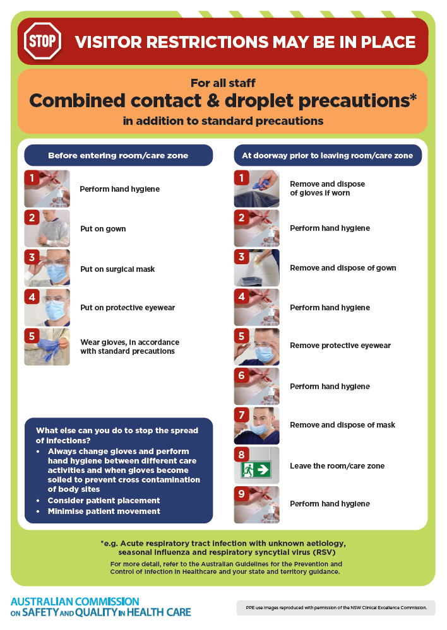
- Poster – Combined airborne and contact precautions
https://www.safetyandquality.gov.au/publications-and-resources/resource-library/infection-prevention-and-control-poster-combined-airborne-and-contact-precautions
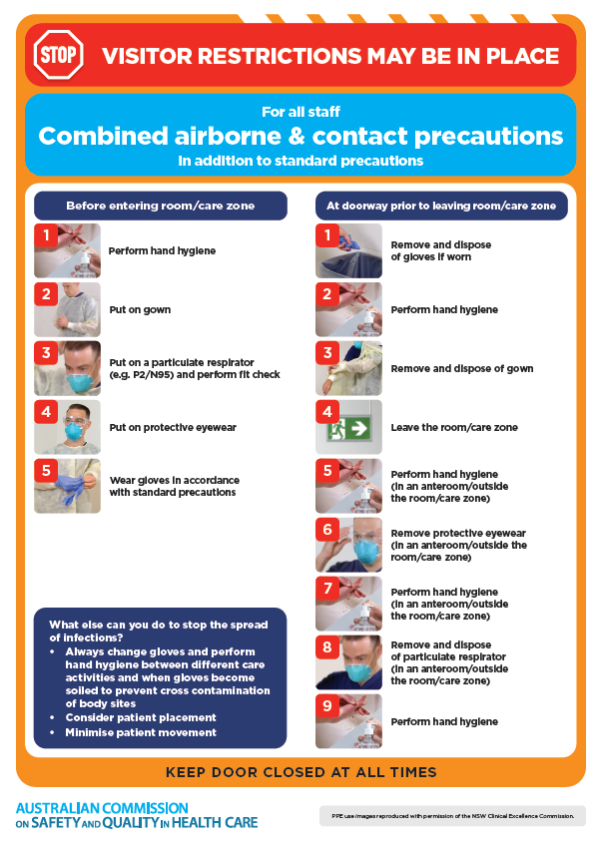
- Environmental Cleaning and Infection Prevention and Control www.safetyandquality.gov.au/environmental-cleaning
- Break the chain of infection poster
https://www.safetyandquality.gov.au/publications-and-resources/resource-library/break-chain-infection-poster
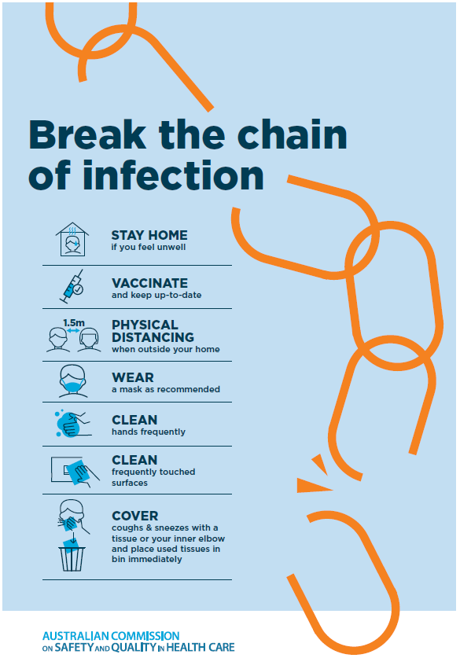

Disclaimer
On the Radar is an information resource of the Australian Commission on Safety and Quality in Health Care The Commission is not responsible for the content of, nor does it endorse, any articles or sites listed The Commission accepts no liability for the information or advice provided by these external links Links are provided on the basis that users make their own decisions about the accuracy, currency and reliability of the information contained therein Any opinions expressed are not necessarily those of the Australian Commission on Safety and Quality in Health Care.

