
On the Radar
Issue 727
22 December 2025

On the Radar is a summary of some of the recent publications in the areas of safety and quality in health care Inclusion in this document is not an endorsement or recommendation of any publication or provider Access to particular documents may depend on whether they are Open Access or not, and/or your individual or institutional access to subscription sites/services Material that may require subscription is included as it is considered relevant.

On the Radar is available online, via email or as a PDF or Word document from https://www.safetyandquality.gov.au/newsroom/subscribe-news/radar

If you would like to receive On the Radar via email, you can subscribe on our website https://www.safetyandquality.gov.au/newsroom/subscribe-news
or by emailing us at mail@safetyandquality.gov.au.
You can also send feedback and comments to mail@safetyandquality.gov.au.

For information about the Commission and its programs and publications, please visit https://www.safetyandquality.gov.au

On the Radar
Editor: Dr Niall Johnson
Contributors: Niall Johnson, Elyse Powell

2025’s most clicked
The most clicked items in On the Radar across 2025 included:
- Creating Team Joy and Wellbeing: A guide for leaders
Interior Health
Kelowna: Interior Health; 2024.
https://www.interiorhealth.ca/sites/default/files/PDFS/Creating-Team-Joy-Wellbeing-Guide-for-Leaders.pdf
- National guidelines for presentation of electronic discharge summaries
Australian Commission on Safety and Quality in Health Care
Sydney: ACSQHC; 2025. p. 30.
https://www.safetyandquality.gov.au/our-work/e-health-safety/electronic-discharge-summary-eds-systems
- Cleaning and disinfection of ultrasound transducers
Sydney: ACSQHC; 2025
https://www.safetyandquality.gov.au/publications-and-resources/resource-library/cleaning-and-disinfection-ultrasound-transducers
- World Hand Hygiene Day (WHHD) 2025
https://www.safetyandquality.gov.au/our-work/infection-prevention-and-control/national-hand-hygiene-initiative/world-hand-hygiene-day
- Documenting oxygen therapy and response for safety
Sydney: ACSQHC; 2025
https://www.safetyandquality.gov.au/publications-and-resources/resource-library/documenting-oxygen-therapy-and-response-safety

Books

Strengthening health systems through nursing: Thematic overview
Rafferty AM, Zander-Jentsch B, Sermeus W, Köppen J, Bruyneel L, Busse R, editors
Copenhagen: WHO Regional Office for Europe, European Observatory on Health Systems and Policies; 2025.
URL | https://eurohealthobservatory.who.int/publications/i/strengthening-health-systems-through-nursing-thematic-overview
Notes | This book explores the deceptively simple question of “who and what is a nurse” by comparing the nursing workforce across fourteen European countries. It demonstrates substantial variation in nurse-to-doctor and nurse-to-population ratios, education, regulation, scope of practice and planning of the workforce. The book aims to highlight the vital and expanding role nurses play in strengthening health systems and improving patient care and raise the profile of nursing in health policy.

Education and Training as Improvement Interventions
Elements of Improving Quality and Safety in Healthcare
Benishek LE, Wu AW, Rosen MA
Cambridge: Cambridge University Press; 2025.
DOI | https://doi.org/10.1017/9781009326308
Notes | This volume is the latest release in the Elements of Improving Quality and Safety in Healthcare series from The Healthcare Improvement Studies Institute (the THIS Institute) in Cambridge, England. This volume ‘provides a review of education and training design, implementation, and evaluation methods used in healthcare improvement.’ In this Element, the authors:  - describe five pillars of effective training and provide actionable guidance based on the best available evidence for each  - offer three examples of quality and safety programmes to show the positive impact of well-designed training, and the challenges of good training design  - critically examine the current state of research and practice, highlighting avenues for future research and innovation.
Reports

Global Strategy on Digital Health 2020-2027
World Health Organization
Geneva: WHO; 2025. p. 60.
URL | https://www.who.int/publications/i/item/9789240116870
Notes | The World Health Organization have published this extension of the global strategy on digital health following the World Health Assembly resolution WHA78(22), adopted on 23 May 2025, that endorsed the extension of the Global Strategy on Digital Health 2020–2025 timeline by two years to 2027. This publication has been updated to reflect the revised timeline as endorsed by the Seventy-eighth World Health Assembly. Apart from the revised timeline, the contents of the updated strategy are identical to those in the Global Strategy on Digital Health 2020–2025.

Public health intelligence competency framework
World Health Organization
Geneva: WHO; 2025. p. 40.
DOI | https://www.who.int/publications/i/item/9789240115408
Notes | Also published by the World Health Organization is this framework designed to aid public health organisations to ‘strengthen preparedness, sharpen decision-making and foster a more agile, informed and connected workforce.’  In the Foreword it is observed that:  ‘Public health systems face an ever-changing landscape shaped by emerging diseases, shifting demographics, environmental pressures and rapid advances in technology. The capacity to respond effectively in such an environment depends on a workforce that can interpret complex information, act on credible evidence and anticipate new challenges before they escalate. Building this capacity requires deliberate investment in the skills and knowledge that form the backbone of public health intelligence. The Public health intelligence competency framework offers a structured approach to cultivating these skills. It defines the expertise needed for effective public health intelligence, ranging from the early detection and verification of signals, through rigorous analysis and assessment, to translating insights into policies and actions that safeguard health.’

Principles for providing patient care in corridors
NHS England
London: NHS England; 2025
URL | https://www.england.nhs.uk/long-read/principles-for-providing-patient-care-in-corridors/
Notes | NHS England has produced this (updated) guidance to ‘support point-of-care staff in delivering the safest and highest quality care possible when corridor care has been deemed unavoidable.’ While NHS England’ considers the delivery of corridor care in departments or wards experiencing patient crowding to be unacceptable and should never be considered standard’ it has produced this guidance for those occasions when it becomes unavoidable. The guidance recognises that ‘The use of corridor care is never acceptable’ and must be avoided when caring for particularly vulnerable patients. The guidance includes core principles for corridor care for patients:  - Assessment and mitigation of risk  - Escalation  - Quality of care  - Raising concerns and reporting incidents  - Data collection and measuring harm  - De-escalation.
Patients’ experiences in emergency departments in 2024–25
Bureau of Health Information
St Leonards: BHI; 2025.

Healthcare Quarterly, July to September 2025
Bureau of Health Information
St Leonards: BHI; 2025.
URL | https://www.bhi.nsw.gov.au/BHI_reports/patient_rvey_results/emergency-department-patient-survey-2024-25  https://www.bhi.nsw.gov.au/BHI_reports/healthcare_quarterly/Jul-Sep2025
Notes | The Bureau of Health Information (BHI) in New South Wales has released a couple of reports recently. These have included:  - Patients’ experiences in emergency departments in 2024–25 summarises the reported experiences of more than 23,000 patients who attended one of 78 emergency departments (EDs) in NSW public hospitals between July 2024 and June 2025.  - Healthcare Quarterly, July to September 2025 reports on activity and performance information for public hospital and ambulance services in NSW from July to September 2025.

Journal articles

BMJ Quality & Safety
Volume 35, Issue 1, January 2026
URL | https://qualitysafety.bmj.com/content/35/1
Notes | A new issue of BMJ Quality & Safety has been published. Many of the papers in this issue have been referred to in previous editions of On the Radar (when they were released online). Articles in this issue of BMJ Quality & Safety include:  - Editorial: Eliminating hospital nurse understaffing is a cost-effective patient safety intervention (Karen B Lasater)  - Editorial: Checklist conundrum: are we checking the right boxes? (Gabriel Torrealba-Acosta, César E Escamilla-Ocañas)  - Cost-effectiveness of eliminating hospital understaffing by nursing staff: a retrospective longitudinal study and economic evaluation (Christina Saville, Jeremy Jones, Paul Meredith, Chiara Dall’Ora, Peter Griffiths)  - Duration of antibiotic therapy in the intensive care unit: factors influencing decision-making during multidisciplinary meetings (Robin M E Janssen, Anke J M Oerlemans, Nynke Bos, Johannes G van der Hoeven, Evelien A N Oostdijk, Lennie P G Derde, Jaap ten Oever, Heiman F L Wertheim, Jeroen A Schouten, Marlies E J L Hulscher)  - Patient-reported harm from NHS treatment or care, or the lack of access to care: a cross-sectional survey of general population prevalence, impact and responses (Helen Crocker, David A romwell, Shivali Modha, Alastair McIntosh Gray, Chris Graham, Lavanya Thana, Raymond Fitzpatrick, Charles Vincent, Helen Hogan, Michele Peters)  - Randomised controlled trial of audit-and-feedback strategies to reduce imaging overutilisation in the emergency department (Karl T Chamberlin, Christopher DiTullio, Jennifer Rossman, Bruce A Barton, Martin Reznek, Kevin Kotkowski)  - Does the use of structured interventions to guide ward rounds affect patient outcomes? A systematic review (Victoria Ando, Alexia Cavin-Trombert, David Gachoud, Matteo Monti)  - Integrating equity into incident reporting and patient concerns systems: a critical interpretive synthesis (Joanne Goldman, Leahora Rotteau, Lisha Lo, Brian M Wong, Ayelet Kuper, Allison Kooijman, Maitreya Coffey, Saleem Razack, Shail Rawal, Michael Palomo, Myrtede Alfred, Marie Pinard, Andrew Milroy, Carol Pauline Anderson, Arvin Minocha, Patricia Trbovich)

Healthcare Quarterly
Volume 28, Number 3, 2025
URL | https://www.longwoods.com/publications/healthcare-quarterly/27726
Notes | A new issue of Healthcare Quarterly has been published. Articles in this issue of Healthcare Quarterly include:  - Beyond the Pandemic Surge: Building a Resilient System for Adolescent and Young Adult Eating Disorder Care (Alene Toulany, Kathryn Trottier, Darryl Yates, Jeff Mainland and Paul Kurdyak)  - Advancing Healthcare Equity Monitoring and Progress: A Framework to Assess Measures for Sensitivity to Inequities (Khandideh K A Williams and Josh Fagbemi)  - A Manhattan Project for Canadian Healthcare? (Neil Seeman)  - Introduction: Digital Tools to Support Mental Health (Ruby Brown)  - Digital Tools to Support Mental Health:  Fifteen Years of Internet-Delivered Cognitive Behaviour Therapy in Saskatchewan: Expanding Access to Evidence-Based Care (Heather D Hadjistavropoulos and Vanessa Peynenburg)  - Digital Tools to Support Mental Health:  Improved Outcomes in Mental Healthcare Using Artificial Intelligence (Andrew Lustig, Masooma Hassan, Ethan Kim, Keith D’Souza, Adam Tasca, Tania Tajirian and David Gratzer)  - Digital Tools to Support Mental Health:  A Click Away From Mental Healthcare: Virtual Urgent Care at the Centre for Addiction and Mental Health (David Gratzer, Wendy MacLellan, Keith D'Souza, Alannah Vila, Dan Harren, Daisy Arko-Dadzie and Faisal Islam)  - Health Quality 5.0: The Future is NOW (Leslee J Thompson and Jeremy Veillard)  - Mobilizing Clinician Voices to Manage Health Supply Chain Disruptions Vital to Safe and Quality Patient Care (Anne Snowdon, Cindy Ly, Alexandra Wright and Saba Ghadiri)  - "Making Canada Whole”: Multi-Jurisdictional Collaboration as a Strategy to Advance Supply Chain Resilience for Canadian Health Systems (Anne W Snowdon, Alexandra Wright, Saba Ghadiri and Cindy Ly)  - Strategies for Implementing AI: Leaders Can Optimize Healthcare Systems With a Strategic Approach to Artificial Intelligence (S Amy Sommer, Julee Minniti and Matthew B Bloom)  - New Models of Care:  The Novel North York Congregate Access and Support Team Model Providing Enhanced Supports for Long-Term Care Homes: Program Description and Early Findings (Seana Bulle, Amit Arya, Zahra Ismail, Katie N. Dainty and Adora Chui)  - New Models of Care:  A Regional Surgical Partnership Program: Lessons Learned in System Transformation of Pediatric Surgical Care (Jessica Ivan, Natasha Bruno, Mary Chen, Bonnie Fleming-Carroll, Daniela D’Annunzio, Alicia Hayes, Jacqueline Howling, Karen Kinnear, Abhaya V Kulkarni, Tharini Paramananthan, Lisa Pendergast, Jeannette So, Thomas D Walters and Julia Orkin)

BMJ Quality & Safety online first articles
URL | https://qualitysafety.bmj.com/content/early/recent
Notes | BMJ Quality &Safety has published a number of ‘online first’ articles, including:  - Who chooses to engage? Understanding the characteristics of physicians who voluntarily engage with an audit and feedback intervention: a retrospective cohort study (Cherry Chu, Noah Ivers, Braeden Terpou, Mina Tadrous, Canyucel Gungor, Geneviève Rouleau, Laura Desveaux)

International Journal for Quality in Health Care online first articles
URL | https://academic.oup.com/intqhc/advance-articles
Notes | International Journal for Quality in Health Care has published a number of ‘online first’ articles, including:  - Challenges and possibilities of enabling person-centred engagement in medication safety with older people living at home (Elizabeth Manias, Chris Moran, Jacqueline Allen, Stephanie Garratt, Roisin McNaney, Helen Rawson)  - Anticholinergic load and quality of life in Australian residential aged care: a retrospective cohort study (Ying Xu  - Why Patients Still Turn to Google: Cross-National Comparison of Physician Review Use and Its Implications for Quality Disclosure in Taiwan Purchased (Tsung-Tai Chen, Chyi-In Wu, Mao-Hung Liao, Wei-Chih Su, Ming-Hsin Phoebe Chiu, Jia-Lien Hsu, Ya-Seng(Arthur) Hsueh, Chih-Kuang Liu)

Online resources

[UK] NICE Guidelines and Quality Standards
https://www.nice.org.uk/guidance
The UK’s National Institute for Health and Care Excellence (NICE) has published new (or updated) guidelines and quality standards The latest reviews or updates include:
- NICE Review NR2 DMD [Duchenne muscular dystrophy] Care UK’s guideline on respiratory care: NICE review https://www.nice.org.uk/advice/nr2
- Interventional procedures guidance IPG810 VA ECMO for postcardiotomy cardiogenic shock in adults https://www.nice.org.uk/guidance/ipg810

Infection prevention and control and COVID-19 resources
The Australian Commission on Safety and Quality in Health Care has developed a number of resources to assist healthcare organisations, facilities and clinicians These resources include:
- Poster – Combined contact and droplet precautions https://www.safetyandquality.gov.au/publications-and-resources/resource-library/infection-prevention-and-control-poster-combined-contact-and-droplet-precautions
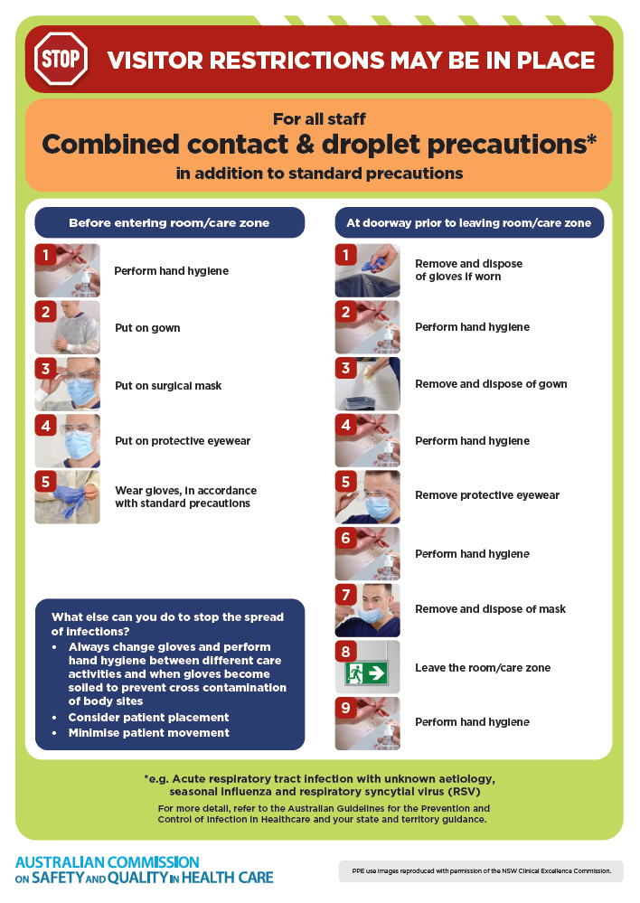
- Poster – Combined airborne and contact precautions
https://www.safetyandquality.gov.au/publications-and-resources/resource-library/infection-prevention-and-control-poster-combined-airborne-and-contact-precautions
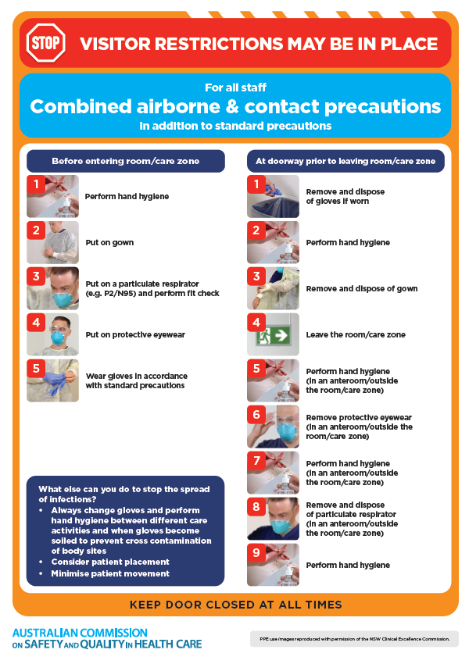
- Environmental Cleaning and Infection Prevention and Control www.safetyandquality.gov.au/environmental-cleaning
- Break the chain of infection poster
https://www.safetyandquality.gov.au/publications-and-resources/resource-library/break-chain-infection-poster
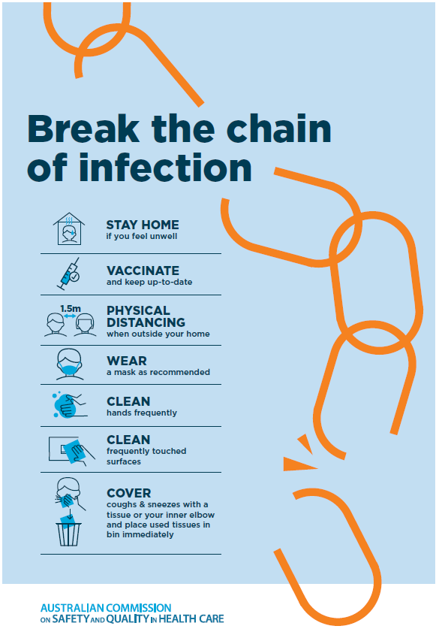

Disclaimer
On the Radar is an information resource of the Australian Commission on Safety and Quality in Health Care The Commission is not responsible for the content of, nor does it endorse, any articles or sites listed The Commission accepts no liability for the information or advice provided by these external links Links are provided on the basis that users make their own decisions about the accuracy, currency and reliability of the information contained therein Any opinions expressed are not necessarily those of the Australian Commission on Safety and Quality in Health Care.

