
On the Radar
Issue 728
19 January 2026

On the Radar is a summary of some of the recent publications in the areas of safety and quality in health care Inclusion in this document is not an endorsement or recommendation of any publication or provider Access to particular documents may depend on whether they are Open Access or not, and/or your individual or institutional access to subscription sites/services Material that may require subscription is included as it is considered relevant.

On the Radar is available online, via email or as a PDF or Word document from https://www.safetyandquality.gov.au/newsroom/subscribe-news/radar

If you would like to receive On the Radar via email, you can subscribe on our website https://www.safetyandquality.gov.au/newsroom/subscribe-news
or by emailing us at mail@safetyandquality.gov.au.
You can also send feedback and comments to mail@safetyandquality.gov.au.

For information about the Commission and its programs and publications, please visit https://www.safetyandquality.gov.au

On the Radar
Editor: Dr Niall Johnson
Contributors: Niall Johnson

Reports

Patient care in temporary care environments
Investigation report
Health Services Safety Investigation Body
Poole: HSSIB; 2026.
URL | https://www.hssib.org.uk/patient-safety-investigations/patient-care-in-temporary-care-environments/investigation-report/
Notes | In late 2025, NHS England released updated guidance Principles for providing patient care in corridors (https://www.england.nhs.uk/long-read/principles-for-providing-patient-care-in-corridors/) to ‘support point-of-care staff in delivering the safest and highest quality care possible when corridor care has been deemed unavoidable.’ The Health Services Safety Investigations Body (HSSIB) has now published this investigation report that ‘explores the management of patient safety risks associated with using temporary care environments, often referred to as ‘corridor care’ and ‘temporary escalation spaces’.’  The HSSIB’s investigation examined acute hospitals in England, with a focus on patient safety aspects of ‘corridor care’. The report discusses how, where, when and why temporary care environments are used, the associated patient safety risks, and impacts on patients and staff. The HSSIB urges healthcare leaders and organisations to ‘better understand and manage the risks that temporary care environments may present to patient safety’. The report includes a safety observation and a series of learning prompts to help staff and organisations respond to this particular patient safety concern.  The Royal College of Nursing in the UK has produced a number of items on these issues, including a 2025 report and a recent statement that has ‘condemned the normalisation of corridor care after a report from the Health Services Safety Investigations Body (HSSIB) found the practice happening all year round’. The RCN has noted the threat posed to patient safety and the risk of moral injury for nursing staff.

Journal articles

Safe and Sufficient—Ibuprofen for Pediatric Musculoskeletal Injuries
Calihan JB, Sutherland TN, Hadland SE
JAMA. 2026.
DOI | https://doi.org/10.1001/jama.2025.25528
Notes | Editorial in JAMA reflecting on an article reporting the results of two clinical trials that had examined pain relief in children with musculoskeletal injuries. The authors of the editorial observe that ‘Pain is among the leading reasons that children and adolescents … seek care in emergency departments (EDs). One of the most common causes is musculoskeletal injury, including nonoperative fractures, sprains, and strains. Such injuries can lead to significant distress for youth and their families, and clinicians have long wrestled with how best to balance pain relief with risk, ensuring that youth are comfortable while also avoiding unnecessary exposure to opioids. Undertreatment of pain contributes not only to unnecessary discomfort, but potentially also to impaired recovery from the injury, heightened future pain sensitivity, and long-term effects on psychosocial well-being and quality of life.’ They proceed to note that the article ‘by Ali et al provides robust evidence that ibuprofen alone is generally sufficient for managing acute musculoskeletal pain for most youth, offering equivalent pain relief to an opioid-containing regimen and far fewer adverse events’.
American Journal of Medical Quality
Volume 41, Issue 1, January/February 2026
URL | https://journals.lww.com/ajmqonline/toc/2026/01000
Notes | A new issue of the American Journal of Medical Quality has been published. Articles in this issue of the American Journal of Medical Quality include:  - Analyzing the Impact of the “Faculty Quality Collaborative”: A Quality Improvement Training Experience for Physicians (Mitchell J. Gitkind, Meghna C Trivedi, Joann L Wagner, Allan J Walkey, K A Fisher, P Iannelli)  - Structuring for Success: A Framework for Building a Cardiovascular Center of Excellence (Adam C Powell, Ronald C Whiting, Jacque J Sokolov)  - A Multidisciplinary Initiative Improves Care for Psychiatric Patients Boarding in the Emergency Department (Joshua J Davis, Minh Khuc, Adria Bolack, Sarah Clemons, LeeAnn Algier, Tammy Northrop, Melisa A Birkey, Jannifer Phan, Patrick McClung, Stephanie J Jordan, Matthew Sinnwell)  - Optimizing Organizational Safety: The Role of Tier 4 Huddles in Escalation Management (Mallory A Koshiol, William Kirven, Akua B Osei-Bonsu, Juliana Aadland, Venkateshwaran K Iyer, Ganesh Asaithambi)  - Transforming Safety Culture: A Systemwide High Reliability Approach to Preventing Serious Harm in Healthcare (Mallory A Koshiol, Juliana Aadland, Julie M Lauria, Venkateshwaran K Iyer, Ganesh Asaithambi)  - Leading with Complexity to Improve Care Team Interactions in Anesthesiology (D Matthew Sherrer, Brooke R Vining, Andrew H Morris, Joseph M Kreutz, Mitchell H Tsai, Sunil Eappen)  - Trauma-Informed Care Through the Lens of Immigration-Related Trauma: A Medical Education Intervention (Julia Gillan, Betsy Mathew, Jessica Occhiogrosso, Nathalia Arias-Alzate, Kristen M Coppola, Karen W Lin)  - Protocolizing Natriuresis-Guided Inpatient Diuretic Therapy in Acute Decompensated Heart Failure (Pranav Puri, Ethan Kuperman, Chad M McPherson, Jonathan M Nizar, Ernesto Ruiz)  - Play it SAFE: Evaluating Self-Efficacy of Healthcare Providers Following Sexual Assault Forensic Examiner Certification Training (Erin Lavin, Samantha Blaine, Leah Gancz, Michelle Tepper, Amy Smith, Samita M Heslin)

BMJ Leader
Volume 9, Issue 4, December 2025
URL | https://bmjleader.bmj.com/content/9/4
Notes | A new issue of BMJ Leader has been published. Articles in this issue of BMJ Leader include:  - Editorial: Leadership in transforming healthcare through data-driven, digital and AI-based innovation (Rachel Gemine, Amelia Compagni, I Joshi)  - Clearing the air: a systematic review on leadership challenges with sustainable inhaler prescribing (Sten Kajitani, Anthony Goodings, Yasmina Richa, Asis A Babun, Allison Chhor, Roberto Velasco, Juan Trujillo)  - Medical leadership competencies for physicians: a systematic scoping review (Lian Dai, Shannon Frattaroli, Christopher G Myers, Conan Dickson)  - Leadership training in healthcare: a systematic umbrella review (Juliette Phillipson, Alexandra Cardoso Pinto, Harry Kingsley-Smith, Nick Krachler, Gerry McGivern, Oscar Lyons)  - Cultivating kindness in healthcare facilities: a quadruple approach to the quadruple aim (Kripa Achan, Stewart Condon, Sandhya Limaye)  - ‘What Matters to Staff Programme’: eight steps to improve staff well-being at work (Karen Turner, Rebecca Longmate, Jane Coy-Terry, Meric Dai)  - Impact of microgeography on communication dynamics in a healthcare environment (Jillian Chown, Katrina Rey-McIntyre, John Kim, Thomas G Purdie, Colleen Dickie, R Tsang, Y Tsang, J Seuntjens, Fei-Fei Liu, C C Liu)  - Impact of department chair gender on paid parental leave across American anaesthesiology residencies (Ofodile Morah, Faisal Khosa)  - Exploring caregiver support: healthcare leaders’ perspectives on medical errors (Denise Cummins, Marie M Prothero)  - Diagnosing conflict in clerkship: insights from medical students’ experiences (Erin S Barry, Joseph C L’Huillier, Bobbie Ann Adair White)  - Impact of humble leadership on attitudes to error disclosure: the mediating role of psychological safety and safety climate in Australian veterinary practices (Luiz C P Santos, Wendy Goodwin, Michelle McArthur)  - Teaching health systems leadership and innovation to physicians (Savithiri Ratnapalan, Abi Sriharan, Geoffrey Anderson, Isser Dubinsky, Benjamin TB Chan, Tina Smith, Sara Allin, Devrim Sen, Christina Lopez, Zoe Downie-Ross, Ajantha Nadarajah, Audrey Laporte)  - Perceptions of artificial intelligence in healthcare: a qualitative study among healthcare professionals in Jordan (Ahmad F Klaib, Tasneem N AlHosanie, Ladees W Mahadin, Enas J Altatar)  - Diversity in leadership: analysing representation in global committees on climate and health (Manish Barik, Kent Buse, Soumyadeep Bhaumik)  - Making evaluations useful for healthcare leadership development programmes (Oscar Lyons, Juliette Phillipson, Joao R Galante, T Jahn)  - Physician burn-out, transformational and servant leadership (Aston Wan)  - Planetary health leadership: essential personal characteristics for addressing the planetary crisis (Elizabeth Cerceo, Lisa Patel, Cecilia Sorensen)  - Importance of modern bedside manners (Rakesh Patel, Elizabeth Wyse)  - Navigating turbulent waters: resilience and recovery of a tertiary care hospital in Sri Lanka during economic crisis through situational leadership (Ranga Sabhapathige, Dilrukshi Deerasinghe)  - The Kind Organisation (Stephen Swensen)  - General practice leadership: an extension of the consultation (Andy Brooks)  - Future of medical leadership in the age of artificial intelligence (V Q Sier)  - NHS needs managers and leaders: a brief report from the Faculty of Medical Leadership and Management conference 2024 (Daniel Jones, Hannah Son, Zoe Howard)  - Hate rota gaps: I’m loving (Guardian) Angels instead – a successful standby initiative to prevent staffing gaps (Nathanael Macdonald, Corina Palmaeda, Matthew Solan)  - Novel approach to improving teamwork in healthcare (Christopher A Collura, Jane E Brumbaugh, Megan M Misgen, Raymond C Stetson, Stephanie C Mavis, Tami K Omdahl, Claire E Reeve, Christopher E Colby)  - Mixed-methods evaluation of targeted leadership development training to support the career progression of the black and minority ethnic NHS workforce (Holly Blake, Keir Scarlett, Sala Kamkosi Khulumula, N Chouliara)

Health Policy
Volume 164, February 2026
URL | https://www.sciencedirect.com/journal/health-policy/vol/164/
Notes | A new issue of Health Policy has been published. Articles in this issue of Health Policy include:  - Beyond income: The overlooked role of institutional trust and digital access in vaccine equity (Iman Nurjaman)  - On “Inequality in COVID-19 vaccine acceptance and uptake” (Zachary D V Abel, Laurence S J Roope, Raymond Duch, Sophie Cole, Philip M Clarke)  - How are transitions from oncology to palliative care regulated across Europe? A grey literature review in eight countries: Pal-Cycles project (Eduardo Garralda, Tamara Radojičić, Sheila Payne, Rachel Hooley, ... María Arantzamendi  - An inventory of policy levers to reduce low value care: Results of a rapid scoping review (Lindsey M Warkentin, Lisa Tjosvold, Ken Bond)  - Cervical cancer in Bulgaria since EU accession in 2007: a struggle in the face of political instability (Irina Todorova, Yulia Panayotova, Tatyana Kotzeva, Rachel Greenley, ... Martin McKee)  - Pricing matters: A retrospective national study of pricing reform impact on hip fracture procedures in Israel (Gideon Leibner, Meir Liebergall, Shuli Brammli-Greenberg)  - Fragmentation of Health Benefits Plans in Chile: Findings from a comparative policy analysis and implications for advancing Universal Health Coverage (Pilar Contreras-Montiel, Nicolás Armijo, Macarena Vera, Oscar Arteaga, ... Manuel A Espinoza)  - Multi-Sector collaboration to promote healthy ageing: A comparative case study of national policy responses in the Western Pacific Region (Tao Yang, Aaron Hagedorn, Wenqian Xu, Siwon Lee, ... Honglin Chen)  - Facemask and respirator use for bushfire smoke protection: A cross-country comparison of public health policies in Australia, Canada, India, and the United States (Abrar Ahmad Chughtai, Elizabeth Kpozehouen, Holly Seale, Smita Shah, ... C Raina MacIntyre)  - Associations between residents’ experience and compliance, staffing and clinical quality Star Ratings for Australian residential long-term care homes (Nicole Sutton, Nelson Ma, Jin Sug Yang, Michael Woods, ... Deborah Parker)  - Impact of COVID-19 on primary care consultation mode in England: An interrupted time series analysis (Nicoletta Mesiano, Rita Santos)  - The impact of pre-admission care on hospital mortality: Results of an instrumental variable analysis from Italy (Francesco Moscone, Elisa Tosetti, Giorgio Vittadini)  - Does pay for performance affect socioeconomic inequalities in access? Evidence from hospital specialised care in England (Alberto Núñez-Elvira, Yan Feng, Søren Rud Kristensen, Paula Lorgelly, ... Matt Sutton)  - Health workforce resilience in the age of polycrisis: A framework to support health workforce policy and planning (Olivier Onvlee, Eelco Jacobs, Noor Tromp, Ajay Bailey, Marjolein Dieleman)  - Cultural competence teaching in public health: a rapid review to support implementation (Martina Paric, Pablo Rodriguez-Feria, María del Carmen Calle, Gloria Lagos, ... Katarzyna Czabanowska)  - Understanding the intention–action gap in physician migration during crises: Interrupted time-series evidence from Turkey (Jebağı Canberk Aydın, Emre Atilgan, Aysu Zekioğlu, Işıl Usta Kara)  - Romania’s 2025 guide for health workforce attraction and retention: Bridging global strategies and local realities (Teodor Cristian Blidaru, Alina-Ioana Forray, Tomas Zapata, Cris Scotter, ... Dragoș Nicolae Garofil)  - From recruitment to retention of young doctors: A comparative analysis of policies in Poland and the United Kingdom (Kamila Michalska, Alejandro Gonzalez-Aquines, Lynn McVey, Gaynor Clark, Alicja Domagała)  - Changing Working Patterns in Irish general practice: Findings from a Qualitative Remote Ethnographic Study (Niamh Humphries, Holly R Hanlon, Mike O’Callaghan, John-Paul Byrne, ... Éidín Ní Shé)  - The role of EU funds in capital investment for health-care: a case study of Estonia's approach to provider network transformation 2004-2024 (Triin Habicht, Kaija Kasekamp, Yulia Litvinova, Mark Hellowell)

Health Affairs
Volume 45, Number 1, January 2026
URL | https://www.healthaffairs.org/toc/hlthaff/45/1
Notes | A new issue of Health Affairs has been published with themes of Artificial Intelligence, Health Spending and more. Articles in this issue of Health Affairs include:  - The AI Arms Race In Health Insurance Utilization Review: Promises Of Efficiency And Risks Of Supercharged Flaws (Michelle M Mello, Artem A Trotsyuk, Abdoul Jalil Djiberou Mahamadou, and Danton Char)  - Artificial Intelligence Payment Policies: Challenges For CMS And The Medicare Physician Fee Schedule (Robert L Longyear and Robert A Berenson)  - Aligning AI Payment Policy With Desired Outcomes Rather Than Inputs May Require Customized Pathways (Sita K Kottilil and Amol S Navathe)  - Medicare Spending On Artificial Intelligence: Payment Policy Is Only Part Of The Story (Hannah T Neprash)  - Anatomy Of A Slowdown: Decomposing The Moderation In Health Spending Growth, 2009–19 (Sherry A Glied and Brendan Lui)  - State Comprehensive Opioid Prescribing Limits Associated With Reduced Opioid-Related Hospitalizations And ED Visits (Yanlei Ma, Coleman Drake, Kosali I Simon, and Hefei Wen)  - Trends In Biopharmaceutical Clinical Trials After Medicare Drug Price Negotiation (So-Yeon Kang, Mingqian Liu, and Yunan Ji)  - When Safety-Net Programs Compete: Medicaid, 340B, And The Battle Over Drug Discounts (Sayeh Nikpay, Mikayla Reinke, and Elizabeth Watts)  - Use Of Independent Medical Review: Almost One-Half Of Coverage Denials Overturned (Grace A Lin, Janet M Coffman, Michael P Douglas, and Kathryn A Phillips)  - Impact Of Housing Support Services For Medicaid Enrollees With Serious Mental Illness, Substance Use Disorder (Tyler Bruefach, Rahma S Mkuu, Jaclyn M Hall, Daniela Rivero-Mendoza, Peyton A Lurk, Christina Vincent, Madison R McCraney, Choeeta Chakrabarti, Kristen Erichsen, and C R Cogle)  - COVID-19 Emergency Rental Assistance Improved Mental Health Care And Psychotherapy Use Among Low-Income Renters (Wei Kang, Qingfang Wang, Tyler D Hoffman, and Bruce G Link)  - Community-Entry Home Health Made Up Nearly Half Of Home Health Episodes And Spending In Traditional Medicare, 2017–21 (Ilana Salant, Mark Shepard, Nicole Maestas, Timothy J Layton, and David C Grabowski)  - Access To Dental Care Among People Newly Eligible For A Medicare Dental Benefit (Lisa Simon and Nicholas Daley)  - Learning The Limits Of Health Care Sharing Plans (Eirene Fudenna)

JBI Evidence Synthesis
Volume 24, Issue 1, January 2026
URL | https://journals.lww.com/jbisrir/toc/2026/01000
Notes | A new issue of JBI Evidence Synthesis has been published. Articles in this issue of JBI Evidence Synthesis include:  - Editorial: Strengthening the evidence base: 12 months of progress (Mara Lambert, Melanie Dankel)  - Experiences of breastfeeding among mothers of preterm infants during their infant’s hospital stay: a qualitative systematic review and meta-aggregation (Tippawan Srichalerm, Donruedee Kamkhoad, R Phonyiam)  - Experiences of adolescents with type 1 diabetes, their parents, and health care providers during the transition to adult health care settings: a qualitative systematic review (Mariam G Ahmed, Emma Wilson, Heather Buchanan, Fatin Pakururazi, James Law, Jo Leonardi-Bee)  - Leadership factors affecting health care professionals as second victims in the hospital context: a scoping review protocol (Maristela Santini Martins, Letícia Tuany de Carvalho Nogueira Manganotti, Ighor Rodrigues Senger Nascimento, Andresa Gomes de Paula, Ellen Regina Sevilla Quadrado, Chennyfer Dobbins Abi Rached, Helena de Rezende)  - Effectiveness of bilayered dermal substitutes for wound healing in adults: a systematic review protocol (Lauren Middleton, Elias Awwad, Elizabeth Concannon, Edoardo Aromataris)  - Allied health interventions for preterm infants with feeding aversion: a scoping review protocol (Ailish Harrison, Sarah Massey, Philip Powell, Samantha Armitage)  - Effectiveness of telemedicine interventions for the management of tuberculosis in low- and middle-income countries: a systematic review protocol (Diana Dalisay A Orolfo, Fredyrose Ivan L. Pinar, Alely S Reyes)  - Challenges in the implementation of mass drug administration programs with ivermectin for the control and elimination of onchocerciasis: a scoping review protocol (Kenny Geomor, K Bogensberger, A van der Zee-Neuen)  - Effectiveness of artificial intelligence–enhanced cognitive behavioral therapy compared to alternative non-pharmacological therapies for treating depression or anxiety among adults: a systematic review protocol (Nivetha K, Vineetha Karuveettil, Anagha S. Pillai, Mamatha Jayachandran, P L Pallaty)  - Virtual care for chronic wounds in residential aged care settings: a scoping review protocol (Heather Russell, Georgina Luscombe, Meredith Makeham, Annie Banbury, Michelle Barakat-Johnson)

BMJ Quality & Safety online first articles
URL | https://qualitysafety.bmj.com/content/early/recent
Notes | BMJ Quality &Safety has published a number of ‘online first’ articles, including:  - Quality framework for perioperative care: rapid review and participatory exercise (Kristina Wanyonyi-Kay, Graham P Martin, Sarah Ball, Paige Cunnington, Oliver Boney, S. Ramani Moonesinghe, Mary Dixon-Woods The Perioperative Expert Contributor Group)  - Lucian Leape’s legacy for patient safety (Atul A Gawande)  - Editorial: Learning to forget: deimplementation and the science of sustainability in healthcare (Rachel Flynn, Christine Cassidy, Shannon D Scott)  - When students run the clinic, who’s watching? A call for a framework to evaluate student-run clinics (Nicholas Peoples, Alireza Ahmadvand)  - Impact of a multimodal care strategy on the prevention of peripheral venous catheter-related phlebitis: findings from the Flebitis Zero project (José Luis Cobo-Sánchez, José Antonio Cernuda Martinez, Eva María Alarcón Duque, Esther Moreno Rubio, María Belén Suárez-Mier, María Camino del Río Pisabarro, Marta Ferraz Torres)  - Scoping review of patient and family engagement interventions in diagnosis: a paradox of too much, yet so little (Mary A Hill, Helen Haskell, Katie N Dainty, Kerry Kuluski, Christine Shea, Layla Heimlich, Sharifa Kazi, Mark Sochaniwskyj, Alessia Priore, Taylor Leslie Marie Mason, Tess Coppinger, Simran Isani, Nicole Scala, Sara Shearkhani, Sadaf Kazi, Traber D Giardina, Kristen E Miller, Kelly M Smith The Patient-Partnered Diagnostic Center of Excellence)  - Retrospective validation study of a large language model approach to screening for intraabdominal surgical site infections for quality and safety reporting (Logan Pierce, Christy Pak, Kim Stanley, Lusha Wang, Caroline Erickson, Deborah S Yokoe, Elizabeth Wick)  - Tailoring improvement to the evidence-practice relationship (R Howard)  - What goes wrong in out-of-hours primary care in Denmark? A compensation claim analysis using the healthcare complaints analysis tool (Maria Louise Køpfli, Linda Huibers, Christian Emil Sejersen Brinck, Morten Bondo Christensen, Kim Lyngby Mikkelsen, Anette Fischer Pedersen)

International Journal for Quality in Health Care online first articles
URL | https://academic.oup.com/intqhc/advance-articles
Notes | International Journal for Quality in Health Care has published a number of ‘online first’ articles, including:  - Development of the National Strategy for Quality of Care and Patient Safety for Greece: Co-creation process and lessons learnt (Válter R Fonseca et al)  - A Review of the Sterile Processing Department’s Reprocessing of Surgical Instruments Lawrence D Fredendall et al)  - Bridging Structural Gaps in Non-communicable Diseases Care: The Expanding Role of Private Providers in Vietnam’s health mixed system (Mai Phuong Nguyen et al)  - Next Generation Accreditation in Healthcare: The Role of Digital Transformation and Artificial Intelligence (İbrahim Halil Kayral et al)  - The know-do gap among intrapartum care (IPC) providers in the Dire Dawa Administration, Eastern Ethiopia (Moti Tolera et al)  - “Segmenting Outpatient Appointment Behavior: A Data-Driven Approach to Understanding No-Shows, Delays, and Walk-Ins in Specialty Care” (Damla Azakli Yazici et ak)  - The Impact of Pharmacist-Led Medication Reconciliation on Quality of Life and Hospital Stay in Chronic Kidney Disease: A Prospective Study in Jordan (Nahlah M Sallam et al)  - Patient Safety and Quality Implications of Large Language Model Use in Healthcare: A Risk-Stratified Assessment of AI-Assisted Medical Consultations (Pouyan Esmaeilzadeh)  - Rethinking Gender and Complaints in Obstetric and Gynecologic Care: A Medical Systems Analysis (Daren Zhao)  - Development and validation of trigger tool for multimorbid patients. (MUPETT—MUltimorbid Patients—Estonian Trigger Tool). A mixed-methods study (Angela Kannukene et al)  - Income Disparities and Accessibility to Semaglutide: Implications for Diabetes Management and Policy Reform (Varun Vaidya et al)  - Beyond “Very Good”: Unveiling Blind Spots in Measuring the Quality of Female Sterilization Services in India (Pavan Pandey and C Moughalian)  - General Practice Organisational Models and Heart Failure Medication Adherence: Multi-Level Evidence from A Regional Cohort in Emilia-Romagna, Italy (Jacopo Palombarini et al)  - Lost in Litigation: How Italy’s Patient Safety Law Drifted from Harm Prevention (Riccardo Tartaglia et al)  - Explaining the Educational Needs of Nursing Students in Preventing Medication Errors: A Qualitative Study (Nayereh Baghcheghi and Hamid Reza Koohestani)  - Toward integrated risk management of patient falls and patient-assisted injuries: Four indicators to support a joint approach (David A Hurtado et al)

Online resources

Australian Living Evidence Collaboration
https://livingevidence.org.au/

[UK] NICE Guidelines and Quality Standards
https://www.nice.org.uk/guidance
The UK’s National Institute for Health and Care Excellence (NICE) has published new (or updated) guidelines and quality standards The latest reviews or updates include:
- NICE Guideline NG12 Suspected cancer: recognition and referral https://www.nice.org.uk/guidance/ng12
- NICE Guideline NG246 Overweight and obesity management https://www.nice.org.uk/guidance/ng246

[USA] Effective Health Care Program reports
https://effectivehealthcare.ahrq.gov/
The US Agency for Healthcare Research and Quality (AHRQ) has an Effective Health Care (EHC) Program The EHC has released the following final reports and updates:
- Comparative Effectiveness of Medical Therapies for Locally Advanced Gastric Adenocarcinoma https://effectivehealthcare.ahrq.gov/products/gastric-cancers/research

Infection prevention and control resources
The Australian Commission on Safety and Quality in Health Care has developed a number of resources to assist healthcare organisations, facilities and clinicians These resources include:
- Poster – Combined contact and droplet precautions https://www.safetyandquality.gov.au/publications-and-resources/resource-library/infection-prevention-and-control-poster-combined-contact-and-droplet-precautions
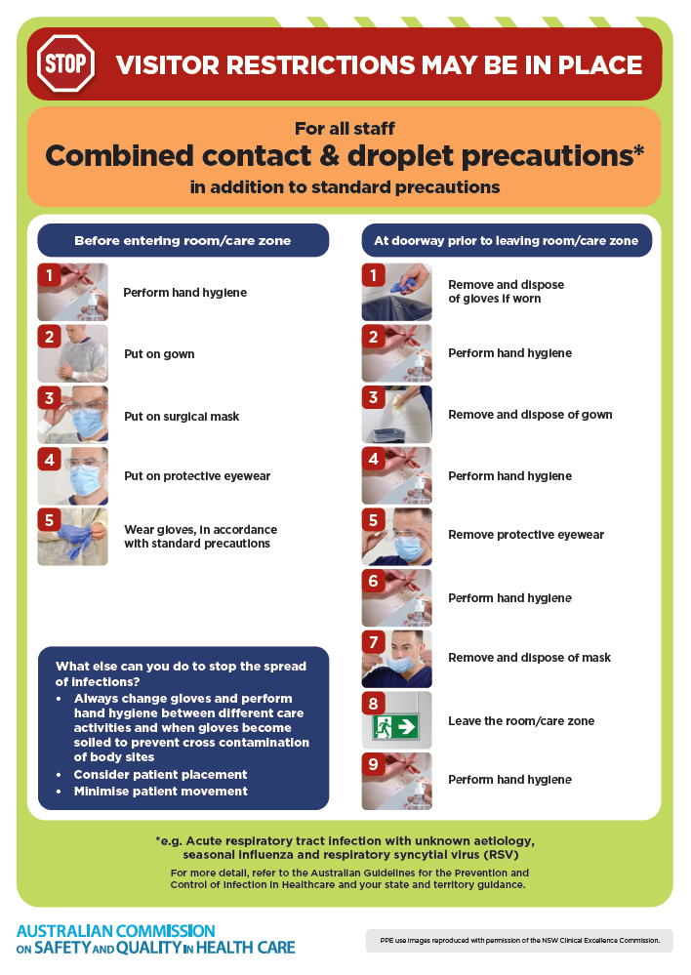
- Poster – Combined airborne and contact precautions
https://www.safetyandquality.gov.au/publications-and-resources/resource-library/infection-prevention-and-control-poster-combined-airborne-and-contact-precautions
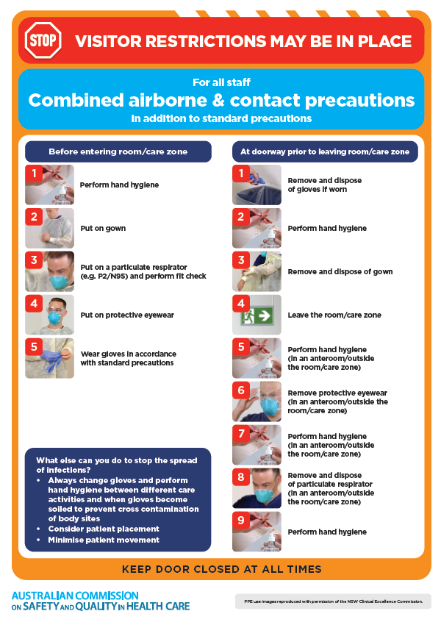
- Environmental Cleaning and Infection Prevention and Control www.safetyandquality.gov.au/environmental-cleaning
- Break the chain of infection poster
https://www.safetyandquality.gov.au/publications-and-resources/resource-library/break-chain-infection-poster
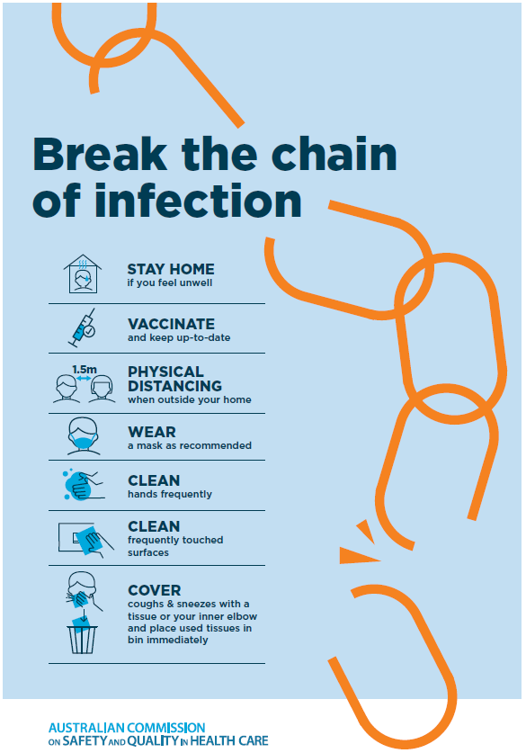

Disclaimer
On the Radar is an information resource of the Australian Commission on Safety and Quality in Health Care The Commission is not responsible for the content of, nor does it endorse, any articles or sites listed The Commission accepts no liability for the information or advice provided by these external links Links are provided on the basis that users make their own decisions about the accuracy, currency and reliability of the information contained therein Any opinions expressed are not necessarily those of the Australian Commission on Safety and Quality in Health Care.

