
On the Radar
Issue 729
26 January 2026

On the Radar is a summary of some of the recent publications in the areas of safety and quality in health care Inclusion in this document is not an endorsement or recommendation of any publication or provider Access to particular documents may depend on whether they are Open Access or not, and/or your individual or institutional access to subscription sites/services Material that may require subscription is included as it is considered relevant.

On the Radar is available online, via email or as a PDF or Word document from https://www.safetyandquality.gov.au/newsroom/subscribe-news/radar

If you would like to receive On the Radar via email, you can subscribe on our website https://www.safetyandquality.gov.au/newsroom/subscribe-news
or by emailing us at mail@safetyandquality.gov.au.
You can also send feedback and comments to mail@safetyandquality.gov.au.

For information about the Commission and its programs and publications, please visit https://www.safetyandquality.gov.au

On the Radar
Editor: Dr Niall Johnson
Contributors: Niall Johnson

Reports

National Cardiac Registry Annual Status Report 2025
Lefkovits J, Poulter R, Pyyvaara J, Brennan A, Dinh D, Stewart R, Sivakumaran T, and Lucas M on behalf of the Registry Steering Committee
URL | https://nationalcardiacregistry.org.au/2025-annual-status-report/
Notes | The Commission has had an active interest in the safety and quality potential of clinical quality registries for many years. This has included the development of the 2008 Operating Principles and Technical Standards for Australian Clinical Quality Registries, various editions of the framework for Australian clinical quality registries, including the Australian Framework for National Clinical Quality Registries 2024 and a range of other resources and materials. Over this period, the number and scope of clinical quality registries in Australia has grown significantly.  The National Cardiac Registry (NCR) has recently published its fifth annual status report. The NCR collects information regarding Percutaneous Coronary Intervention (PCI), a procedure to widen or unblock arteries to restore blood flow to the heart. The NCR Annual Status Report 2025 is a comprehensive summary of PCI activity in Australia, including performance and outcome data on procedures from January to December 2024. The NCR reports that it captured data on 50% of all PCI procedures undertaken in Australia with data from 59 hospitals in 8 states and territories.

For information on the Commission’s work on clinical quality registries, see https://www.safetyandquality.gov.au/our-work/indicators-measurement-and-reporting/national-guidance-clinical-quality-registries

Journal articles

Artificial intelligence in primary care: innovation at a crossroads
Laranjo L, Tudor Car L, Payne RE, Neves AL, Kidd M, Jaime Miranda J
The Lancet Primary Care. 2025.
DOI | https://doi.org/10.1016/j.lanprc.2025.100078
Notes | Review article that examines the state and potential of artificial intelligence (AI) in primary care. The authors observe ‘The latest advancements in artificial intelligence (AI) offer new opportunities to transform primary care. However, the rapid deployment of AI ahead of robust real-world evaluation or regulation raises concerns about unintended consequences on the quality of care. We review applications of AI in primary care, covering AI to support primary care providers and people with their health.’

For information on the Commission’s work on artificial intelligence, including the ‘Pragmatic AI guidance for clinicians’, see https://www.safetyandquality.gov.au/our-work/e-health-safety/artificial-intelligence

Digital competencies for health service managers and health service implications for Australia
Brommeyer M, Whittaker M, Mackay M, Liang Z
Health Information Management Journal. 2025:18333583251396573.
DOI | https://doi.org/10.1177/18333583251396573
Notes | In the latest paper from a program of work looking at digital health from the health service manager and health service organisation perspectives, the authors explore the key competencies that health service managers will need. The authors observe that ‘As the healthcare delivery landscape evolves and the impact of digital technologies and transformations becomes increasingly apparent, a competent healthcare management workforce, confident in the capabilities to employ and effectively incorporate digital health technologies into health service delivery is imperative.’ The authors identified eight ‘Digital competencies for health service managers’, namely:  - Applying digital system knowledge  - Data management  - Change, project and risk management  - Supporting digital development  - Vendor management and negotiating  - Governance, security and decision making  - Contextualising digital system functionality  - Digital agility and shared digital language.  The authors state that this work ‘revealed two key areas of management competency enhancement required: firstly, competence in digital data management and security; and secondly, the management of digital technologies in practice.’

The Joint Commission Journal on Quality and Patient Safety
Volume 52, Issue 1, January 2026
URL | https://www.sciencedirect.com/journal/the-joint-commission-journal-on-quality-and-patient-safety/vol/52/issue/1
Notes | A new issue of The Joint Commission Journal on Quality and Patient Safety has been published. Articles in this issue of The Joint Commission Journal on Quality and Patient Safety include:  - Reducing Delays in Postoperative Gynecologic Evaluations Through Automated Electronic Alerts (Bertie Geng, Nishita Pondugula, Lisbet Lundsberg, Holly Zurich, Rohit B Sangal, Linda Fan)  - Enhancing Code Blue, Rapid Response, and Emergency Response Safety in the Veterans Health Administration: Using a Combined Proactive Risk Assessment (CPRA) Approach to Detect Failure Modes and Identify Improvement Actions (John A Bender, Peter D Mills, S F Kulju, J R Turner)  - Long-Term Sustainability of QI Interventions: Outcomes in Opioid Prescribing for Postoperative Care (Andrii Khomiak, Joshua D Billings, Victoria Huynh, Laura D Leonard, Viviane L Abud, Teresa L Jones, Salvador Rodriguez Franco, Ioannis A Ziogas, Kyle Bata, Nicole Christian, Marco Del Chiaro, Ethan Cumbler, Sarah E A Tevis)  - Reducing Labeling Errors in Histopathology Specimens: A Quality Improvement Initiative on Endometrial vs. Endocervical Specimens to Promote Patient Safety in KK Women’s and Children’s Hospital (Yash Bhanji Boricha, Junzhe Zhao, Felicia Yiqian Ang, Kim Teng Tan)  - Evaluating a Disease-Specific Look-Back Trigger Methodology vs. Traditional Screening for Diagnostic Errors in the Emergency Department (Suresh K Pavuluri, Rohit B Sangal, Craig Rothenberg, Arjun Venkatesh, Richard Andrew Taylor, John Sather)  - Impact of Note-Extracted Blood Pressures on Measured Hypertension Control Performance (Jonathan A Handler, Tiaranesha Jackson, Kyle Espejo, Jeremy McGarvey, Ethan C Handler, Mark A Meeker)  - Myth Busters: A Discussion of the Misconceptions Surrounding Patient Hndoffs (Elizabeth H Lazzara, Sabina M Patel, Scott I Tannenbaum, Rosemarie Fernandez, Eduardo Salas, Joseph R Keebler)

BMJ Quality & Safety online first articles
URL | https://qualitysafety.bmj.com/content/early/recent
Notes | BMJ Quality &Safety has published a number of ‘online first’ articles, including:  - Culturally adapted, pharmacist-supported heart failure day hospital: mixed-methods evaluation of outcomes and implementation mechanisms (Marine Taranzano, Indira Cabrera Rubio, Jérôme Corré, Sophien Horri, Dickens Fanfan, Sebastien Molinari, Thiziri Si Moussi, Reza Rossanaly Vasram, Shamir Vally, Jeremy Marot, Clara Lallemand, Romain Perrin, Floriane Auclair, Fanny David, Catherine Marimoutou, Louis-Marie Desroche)

Online resources

Australian Living Evidence Collaboration
https://livingevidence.org.au/

Guidance
A number of guidelines or guidance have recently been published or updated These include:
- European Respiratory Society, Clinical practice guideline for the management of adult bronchiectasis https://doi.org/10.1183/13993003.01126-2025

[UK] NICE Guidelines and Quality Standards
https://www.nice.org.uk/guidance
The UK’s National Institute for Health and Care Excellence (NICE) has published new (or updated) guidelines and quality standards The latest reviews or updates include:
- Interventional procedures guidance IPG811 Balloon cryoablation for Barrett's oesophagus https://www.nice.org.uk/guidance/ipg811

Infection prevention and control resources
The Australian Commission on Safety and Quality in Health Care has developed a number of resources to assist healthcare organisations, facilities and clinicians These resources include:
- Poster – Combined contact and droplet precautions https://www.safetyandquality.gov.au/publications-and-resources/resource-library/infection-prevention-and-control-poster-combined-contact-and-droplet-precautions
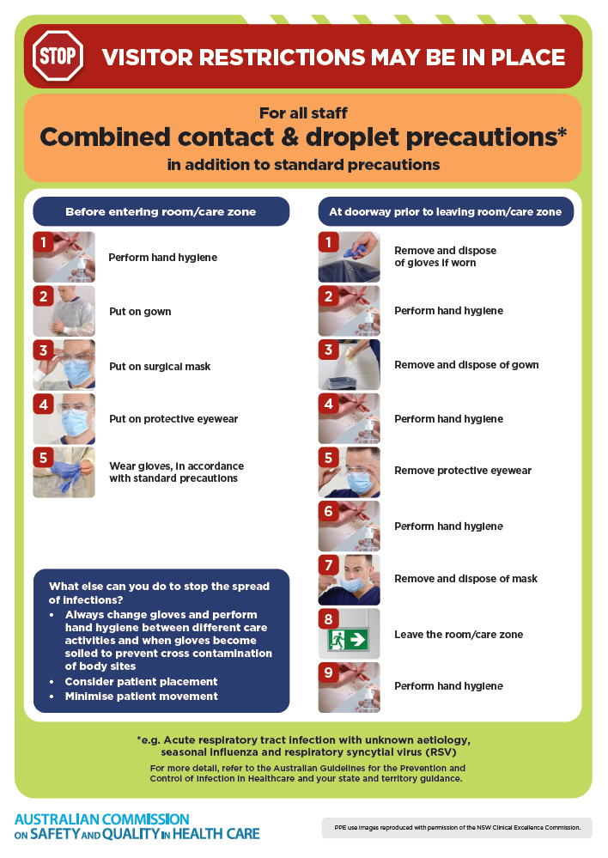
- Poster – Combined airborne and contact precautions
https://www.safetyandquality.gov.au/publications-and-resources/resource-library/infection-prevention-and-control-poster-combined-airborne-and-contact-precautions
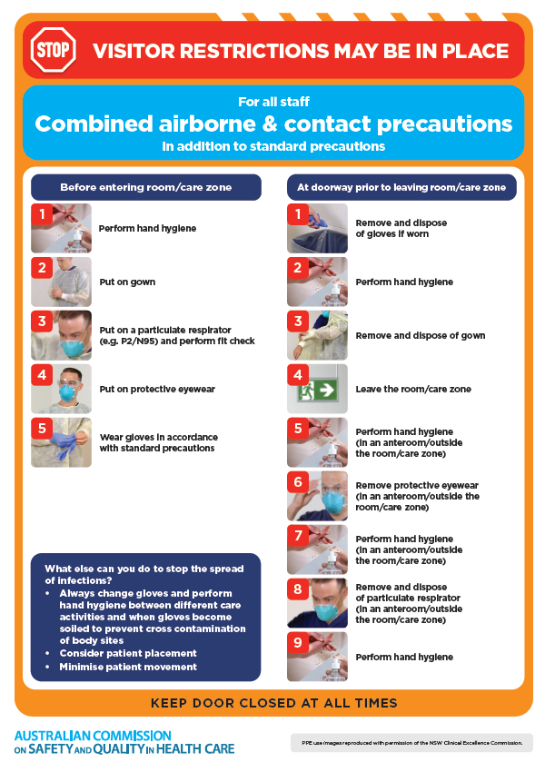
- Environmental Cleaning and Infection Prevention and Control www.safetyandquality.gov.au/environmental-cleaning
- Break the chain of infection poster
https://www.safetyandquality.gov.au/publications-and-resources/resource-library/break-chain-infection-poster
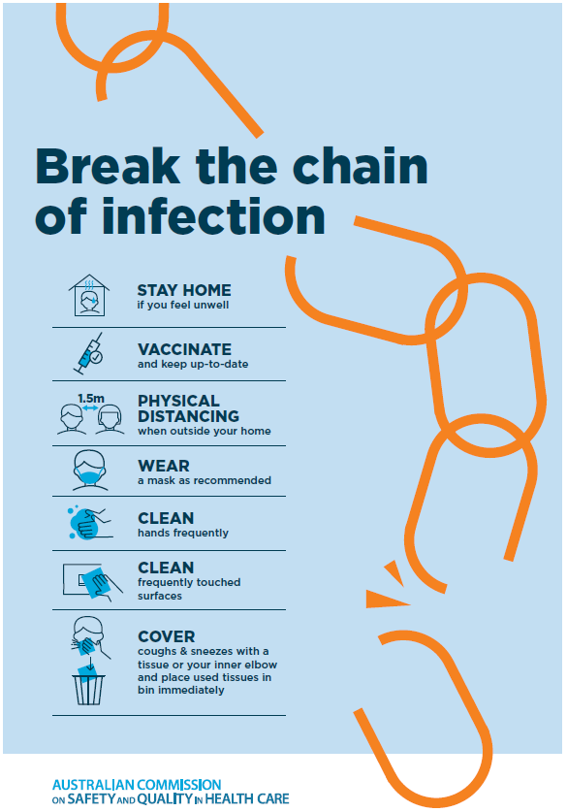

Disclaimer
On the Radar is an information resource of the Australian Commission on Safety and Quality in Health Care The Commission is not responsible for the content of, nor does it endorse, any articles or sites listed The Commission accepts no liability for the information or advice provided by these external links Links are provided on the basis that users make their own decisions about the accuracy, currency and reliability of the information contained therein Any opinions expressed are not necessarily those of the Australian Commission on Safety and Quality in Health Care.

