
On the Radar
Issue 730
2 February 2026

On the Radar is a summary of some of the recent publications in the areas of safety and quality in health care Inclusion in this document is not an endorsement or recommendation of any publication or provider Access to particular documents may depend on whether they are Open Access or not, and/or your individual or institutional access to subscription sites/services Material that may require subscription is included as it is considered relevant.

On the Radar is available online, via email or as a PDF or Word document from https://www.safetyandquality.gov.au/newsroom/subscribe-news/radar

If you would like to receive On the Radar via email, you can subscribe on our website https://www.safetyandquality.gov.au/newsroom/subscribe-news
or by emailing us at mail@safetyandquality.gov.au.
You can also send feedback and comments to mail@safetyandquality.gov.au.

For information about the Commission and its programs and publications, please visit https://www.safetyandquality.gov.au

On the Radar
Editor: Dr Niall Johnson
Contributors: Niall Johnson

Reports

Framework for respectful maternity and newborn care
A guide for health services, clinicians and consumers on maternity and newborn services
Safer Care Victoria
Melbourne: SCV; 2025. p. 66.
URL | https://www.safercare.vic.gov.au/publications/respectful-maternity-and-newborn-care-framework
Notes | Safer Care Victoria (SCV) released this new resource early in the new year. It is designed to be ‘a practical tool that supports clinicians and consumers to work in genuine partnership – especially when a woman makes an informed decision about her care pathway that differs from clinical recommendations. It provides case studies, flowcharts, and tools to guide informed decision-making, ensuring that a woman’s autonomy, dignity, and cultural needs are respected throughout her maternity journey.’ The framework is intended to support (Victorian) health services at all levels of capability and across all specialties.

Equally Well Victoria: 2nd Edition (2025)
Physical health framework for mental health services
Safer Care Victoria
Melbourne: SCV; 2025. p. 88.
URL | https://www.safercare.vic.gov.au/publications/equally-well-victoria-2nd-edition-2025
Notes | Also published by Safer Care Victoria is a new edition of their physical health framework for mental health services, Equally Well Victoria. This resource is intended to assist mental health services to improve physical health outcomes, promote equity, and address priority areas like cancer screening, women’s health, and culturally safe care for all Victorians.

Learning through national Health System Performance Assessment (HSPA).
Emerging findings from OECD countries
OECD
Paris: OECD Publishing; 2026. p. 39.
DOI | https://doi.org/10.1787/2fa1314a-en
Notes | Policy paper from the OECCD that examines how Health System Performance Assessment (HSPA) frameworks can aid in using health data to inform better policy. Reflecting on experiences from eleven OECD member nations, the report examines the importance of quality data, inclusive governance, clear policy alignment, and engagement.

Final report. Review of the PHN Business Model and Mental Health Flexible Funding Stream
Boston Consulting Group
Canberra: Department of Health, Disability and Ageing; 2025. p. 39.
URL | https://www.health.gov.au/resources/publications/primary-health-network-program-final-report?language=en
Notes | Final report of a review of the Primary Health Network (PHN) program commissioned from the Boston Consulting Group by the Australian Department of Health, Disability and Ageing. The review ‘recommends two streams of immediate reforms to the PHN Business Model to rise confidence in PHNs through governance and engagement standards and performance assessment and to improve processes for funding.

Journal articles

Best Practice Principles to Work With Consumer Representatives on Patient Safety Investigation Teams
Yu Y, Molloy CJ, Bowditch L, Bierbaum M, Watson L, Morris J, et al
Health Expectations. 2026;29(1):e70543.
DOI | https://doi.org/10.1111/hex.70543
Notes | This is the latest paper from a project looking at the role, contributions, potential and experiences of consumer representatives (CRs) in patient safety investigation teams. This paper offers a series of best practice principles distilled from the study. The Best practice principles for health services to work with consumer representatives include:  - Formalise the CR role – Professionalise the role of CRs by implementing a standardised and formal recruitment process that includes clearly defined selection criteria to ensure an appropriate fit for the role.  - Provide investigation team-level support – Training programmes for CRs should cover core principles, methodologies, investigation processes and relevant state and national legislation.  - Organisational integration of the role – Develop training and awareness initiatives and implement them across healthcare services to emphasise the benefits and contributions of CRs within organisational structures.  - System-wide cultural shift – At the policy level, take a leadership role and set enforceable standards and expectations regarding the involvement of CRs in investigation teams.

For information on the Commission’s work on partnering with consumers see https://www.safetyandquality.gov.au/our-work/partnering-consumers

Co-Producing a Patient Reported Experience Measure (PREM) With and for People With Intellectual Disability
Newman B, Wu L, Mimmo L, Catlett B, Van Hoeke M, Tokutake M, et al.
Health Expectations. 2026;29(1):e70562.
DOI | https://doi.org/10.1111/hex.70562
Notes | Patient reported outcome measures (PROMs) and Patient reported experience measures (PREMs) have become more widely used in recent years. This paper describes a project to develop a PREM for use by people with intellectual disability.  The paper ‘reports the coproduction of accessible PREMs for people with intellectual disability from a 3-year inclusive research project called Listen to Me’ in Australia. The authors report that ‘Co-production occurred through inclusive data collection methods in five hybrid co-production workshops’ and ‘included two people with intellectual disability, six people who support family members with intellectual disability, three researchers and three people with experience health service management or direct care’ with ‘preliminary user testing completed by 11 people with intellectual disability with a range of communication needs and preferences’.  The authors argue that ‘The Listen to Me PREMs provide an innovative tool to capture patent-reported experiences directly from people with intellectual disability.’

For information on the Commission’s work on patient-reported outcome measures see https://www.safetyandquality.gov.au/our-work/indicators-measurement-and-reporting/patient-reported-outcome-measures

Standard Elements in Studies of Adverse Events and Medical Error: the SESAME statement
Griffey RT, Unbeck M, Stockwell DC, Adler LM, Ancona R, Classen D, et al
BMJ Quality & Safety. 2026
DOI | https://doi.org/10.1136/bmjqs-2025-019458
Notes | Paper describing the development of ‘the SESAME (Standard Elements in Studies of Adverse Events and Medical Error) reporting guideline. SESAME is a 44-item checklist designed to support comprehensive and standardised reporting in studies evaluating potential patient harm.’ The authors argue that ‘Standard, transparent and complete reporting of methodological components is important to ensure reproducibility, actionability and shared understanding of findings. Adherence to the Standard Elements in Studies of Adverse Events and Medical Error Statement will improve the clarity of reporting, with positive downstream consequences including more accurate translation of study findings for patient safety measures and policy decisions.’

Patient safety incidents associated with EMR use: Results of a national survey of Swiss physicians
Schwappach D, Hautz W, Krummrey G, Pfeiffer Y, Ratwani R
Digital Health. 2026;12:20552076251403204.
DOI | https://doi.org/10.1177/20552076251403204
Notes | That technologies can both resolve issues and introduce new ones is quite well understood. Electronic medical record (EMR) systems offer many benefits and are widely used. This paper reports on a Swiss study that surveyed clinicians on their experiences of using EMRs and patient safety incidents encountered. The authors report that ‘Of the 1933 inpatient and outpatient physicians who completed the survey, 23.9% (n = 398) reported experiencing an EMR-related safety incident in the previous four weeks’ with 49.7% of these incidents not formally reported. Thematic analysis of the free-text descriptions of incidents led to the dentification of ‘seven emergent themes:  - patient identification and selection errors (16.7%),  - system reliability and performance issues (15.8%),  - interoperability and system integration (8.8%),  - usability, interface, and design problems (21.8%),  - system errors and unexpected behavior (8.8%),  - security and access control (2.6%), and  - problems with order entry, decision support, alerting, and verification (25.2%).’

For information on the Commission’s work on e-health and digital health, see https://www.safetyandquality.gov.au/our-work/e-health-safety

Digital Inclusion Pathways To Health Equity
Sheon AR, Khoong EC
Health Affairs Health Policy Brief
DOI | https://www.healthaffairs.org/do/10.1377/hpb20260115.890623/full/
Notes | Digital health and digitally enabled health are changing health care and have potential to bring further change. One of the potentials for digital health lies in improving health equity. This policy brief examines how digital inclusion strategies can ‘ensure that digital health technology advances, rather than undermines, health equity’. Among the briefs key point is the observation ‘Digital inclusion offers pathways to health equity by expanding access to the formal health care sector and supporting independent health management. Yet poverty- and education-related disparities reemerge with each new technology (artificial intelligence, telehealth, patient portals, mobile apps, and remote biometric monitors), exacerbating health inequities.’

What counts as care? Structural critique of digital health models
Wang X, Yang F, Trafford J, Qiu W, Conn C
Digital Health. 2026;12:20552076251411273.
DOI | https://doi.org/10.1177/20552076251411273
Notes | Digital health has many benefits and potentials. The authors of this piece asks ‘In a world increasingly saturated with digital health technologies, the promise of empowerment through information has become almost axiomatic. Yet what if access does not equate to understanding, and what if the sleek interfaces and personalized nudges of today's tools merely simulate agency while displacing it?’ In examining a number of the models framing digital health design the authors argue that ‘addressing the digital divide requires structural interventions, such as participatory oversight and redistributive design, ensuring that digital health systems are grounded in human understanding rather than just administrative efficiency.’

Caffeinated Coffee Consumption or Abstinence to Reduce Atrial Fibrillation: The DECAF Randomized Clinical Trial
Wong CX, Cheung CC, Montenegro G, Oo HH, Peña IJ, Tang JJ, et al
JAMA. 2026;335(4):317-325.
DOI | https://doi.org/10.1001/jama.2025.21056
Notes | Paper reporting on a randomised clinical trial conducted in 5 hospitals in the USA, Canada, and Australia between November 2021 and December 2024 with 200 patients that sought ‘To determine the effect of caffeinated coffee consumption compared with abstinence from coffee and caffeine on recurrent AF’ (atrial fibrillation). The 200 ‘current or previous (within past 5 years) coffee-drinking adults with persistent AF, or atrial flutter with a history of AF, planned for electrical cardioversion’ were ‘randomized in a 1:1 ratio to regular caffeinated coffee consumption vs coffee and caffeine abstinence for 6 months’. The authors report that ‘In the primary analysis, AF or atrial flutter recurrence was less in the coffee consumption (47%) than the coffee abstinence (64%) group, resulting in a 39% lower hazard of recurrence (hazard ratio, 0.61 [95% CI, 0.42-0.89]; P = .01). A comparable benefit of coffee consumption was observed with AF recurrence only. There was no significant difference in adverse events.’

BMJ Quality & Safety online first articles
URL | https://qualitysafety.bmj.com/content/early/recent
Notes | BMJ Quality &Safety has published a number of ‘online first’ articles, including:  - Standard Elements in Studies of Adverse Events and Medical Error: the SESAME statement (Richard T Griffey, Maria Unbeck, David C Stockwell, Lee M Adler, Rachel Ancona, David Classen, Ryan M Schneider, Anne Wilhelmina Saskia Rutjes, Christopher R Carpenter, The SESAME Development Team)  - Impact of COVID-19 on incidence and trends of adverse events among hospitalised patients in Calgary, Canada: a retrospective chart review study (Guosong Wu, Cathy A Eastwood, Cheligeer Cheligeer, Danielle A Southern, Yong Zeng, William A Ghali, Jeffrey A Bakal, Bastien Boussat, Ward Flemons, Alan Forster, Yuan Xu, Hude Quan)  - Learning from complaints about surgical care: a large language model-assisted sequential methods analysis (Cameron Wells, Allan Han, Nejo Joseph, Chris Varghese, Greg O’Grady, Ian Bissett)

International Journal for Quality in Health Care online first articles
URL | https://academic.oup.com/intqhc/advance-articles
Notes | International Journal for Quality in Health Care has published a number of ‘online first’ articles, including:  - From Standardization to Trust: The Greek Experience with ISO and EN 15224 in Public Hospitals (Georgia Kyriakeli)  - ISO 9001 in hospitals: a systematic review and implementation framework for clinical services in emerging countries (Jihad Boukhaldi, Hind Kechkar , Abderrahmane Errami , Ibtihal Benhsaien , Nabiha Kamal , Ahmed Aziz Bousfiha , Jalila El Bakkouri)

Online resources

Australian Living Evidence Collaboration
https://livingevidence.org.au/

Lancet MedZero
https://www.medzerocarbon.com/
Lancet MedZero is intended to ‘serve as a one-stop global platform for robustly evaluating the carbon footprint of healthcare at unprecedented scope and scale.’ It has been developed for clinicians, procurement and sustainability professionals, and health policymakers to provide carbon data of every part of the clinical pathway, including medical and surgical devices, pharmaceuticals, diagnostic services, and care pathways.

[USA] Effective Health Care Program reports
https://effectivehealthcare.ahrq.gov/
The US Agency for Healthcare Research and Quality (AHRQ) has an Effective Health Care (EHC) Program The EHC has released the following final reports and updates:
- Dietary Total Fat Intake and Dietary Polyunsaturated Fatty Acid Intake and Child Growth and Development Outcomes: A Systematic Review
https://effectivehealthcare.ahrq.gov/products/child-growth-development-outcomes/research

Infection prevention and control resources
The Australian Commission on Safety and Quality in Health Care has developed a number of resources to assist healthcare organisations, facilities and clinicians These resources include:
- Poster – Combined contact and droplet precautions https://www.safetyandquality.gov.au/publications-and-resources/resource-library/infection-prevention-and-control-poster-combined-contact-and-droplet-precautions
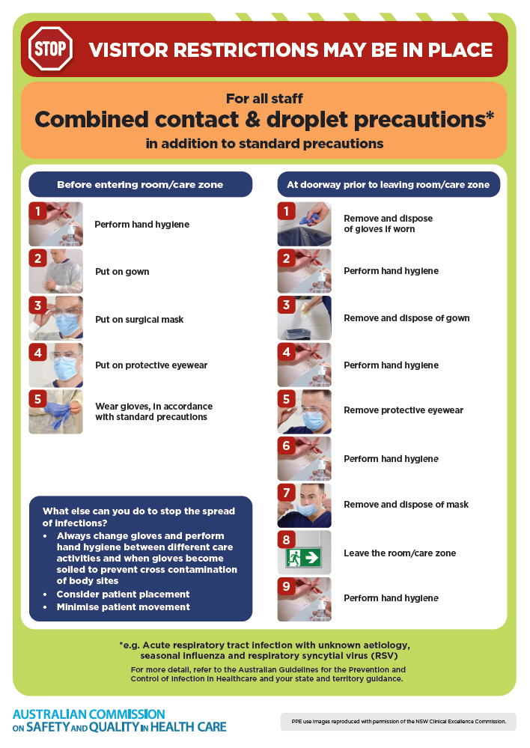
- Poster – Combined airborne and contact precautions
https://www.safetyandquality.gov.au/publications-and-resources/resource-library/infection-prevention-and-control-poster-combined-airborne-and-contact-precautions
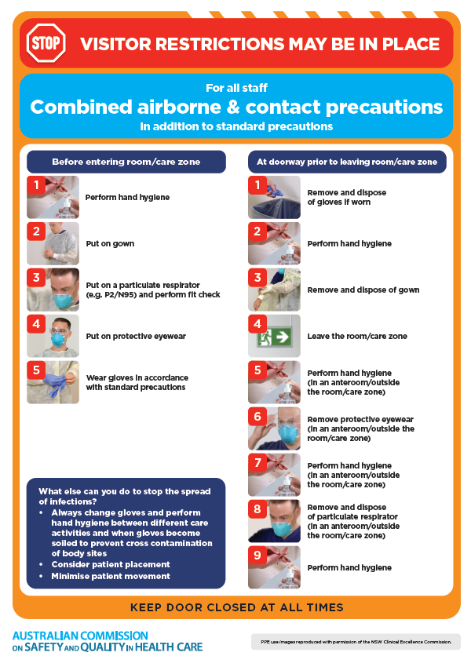
- Environmental Cleaning and Infection Prevention and Control www.safetyandquality.gov.au/environmental-cleaning
- Break the chain of infection poster
https://www.safetyandquality.gov.au/publications-and-resources/resource-library/break-chain-infection-poster
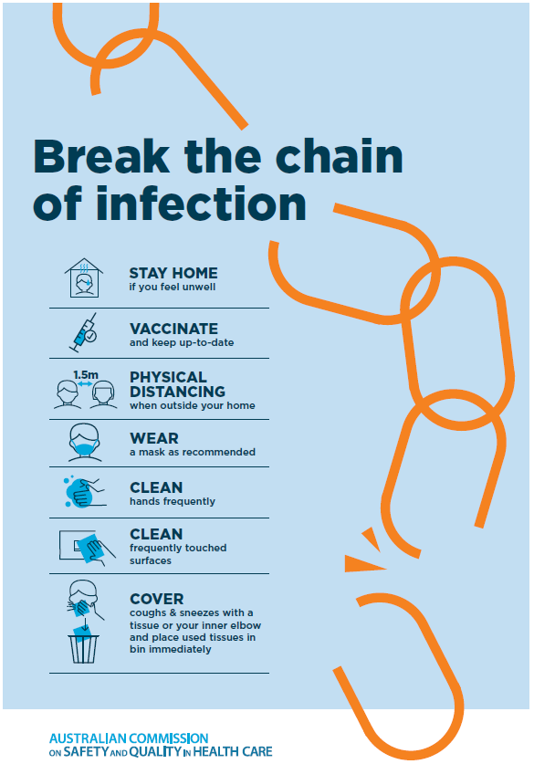

Disclaimer
On the Radar is an information resource of the Australian Commission on Safety and Quality in Health Care The Commission is not responsible for the content of, nor does it endorse, any articles or sites listed The Commission accepts no liability for the information or advice provided by these external links Links are provided on the basis that users make their own decisions about the accuracy, currency and reliability of the information contained therein Any opinions expressed are not necessarily those of the Australian Commission on Safety and Quality in Health Care.

