
On the Radar
Issue 731
9 February 2026

On the Radar is a summary of some of the recent publications in the areas of safety and quality in health care Inclusion in this document is not an endorsement or recommendation of any publication or provider Access to particular documents may depend on whether they are Open Access or not, and/or your individual or institutional access to subscription sites/services Material that may require subscription is included as it is considered relevant.

On the Radar is available online, via email or as a PDF or Word document from https://www.safetyandquality.gov.au/newsroom/subscribe-news/radar

If you would like to receive On the Radar via email, you can subscribe on our website https://www.safetyandquality.gov.au/newsroom/subscribe-news
or by emailing us at mail@safetyandquality.gov.au.
You can also send feedback and comments to mail@safetyandquality.gov.au.

For information about the Commission and its programs and publications, please visit https://www.safetyandquality.gov.au

On the Radar
Editor: Dr Niall Johnson
Contributors: Niall Johnson

Reports

Global State of Patient Safety 2025
Illingworth J, Batchlor S, Khalsa I, Leis M, Howitt P, Titcombe J, et al
London: Imperial College London; 2026
URL | https://www.imperial.ac.uk/Stories/global-state-patient-safety-2025
Notes | This updated Global State of Patient Safety report has been released, along with an updated interactive global patient safety dashboard that incorporates 108 indicators across 209 countries over 25 years.  Many of the findings of this report are similar to the 2023 report. It was observed that ‘Few countries showed significant movement since 2023, suggesting that meaningful change in patient safety takes time.’ The report provides something of a “league tables” ranking on patient safety. However, the value of such rankings – in almost any domain – are debatable. The limitations of data availability are acknowledged with gaps in the data for lower and middle income nations along with a recognition that ‘Most data represents performance in acute care, leaving notable gaps in our knowledge in primary and community settings. These gaps mean it is impossible to provide a truly global picture of patient safety, and why much of our focus remains on OECD and HICs’ [High Income Countries]. While this is a global report, much of the focus is on the UK.  The report offers ‘16 ambitions for safer systems’ and a number of recommendations.. The ‘ambitions’ fall into ‘four domains (strategy and governance, implementation and learning, involvement and capability, and data and measurement)’ and ‘describe how countries can strengthen their patient safety systems.’  The updated and expanded recommendations in this report are:  - To create a more comprehensive set of global patient safety indicators, we encourage international organisations focused on safety and quality to develop a roadmap to improve data coverage in LMICs. The example of maternal and neonatal safety data shows how collective action can lead to global coverage, supporting safety improvement efforts.  - To support improved adoption of best practice in patient safety, we advise countries to use our patient safety dashboard, international insights, and ambitions for national patient safety systems to learn from best practice in core aspects of patient safety. These tools complement emerging resources, including the WHO Global Knowledge Sharing Platform for Patient Safety.  - To help ensure patients, families and carers become active partners in the delivery of safe care, we advocate national and international action to address the inequities in safe care identified in this report. Our case studies demonstrate how patients and the public can become part of the solution, helping to design and inform national policies and interventions for safer care.  This edition is accompanied by a number of country case studies, including one on Australia that includes contributions from the Australian Commission on Safety and Quality in Health Care and Safer Care Victoria. The Australian case study notes a focus on clinical governance along with the roles of standards, accreditation and the collection and use of data.

Promoting mental health through cycling and walking: a win-win approach for health and sustainability
World Health Organization
Copenhagen: WHO Regional Office for Europe; 2026. p. 18.
URL | https://www.who.int/europe/publications/i/item/WHO-EURO-2026-12905-52679-81719
Notes | Policy brief from the WHO Regional Office for Europe that ‘presents evidence on the impacts of active mobility on mental health and provides tips and recommendations on interventions that support both health and environmental objectives as well as recommended actions and conclusion for policy-makers and practitioners, with a special focus on the mental health benefits of walking and cycling.’

Journal articles

Uptake and performance of self-collection offered through primary care to all eligible participants in a national cervical screening programme in Australia: a retrospective cohort study
Sultana F, Smith M, Saville M, Bateson D, Roder D, Milch V, et al
The Lancet Public Health. 2026;11(2):e101-e10.
DOI | https://doi.org/10.1016/S2468-2667(25)00304-4
Notes | Paper reporting on the impact of self-collection for cervical cancer screening in Australia. The study was a ‘retrospective cohort study was conducted as part of ongoing quality assurance and safety monitoring of the Australian National Cervical Screening Program, which expanded self-collection eligibility’ from 1 July 2022. The authors report uptake of self-collection ‘steadily increased after the eligibility criteria were expanded’. From their analyses the authors assert that ‘Universal access to self-collection through primary care substantially increased cervical screening uptake in under-screened populations in Australia, while maintaining performance in the histological detection of high-grade lesions and cancer. Offering self-collection to every woman is an important addition to cervical screening programmes to improve equity and drive efforts in the global elimination of cervical cancer.’

Inequity Is Our Biggest Killer: Looking Upstream to Tackle the Burden of Disease in Australia
Khalatbari-Soltani S, Jegasothy E, Abimbola S, van Zwieten A
Medical Journal of Australia. 2026;224(1):e70119.
DOI | http://doi.org/10.5694/mja2.70119
Notes | In an era of increasing inequality that in turn drives politics of grievance and division, the issue of inequity is arguably also of increasing importance. This perspective piece in the Medical Journal of Australia suggests ‘inequity is our biggest killer’ and ‘that to effectively move the dial on disease burden, we must shift our focus from downstream action on individual-level risk factors to upstream action on structural causes. Failure to do so represents a missed opportunity to improve population health and tackle health inequity’.

HealthcarePapers
Volume 23, Number 3, December 2025
URL | https://www.longwoods.com/publications/healthcarepapers/27753/
Notes | A new issue of HealthcarePapers has been published. Articles in this issue of HealthcarePapers include:  - Are Canada’s Health Systems Capable of Innovation? Plus ça change, plus c’est la même chose (Sara Allin and Audrey Laporte)  - Ten-Year Anniversary of the Advisory Panel on Healthcare Innovation Report: Assessing Progress and What Is Left to Do (Braden J Manns, Stephanie Hastings and Alan J Forster)  - From Stasis to Crisis: How and What Now for Canada’s Healthcare Systems? (C David Naylor)  - Time to Go Big or Go Home: A Reflection on the Advisory Panel on Healthcare Innovation (Alex Munter)  - Ten Years of Progress in Patient Engagement: A Foundation Built, But Time to Deliver (Robin Urquhart)  - Health Workforce Canada: A Source of Innovation in Health Workforce Planning (Deb Gordon and Glenda Yeates)  - Beyond Silos and Perpetual Pilots: Data as the Catalyst for Canada’s Healthcare Innovation Revolution (Anderson W Chuck)  - Accelerating Innovation and Technological Transformation on a National Scale (Eyal Zimlichman)  - Scaling Innovation in a Publicly Funded System: A UK Pathway From Evidence to Adoption (Matthew Whitty and David Walliker)  - Rethinking the Federal Role in Health: Revisiting the 2015 Naylor Report on Healthcare Innovation (Marcel Saulnier)  - Is Health Canada The Key to Cracking the Nut of Healthcare Reform? (Jason M Sutherland)  - Building the Structures and Ecosystem Required for Sustainable Health Innovation in Canada (Alan J. Forster, Stephanie Hastings and Braden J Manns)

Health Policy
Volume 165, March 2026
URL | https://www.sciencedirect.com/journal/health-policy/vol/165/
Notes | A new issue of Health Policy has been published. Articles in this issue of Health Policy include:  - Survey data collection during the COVID-19 pandemic in Germany: Recommendations for an improved data collection infrastructure (Tobias Gummer, K von Glasenapp, T Skora, E Naumann, S Bartholomäus, S Piesch)  - Health access reforms in the Caribbean Netherlands from 2010-2023 (Nathan Shuftan, Jane O’Flynn, J Meijer, R Borst, S Verstraeten, D Courtar, G Frans, A van der Linden, I Madhuban, M Mercuur, E van Ginneken)  - The relationship between trust and compliance in the Italian NHS: Results of the People's Voice Survey (Rosanna Tarricone, Patrizio Armeni, Catherine Arsenault, Margaret E Kruk)  - South Korea's 2024 medical school expansion: From healthcare reform to constitutional crisis (Daihun Kang)  - Factors influencing eHealth adoption among healthcare users in Türkiye: A stepwise logistic regression analysis (Zeynep Güldem Ökem, Betül Akbuğa Özel, Gül Pamukçu Günaydın, Furkan Enes Dilek)  - Factors influencing the experience of client-centeredness in flemish (Proxy) budget holders: a moderation analysis (Eva Pattyn, Paul Gemmel, Ruben Willems, Susan Lagaert, Jeroen Trybou)  - Impact of prospective payment systems: An umbrella review of systematic reviews (Mélanie Lefèvre, Koen Van den Heede, Carine Van de Voorde)  - National policy responses to address loneliness: A global scoping review of 194 WHO member states (Nina Goldman, Melek Alemdar, Herlind Megges, Naka Matsumoto, Eric Schoenmakers, Pauline van den Berg, M Lasgaard, J Christiansen, N Junttila, A Goldman, D Draxl, A El-Osta, P Qualter)  - Pancreatic cancer mortality and associated productivity losses in Spain: A population-based estimate (2013–2022) (Josep Darbà, Meritxell Ascanio, Antonio Rodríguez)  - The impact of the new ‘guard rails’ for price negotiations on pharmaceutical expenditure in Germany: A simulation exercise and retrospective analysis (C. Kranich, D. Möller, C.M. Dintsios)  - The impact of primary care networks on emergency hospitalisations in the English NHS: An interrupted time series analysis (Lana Kovacevic, Lindsay Forbes, Hutan Ashrafian, Erik Mayer, E Mossialos, D Lugo-Palacios)  - A composite and synthetic index of potentially avoidable hospitalization in adults to assess primary care quality: an application across Italian geopolitical areas (Aurora Heidar Alizadeh, Marcello Cuomo, Alessandra Burgio, Alessandro Solipaca, Paola Arcaro, Danilo Catania, Barbara Giordani, Walter Ricciardi, Giovanni Baglio, Gianfranco Damiani)  - Judicious resource managers or administrative intermediaries: A systematic review of family physician perspectives on the administrative process of referring patients to other clinicians in high income countries (Asiana Elma, Alison K. Scholes, Alexander Singer, Jennifer Shuldiner, Katrina Shen, Ian Scott, Danielle O’Toole, Deena M Hamza, Lawrence Grierson, Russell Dawe, Alexandra Cernat, Meredith Vanstone)  - Provision of community health services and use of hospital care in England: Nationwide retrospective observational study (Beth Parkinson, Matt Sutton, Rachel Meacock)  - Prosocial versus self-interested appeals in offline health communication: A randomized trial of framed messages during the COVID-19 pandemic in Switzerland (Anna-Corinna Kulle, Stefanie Schumacher, F von Bieberstein)  - Editorial for the special issue How do Health Systems and Health contribute to the Sustainable Development Goals? (Luigi Siciliani, Jonathan Cylus, Michelle Falkenbach, Josep Figueras, Scott Greer, Matthias Wismar)  - Social policies, health systems, and care delivery: Policy implications of eight papers in empirical health economics (Chiara Seghieri, Luigi Siciliani, John Mullay)  - Healthcare workforce distribution during multiple crises: a 12-year analysis of physician allocation, retention and equity patterns in Turkey (Eray Ontas, Cavit Işık Yavuz)  - Community health workers: a comparative assessment of capacities of a global policy approach in selected European health systems (Ellen Kuhlmann, Gabriela Lotta, Viola Burau, Tiago Correia, Michelle Falkenbach, Marius-Ionut Ungureanu, Iris Wallenburg, Gemma A Williams, Uta Lehmann)  - Small countries face specific challenges in health workforce sustainability, but policy responses are a testbed for resilience for all countries (Erica Richardson, Natasha Azzopardi-Muscat, Marios Kantaris, Anne-Charlotte Lorcy, Bernd Rechel, Nathan Shuftan, Ewout van Ginneken, G A Williams)  - Editorial. The health and care workforce: How to move from crisis to capacities? (Ellen Kuhlmann, Tiago Correia, Michelle Falkenbach, Gabriela Lotta, Ligia Paina)  - Nurse-led models of care and their potential to improve primary healthcare for refugees in Germany: A qualitative multiple-case study (Andreas W Gold, Clara Perplies, Kayvan Bozorgmehr)

Health Affairs
Volume 45, Number 2, February 2026
URL | https://www.healthaffairs.org/toc/hlthaff/45/2
Notes | A new issue of Health Affairs has been published with themes of ‘Health Spending, Physician Practice and more’. Articles in this issue of Health Affairs include:  - National Health Care Spending Increased 7.2 Percent In 2024 As Utilization Remained Elevated (Micah Hartman, Anne B Martin, David Lassman, and Aaron Catlin)  - Bundled Payments For Care Improvement Advanced: Effects On Hospital And CMS Spending, 2018–21 (Andrew M Ryan, Yan Lin, Jason D Buxbaum, Sukruth A Shashikumar, and Peter Hull)  - ‘Ghost’ Physicians: More Than One-Quarter Of Physicians Enrolled In Medicaid Delivered No Care To Beneficiaries In 2021 (Jane M Zhu, Kirbee A Johnston, Kyle Hart, Daniel Polsky, and K John McConnell)  - Changes In Primary Care Physicians’ Electronic Health Record Patterns After They Reduced Clinical Visit Volume (Gabe G Weinreb, A J Holmgren, Nate C Apathy, David W Bates, Bruce E Landon, and Lisa S Rotenstein)  - Prescription Real-Time Benefit Tools: Clinicians Receive Frequent Alerts Yet Rarely Accept The Suggested Changes (Ishani Ganguli, Nicholas E Daley, Mark J Soto, Caroline E Sloan, Foster R Goss, and Anna D Sinaiko)  - Changes In Medical Debt And Bankruptcy After Acute Traumatic Injuries, 2019–21(John W Scott, Nora V Becker, Mark R Hemmila, Nicholas Kunnath, John Z Ayanian, A Mark Fendrick, Andrew M Ryan, and Justin B Dimick)  - Switching Medicare Plans Outside Open Enrollment Was Increasingly Common, Especially Among Sicker Enrollees, 2015–22 (Grace Mackleby, Angela Liu, and Erin Trish)  - Assessing The Inclusion Of Federally Qualified Health Centers In Medicare Advantage Networks (Nicole C Giron, David J Meyers, Megan B Cole, Brad Wright, and Amal N Trivedi)  - Review Times For New Drugs And Submission Delays Among The FDA And 4 International Regulators, 2014–22 (Irene Papanicolas, O J Wouters, Tania Sawaya, Jihye Han, Jinru Wei, and Huseyin Naci)  - Staffing Conditions In US Nursing Homes Before, During, And After The COVID-19 Pandemic (Deepon Bhaumik, Momotazur Rahman, Emily A Gadbois, E M White, B E McGarry, F Geng, R T Braun, and D C Grabowski)  - Fluctuating State Medicaid Dental Coverage: Asymmetric Impact Of Benefit Cuts And Expansions, 2010–21 (Hawazin W Elani, Benjamin D Sommers, Ichiro Kawachi, Renuka Tipirneni, and Meredith B Rosenthal)  - Addressing Nutrition And Food Insecurity Among Black Households In Georgia Through Guaranteed Income (Stephen Roll, Leah Hamilton, Laura Brugger, Toby Beckelman, Alla Hill, and Joelle Johnson)  - Strategic Selection And Pricing Power: Optum’s Acquisitions Of Ambulatory Surgery Centers And Physician Practices (Derek T Lake, Lawrence P Casalino, Michael R Richards, Sean Nicholson, Rahul Fernandez, Manyao Zhang, and Robert Tyler Braun)  - How Trauma-Informed Care Helped Me Heal (Martine K Geary-Souza)

BMJ Quality & Safety online first articles
URL | https://qualitysafety.bmj.com/content/early/recent
Notes | BMJ Quality &Safety has published a number of ‘online first’ articles, including:  - AI-driven analysis of patient safety reports using large language models: an exploratory multiple methods study (Kevin Chen, Kiley Rogers, William Haberkorn, Matthew Lew, Jeanmarie Kanegan, Haemi Nam, Jean Chantra, Steven M Asch, Grace M Lee)  - Evidence of availability bias in diagnostic reasoning following real clinical encounters: a cross-sectional survey of physicians (Eduardo Cardoso de Moura, Rafael Goldszmidt, Eduardo Bittencourt Andrade)  - Double trouble: a propensity-matched cohort study evaluating the associations between duplicate medical records and patient outcomes (Gavriel Roda, Angela Keniston, Nicholas Wood, Hillary Western)

International Journal for Quality in Health Care online first articles
URL | https://academic.oup.com/intqhc/advance-articles
Notes | International Journal for Quality in Health Care has published a number of ‘online first’ articles, including:  - Organization and Communication in Critical Situations: A National Survey of French Healthcare Professionals Involved in Emergency (J-D Moyer Jean-Denis, N Zappella, V Ramonda, P-S Abback, P Ouatiki, P Devauchelle, E Cesareo Eric, T Clavier, for the ACUTE SFAR (French Society of Anesthesiology and Intensive Care) committee)  - Systems leadership for quality in health care: From principles to actions (Anurag Saxena, Graham Dickson, Carsten Engel, Vijay Agarwal , Zakiuddin Ahmed, Kirsten Armit, Jeffrey Braithwaite, Stewart Dickson, Peter Lachmann, Susan Moffat-Bruce, Ulfat Shaikh, Siri Wiig)  - Strategies to reduce extubation failure in the neonatal intensive care unit: A Quality improvement approach (Triptee Agrawal , Jogender Kumar , Shiv Sajan Saini , Praveen Kumar)

Online resources

Australian Living Evidence Collaboration
https://livingevidence.org.au/

[USA] Effective Health Care Program reports
https://effectivehealthcare.ahrq.gov/
The US Agency for Healthcare Research and Quality (AHRQ) has an Effective Health Care (EHC) Program. The EHC has released the following final reports and updates:
- Prehospital EMS Blood Transfusion and Fluid Interventions for Hemorrhagic Shock. Systematic Review https://effectivehealthcare.ahrq.gov/products/ems-blood-transfusion/research
- Recurrent Nephrolithiasis in Adults and Children: Comparative Effectiveness of Preventive Medical Strategies. Systematic Review
https://effectivehealthcare.ahrq.gov/products/kidney-stones/research

Infection prevention and control resources
The Australian Commission on Safety and Quality in Health Care has developed a number of resources to assist healthcare organisations, facilities and clinicians These resources include:
- Poster – Combined contact and droplet precautions https://www.safetyandquality.gov.au/publications-and-resources/resource-library/infection-prevention-and-control-poster-combined-contact-and-droplet-precautions
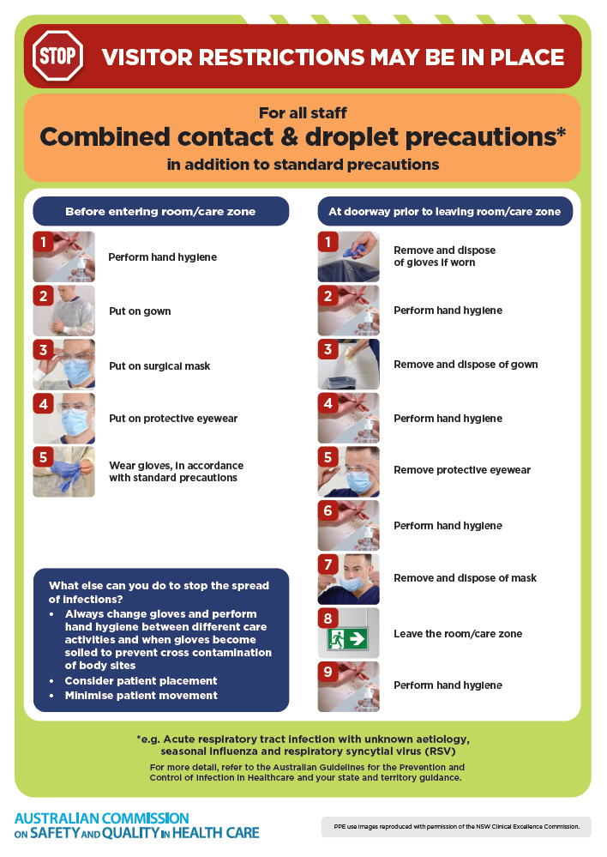
- Poster – Combined airborne and contact precautions
https://www.safetyandquality.gov.au/publications-and-resources/resource-library/infection-prevention-and-control-poster-combined-airborne-and-contact-precautions
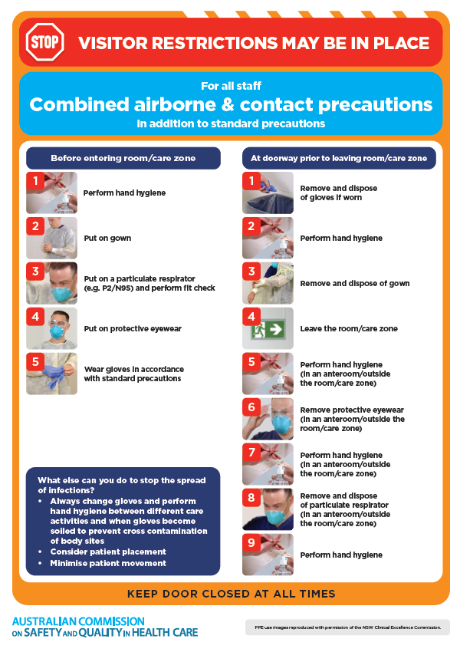
- Environmental Cleaning and Infection Prevention and Control www.safetyandquality.gov.au/environmental-cleaning
- Break the chain of infection poster
https://www.safetyandquality.gov.au/publications-and-resources/resource-library/break-chain-infection-poster
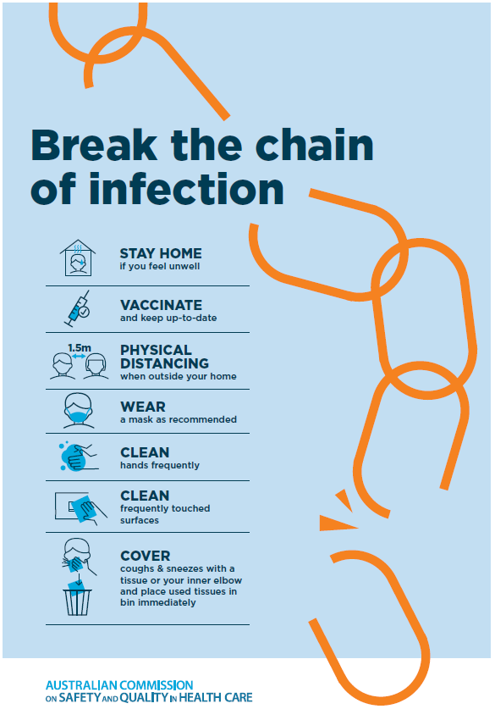

Disclaimer
On the Radar is an information resource of the Australian Commission on Safety and Quality in Health Care The Commission is not responsible for the content of, nor does it endorse, any articles or sites listed The Commission accepts no liability for the information or advice provided by these external links Links are provided on the basis that users make their own decisions about the accuracy, currency and reliability of the information contained therein Any opinions expressed are not necessarily those of the Australian Commission on Safety and Quality in Health Care.

