
On the Radar
Issue 732
16 February 2026

On the Radar is a summary of some of the recent publications in the areas of safety and quality in health care Inclusion in this document is not an endorsement or recommendation of any publication or provider Access to particular documents may depend on whether they are Open Access or not, and/or your individual or institutional access to subscription sites/services Material that may require subscription is included as it is considered relevant.

On the Radar is available online, via email or as a PDF or Word document from https://www.safetyandquality.gov.au/newsroom/subscribe-news/radar

If you would like to receive On the Radar via email, you can subscribe on our website https://www.safetyandquality.gov.au/newsroom/subscribe-news
or by emailing us at mail@safetyandquality.gov.au.
You can also send feedback and comments to mail@safetyandquality.gov.au.

For information about the Commission and its programs and publications, please visit https://www.safetyandquality.gov.au

On the Radar
Editor: Dr Niall Johnson
Contributors: Niall Johnson

Books

Operations Management
Elements of Improving Quality and Safety in Healthcare
Lewis ME, Vasilakis C
Cambridge: Cambridge University Press; 2026.
DOI | https://doi.org/10.1017/9781009325868
Notes | This volume is the latest release in the Elements of Improving Quality and Safety in Healthcare series from The Healthcare Improvement Studies Institute (the THIS Institute) in Cambridge, England. This volume provides ‘an overview of three major topics in healthcare operations management: capacity and demand, focus, and people and process’. The authors argue that ‘Operations management, as an improvement approach, offers a range of useful analytic approaches, insights, and techniques.’
Reports

State of person centred care 2025
Picker Institute Europe
Oxford: Picker Institute Europe; 2026. p. 18.
URL | https://picker.org/research_insights/new-report-reveals-state-of-person-centred-care-in-the-nhs-in-england/
Notes | Report from the Picker Institute Europe that compiles findings from nine national NHS patient and staff surveys commissioned by Care Quality Commission and NHS England and relates them to the eight Picker Principles of Person Centred Care. The report also provides examples from the Picker Experience Network Awards 2025 that indicate how engagement and co-production can help drive improvement.  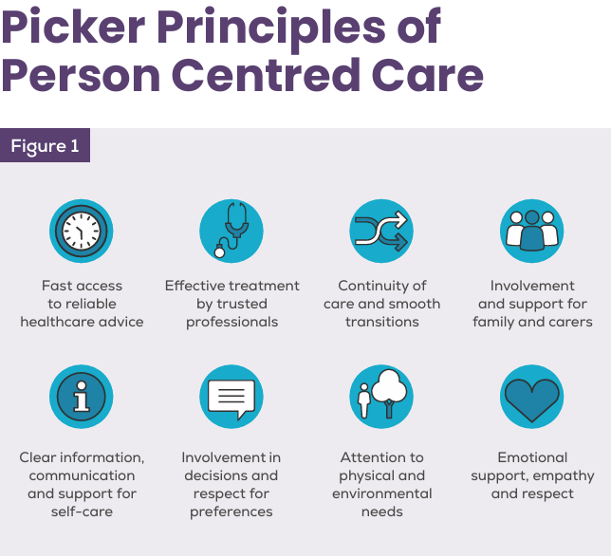

For information on the Commission’s work on person-centred care, see https://www.safetyandquality.gov.au/our-work/partnering-consumers/person-centred-care

Report on Government Services 2026 Health (part E)
SCRGSP (Steering Committee for the Review of Government Service Provision)
Canberra: Productivity Commission; 2026. p. 201.
URL | https://www.pc.gov.au/ongoing/report-on-government-services/health/
Notes | The Productivity Commission regularly releases its Report on Government Services (ROGs) report, including a volume on health. The Report on Government Services 2026 Health report and the related data, including expenditure, activity and performance data, were released on 5 February 2026. The ROGS health report examines aspects of:  - Primary and community health  - Ambulance services  - Public hospitals  - Services for mental health.  Other parts of the ROGS report that have been released recently include:  - Part C Justice  - Part D Emergency management  - Part F Community services  - Part G Housing and homelessness.

GIRFT Greener Pathways: A practical guide to decarbonising the total hip replacement pathway
Getting It Right First Time (GIRFT)
London: NHS England; 2026. p. 29.
URL | https://gettingitrightfirsttime.co.uk/girft-shares-greener-guidance-to-help-reduce-the-carbon-footprint-of-the-elective-hip-replacement-pathway/  https://gettingitrightfirsttime.co.uk/wp-content/uploads/2026/01/A-practical-guide-to-decarbonising-the-total-hip-replacment-pathway-FINAL-January-2026.pdf
Notes | Guidance from the Getting It Right First Time (GIRFT) initiative in the UK that lists thirteen clinical recommendations for decarbonising elective hip replacement surgery. The GIRFT Greener Pathways ‘identify opportunities for the NHS to improve or maintain the quality of patient care while mitigating its environmental impact.’ ‘The guide describes best practice, alongside estimates of the associated greenhouse gas emissions for a typical UK hospital, to guide prioritisation. Each recommendation is intentionally deliverable on a relatively short timescale.’  This guide is the second in the Greener Pathway series, following the bladder cancer care pathway.

For information on the Commission’s work on environmentally sustainable healthcare, see Environmentally Sustainable Healthcare | Australian Commission on Safety and Quality in Health Care

Journal articles

Supporting the appropriate use of psychotropic medicines in aged and disability care
Macfarlane S, Trollor JN, Koncz R, Sukkar M, Hullick C
Australian Prescriber. 2026;49(1):4-9.
DOI | https://doi.org/10.18773/austprescr.2026.006
Notes | The authors of this piece note that ‘the Royal Commission into Aged Care Quality and Safety, and the Royal Commission into Violence, Abuse, Neglect and Exploitation of People with Disability, highlighted the extent to which inappropriate prescribing of psychotropic medicines was occurring in the aged-care and disability sectors in Australia.’ Further, ‘As part of a national effort to address these concerns and establish the standard of care for clinicians and health service providers, the Australian Commission on Safety and Quality in Health Care developed the Psychotropic Medicines in Cognitive Disability or Impairment Clinical Care Standard (the Standard) in consultation with the NDIS (National Disability Insurance Scheme) Quality and Safeguards Commission and the Aged Care Quality and Safety Commission.’ The article ‘provides an overview of the best-practice use of psychotropic medicines in people with cognitive disability or impairment based on the Standard’.

Increasing the environmental sustainability of operating rooms in Canada: an evidence-informed guideline for policy
Goldman J, Pearsall EA, Liu K, De Castro C, Le N, Abbass SA, et al
Canadian Medical Association Journal. 2026;198(5):E159.
DOI | https://doi.org/10.1503/cmaj.251192
Notes | With increasing concern about the environmental impact and sustainability of health care there have been efforts to ameliorate those impacts. This paper reports on the development of a guideline to increase the environmental sustainability of operating rooms. The guideline includes 21 recommendations grouped into 4 categories: reduce, reuse, recycle, and rethink.  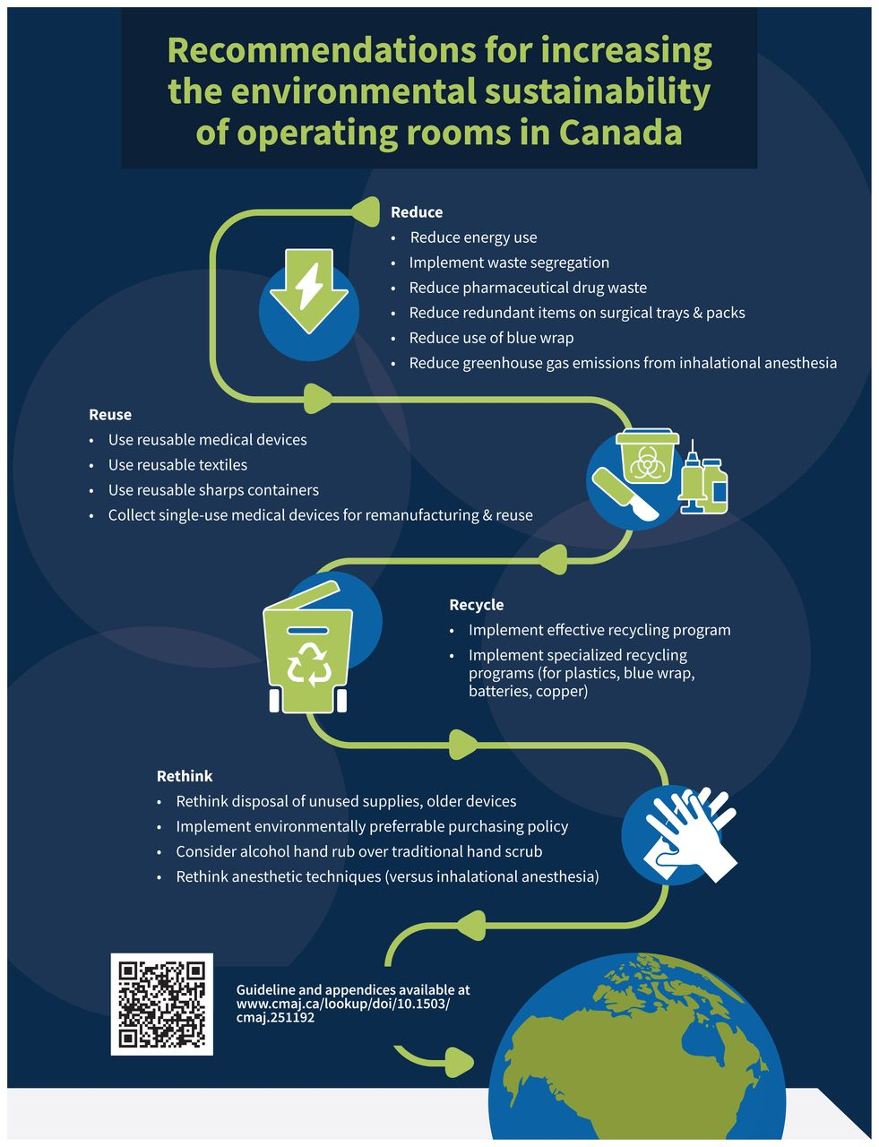

For information on the Commission’s work on environmentally sustainable healthcare, see Environmentally Sustainable Healthcare | Australian Commission on Safety and Quality in Health Care

Increased Utilization of Telemedical Emergency and Nonurgent Care Following Deployment of Virtual Triage and Care Referral in Australia
Gellert GA, McMahon B, Price T, Liu Z, Kabat-Karabon A, Marecka M, et al.
Mayo Clinic Proceedings: Digital Health 2026;4.
DOI | https://doi.org/10.1016/j.mcpdig.2025.100331
Notes | Paper reporting on how Healthdirect Australia has been using AI tools in its triage and referral. The study sought ‘To evaluate whether an artificial intelligence–based national virtual triage and care referral (VTCR) service in Australia improved care acuity level alignment, increased patient engagement of telemedicine services, and reduced emergency department demand by offering lower acuity, less costly options for urgent, virtual, or in-person care services.’ The authors claim that ‘Virtual triage and care referral more than doubled the number of patients selecting appropriate, lower acuity nonurgent care from 330,279 (21.3%) to 820,800 (52.9%), an increase of 31.6 percentage points [PPs] (P<.01), and effectively eliminated uncertainty in patient care seeking from 670,502 to 2557 patients, a decrease of 99.6%. Intent for in-person emergency care fell significantly from 119,414 (36.7%) to 105,349 patients (24.6%) (–12.1 PP; P<.01), replaced by substantial growth in patient intent to use virtual emergency care (from 612 to 11,840 patients or +10.1 PP) and nonurgent virtual care use (from 20,467 to 26,289 patients or +2.9 PP) (P<.01).’  It is noted that nurses agreed with AI tool care acuity level recommendation in 83.3% of cases.  The authors conclude that ‘Artificial intelligence–based VTCR improved alignment between patient perceived needs and recommended care pathways, not only driving greater use of appropriate, lower acuity, and telemedicine services but also reducing unnecessary in-person emergency visits. By eliminating uncertainty in care seeking and advancing adoption of new virtual emergency and nonurgent care options, VTCR offers a scalable, evidence-based solution for optimizing emergent and urgent care delivery and easing pressure on emergency departments across Australia.’

Factors associated with continuity of medication administration when patients transfer from hospital to residential aged care: a multicentre study
Elliott RA, Taylor SE, Griffett K, Howell T, Khalil V, Lalic S, et al
Australian Journal of Primary Health. 2026;32(1):PY25256.
DOI | https://doi.org/10.1071/PY25256
Notes | Paper reporting on a study that sought to ‘identify factors associated with continuity of medication administration following transitions-of-care from hospitals to residential aged-care facilities (RACFs).’ The paper reports on a ‘a prospective, observational study of randomly selected patients discharged to an RACF from hospitals within four public health services in Victoria, Australia’ in which ‘Nurses for 397 patients at 78 RACFs were interviewed’. The authors report that ‘22.7% patients had one or more missed or significantly delayed doses. There was lower risk of missed/delayed doses when the hospital supplied discharge medications (RR 0.53, 95% CI 0.33–0.85), community pharmacy delivered repackaged medications on the day-of-discharge (RR 0.48, 95% CI 0.30–0.76), the hospital provided an interim medication administration chart (RR 0.63, 95% CI 0.46–0.85), and there was more time between discharge and the first post-discharge medication dose-time (RR 0.91, 95% CI 0.86–0.96 for each additional hour).’

For information on the Commission’s work on medicine safety and quality, see https://www.safetyandquality.gov.au/our-work/medicines-safety-and-quality
For information on the recently released Medication Management at Transitions of Care Stewardship Framework, see https://www.safetyandquality.gov.au/our-work/transitions-care/medication-management-transitions-care-stewardship-framework

Emergency Department Use in the Last 90 Days of Life: A Retrospective Audit Regression Analysis
Osborne TR, Triandafilidis Z, Jeong SY-S, Szwec S, Leigh L, Goodwin N
Journal of Palliative Care. 2026:08258597251413029.

The politics of palliative care
Stein E
The Saturday Paper. 7 February 2026.
DOI | Osborne et al https://doi.org/10.1177/08258597251413029  Stein https://www.thesaturdaypaper.com.au/comment/topic/2026/02/07/the-politics-palliative-care
Notes | Osborne et al report on a retrospective audit of electronic clinical records that sought to ‘examine patterns of emergency department (ED) presentation and emergency hospital admission in the last 90 days of life for residents of New South Wales, Australia.’ The authors report that ‘2869 ED presentations are included across 1730 decedents. 80% of ED visits led to admission. 92% of people had at least 1 ED presentation in the final 90 days of life, with 18% having 3 or more. 86% of people had at least 1 emergency admission, with 9.5% having 3 or more.’ They observe that ‘ED presentations in the final months of life are common’ and suggest that ‘Alternative models of care are needed to support escalating nursing needs at home, and funding for palliative services must keep pace with the rising demand.’  Stein’s comment piece in The Saturday Paper echoes the call for increased funding of and access to palliative care. Stein is noted as ‘a former chief of staff to a federal aged care minister and former national director at St Vincent’s Health Australia.’

Australian Prescriber
Volume 49, Issue 1, February 2026
URL | https://australianprescriber.tg.org.au/volumes/49/issues/1.html
Notes | A new issue of Australian Prescriber has been published. Content in this issue of Australian Prescriber includes:  - Editorial: Defining psychotropic medicines in aged and disability care (J Breen, M Callary, L deVries)  - Supporting the appropriate use of psychotropic medicines in aged and disability care (S Macfarlane, JN Trollor, R Koncz, M Sukkar, C Hullick)  - Pharmacological management of attention deficit hyperactivity disorder in adults (S Suetani, J Hull, JG Scott)  - Intra-articular hyaluronic acid (viscosupplementation) for osteoarthritis: is it effective? (HL Pisaniello, S Goh, R Buchbinder)  - Preventing infections in immunosuppressed patients (A Ashok, AI MacPhail, ML Giles, BJ Gardiner)  - Secondary prevention of acute coronary syndromes: a summary of the new 2025 Australian guideline (J Just, D Brieger, A Bennett, T Briffa)  - New drugs:  – Ivosidenib for cholangiocarcinoma and acute myeloid leukaemia  – Vutrisiran for transthyretin amyloidosis

Australian Journal of Primary Health
Volume 32, Issue 1, February 2026
URL | https://connectsci.au/py/issue/32/1
Notes | The Australian Journal of Primary Health has moved to a continuous publication model. In the continuous publication model, once an article is ready for publication, it is immediately published online with final citation details. Recent articles in the Australian Journal of Primary Health include:  - Perspectives of general practitioners and practice nurses on integration of traditional and complementary medicine with Australia’s healthcare system (Elisheba Jeyasingham, Phyllis Lau, Rachel Canaway)  - Improving the experiences of young adults with the Australian healthcare system (Katharine Keller, Barbara J Mintzes, Eliza J McEwin)  - Developing a co-designed triage support tool for disability support workers to determine the most appropriate urgency and care pathway for their clients (David Nouju, Darren Daff, Pamela Everingham))  - Clinical indicator prioritisation for the ACTMed trial: a modified nominal group technique approach for primary care research in the electronic age (Andrew Donald, Nicolette Ellis, Esa Chen, R Violette, L Nissen, J Spinks)  - A systematic-narrative review of goal-setting guidelines in workers’ compensation rehabilitation in Australia (Jack Sargeant, Dylan Poulus, Charmaine Bernie, Christian Swann)  - Mapping the evidence for Multipurpose Health Services in rural Australia (Karla Kuzmins, Katherine Riley, Elizabeth Halcomb)  - Exploring Australian community pharmacists’ perspectives, practices and use of emergency hormonal contraception guidelines: a qualitative study using the Theoretical Domains Framework (Ruth A Nona, Robin A Ray, Selina M Taylor, Beverley D Glass)  - Physiotherapy telerehabilitation activity and cost as part of the Australian Government Medicare Benefits Scheme (MBS)(Centaine L Snoswell, Megan H Ross, Trevor Russell)  - Understanding how culture shapes Chinese patients’ mental health decision-making in Australian general practice (Jia Shing See, Catherine Kaylor-Hughes, Caroline Johnson, Amy Coe)  - Establishing a GP-led paediatric minor injury and illness clinic in the Queensland Children’s Hospital: pilot evaluation results (Anton Pak, Nora Phelan, Fiona Thomson, Kym Roberts, Rosy Dobrijevic, Perrin Moss)  - Factors associated with continuity of medication administration when patients transfer from hospital to residential aged care: a multicentre study (Rohan A Elliott, Simone E Taylor, Kerryn Griffett, Toni Howell, Viviane Khalil, Samanta Lalic, Erini Mathiopoulos, E Ong, M Wiseman, C Y L Yap)

BMJ Quality & Safety
Volume 35, Issue 2, February 2026
URL | https://qualitysafety.bmj.com/content/35/2
Notes | A new issue of BMJ Quality & Safety has been published. Many of the papers in this issue have been referred to in previous editions of On the Radar (when they were released online). Articles in this issue of BMJ Quality & Safety include:  - Editorial: From parallel tracks to integrated practice: advancing the integration of quality improvement and implementation science (Stephanie Bogdewic, Susan Cronin, Rohit Ramaswamy)  - Editorial: Learning from healthcare complaints: challenges and opportunities (Tom W Reader)  - Using implementation science to define the model and outcomes for improving quality in NEST360, a multicountry alliance for reducing newborn mortality in sub-Saharan Africa (Kylie Dougherty, Nebiyou Hailemariam, Georgia Jenkins, Junwei Chen, Jackson Ilangali, John Mwangi, Julius Thomas, Hannah Mwaniki Mwaniki, Olabisi Dosunmu, Robert Tillya, Samuel Ngwala, Joy E Lawn, R Richards-Kortum, Z M Oden, C Bohne, L R Hirschhorn)  - Implementation of national guidelines on antenatal magnesium sulfate for neonatal neuroprotection: extended evaluation of the effectiveness and cost-effectiveness of the National PReCePT Programme in England (Hannah B Edwards, Carlos Sillero-Rejon, Hugh McLeod, Elizabeth M Hill, Brent C Opmeer, Colin Peters, David Odd, Frank de Vocht, Karen Luyt)  - Association between Child Opportunity Index and paediatric sepsis recognition and treatment in a large quality improvement collaborative: a retrospective cohort study (Lori Rutman, Troy Richardson, Jeffery Auletta, Fran Balamuth, Amber Chambers, Julie Fitzgerald, Javier Gelvez, Karen A Genzel, Amy Grant, Vishal Gunnala, Hana Hakim, Leslie Hueschen, Sarah Kandil, Gitte Larsen, Justin Lockwood, Kate Lucey, Elizabeth Mack, Kate Madden, Matthew Niedner, Raina Paul, Anireddy Reddy, Ruth Riggs, Johanna Rosen, Melissa Schafer, Halden Scott, Jennifer Wilkes, Matthew A Eisenberg)  - Implementing quality and safety regulations in residential disability services: a qualitative interview study (Paul Dunbar, Laura Keyes, John Browne)  - From complaint material to quality improvement: Exploring the use of patient complaints or compensation claims in quality improvement initiatives—a scoping review (Sebrina Maj-Britt Hansen, Mette Kring Clausen, Nana Roust Hansen, Mette Brandt Eriksen, Anne Kragh Sørensen, Søren Bie Bogh, Søren Fryd Birkeland, Lars Morsø)  - Partnership makes performance: integration approaches to optimise implementation science and quality improvement collaboration (Rinad S Beidas, Cynthia Barnard, Lisa R Hirschhorn, Miriam R Rafferty, Kelli Scott, Sara J Becker, Patricia D Franklin)

The Joint Commission Journal on Quality and Patient Safety
Volume 52, Issue 2, February 2026
URL | https://www.sciencedirect.com/journal/the-joint-commission-journal-on-quality-and-patient-safety/vol/52/issue/2
Notes | A new issue of The Joint Commission Journal on Quality and Patient Safety has been published. Articles in this issue of The Joint Commission Journal on Quality and Patient Safety include:  - What Saves a Patient? A Human Factors Approach to Understanding Near Misses in the ICU (Harshini Ravi, Aleeque Marselian, F Kanji, T N Cohen)  - Cost Savings Realized Through a Statewide Quality Improvement Collaborative for Spine Surgery (David R Nerenz, Kari Jarabek, Jamie Myers, Thomas Leyden, ... Muwaffak Abdulhak  - Assessment of Instrument Utilization in Cesarean Births: Taking a Step Toward Sustainability (Charlotte M ter Haar, Quetzal A Class, Lopa K Pandya)  - The Effect of Transitional Services on 30-Day Avoidable Hospital Readmission Following Inpatient Rehabilitation Facility Admission (Megan Kennelly, Zana Percy, Jessica Kurtz, Sima Desai, Shanti Pinto)  - Suboptimal Diagnostic Decisions In Hospitalized Patients with Fever: A Prospective Record Review with Physician Interviews (Jacky Hooftman, Jonne J. Sikkens, Nienke van Wingerden, Djoeke G. Beekman, C Wagner, L Zwaan  - Medication Reconciliation and Patient Safety in India: A Prospective Observational Study at a Tertiary Care Hospital (Ashish Kumar Dogra, Shivani Juneja, Josmy Maria Job)  - Reasons for eCQM–Identified Concurrent Opioid and Benzodiazepine Prescribing at Discharge: A Cohort Study (Lauren Zabel, James Willey, Jennifer McDanel, Ethan Kuperman)  - Rapid Implementation of Guideline-Based Care for Acute Exacerbations of COPD in a Low-Resource Setting: An Improvement Brief (Muhammad Saqib)

BMJ Quality & Safety online first articles
URL | https://qualitysafety.bmj.com/content/early/recent
Notes | BMJ Quality &Safety has published a number of ‘online first’ articles, including:  - Thinking critically about AI documentation quality in primary care (Gordon D Schiff, Maram Khazen)  - Implementing and evaluating a low-carbon, high-quality perioperative patient warming pathway (Karina Spoyalo, Thais Ayres Rebello, Christina Schwarz, Gyan Chhipi Shrestha, Kasun Hewage, Rehan Sadiq, Shawn E Mondoux, Matthew Walker, Kelly Mayson, Andrea J MacNeill)

International Journal for Quality in Health Care online first articles
URL | https://academic.oup.com/intqhc/advance-articles
Notes | International Journal for Quality in Health Care has published a number of ‘online first’ articles, including:  - Participative Leadership and Nurses’ Error Reporting: Psychological Safety as a Mediator in Multi-Hospital Data (Jiwoo Baek , Soyoung Yu)  - Root cause analysis of sentinel events in a public hospital: A mixed method study of reporting culture and contributing factors (Hatic Esen Koç, Nazife Ozturk)  - Gaining Insight into Study Cohorts: Challenges of Follow-up Research Post Intensive Care (Susanne van Santen, Sonali Desai, Bena Hemmen)  - Does Physician Communication of Hospital Quality Information Influence Patients’ Hospital Choice? An Experimental Vignette Study (Moo Hyuk Lee, Soela Kim, Young Kyung Do)

Online resources

Australian Living Evidence Collaboration
https://livingevidence.org.au/

Guidance
A number of guidelines or guidance have recently been published or updated These include:
- Clinical Practice Guidelines for the Appropriate Use of MDMA-Assisted Psychotherapy for Post-traumatic Stress Disorder, Monash University https://app.magicapp.org/#/guideline/Ee438n

[USA] Exploratory Cancer-Related Diagnostic Excellence Measures
https://qualityindicators.ahrq.gov/tools/diagnostic_excellence#Cancer-Tab
The US Agency for Healthcare Research and Quality (AHRQ) has released draft technical specifications for exploratory cancer-related diagnostic excellence measures. The measures are intended to support population-level diagnostic excellence surveillance and quality improvement by identifying patterns that may represent potential missed opportunities in the diagnostic process.

Infection prevention and control resources
The Australian Commission on Safety and Quality in Health Care has developed a number of resources to assist healthcare organisations, facilities and clinicians These resources include:
- Poster – Combined contact and droplet precautions https://www.safetyandquality.gov.au/publications-and-resources/resource-library/infection-prevention-and-control-poster-combined-contact-and-droplet-precautions
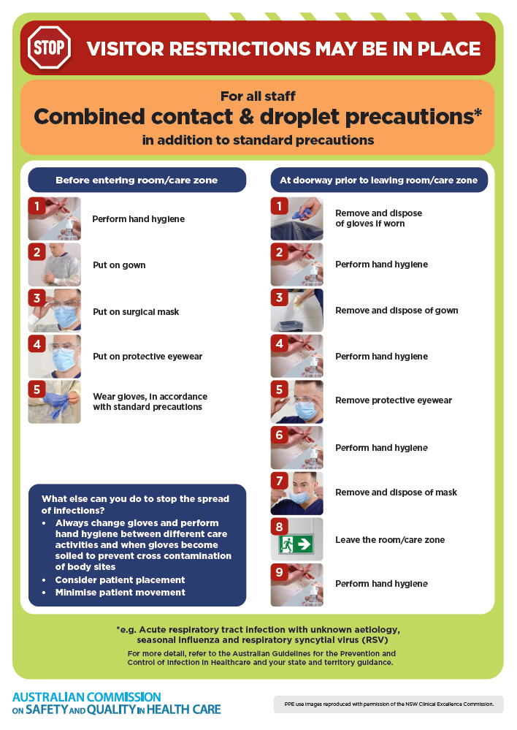
- Poster – Combined airborne and contact precautions
https://www.safetyandquality.gov.au/publications-and-resources/resource-library/infection-prevention-and-control-poster-combined-airborne-and-contact-precautions
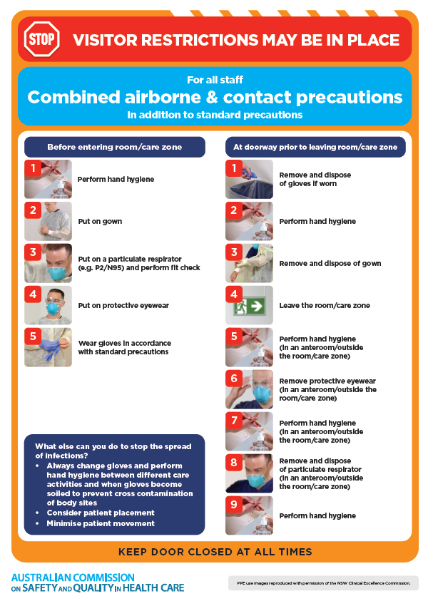
- Environmental Cleaning and Infection Prevention and Control www.safetyandquality.gov.au/environmental-cleaning
- Break the chain of infection poster
https://www.safetyandquality.gov.au/publications-and-resources/resource-library/break-chain-infection-poster
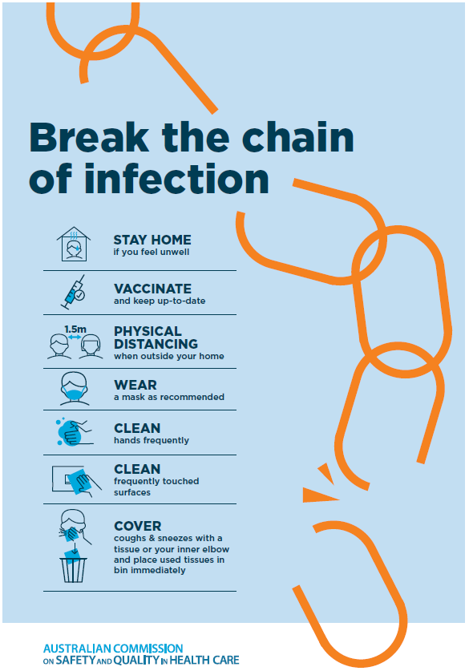

Disclaimer
On the Radar is an information resource of the Australian Commission on Safety and Quality in Health Care The Commission is not responsible for the content of, nor does it endorse, any articles or sites listed The Commission accepts no liability for the information or advice provided by these external links. Links are provided on the basis that users make their own decisions about the accuracy, currency and reliability of the information contained therein Any opinions expressed are not necessarily those of the Australian Commission on Safety and Quality in Health Care.

