
On the Radar
Issue 733
23 February 2026

On the Radar is a summary of some of the recent publications in the areas of safety and quality in health care Inclusion in this document is not an endorsement or recommendation of any publication or provider Access to particular documents may depend on whether they are Open Access or not, and/or your individual or institutional access to subscription sites/services Material that may require subscription is included as it is considered relevant.

On the Radar is available online, via email or as a PDF or Word document from https://www.safetyandquality.gov.au/newsroom/subscribe-news/radar

If you would like to receive On the Radar via email, you can subscribe on our website https://www.safetyandquality.gov.au/newsroom/subscribe-news
or by emailing us at mail@safetyandquality.gov.au.
You can also send feedback and comments to mail@safetyandquality.gov.au.

For information about the Commission and its programs and publications, please visit https://www.safetyandquality.gov.au

On the Radar
Editor: Dr Niall Johnson
Contributors: Niall Johnson

Reports

AURA REPORT: Sixth Australian report on antimicrobial use and resistance in human health
Australian Centre for Disease Control
Canberra: Australian Centre for Disease Control; 2026. p. 99.
URL | https://www.cdc.gov.au/newsroom/media-releases/national-snapshot-antimicrobial-resistance-and-use-released
Notes | The Australian Centre for Disease Control (an organisation that some hoped would have the initialism ACDC) have released their first edition of the AURA report, the Sixth Australian report on antimicrobial use and resistance in human health documenting the latest antibiotic resistance and antimicrobial use data. The data shows reports of critical antibiotic resistance in Australia increased by 25% in 2024 and less than half the antibiotics given after surgeries were appropriate.
For information on the Commission’s work on antimicrobial resistance, including the previous AURA reports, see https://www.safetyandquality.gov.au/our-work/antimicrobial-resistance and https://www.safetyandquality.gov.au/our-work/antimicrobial-resistance/antimicrobial-use-and-resistance-australia-aura

Demystifying artificial intelligence in health: what health policy-makers need to know
del Rey Puech P, Saund J, Panteli D, McKee M
Copenhagen: European Observatory on Health Systems and Policies, WHO Regional Office for Europe; 2026.
URL | https://iris.who.int/handle/10665/384851
Notes | The European Observatory on Health Systems and Policies is a partnership, hosted by the WHO Regional Office for Europe, that supports and promotes evidence-based health policy-making. The Observatory has released this book on Artificial Intelligence (AI) in health care that ‘provides timely, practical guidance to help professionals and decisionmakers navigate the opportunities and challenges presented by AI’. The authors observe that ‘AI offers exciting possibilities for improving the health of populations and individuals, and its deployment must be grounded in the appropriate technical, ethical and governance foundations. Many experts believe that the hype will eventually settle (some say it already has) and AI will become one tool among many. The challenge is to use it wisely, ensuring that it enhances care, promotes equity and protects patient safety.’

Dealing with the challenges in urgent and emergency care: What are the policy options?
Policy Brief 74
Edwards N, Lewis R, Chaouali M, Zapata T, Richardson E
Copenhagen: European Observatory on Health Systems and Policies, WHO Regional Office for Europe; 2026. p. 32.
URL | https://iris.who.int/handle/10665/384833
Notes | Policy brief from the European Observatory on Health Systems and Policies and WHO Regional Office for Europe examining issues around urgent and emergency care. The authors observe that ‘Urgent and emergency care is a key part of the health care system. These services are highly visible to the public and their performance is critical to delivering high-quality outcomes as well as maintaining public support and confidence in the health care system.’ It is also acknowledged that ‘Differences in history, geography and resources mean that there is no standard model for an emergency care system. The system is complex and not necessarily easy for patients, the public or health professionals to understand.’ The brief examines some of the issues, expectations and approaches to urgent and emergency care. Among the issues identified, ‘patients and the public are not passive actors in the system, and how they understand, trust and interact with it is a key determinant of how it works’

For information on the Commission’s work on person-centred care, see https://www.safetyandquality.gov.au/our-work/partnering-consumers/person-centred-care

For information on the Commission’s work on environmentally sustainable healthcare, see Environmentally Sustainable Healthcare | Australian Commission on Safety and Quality in Health Care

Journal articles

Delirium and adverse clinical outcomes: a matched cohort study in the UK Biobank
Haapanen MJ, Ward DD, Mudge AM, Gordon EH, Graham FA, Rockwood K, et al
The Lancet Healthy Longevity. 2026.
DOI | https://doi.org/10.1016/j.lanhl.2025.100816
Notes | Paper reporting on a study that sought to ‘examine the association of in-hospital delirium with the occurrence of a range of adverse outcomes during later hospitalisations’. The study was ‘a matched cohort study among hospitalised UK Biobank participants’ that ‘matched 14 909 individuals with delirium (1:1) to hospitalised control individuals without delirium by age, sex, Hospital Frailty Risk Score, primary diagnosis, episode length of stay, and intensive care unit length of stay of the index episode.’ The authors report that ‘In-hospital delirium was consistently and dose-responsively associated with a range of adverse outcomes, independent of frailty and pre-existing dementia, supporting its recognition as a sentinel event indicating longer-term vulnerability.’  The Australian Commission on Safety and Quality in Health Care has included delirium on the national list of hospital-acquired complications.

For information on the Commission’s work on cognitive impairment, including dementia and delirium and the Delirium Clinical Care Standard, see https://www.safetyandquality.gov.au/our-work/cognitive-impairment

Health Literacy-Focused Communication Training for Primary Healthcare Providers Working With Older Adults: A Co-Designed Prototype
O'Brien L, Lawless M, Townsin L, Mills P, Ta D, Beilby J, et al
Health Expectations. 2026;29(1):e70590.
DOI | https://doi.org/10.1111/hex.70590
Notes | Health literacy is a safety and quality issue. This paper describes the development of a training program for those working in primary healthcare to improve health literacy communication, particularly with older patients. The project ‘drew on an Experience-Based Co-Design approach’ with workshops of ‘adults aged 50+ years and primary healthcare professionals’ and led to the development of ‘a final training program that integrates real-world needs with pedagogical frameworks and aligns with evidence from prior training interventions. There is potential for implementation in primary healthcare provider training environments.’

For information on the Commission’s work on health literacy, including the 2014 National Statement on Health Literacy, see https://www.safetyandquality.gov.au/our-work/patient-and-consumer-centred-care/health-literacy

When Protocol Meets Reality
Burks W
JAMA. 2026.
DOI | https://doi.org/10.1001/jama.2026.0064
Notes | This piece in JAMA that reflects on person-centred care, in the setting of advanced dementia and emergency hospitalisation. Written by a clinician who has ‘spent more than 4 decades in medicine, much of it caring for children and their families and helping to lead large health care systems’ and thought he had understood what it meant to meet patients where they were emotionally and developmentally. His experience of caring for his partner as ‘she has moved through the stages of Alzheimer disease’. He observes that ‘nothing prepared me for how sharply the worlds of protocol and lived reality can collide in a moment of crisis’, particularly how clinicians tended to follow protocols rather than recognise the lived reality of the patient before them. The author concludes with the observation ‘When protocol meets reality, the human connection between clinician, patient, and caregiver becomes the most reliable tool we have. And when clinicians approach dementia care with that awareness, the room becomes just a little gentler—for everyone.’

For information on the Commission’s work on person-centred care, see https://www.safetyandquality.gov.au/our-work/partnering-consumers/person-centred-care

Coffee and Tea Intake, Dementia Risk, and Cognitive Function
Zhang Y, Liu Y, Li Y, Li Y, Gu X, Kang JH, et al
JAMA. 2026.
DOI | https://doi.org/10.1001/jama.2025.27259
Notes | Possibly not the most important paper published recently, but one that is likely to garner a lot of attention. The paper reports on a ‘Prospective cohort study that included female participants from the Nurses’ Health Study (NHS; n = 86 606 with data from 1980-2023) and male participants from the Health Professionals Follow-up Study (HPFS; n = 45 215 with data from 1986-2023) who did not have cancer, Parkinson disease, or dementia at study entry (baseline) in the US.’ The participants’ ‘Dietary intake was collected every 2 to 4 years using validated food frequency questionnaires.’ The authors report that ‘Among 131 821 participants … during up to 43 years of follow-up …there were 11 033 cases of incident dementia.’ From their analyses, the authors found ‘Greater consumption of caffeinated coffee and tea was associated with lower risk of dementia and modestly better cognitive function, with the most pronounced association at moderate intake levels.’ They observe that ‘The most pronounced associated differences were observed with intake of approximately 2 to 3 cups per day of caffeinated coffee or 1 to 2 cups per day of tea.’

BMJ Quality & Safety
Volume 35, Issue 3, March 2026
URL | https://qualitysafety.bmj.com/content/35/3
Notes | A new issue of BMJ Quality & Safety has been published. Many of the papers in this issue have been referred to in previous editions of On the Radar (when they were released online). Articles in this issue of BMJ Quality & Safety include:  - Editorial: Translation without substitution: the need for responsible AI integration in patient instructions (Ricky Odedra, Ruud Gerard Nijman, Phoebe Averill, Erik Mayer)  - Evaluation of the accuracy and safety of machine translation of patient-specific discharge instructions: a comparative analysis (Marianna Kong, Alicia Fernandez, Jaskaran Bains, Ana Milisavljevic, Katherine C Brooks, Akash Shanmugam, Leslie Avilez, J Li, V Honcharov, A Yang, E C Khoong)  - Investigators are human too: outcome bias and perceptions of individual culpability in patient safety incident investigations (William Lea, Luke Budworth, Jane O'Hara, Charles Vincent, Rebecca Lawton)  - Understanding patient safety during earthquakes: a phenomenological study of disaster response (Tunçay Palteki, Saleh Salimi, Ahtisham Younas, Selahattin Taylan, Emre Aydın)  - Patient portal messaging to address delayed follow-up for uncontrolled diabetes: a pragmatic, randomised clinical trial (Arielle R Nagler, Leora Idit Horwitz, Aamina Ahmed, Amrita Mukhopadhyay, Isaac Dapkins, William King, Simon A Jones, Adam Szerencsy, C Pulgarin, J Gray, T Mei, S Blecker)  - Confidence and certainty in medical diagnoses within acute healthcare: a scoping review (Sriraj Aiyer, Helen Higham, Nick Yeung)  - Re-establishing control limits in statistical process control analyses: the stable shift algorithm (Thomas Woodcock, Imogen O’Connor, Derek Bell)  - Advancing AI in healthcare: three strategic roles for quality and safety leaders (Jeffrey Rakover, Marina Lynne Renton, Pierre Barker, Gareth Kantor)

Journal of Patient Experience
Volume 12, January–December 2025
URL | https://journals.sagepub.com/toc/jpxa/12
Notes | The 2025 volume of the Journal of Patient Experience is now available. Various journals have moved to models in which the discrete issues are less clearly delineated. This may be accompanied with a switch to online-only publication. This shift may provide more flexibility and space for publishers and authors but can pose challenges for readers. These challenges can include overly long listing of contents that frustrate readers as they make it cumbersome and time-consuming to identify the articles that may be relevant to the reader. This is exacerbated when there is a perception that increased volume has led to a diminution of article quality.  Articles in this volume of the Journal of Patient Experience include:  - Developing and Validating a User-Friendly Quality Benchmark: Enhancing the Integrity of Online Health Information for Patients and Clinicians (Lubna Daraz, Cicek Dogu)  - Reflecting on the Deaf Experience in Healthcare (Bruna Tavares Leite, Ligia F N Reato, Patrícia Pereira, Luciana Pereira)  - Investigating Inpatient Acceptance of a Unique Telemedicine Service Trialled in the Acute Ward in Rural Australia (Carol J Reid, Catherine Church)  - Understanding Patient Registries for Diabetes: A Scoping Review of Published Literature (Lana Moayad, Paige Alliston and Diana Sherifali)  - Development of a Brief Client Satisfaction and Quality Improvement Tool for Hospital-Based Violence Intervention Programs: Opportunities for Enhancing Client Perspectives (Rachel K Myers, Hillary M Kapa, Stephanie M Garcia, Laura Vega, Joel A Fein)  - Impact of Standardized Reporting Systems on Patient Experience in Radiology (Igor Toker, Sven Jansen, Daniel Lorenz)  - Patient and Family Experience: Targets for Improvements in Care and Communication in the ICU (Caitlin A LaGrotte, Caitlin Baldwin, Krystal Hunter, Emily Damuth)  - Use of Hospital Patient and Family Advisory Councils: A Scoping Study (Barbara Lewis, Chris Cochran, Erika Marquez, Neeraj Bhandari, Jennifer Pharr, Soumya Upadhyay, Stowe Shoemaker)  - Reimagining the ADHD Experience: Transforming Parent Engagement in ADHD Care (Brooke T McLaughlin, Martha L Bruce, Susanne E Tanski)  - Orchestrating Excellent Health and Care Experiences: The Essential Role of Leadership (Laura Cooley)  - Does Communication Effectiveness Assessed by Communication Scholars Correlate with Patient Perception of Clinician Empathy? (Haley Ponce, Rafael Cordero, Jacinta Tran, Natalie Wellman, David Ring)  - A Mixed-Methods Analysis of Negative Patient Experiences in Emergency Department Care: Identifying Challenges and Evidence-Informed Strategies Across the Care Continuum (J K Fujioka, M Walker, D Rajab, S A Bartel)  - Rethinking Patient Motivation for More Inclusive Mental Healthcare (James Downs)  - Putting the WHO Global Patient Safety Action Plan into Practice: Establishing the Austrian Patient Council as a Best Practice Example of Patient Involvement (Anna Teufel, Elisabeth Klager, Hannah Hausegger, Christiane Grill, Benjamin Schuster, Maria Kletecka-Pulker, Eva Schaden)  - Addressing Health Communication Gaps: Improving Patient Experiences and Outcomes Through Human-Centered Design (Sylvie Leotin)  - Towards a Novel Patient Experience Survey System: Incorporating Physician Perspectives into Performance Feedback Dashboard Design (Stacie Vilendrer, C Bragdon, R K Miller-Kuhlmann, N Vora, C A Gold, M Winget)  - Digital Disparities in Healthcare: A Tale of the Haves and Have-Nots? (Allen M Chen)  - Patient-Centered Care: A Qualitative Analysis of Patient and Caregiver Experiences in a Hospital at Home Program (Matthew D Dalstrom, Colleen J Klein, Meagan Rothrock-Magana, Melinda Coolin)  - Exploring Positive Health in Cardiac Patients: Personal Goals and Key Factors for Achieving Improved Well-Being (Marleen Hofman-van der Gronden, Martine te Hoonte-Veehof, I van Bunningen, S van Hogen-Koster)  - Associations of Patient Experience With Doctor-Patient Communication and Patient-Reported Physical and Mental Health in Seriously Ill Adults (Sarah F D’Ambruoso, Anne M Walling, Neil S Wenger, Rebecca L Sudore, Lisa Gibbs, Maryam Rahimi, Ron D Hays)  - The Pediatric Experience Collaborative: Paving the Way in Pediatric Experience (Lauren Hamilton, Trenton House, Taylor B Sewell, Harris Baden, Brianna Combs, Sara L Toomey, Shehzad Saeed, Jana Rojas, Molly Warneke, Maureen Hoff, Andréa Aken’Ova, Lisa Rubino, Dana I Williams, S P Hanke)  - Exploring Factors That Drive Nonurgent Emergency Department Use (Carina Mireles-Romo, Eddie Hernandez, I Choi, J Roh, S Saadat, S Toohey)  - The Impact of Discrimination and Poor Provider Communication on Public Trust in Cancer Advice From Physicians (A Shaykevich, M Wojtowyc)  - Hospital Patient and Family Advisory Council Accelerators and Barriers: A Qualitative Study (Barbara Lewis, Erika Marquez, Chris Cochran, Neeraj Bhandari, Soumya Upadhyay, Stowe Shoemaker)  - I Want to be Known as a Whole Human Being: A Qualitative Study About Patients' Experiences of Empathy in Health Care (Johanna von Knorring, Arja Lehti, Kristina Lindvall, Olof Semb)  - What Factors Are Associated With Trust and Experience With the Clinician? (L Bashour, A Razi, J Thompson, R Looman, D Ring, N Brinkma)  - Barriers and Facilitators to the Recruitment and Engagement of Diverse Populations Into Patient and Family Advisory Councils: A Scoping Review (Madison P Leia, Kaitlin See, Colleen Cuthbert)  - Clinician-Caregiver Engagement in Older Adult Care. Development of a Validated Caregiver Experience Survey to Inform the Optimization of the Caregiver Role (Ronaye T Gilsenan, Rhonda E Schwartz, Iris A Gutmanis)  - A Seat at the Table, But on Whose Terms? The Illusion of Meaningful Engagement (Mark Thomaz Ugliara Barone, Emma Klatma)  - Experiences of the Development of a Revised, Population-Adjusted Communicative Health Literacy Scale (Erika Szilágyi-Hornyák, Gabriella Nagy-Pénzes, Gabriella Mátyás, Róza Ádány, Éva Bíró)

BMJ Quality & Safety online first articles
URL | https://qualitysafety.bmj.com/content/early/recent
Notes | BMJ Quality &Safety has published a number of ‘online first’ articles, including:  - ‘They don’t know my body’: health consumer recognition and escalation of acute deterioration – a systematic review (James Bonnamy, Janeane Dart, Claire Palermo, Renee Molloy, Kirsten Small, Clifford Connell)  - Editorial: Quality as a catalyst to achieve environmentally sustainable healthcare (Sara Ehsan, Hardeep Sing)  - Who chooses to engage? Understanding the characteristics of physicians who voluntarily engage with an audit and feedback intervention: a retrospective cohort study (Cherry Chu, Noah Ivers, Braeden Terpou, Mina Tadrous, Canyucel Gungor, Geneviève Rouleau, Laura Desveaux)

International Journal for Quality in Health Care online first articles
URL | https://academic.oup.com/intqhc/advance-articles
Notes | International Journal for Quality in Health Care has published a number of ‘online first’ articles, including:  - Co-constructing Patient Partnership: Highlighting Professional Competencies and Tools to Move from Knowledge to Action (Cindy Castro, Stéphane Coendoz, Anthony Staines)  - Unintended Retained Surgical Items: A Systematic Review of 743 Cases (Seong-Hi Park, Yoon Soo Cho)  - Characterisation of adverse events leading to unscheduled intensive care admissions (Abid Omar, Julien Carlier, Nordin Zaidi, Lahcen El Hiki, Christian Delvosalle, Stéphane Carlier)

Online resources

Australian Living Evidence Collaboration
https://livingevidence.org.au/

[UK] NICE Guidelines and Quality Standards
https://www.nice.org.uk/guidance
The UK’s National Institute for Health and Care Excellence (NICE) has published new (or updated) guidelines and quality standards The latest reviews or updates include:
- NICE Guideline NG28 Type 2 diabetes in adults: management https://www.nice.org.uk/guidance/ng28
- Quality Standard QS209 Type 2 diabetes in adults https://www.nice.org.uk/guidance/qs209

[USA] Effective Health Care Program reports
https://effectivehealthcare.ahrq.gov/
The US Agency for Healthcare Research and Quality (AHRQ) has an Effective Health Care (EHC) Program. The EHC has released the following final reports and updates:
- Machine Learning Tools To (Semi-)Automate Evidence Synthesis: A Rapid Review and Evidence Map https://effectivehealthcare.ahrq.gov/products/machine-learning-tools/white-paper

Infection prevention and control resources
The Australian Commission on Safety and Quality in Health Care has developed a number of resources to assist healthcare organisations, facilities and clinicians These resources include:
- Poster – Combined contact and droplet precautions https://www.safetyandquality.gov.au/publications-and-resources/resource-library/infection-prevention-and-control-poster-combined-contact-and-droplet-precautions
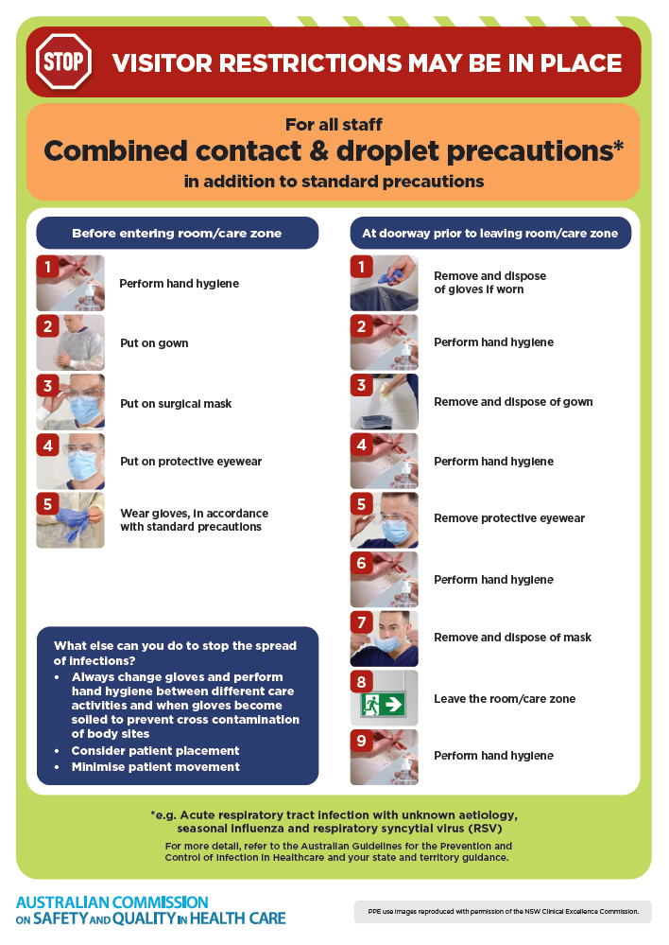
- Poster – Combined airborne and contact precautions
https://www.safetyandquality.gov.au/publications-and-resources/resource-library/infection-prevention-and-control-poster-combined-airborne-and-contact-precautions
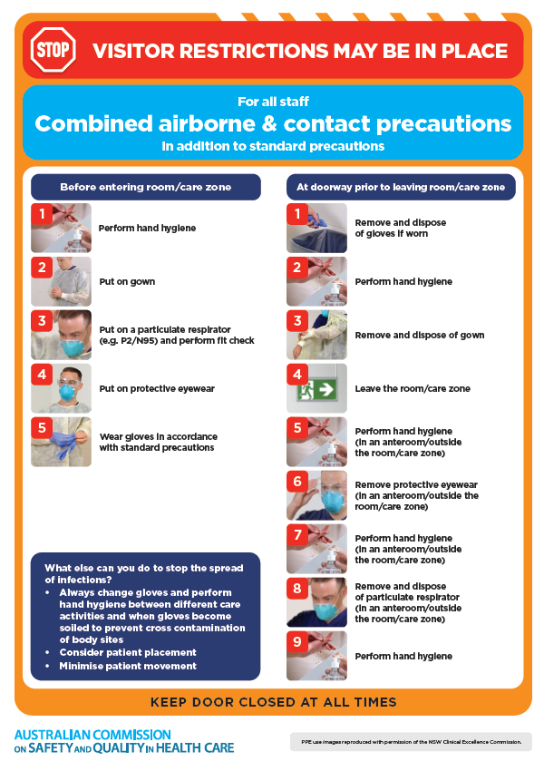
- Environmental Cleaning and Infection Prevention and Control www.safetyandquality.gov.au/environmental-cleaning
- Break the chain of infection poster
https://www.safetyandquality.gov.au/publications-and-resources/resource-library/break-chain-infection-poster
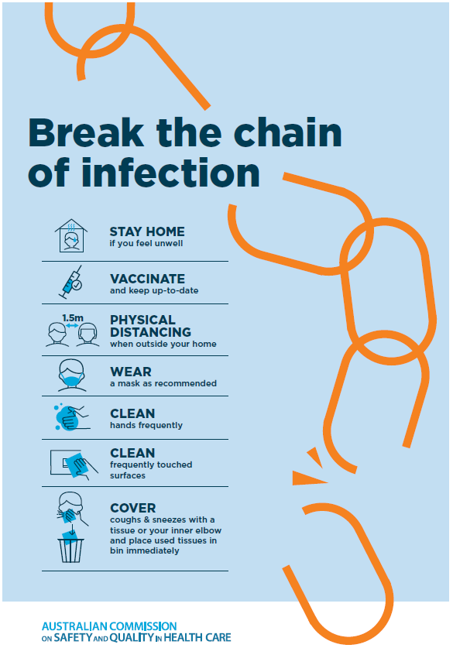

Disclaimer
On the Radar is an information resource of the Australian Commission on Safety and Quality in Health Care. The Commission is not responsible for the content of, nor does it endorse, any articles or sites listed The Commission accepts no liability for the information or advice provided by these external links. Links are provided on the basis that users make their own decisions about the accuracy, currency and reliability of the information contained therein Any opinions expressed are not necessarily those of the Australian Commission on Safety and Quality in Health Care.

