
On the Radar
Issue 734
2 March 2026

On the Radar is a summary of some of the recent publications in the areas of safety and quality in health care Inclusion in this document is not an endorsement or recommendation of any publication or provider Access to particular documents may depend on whether they are Open Access or not, and/or your individual or institutional access to subscription sites/services Material that may require subscription is included as it is considered relevant.

On the Radar is available online, via email or as a PDF or Word document from https://www.safetyandquality.gov.au/newsroom/subscribe-news/radar

If you would like to receive On the Radar via email, you can subscribe on our website https://www.safetyandquality.gov.au/newsroom/subscribe-news
or by emailing us at mail@safetyandquality.gov.au.
You can also send feedback and comments to mail@safetyandquality.gov.au.

For information about the Commission and its programs and publications, please visit https://www.safetyandquality.gov.au

On the Radar
Editor: Dr Niall Johnson
Contributors: Niall Johnson

Reports

Improving medication management together: A practical guide to establishing and leading a quality improvement collaborative
Flinders University and Monash University
2026
URL | https://www.monash.edu/mips/themes/medicine-safety/research-groups/aged-care-services/our-research/current-projects/mega-mac-quality-improvement-collaborative-guide
Notes | This resource has been developed by researchers at Monash University and Flinders University to provide guidance on how to establish and lead a quality improvement collaborative (QIC) to support senior healthcare professionals, managers and leaders across healthcare settings who are seeking to improve medication management practices.

For information on the Commission’s work on medicine safety and quality, see https://www.safetyandquality.gov.au/our-work/medicines-safety-and-quality

For information on the recently released Medication Management at Transitions of Care Stewardship Framework, see https://www.safetyandquality.gov.au/our-work/transitions-care/medication-management-transitions-care-stewardship-framework

Policies and approaches to promote safe nurse staffing: Technical brief
World Health Organization
Copenhagen: WHO Regional Office for Europe; 2026. p. 58.
URL | https://www.who.int/europe/publications/i/item/WHO-EURO-2026-13146-52920-82459
Notes | The World Health Organization’s Regional Office for Europe has published this technical brief on safe nurse staffing. The abstract states that ‘this technical brief sets out the case for investing in safe nurse staffing. It equips policy-makers with evidence for strategic and operational implementation of safe nurse staffing. Examples from countries participating in the European Union-funded Nursing Action showcase country experiences, alongside global evidence to inform and guide the implementation of safe nurse staffing policies and practices. Improving nurse staffing practices serves to enhance patient care while also contributing to the retention and recruitment of nurses…’

Consolidated guidelines for the prevention, diagnosis and treatment of postpartum haemorrhage: Implementation guide
World health Organization
Geneva: World Health Organization; 20265. p. 34.
URL | https://iris.who.int/handle/10665/384922
Notes | The World Health Organization has released this implementation support document. As is noted in the document’s executive summary, ‘Postpartum haemorrhage (PPH) represents one of the most critical yet preventable causes of maternal mortality worldwide. Despite the availability of evidence-based interventions, implementation remains inconsistent and inadequate, perpetuating preventable maternal deaths and undermining international commitments to ensure women’s fundamental rights to survive pregnancy and childbirth, and to access respectful, gender-responsive maternity care that upholds their dignity and autonomy.’ It’s also stated that the implementation guide has been developed ‘to directly address challenges to operationalizing evidence-based PPH recommendations. This systematic approach provides national health systems with a comprehensive framework for translating the Consolidated guidelines for the prevention, diagnosis and treatment of postpartum haemorrhage (2025) into sustained clinical practice and policy reform’

Journal articles

Nursing Leadership
Volume 38, Number 3, 2026
URL | https://www.longwoods.com/publications/nursing-leadership/27782/
Notes | A new issue of Nursing Leadership has been published with a focus on ‘Preparing the Nursing Workforce for the Future’. Articles in this issue of Nursing Leadership include:  - Readying the Nursing Workforce to Embrace an Ever-Changing World (Patrick Chiu and Ruth Martin-Misener)  - The Importance of Embedding a Global Perspective Into Canadian Nursing Workforce Policy and Planning (Lisa Little)  - Leveraging Nursing Regulation to Achieve Workforce, Health System and Societal Goals (Patrick Chiu and Kathleen Leslie)  - The Strategic Role of Nursing Regulatory Leaders in Leveraging Data to Support the Nursing Workforce (Sophia Myles and Ivy Bourgeault)  - Preparing the Nursing Workforce for Internationally Educated Nurse Integration: Implications for Nursing Leadership and System Transformation (Alyssa Indar and Nasrin Alostaz)  - Leading Trauma-Informed Cultures of Care in Times of Uncertainty and Change: How Trauma-Informed Organizational and Leadership Practices Can Bolster Psychological Health and Safety (Rosanra Yoon)  - Artificial Intelligence and the Sustainable Development Goals: Implications for Canadian Nurses and Nurse Leaders (Manal Kleib and Laura Vogelsang)  - Mobilizing Nursing Leadership for Planetary Health: Preparing the Healthcare Workforce for a Warming World (Raluca Radu and Agnes Black)  - Rebuilding Nursing on Foundations of Anti-Racist Worldmaking: A Political Imperative (Samantha Louie-Poon)  - Advancing Equity, Diversity and Inclusion in Nursing: Reflection on Over a Decade of Research (Matthew Idowu Olatubi, Emmanuel Akwasi Marfo and Bukola Salami)  - Reflections on the Evolving Purpose and Power of Nursing Associations in Canada (Valerie Grdisa)

Health Expectations
Volume 29, Issue 1, February 2026
URL | https://onlinelibrary.wiley.com/toc/13697625/2026/29/1
Notes | A new issue of Health Expectations has been published. Articles in this issue of Health Expectations include:  - Co-Designing a Primary Healthcare Intervention to Improve Diabetes Care in Mendoza, Argentina: A Qualitative Case Study (Javier Roberti, Agustina Mazzoni, Marina Guglielmino, Cecilia Silva, Yanina Mazzaresi, Andrea Falaschi, Lisa R Hirschhorn, John J Parker, Ezequiel García-Elorrio)  - ‘Pagbangon at Pag-Asa’ (Resurgence and Hope): A Qualitative Study of the Lived Experiences of People With Stroke and Household Carers in the Philippines (Sarah Ann Buckingham, Elda Anota, Maria Mercedes Barba, Vergil Boac, Myrna Estrada, L Faeldon, B Kent, F Leggat, R F Navea, A P R Ong, N M Santos, A Teves, P M Valera, F Jones, the TULAY project team)  - Exploring Medicines Optimisation and Safety in the Community Following Mental Health Hospital Discharge: A Qualitative Interview Study (Mark Jeffries, Fiona Naylor, N Tyler, C Robinson, M Panagioti, R N Keers)  - Exploring the Views of Children With Cerebral Palsy, Their Parents and Physiotherapists on Participating in a Feasibility Randomised Controlled Trial Testing an Exergaming Device: A Qualitative Study (Rachel Rapson, Jos M Latour, Jonathan Marsden, Bernie Carter)  - ‘How Does Nothing Show Up When I'm in So Much Agony?’: A Qualitative Study Exploring Patient Experiences of Non-Specific Abdominal Pain in Acute Surgical Care (Anna Kathryn Taylor, Daniel Romeu, Jess Dodd, C Moriarty, A Peckham-Cooper, M Henderson, E Guthrie, G Toogood)  - Living With the Fear of Recurrence in Benign Paroxysmal Positional Vertigo (Seo-Jin Lee, Yujin Hur)  - Care My Way: Co-Designing a Patient-Held Resource to Improve Information Sharing Between Primary and Specialist Care for People With Cancer (Reema Harrison, Bronwyn Newman, Ashfaq Chauhan, Kellie Holland, Clarel Philibert, Juliana Emerick, K Oataway, E Manias, C Wilson)  - Pregnancy in the Shadow of Covid-19: A Qualitative Study (Giti Ozgoli, Sedigheh Sedigh Mobarakabadi)  - “Convenience, Quickness, and Compassion”: Experiences of People Involved in the Criminal-Legal System Accessing Medications for Opioid Use Disorder Services From a Mobile Unit in Chicago (Toni Martinford, Dennis P Watson, Sarah Messmer, Leyla Rashid, Monte Staton, Michael L Dennis, Christine E Grella, Abigail Elmes-Patel)  - Prescriptions for Connection—Social Prescribing for Older People in Australia: Protocol for a Feasibility Study (Heather Block, Candice Oster, Suzanne Dawson, Claire Gough, Gregory B Crawford, Adelaide Boylan, Jan Angelo, Matthew Freeman, Rachel Milte, Helen Exley, Stacey George)  - Theoretically Universal, Practically Unequal: Socio-Economic Inequalities in Healthcare Access for Long Covid-19 Patients in Austria (Peter Gamillscheg-Müllner, A Łaszewska, S Diexer, K Hoffmann, J Simon, S Mayer)  - Designing Meaningful Engagement for Older Adults: An Evaluation of Participation in a Five-Day Co-Design Sprint (Susanna Nordin, Aaron Davis, France Légaré, Allyson Jones, Louise Meijering, Marie Elf)  - Cultural Competency in Research: A Practical Framework for Use by Researchers, Policymakers, Community Leads and Others When Working With People From Diverse Groups (Evgenia Stepanova, Matthew Cooper, A Robinson-Barella, V Harris, A Rance, A Husband, D Wright, F Lorencatto, C Tolley, W Tovey, G Wong, D Cowie, K Parker, E Crayton, H Nazar)  - Editorial: Writing Patient Engagement Effectively Into Grant Applications: Practical Tips for Grant Writers (Lisa D Hawke, Katie Upham, Hajar Seiyad, Mary Rose van Kesteren)  - How to Tell a Recovery Story ‘Professionally’? Issues Related to the Transformation of Personal Stories During a Training for Becoming a Peer Support Worker (Elena Faccio, Michele Rocelli, Giuseppe Salamina, L Aquili)  - Peer Support Workers in Mental Health Care: Plural Positionings Beyond Transformation and Assimilation Dichotomy (Ludovica Aquili, Michele Rocelli, Susanna Brunelli, Federica Mangione, M Negri, G Salamina, E Faccio)  - Initial Co-Design Development of a Questionnaire to Measure Patient Preferences in a Danish Mental Healthcare Setting (Klaudia Kristensen, Anna Skov, Solvejg Kristensen, Ottar Ness, Søren Paaske Johnsen, M Jan, M Terp)  - Engaging Culturally and Linguistically Diverse Communities to Prepare for Lung Cancer Screening Implementation in Australia: A Qualitative Focus Group Study (Tescha Nicholls, Sarah York, Nathan J Harrison, Georgia Bartlett, John Paul Troiani, Biljana Stanoevska, Mei Ling Yap, Joel Rhee, R H Dodd, H M Marshall, A McWilliams, E Stone, L Pitts, N M Rankin)  - Interprofessional Collaboration Between Community Health Workers and Pharmacists (Carole Bandiera, Megan Darwood, Sabuj Kanti Mistry, Elizabeth Harris, Mark F Harris, Parisa Aslani)  - Involving Societal Stakeholders in Dementia Risk Reduction: An Explorative Study (Jolanda H M Dobbe, Ellen M A Smets, Esmee Kreuk, Simone Coppelmans, Lars Ramaker, Moniek Schröder, Diny E Stekelenburg, Wiebe de Vries, W M M Verschuren, K Deckers, F J Wolters, L N C Visser)  - Co-Producing a Patient Reported Experience Measure (PREM) With and for People With Intellectual Disability (Bronwyn Newman, Ling Wu, Laurel Mimmo, Beth Catlett, Matthew Van Hoeke, Maya Tokutake, Karen Phillips, Deborah Van Hoeke, Kim Bowen, Dalal Dawood Baumgarter, Pandora Patterson, Elizabeth Manias, Tracey Szanto, Nadine A Hackl, Dhruve Basur, Mingye Li, Corey Adams, P Olivier, I Strnadová, J N Trollor, R Harrison)  - Reducing the ‘Silence Between Sessions’: A Qualitative Study on Youth and Professionals' Perspectives on Digital Tools for Suicide Prevention (Elise Carrotte, India Bellairs-Walsh, Sarah Hetrick, Jo Robinson, Eleanor Bailey)  - From Documents to Digital: Co-Designing Nutrition Information Videos With Consumers and Dietitians (Hannah Olufson, H Do, B Noble, G Power, J Moore, R Ong, S Harding, S Robertson, T Gunawardena, J Ellick, A Young)  - Best Practice Principles to Work With Consumer Representatives on Patient Safety Investigation Teams (Yinghua Yu, Charlotte J Molloy, Lorelle Bowditch, Mia Bierbaum, Liat Watson, Jennifer Morris, Zoe Fernance, Jenny Berrill, Duncan Brown, Matthew Ames, Peter D Hibbert)  - Turning to Service Users for the Understanding of Current and Future Mental Health Services in the Development Process of Research and Practice: A Qualitative Study (Emmy Nilsson, Carina Tjörnstrand, Daniel Lindqvist, Jenny Wetterling, Annika Lexén, Ulrika Bejerholm)  - Evaluating the Process of Patient Engagement: Insights from a Mixed-Methods Evaluation of a Cancer Center Patient Advisory Group (Lauren Kearney, Tracy Battaglia, K Verma, S Shusterman, M Hall, G Fix, K Steiling)  - User Involvement in Transition Care in Virtual 4-Party Meetings: A Qualitative Study (Ditte Høgsgaard, Janet Froulund Jensen, H M Andersen)  - Access to Healthcare Services for the Deaf: A Scoping Review of Reviews (Marie-Mychèle Pratte, Magaly Brodeur, Marie-Eve Perron, Catherine Hudon)  - ‘Until You Get the Diagnosis You're Forever in Limbo’—Parents' Experiences of Waiting for an Attention-Deficit/Hyperactivity Disorder Assessment With Child and Adolescent Mental Health Services (Ellen Hedstrom, K Kostyrka-Allchorne, C Ballard, N James, H Wright, D Daley, C Glazebrook, J Kreppner, C Cattel, D Gordon, N Gordon, T Tuttlebee, E Sonuga-Barke)  - Co-Designing a Peer Navigator Role to Improve Equity in Healthcare Access for Pacific Islander, Māori and Arabic Communities in Australia (Lubab Shwaita, Simone Said, Susan D Whicker, Fan Hoak, Lizcha Kaivaha, Wadeed Salboud, Charan Stevenson, M Mohammed, Y Hu, R L Jessup)  - Empowering Older Patients in Advance Care Planning: Evaluating MyCare™ as a Decision Support Tool (Alixe Ménard, Yamini Singh, C Yin, S Ruller, L Konikoff, J Kierulf, C Bennett, D Manuel, S Kirkham, D Kobewka)  - Public Contribution in Qualitative Research With Parents of Children Treated for Cancer: Description of and Reflections on a Collaborative Data Analysis Approach (Ella Thiblin, Christina Reuther, Mattias Bergqvist, Tho Huynh, Johan Lundgren, Sandra Rösler, Joanne Woodford, Louise von Essen)  - Co-Design of a New Integrated Care Model With People Affected by Huntington's Disease: A Mixed Methods Study (Sandra Bartolomeu Pires, Dorit Kunkel, Karine Manera, Nicholas Goodwin, C Kipps, M C Portillo)  - Investigating the Applicability of the SAFER-YCL Care Bundle for Transitions From CAMHS Crisis and Liaison Services: The Barriers and Enablers (James Roe, Neve Jones, Leonie Lewis, Natasha Tyler, M Panagioti, S Awhangansi, N Balan, N Wright, R Morriss, K Sayal, P Majumder, J Holland)  - Developing the Patient Experience Assessment Questionnaire for Hospital Inpatient Care in South Korea (Yeongchae Song, Jung-Eun Kim, Bon Mi Koo, Young-Geun Choi, Un-Na Kim, Jin Yong Lee, Min-Woo Jo, Minsu Ock, Young Kyung Do)  - Co-Designing a Multimodal Physical Activity Intervention for Individuals With Young-Onset Type 2 Diabetes (18–40 Years) in China (Xiaoyan Zhao, Angus Forbes, Haya Abu Ghazaleh, Li Cheng, Xiaodi Guo, Maria Duaso)  - Investigating the Acceptability of Cervical Screening and Self-Sampling in Postnatal Women at the 6-Week Postnatal Check-Up: A Qualitative Study (Rebecca Newhouse, Lorna McWilliams, Holly Baker-Rand, Victoria Cullimore, Emma Davidson, Sudha Sundar, Jo Morrison)  - A Scoping Review of Active Service User Involvement in Undergraduate Allied Health Professions Education (Chloe Shand, J D Lynn, K Pedlow)  - Living With Diabetes in Alberta: Patient and Caregiver Priorities for Diabetes Care, Management, and Treatment (Sadia Ahmed, Paul Fairie, Iqmat Iyiola, Dorothy Nelson, Maria J Santana)  - Researching Sensitive Topics: The Value of Inclusive Patient and Public Involvement and Engagement in the Design and Implementation of the Larger Bodies in Radiography Project (Hancock Amy, Heales Christine, Ulett Poppy, Graham Carolyn, Manning Fay)  - The Language Used Around Diabetes: A Qualitative Study Focusing on the Experience of People Living With Type 1 and Type 2 Diabetes in Ireland (Ellie Patterson, Méabh Finnegan, Sonya Deschênes, Michelle Lowry, Tomás P Griffin, Ann-Marie Creaven, Eimear C Morrissey)  - Empowering Mental Health Management: A Participatory Approach for Black Communities Using Psychological Ownership (Clarissa Gardner, Weston Baxter)  - Health Literacy-Focused Communication Training for Primary Healthcare Providers Working With Older Adults: A Co-Designed Prototype (Lesley O'Brien, Michael Lawless, Louise Townsin, Peter Mills, David Ta, Justin Beilby, Glenn Errington, Rachel Ambagtsheer)  - Optimising the PTSD Hub App Through Co-Production: Enhancing Digital Support for PTSD Management in Primary Care (Natasha Tyler, Sarah Croke, Chloe-Nicole Low, N Cassidy, E Gkintoni, B McMillan, M Panagioti)  - Partnering With Teens With Past Suicide-Related Crises: Development, Application and Refinement of Safety Procedures for Co-Design (Marisa E Marraccini, Telieha J Middleton, Lauren E Delgaty, Ceren E Iz)  - User Testing of Information Materials Developed for the Australian National Lung Cancer Screening Program: A Qualitative Study (Dan Luo, Kate L A Dunlop, Kathleen McFadden, Marianne Weber, Nicole M Rankin, Claire Nightingale, Kate Broun, Hailey Fisher, O Bello, V Milch, R H Dodd)  - Navigating Dynamic Power Relations in Patient Involvement: Researchers' Perspectives From University Research (Eeva Aromaa, Päivi Eriksson, Tero Montonen, Pasi Hirvonen)  - Defining Patient and Public Involvement and Engagement Tasks in Health Data Research: A Consensus Study (Hayley G Evans, Olivia C Robinson, Linda von Nerée, Brenda Smith, Rosamund Yu, Ester Bellavia, Jan Speechley, Julia Walsh, Simon Stanworth, Robbie Foy)  - Exploring the Intensity and Continuity of Hospital Care for Patients With Long Covid: Evidence From an English Urban Healthcare System (Jonathan Clarke, Sneha Jha, Denys Prociuk, Erik Mayer, Simon de Lusignan, Nikki Smith, Ruairidh Milne, Cassie Lee, Johannes De Kock, Manoj Sivan, Brendan C Delaney, LOCOMOTION Study Consortium)  - Cognitive Communication, Voice and Swallowing Difficulties Experienced by Adults With Long-COVID: A Scoping Review (Kathleen McTiernan, Caoimhe Hughes, Órla Gilheaney)  - Perceptions of HIV-Related Stigma Among Youth Exposed to the PPSAC Programme in Yaoundé, Cameroon (Bernice Njita, I Tsocheva, D Hewson)  - Delivering Inclusive Cultural Offers for Social Prescribing: A Realist Evaluation Involving Older People From Global Majority Backgrounds and Cultural Sector Providers in the UK (Debra Westlake, Kamal R Mahtani, Geoffrey Wong, Jordan Gorenberg, Marta Santillo, K Husk, S Vougioukalou, R Baxter, S Dawson, C M Potter, H Warburton, B McDougall, S Tierney)  - Better Design, Better Engagement, Better Data: Adolescents' Insights for Improving Health Research (Mohammad Karimipour, M Fazel, E Soneson)  - Psychometric Evaluation of the Patient-Experienced Continuity of Care Questionnaire (PECQ) Using Rasch Model (Linda Ljungholm, Mirjam Ekstedt, Cecilia Fagerström, Ingrid Djukanovic, Kristofer Årestedt)  - Understanding Preferences for Preconception Care in Australia: Insights From a Discrete Choice Experiment (Marion Haas, Jody Church, Edwina Dorney, Deborah J Street, Kirsten I Black)  - The Work Undertaken by Patients and Their Families Whilst in the Emergency Department (Michael Clancy, Mark J Johnson, Joanne Turnbull)  - Contextualisation of the safeTALK™ Suicide Prevention Program: A Descriptive Qualitative Study (Rita Pokharel Poudel, Diana Jefferies, Sheeja Perumbil Pathrose, Peter M Gutierrez, Lucie M Ramjan)  - Combining Listening Cafés and a Games-Based Co-Design Approach for Public Involvement With Underserved Communities: A Methodology and Lessons Learned From Health Research (Sian Holt, Sarah Newman, Julie Powell, Kate Henaghan-Sykes, Sonia Newman, Miriam Santer, L Morrison)  - Integrating Community Health Workers Into Clinical Settings (Pearl A McElfish, Sara Sorrell, Luis Paganelli Marin, Judy Pile, Anna Huff, Bonnie Faitak, Sarah Moore, Amy Ayala, Sergio Bonilla, Carolina N Vargas, Manuel E Tejada, Nicole Thornton, Krista Langston)  - University Students’ Perceptions and Experiences of a Suicide Prevention Gatekeeper Program (GUIAS_Program): Improvements and Implications for Education (Patricia García-Pazo, Paula Nadal Canet, Margalida Miro-Bonet, Elena Gervilla García)  - Consensus on Culturally Competent Mental Health Services Recommendations: A Modified Delphi Consensus Study With Ethnic Minorities, Carers, Public Advisors and Health Professionals (Evgenia Stepanova, Sarah Croke, Maria Panagioti, Ge Yu, Yu Fu)  - ‘It Was a Bit of a Now or Never Situation’: Experiences of Preconception Care and Support for Women With Multiple Long-Term Health Conditions (Stephanie J Hanley, Sharon McCann, Siang Ing Lee, Danielle Schoenaker, Megha Singh, Ngawai Moss, Nishshanka Mudiyanselage Chamendi Lakshrieni Nishshanka, Zoe Vowles, Rachel Plachcinski, Krishnarajah Nirantharakumar, Mairead Black, Louise Locock, Beck Taylor)  - Data Sources and Analytic Approaches Used to Evaluate the Impact of Patient and Public Involvement in Child Health Research: Simple Random Survey of Individual Studies in Published Reviews (Isabella Miklaucic, Cornelia M Borkhoff, Sadia Akbar, Francine Buchanan, Nayantara Hattangadi, Antonia Giannarakos, Susan Law, Colin Macarthur)  - Communities of Practice and Living Labs: A Scoping Review of Principles and Methodologies for Involvement of Lived Experience Experts in Health and Healthcare Research (Eliza Watson, Sadia Afrin, Katrina M Long, Clarissa Giebel, Chris Moran, Darshini Ayton)  - Consumer Engagement in Chronic Conditions Research: An Integrated Framework Informed by Recognition Theory (Mingming Zhou, Anne Parkinson, Leanne Watts, Julie Veitch, Hanna Suominen, Jane Desborough)

Emergency Medicine Australasia
Volume 38, Issue 1, February 2026
URL | https://onlinelibrary.wiley.com/toc/17426723/2026/38/1
Notes | A new issue of Emergency Medicine Australasia has been published. Articles in this issue of Emergency Medicine Australasia include:  - Genomics and Adult Cardiovascular Emergencies: A Primer for Emergency Medicine Clinicians (Shalina Navaratnam, Ari Horton, Fiona Cunningham, Laura Barth, Kunal Verma, Joe Anthony Rotella)  - Impact of COVID-19 on Abdominal Pain Presentations and Hospital Outcomes in New South Wales: Findings From the ICON Study (Lydia Lozzi, Hatem Alkhouri, Huei-Yang Chen, Symret Singh, T J Hugh, M Gillett)  - A Scoping Review of Benzodiazepine Dosing Regimens for Adults Experiencing Moderate-to-Severe Alcohol Withdrawal Syndrome in the Acute Hospital Setting (Scott Dickson, Joe Anthony Rotella)  - Primer for Clinical Researchers on Ordinal Outcomes for Emergency Medicine (Chris J Selman, Sean W X Ong, Melissa Middleton, Leon Di Stefano, Elyssia M Bourke, Elliot Long, Franz E Babl, Katherine J Lee)  - Clinical Characteristics of Patients With Spinal Epidural Abscess: A Systematic Review and Meta-Analysis (Larasati Budiman, Jeremy W Abetz, Biswadev Mitra)  - Paediatric Ketone Measurement and Intervention in Non-Diabetic Patients in Australasian Emergency Departments: A PREDICT Clinician Survey (Shannon E Trenwith, Robert Millar, Simon S Craig)  - Epidemiology and Clinical Manifestations of Individuals Presenting to St Vincent's Emergency Department From Victorian Correctional Facilities: An Observational Study (Hamed Akhlaghi, Sowon Park, Archit Vora, Eden Pham, Felicia Zurzolo, Brendan Morrissey, Georgina Phillips, Nicola Cunningham, Nicole Watt, Jonathan Karro, Sam Freeman)  - Why I Left the Emergency Department Before Receiving Care (Did Not Wait): A Cross-Sectional Study (Abdi D Osman, Jahar Bhowmik, Robert Millar, Negar Mansouri, Hans Goh-Davis, D Yeak, M Ben-Meir, G Braitberg)  - Mismatch Between Antecubital Peripheral Intravenous Catheter Insertion and Contrast CT Use in the Emergency Department: A Retrospective Analysis (Hui (Grace) Xu, Anna Doubrovsky, Nicola Robinson, Claire Rickard, Gillian Ray-Barruel)  - Use of Point-of-Care Ultrasound During Cardiac Arrest in the Emergency Department: A Multicentre Retrospective Study (Geraldine Hancock, Eugenie Batterby, Elliot Dovers, Chris Harrington, S Korbel, A Hudson, A L Chiew)  - Non-Specific Low Back Pain in South Australian Public Hospital Emergency Departments: A Retrospective Observational Study (Kexun K Chen, Tina Hardin, A Mohtasham, J F Orlando, R M J de Zoete, A L J Burke)  - Clinical Teacher in the Emergency Department: How Does It Benefit Emergency Medicine Trainees? (Christopher L Jones)  - Identifying Predictor Variables for a Future Clinical Decision Rule for Ordering of Chest X-Rays (CXR) for Non-Traumatic Chest Pain in Adult Emergency Department (ED) Patients (Joe Anthony Rotella)  - Long Term Trends in Emergency Department Presentation Characteristics and Performance 2015–2022: A State-Wide Data Linkage Analysis From New South Wales Australia (Thomas Stefoulis, Kendall Bein, Radhika Seimon, Michael M Dinh)  - Retrospective Case Series Ocular Exposure Referrals to a Poisons Centre (Arjune Murali, Christopher Martin, Keith Harris, Danielle Dean, K Isoardi)  - A Review of 3 Years of Cardiac Arrest Phone Calls to a State-Based Poisons Centre (Pramod Chandru, Darren M Roberts, Mark Salter, Úna Nic Ionmhain, Ben Tisdell, Angela L Chiew)  - Evaluating the Rate of Emergency Department Avoidance Achieved in a Collaboration Between an Ambulance and Virtual Care Service: A Retrospective Observational Study (Chad Lumsden, Leah Maitland, Rachel Rossiter, Steven Chung)  - Building a Dataset for Emergency Care by Identifying Consumer-Informed Quality Indicators: An Analysis of Focus Group Discussions (Emma Solly, G M O'Reilly, E Flemming-Judge, F J Clay, A Johnston, S J Parker, S Craig)  - Understanding Consumer Attitudes and Awareness After Admission to a Toxicology Unit (I Berling, P Albert-Thenet, H Anderson, G K Isbister)  - Is Emergency Department Care for Low Back Pain Meeting Contemporary Standards? A Medical Record Review (Pippa Flanagan, Piers Truter, Gustavo C Machado, Kym Moiler, Rosalind Taylor, Paul Atkinson, Julie Bayliss, Ivan Lin, Karen Richards, Vinicius Cavalheri, Robert Waller)  - d-Dimer With the Aortic Dissection Detection Risk Score May Improve Patient Selection for Acute Aortic Syndrome Diagnostic Imaging (Sameer Bhat, Shreya Bhat, F Schreve, C J Bergin, P G Jones, S W F R Waqanivavalagi  - RESPECTED-Long: A Retrospective Longitudinal Cross-Sectional Single Centre Study Finds Increasing Emergency Department CT-Pulmonary Angiography Rates Over a Decade With Sustained Pulmonary Embolism (PE) Diagnostic Yield (David Mountain, Ella Girdler, A Roy-Choudry, A Jacques)  - Death by Protocol (David Hillebrandt, Piotr Szawarski)  - Time Trends in the Rates of ED Visits in Australia, an Age-Period-Cohort Approach (Ibrahima Diouf, Justin Boyle, Hwan-Jin Yoon, Vahid Riahi, Emma Bosley, A Staib, M Samadbeik, C Sullivan, J Lind, H Hassanzadeh, S Khanna)  - Time-Sensitive Conditions in Melanesia: A Descriptive Analysis of Global Burden of Disease Data for Fiji, Papua New Guinea, Solomon Islands, and Vanuatu (Marina Guertin, Rob Mitchell)  - Relationship Between Emergency Department Patient Volume on Arrival and Adverse Outcomes for Admitted Patients: A Data Linkage Study of NSW Tertiary Hospitals Australia (Michael M Dinh, Saartje Berendsen Russell, R Seimon, S Ni Bhraonain, J Edwards, P Haywood, K Mansfield, K J Bein)  - A Survey of Workplace Violence in a New Zealand Emergency Department—Is the Current Reporting System Working? A Short Report (Katherine Corney, Zoë Neilson, Nikita Brazil, Brad Peckler, Alice Rogan)  - Beyond ICD-10 M00–M99: Underestimated Prevalence of Musculoskeletal Conditions in Australian Emergency Departments (Qiuzhe Chen, Chris Maher, Gustavo Machado)  - Self-Rostering for Emergency Career Medical Officers (CMOs) and Registrars Within a Small Metropolitan Emergency Department: A Mixed Methods Study on Employee Satisfaction and Implementation Processes (Khanh Nguyen, Pramod Chandru)  - The Effect of Increasing Age on Outcomes in Major Trauma: A Retrospective Cohort Study (Maria Nonis, Andrew McCombie, Christopher Wakeman, John Geddes, Laura R Joyce)  - Predictive Symptoms for Acute Coronary Syndrome in Aboriginal and Torres Strait Islander People Assessed in the Emergency Department (Laura C Stephensen, Michelle L Gatton, Ray Mahoney, William Parsonage, Jaimi H Greenslade, Louise Cullen)  - Risk Stratification for Acute Aortic Syndrome: Premise, Promise and Performance (Steve W F R Waqanivavalagi, Sameer Bhat, Peter G Jones)  - Radiologist Approval for CTPA in the ED: A Single-Centre Pilot Study Did Not Demonstrate a Statistically Significant Difference in Diagnostic Yield (Hwang Tan, Pramod Chandru)  - Patient and Staff Satisfaction With Use of Methoxyflurane in the Emergency Department (Nathan Kwong, Carl Luckhoff, Cristina Roman, Biswadev Mitra, Natasha Jennings, Louisa Lam, Peter Cameron)  - The Impact of Aboriginal Health Liaison Officers and Culturally Safe Strategies on Emergency Department Leave Events: A Scoping Review (M Budda-Deen (Gomeroi), I Reidy, L Rose, R Rossiter)  - What Is the Distribution of Aortic Dissection Detection Risk Score in an ED Population Undergoing CT Aortography for Potential Aortic Dissection? (Emma Duffett, Matthew Birdsey, Thomas Webster, J Mathai, A-M Kelly)  - A Retrospective Evaluation of Emergency Department Electric Scooter Impact Before and After the Introduction of a Hire Electric Scooter Service (Amanda McConnell, H McNeil, J Singh, W Kitchen, M Johnson, L Atkinson)  - Short-Term Outcomes and Sex-Based Analysis Following Chest Pain Presentations to Emergency Departments in Western Australia—An AUS-MOCHA Substudy (Jonathon Stewart, Juan Lu, Adrian Goudie, Frank M Sanfilippo, Girish Dwivedi)  - Replacing ADT With dTpa in Queensland Emergency Departments: Another Opportunity for Pertussis Control? (Michael D Nissen, Faye Jordan, Polash Adhikari, Sebastian Vernal, Luis Furuya-Kanamori)

JBI Evidence Synthesis
Volume 24, Issue 2, February 2026
URL | https://journals.lww.com/jbisrir/toc/2026/02000
Notes | A new issue of JBI Evidence Synthesis has been published. Articles in this issue of JBI Evidence Synthesis include:  - Health net-outcome objectives and approaches for spatial planning and development: a scoping review (Stewart-Evans, James; Wilson, Emma; Langley, Tessa; Hands, Angela; Exley, Karen; Leonardi-Bee, Jo)  - Physical activity and endogenous pain modulation in older people: a scoping review (Verbelen, Debora; Korogod, Natalya; Opsommer, E)  - Indicators for monitoring and evaluating the implementation of HIV pre-exposure prophylaxis (PrEP) in low- and lower-middle-income countries: a scoping review protocol (Silva, Marcos Morais Santos; Almeida, Mayara Maria Souza de; Pereira, Mayára Marcato; Pimentel, R R da Silva; Nichiata, L Y I)  - Pelvic floor dysfunctions among people who are LGBTQIA2S+: a scoping review protocol (Boulanger, V; Perreault, K; Morin, M; Monis, G; Bernard, S)  - Recovery after delirium in patients with neurological diseases: a systematic review protocol (Jensen, Cecilie F; Wienecke, Troels; Hägi-Pedersen, Daniel; Poulsen, Ingrid; Jensen, Janet)  - Identification and mapping of mHealth interventions applied in palliative care in sub-Saharan Africa: a scoping review protocol (Ndinawe, John Bosco; Kabakyenga, Jerome; Namukwaya, Elizabeth; Mulogo, E M; Katushabe, E)  - Prevalence and types of prescribing errors made by non-medical prescribers in health care settings globally: a systematic review protocol (Koskiniemi, Saija; Syyrilä, Tiina; Jukarainen, Laura; Franklin, Bryony Dean; Mykkänen, Minna; Jylhä, Virpi; Härkänen, Marja)  - Mapping application, facilitators, and barriers to virtual nursing for inpatients in acute care hospitals: a scoping review protocol (Kruhøffer, Charlotte Brandt; Buus, Amanda Agnes Østervig; Cusak, L, Grønkjær, M)  - Effectiveness of hospital-based developmental care interventions for improving neurodevelopmental outcomes in preterm infants during the first 2 years at corrected age: a systematic review protocol (Kankaew, Sukanya; Srichalerm, Tippawan; Saehoong, Sutasinee)  - Strategies of nutrition education for older adults with a neurocognitive disorder and their informal caregivers: a scoping review protocol (Kawada, Aki; Ishikawa, Kazue; Kamei, Tomoko)  - Medical futility in psychiatry: a qualitative systematic review protocol (Sousa, Alexia Jade Machado; Jorge, Maria Salete Bessa; Fernandes, Helder Matheus Alves; de Sousa, Marina Ferreira)  - Self-management strategies and assessment tools for people with multimorbidity in the context of health services: a scoping review protocol (Riffo Parra, Richard; Lagos Garrido, María Elena; Gutierrez-Arias, Ruvistay)

BMJ Quality & Safety online first articles
URL | https://qualitysafety.bmj.com/content/early/recent
Notes | BMJ Quality &Safety has published a number of ‘online first’ articles, including:  - Cocreation and codesign in maternal health: processes, outcomes and implementation challenges (Mohamed Rishard, Kavinda Rajaratne, Kavinda Jayasingha, Hemantha Senanayake, Millawage Supun Dilara Wijesinghe)

International Journal for Quality in Health Care online first articles
URL | https://academic.oup.com/intqhc/advance-articles
Notes | International Journal for Quality in Health Care has published a number of ‘online first’ articles, including:  - Why leaders are key for improving resilience and mental wellbeing in healthcare (Siri Wiig , Hilda Bø Lyng)  - Clinical Handoffs in Low-Resource Settings: Structural Blind Spots Beyond SBAR (Kanza Farhan , Fatima Sohail , Ayesha Qayyum , Syeda Kainat Zehra Rizvi , Syeda Nashrah Ayaz , Ahmed Asad Raza)  - Long-Term Implementation of Accreditation Standards in Children’s Hospitals and Family Satisfaction: A Comparative and Sensitivity Analyses Study (Yazan D Al-Mrayat, Majd T Mrayyan, Abdallah Abu Khait, Omamah Khaled Al-Soudi, Salman M Alreshidi)  - Patients’ and Their Caregivers’ Experiences with Home Parenteral Nutrition: A Qualitative Study Using the Donabedian Model (Fatma Tamer, Sevgisun Kapucu, Meltem Gülhan Halil)  - Next Generation Accreditation: Building the Foundations for a Digitally Enabled Future (Tosin Harold Akingbemisilu and Rosa Suñol)

Online resources

Australian Living Evidence Collaboration
https://livingevidence.org.au/

Guidance
A number of guidelines or guidance have recently been published or updated These include:
- National Heart Foundation of Australia and Cardiac Society of Australia and New Zealand: Australian Clinical Guideline for Diagnosing and Managing Acute Coronary Syndromes 2025
https://doi.org/10.5694/mja2.70127
http://www.heartfoundation.org.au/for-professionals/acs-guideline

[UK] NICE Guidelines and Quality Standards
https://www.nice.org.uk/guidance
The UK’s National Institute for Health and Care Excellence (NICE) has published new (or updated) guidelines and quality standards The latest reviews or updates include:
- Quality Standard QS138 Blood transfusion https://www.nice.org.uk/guidance/qs138
- NICE Guideline NG24 Blood transfusion https://www.nice.org.uk/guidance/ng24
- NICE Guideline NG136 Hypertension in adults: diagnosis and management https://www.nice.org.uk/guidance/ng136

Infection prevention and control resources
The Australian Commission on Safety and Quality in Health Care has developed a number of resources to assist healthcare organisations, facilities and clinicians These resources include:
- Poster – Combined contact and droplet precautions https://www.safetyandquality.gov.au/publications-and-resources/resource-library/infection-prevention-and-control-poster-combined-contact-and-droplet-precautions
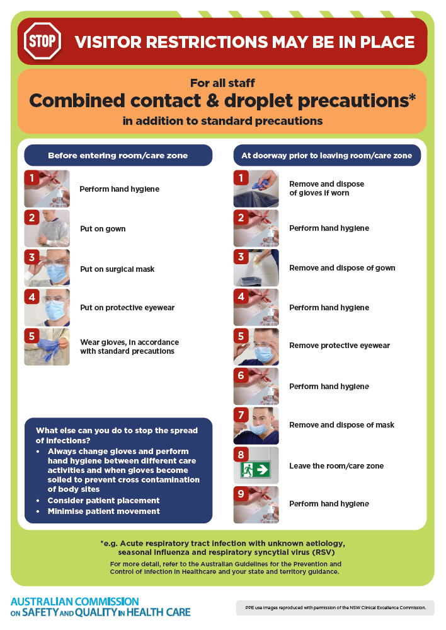
- Poster – Combined airborne and contact precautions
https://www.safetyandquality.gov.au/publications-and-resources/resource-library/infection-prevention-and-control-poster-combined-airborne-and-contact-precautions
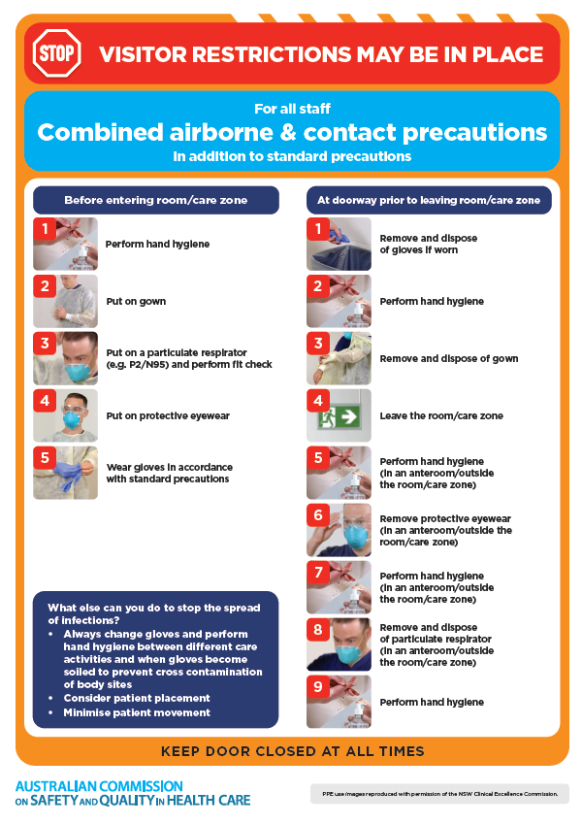
- Environmental Cleaning and Infection Prevention and Control www.safetyandquality.gov.au/environmental-cleaning
- Break the chain of infection poster
https://www.safetyandquality.gov.au/publications-and-resources/resource-library/break-chain-infection-poster
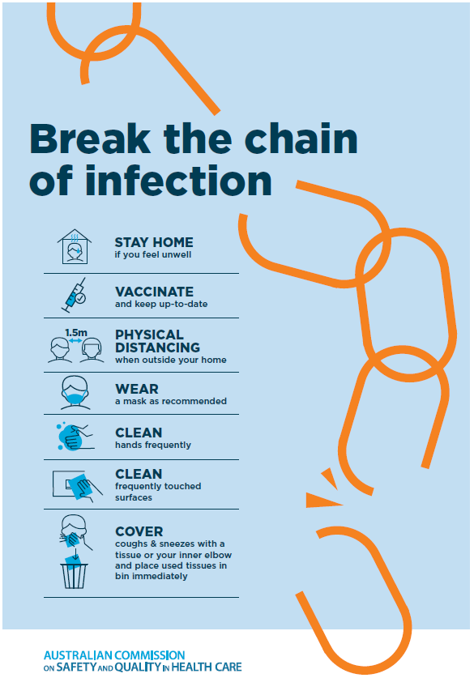

Disclaimer
On the Radar is an information resource of the Australian Commission on Safety and Quality in Health Care The Commission is not responsible for the content of, nor does it endorse, any articles or sites listed The Commission accepts no liability for the information or advice provided by these external links. Links are provided on the basis that users make their own decisions about the accuracy, currency and reliability of the information contained therein Any opinions expressed are not necessarily those of the Australian Commission on Safety and Quality in Health Care.

