
On the Radar
Issue 735
9 March 2026

On the Radar is a summary of some of the recent publications in the areas of safety and quality in health care Inclusion in this document is not an endorsement or recommendation of any publication or provider Access to particular documents may depend on whether they are Open Access or not, and/or your individual or institutional access to subscription sites/services Material that may require subscription is included as it is considered relevant.

On the Radar is available online, via email or as a PDF or Word document from https://www.safetyandquality.gov.au/newsroom/subscribe-news/radar

If you would like to receive On the Radar via email, you can subscribe on our website https://www.safetyandquality.gov.au/newsroom/subscribe-news
or by emailing us at mail@safetyandquality.gov.au.
You can also send feedback and comments to mail@safetyandquality.gov.au.

For information about the Commission and its programs and publications, please visit https://www.safetyandquality.gov.au

On the Radar
Editor: Dr Niall Johnson
Contributors: Niall Johnson

Reports

PHARMA-Care National Quality Framework
Sluggett JK, Javanparast S, Gutteridge D, Calder A, on behalf of the PHARMA-Care Investigators
Adelaide: University of South Australia; 2025, p.16.
URL | https://doi.org/10.25954/7kgp-6q42
Notes | The PHarmacists Actioning Rational use of Medicines in Aged Care (PHARMA-Care) research program has developed this Framework that ‘guides credentialed pharmacists, aged care providers, professional societies, policy makers and other relevant stakeholders in the quality monitoring and evaluation of credentialed pharmacist services and quality use of medicines (QUM) in Australian residential aged care homes (RACHs).’  The framework comprises five domains and six enablers. The domains are:  - person-centred  - governance, leadership, and culture  - safety and quality  - communication and collaboration, and  - access and equity.  The Australian Commission on Safety and Quality in Health Care is a project partner for this project.  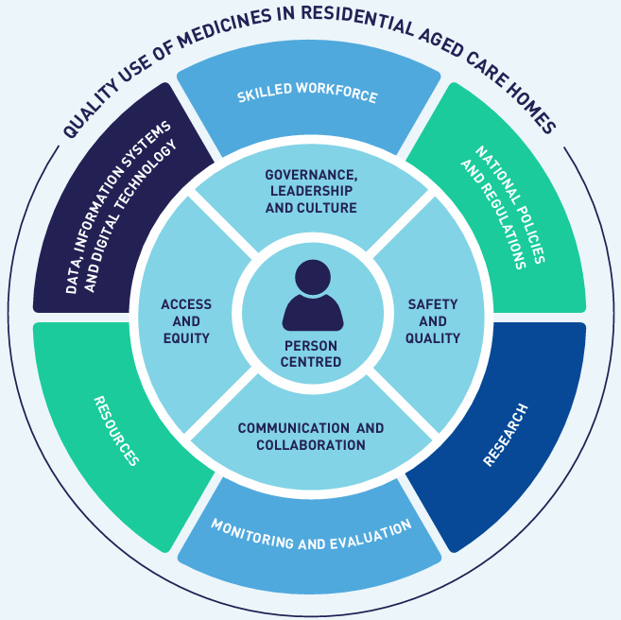
For information on the Commission’s work on medicine safety and quality, see https://www.safetyandquality.gov.au/our-work/medicines-safety-and-quality

For information on the recently released Medication Management at Transitions of Care Stewardship Framework, see https://www.safetyandquality.gov.au/our-work/transitions-care/medication-management-transitions-care-stewardship-framework

Embedding High-Reliability Principles for Safer Medication-Use Systems
ISMP Canada Safety Bulletin, Volume 25, Issue 11
Toronto: ISMP Canada 2025
URL | https://ismpcanada.ca/bulletin/embedding-high-reliability-principles-for-safer-medication-use-systems/
Notes | The latest safety bulletin from ISMP Canada (the Institute for Safe Medication Practices Canada) ‘describes a hospital network’s journey to embed high-reliability principles for safer practice through their implementation of bidirectional smart infusion pump interoperability.’ The case study discusses how the network applied the foundational principles of high-reliability organizations to the particular issue. The principles are given as:  - Preoccupation with Failure  - Sensitivity to Operations  - Reluctance to Simplify  - Commitment to Resilience  - Deference to Expertise.

Menopause and mental health Implications for clinical practice, services and policy
Position Statement PS02/26
Royal College of Psychiatrists
London: Royal College of Psychiatrists; 2026. p. 48.
URL | https://www.rcpsych.ac.uk/improving-care/campaigning-for-better-mental-health-policy/position-statements/2026-position-statements/menopause-and-mental-health-(ps02-26)
Notes | The Royal College of Psychiatrists in the UK have released a position statement that ‘examines how menopause affects mental health and its implications for clinical practice, services, and policy across the UK.  Drawing on lived experience, clinical evidence and an intersectional approach, it highlights that menopause can significantly impact mental health and wellbeing, and is associated with anxiety, depression, cognitive changes and, sometimes, triggering or worsening serious mental illness.  Without proper support, many women struggle unnecessarily during the time of menopause transition. This statement outlines how healthcare, policy and workplaces can better respond to ensure compassionate, equitable and evidence-based care.’

Trauma-informed practice implementation pilot project in Victoria’s mental health and wellbeing services: Evaluation report
Couineau A-L, Pedder DJ, Watson L, Strauven S, Durham C, Smith V, et al
Melbourne: Phoenix Australia – Centre for Posttraumatic Mental Health; 2025. p.51.

Policy brief: Embedding Trauma-Informed Practice: Building Sustainable Change in Victoria’s Mental Health and Wellbeing Services
Melbourne: Phoenix Australia – Centre for Posttraumatic Mental Health; 2025. p.4.

Research brief: Insights from co-designing and implementing trauma-informed practice within Victoria’s mental health and wellbeing services
Melbourne: Phoenix Australia – Centre for Posttraumatic Mental Health; 2025. p.6.
 | https://vccmhw.vic.gov.au/vccmhw/Projects/Enhancing-Trauma-Informed-Practice--A-Hospital-in-the-Home-Project
Notes | A collection of resources developed through a trauma-informed practice implementation pilot conducted across several Victorian mental health and wellbeing services. These resources ‘bring together insights from service users, families, carers, supporters and kin, practitioners, and leaders — offering practical tools, evidence, and learnings to support trauma-informed care in Hospital in the Home programs and beyond.’  The evaluation report assessed the pilot project and findings and recommendations. The authors report that ‘The pilot project demonstrated the value of collaborative, context-specific approaches to adapting trauma informed language and principles as well as implementation support.’  A policy brief and a research brief on trauma-informed practice have also been developed and are available from The Victorian Collaborative Centre For Mental Health & Wellbeing’s website https://vccmhw.vic.gov.au/vccmhw/Projects/Enhancing-Trauma-Informed-Practice--A-Hospital-in-the-Home-Project.

Carbon Hotspot Briefs: Addressing Major Sources of Carbon Emissions for Health Care Products
National Academy of Medicine
Washington DC
URL | https://nam.edu/product/carbon-hotspot-briefs-addressing-major-sources-of-carbon-emissions/
Notes | The National Academy of Medicine in the USA has developed a series of briefs that ‘identify key emission sources across common health care products and outline practical actions to drive meaningful climate benefits across the supply chain’. The briefs completed include:  - Nitrile Gloves  - Labor and Delivery Custom Packs  - Disposable Blood Pressure Cuffs  - N95 Filtering Facepiece Respirators  - CT Scanners  - Surgical Gowns.

For information on the Commission’s work on environmentally sustainable healthcare, see https://www.safetyandquality.gov.au/our-work/environmentally-sustainable-healthcare
Building investigation excellence: our strategy for strengthening the capability of healthcare investigations
Health Services Safety Investigation Body
Poole: HSSIB; 2026

Insulin: supporting safe self-administration for patients in the community with a mental health problem
Investigation report
Health Services Safety Investigation Body
Poole: HSSIB; 2026
URL | Strategy https://www.hssib.org.uk/about-us/corporate-publications/building-investigation-excellence/  Investigation report https://www.hssib.org.uk/patient-safety-investigations/insulin-supporting-safe-self-administration-in-vulnerable-patient-groups-in-the-community/investigation-report/
Notes | The Health Services Safety Investigations Body (HSSIB) in the UK has released two documents, one a report from an investigation, the other a new strategy document.  The investigation report examined issues around patients under the care of community mental health services where people have intentionally not taken their insulin as prescribed and subsequent incidents leading to life-changing harm and death. The report’s findings and safety recommendations are designed to strengthen care for people with co-existing mental health conditions and insulin-treated diabetes  The strategy document Building Investigation Excellence is intended to support investigators across the UK’s National Health Service (NHS) to carry out high-quality investigations that drive improvements in patient safety.

Journal articles

Embedding cultural safety to combat racism against Aboriginal and Torres Strait Islander peoples: Advice for healthcare settings
Wilkes B, Whop L, Thurber K, Colonna E, Lovett R
Australian Journal of General Practice. 2026;55:91-96.
URL | https://www1.racgp.org.au/ajgp/2026/march/embedding-cultural-safety-to-combat-racism-against  https://doi.org/10.31128/AJGP-09-25-7844
Notes | Article from an issue of the Australian Journal of General Practice that highlights key messages from the National Guide to preventive healthcare for Aboriginal and Torres Strait Islander peoples. This article ‘offers guidance for health practitioners on meeting their responsibilities to provide culturally safe care for Aboriginal and Torres Strait Islander peoples.’

Sufficient and Efficient Spending on Primary Care Benefits National Health and Health Systems
Phillips RL, Fisher R, Jackson C, Martin D, Olde Hartman TIM, Goodyear-Smith F
The Milbank Quarterly. 2026.
DOI | https://doi.org/10.1111/1468-0009.70075
Notes | Paper examining issues around funding primary care in a number of countries, including the UK, USA, Canada, Australia, New Zealand and The Netherlands. The authors argue that all these nations face challenges in primary care and that ‘Common drivers include underfunding and spending that is inefficient, leading to workforce crises and rising clinical and administrative burdens that drive burnout.’  Among the highlighted policy points from this article are:  - Primary care is undervalued and under-funded in many countries despite different care and payment models.  - High-quality, accessible primary care requires sustained and strategic investment.  - Team-based care, sustainable and engaged workforce models, and technology that enhances rather than fragments care are priorities that are shared across nations.  - Countries can adopt a principled approach by paying for primary care teams to care for people not physicians to deliver services; ensure that high-quality primary care is available to every individual and family in every community, and ensure that high-quality primary care is implemented with measurement and accountability.

Primary Care Physician Trends: Dissatisfaction, Stress, And Burnout In The US And 9 Comparator Countries, 2012–22
Steinbeck V, Ganguli I, Papanicolas I
Health Affairs. 2026;45(3):251-260.
DOI | https://doi.org/10.1377/hlthaff.2025.00880
Notes | Also looking at primary care is this study which presents a secondary analysis of the Commonwealth Fund’s survey of ‘primary care physicians in the United States and nine other high-income countries’, including Australia. The authors observe that ‘Burnout and decreased well-being among primary care physicians threaten workforce sustainability and health outcomes.’ They argue that ‘policy solutions could focus on ensuring manageable work hours and administrative work, in-person support structures, fair payment, work-life balance, and the opportunity to provide consistent quality of care.’  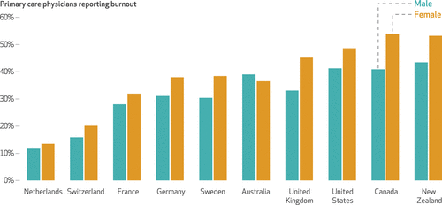

The Joint Commission Journal on Quality and Patient Safety
Volume 52, Issue 3, March 2026
URL | https://www.sciencedirect.com/journal/the-joint-commission-journal-on-quality-and-patient-safety/vol/52/issue/3
Notes | A new issue of The Joint Commission Journal on Quality and Patient Safety has been published. Articles in this issue of The Joint Commission Journal on Quality and Patient Safety include:  - Impact of a Multifaceted Quality Improvement Initiative Aimed at Reducing Primary Cesarean Delivery Rates (Melissa Peskin, Brittany H Sanford, Celia A Muoser, Emma Chew Murphy, Amoli Kulkarni, Beatrice Lynch, Tess Nienaltowa, Marlena Gehret Plagianos, Peter Bernstein, Pe’er Dar)  - Perceptions of Consent for Operative Vaginal Delivery: A Service Evaluation (Frances Hand, Morganne Wilbourne, Sophie McAllister, Nadia Muspratt-Tucker, Jonathan Herring, Sujay Chakravarti, Meena Bhatia)  - Evaluation of Declined Inter-ICU Transfer Requests to a Tertiary Care Hospital (Gabrielle Matias, Mengou Zhu, Nandita R Nadig, John M Coleman, Michelle Prickett, Lindsey Gradone, Susan R Russell)  - Aligning Patient Safety Event Reporting: 2025 Updates to Sentinel Events and Serious Reportable Events  - Decluttering for Safety: Can We Simply Apply Approaches Used in De-Implementing Low-Value Care? (Hana Shamsan, Andrew John Rea, Alison Bravington, Daisy Halligan, David Alldred, Robbie Foy, Rebecca Lawton)  - Book review: Fundamentals of Health Care Improvement: A Guide to Improving Your Patient’s Care, Fifth Edition

Health Policy
Volume 166, April 2026
URL | https://www.sciencedirect.com/journal/health-policy/vol/166/
Notes | A new issue of Health Policy has been published. Articles in this issue of Health Policy include:  - Hybrid threats require hybrid solutions: A roadmap for healthcare security (Petrut Gogalniceanu)  - The social media turn in medicine: platform-based marketization of health care, ethics, professionalism, and lessons from Turkey (Bülent Özlek)  - Staff awareness and engagement with the Green Plan: A cross-sectional survey of one of the largest NHS trusts in the UK (Vishal Madan)  - Integrated care in the Baltic countries over a five-year period: an expert-informed cross-country analysis of progress, challenges and future directions (Nathan Shuftan, Giada Scarpetti, Katherine Polin, Kaija Kasekamp, Daiga Behmane, Liubove Murauskiene, Verena Struckmann)  - Experiences and social constructions of loneliness in later life: Collaborative focus group discussions in Germany (Andrea Kastl, Ulrike Fettke, L Dobusch)  - What determines earnings of self-employed physicians in Austria? Evidence from quantile regressions using linked tax records (Christoph Stegner, Miriam Reiss, Thomas Czypionka)  - Gender disparities in healthcare access persist even in more equitable societies: A multilevel assessment across 29 countries (Matthijs Fakkel, Victoria Ustenko, Susan Witt, Jandirk Veenstra, Rao R Bhavani)  - Prospects for implementing the European Code of Cancer Practice: Lessons from Poland (Joanna Kufel-Grabowska, Jacek Jassem)  - Made in Europe – assessing the feasibility of reshoring active pharmaceutical ingredient production to Europe (Verena Knoll, Caroline Steigenberger, Stefan Fischer, Sabine Vogler)  - Germany's Path to a National Kidney Exchange Program: An Assessment of the 2024 Legislative Proposal (Péter Biró, Klemens Budde, Lisa Burnapp, Ágnes Cseh, Christine Kurschat, David Manlove, Axel Ockenfels)

Health Affairs
Volume 45, Number 3, March 2026
URL | https://www.healthaffairs.org/toc/hlthaff/45/3
Notes | A new issue of Health Affairs has been published with themes of ‘Health Care Workforce, Medicare and more’. Articles in this issue of Health Affairs include:  - Practice Pattern Changes After Adoption Of Diagnostic AI Tool Used In Conjunction With Cardiac Imaging (Anna Zink, Michael E Chernew, and Hannah T Neprash)  - Majority Of Family Physicians Still Choose To Practice In The State Where They Were Trained (Michael Topmiller, Lars E Peterson, Andrew W Bazemore, Mark Carrozza, Jené Grandmont, and Yalda Jabbarpour)  - Primary Care Physician Trends: Dissatisfaction, Stress, And Burnout In The US And 9 Comparator Countries, 2012–22 (Viktoria Steinbeck, Ishani Ganguli, and Irene Papanicolas)  - Private Equity Acquisition Of Primary Care Practices: Modest Growth In Clinicians Offset By Increased Clinician Exits (Jane M Zhu, Aine Huntington, Mia Giuriato, Daniel Polsky, and Zirui Song)  - State Nursing Home Minimum Staffing Mandates: Increased Staff Levels, Minimal Impact On Finances And Closures, 2010–23 (Rachel M Werner, Xinwei Chen, Norma B Coe, and Andrew R Olenski)  - The Effects Of Labor Unions On Nurse Staffing Ratios And Quality Of Care In US Nursing Homes, 2013–21 (Adam Dean, Jamie McCallum, Atheendar S Venkataramani, Paula Chatterjee, Norma B Coe, and D Michaels)  - Rapid Disenrollment Rates Tripled For Medicare Advantage Beneficiaries, 2017–22 (Em Balkan, Jay Shroff, Amal N Trivedi, A M Ryan, and D J Meyers)  - SSDI Beneficiaries Had Elevated Mortality During The 2-Year Waiting Period For Medicare, 2000–21 (David Powell, Seth Hartig, and M Jacobson)  - CMS’s New Risk-Adjustment Model Had Limited Impact On Medicare Advantage Benefits, 2024–25 (Paul D Jacobs and Richard Kronick)  - Disenrollment Rate For Dual-Eligible Beneficiaries During Medicaid Unwinding, 2023–24 (Eric T Roberts, Dominic Ruggiero, Syama Patel, John Z Ayanian, Erin Beathard, M Kirch, J T Kullgren, G Switzer, and R Tipirneni)  - Half Of Rural Patients Bypassed Their Local Hospital But Received Lower-Quality Surgical Care Elsewhere, 2016–20 (Cody Lendon Mullens, P Johnson, C Rentas, N Kunnath, J C Probst, A M Ibrahim, and J B Dimick)  - List Price Reductions Among Brand-Name ICS-LABA Inhalers In 2024 Were Associated With Increased Generic Uptake (Jihye Han, Shirley V Wang, Aaron S Kesselheim, Jerry Avorn, and William B Feldman)  - Substantial Variation In Administrative Spending And Profit Across State Insurance Markets, 2023 (Jason D Buxbaum, Daniel R Arnold, Erin C Fuse Brown, Christopher M Whaley, and Andrew M Ryan)  - A Geriatric Geriatrician Speaks Out (Jerald Winakur)
BMJ Quality & Safety online first articles
URL | https://qualitysafety.bmj.com/content/early/recent
Notes | BMJ Quality &Safety has published a number of ‘online first’ articles, including:  - AI mirage: medical algorithms and the vanishing autopsy (Qi Wang)

International Journal for Quality in Health Care online first articles
URL | https://academic.oup.com/intqhc/advance-articles
Notes | International Journal for Quality in Health Care has published a number of ‘online first’ articles, including:  - Lessons Learned from the Safety Investigation of an Omitted Dose-Dispensed Medicine (Hanna Tiirinki, Alpo Vuorio)  - Reliability of retrospective medical record review for identifying adverse events: Findings from the 2023 Korean Patient Safety Incident Inquiry (Eun Young Choi, Won Lee, Seung Gyeong Jang, Jeehee Pyo, Minsu Ock)  - Reporting aged care quality data monthly, quarterly or annually? A cross-sectional study of 349,613 residents and 2,803 long term care facilities (Robert N Jorisse, Gillian E Caughey, Dylan Harries, Johannes Schwabe, Brian W Pulling, Tracy Comans, Maria C Inacio, the ACAC QMET Collaborators)  - Insights from open-ended questions of a multi-country patient safety culture survey (Alejandro Arriet, Fiorela Sacha Quillca, Hugo Renato Siu Guillen, Nataly Agudelo Aldana)

Online resources

Australian Living Evidence Collaboration
https://livingevidence.org.au/

Residential Aged Care Communiqué
https://www.thecommuniques.com/post/residential-aged-care-communiqu%C3%A9-volume-21-issue-1-february-2026
Volume 21, Issue 1, February 2026
This issue of Residential Aged Care Communiqué examines ‘two cases where the nature and level of staff supervision provided for the residents was called into question’. It is noted that these two fatal incidents had ‘at least three areas of commonality’. These being, the aged care facilities sought to respect the residents’ autonomy, the nature of the residents’ cognitive impairment was not fully appreciated or understood and the level of supervision required and how to implement it to ensure the safety of the resident.

[UK] NICE Guidelines and Quality Standards
https://www.nice.org.uk/guidance
The UK’s National Institute for Health and Care Excellence (NICE) has published new (or updated) guidelines and quality standards The latest reviews or updates include:
- Quality Standard QS214 Rare diseases https://www.nice.org.uk/guidance/qs214

Infection prevention and control resources
The Australian Commission on Safety and Quality in Health Care has developed a number of resources to assist healthcare organisations, facilities and clinicians These resources include:
- Poster – Combined contact and droplet precautions https://www.safetyandquality.gov.au/publications-and-resources/resource-library/infection-prevention-and-control-poster-combined-contact-and-droplet-precautions
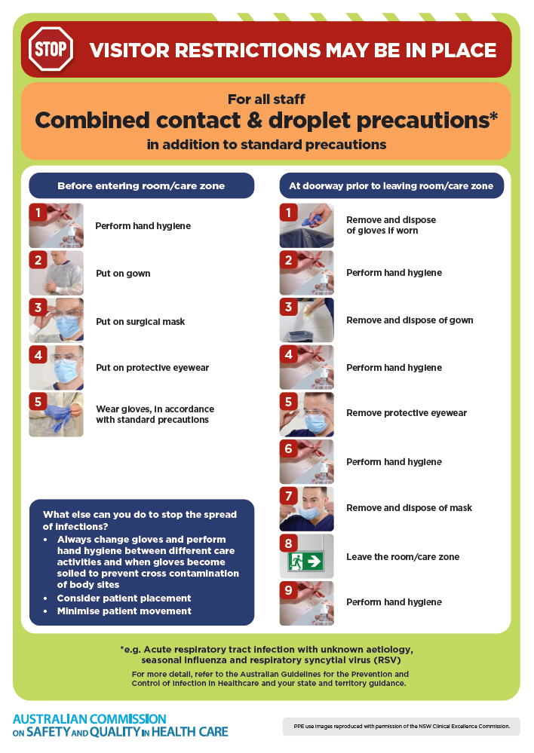
- Poster – Combined airborne and contact precautions
https://www.safetyandquality.gov.au/publications-and-resources/resource-library/infection-prevention-and-control-poster-combined-airborne-and-contact-precautions
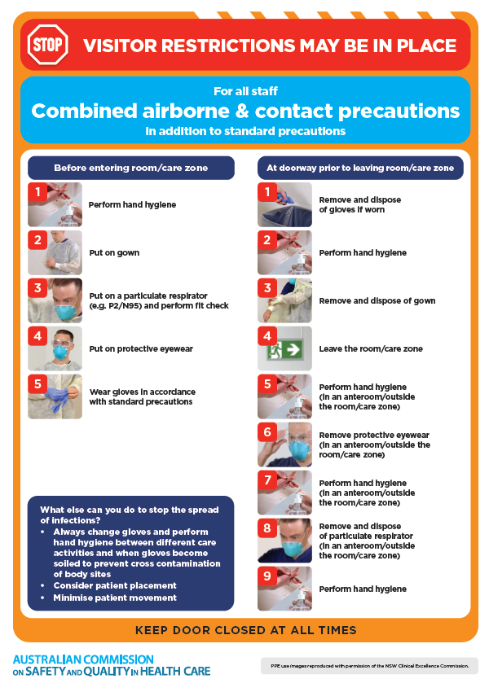
- Environmental Cleaning and Infection Prevention and Control www.safetyandquality.gov.au/environmental-cleaning
- Break the chain of infection poster
https://www.safetyandquality.gov.au/publications-and-resources/resource-library/break-chain-infection-poster
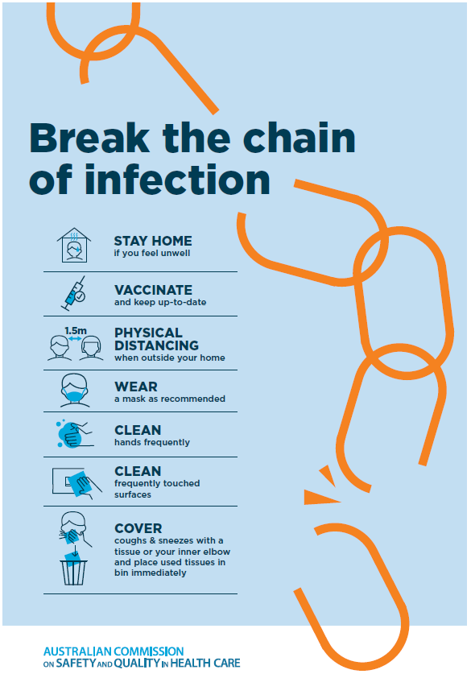

Disclaimer
On the Radar is an information resource of the Australian Commission on Safety and Quality in Health Care The Commission is not responsible for the content of, nor does it endorse, any articles or sites listed The Commission accepts no liability for the information or advice provided by these external links. Links are provided on the basis that users make their own decisions about the accuracy, currency and reliability of the information contained therein Any opinions expressed are not necessarily those of the Australian Commission on Safety and Quality in Health Care.

