World AMR Awareness Week
Ideas for activities and events in 2025
Each year many individuals, organisations and groups come up with novel and exciting ways to engage the public and other health professionals in the important messages of World AMR Awareness Week (WAAW). This guide provides ideas from the Commission and other groups for running activities and events during WAAW.

Audit the volume and appropriateness of local antimicrobial prescribing
Health service organisations can review the volume and appropriateness of antimicrobial use and prescribing by using audit tools. The National Antimicrobial Utilisation Surveillance Program (NAUSP) can be used to review usage rates whilst tools such as the National Antimicrobial Prescribing Survey (NAPS), can be used to assess appropriateness. Some health service organisations may have their own local tools which they can use. The local audit data for volume and appropriateness can be used for local feedback and discussion during WAAW. Consider incorporating slides on local health service results in the Commission’s PowerPoint presentation.

Display the WAAW logo
Promote WAAW on local intranet and home screens. Ask your Information Technology (IT) team to place the Commission’s web banner on your intranet page, or include an article on World AMR Awareness Week on your staff intranet homepage with links to more details about the week and your planned activities. You could also ask your IT Department to load a WAAW screensaver on to all computers.

Use the World Health Organization’s (WHO) WAAW logo on meeting notes and in other correspondence and the Commission’s email banner in your email signature.

Download the World AMR Awareness Week Presentation
The Commission has a PowerPoint presentation that can be used to raise awareness and understanding amongst healthcare workers on antimicrobial resistance. You can use or adapt this presentation for grand rounds or for team, unit or departmental meetings and education sessions. You could also add some local information to your presentation. For example, ask:
- a team or department to talk about how they have improved antimicrobial use, including the lessons learned on the improvement journey
- a surgical team or anaesthetist to discuss surgical prophylaxis
- an infectious diseases team to give a case presentation focused on management of a specific clinical condition, and how antimicrobial stewardship supported patient care
- a nurse and pharmacist to be involved in the presentation to discuss their roles in antimicrobial stewardship as members of the multidisciplinary team
- a patient for a story to illustrate the personal challenges of dealing with a multidrug-resistant infection.

Target healthcare worker groups
Run information sessions for specific healthcare worker groups and discuss their role in the appropriate use of antimicrobials and antimicrobial stewardship. For example, organise ward-based education sessions with nurses, information sessions with pharmacists, or run a feedback session for prescribers (consider who is the best group to target in your facility e.g. junior doctors or consultants or visiting medical officers) to provide the results of antimicrobial prescribing audits and highlight results against the Antimicrobial Stewardship Clinical Care Standard indicators.

Conduct consumer information sessions
Inform consumers (including patients and their carers) about the reasons why antimicrobials need to be used carefully, and how they can do so. You can use the Commission’s consumer PowerPoint presentation, and distribute written information to consumers about the Antimicrobial Stewardship Clinical Care Standard, and what it means for patients and consumers. You could also hand out the Commission’s Do I really need antibiotics? fact sheet and information on making decisions about antimicrobials for middle ear infection in children, bronchitis, sore throat, COPD and sinusitis.

Create an information display
Choose a prominent area of the health facility to display the Commission’s resources as well as local resources from your health service. You could also.
- Hand out written material with details of where to find local policies, procedures, and local processes for seeking specialist advice or referral, as well as contact details of antimicrobial stewardship team members.
- Have a range of healthcare workers rostered to staff the display – doctors, nurses, pharmacists, managers – to reflect the multidisciplinary nature of good antimicrobial management.
- Create a display of local information relevant to antimicrobial use. For example, antimicrobial usage audit results or local resistance and susceptibility information. The Commission has a poster that can be printed and displayed.
- Be innovative! A mobile WAAW trolley with an entry box for the WAAW quiz; creative catering such as bacteria cake pops, WAAW fortune cookies or jelly agar treats with WAAW messages printed.

Run games and competitions
- Engage your organisation with a WAAW poster competition. Display competition entries around the organisation.
- Create a bingo game that can be played in your department or ward. Design a bingo card that contains the names of various antibiotics in each square and prepare a list of common bacteria. The game host will call out the bacteria and players must mark their bingo cards if they identify an antibiotic that they can use to treat the bacteria Whoever has a complete row of marked antibiotics will be declared the winner.
- Set up a guessing game for how many vials of ceftriaxone or another broad-spectrum antimicrobial were used in the year. This is a simple game that can get consumers, clinicians and other hospital staff all involved.
- Display posters with a QR code that links to the WAAW Clinician Quiz or WAAW Consumer Quiz. Examples of posters can be found on the WHO website – Campaign materials.
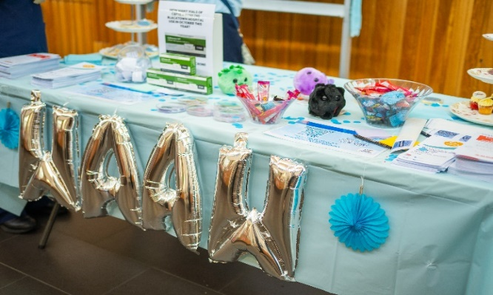
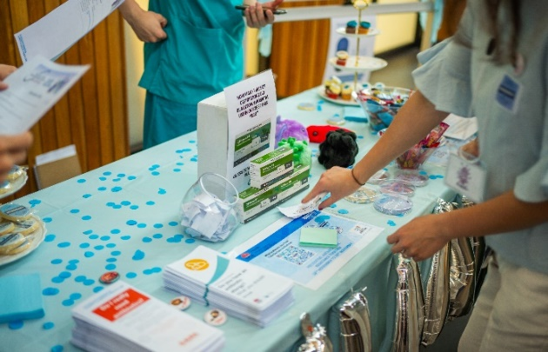
Figure 1. Example of WAAW stall

Use social media and join the discussion
If your health service organisation has a social media account, use these to promote and distribute messages about antimicrobial resistance and events and activities happening during the week.
Consider wearing light blue – ask your health organisation’s executive and communications team to promote staff wearing light blue attire during the week. Organise photos of colleagues wearing light blue and post it in hospital newsletters or the health service organisation’s social media account with a message on why your organisation is ‘Going Blue for AMR.’
Check your organisation’s social media policy before you begin.

For more information
Please visit: https://www.safetyandquality.gov.au/waaw

© Australian Commission on Safety and Quality in Health Care 2025

